PLC’s and control

Design and produce a conveyor system using Programmable Logic Controller application.

By Alex Kazemi
Gower College Swansea (UWTSD)

Abstract
The aim of this report is to design and produce a conveyor system using Programmable Logic Controller application. By compiling this report, I hope to understand the basic principles that allow this system to operate.
The report has three specific areas outside of the abstract, introduction and conclusion. These are listed in the table of contents and include system specification, design, and system operation.
The report is to be approximately 2,500 words and should include a high level of information regarding the subject matter. It also includes drawings and diagrams as well as a range of referencing material.

Table of Contents
Title page 1
Abstract 2
Table of contents 3
Introduction 4
System specification 5-7
Design 8-9
System operation 10-20
Conclusion. 21
References 22

Introduction
I have been tasked with researching, designing, and producing a conveyor system using Programmable Logic Controller application. The conveyor system will sort cylinders, small, medium and large based on their diameter. The start of the report will focus on system specification, mainly what is required within the system through the modelling of a technical specification document.
The report will then move on to the design of the conveyor system. This will include a layout of the design as well as a flow chart explaining how the conveyor system should operate and what the system does if it doesn’t operate correctly.
The report will finish with the conveyor system operation. This will include pictures of the system in use and the Siemens software used to design and create the system, enabling it to work correctly.

System specification
A technical specification document is predominately a technical design document which highlights the plan of a software development project. This includes the needs, constraints, and requirements of the project. It provides a step-by-step process which enables a clear path for the team involved in the project. This ensures that the team are all working toward the same end goal.

The technical specification document will include the functional/non-functional requirements of the software, the scope of the project, a timeline, the internal standards, the impact, the work involved and the budget (www.document360.com).

Functional and non-function requirements
Functional requirements can be through a range of functions such as user authentication, data management, reporting and notifications. User authentication in a system would require different functions such as users creating accounts, needing to login, support via password recovery etc. Another aspect of functional requirements would be data management. The system should allow users to create, read, update, and delete their profile information (www.educative.io). It should enable users to manage and upload documents. The system should also allow for generic performance reporting on a regular cycle and notify the user of any changes or updates to the software. These requirements are met through the Siemens PLC software used to control the conveyor system. The software requires a login and provides satisfactory data management. It also allows you to monitor the performance and provides notifications to any software updates. This is a necessity when software is regularly being updated to improve systems.

Non-functional requirements specify the operation capabilities of the system as well as the systems constraints. Examples of this would be performance, usability, reliability, security, and maintainability (www.altexsoft.com). Performance is one of the key elements of non-functional requirements. The system should be able to perform at a high level regularly without the performance of the system deteriorating. It must also respond to the user request within a set time. This is achieved through start/stop buttons enabling the system to respond within the set time. The system should also be reliable, working with almost no downtime and will recover from any failures within a short time. The conveyor must constantly sort the right blocks in the right compartments are per design. The system must have a highly sensitive security network in place which restricts access based on certain user’s job roles. Data must be encrypted to avoid any hacking or interference from taking place. The systems maintainability must also be sufficient to allow for regular updates. It should allow for system shutdown and no loss of data when this takes place. The Siemens PLC software allows for this, being an encrypted and professional system.

Project scope
The aim of the project is to design and create the software for a conveyor belt system that sorts cylinders of three different sizes. These sizes are small, medium and large. This will include researching and understanding Programmable Logic Controllers. Regular use of the Siemens PLC software will develop a greater understanding and improve skills in using the software. Once completed, this conveyor system will be used to show and record findings (www.business.adobe.com).

Project timeline
September 2023 – Start PLC research.
October 2023 – Start Siemens software training.
December 2023 – Project assignment received.
December 2023 – April 2024 – Software designed, and practical tests carried out.
May 2024 – Report produced on conveyor system project.
May 24th, 2024 – Project completion.

Internal standards
The conveyor project must adhere to college standards and college working practices. The Siemens software should only be used for its intended purpose, in this case, creating the relevant software for the conveyor system. During the practical, all tools are to be used for their intended purpose and the correct personal protective equipment worn. The quality of work must be to that of the college standards.

Impact
There will be no real impact to any external parties or businesses. The project work will be carried out in the college during college hours.

Process of work
The process of work will be every Thursday afternoon, project work will commence for two hours per week other than weeks where the college is closed for half term. The project timeline as stated previously, provides the structured process in when the work takes place and what work is being undertaken.

Budget
There is no budget in relation to this project. The project work will be carried out during college time using college equipment and work areas.

Constraints
Time is the biggest constraint of this conveyor system project. Unfortunately, I only have a weekly two-hour window to carry out my Programmable Logic Controller lesson. By the time the following week comes around, it takes time to get back up to speed from the following week. Therefore, the research and learning process can be quite stop start. Another constraint is accessibility. The Siemens software is only available on college computers in the technical block. Due to the working week, it is only possible to access these computers during PLC class one day a week for the two-hour slot. This again will hinder the amount of work that can be done and the speed that it can be done at.

To conclude, the scope of the project and any underlying factors have been outlined. Following this, the next part of the project is to proceed with the conveyor system design. This will follow on in the next section of the report.

Design
Conveyor belt Motor Pneumatic cylinders
Air supply 3 2 1 Sensor 2 Sensor 1
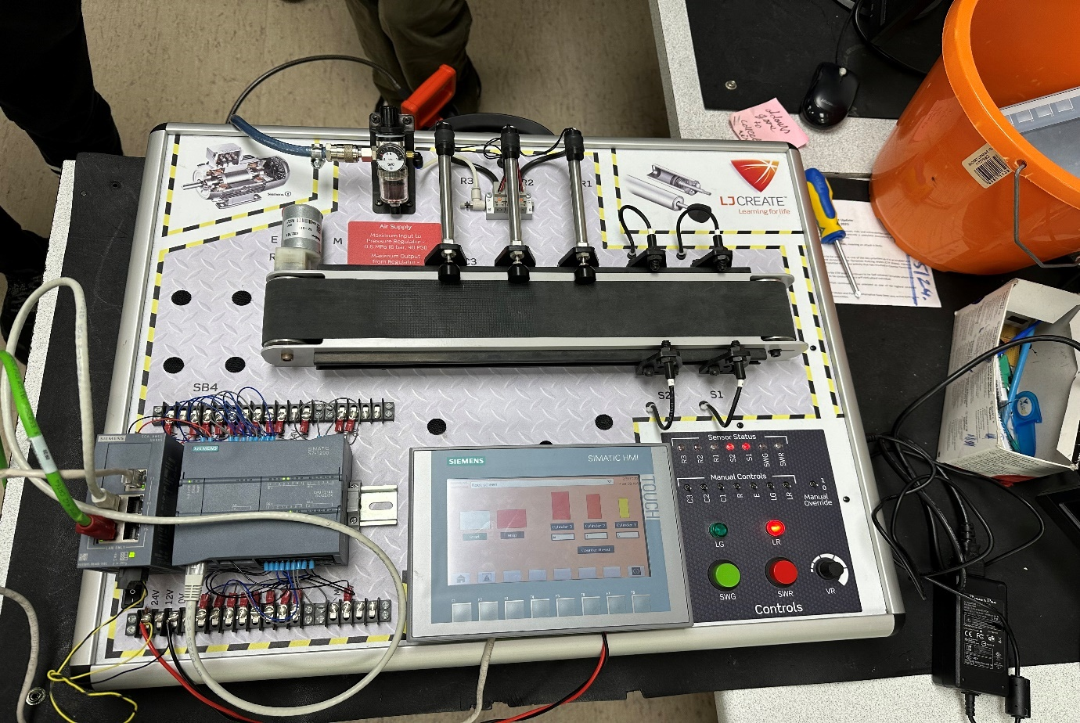

Power supply Start button
PLC Manual override Stop button
HMI Sensor status LED
I have added a picture above of the conveyor belt system, and labelled each individual component to show how the system looks. As you can see, the components are the start and stop buttons, these also have a green and red LED above each button of the same colour. Manual override switches and sensor status LEDs are above these. To the left of this you have the Siemens HMI followed by the power supply and the Siemens Programmable Logic Controller. At the top of the picture, you have the conveyor belt and the motor, next to these is the air supply. These are followed by the two optical sensors named one and two. Finally, these are next two the three pneumatic cylinders labelled one, two and three.

Start

System and motor start up

Conveyor belt start

Image capture of object
Verify object size

Is object require size?
NO
Remove unrequired object

YES
Keep object on belt
Conveyor belt still operates
Put object in correct tray

Switch still on?

YES NO
Stop

Above is a flow chart on how the system operates. This shows a step-by-step basis on how the system sorts the parts and what happens if the wrong size passes the sensors.
System operation
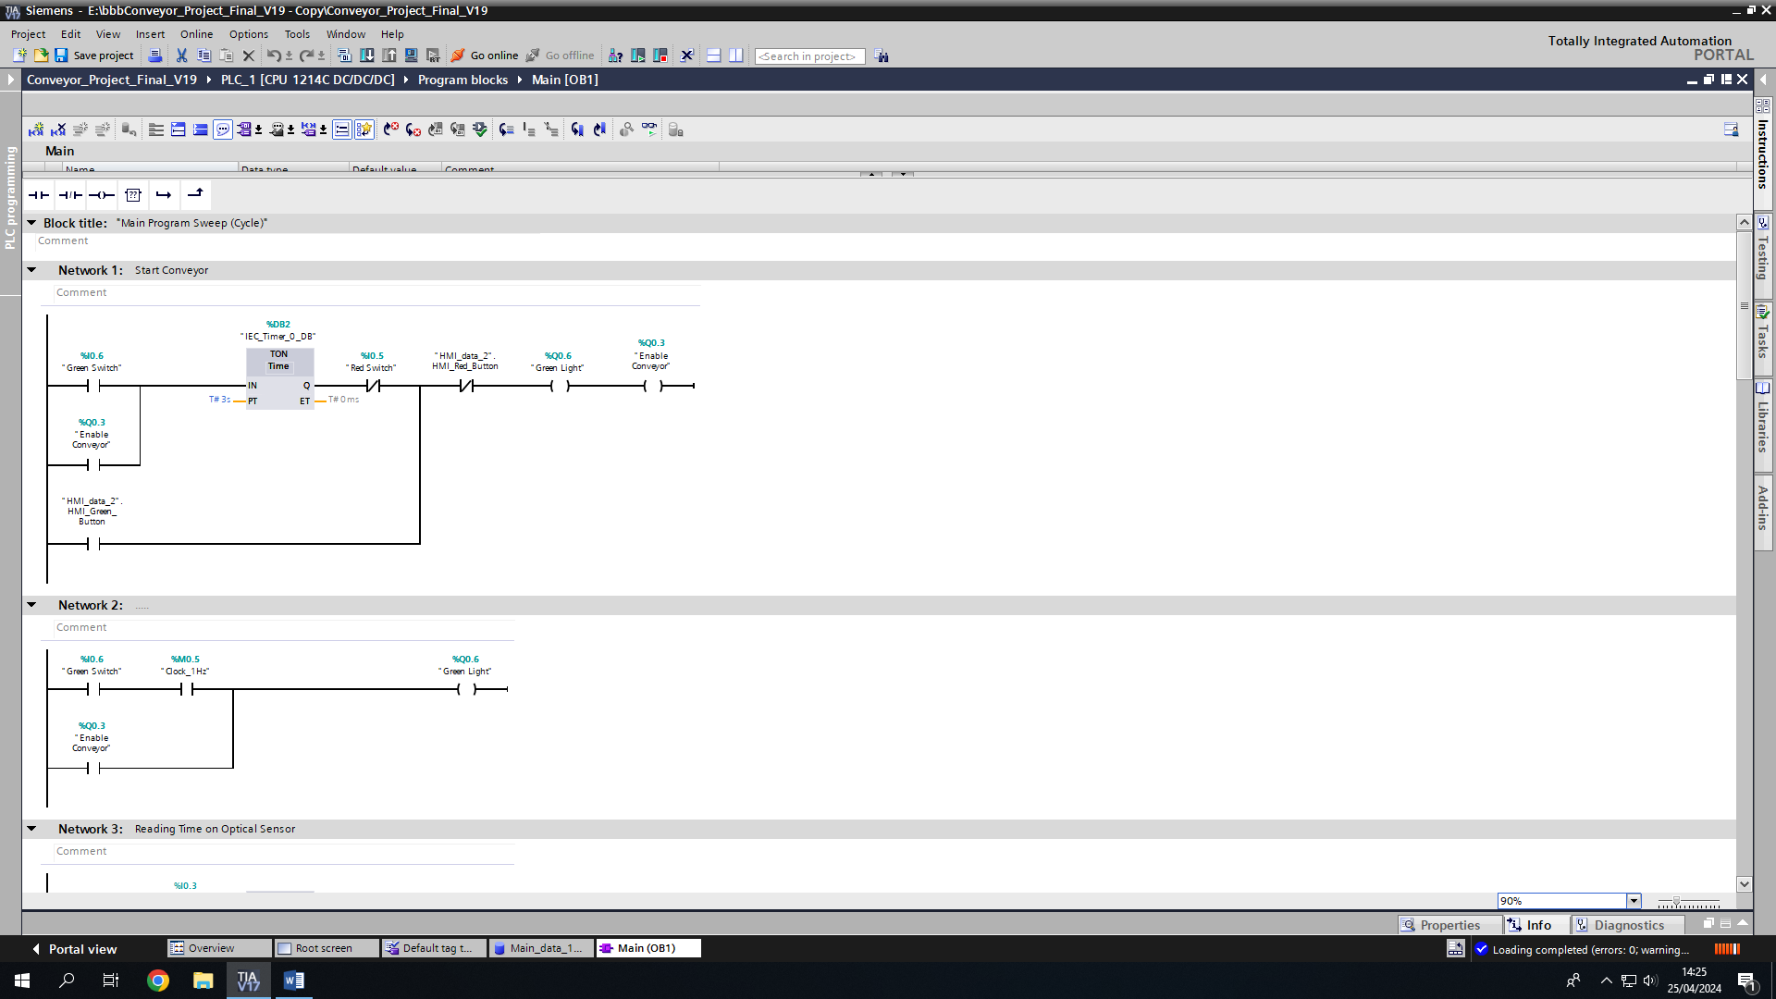
Network 1 and 2

The conveyor system will start to run when the green push button is operated. There is a 3 second delay timer which starts upon operation. Connected in series is a red stop button which is normally closed. If this red stop button is activated, then the conveyor system will stop immediately. An HMI screen has been connected to allow the user to operate these on the HMI screen.
As the start button is pushed for 3 seconds, to start the conveyor system, a 1Hz clock signal is sent to the green light. This will cause the green LED to illuminate.
If the switch is pressed for longer than the required 3 seconds, the conveyor system will start, and the output is relayed to the starting operation. The conveyor belt will then run until either 30 seconds have lapsed without activating the sensors, or the stop button is pushed.

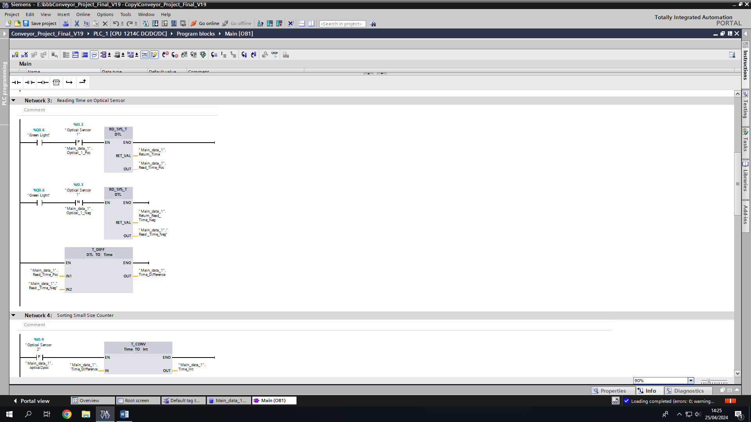
Network 3

As the system starts, a clock begins to run forming the time and date. This is set to read time pos and read time neg. Once this is activated then optical sensor one will look for a positive and negative signal. As soon as this occurs, the time for the signal change us sent to the outgoing time difference. The time difference calculates the difference in time in order to send a signal to the counter network to continue the process of the conveyor system.

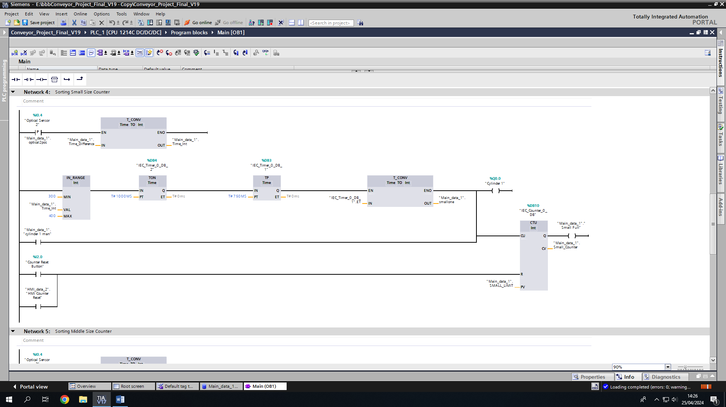
Network 4, 5 and 6

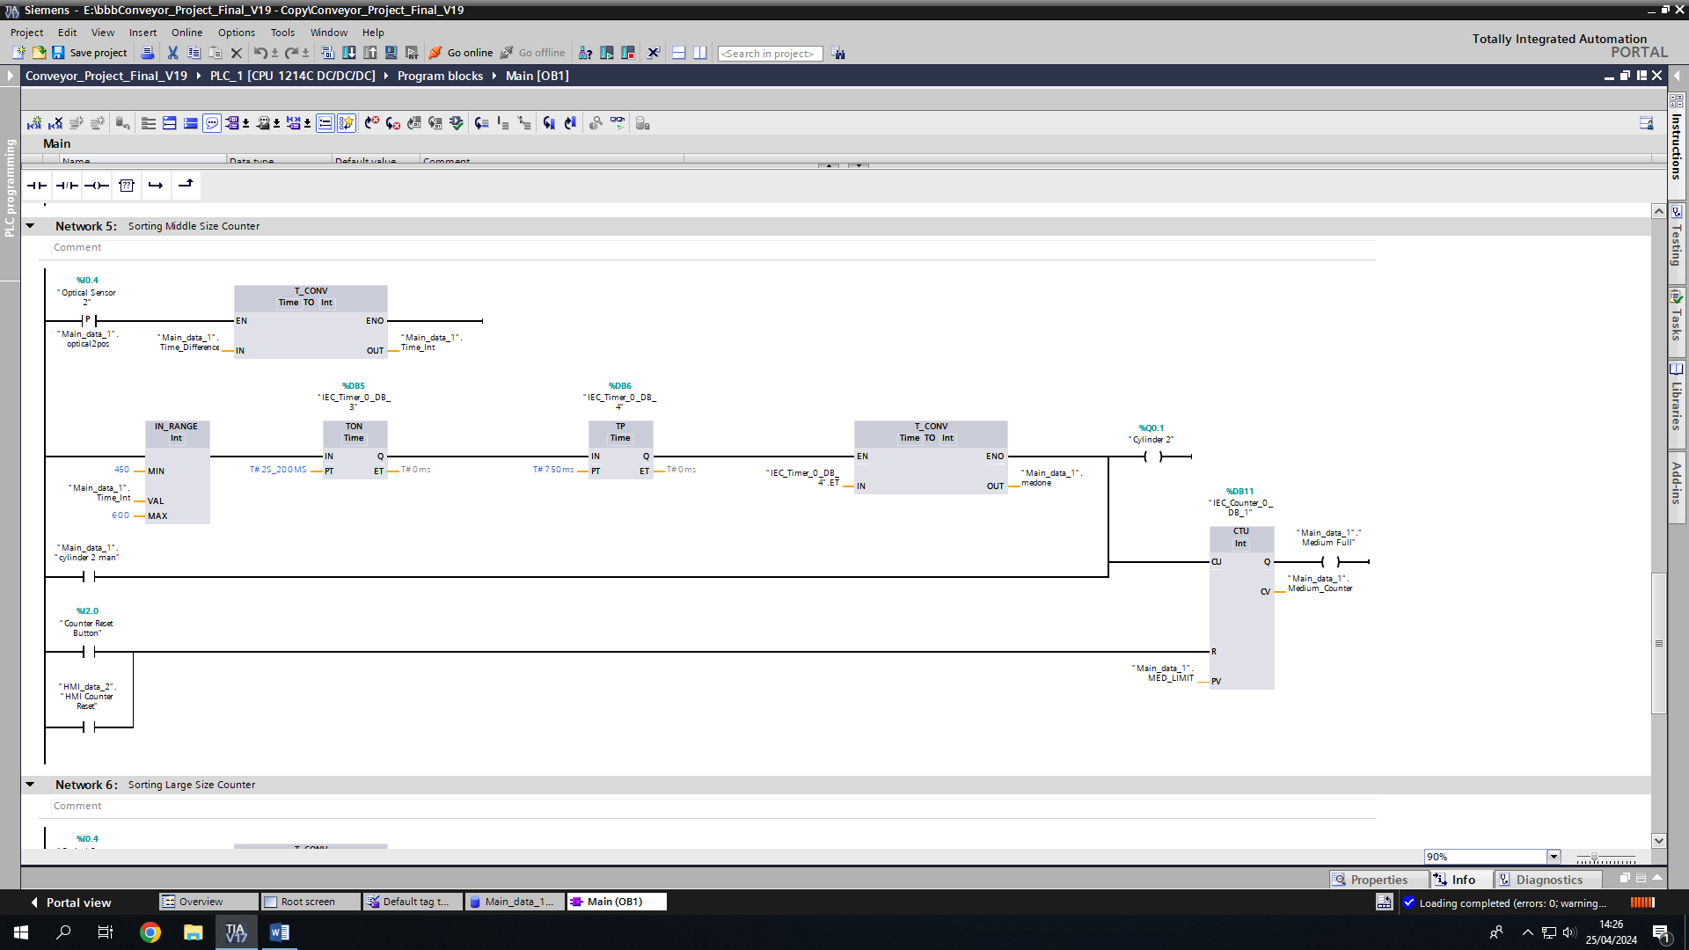

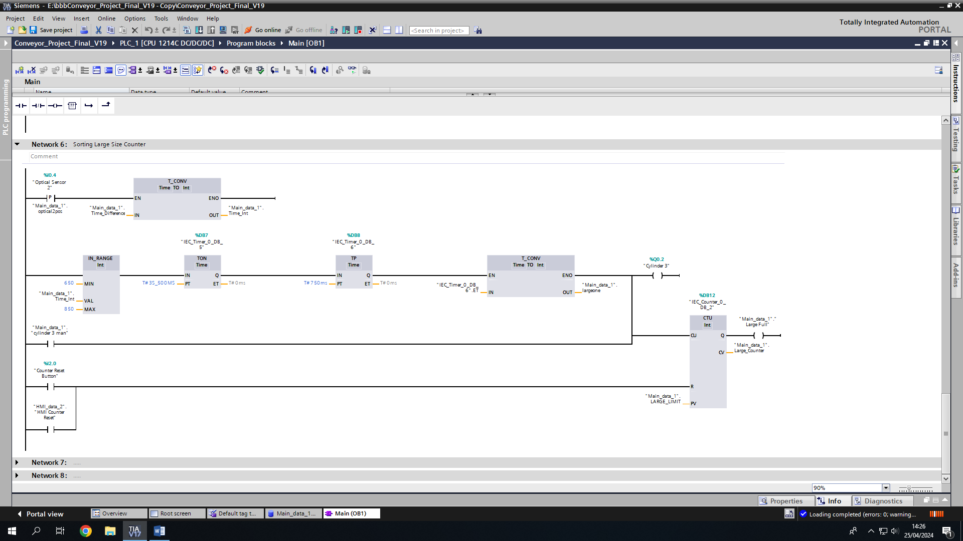

The second optical sensor will then trigger one of networks 4, 5 or 6. This will be dependant on the time difference sent into the time conversion operation. If this converted value is within the time conversion range, the set cylinder will then push the item in to the tray. There is a slight delay from the cylinder, due to the timer, to allow the item to move on the conveyor belt until it reaches its destination. Upon the cylinder operating, a counter increases by each movement it makes, which also appears on the HMI screen. This function also has the option to reset the counters back to zero.

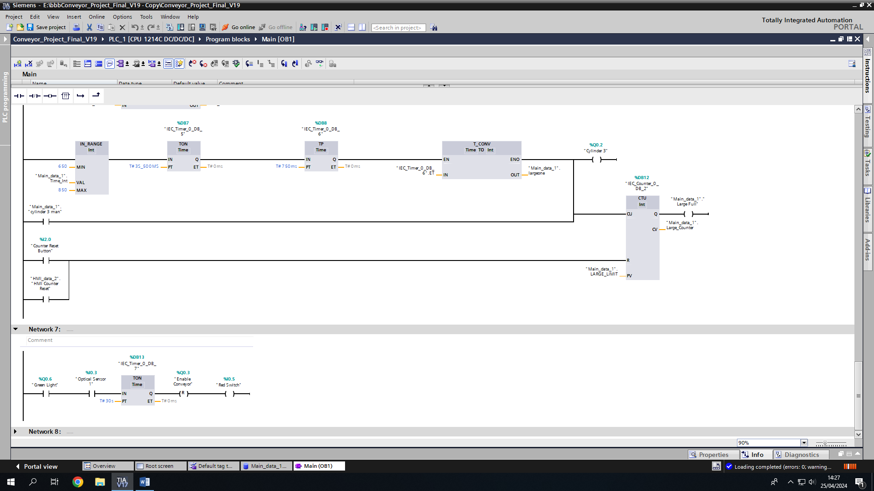
Network 7 and 8

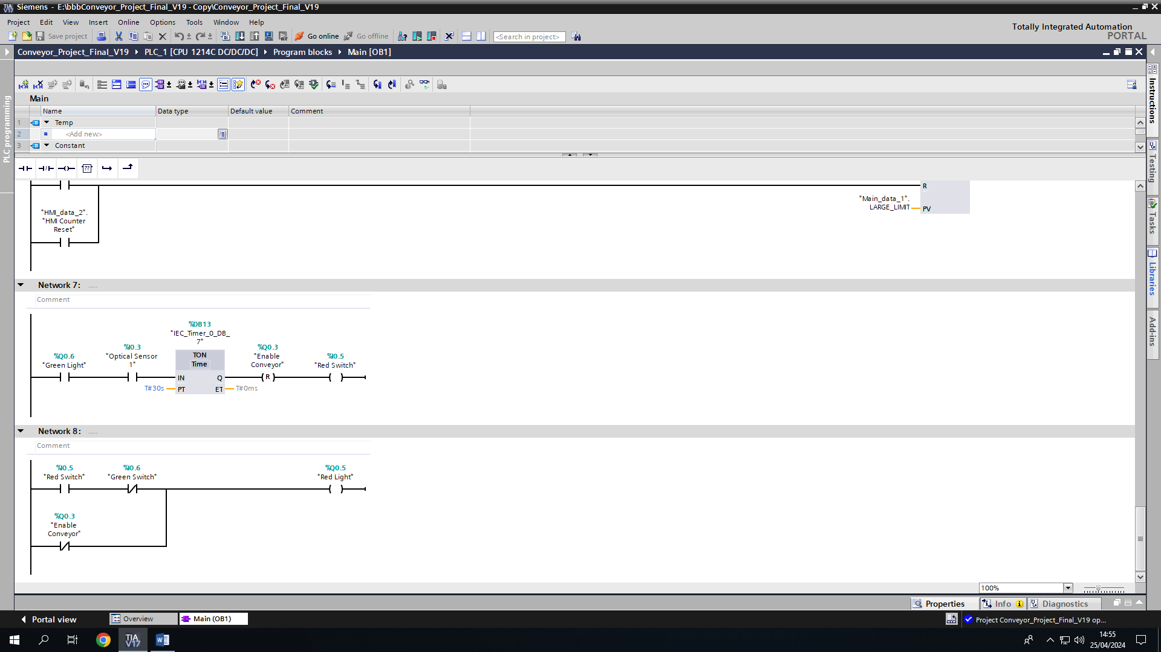

Finally, networks 7 and 8 operate once the conveyor system starts. This is the counter that allows the conveyor system to run for 30 seconds without any sensors being activated. Once 30 seconds passes without any sensor being activated, the conveyor will stop. If the sensor is activated the counter will restart until another 30 seconds passes without any items passing.
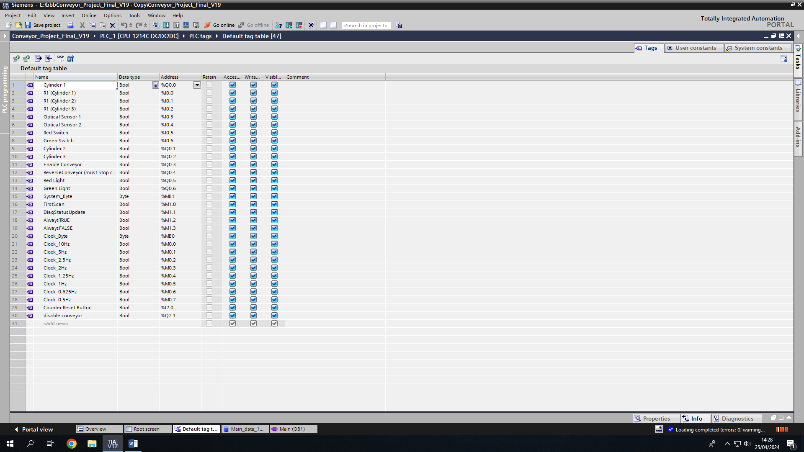

Above is the tag table associated with the conveyor system showing the names, data types and inputs, outputs, or memory commands.

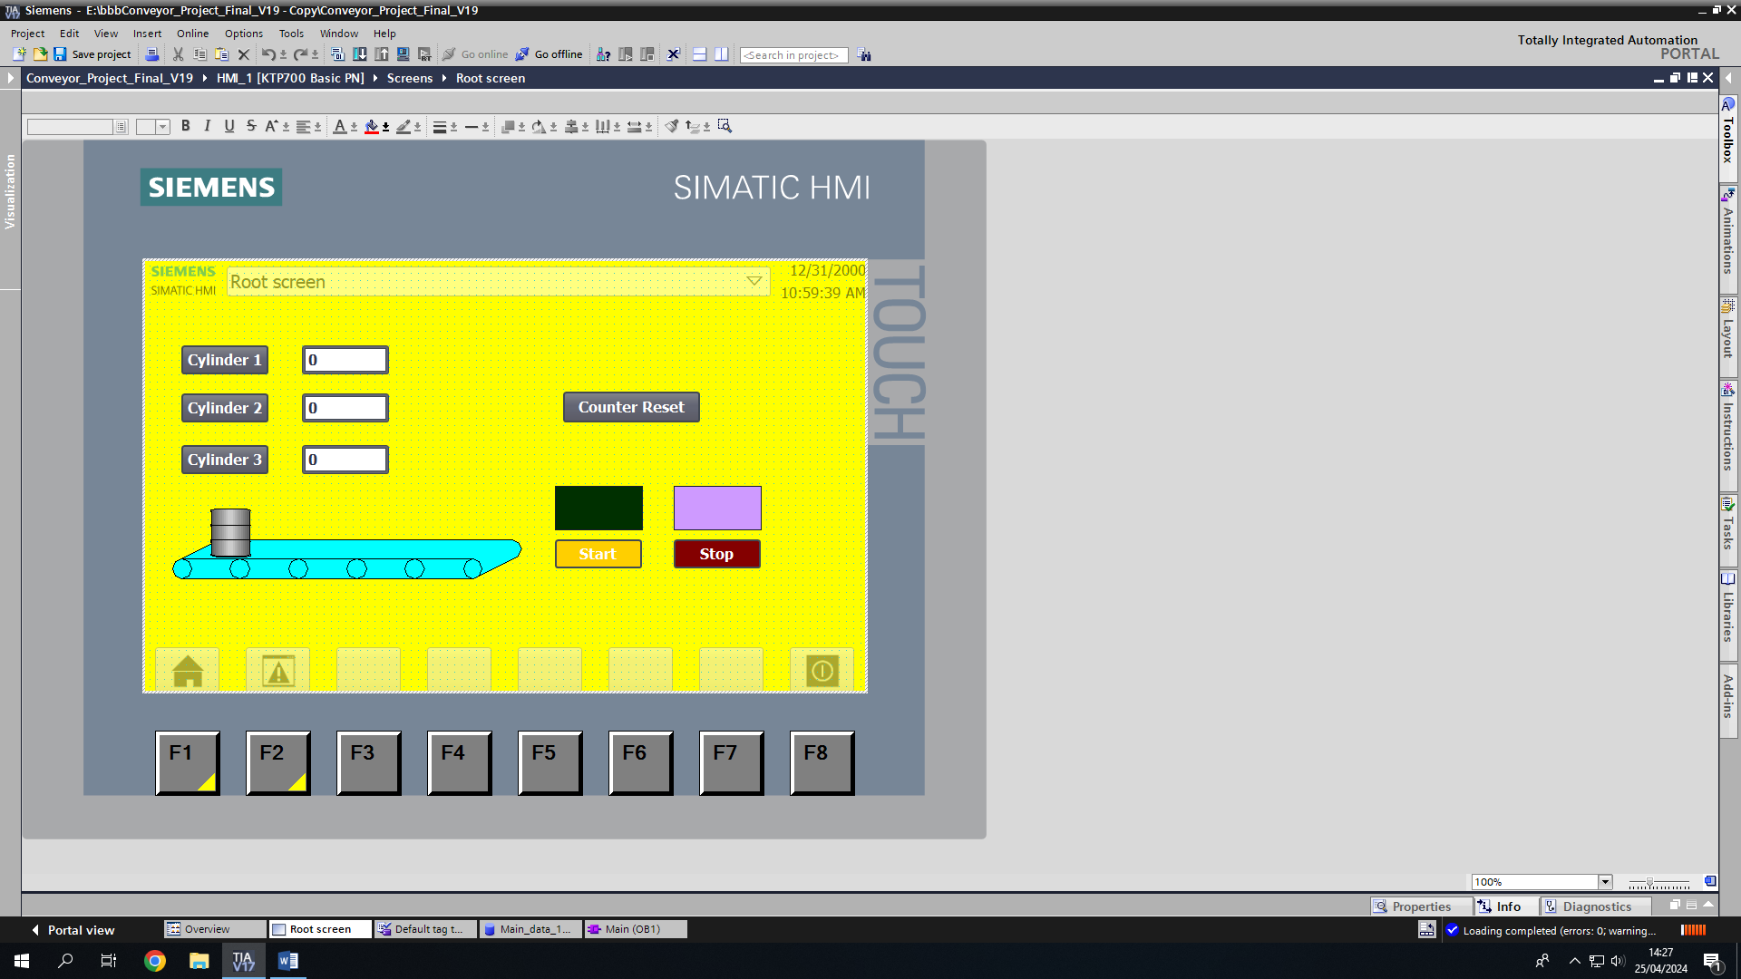

Above is a screenshot of the HMI root screen. This is designed on the Siemens software and can be altered to move buttons, change colours etc.
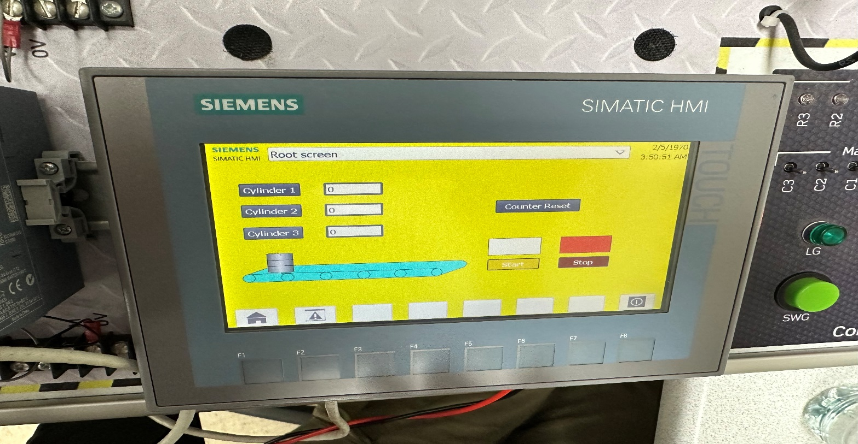

This is how the HMI actually looks in reality compared to the software.

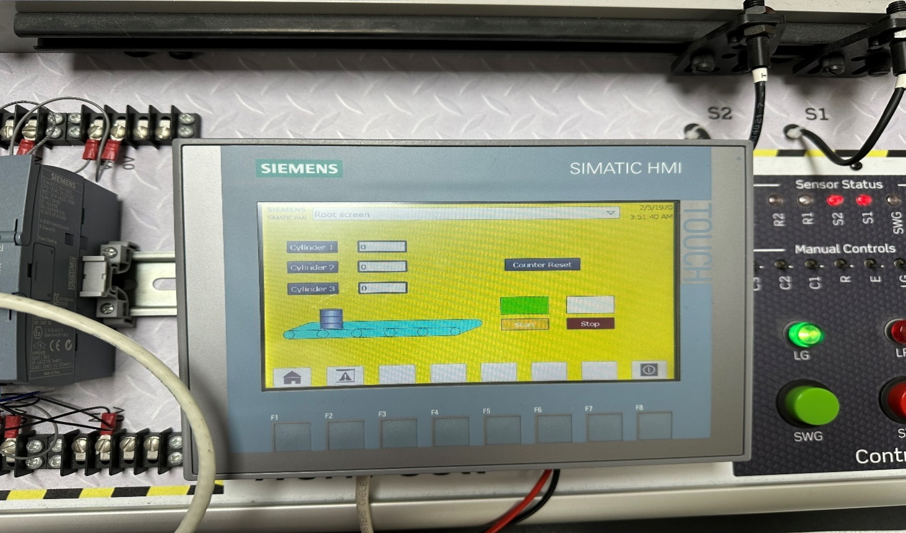

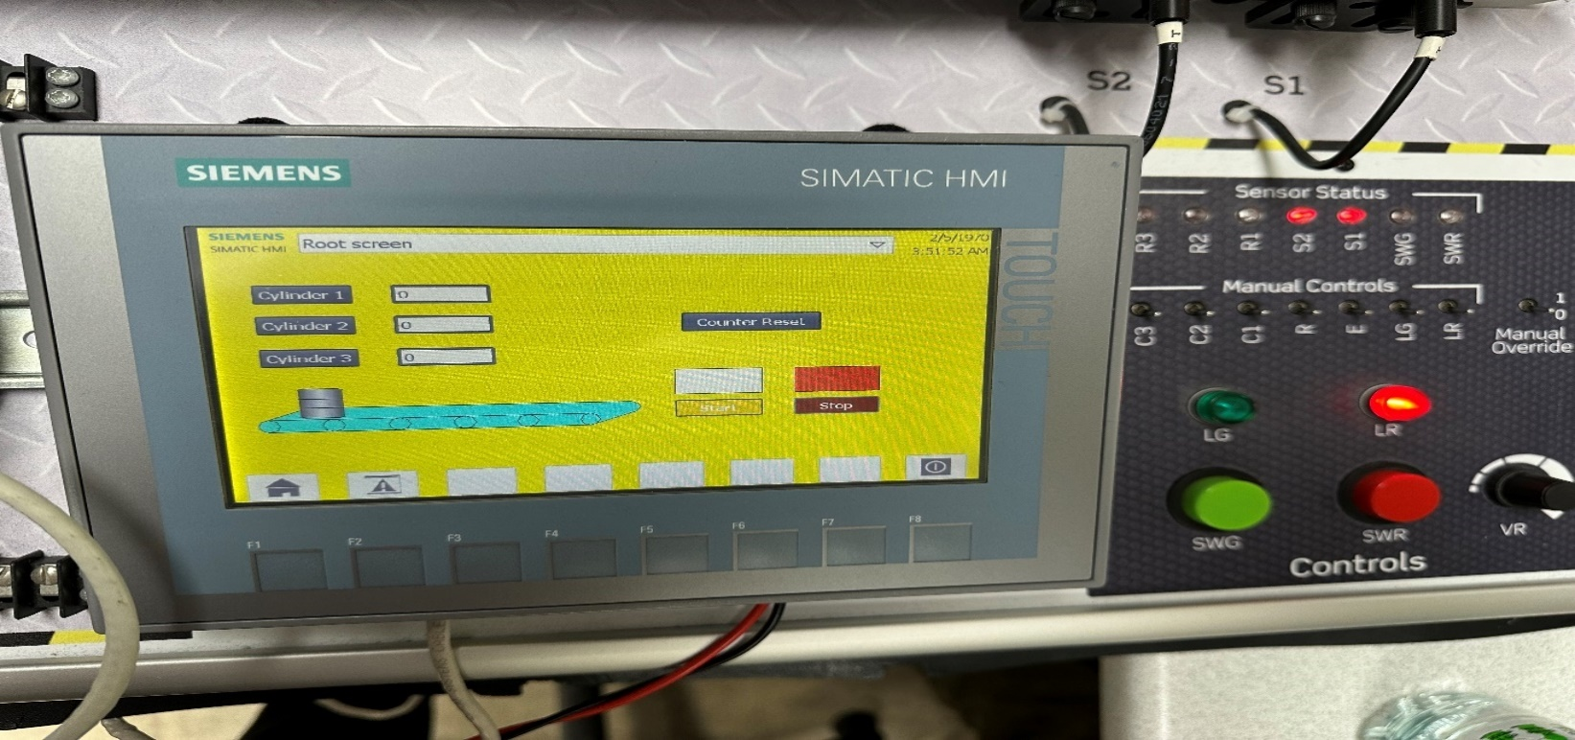
This is the conveyor system once the green button has been pushed for longer than 3 seconds.

This is the conveyor system once the red button is pushed, turning off the conveyor immediately.

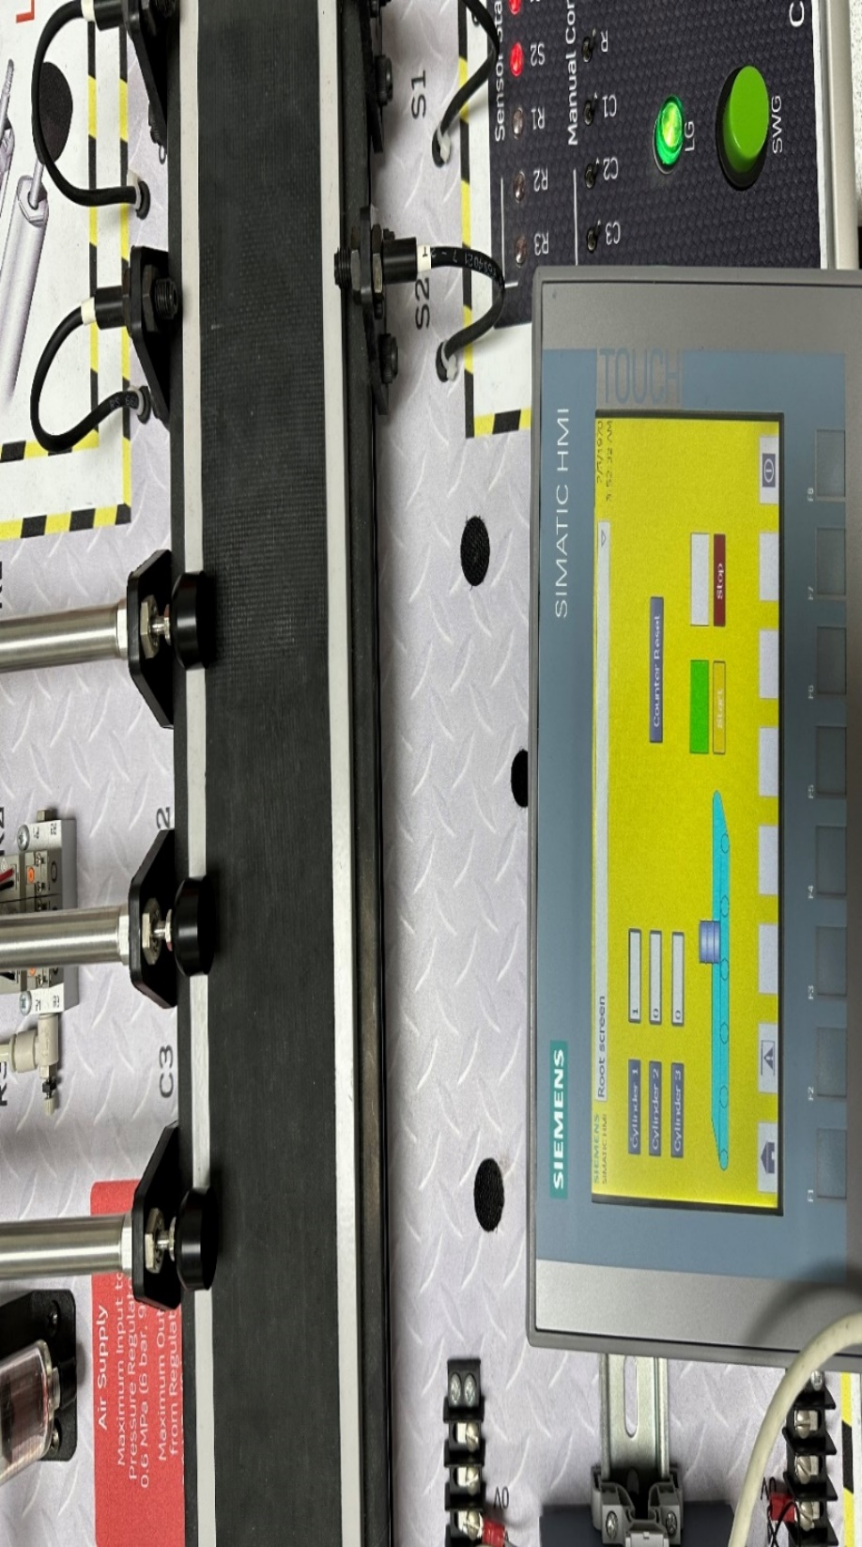

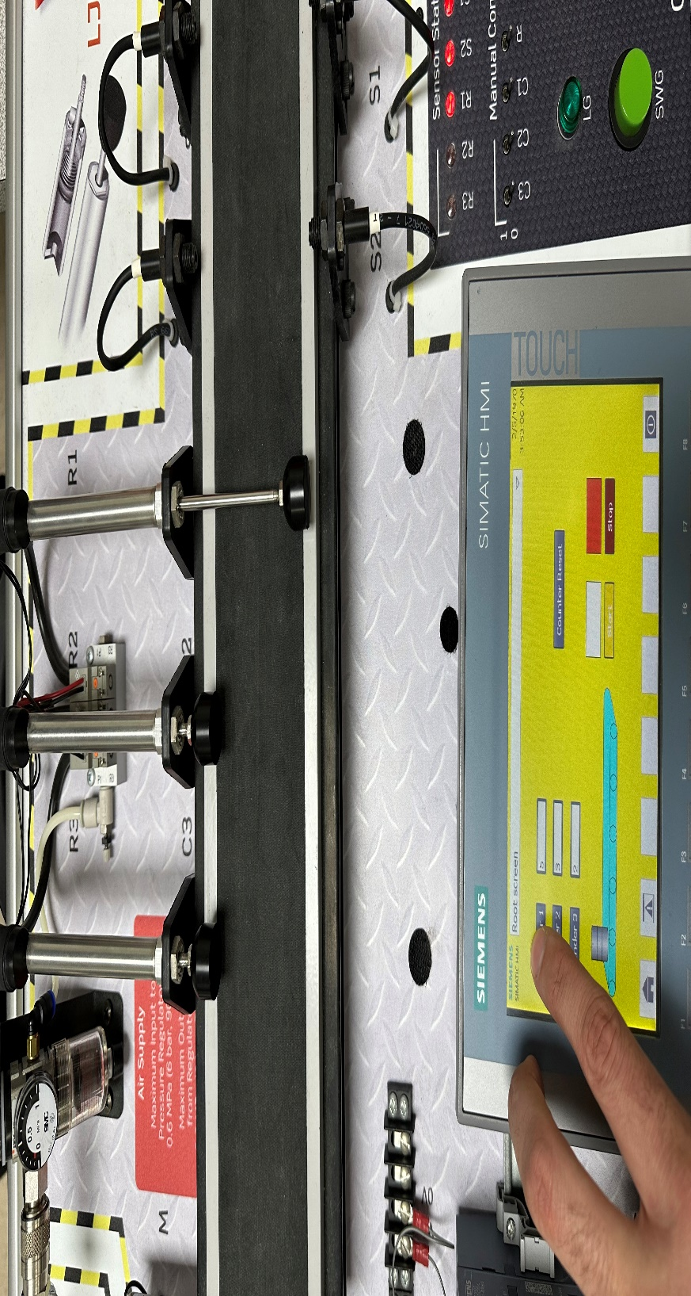

This picture confirms that cylinder 1 has made one movement and that the counter operation works correctly with cylinder 1 showing 1. Cylinder 2 and cylinder 3 show 0.

This picture shows the ability to manually override the cylinders on the HMI. Cylinder 1 is being operated and as you can see, the cylinder is extended.

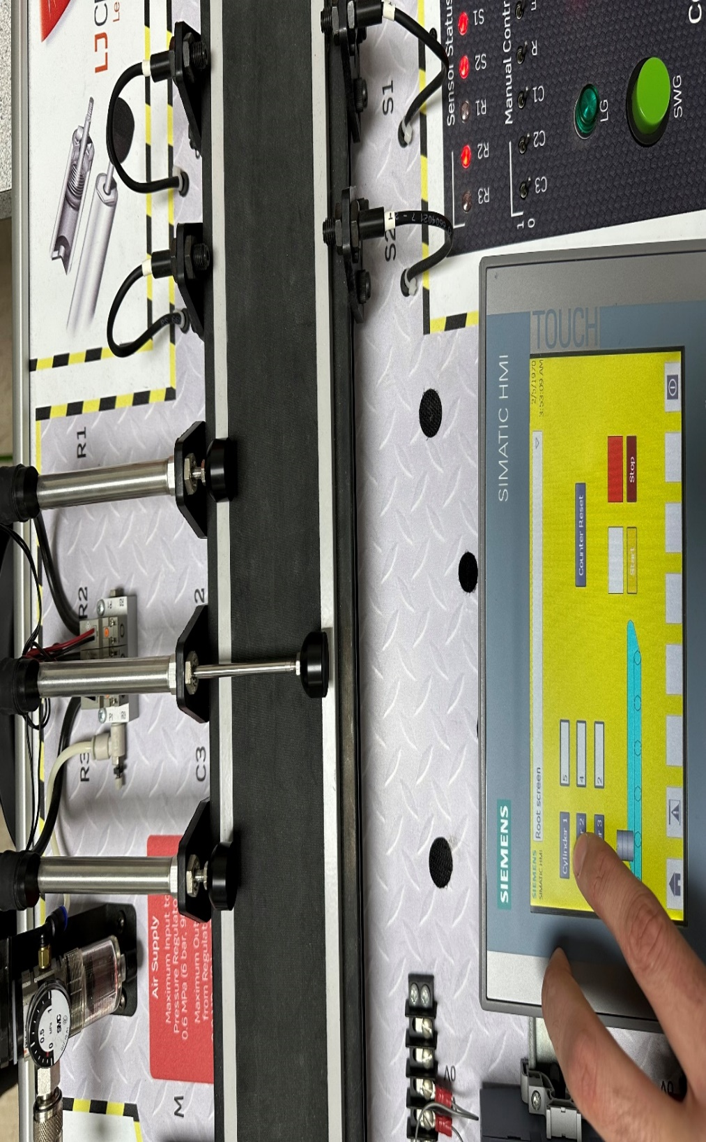

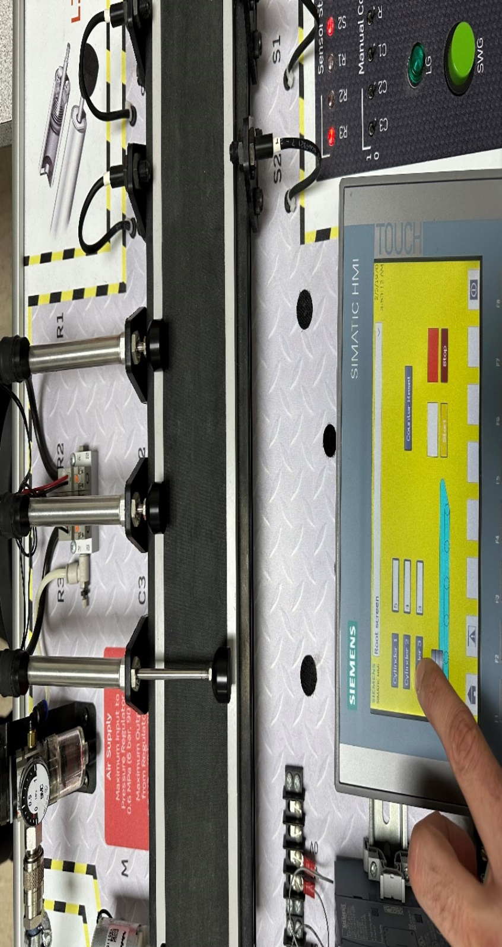

This picture again shows the ability to manually override the cylinders on the HMI. Cylinder 2 is being operated and as you can see, the cylinder is extended.

Finally, this picture shows the ability to manually override the cylinders on the HMI. Cylinder 3 is being operated and as you can see, the cylinder is extended.
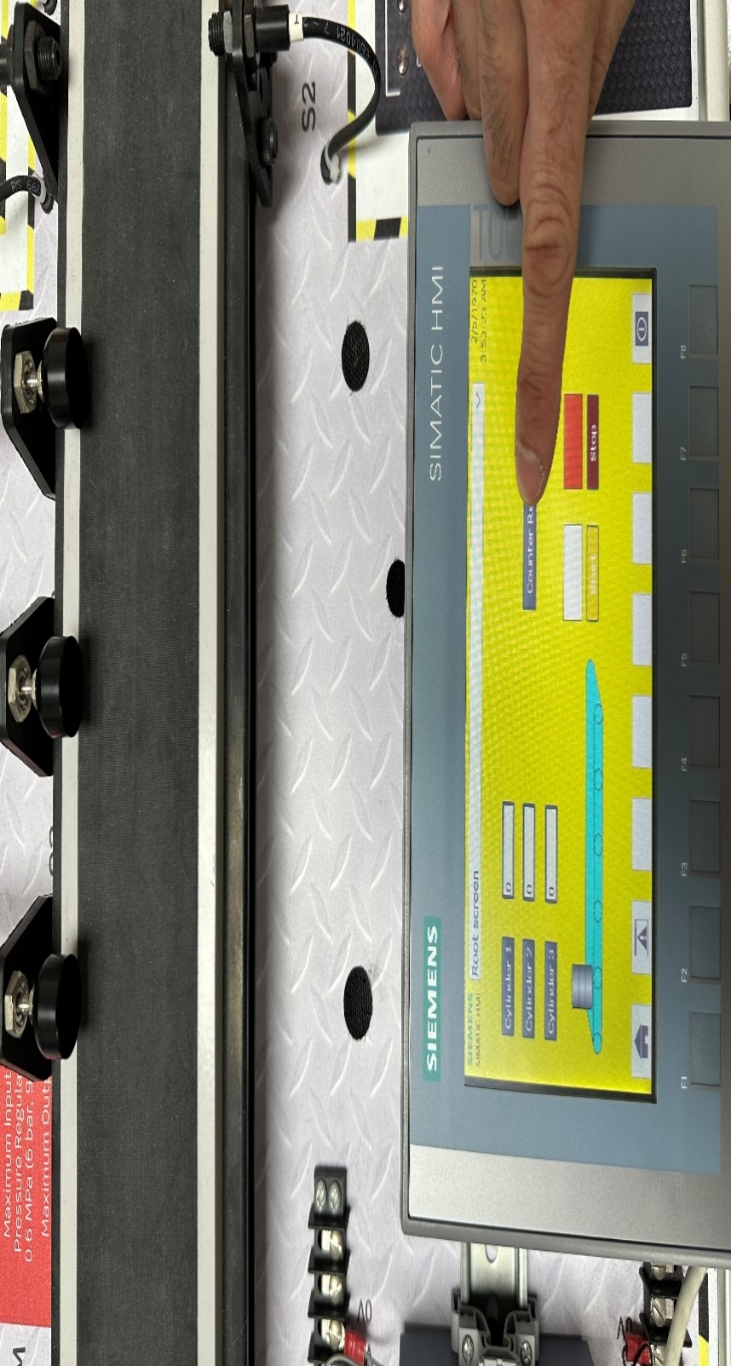

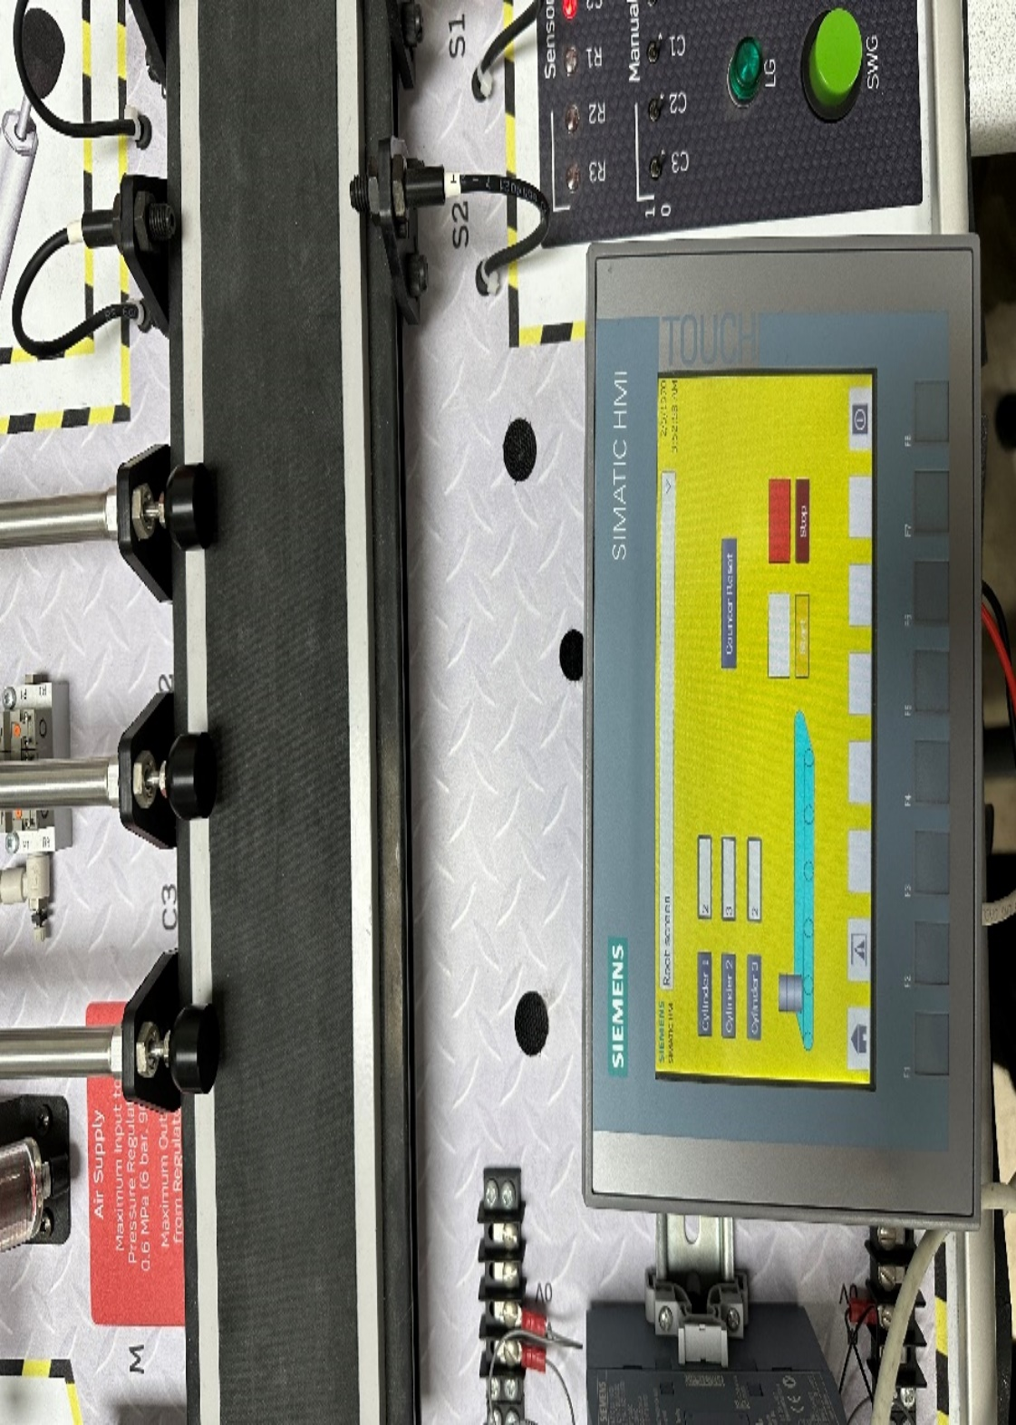

This picture shows the ability to reset the counters on the HMI. As you can see, cylinder 1, cylinder 2 and cylinder 3 all now show 0.

This is upon completion that all cylinders show that they have counted operations.
Conclusion
To conclude, the conveyor belt sorting system project was an overall success. From the practical side of the project, the system worked as I had hoped it would. Equally, the software side of the project was also a success. The software being accurate, was a necessity of the conveyor belt system working correctly. Any flaws in the software, would have resulted in the conveyor system not working correctly.
From a project scope aspect, everything I set out in the scope and technical specification was achieved. The step-by-step basis was carried out correctly and the timeline was adhered to punctually.
From a design aspect, the product was what I had planned during the process. The software worked, the equipment worked, and the conveyor belt system delivered on its intended purpose.
Reflecting on the project, I would possibly look at approaching it differently, personally I would research more into the Siemens software. An advanced underpinning knowledge on this software, would help greatly with improving my skills on Programmable Logic Controllers. However, overall, as stated previously I deem the project a success.

References
- Guide to Create Technical Specification Document with Example (document360.com) [Accessed 22nd May 2024]
- CRUD operations explained: Create, read, update, and delete (educative.io) [Accessed 22nd May 2024]
- Nonfunctional Requirements: Examples, Types and Approaches (altexsoft.com) [Accessed 22nd May 2024]
- Project scope — definition, best practices, examples, and more (adobe.com) [Accessed 22nd May 2024]

