Effective Teamworking for
team success
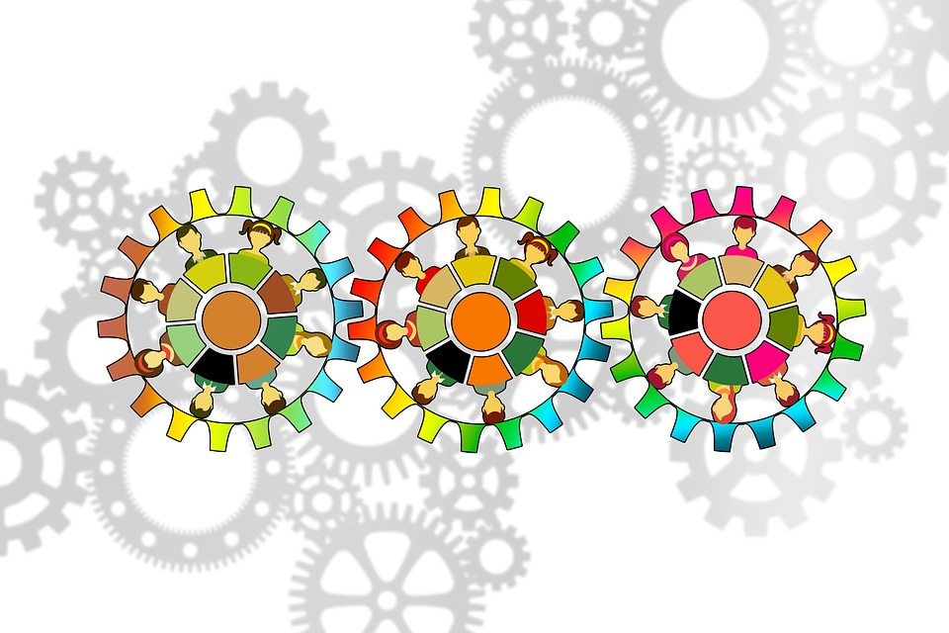
Modul code: | BMSW4002
Student name: | Hristina Bufi
Student ID number: | 2121309
Lecturer: | Akash Puranik

Report

to: University of Wales Trinity Saint David
from: Hristina Bufi
date: 3 July 2022
subject: Effective Teamworking for team success

Summary: This report describes effective teamwork. What is a team? What development models are there, and what obstacles can arise in the team. What roles does each team have? How to have an effective team that works effectively. All of this is represented by a survey of online sites and books.
keywords: team, effective work, teamwork
Contents
1 Introduction 5
2 Overview of Team working 6
2.1group or team 6
2.2 Incentives and barriers to team effectiveness 6
3Models of team development 7
Tuckman’s Model (1965) 8
3.2 Gersick model (1988;1989) 8
4 Roles to create an effective team. 8
4.1 Belbin roles 9
5 Discussion of effective teamwork and team success. 10
6Conclusion 11
7Recommendation 11
8 References 12

1 Introduction
Next Plc has a team that has to present a new collection of children's clothes, but in the team, there are small misunderstandings that need to be resolved in order to do a good job. To this end, the report will explain the difference between a team and a group, which are presented to us by King and Lawley, (2016, p171). The report will use Tuckman and Gersick models to determine the level of the team. The report will also look at what roles are needed in each team represented by Belbin. This report will explore the weaknesses of the team that can be derived from unallocated or inaccurate distribution of roles and how the team will work effectively to make the best performance.

2 Overview of Team working

2.1group or team
King and Lawley, (2016, p.171) identify following differences between a group and a team
Group | team
Individually reported; have different perspectives but exchange information, focus on individual goals and outcomes, and undertake individual tasks that are sometimes performed in conjunction with others. | Collective reports; plan their development together; decide collective actions in the future and focused on the goals and results of the team

They have chosen to be a team.
Hackman (2008)” Five Factor Model”
- Real Team
- Compelling Direction
- Plan
- Resources
- Coach
Next Plc team have a common goal to present the new line of children's clothing. We work collectively and plan the presentation of our task. Everyone has a task and a role in the team.
Every team goes through different stages. To determine the team stage from a procedural point of view will consider
two models.

2.2 Incentives and barriers to team effectiveness
Barriers to the team can be unclear goals, insufficient resources, the struggle for supremacy and conflict, inappropriate leadership style, job insecurity, and change in goals and priorities. As there are barriers, so there are incentives. They can be interesting tasks, recognition and achievements, experienced leaders, appropriate leadership and leadership style, qualified team members, professional development, and others.
Team effectiveness is a dynamic process. It depends on many variables, which in addition to incentives and barriers, include environmental factors, management style, and team characteristics. In fact, the team is an open social system, and therefore its effectiveness changes over time depending on how internal processes interact with the external environment.

3Models of team development
All organizations strive to organize teams. Every manager wants his people to work as a team, and that's not from today. The team form of work is among the most important topics for modern management due to the evidence of higher efficiency of work using appropriate principles and techniques. Despite the diversity of the types of formal and informal groups, the higher performance of teams has long been taken into account compared to groups of people who do not feel part of a team.
3.1 Group | team
Individually reported; have different perspectives but exchange information, focus on individual goals and outcomes, and undertake individual tasks that are sometimes performed in conjunction with others. | Collective reports; plan their development together; decide collective actions in the future and focused on the goals and results of the team

That's why we chose to be a team.
Hackman (2008)” Five Factor Model”
- Real Team
- Compelling Direction
- Plan
- Resources
- Coach
We have a common goal to present the new line of children's clothing. We work collectively and plan the presentation of our task. Everyone has a task and a role in the team.
Every team goes through different stages. To determine our team stage from a procedural point of view, we will consider
two models.

3.1Tuckman’s Model (1965)

He presents 5 stages:
- Forming -Getting to know the people in the team.
- Storming-Different views and conflicts.
- Norming-the team starting to work more efficiently. Each member agree with the rules in the team.
- Performing- The team reach a common solution.
- Adjourning-The team finish the given task.

Because of misunderstandings, background conversations and sometimes team conflict. It seems that the team is in a storming stage. Another model could be considered to evaluate the same.

3.2 Gersick model (1988;1989)
Unlike the Tuckman model, Gersick it presents us with three main stages:
-Stable phase - established on the first meeting.
-A phase of instability- Where think the team is
-Stability phase - where they have decided to achieve their collective goals.
Once this team convinced that they are in a phase of instability or storming. The team to look at the perspectives of each member of the team to move on to the next phase. Everyone should ask themselves the question "why am I here?", "Who are we?", "What are we going to do?", "How?" (Gibb et al.)
If one of the team can't answer these questions, then the symptom of dependence on someone who "knows how" appears. Or you can't take an active part, as there are such cases in the team.

Ultimately, suppose that members of this team work productively when their relationships are characterized by conscious and manageable interdependence.

4 Roles to create an effective team.

In order to become a normal stage, the roles of each team member must be defined. To do this, Belbin's team roles (2016) will be used

4.1 Belbin roles

They are 9 roles divided into 3 categories.

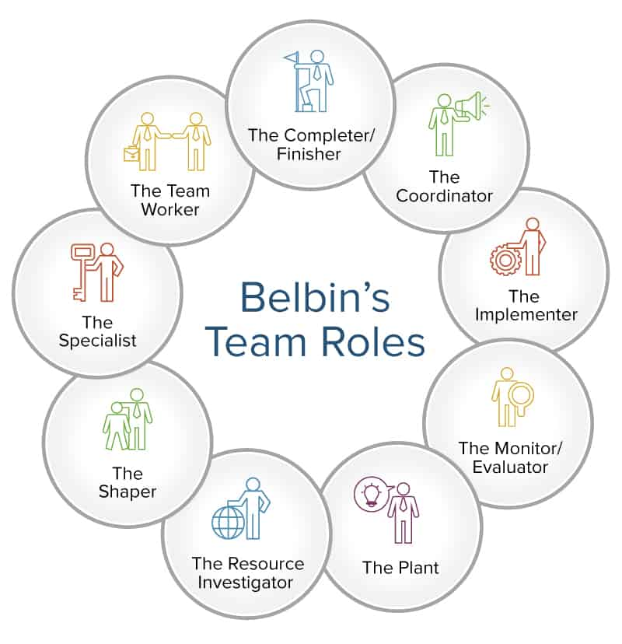
Figure 1 (Simon, August 7, 2017)

Once we define the roles of each participant based on his skills and qualities, the desired result will be achieved.
They need to be identified to avoid team weaknesses identified by the Lencioni model (2006). He presents fife weaknesses that can arise if the roles in the team are not defined.
- Lack of trust.
- Fear of conflict.
- Lack of commitment.
- Avoid seeking responsibility.
- Deviation of the result.
Having looked at this model, it is now clear that there is a weakness in this team, a "lack of commitment." because not everyone is actively involved in the meetings
Lencioni's model provides accessible knowledge of the main negative factors for the successful functioning of the team and the techniques for overcoming them that are applicable in any environment.

5 Discussion of effective teamwork and team success.

Effective teamwork is achieved when all team members are motivated and committed to a sense of responsibility for teamwork. The personal efficiency and professionalism of individual team members are not a guarantee for achieving high team efficiency.
This is because teamwork is a skill that needs to be developed. For this purpose, the team needs to follow certain principles introduced by the group manager.
Some of these principles are:
-common goal-The common goal is meaning. They are the main reason the team exists.
-General rules - They are the ones who regulate the way group members interact with each other.
-Effective Communication-Goals should be communicated clearly to everyone and as often as possible.
-Conflict management-
Conflict is one of the natural things that can happen in a team. What will help us in conflict is the knowledge of the process phases and what behavior we should have in the different stages of conflict.
As in all teams, a high level of trust must be maintained in this team. Lack of trust will lead to a large increase in the cost of all resources (time, information, people, etc.) that the team uses to achieve its goal. Team building and increasing team efficiency are based on principles that improve efficiency and reduce stress, intrigue, and fading team relationships.
Teamwork will also help each team member: to improve communication skills by listening to several different opinions help to build the ability to accept feedback; To increase the level of efficiency, as everyone does what he is best at. Then the result of the joint work will be achieved most effectively; For personal enrichment and development through regular communication and acceptance of different points of view, we can enrich not only consciousness but also learn from the mistakes of others, as well as share our experiences
If everyone learns to work in a team, success will be guaranteed.
But for that, everyone needs cultural communication. Coyle (2018) identifies some of the secrets of cultural communication that can be used in this team.For example, to use body language when talking face to face;
To ask the opinion of others in the team: when have a negative opinion to express it culturally face to face; everyone on the team needs to feel protected and supported, all team members need to help each other so they don't have to worry about asking for help. That's why everyone should be a good member of the team, but to be one, they should not blame others on the team for problems. If he doesn't know what happened or doesn't understand, he must ask questions. Don't worry, everyone listens, tell yourself. (Whelan, 2014)
If all this is done, the team will not be unnecessarily burdened with conflicts, quarrels and, most of all, a waste of time.

6Conclusion
When working in a team, the efforts are the same, but the results are many times greater. If there is a clear goal and everyone follows it. If the right questions are asked, all theories and rules for effective teamwork are followed.
If the team has the necessary knowledge and makes the right investments, it will have a well-functioning team and will achieve an excellent result.

7Recommendation

This team needs more trust and in order to build, it needs more meetings, communication, face to face. In order to consider more ideas so that all members are present, questions should be asked of inactive members. The level of each team member should be checked to determine the exact roles and set the right tasks. Each member of the team should be encouraged to arouse interest and desire in him. Once all this is done. And each member of the team works with desire and dedication, and is aware of the task, then there is no obstacle not to present the team best

8 References
Gibbs G (1988). Learning by Doing: A guide to teaching and learning methods. Further Education Unit. Oxford Polytechnic: Oxford. Gibbs' Reflective Cycle | The University of Edinburgh
Katz, J.A., 1993. The Dynamics of Organizational s Emergence: A Contemporary Group Formation Perspective. Entrepreneurship theory and practice, 17(2), pp.97-101

King, D. and Lawley, S., 2016. Organizational behaviour. Oxford University Press.
Lencioni, P., 2006. Overcoming the five dysfunctions of a team. John Wiley & Sons.

Omar, M., Hasan, B., Ahmad, M., Yasin, A., Baharom, F., Mohd, H. and Muhd Darus, N., 2016. Applying fuzzy technique in software team formation based on belbin team role. Journal of Telecommunication, Electronic and Computer Engineering, 8(8), pp.109-113.
Simon, B., August 7, 2017. How to Use Teamwork Roles to Build Winning Teams. [Online]
Available at: https://www.smartsheet.com/how-to-use-team-roles-to-boost-performance
[Accessed 7 August 2017]
Théry, C., Witwer, K.W., Aikawa, E., Alcaraz, M.J., Anderson, J.D., Andriantsitohaina, R., Antoniou, A., Arab, T., Archer, F., Atkin‐Smith, G.K. and Ayre, D.C., 2018. Minimal information for studies of extracellular vesicles 2018 (MISEV2018): a position statement of the International Society for Extracellular Vesicles and update of the MISEV2014 guidelines. Journal of extracellular vesicles, 7(1), p.1535750
Tuckman’s, B., 1965. FORMING, STORMING, NORMING & PERFORMING TEAM DEVELOPMENT MODEL.
Vivas-López, S., 2014. Talent management and teamwork interaction: Evidence in large Spanish companies. International Journal of Business, 19(1), p.30.
Wageman, R., Nunes, D.A., Burruss, J.A. and Hackman, J.R., 2008. Senior leadership teams: What it takes to make them great. Harvard Business Review Press.
.

