BMIH4005 Marketing Essentials-AS 2
Presentation Notes
Slide 1
Slide 2
The Xara Mansion Boutique Hotel appears to be a unique 17th-century mansion hidden away in Mdina, Malta's ancient capital and mediaeval walled city. The Xara Palace Relais & Châteaux, with its luxurious rooms and award-winning haute cuisine, is really a haven for relaxation and pampering. The goal of this marketing strategy is to help the hotel as a company focus on perceived marketing efforts in order to ensure their customers' ultimate happiness.

Slide 3
Halls for rent, beverages and cuisine, banquet rooms, and conference facilities are among the services provided by The Xara Palace. The Xara Palace uses a variety of marketing and communication platforms, including brochures, television commercials, hotel websites, Twitter channels, Facebook pages, and Google; pens and paper for the hotel; and television commercials. For their clients, the Xara Palace uses a variety of lodging and service price methods, including peak season, valley season, as well as shoulder period (Dibb & Simkin, 2013).

Slide 4
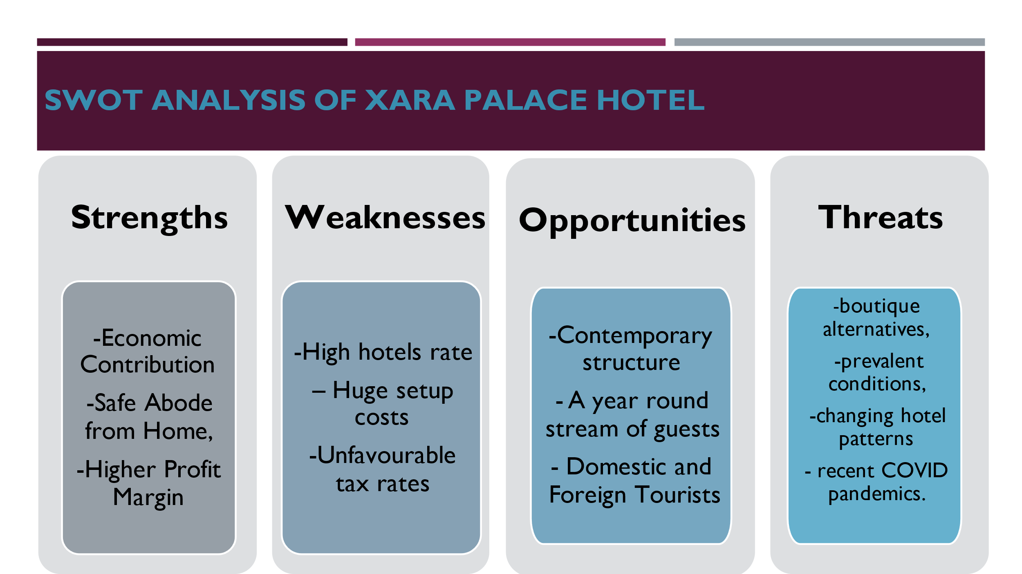
The Xara Palace can potentially experience annually stream of guests due to its modern structure, which may be organised as an opportunity for any hotel business. During peak season, the Xara Palace accommodates to both domestic and international visitors, along with local vacationers. Herein lies the allure of the hotel sector. Along with significant potential, the firm faces a number of dangers (Shepherd, 2014). Boutique alternatives, current circumstances, shifting hotel trends, and current COVID epidemics are examples of risks. The Xara Palace Hotel's potential strengths include helping the economy, providing a safe haven away from home, and a larger profit margin, as well as the hotel's suppliers and distributors. By overcoming these flaws, hoteliers gain a competitive edge.

Slide 5
The hotel sector does badly in places where political instability exists. The Xara Palace, a high-profile boutique hotel, is expanding thanks to open borders and a supportive political climate. The current generation has a strong desire to travel. This is fueled somewhat by social media platforms, which allow users to access their outdoor adventures and therefore create peer pressure to go on vacations. The Xara Palace, a high-profile boutique hotel, is expanding thanks to open borders and a supportive political situation. The current generation has a strong desire to travel. This is fueled even further by social media platforms, which allow people to share their travel experiences and therefore create peer pressure to go on vacations. WI-FI, escalators, and intercoms are just a few of the modern conveniences that any hotel may provide.

Slide 6
As a hotel, the Xara Palace should emphasise destinations before services. For a luxury hotel such as the Xara Palace, precise nature is always powerful (Shin & Perdue, 2021). If the focus is on creating useful content about the hotel's services that people want to share because it's useful, brand reputation may improve. Any and all social media questions should be answered by the hotel. The Xara Hotel must first recognise its organisational constraints before implementing a comprehensive social media plan. Before jumping into social media, make sure the hotel's product management and support delivery systems match or surpass customers’ expectations (V.A., I.N. & V.A., 2019).

Slide 7
Social media is the hotel's best friend – or worst foe. When planning a trip to a certain country or region, many people are using social media for their major source of hotel information. Social media has grown into one of the most significant platforms for customer service, in addition to being a tool for recruiting people (McDaniel, Lamb & Hair, 2012). Despite the abundance of communication platforms accessible, email continues the most essential medium for corporations and should be included in your marketing strategy to attract clients. Email may be used by the Xara Palace to advertise special deals to a specific audience and strengthen relationships with frequent guests.

Slide 8
For its current business situation, the hotel should have integrated marketing strategy. The internal and external environmental marketing strategy for Xara Palace, on the other hand, obstructs several political and legal issues that the hotel industry is dealing with. Unfavorable tax rates, seasonality hotel construction, and rising hotel rates have all posed challenges to this hotel's marketing strategy. As a result, the firm should concentrate on increasing consumer engagement through more social media interaction, e-mail marketing, website design, and influencer postings. Before developing a complete social media plan, the Xara Hotel should first identify its organisational limits.

Slide 9


