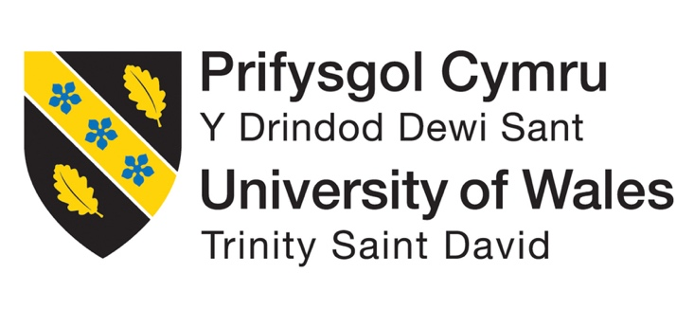 MBA Dissertation

Topic: Analysing the Impact of Integrated Marketing Communications Strategies of the Fashion Industry on Brand Equity in the Digital Era – Case study analysis of H&M

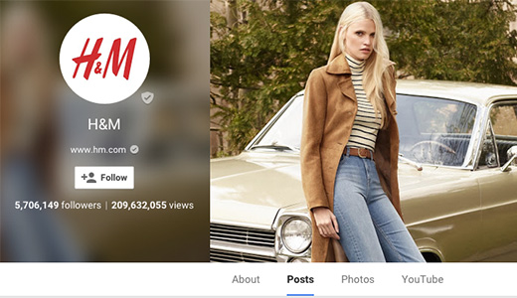
Acknowledgements
I would like to thank my supervisor for providing me immense support and guidance throughout the task. Without this help it won’t be possible to so complete the paper on time. So, my heartfelt gratitude for all the superiors and team members for helping me to witness an inspiring experience.

Declaration

Abstract
This research paper is based on the integrated marketing communication strategy which is use by the H&M company. to sustain in the competitive market in fashion industry there are several new strategies adopt by the company. H&M also evolved their strategic decision with time. This research discusses the main benefits and challenges which is faced by the company by using qualitative secondary method. The outcomes have sighted H&M using email marketing and different social media platforms for its integrated marketing strategy, where different benefits have been indicated, like better consumer engagement and personalised approaches. Still, some challenges also develop with data protection and managing the large-scale data of the consumers for implementing IMC. Comparison to UK fashion brand ASOS indicates that H&M focuses on sustainability, whereas ASOS focuses more on community engagement. The adopted IMCC approaches has helped H&M to create a strong brand value and competitive advantage in the marketplace. The UK fashion market is digitally evolving so the wide spectrum approach of H&M to attract and retain its customers is giving positive values which can help for long term growth. But being a fast fashion business focusing on the sustainability measures are important for H&M to ensure long term sustainability. The last chapter aligns the objective of the study and the findings of the study. From the last chapter analysis, it is found that the four objectives of the study have been met with the findings of the study. Then, the recommendations of the topic or industry are discussed, and then the study-related recommendations are given. Then future research of the study was analyzed.

Table of Contents
Chapter 1: Introduction 10
1.1. Research background 10
1.2. Research problem 10
1.3. The research aims and objective. 11
1.4. Research question 11
1.5. Significance 11
1.6. Rationale 12
1.7. Theoretical framework 13
1.8. Structure 14
Chapter 2: Literature Review 15
2.1 Introduction 15
2.2 Theoretical framework 16
2.3 Empirical studies 18
2.3.1 Current integrated marketing communication strategy uses UK fashion brands to strengthen brand equity 18
2.3.2 Current challenges to using integrated marketing communication strategy faced by UK fashion brands in respect of the digital era 20
2.3.3 Benefits of integrated marketing communication to increase brand awareness 23
2.3.4 Comparison analysis of integrated marketing strategy among UK fashion brands 26
2.3.5 Impact of integrated marketing strategy on consumer behaviour 27
2.3.6 Competitor analysis 28
2.4 Literature gap 29
2.5 Summary 30
Chapter 3: Methodology 31
3.1 Introduction 31
3.2 Research philosophy 31
3.3 Research Approaches 32
3.4 Research Strategies 32
3.5 Research choice 33
3.6 Time horizon 33
3.7 Techniques and procedures 34
3.7.1 Data collection 34
3.7.2 Data analysis 36
3.8 Research limitation 37
3.9 Ethical considerations 38
3.10 Summary 39
Chapter 4: Findings and Discussion 40
Introduction 40
4.1 Findings 40
4.1.1 Integrated marketing communication strategy used by H&M for brand equity in the UK market. 40
4.1.2 Challenges faced by H&M for implementing IMC 41
4.1.3 Benefits of using IMC for H&M 42
4.1.4 Comparison and contrasting of IMC among UK fashion brand and H&M 43
4.2 Discussion 44
4.2.1 Critical discussion on the current integrated marketing communication strategy used by H&M in recent time for the development of brand equity in the competitive fashion market 45
4.2.2 Challenges faced by fast fashion companies for implementing integrated marketing communication strategy in the digital era 46
4.2.3 Analysis of the impact of using integrated marketing communication for memorizing fashion products in the digital era 49
4.2.4 Comparison analysis of the current market position of H&M by using an integrated marketing communication strategy in the UK competitive fashion market 51
Summary 52
Chapter 5: Conclusion and Recommendations 53
5.1 Introduction 53
5.2 Linking with Objectives 53
5.2.1 Objective 1 53
5.2.2 Objective 2 53
5.2.3 Objective 3 54
5.2.4 Objective 4 54
5.3 Recommendations 55
5.3.1 Industry recommendations 55
5.3.2 Study recommendations 56
5.4 Future scope 56
Reference list 57

Table of Figures
Figure 1:Keller’s brand equity model 16
Figure 2:Revenue of the fashion market in UK (2020-2029) 24
Figure 3:Brand positioning map 28
Figure 4:IMC strategy by H&M 41
Figure 5:Benefits of IMC for H&M 43
Figure 6:H&M in the UK market 46
Figure 7:ZARA market share in 2023 48
Figure 8:Measuring customer mindset for brand engagement 50

Chapter 1: Introduction

1.1. Research background
Integrated marketing communication refers to the strategic approach which combines various marketing channels, technologies and tools to deliver cohesive brand information and messages to the target audience across different platforms. In the digital era, the use of integrated marketing communication strategies increased by 78 % (Blakeman, 2023). It helps to create a strong position in the market. The marketing strategy of a fashion company helps to determine its position and market value. An effective integrated marketing communication strategy ensures coherence and consistency in communication with customers. This research is based on the integrated marketing communication strategy which the uk fashion brands use in the current digital era. In recent times, there are several strategic changes have been noticed in the marketing communication policies to build brand quality in the market (Camilleri and Camilleri, 2018). This research helps to provide the board with an understanding of the current approaches used by the fashion brand to build a strong connection with customers. The integrated communication approach increases the customer engagement rate. Recently, digital technology has improved the service system, which increased customer satisfaction rates. This research helps to develop the idea about the impact of integrated marketing communication on brand performance to the existing and new players in the fashion sector.

1.2. Research problem
Every fashion organization has their own integrated marketing communication strategy to retain customers. An integrated marketing communication strategy is mainly used for competitive advantages. Due to this reason, popular brands do not disclose the full information due to privacy concerns and maintain their uniqueness in the fashion world. This research has a fixed time limitation to complete this research (Juska, 2021). To complete a research study within a limited period is very tough. Within a limited period, it is not possible to establish the logical points and facts about the research topic. Word count limitation is another challenge to describe each of the sections critically.

1.3. The research aims and objective.
- The main purpose of this research is to evaluate the impact of integrated marketing communication strategies used by fashion brands to develop brand equity in the digital era.
Objective
- To discuss the current integrated marketing communication strategy used by H&M fashion company to develop strong brand equity in the competitive market
- To evaluate the challenges faced by H&M to implement an integrated marketing communication strategy in the digital era
- To analyse the benefits of using integrated marketing communication to memorize recognizable H&M’s fashion products in the digital era
- To compare and contrast integrated marketing communication among UK fashion brands

1.4. Research question
- What is the impact of integrated marketing communication strategies on building brand equity for H&M as a fashion brands in the digital modern era?

1.5. Significance
Currently, in the UK fashion market, 67 % of companies have started using integrated marketing communication strategies in their business functions. It helps to increase the brand reach. The main reason for using this strategy in the marketing section is that it helps to get the scope to communicate with customers directly (Belch and Belch, 2018). Mainly, fashion hubs are selecting digital platforms to communicate with customers. From the current statistics, it is clearly seen that globally, 56 % of women are engaged in digital or social platforms. 67% of young adults are engaged in the social platform (Ihzaturrahma and Kusumawati, 2021). UK is a technologically advanced region where Generation Z is highly engaged in social platforms.
The fashion companies switch their marketing communication channel from traditional mode to digital mode. Currently, different digital modes and platforms help to get a strong connection with the customers instead of traditional modes. Mobile applications, laptops, tablets or any other electronic devices are more flexible items for today’s generation (Galloway, 2020). Marketing through newspapers, magazines radio does not help to create any strong market awareness. Due to this reason, there is a huge transition noticed in the marketing communication strategy on the digital edge. This research is focused on the integrated marketing communication strategy which fashion companies use. The benefits of building a brand equity model in the business function are explored in this research (Dharmappa, 2018). Discussion of integrated marketing communication strategy helps to know the current digital channel, media and platform used by the fashion company. On the basis of the discussion, it is easy to know about the popular channel which has a significant impact on the marketing strategy. This research will help other fashion entrepreneurs to know the existing brands follow current business strategy hitch (Çınar, 2020). This research also states the different company policies, which are useful for documenting the current information. Mainly, this research uses all the large to medium-scale companies which are currently operating in the UK fashion industry. It helps to understand the challenges and barriers which the company faces in adopting the integrated marketing communication strategy.

1.6. Rationale
Digital transformation significantly impacts the marketing strategy of the fashion company. To improve the relationship with the customer, the marketing managers of the fashion companies adopt several new approaches which help them to be recognizable in the market through the brand equity model (Dharmappa, 2018). The contribution of the brand equity model with respect to customer relations is very high. Based on the customer's feelings, persona, preferences and needs currently, fashion brands develop their marketing communication strategy. The strategic decisions differ from one another, which creates a different value in this competitive market. This research helps to get the overviews that in which way integrated marketing communication strategy in fashion industry helps to develop the brand image (Dharmappa, 2018). This reach helps to develop a clear understanding and overview of the current integrated marketing communication strategy, which fashion companies use to target audiences. Primary data helps to know the current situation of the brand in fashion firms. To build a strong market position in the market, fashion companies made several changes in the digital era. Current data from the fashion industry helps to know the current challenges which fashion brands face in the digital era to implement integrated marketing communication strategies to develop brand equality in the competitive market (Galloway, 2020). In the current time, it has been noticed that by using an integrated marketing communication strategy, companies are able to get several benefits. It helps to build a direct connection with customers. On the basis of the consumer persona, fashion brand selects the channel to promote their product. In the current time, it has been noticed that the main motto of fashion brands is to create high market awareness, which helps to boost sales performance. To create brand loyalty, it is important to stay connected with the customer. Through email marketing, digital marketing, messaging, and social media promotion fashion companies are given the scope to stay connected (Galloway, 2020). Digital connectivity increases the accessibility rate. Customers can easily get product details and information. In this digital era, the competition is in case adopt. Without the help of modern features, it is not possible for the firm to sustain itself in the market. This research critically evaluates the impact of the integrated marketing communication strategy in the digital era.

1.7. Theoretical framework
The brand equity model helps to define the framework that assesses the perception, values, and feelings of customers and strengthens the brand's position in the market. The brand equity model helps to evaluate the various kinds of parameters in the business function, such as brand awareness, brand associations, brand loyalty and perceived quality (Juska, 2021). By using the brand equity model, it is easy to measure the brand value in the market. Application of the brand equity model in the business function correctly helps to enhance brand recognition in the market. All fashion brands use this model in their business function. But the focused area is different from one another. In major cases, it has been noticed that the fashion brand prioritises brand loyalty or brand awareness in the market. By using the brand equity model, it is easy for the firm to select the strength of the brand which helps to create strong awareness. Storing a brand helps to make the company different from other competitors. In the general case, fashion companies focus on customer behaviors (Blakeman, 2023). The fashion industry is highly dynamic. In the current time, marketing managers are using advice demand forecasting tools to predict consumer behaviour. Products and services based on customer behaviour help to increase brand loyalty. In this regard, currently, the fashion firm has started to promote products through various channels. The application of Aaker’s Brand equity model emphasises liabilities, brand association and perceived quality. This research will explore this factor to build strong value in the competitive fashion market (Shariq, 2018). A positive brand equity model in the business function helps to facilitate the long-term growth of the business. The sustainability rate in competitive fashion mate gets increased.

1.8. Structure
The following chapter reviews and discusses the existing literature and concepts. The next chapter starts by providing clear objectives, specific discussions, and understanding. The third section clearly states the method of collecting data. Chapters 4 and 5 lay out the major research findings.

Chapter 2: Literature Review

2.1 Introduction
The fashion industry is a highly competitive market at the current time. It has been noticed that fashion brands are trying to improve their marketing tactics to build strong relationships with customers. Integrated marketing communication strategy is one of the popular marketing approaches in the fashion industry. From the current scenario evaluation, it has been noticed that there are many fashion brands in the United Kingdom that are using an integrated marketing strategy (Blakeman, 2023). The rate of using integrated marketing strategies has increased in recent years. Mainly, the global pandemic, digitalization, internationalization and modernization help to flourish this marketing approach (Hyun, Park and Hong, 2024). Using an integrated marketing communication strategy helps to deliver the brand message to the target audience in a consistent way. For fashion brands, it is important to maintain consistency. In the competitive market, fashion brands are not able to maintain consistency. They face huge difficulties in sustaining for the long term.

2.2 Theoretical framework
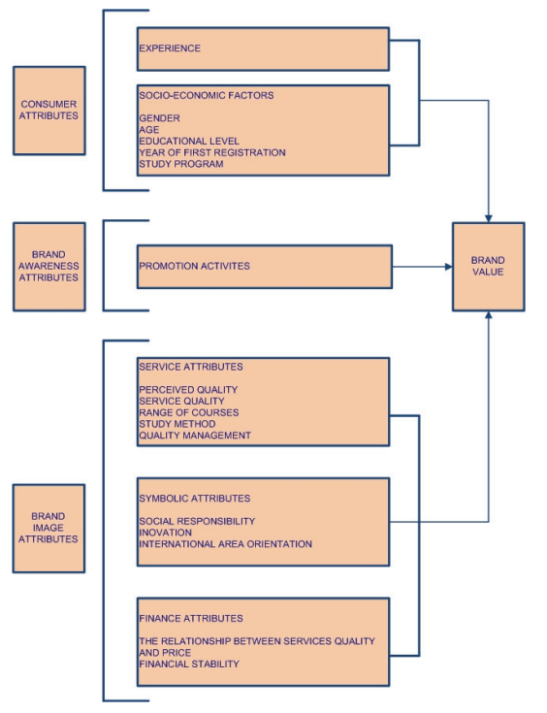
Figure 1:Keller’s brand equity model
(Source: self-created, idea taken from Vukasović, 2022)
The brand equity model is designed to derive a way of creating brand value in the market. The brand equity model provides a deeper understanding of the company. The brand equity model is used to design marketing strategies at different stages. Application of Keller brand equity model through interacted marketing communication easy to deliver about the company details (Vukasović, 2022). It clearly explains in past existing data about the company details and product details and shares meaningful insight about the company through messaging. Application of the brand equity model creates a huge influence on customer buying behaviors to create strong sustainability for the long term. UK fashion brands are highly aware of the market condition. More or less, all UK fashion brands are using the brand equity model in the marketing segment for better brand reach.
Keller's brand equality model helps to understand that a brand can build a strong impression to the customer. In the current competitive era brand equity model provides the proper guidance to build a positive impression to the stakeholders. Using the brand equity model helps to maintain the standard in the market (Ray and Nayak, 2023). Currently, the competition in the fashion industry is continuously increasing which shows in the past data. From this aspect, it can be said that maintaining product quality or the standard of the brand is highly important. Using the brand equity model helps to build a positive customer experience. The brand equity model is based on some stages which entities with the value of a customer. It is entirely focused on the customer's viewpoint and perception (Noris et al., 2021). Using the customer base brand quit model helps to add value. In general cases, it has been noticed that H&M is using a customer-based brand equity model in the business function. By using advanced technology in the business function, the marketing manager derives customer preference, which helps to improve the product and service design. It enhances customer loyalty rate gradually (Goworek et al., 2020). Using a customer-based brand equity model ensures the market success of the company with a positive experience. In this current competitive market, it is essential to develop a positive brand image. Every organisation uses a sustainable strategy to meet the preferences of the company (Nobile et al., 2021). It develops the idea that brand advocacy and brand loyalty are increased through a sustainable development strategy. The marketing manager of H&M follows the same functional strategy to add value to the business function.
The brand equity model helps to know the current feeling of the company; since 2020 there are huge changes have been noticed in customer feelings and preferences. Mainly, the demand for sustainable products has increased (Lynch and Barnes, 2020). The past data develop the insight that Customers are starting to use sustainable products. Increasing social and environmental awareness fully controls the customer's feelings. The brand equity model helps to get the opportunity to develop an emotional attachment with the customer. To sustain itself in the competitive market, it is important to build an emotional connection.
As per, Rathore (2021), Many companies use Keeler's brand equity model. Fashion brands follow the traditional technical concept to strengthen the basic layer of the business function and operational activity. In this current competitive market, it is important to create own identity through brand logo, brand icon and brand image. According to customer preference, there are several modifications have been taking place in brand identity (Mukendi et al., 2020). From the current scenario analysis, it is clear that many organisations have changed their brand identity to reconnect with the feelings of customers.

2.3 Empirical studies

2.3.1 Current integrated marketing communication strategy uses UK fashion brands to strengthen brand equity
The popular integrated marketing communication strategy is advertising (Andrews and Shimp, 2018). As per, (Belch and Belch (2018), According to the preference of the target audience, ASOS uses public reaction and digital marketing strategy. Similarly, it found that Burberry, which is a popular UK fashion brand, has been using an integrated marketing communication strategy for the last 10 years (Widjaja, 2022). An article based on the ASOS company develop the idea that the company had set their target audience, which helped it to design its integrated marketing communication approach. From the current scenario evaluation of the fashion sector of the United Kingdom, it has been noticed that the fashion hub uses several integrated marketing communication strategies. Direct marketing, unique value proposition, public relations, digital marketing, etc.
As per, Ihzaturrahma and Kusumawati (2021), The marketing manager of the organization is utilizing various platforms like social media, social sites, and digital collaborative tools to build a direct relationship with the customer. As per, Lasi (2021), Mainly it has found that according to budget. With financial capability and technological capability, the marketing manager decides the channel for promotional purposes. As per, Theodora (2021), The main step in that framework is to the identification of the customer and their preference and select chances wisely. Research which is based on the primary quantitative data develop the idea that in the current time application of integrated marketing communication is based on a particular framework which includes several processes. The marketing manager of H&M follows this step minutely which helps them to develop a strong content plan to target audience. Some of the integrated marketing communication strategies which UK fashion brands use are discussed below. On the basis of the resources and capabilities, UKL fashion brands adopt the below-mentioned integrated marketing communication strategy.
Advertisement – In the first place, it has been noticed that from the past data that the marketing manager of the company makes the decision to use a paid communication strategy to sell products or services in the market, which helps to build awareness. Advertisement from various angles helps to increase the attachment with the target audience. In general cases, it is noticed that the UK fashion brands are currently using Television channels, commercial ads, print media, print advertainment, social media platforms for advertising billboards, etc (Niinimäki et al., 2020). Each of the platforms has a distinctive customer base, which helps to target the audience. H&M has a strong existence and presence in each of the communication platforms. Mainly, the marketing manager of H&M uses social media to target the audience. However, the companies are active in offline marketing strategies as well.
Sales promotion – Marketing activities aim to stay connected with the customer, which helps to boost the sales performance of the company. The marketing management of a fashion company incorporates different types of sales promotional activity. From the general case and overview, it can be said that the highest sales promotional activity has been noticed in the fashion brands, such as flat 50 % off, up to 10 % off, buy one get one free, buy 2 get one free, etc (Alexander and Kent, 2021). This kind of saes related promotion is very common. Through flash messages and email marketing, fashion brand informs their customer regarding new arrivals, sales promotions, newly launched items, new outlet launches, etc (Hidayati, 2023). This kind of activity in the business function grabs the attention of customers.
Public relations – As per, Fetais et al. (2023), public relations play a big factor in the fashion company. Cause of the public reaction is not strong, then it is not possible to create the own business market. Due to this reason, it helps to develop the idea that fashion brands strongly prefer to build a positive public reaction with customers. In this respect it can be said that good public relation develops and create positive brand image. As per, Ozuem et al. (2021), In the age of social media, it is very common to face negative publicity on social media through the customer end. Poor service systems and poor product quality are enough to share negative feedback on social media, which impacts brand perception. Due to this reason, it develop the insight that the PR team of H&M is highly active. The PR team instantly takes action against negative publicity in social media or social platforms to maintain goodwill.
Direct marketing - Direct marketing refers to the distribution of products and services directly to the consumers. There is no third party to get the scop to be involved in the distribution procedure. Third-party refers to the mass media in general terms (Juska, 2021). Through direct marketing, a fashion brand has the scope to increase the customer engagement rate, which fosters conversation with customers directly.

2.3.2 Current challenges to using integrated marketing communication strategy faced by UK fashion brands in respect of the digital era
As per, Guercini, Bernal and Prentice (2018), Mainly, the small-scale organization does not have the huge resource capabilities to implement the advanced level technology to minutely check the performance of content in different platforms. Managing cross-media activity is a difficult task. As per this opinion it can be said that from the general case studies, the marketing manager faces difficulties in adopting an integrated marketing communication strategy in the business functions.
Bormane (2018), support this and claimed that the resource capability of every fashion organization is not the same in the United Kingdom. Different scales of organizations are operating businesses. Different scales of business and different capabilities of business operation. In recent times, customer preferences have been rapidly changing (Noris et al., 2021). This discussion develops the knowledge that in this digital era, several external functions affect the purchasing behaviour of customers. In comparison to this situation, it has been noticed that there are many fashion brands like Clark, River Island, and Belstaff that are struggling to target the audience through the selected content. not only external forces impact on the marketing decision.
As per, Nash (2019), Through limited editions of content, it is not possible for UK fashion brands to target an audience. Burberry is performing well in this aspect. Cause the company has huge diversification in their content to target audience. As per, Goworek et al. (2020), It is a large-scale organization which has strong financial capabilities. In respect of H&M, it can be said that the managing directors built a separate team to execute the marketing plan. It helps to know that secondary data sources with a limited number of qualitative case studies state that technological integration is poor in H&M, which creates a barrier to running the marketing communication planning. Efforts across multiple marketing channels are different, which does not help to meet the expectations of the organization. Existing data sources helps to know that implementation of integrated marketing comminution strategy in business function is a hectic matter for small to medium-scale fashion brands. Challenges of implementing an integrated approach are a matter of concern from the past edge. An integrated approach requires strong support from the internal and external aspects. From different case study analyse, it has been seen that major fashion organisations face difficulties due to the lack of awareness. Many fashion organisations in the United Kingdom do not prioritise the opinions and feedback of customers, which plays the biggest role. In respect of this point, it can be said that PRIMARK is a leading fashion retail brand in the United Kingdom. For a long tenure, the company has been functioning in these areas successfully, but it has been noticed that the company has a very poor understanding of their target audience (Fuxman et al., 2022). Due to this reason, the content they shared on different channels and platforms does not help to create an effective movement which is suggest by existing data. Existing data helps to know that, the company realised their issue, which they rectified. However, from this analysis, it is clear that shared information about products and services through various channels and platforms is not enough it is important to have strong marketing communication with customers.
According to the current dataset, it is clear that the marketing manager conducts a specific market analysis campaign to collect the opinions and feedback of employees. Due to this reason, H&M face less difficulty in identifying the preferences and choices of customers. Existing data develop the idea that Marketing communication refers to the development of attachment with customers. Marketing communication is a two-way method. Only sharing information from the company end does not help to achieve success. In comparison to this point, it can be said that H&M is a successful company in that respect (Kushwaha et al., 2020). In every manner, the marketing manager of H&M collects the opinions of customers.
As per, Ihzaturrahma and Kusumawati (2021), H&M never fail to meet the demands of the customer. The company value the opinions and choices of customers. As per the opinion of the customers it develops the idea that H&M changed and modified the prediction and service design, which helped to feel valued. It is important to the customer that the company accept their opinion and feedback or not. Mainly, the high traffic has been noticed in those company which has direct conversations with customers.
Above challenges develop the critical insight about Budget allocation. Budget allocation is a common issue faced by some fashion organisations. When managing budgets few companies get very limited budgets to design the marketing content or campaigning, which does not allow or support to build a strong connection with customer. Marketing managers face difficulties in designing content within a limited budget. It is very different, especially here, every company is starting to develop its own PR team and creative digital marketing team.
As per. Rehman, Gulzar and Aslam (2022), It is the responsibility of the marketing manager of the fashion company to ensure the budget. Because effective budget allocation does not help to face any issue in designing the marketing communication approach. Enough budget helps to select the marketing channel and platform effectively. This organisation has enough budget can design the content and tactics smoothly.
Some existing cases, develop the idea that the few fashions organisation is suffering through fragmented data. It is not possible to reach customers through fragmented data sets. Fragmented data does not help to provide enough information to the customer. Damaged data can make it difficult to get clear information and a clear picture of the scenario to the customer regarding brand activity.
At the time of operating a business on a large scale, sometimes customers get confused about the characteristics of the customer. Due to this reason customer segmentation is required. However, some of the fashion hubs in the United Kingdom do not segment their customer properly which shows in past data. On a random basis, some fashion hubs are operating and marketing in the United Kingdom. At the current time, entering in UK fashion hub is very common due to technical, legal, ethical and political support which shows in past data.
As per, Ihzaturrahm and Kusumawati (2021), The government acts, and policies are liberal for the fashion industry in the United Kingdom. It has been noticed that organisations disguise content on the basis of customer segmentation. As per, Kushwaha et al. (2020), It is easy for them to get a strong position or create a strong position in the market. Some of the company in the fashion industry has a serious concern regarding collaboration. Poor teamwork and collaboration do not help to execute the marketing plan; collaboration with marketing partners is essential (Fuxman et al., 2022). Author discussion in these articles helps to know that Poor coordination and collaboration among the internal departments create huge issues. Mainly, the managing committee is responsible for this factor, which does not help to execute any strategic decision or option properly. At the current time, most of the marketing channels and partners prefer to work in digital mode. However, some fashion organisation has restrictions on digital collaboration, which affect organisational performance through the UK government's support of digital activity in business operations.

2.3.3 Benefits of integrated marketing communication to increase brand awareness
By using an integrated marketing communication strategy, the fashion company gets the opportunity to target a large number of audiences at a time. The efficiency of targeting customers is enhanced (Steenkamp, 2019). As per, Nobile et al. (2021), It helps get the opportunity to share seamless and consistent information about the company, product and service through various channels. It helps to know that Integrated marketing communication ensures that it helps to deliver the message of the fashion brand to the customer through various channels. As fashion brands choose the most highly engaged platform, it is better to increase the brand reach (Goworek et al., 2020). Past data develop the idea that In the digital world, it is easy to increase brand reach through an integrated marketing communication strategy. A study which is based on the secondary data sets claims that integrated marketing communication is not only based on brand awareness. It also helps to build strong communication with customers. Collaboration with customers improved in this way. Asos launched its product through an integrated marketing approach, which helped to increase the customer engagement rate by 23 % in a year (Nash, 2019). It suggests that Integrated marketing communication maintains consistent communication with the public. For fashion brands, it is important to maintain clarity regarding business performance, operational activity, etc. At the current time, it has been noticed that the marketing leaders of fashion brands are starting to add social responsibilities and environmental policies to product labels and marketing tactics. Mentioning CSR policy as a message helps to increase the brand awareness rate. In every product promotional activity of large-scale organizations in the United Kingdom, add its sustainable practice to retain customers.
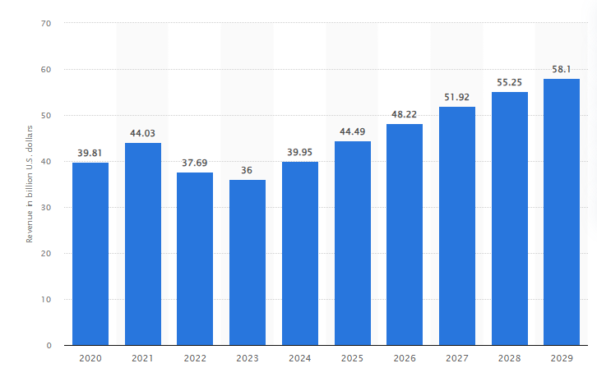
Figure 2:Revenue of the fashion market in UK (2020-2029)
(Source: Statista Research Department, 2024)
From the current scenario analysis of the UK fashion industry, it can be said that the rate of using integrated marketing strategies is increasing rapidly as per above diagram which derived from Statista. Mainly, the technological factor and legal factors play the main role in to use and application of integrated marketing strategy. Gradual changes in the marketing segment, which is experienced by the old fashion brand in the United Kingdom, stated that it is a useful technique which saves the marketing cost. An authentic report, which is based on the primary data sets and uses some statistical analysis, critically explains that the usefulness and effectiveness of an integrated marketing strategy are high in comparison to any marketing strategy (Juska, 2021). The current data sets, which are available as an existing past dataset, help to understand that integrated marketing strategy helps to reuse the idea in different plat from indifferent from, which creates positive impacts on the customer. Maintain the same motto the marketing manager get the scope to reform and redesign the marketing strategy. All brands are trying to improve the financial cost structure. The use of cost-saving methods is the main aim of fashion brands, especially with respect to marketing segments (Ozuem et al., 2021). However, the currently available data clearly develop the insight that marketing strategy plans a viral rile. Due to this reason, planned investment for marketing purposes is essential, which is supported by the integrated marketing approach.
Integrated marketing communication strategy is totally depending on the design and quality. If the marketing strategy is not effective and attractive, then it does not help to impact consumer behaviour. In the current time fashion industry is continuously changing (Fetais et al., 2023). In that respect it develops the critical understanding that, a major number of UK fashion brands are starting to use fast fashion technology. Fast fashion technology helps to share and spread the continuous message to the target audience. The company needs to build a continuous relationship with customers. Cause if the continuous relationship with the customer is not maintained properly, then it affects the overall brand image. ASOS is a premium quality fashion brand that has been operating business in the United Kingdom for a long time (Alexander and Kent, 2021). It has been noticed that using an integrated marketing communitarian strategy gives the opportunity to create seamless, multidimensional customer-centric options. The marketing manager of ASOS develops their own promotional team. Public relations are maintained by the marketing team and digital marketing team to maintain the continuous t; relations with the customer. An integrated marketing communication strategy ensures that the company is sharing information with the customers at a level. This helps to build a strong recognition in the fashion market. The current data shows that an integrated marketing communication approach strengthens the customer perception of the brands. As per, Niinimäki et al. (2020), Through various platform a brand share product reacted comet which helps to know about the detail of the product. New and latest information through various channels customers come to know. Mainly, the fashion companies in the United Kingdom use both online and offline marketing strategies which help them boost their performance (Rathore, 2021). From the general case study of the UK fashion brands, it has been noticed that the popularity of offline media is high. Even now, television, newspapers and billboards are popular in this location, which is the biggest advantage to the old-fashioned hubs cause the old-fashioned hub gets the opportunity to incorporate both online and offline media in the business function.
An integrated marketing communication approach helps to boost the brand consistency rate of Burberry. From the recent performance analysis of the company, it has been noticed that the firm has experienced stiff competition in the fashion market. It is become really tough for the company to sustain. During the phase of 2015-2020, the company experienced a declining growth rate in the business performance (Lynch and Barnes, 2020). These financial years play a crucial role in the business function. It has been noticed that during this tenure, the company has focused on market analysis and market surveys. On the basis of that, the managing director of Burberry made the decision to use an integrated marketing communication approach, which helped them to improve the brand performance gradually. The company experience a gradual movement in the financial performance (Nobile et al., 2021). By using an integrated marketing commutation strategy, Burberry is starting to provide more value to its target audience, which is highly important in this intensely competitive market. Every case study in the fashion industry is different from others. So, the overall overview point it can be said that integrated marketing communication is a scope to welk establish the branding in the market from the grass root level.

2.3.4 Comparison analysis of integrated marketing strategy among UK fashion brands
The UK fashion sector is highly competitive. Each of the fashion brands has its market base. Mainly, the large-scale organization is operating business on a global basis. From the performance analysis of the UK fashion brands, it has been noticed that each of the fashion companies in the United Kingdom is using an integrated marketing communication approach for one treason to increase brand awareness. From authentic data, which is based on the primary datasets is mentioned that Burberry is using an integrated marketing communication strategy to target a large audience. As per, Noris et al. (2021), The marketing manager considers it a cost-effective method which helps to reduce the experience for marketing purposes. Considering this point, one article stated that integrated marketing communication is used to build trust among the customer. From various platforms, fashion brands are trying to deliver the same message about new products and services. As per, Guercini, Bernal and Prentice (2018), Using an integrated marketing communication strategy allows customers to brand recall through consistent messaging. A renowned UK fashion brand is using an integrated marketing communication strategy to boost sales performance through high brand awareness. According to the current market research, one platform for promotional activity provides limited opportunity to the company, whereas various channel provides a streamline to share the information (Theodora, 2021). All the new fashion hub Union United Kingdom is using an integrated marketing communication strategy in the business function to build a strong presence in the market. As per, Lasi (2021), It helps to stand out as a new hub among other existing brands. Creating brand identity through integrated marketing communication is considered a wise decision for fashion brands, especially in the case of a new fashion hub.

2.3.5 Impact of integrated marketing strategy on consumer behaviour
Integrate marketing communication strategy considered as the key element in the fashion company to show a modern effort to engage customers. It helps to build a long-term customer relationship. The fashion company is able to get the opportunity to estimate which tools, format and form of the promotional purpose are useful to share the message to the target customers (Ihzaturrahma and Kusumawati, 2021). According to the buyer persona, the company decide the message and choose a communication channel which helps to influence customer behaviour. Meaningful messages and influential content influence purchasing behaviour. In the current time, it has been noticed that fashion brands have their website and mobile applications to engage with customers (Widjaja, 2022). Customers can easily connect with the company. There is a common buying behaviour that has been noticed among customers to conduct market research before buying. Due to this reason, popular fashion brands in the United Kingdom create an easy user interface and share all the details on their websites. So those customers get easy information (Ihzaturrahma and Kusumawati, 2021). Flash messages and email marketing help to know how about sales, offers, gifts, bonuses, etc. Which highly influences consumer purchasing behaviour.

2.3.6 Competitor analysis
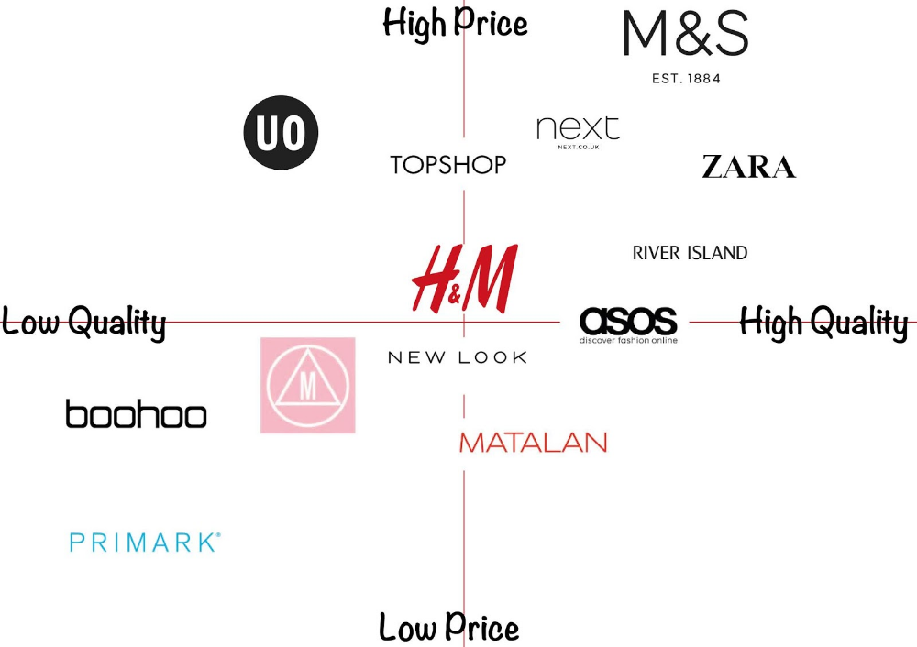
Figure 3:Brand positioning map
(Source: self-created, idea taken from Lasi, 2021)
From the above diagram, it is clear that H&M is placed in the neutral position, with high quality with high price. It influences customer buying behaviour (Theodora, 2021). The company is using a value-based pricing strategy, which increases the traffic flow in comparison to other popular global fashion brands such as M&S, Zara, ASOS, River Island, Next PLC, etc. The above figure currently shows that H&M is developing a strong position in the market with some good quality products. The main USP of the company is to continuous improvement in product quality. The company, from the initial stage, focus on the research and development program, which helps them to gain a sustainable position in the market (Ray and Nayak, 2023). The company is struggling to maintain its position in the market due toy to the intense competition. The above perceptual map helps to know the current situation of the company in compare to other brands. As per, Noris et al. (2021), There are already maintained companies which are successfully adopted green marketing strategies in their business function, which helps to make them more reliable to the customer. The competitor's analysis is used to describe the current situation and position of H&M. The existing data revealed that the marketing manager of H&M invests 23% of their total revenue in green marketing strategy (Goworek et al., 2020). From the competitor analysis, it is easy to develop the current insight about the fashion brands which are operating business in the United Kingdom. This analysis helps to know the business position and business value of the organisation depending on the product and price. High quality product with low prices has huge demand in the market. But in the UK market, there are few companies offering high quality products at affordable range. It clearly shows that the organisation is offering high quality products and has high product prices as well. Each of the competitors of H&M has its own marketing channel and marketing platform to target the audience (Nobile et al., 2021). Customer segmentation and marketing channels play the main role in increasing customer flow. This diagram helps to understand that those UK fashion brand has some financial constraints and are not able to improve their brand position in the market. Only the financially strong fashion brands are able to complete with H&M in respect of all aspects. Integration of marketing communication strategy requires huge investment, which is only possible for large-scale fashion hubs, and this figure consists of the names of large and popular fashion hubs in the UK.

2.4 Literature gap
The major gap findings in the existing literature are methodological gaps. A maximum number of literatures is based on the secondary data. Secondary data does not help to develop an accurate idea about the current brand performance of H&M. As it is a company-specific study so, it is essential to get an overview from the survey (Syahputra, 2023). Employees and the executive board of the organization help to get a real-time understanding. However, limited primary data sets do not help to draw a strong emphasis on the research objectives. Primary data sources use statistical analysis, which I a complex and critical analysis. For this research, it is quite difficult to derive ideas within a limited period from statistical analysis. Many journals and articles do not focus on the current challenges which fashion brands face in the United Kingdom to use integrated marketing communication strategies (Noris et al., 2021). The majority state that the UK, as a developed country, has high prosperity. It does not help to develop a critical understanding of the research object Yves.

2.5 Summary
The existing data sets help to derive the benefit of using an integrated marketing communication strategy in the business function. It mentions in the second chapter that it is a strategic approach which helps to guide the communication tactics of fashion brands to build a strong connection with customers through multiple marketing channels. In general terms, it is mentioned that newspapers, magazines, TV, radio and social media play a great role in increasing brand awareness in the matter. It also highly some challenges in using this approach in the business operations. Mainly, biasness among customers affects sales performance. The technological application helps to develop a strong understanding of the current performance of using this approach to develop a positive customer experience.

Chapter 3: Methodology

3.1 Introduction
Research methodology is a systematic approach which helps to complete the research on time. A systematic approach at the time of collecting data is highly essential. It helps to maintain the quality of data and information. This research uses Research Onion to provide the board understanding boot the collection of data. Based on the data collection procedure, it is easily able to select the data analysis, data collection and data interpretation tools and techniques. Research onion is the most used methodological framework to develop the research methodology.

3.2 Research philosophy
Research philosophy is an assumption and belief which helps to guide and progress the report step by step. Research philosophy helps to design the research in the proper format to provide the board understanding of the research scenario (Pandey and Pandey, 2021). Different types of research strategies are available to use in research, such as interpretivism, realism, positivism and pragmaticism. On the basis of the suitability of the research topic it decides the philosophical model. The selected research is based on social phenomena, which makes it easy to discuss interpretivism research philosophy.
Justification
Interpretivism's research philosophy is based on subjective matter. It helps to develop the core insight about the research topics. Interpretivism research philosophy helps to get the opportunity to discuss every individual factor which is related to the research topic (Verma, Verma and Abhishek, 2024). It is an extensive decision to develop the idea based on social context. Social factors highly influence consumer behaviours and perceptions. Through interpretivism research philosophy, it is easy to discuss these concepts and components. In this digital edge, several new elements start to impact the marketing strategy of the selected brand, which is discussed under this approach. The main benefit of using the interpretivism research approach is it helps to cover all the sociological factors. It provides reliable information to critically analysis the research topic.

3.3 Research Approaches
The research approach is a procedure which helps to select the right way to gather, analyse and interpret the data and information. Generally, two types of research approaches are used to analyse the research topic – inductive and deductive. The inductive research approach is generally used for qualitative research studies, and the deductive research approach is for quantitative research (Ocaña-Fernández and Fuster-Guillén, 2021). The deductive research approach helps to experiment with the study. This research is based on the quality research approach, which is supported by the interpretivism research philosophy. In that case, it is better to choose an inductive research approach.
Justification
The inductive research approach develops a reasoning idea to analyse the research topic. It helps to draw general conclusions about the research topic. As per, Al-Ababneh (2020), It helps to discuss the research topic based on observation. Based on the gathered data quality and movement and its analysis of the research topic, inductive research scans the data sets to derive the pattern. It helps to develop a strong idea about the research topic. Theoretical experiments help to provide a strong synthesis of the research topic.

3.4 Research Strategies
The research strategy develops the framework to collect the data and information. Research strategy is the responsible factor in developing an in-depth idea about the selected research objectives. This research is using case study research strategy. The main reason for selecting a case study research strategy is it helps to get many cases regarding the selected company (Nayak and Singh, 2021). Different case studies from the fashion industry are also available, which helps to compare the integrated meriting approach of H&M to create value in the market. The case study research strategy involves a detailed examination of the integrated marketing strategy. It discusses the research topic from a natural setting, which helps to develop real real-time understanding of the research scenario.
Justification
The case study research approach helps collect data from multiple sources. It helps observe the Scenario (Vebrianto et al., 2020). Different documents help to get different insights to critically analyze the research topic. The case study research strategy is also known for the naturalistic research design. It helps to explore the phenomenon of the fashion industry from a natural context. An overview of the fashion industry is highly required to develop the idea about the reason for using an integrated marketing strategy in the business function of H&M.

3.5 Research choice
This research is relayed to a different enquiry regarding the current strategic decision options and impact on business function on H&M. Discussion regarding this topic within the limited time is only possible through qualitative research method. Non-numerical data sets develop a strong idea about the forces or factors which influence to follow of intergrade marketing strategy. There is an open background story which influences to follow this strategy in the business function to stay sustainable. Qualitative research, through a natural viewpoint, discusses and addresses all these points (Ruggiano and Perry, 2019). Research choice is often based on the nature of the research topic and concern area. This research uses a mono-method. It collects data using the qualitative research approach (Firdaus, Zulfadilla and Caniago, 2021). Only a non-numeric data set is evaluated in this research.
Justification
Qualitative data is based on a focused group, which helps to complete the research within the estimated time. The main benefit of using qualitative data sets is that they are flexible (Babii, 2020). They explore a variety of research papers to collect good quality, reliable information. They are based on real-time information, which enhances their quality.

3.6 Time horizon
The time horizon refers to the fixed point from where the research is evaluated to develop the conclusion. This research uses a cross-sectional time horizon. A cross-sectional time horizon divides the research topic into separate parts, which helps to complete the study within a limited period (Kang and Hwang, 2021). It involves collecting data from individual units from a single point, which saves time.
Justification
As per, Mohajan and Mohajan (2022), Within a limited time frame, a cross-sectional time horizon helps to describe the current moment. It helps to determine the characteristics of H&M's current integrated marketing strategy, which adds value. A quick correction method from a particular point is required to meet the estimated time, which is possible through a cross-sectional time horizon.

3.7 Techniques and procedures

3.7.1 Data collection
Data collection is a process of collecting and gathering relevant information for the study. This research uses using qualitative research approach, and there is a certain time limitation. So, better to use a secondary data collection method. The secondary data collection method refers to the use and process of data sets. Secondary data collection helps to retrieve the data which is already available in many forms (Urcia, 2021). This research uses using online database to gather information. ScienceDirect and Google Scholar, google ebooks, etc, are good quality data bases from where easy to get reliable information. The article, journals, new papers, statistics, company annual reports, etc., is used to analyse the main findings. H&M is a famous fashion organisation. There are multiple research projects already done on this company, which helps to get good quality information. Every year, H&M publish their company annual report, which is a good source for authentic reports about the company.
Justification
Secondary data is a time-saving option. No financial support is available to conduct this research. So, it is better to collect data from open, accessible sources, which is time-consuming and less expensive. As per, Hennink, Hutter and Bailey (2020), By using secondary data sources, a vast amount of data is revealed, which develops a broad understanding. Secondary data collection is the most used data collection strategy in qualitative research strategy. The main reason for using this strategy or data collection process is it helps to get the scope to access the vast amount of literature and sources. With the help of different methods, it is easy to filter the right information for the study. Secondary data is already used and processed in another study or research paper. From that study or research paper, it is easy to know the validation of the information. It helps to evaluate the validity of the research study (Sileyew, 2019). There is a common tendency to collect random data sets to evaluate the main findings. It can hamper the quality of the data sets. Secondary data is less reliable and validated compared to any other data collection procedure. Due to this reason, it can be said that it is better to use some sampling strategy and inclusion and exclusion strategy. This strategy helps to maintain the uniqueness of the research paper. This research has used only published data. Full authentic data sets are used from a reliable database. A limited number of data base is used in this study to avoid any confusion. It has been noticed that different database has different types of information, which can impact quality (Roh, Heo and Whang, 2019). For comparison and contrast, different data sets have been collected to make the study authentic and valid. It is already mentioned in the above section that this research uses using cross-sectional time horizon, which indicates that the researcher has very limited time to complete the dissertation. In that respect, it can be said that it is better to collect the data from the secondary sources. This is the easiest option to collect the data within a limited time. Cause data is already processed and analysed (Alam, 2021). Only with the help of critical thinking ability and analytical aspects, the data is evaluated as the main findings.
- Sampling strategy— Sampling strategy refers to a plan which helps to guide the research in the right direction to extract good quality authentic information for the research. The sampling strategy helps to subgroup the research from a large number of groups to a small number of groups. It helps to refer to the real-time easily. Different type of sampling strategy is used in research. But to make the relevance of the research strategy it is using purposive sampling strategy (Lobe, Morgan and Hoffman, 2020). It is well known sampling strategy to collect the data in a systematic format. It helps to data in a direct way to analyse the main findings. It is company company-specific study, so it enhances the quality by using a purposive sampling strategy. It follows a selective manner while collecting information. Only the company-specific data is collected. The data is collected using a purposive sampling strategy, which is the most unique format used for qualitative data collection. It helps to gain a deep understanding of the research phenomena from a specific perspective.
- Inclusion exclusion criteria - Inclusion exclusion criteria help to filter the collected information to get the most accurate information which is relevant to the research topic (Urcia, 2021). Inclusion refers to the included factors which guide the data collection and exclusion criteria, which factor is eliminated from the data collection process.
Criteria | Inclusion | Exclusion
Industry specification | Data from the fashion industry is used in this research | Data, which is based on retail, aviation, automotive, aviation, health care etc, are excluded
Year of publication | Recently published data from 2020-2024 is used to maintain the relevance of the digital era. | Any past data published before 2020 that does not have any link with the present time is excluded.
Language specification | English language-based articles and journals are used as a convenient option. | Limited language proficiency does not allow to collection of any data other than English.
Company specification | This research is company company-specific study. Better to gather information from company reports, online sources and annual report | Nay data, which is based on any other renowned company from the fashion industry, is excluded from this research.
- Search terms – Impact, significance, Integrated Marketing, Marketing Communications, Marketing Strategies, Brand Equity, brand equity model, Digital Era, digital advertisements, digital technology, influence. Digital factors, consumer perception, fashion, fashion industry, H&M, H&M company
Keywords in research are the selected processes to derive data from a database in an accurate format. They help to make data easy to access.

3.7.2 Data analysis
Data analysis is the examination process of collected data and information. It helps to extract new insights about the research. It helps to develop a new decision for the main key findings. Data analysis helps to organise the study in the right way to make a better decision. The efficiency and accuracy of the data sets depend on the data analysis tools and technology. Different type of tools and technology is used in research, which helps to make the sturdy easier to develop new insight (Nassaji, 2020). This research is deciding to follow thematic analyses. This is the most accurate form of qualitative research study. The main benefit of using thematic analysis is it helps to adopt any type of qualitative information easily for interpretation. It is a flexible method to analyse the information as it follows secondary data. It helps to cover a broad aspect of research and collected data. A different perspective is used in this research, which helps to develop an idea about the concepts. The thematic analytical tool improves the consistency of the research process in the case of qualitative analysis. In secondary qualitative research, it is required to have high accuracy, which is possible through this data analytical tool (Ruggiano and Perry, 2019). Data analysis is the process of examining data sets. It examines large amounts of data to derive the right pattern to develop strong insight (Mohajan and Mohajan, 2022). A thematic analytical tool is used to develop new insight.
Justification
Themes are generated based on the research objective, which helps to get an entire overview of the research topic. Theme-based analysis easily meets the research objectives. This is the most accurate data analysis tool for qualitative research (Kang and Hwang, 2021). It identifies the pattern to interpret the research concepts. A five-step thematic analysis is used to develop the themes from the research objectives through code generation. Thematic data analysis follows five basic steps to develop the new Insight. It is mainly based on the research objectives. Based on the research objectives, a set of codes has been derived, which helps to develop different sub-themes. The checking system helps to develop the acctracct5e theme to discuss the main findings to achieve the research aims and objectives.

3.8 Research limitation
At the time of collecting data, several types of research limitations arise, which impact the overall quality of the research study. This research has a few limitations, which create some issues in maintaining the quality. A research study faced different types of limitations while conducting it. Limitations cannot be measured or predicted from an earlier stage. During the data collection procedure, different types of obstacles occur.
- Time constraint—The biggest limitation of this research is the time constraint. The limited time frame does not allow research to collect good-quality information. Collecting good-quality information takes a long time, but within a fixed time, the entire research is carried out. There is a force to complete the research within the estimated time. Forced submission does not help to develop strong arguments and critical insights.
- Access to data -There are numerous good quality data sets in the online platform is require permission and a purchase option. Financial constraints do not allow to collection of data from these good-quality journals (Babii, 2020). Recently, Statista and Mintel, which a popular source of qualitative data, also required permission and purchase options. Due to financial constraints quality of the data gets compromised. Cause there is no option to collect information from these data sources.
- Biasness – The common issue which is faced while using secondary qualitative data is biasness. All the secondary data for using keywords provide the same type of understanding about the research phenomena, which creates biasness. It does not help to develop a critical understanding of the scenario which is required.
- Language fluency – There is an issue occur regarding language fluency. Limited language-related knowledge does not allow to collection of data from different languages except English. It is also mentioned in the inclusion and exclusions criteria that it only collects the data which is based on the English literature. Cause it is not possible to type derived data from any other language-specific article or journal. Research limitation has a huge influence on the overall research quality. Cause it does not allow to collect the all the required information for the study (Ruggiano and Perry, 2019). Research limitations are theoretical or practical shortcomings of the study, which often control the research’s movement to collect data and information.
- Sample size – There is no confirmation about the number of data sets which is used in this study. Cause at the time of collecting data, there is no fixed number of data collected. Those articles and journals are like this research topic and make some relevance to the research topic gathered for future reference. However, good quality research pieces follow some specific sample sizes (Ruggiano and Perry, 2019). Based on a fixed sample size, it evaluates data and information. Integrated marketing strategy is the latest concept. A limited number of drat is based on the selected company, which creates a barrier to evaluating the main conceits.

3.9 Ethical considerations
Research ethics are the common guidelines followed by the research to avoid any issue. Mainly, research faces different types of ethical and legal obligations. To avoid this kind of risk and threats better to follow some ethical principles and guidelines (Firdaus, Zulfadilla and Caniago, 2021). This research mainly faces less ethical risk in compared to others. Cause involvement of primary data collection in secondary qualitative data collection increases the number of ethical and legal issues. However, the selected approach to collect the information reduces the legal threats. Still, for safety and security purposes, it used some guidelines. Mainly, secondary data collection faces similarity-related issues. Due to this reason, all the selected data and information is kept in the USB device. There is a google folder is created to separate and store the data as a backup option. To avoid plagiarism issues, all the information is stated in your own words. Based on the learning and understanding, critically review the paper. Any private information of any case study it not used in this research to maintain confidentiality. Those data are required consent access is denied or rejected from the data collection procedure. The selected ethical policies enhance reliability and validity.

3.10 Summary
From the overall discussion in the methodology section, it is clear that this research is using a qualitative secondary data collection approach. All the secondary resource materials are collected from the authentic database. The selected database for this research is Google Scholar and Science Direct. With the help of help of inclusion and exclusion criteria. It selects the most relevant data and information for this study. Only the research articles, journals, newspapers, company reports, etc, are used to analyse the main findings of the study. Based on the thematic analysis, it interprets the main research topic. The last section of this chapter mentions some limitations of using a secondary qualitative data collection process, which impacts the overall quality of the study. It uses some ethical guidelines to avoid legal obligations and maintain quality.

Chapter 4: Findings and Discussion

Introduction
Integrated communication marketing strategy is the latest strategic decision that the managing director of H&M. takes. There are some external factors which influence to follow of the integrated marketing communication strategy in the business function for better business performance. This section critically discusses the main factors which impact the business performance for long-term success. Discussion on the influencing factors helps to know the back story of the decision-making process.

4.1 Findings

4.1.1 Integrated marketing communication strategy used by H&M for brand equity in the UK market.
Fashion brands like H&M have their focus on using smart integrated marketing communications (IMC) techniques in the dynamic digital environment to establish their great brand equity. Development of consistency in brand equity, which can appeal to the consumers, a business must design messages that are cohesive in their different digital media in the new era of technology. H&M focuses on providing a smooth consumer experience where they implement an integrated marketing communication strategy that combines traditional and digital marketing techniques (Blakeman, 2023). The company use different social media platforms like Facebook, Instagram, etc., email marketing programs, content development in-store promotions and TV commercials too. Research has highlighted that H&M has embraced digital channels like YouTube, Instagram, and Facebook to engage with their target audiences. This is like the Gen Z and Millennials. The brand has 41M Instagram followers and over 8M TikTok followers as of 2023, which makes the brand one of the most followed brands in the UK (H&M Group, 2024). With the channels, the brand interacts with its audience, and influencers exchange user-generated content and develop better consumer engagement and interactive marketing initiatives. For example, H&M regularly uses social media influencers to promote sustainability efforts with programs like "Conscious Collection" through different platforms. These tactics helped the company enhance its brand image by developing lines of authenticity in the fiercely competitive market in the UK. The company used TV advertisements to promote the program, too, which led to a 10% increase in sustainable product sales within quarters. The company's omnichannel marketing strategy contributes to the development of brand equity. Customers who focus on purchasing in-store or online at H&M are guaranteed to receive a consistent message with their integration of online and physical experiences. For example, the company's social media initiatives are linked with their store promotions that develop the synergy effect that increases their client loyalty. The company established great brand equity in the fashion industry by using a unified strategy in all forms of communication, complementing one another. The company also uses email marketing approaches for developing communication with its 120M consumer base all over the world. The company has estimated 2.5% conversation rates from their personalised material marketing, which has become a key factor for building their brand equity.
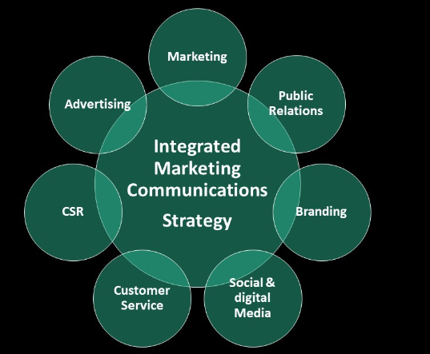
Figure 4:IMC strategy by H&M
(Source: Linkedin, 2024)

4.1.2 Challenges faced by H&M for implementing IMC
Even though the company H&M has the effectiveness for integrating IMC methods for matching and integrating communication in the quickly changing digital environment, different difficulties arise for the company, too. As per, Shah and Murthi (2021), the differences and disarrays of the media outlets are among one of the major problems. It gets much harder for H&M to keep the consistency of their brand message in every and growing number of platforms. These are social media and streaming services, etc. The brand seeks to establish consistency, but the amount of content needed to develop overwhelms the main points sometimes. One of the major challenges that also develops from sustaining personalisation and relevance. Consumers in the digital era want material that is tailored to them and fits with their interests. Data-driven marketing approaches are needed to develop this kind of content for consumers. Being a major fashion retailer in the UK market, H&M need to handle a large amount of data and various kinds of client data for properly customising their messages. This creates the challenge for the development of proper data-driven approaches, and it becomes challenging for managing and using technologies like big data. This can also challenge the company with developing the adherence to rules toward privacy and data use like GDPR. Inappropriate use of the data can cause the brand to lose clients' lines rather than win them over. One of the major challenges that come across which H&M has to face is dealing with keeping its integrated brand voice in different markets and cultures (H&M Group, 2024). As per Schultz (2020), the IMC strategy with universal principles and taking regional tastes into account develop many hurdles for the company. Different markets have different wants and cultural norms. H&M must compete in the worldwide market with a different range of consumer demographics. This develops an additional need for aligning their IMC strategy with local cultures, values and norms while also focusing on managing standardised approaches.

4.1.3 Benefits of using IMC for H&M
H&M has been able to produce fashion items that are memorable and recognised through their application of the IMC methods, the specific approach in the digital age where consumers are continuously exposed to multitudes of insights and different information (Ihzaturrahma and Kusumawati (2021). Consistency maintenance in brand messages across different touchpoints is a major advantage of IMC. This helped in ensuring that the customers, especially in the face of the high level of rivalry associated with certain items with the brand. IMC's strategy helps H&M make sure that its fashion lines and new offers reach large-scale consumers with an integrated marketing approach. The IMC benefits them by promoting seasonal collections and limited editions among their consumers by employing consistent messaging in different media platforms. As per, Kushwaha et al. (2020), for example, influencer marketing and endorsements, email marketing with newsletters and in-store promotions are used for digital ad campaign promotions and the use of social media for promoting their new collection and product lines. This consistent and unified brand image helps make it easier for the consumers to identify their brand and recall the fashion items connected to H&M. Another major benefit that developed for H&M with IMC strategy is the development of emotional appeals and narratives. IMC improve the brand memory values to appeal to contemporary consumers. This is with inclusivity and environmental sustainability aspects too. H&M focuses on promoting this aspect in their IMC in their campaigns and individual departments. This push is not just with their digital advertisements but also partnerships with eco-friendly designers, influencers and celebrities who focus on sustainable fashion. These employments increase the brand equity and make sure that the consumers remember the brand and connect with its values that are important to them. Further benefits have been gained where consumers are guaranteed to receive proper insights that match with their taste form the IMC. This gives H&M the scope for better consumer engagement and personalised marketing help (H&M Group, 2024). They develop better connections with consumers, and they are more likely to remember the products when they gain personalised products and services.
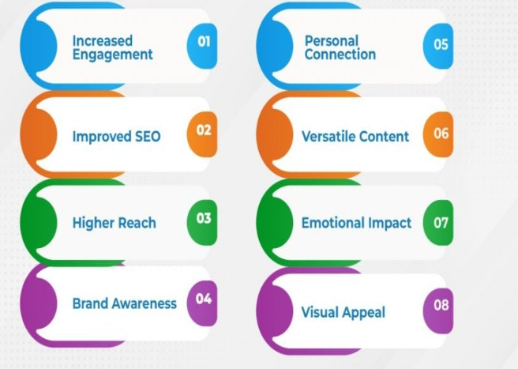
Figure 5:Benefits of IMC for H&M
(Source: Cyfuture Blog, 2023)

4.1.4 Comparison and contrasting of IMC among UK fashion brand and H&M
H&M has effective sues the IMC for increasing their brand equity. Still, it is much more important for companies to continue their approaches with other well-known UK fashion retailers like ASOS (Ziginov, 2021). Realising the values of the young, technology-savvy consumers has influenced H&M and ASOS for adopting to IMC strategy. Like H&M, ASOS is also quite active on the social media platforms. ASOS will also have tehri 13M followers on Instagram in 2023. Both brands focus on developing IMC with a consistent message, and influencer marketing is one of the major tools for both brands. They use the method for engaging the target guidance and promoting new collections. Influencer marketing invites by ASOS, like their partnership with bloggers, youtubers help them reach large-scale consumers. This is equally successful for H&M, too, with the capabilities that develop ethical consumer reach with the process.
In contrast, among H&M and ASOS, the company ASOS devotes more large-scale money to their digital marketing. H&M spent almost Euro 480 M on marketing in 2023, focusing 70% of its spending on digital marketing, whereas ASOS spent Euro 300M on marketing, with 80% spent on digital efforts. Another major difference that has been seen in the IMC approaches is where ASOS focus on using user-generated contents which can be seen from their #AsSeenOnME campaign, which invited shoppers to share their experience of using ASOS products on Instagram has been a big hit (Ziginov, 2021). This indicates towards ASOS brand image as a community-driven brand (ASOS Plc, 2022). On the other hand, H&M focus on prioritising sustainability and corporate social responsibility in user-generated content. A large proportion of H&M IMC content is for showcasing eco-friendly endeavours. The company's product lines also fall in their category, which helps it boost the sales of eco-friendly apparel with the IMC strategy. Both brands have their effective IMC strategy, where ASOS focus on community engagement, and H&M focuses on sustainability and global reaching.

4.2 Discussion
Code generation
Code | Sub-theme | Main theme
Current, recent, recent time, integrated marketing communication, communication, approach, marketing strategy, development, competitive, fashion industry, brand equity | The current integrated marketing communication strategy approach used by fashion brands for long-term sustainability | Critical discussion on the current integrated marketing communication strategy used by H&M in recent time for the development of brand equity in the competitive fashion market
 | Discuss the integrated marketing communication approach used by H&M.
Current and recent issues, implementation barriers, challenges, integrated marketing communication strategy | Current challenges of using integrated marketing communication strategy in fashion company | Critical evaluation of current challenges tackle by H&M to implement an integrated marketing communication strategy
 | External and internal issues faced by fashion brands to use integrated marketing communication strategy
Impact, benefits, significance, communication approach, H&M, brand equity, recognisable, memorable | Benefits of using integrated marketing communication strategy in a fashion company | Critical analysis of the impact of using an integrated marketing communication approach to make the brand memorise and recognisable in the competitive market of H&M
 | Significance of using an integrated marketing communication approach for improving financial statements
Market position, H&M, communication strategy, marketing communication strategy, fashion market, H&M | Compare and contrast current integrated marketing communication used by fashion brands. | Comparison analysis of the current market position of H&M by using an integrated marketing communication strategy in the UK competitive fashion market
 | The current market position of H&M in the fashion industry by using an integrated marketing communication strategy

4.2.1 Critical discussion on the current integrated marketing communication strategy used by H&M in recent time for the development of brand equity in the competitive fashion market
The current scenario of H&M helps to note that the company has successfully adopted an integrated marketing communication strategy in the business function. The company channels its products and services through various platforms. The company has designed their integrated marketing communication strategy based on smart goals. The main goal of the company is to stay consistent in the global competitive fashion market (Kaner, 2021). The company is constantly sharing the message with the customer regarding their products and services. In recent times, the application of digital technology has increased. Due to this reason, the leader takes the decision to channel their products through digital media. H&M is highly dependent on digital media. It helps to get the scope to target the mass media. H&M is a large-scale organisation which takes assistance from the IT infrastructure system to improve its integrated marketing communication strategy. The company organises different types of campaigns through offline and online modes. Online campaigning helps to target the global population. The company recently introduced a website personalised system in their brands, which helps to regenerate their profit margin. Personalized ads, email service and website make the communication process easier for customers. Based on their choice and preference, customers get auto updates and auto-suggestion, which is the unique form of the company. (Mäkelä, 2020; Pisa, 2021). H&M has a credible team to develop creative content to target customers. Rapidly, the company increased their visibility through offline and online modes, which increased customer engagement rate. Continuous the marketing team of H&M update about the product portfolio and other services. Communication with customers through various channels makes the company more sustainable. H&M prioritise the opinions and feedback of the customers. As per feedback, H&M changed the website design and ads design, which helps to make easy options for customers. Easy web page development makes the company more convenient to reach.

4.2.2 Challenges faced by fast fashion companies for implementing integrated marketing communication strategy in the digital era
Analysis of the challenges for integrated marketing
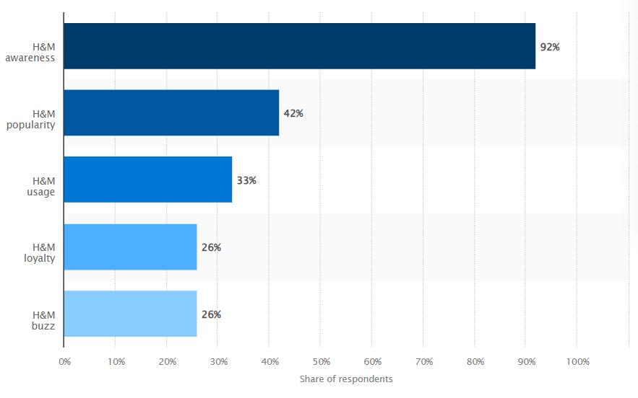
Figure 6:H&M in the UK market
(Source: Kunst, 2024)
fast fashion is having a negative impact on the business environment and, at the same time, is severely damaging the environment of the business on a large scale. Sustainability has become a major issue for fast fashion brands. H&M has also used certain sustainability practices which help the brand to promote strong and strategic sustainable initiatives but also works for balancing the core business model, which has become challenging. From the literature review, it can be identified that the marketing manager faces large-scale difficulties while planning the adoption of integrated marketing communication strategies (Rukhaya, et al., 2021). As the integrated marketing communication strategies include collaborative brand campaigns, consistent brand messaging, customer targeting and long-term marketing initiatives by delivering consistent messages, it is more structured, which requires strategic planning for implementation. Integrated marketing practices allow all the brands to work in harmony, but in this competitive business landscape, it has become a challenging task. One of the biggest challenges is the speed, which is the uniqueness of the fast fashion business (Kushwaha, et al., 2020). As a result, the rapid turnover of the business needs updates across all the marketing channels including social media and in-store display. At the same time, the customer base for fast fashion is huge, which requires engagement of a wide range of customer demographics, each with different preferences and expectations. Identification of such diverse market needs and efforts can be complex, which works for developing a seamless customer touchpoint at all levels. In this digitalized era, all business practices have become digitalized. In the case of H&M also, the brand has made certain efforts which can ensure seamless customer experiences at a large scale. The sustainability initiatives of the H&M sustainability practices were criticized by the consumers. Also, the social media posts from H&M have highlighted the display measurements, which created challenges and affected the customer base of the business.
Competitor analysis of H&M in the UK market
Competitors play a major and strategic role in the companies, which uses identification, evaluation and understanding of the current and future competitor analysis within the customer engagement practices, which can easily understand the current and potential competitor needs. Some of the major competitors of H&M in the UK include ZARA and Shein, who are creating strong challenges in the market.
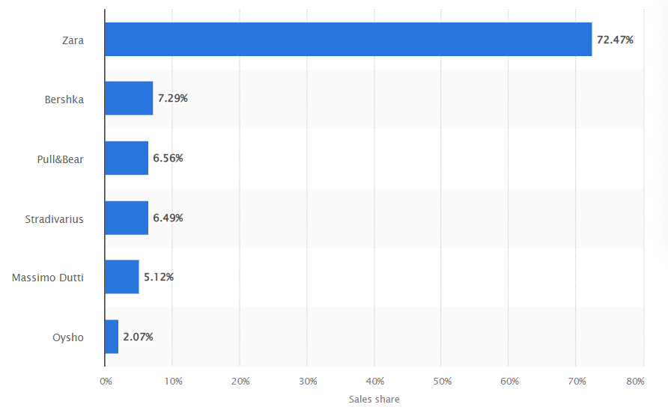
Figure 7:ZARA market share in 2023
(Source: Statista, 2023)
- ZARA – ZARA is one of the major competitors in the market, which has gained a large-scale shopper base in the UK and created strong competition for H&M. In 2023, the brand has gained more than 25% shoppers from H&M, which has increased by 5% as compared to the previous year (Statista, 2023). ZARA shoppers also prefer to shop from H&M more which creates a strong brand value in the market.
- ASOS – It is one of the most popular brands in the UK, which offers services to customers at competitive prices. This brand is a popular choice for online customers, which is creating a large-scale competitive edge in the market. The online-only availability is leaving a strong value proposition for H&M. But at the same time, the value proposition for the business is hard to ignore in the current marketplace.
Considering the competitive analysis of the business, it can be identified that H&M has strong brand recognition, which helps the business ensure its global market presence. Adaptation of sustainability initiatives is suitable for catering for the different styles and preferences of the customers.

4.2.3 Analysis of the impact of using integrated marketing communication for memorizing fashion products in the digital era
Impact of using integrated marketing communication (IMC) for H&M
Integrated marketing communication helps fast fashion companies get the right opportunity, which can help them gain a larger audience in the marketplace. This is helpful for efficiently targeting the customers, which is helpful for gaining customers a large-scale opportunity which can share consistent information about the brand, product and services through multiple channels and engagement measures. It has helped to share valuable information with customers through multiple channels and, at the same time, helped to increase brand engagement. As it is a cost-effective practice, it is suitable for enhancing efficiency, which can easily work for streamlining the distribution and production schedules. Moreover, with the use of integrated marketing communication, audience engagement has become simpler, which has helped the brands to easily connect with customers at a deeper level. IMC is suitable for engaging positive marketing efforts from engaging with marketing practices, social media engagement and public relations at a large scale (Tairova, Giyazova, and Dustova, 2020). This is suitable for reinforcing the brand identity and more engaging to the customers. H&M is a global retailer its global expansion practices are engaged with consistent branding practices across all of its markets, and in such a scenario, IMC helps the brand to ensure that its values and practices are maintained and communicated effectively through its different cultures. H&M launches its new products and promotions frequently, so using an effective promotional approach helps to easily coordinate these efforts so that the brand can ensure that they are communicated effectively. In this case, social media plays a major role, and for H&M, it's a core part of the marketing strategy. H&M has also made strategic efforts to promote its sustainable initiatives which has ensured to communicate with the customers effectively (Gao, 2024). Integrated marketing communication measures offer numerous benefits for a business, and in the case of the fast fashion industry, it has helped to enhance brand engagement and customer communication measures. The use of IMC in H&M has supported driving its business growth at a large scale.
Relevance of Keller brand equity model in H&M
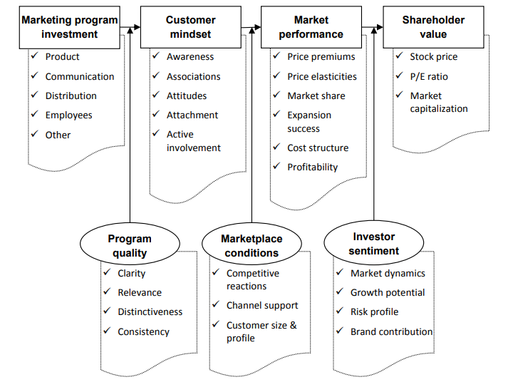
Figure 8:Measuring customer mindset for brand engagement
(Source: Cristea, and Munteanu, 2022)
Keller's brand equity model is widely considered for understanding brand values and building trust with consumers. In the case of the global fast-fashion retailer H&M, this engagement has been significant and ensured business growth. The relevance of Keller brand equity model brand engagement in H&M is discussed briefly,
Brand development – H&M focuses on brand engagement measures, which help it to get engaged with the customers and allow it to enhance its brand equity. By critically focusing on brand awareness, customer association, customer loyalty and perceived brand quality measures, H&M can enhance its brand position among its competitors.
Competitiveness – A strong brand equity is helpful for enhancing competitive advantage in the marketplace. In this fast-paced business marketplace customer focused business helps to create competitive advantage.
Customer engagement – maintaining long-term relationships with the customers is helpful for developing positive brand awareness and ensures association with brand loyalty. Fostering long-term relationships with customers has helped H&M to increase customer lifetime values.
Valuation of the business – Creating strong values for the business has helped H&M leaders to increase company values. H&M has created a strong brand presence which has helped for attracting investors who can support future growth in business.

4.2.4 Comparison analysis of the current market position of H&M by using an integrated marketing communication strategy in the UK competitive fashion market
In the UK fast fashion market ASOS, ZARA has been a strong competitor for H&M, which has created a challenging scenario for the business. All the brands have different brand values and approaches but have followed a unique approach to attract customers (Lanzolla, and Markides, 2021). As H&M, ZARA, and ASOS are key players in the UK market, each has implemented different IMC strategies. A comparison analysis of the strategies is given in the table below,
Comparison features | H&M | ASOS | ZARA
Brand engagement channels | It uses both the online and in-store business model | It uses only the digital model for brand engagement | It has both in-store and online channel
Customers | It focuses on a wider customer demographic, including all age group | It mainly focuses on young generations | It mainly targets GenZ customers who are fast-fashion-focused
Business strategy | It uses a balanced approach to brand engagement | It uses a digitalized approach | It has a fast-fashion-focused business strategy
Competitiveness | It has a strong competitive advantage through its strong physical presence and digital engagement planning | It has a competitive advantage in the online domain and is suitable for the online shoppers | It’s competitive advantage is based on creating urgency and excitement
So, from the comparison analysis, it can be easily identified that the balanced approach of H&M is well positioned, which reaches a wider customer base. But at the same time the highest effective customer strategy completely depends on the unique goals of the business, its target audience and the competitive landscape of the market. As per Javed, et al., (2020), H&M and its competitors have adopted different strategies in the marketplace through the integration of IMC practices, they have created strong brand awareness, customer engagement and revenue in the UK fashion market.

Summary
The overall discussion in this section helps to develop the idea that the managing committee makes the right decision at the right moment to use an integrated marketing communication strategy in the business function. It is the most accurate decision of the company. From the competitor’s analysis, without making any difference in the business functions, it is not possible for H&M to sustain itself in the fashion industry. Strong communication with customers is highly required in recent times, which is discussed in this section. Different themes help to develop different ideas about the research phenomena regarding H&M's integrated marketing communication approach.

Chapter 5: Conclusion and Recommendations

5.1 Introduction
This is the last chapter of the research. The research is about integrated marketing communication for the fashion industry on brand equity. The company is H&M. In this situation, the entire research has taken place, and a secondary data analysis method has been taken for analysing the research. There are some concrete findings that have been developed from the analysis. This chapter can give a view of whether the objectives of the research have been met or met. It also can give recommendations for the improvement of the study. This study's future scopes and the current gaps of the study can be identified in this paper.

5.2 Linking with Objectives

5.2.1 Objective 1
The first objective is to identify the currently integrated marketing strategies that have been taught by most of the UK fashion companies, including H&M, in this digital era. From the findings from different articles and internet sources, it has been found that most fashion companies are using the integration of traditional marketing approaches as well as digital marketing strategies, and they try to blend the digital and traditional marketing strategy. They use advertisements in the local newspapers, and magazines as well as they use social media platforms or different influencers for their product advertisements. On the other hand, they also use coupon systems or loyalty programs through their websites. They target different festive seasons, such as Christmas, for conducting their shows, campaigns or events, and they also conduct social media campaigning. Thus, they can be able to blend digital and traditional marketing strategies or communication strategies with their target customers. Apart from that, they also use different modes of digital marketing approaches such as SEO, mail marketing, influencer marketing etc. So, from the findings, objective 1 is met as it talks about the currently used strategies.

5.2.2 Objective 2
Objective 2 is about the challenges faced by the fashion industry, especially H&M. From the articles available in the database and the blogs or articles published in the newspaper or websites, it has been found that H&M is facing a lack of expertise or human resources for the integrated marketing communication. Integrated marketing communication needs strong expertise, but lack of expertise and lack of training for this creates issues. Lack of resources is another issue. A perfect combination is required for this, so expertise in traditional and digital marketing is required, but it is found that there needs to be more proper coordination. It also requires huge technological support. The blending between traditional and digital marketing requires high quality technology and innovation. However, the lack of innovative strategies and lack of technological availability creates issues for the company. The company was facing some growth issues during the covid period, so lack of profitability creates a lack of resources and technological support that can impact their IMC. IMC also needs good strategy planning for implementation. In this situation, a lack of planning or creative planning may create issues. All these issues have been found from the findings that can show that objective 2 is also met.

5.2.3 Objective 3
The benefits of using the integrated marketing strategy in the fashion industry are the third objective of the study. Integrated marketing is one of the popular marketing strategies that is used by most of the companies. Almost all fashion brands use the ICM, and H&M is also among them. This strategy has different positive sides, such as it can improve the overall production and marketing efficiency of the organisation and sales growth and reaching the target customers can be easier. It can reach out to a huge audience, even out of the country or region, which can improve the overall sales of the organisation. It is more cost-effective, and it can consistently communicate with the target audience so that it can create brand loyalty and brand equity. The brand's reputation and loyalty can be improved through it, and that can improve brand equity in the world market. It can improve the overall customer experience of the organisation, and it can give competitive advantages and recognition in the world of fashion. All these findings can help to meet objective 3.

5.2.4 Objective 4
This last objective is developed to compare and contrast the different types of IMCs that the company uses. The company used the global branding strategy by using social media marketing and other digital marketing strategies, and they do global marketing through social media, TV, and print. In their global marketing strategy, they adopt the regional strategy, such as trying to make their campaigns and advertisements based on the regional festivals and cultures. But they also use the regional IMC in the UK, where they make advertisements and make campaigns based on the culture and celebration within the UK. They use influencer marketing, and they collaborate with global fashion icons regional fashion influencers, or social media influencers to reach maximum numbers of the maximum audience. They use online and offline marketing strategies. They use TV and print media to reach a section of society, and they use social media marketing and SEO to reach the young generation. A sustainable fashion marketing strategy is quite different from others. They highlight their sustainability in their marketing, and through their marketing activities, they promote sustainability. These strategies are found from the findings, which can show that objective 4 is also met.

5.3 Recommendations

5.3.1 Industry recommendations
The integrated marketing strategy of the organisation is already very strong, but some things need to be addressed, or some issues have been identified from the findings. Those areas or those issues can be solved by the organisation so that they can improve their integrated marketing communication, and their sales and growth can be improved too. The recommendations are discussed below:
- Hiring experts: The main issue that the organisation is facing is a lack of experts who can effectively handle integrated marketing communication. So, the company must hire some experts who have enough experience in integrated marketing communication in the fashion industry and from the global level, the experts must be hired. They have to use the global recruitment process or the global marketing process to find out the best talent. They must ensure all those experts have deep expertise in digital marketing tools and the use of advanced technologies.
- Training and development opportunities: The organisation have to arrange some training programs and education programs for their employees. They can arrange seminars, workshops or other training programs where their employees, especially employees from the marketing department, can get training about the current and trading IMC strategies, and they can come to know about the innovations of these strategies. It can make the IMC strategies more effective.
- Resource and technological development: The organisation has to focus on resource allocation for their marketing strategies. Marketing strategy can only improve their growth, so they have to finance their marketing and invest in adapting the advanced technologies; these can improve the overall IMC strategy of the organisation.
- Proper collaboration and planning: For IMC planning exp, parts are required, and they must create appropriate collaboration among the digital marketing and traditional marketing teams. S strong leadership can give the opportunity to make strong collaboration and proper planning for blending traditional and digital marketing strategy.
- Using the communication mix with the marketing mix: They individually use the aspects of the communication mix and also the marketing mix. The marketing mix 7P and the communication mix components are the best sources for creating a perfect marketing communication strategy for the current digital era.

5.3.2 Study recommendations
The study also has some limitations, and if those limitations can be overcome, then the study can create more valuable and relevant outcomes.
Primary research: The study has been done in secondary research. Secondary data are collected from different sources, and those are analyzed thematically. If the primary data are collected from the marketers or digital marketing experts of H&M, then the current process of IMC, its challenges based on the company and its benefits can be known more effectively. More valid and accurate data can be collected through primary research.
Quantitative study: The entire work has been done using quantitative data analysis. The quantitative method can be more fruitful because quantitative data can show the relationship between brand equity and the growth of the organisation with IMC adaption. On the other hand, quantitative data analysis can give more value and concrete findings for the research.

5.4 Future scope
The study has been done on H&M company. Still, there are different other fashion brands in the UK, such as M&S and Zara, and their IMC strategies. Comparing and contrasting their IMC strategies can give a view of which method is more fruitful. In the future, different IMC strategy research on different global brands can be done. This study can help to conduct IMC innovation and innovative strategies for fashion brands as well as other lifestyle brands.

Reference list
Al-Ababneh, M., (2020). Linking ontology, epistemology and research methodology. Science & Philosophy, 8(1), pp.75-91. http://eiris.it/ojs/index.php/scienceandphilosophy/article/viewFile/500/732
Alam, M.K., (2021). A systematic qualitative case study: questions, data collection, NVivo analysis and saturation. Qualitative Research in Organizations and Management: An International Journal, 16(1), pp.1-31. https://www.emerald.com/insight/content/doi/10.1108/QROM-09-2019-1825/full/html
Alexander, B. and Kent, A., (2021). Tracking technology diffusion in-store: a fashion retail perspective. International Journal of Retail & Distribution Management, 49(10), pp.1369-1390. https://ualresearchonline.arts.ac.uk/id/eprint/16748/1/IJRDM-05-2020-0191.R2_Proof_hi.pdf
Andrews, J.C. and Shimp, T.A., (2018). Advertising, promotion, and other aspects of integrated marketing communications. Cengage Learning. https://thuvienso.hoasen.edu.vn/bitstream/handle/123456789/12329/Contents.pdf?sequence=1
ASOS (2024) About Us | ASOS, ASOS. Available at: https://www.asos.com/about/. [ Accessed on: 14th Oct]
ASOS Plc (2022). Acceleration Of ASOS Brands Strategy. [online] ASOS plc. Available at: https://www.asosplc.com/news/acceleration-asos-brands-strategy/[Accessed 14 Oct. 2024]
Babii, A., (2020). Important aspects of the experimental research methodology. Вісник Тернопільського національного технічного університету, 97(1), pp.77-87. https://elartu.tntu.edu.ua/bitstream/lib/32426/2/TNTUSJ_2020v97n1_Babii_A-Important_aspects_of_the_experimental_77-87.pdf
Belch, G.E. and Belch, M.A., (2018). Advertising and promotion: An integrated marketing communications perspective. mcgraw-hill. https://thuvienso.hoasen.edu.vn/bitstream/handle/123456789/8039/Contents.pdf?sequence=4&isAllowed=y
Belch, G.E. and Belch, M.A., (2018). Advertising and promotion: An integrated marketing communications perspective. mcgraw-hill. https://thuvienso.hoasen.edu.vn/bitstream/handle/123456789/8039/Contents.pdf?sequence=4&isAllowed=y
Blakeman, R., (2023). Integrated marketing communication: creative strategy from idea to implementation. Rowman & Littlefield. https://thuvienso.hoasen.edu.vn/bitstream/handle/123456789/12524/Contents.pdf?sequence=1&isAllowed=y
Blakeman, R., (2023). Integrated marketing communication: creative strategy from idea to implementation. Rowman & Littlefield. https://thuvienso.hoasen.edu.vn/bitstream/handle/123456789/12524/Contents.pdf?sequence=1&isAllowed=y
Blakeman, R., (2023). Integrated marketing communication: creative strategy from idea to implementation. Rowman & Littlefield. https://thuvienso.hoasen.edu.vn/bitstream/handle/123456789/12524/Contents.pdf?sequence=1&isAllowed=y
Blakeman, R., (2023). Integrated marketing communication: creative strategy from idea to implementation. Rowman & Littlefield. https://books.google.com/books?hl=en&lr=&id=tPDIEAAAQBAJ&oi=fnd&pg=PP1&dq=Integrated+marketing+communication+strategies&ots=kPXsGQyKwU&sig=dqG811XGC1rJt0iLGBorAF9grvc
Blakeman, R., (2023). Integrated marketing communication: creative strategy from idea to implementation. Rowman & Littlefield. https://books.google.com/books?hl=en&lr=&id=tPDIEAAAQBAJ&oi=fnd&pg=PP1&dq=integrated+marketing+communication&ots=kPXsGQAKBQ&sig=iX-Fur1wZP2GTAloDVN26kQ2444
Bormane, S., (2018, May). Integrated marketing communications in sustainable business. In Society. Integration. Education. Proceedings of the international scientific conference (Vol. 6, pp. 80-96). https://journals23.rta.lv/index.php/SIE/article/download/3405/3238
Camilleri, M.A. and Camilleri, M.A., (2018). Integrated marketing communications (pp. 85-103). Springer International Publishing. https://www.um.edu.mt/library/oar/bitstream/123456789/21432/5/Integrated%20Marketing%20Communications.pdf
Çınar, K., (2020). Customer based brand equity models in hotel industry: A literature review. Strategic Innovative Marketing and Tourism: 8th ICSIMAT, Northern Aegean, Greece, 2019, pp.281-288. https://www.researchgate.net/profile/Mounir-Elatrachi/publication/339812910_Determinants_of_ICT_Integration_by_Teachers_in_Higher_Education_in_Morocco/links/5ec31c49299bf1c09ac8f187/Determinants-of-ICT-Integration-by-Teachers-in-Higher-Education-in-Morocco.pdf#page=293
Cristea, A. and Munteanu, C.C., (2022). A Holistic Perspective on Brand Equity Measurement Methods. Business Management Dynamics, 11(7). https://www.researchgate.net/profile/Claudiu-Catalin-Munteanu/publication/362531078_A_holistic_perspective_on_brand_equity_measurement_methods/links/637cb90f2f4bca7fd08094ed/A-holistic-perspective-on-brand-equity-measurement-methods.pdf
Cyfuture Blog. (2023). Data Center [online] Available at: https://cyfuture.com/blog/the-future-of-social-media-marketing-services-trends-to-watch/[Accessed 14 Oct. 2024].
del Rocío Bonilla Quijada, M., Arriaga, J.L.D.O. and Domingo, D.A., (2021). Insights into user engagement on social media. Findings from two fashion retailers. Electronic Markets, 31(1), pp.125-137. https://link.springer.com/article/10.1007/s12525-020-00429-0
Dharmappa, S., (2018). Study of the effectiveness of online marketing on integrated marketing communication. GRIN Verlag. https://uniselinus.us/sites/default/files/2021-06/Tesi%20Dharmappa.pdf
Fetais, A.H., Algharabat, R.S., Aljafari, A. and Rana, N.P., (2023). Do social media marketing activities improve brand loyalty? An empirical study on luxury fashion brands. Information Systems Frontiers, 25(2), pp.795-817. https://link.springer.com/content/pdf/10.1007/s10796-022-10264-7.pdf
Firdaus, F., Zulfadilla, Z. and Caniago, F., (2021). Research methodology: types in the new perspective. Manazhim, 3(1), pp.1-16. https://ejournal.stitpn.ac.id/index.php/manazhim/article/download/903/760
Fondevila-Gascón, J.F., Bernal, P.M., SanMiguel, P., Sádaba, T. and Pérez-Bou, S., (2021), June. Millennials and fashion: branding and positioning through digital interactions. In International Conference on Fashion communication: between tradition and future digital developments (pp. 117-128). Cham: Springer International Publishing. https://link.springer.com/chapter/10.1007/978-3-030-81321-5_10
Fuxman, L., Mohr, I., Mahmoud, A.B. and Grigoriou, N., (2022). The new 3Ps of sustainability marketing: The case of fashion. Sustainable Production and Consumption, 31, pp.384-396. https://www.sciencedirect.com/science/article/pii/S2352550922000586
Galloway, C., (2020). Integrated marketing communication. In Public Relations (pp. 186-207). Routledge. https://www.taylorfrancis.com/chapters/edit/10.4324/9781003116950-10/integrated-marketing-communication-chris-galloway
Gao, Y., (2024). Analysis of Brand Marketing Strategy under the Background of Digital Media--Case Study of H&M Company. Journal of Education, Humanities and Social Sciences, 27, pp.431-438. https://drpress.org/ojs/index.php/EHSS/article/download/18249/17782
Goworek, H., Oxborrow, L., Claxton, S., McLaren, A., Cooper, T. and Hill, H., (2020). Managing sustainability in the fashion business: Challenges in product development for clothing longevity in the UK. Journal of Business Research, 117, pp.629-641. https://irep.ntu.ac.uk/id/eprint/34228/1/11676_Oxborrow.pdf
Goworek, H., Oxborrow, L., Claxton, S., McLaren, A., Cooper, T. and Hill, H., (2020). Managing sustainability in the fashion business: Challenges in product development for clothing longevity in the UK. Journal of Business Research, 117, pp.629-641. https://irep.ntu.ac.uk/id/eprint/34228/1/11676_Oxborrow.pdf
Guercini, S., Bernal, P.M. and Prentice, C., (2018). New marketing in fashion e-commerce. Journal of global fashion marketing, 9(1), pp.1-8. https://www.tandfonline.com/doi/pdf/10.1080/20932685.2018.1407018
H&M Group (2024). Markets and expansion. [online] H&M Group. Available at: https://hmgroup.com/about-us/markets-and-expansion/[Accessed 14 Oct. 2024].
Hennink, M., Hutter, I. and Bailey, A., (2020). Qualitative research methods. Sage. https://books.google.com/books?hl=en&lr=&id=_InCDwAAQBAJ&oi=fnd&pg=PP1&dq=qualitative+research+methodology&ots=3v9RlTp0iA&sig=VZ7GyPAlx49S8652E9Q33MRN2sY
Hidayati, N., (2023). Exploring Gen Z Social Media Marketing Engagement on Brand Experience, Brand Equity, and Brand Trust: The Context of Muslim Fashion. Jurnal Manajemen Teori dan Terapan, 16(3). https://e-journal.unair.ac.id/JMTT/article/download/48761/27476
Human, S., Pandit, H.J., Morel, V., Santos, C., Degeling, M., Rossi, A., Botes, W., Jesus, V. and Kamara, I., (2022), June. Data protection and consenting communication mechanisms: Current open proposals and challenges. In 2022 IEEE European Symposium on Security and Privacy Workshops (EuroS&PW) (pp. 231-239). IEEE. https://ieeexplore.ieee.org/abstract/document/9799369/
Hyun, H., Park, J. and Hong, E., (2024). Enhancing brand equity through multidimensional brand authenticity in the fashion retailing. Journal of Retailing and Consumer Services, 78, p.103712. https://www.sciencedirect.com/science/article/pii/S0969698924000080
Ihzaturrahma, N. and Kusumawati, N., (2021). Influence of Integrated Marketing Communication To Brand Awareness and Brand Image Toward Purchase Intention of Local Fashion Product. International Journal of Entrepreneurship and Management Practices, 4(15), pp.23-41. https://www.academia.edu/download/88108351/IJEMP-2021-15-09-02.pdf
Ihzaturrahma, N. and Kusumawati, N., (2021). Influence of Integrated Marketing Communication To Brand Awareness and Brand Image Toward Purchase Intention of Local Fashion Product. International Journal of Entrepreneurship and Management Practices, 4(15), pp.23-41. https://www.academia.edu/download/88108351/IJEMP-2021-15-09-02.pdf
Ihzaturrahma, N. and Kusumawati, N., (2021). Influence of Integrated Marketing Communication To Brand Awareness and Brand Image Toward Purchase Intention of Local Fashion Product. International Journal of Entrepreneurship and Management Practices, 4(15), pp.23-41. https://www.academia.edu/download/88108351/IJEMP-2021-15-09-02.pdf
Ihzaturrahma, N. and Kusumawati, N., (2021). Influence of Integrated Marketing Communication To Brand Awareness and Brand Image Toward Purchase Intention of Local Fashion Product. International Journal of Entrepreneurship and Management Practices, 4(15), pp.23-41. https://www.academia.edu/download/88108351/IJEMP-2021-15-09-02.pdf
Javed, T., Yang, J., Gilal, W.G. and Gilal, N.G., (2020). The sustainability claims' impact on the consumer's green perception and behavioral intention: A case study of H&M. Advances in Management and Applied Economics, 10(2), pp.1-22. https://www.researchgate.net/profile/Tahira-Javed-2/publication/344348730_The_sustainability_claims'_impact_on_the_consumer's_green_perception_and_behavioral_intention_A_case_study_of_HM/links/5f6ae8ff92851c14bc8e3ea5/The-sustainability-claims-impact-on-the-consumers-green-perception-and-behavioral-intention-A-case-study-of-H-M.pdf
Javed, T., Yang, J., Gilal, W.G. and Gilal, N.G., (2020). The sustainability claims' impact on the consumer's green perception and behavioral intention: A case study of H&M. Advances in Management and Applied Economics, 10(2), pp.1-22. https://www.researchgate.net/profile/Tahira-Javed-2/publication/344348730_The_sustainability_claims'_impact_on_the_consumer's_green_perception_and_behavioral_intention_A_case_study_of_HM/links/5f6ae8ff92851c14bc8e3ea5/The-sustainability-claims-impact-on-the-consumers-green-perception-and-behavioral-intention-A-case-study-of-H-M.pdf
Juska, J.M., (2021). Integrated marketing communication: advertising and promotion in a digital world. Routledge. https://www.taylorfrancis.com/books/mono/10.4324/9780367443382/integrated-marketing-communication-jerome-juska
Juska, J.M., (2021). Integrated marketing communication: advertising and promotion in a digital world. Routledge. https://www.taylorfrancis.com/books/mono/10.4324/9780367443382/integrated-marketing-communication-jerome-juska
Juska, J.M., (2021). Integrated marketing communication: advertising and promotion in a digital world. Routledge. https://www.taylorfrancis.com/books/mono/10.4324/9780367443382/integrated-marketing-communication-jerome-juska
Kaner, G., (2021). Greenwashing: How difficult it is to be transparent to the consumer—H&M case study. Green marketing in emerging markets: strategic and operational perspectives, pp.203-226. https://link.springer.com/chapter/10.1007/978-3-030-74065-8_9
Kang, E. and Hwang, H.J., (2021). Ethical conducts in qualitative research methodology: Participant observation and interview process. Journal of Research and Publication Ethics, 2(2), pp.5-10. https://koreascience.kr/article/JAKO202130550806959.pdf
Kim, Y. and Oh, K.W., (2020). Which consumer associations can build a sustainable fashion brand image? Evidence from fast fashion brands. Sustainability, 12(5), p.1703. https://www.mdpi.com/2071-1050/12/5/1703
Kipnis, E., Demangeot, C., Pullig, C., Cross, S.N., Cui, C.C., Galalae, C., Kearney, S., Licsandru, T.C., Mari, C., Ruiz, V.M. and Swanepoel, S.,( 2021). Institutionalising diversity-and-inclusion-engaged marketing for multicultural marketplace well-being. Journal of Public Policy & Marketing, 40(2), pp.143-164. https://journals.sagepub.com/doi/abs/10.1177/0743915620975415
Kunst, A. (2024) H&M brand profile UK 2022, Statista. Available at: https://www.statista.com/forecasts/1335613/handm-fashion-stores-brand-profile-in-the-uk. [Accessed on: 14th Oct]
Kushwaha, B.P., Singh, R.K., Varghese, N. and Singh, V.N., (2020). Integrating social media and digital media as new elements of integrated marketing communication for creating brand equity. Journal of Content, Community & Communication, 11(6), pp.52-64. https://www.researchgate.net/profile/Zinggara-Hidayat-2/publication/350639866_Data-Driven_Journalism_Based_on_Big-Data_Analytics_A_Model_Development_from_Indonesia's_Experience/links/6070302692851c8a7bb38cbc/Data-Driven-Journalism-Based-on-Big-Data-Analytics-A-Model-Development-from-Indonesias-Experience.pdf#page=59
Kushwaha, B.P., Singh, R.K., Varghese, N. and Singh, V.N., (2020). Integrating social media and digital media as new elements of integrated marketing communication for creating brand equity. Journal of Content, Community & Communication, 11(6), pp.52-64. https://www.researchgate.net/profile/Zinggara-Hidayat-2/publication/350639866_Data-Driven_Journalism_Based_on_Big-Data_Analytics_A_Model_Development_from_Indonesia's_Experience/links/6070302692851c8a7bb38cbc/Data-Driven-Journalism-Based-on-Big-Data-Analytics-A-Model-Development-from-Indonesias-Experience.pdf#page=59
Kushwaha, B.P., Singh, R.K., Varghese, N. and Singh, V.N., (2020). Integrating social media and digital media as new elements of integrated marketing communication for creating brand equity. Journal of Content, Community & Communication, 11(6), pp.52-64. https://www.researchgate.net/profile/Zinggara-Hidayat-2/publication/350639866_Data-Driven_Journalism_Based_on_Big-Data_Analytics_A_Model_Development_from_Indonesia's_Experience/links/6070302692851c8a7bb38cbc/Data-Driven-Journalism-Based-on-Big-Data-Analytics-A-Model-Development-from-Indonesias-Experience.pdf#page=59
Lanzolla, G. and Markides, C., (2021). A business model view of strategy. Journal of Management Studies, 58(2), pp.540-553. https://onlinelibrary.wiley.com/doi/abs/10.1111/joms.12580
Lasi, M.B.A., (2021). The relationship between E-marketing mix strategy and integrated marketing communication: a conceptual framework. International Journal of Economics and Management Systems, 6. https://www.iaras.org/iaras/filedownloads/ijems/2021/007-0017(2021).pdf
Linkedin (2024). Integrated marketing and communications for business growth. [online] Available at: https://www.linkedin.com/pulse/integrated-marketing-communications-business-growth-hazel-king-ori[Accessed 14 Oct. 2024].
Lobe, B., Morgan, D. and Hoffman, K.A., (2020). Qualitative data collection in an era of social distancing. International journal of qualitative methods, 19, p.1609406920937875. https://journals.sagepub.com/doi/pdf/10.1177/1609406920937875?%5D
Luck, E., Barker, N., Sassenberg, A.M., Chitty, B., Shimp, T.A. and Andrews, J.C., (2020). Integrated marketing communications. Cengage AU. https://books.google.com/books?hl=en&lr=&id=sdsBEAAAQBAJ&oi=fnd&pg=PR11&dq=Integrated+marketing+communication+ASOS&ots=te6On6mDNW&sig=9Ej9FqhzM0SaRJX8gPpCich2C6g
Lynch, S. and Barnes, L., (2020). Omnichannel fashion retailing: examining the customer decision-making journey. Journal of Fashion Marketing and Management: An International Journal, 24(3), pp.471-493. https://e-space.mmu.ac.uk/625697/3/JFMM_09-2019-0192%20Final%20Word.%20docx.pdf
Mäkelä, J., (2020). Creating an Authentic Sustainable Brand: Case Companies H&M Group and Marimekko. https://www.theseus.fi/bitstream/handle/10024/341976/Makela_Jasmiina.pdf?sequen
Mohajan, D. and Mohajan, H., (2022). Memo writing procedures in grounded theory research methodology. https://mpra.ub.uni-muenchen.de/115246/1/MPRA_paper_115246.pdf
Mukendi, A., Davies, I., Glozer, S. and McDonagh, P., (2020). Sustainable fashion: current and future research directions. European journal of marketing, 54(11), pp.2873-2909. https://researchportal.bath.ac.uk/files/202239989/EJMSI_SustainableFashionReview_accepted.pdf
Nash, J., (2019). Exploring how social media platforms influence fashion consumer decisions in the UK retail sector. Journal of Fashion Marketing and Management: An International Journal, 23(1), pp.82-103. http://eprints.bournemouth.ac.uk/30793/3/Paper.%20version%20submitted%20Social%20media%20influences%20on%20fashion%20consumers_paper%20.pdf
Nassaji, H., (2020). Good qualitative research. Language Teaching Research, 24(4), pp.427-431. https://www.academia.edu/download/81689060/1362168820941288.pdf
Nayak, J.K. and Singh, P., (2021). Fundamentals of research methodology problems and prospects. SSDN Publishers & Distributors. http://dspace.vnbrims.org:13000/jspui/bitstream/123456789/4653/1/Fundamentals%20of%20Research%20Methodology_Nayak.pdf
Niinimäki, K., Peters, G., Dahlbo, H., Perry, P., Rissanen, T. and Gwilt, A., (2020). The environmental price of fast fashion. Nature Reviews Earth & Environment, 1(4), pp.189-200. https://research.aalto.fi/files/78950024/The_environmental_price_of_fast_fashion.pdf
Nobile, T.H., Noris, A., Kalbaska, N. and Cantoni, L., (2021). A review of digital fashion research: before and beyond communication and marketing. International journal of fashion design, technology and education, 14(3), pp.293-301. https://www.tandfonline.com/doi/pdf/10.1080/17543266.2021.1931476
Nobile, T.H., Noris, A., Kalbaska, N. and Cantoni, L., (2021). A review of digital fashion research: before and beyond communication and marketing. International journal of fashion design, technology and education, 14(3), pp.293-301. https://www.tandfonline.com/doi/pdf/10.1080/17543266.2021.1931476
Nobile, T.H., Noris, A., Kalbaska, N. and Cantoni, L., (2021). A review of digital fashion research: before and beyond communication and marketing. International journal of fashion design, technology and education, 14(3), pp.293-301. https://www.tandfonline.com/doi/pdf/10.1080/17543266.2021.1931476
Noris, A., Nobile, T.H., Kalbaska, N. and Cantoni, L., (2021). Digital fashion: A systematic literature review. A perspective on marketing and communication. Journal of Global Fashion Marketing, 12(1), pp.32-46. https://www.academia.edu/download/74785927/Noris_et_al_2021_Digital_Fashion_A_systematic_literature_review..pdf
Noris, A., Nobile, T.H., Kalbaska, N. and Cantoni, L., (2021). Digital fashion: A systematic literature review. A perspective on marketing and communication. Journal of Global Fashion Marketing, 12(1), pp.32-46. https://www.academia.edu/download/74785927/Noris_et_al_2021_Digital_Fashion_A_systematic_literature_review..pdf
Ocaña-Fernández, Y. and Fuster-Guillén, D., (2021). The bibliographical review as a research methodology. Revista Tempos e Espaços em Educação, 14(33), pp.e15614-e15614. https://ufs.emnuvens.com.br/revtee/article/download/15614/11680
Ozuem, W., Willis, M., Howell, K., Helal, G., Ranfagni, S. and Lancaster, G., (2021). Effects of online brand communities on millennials' brand loyalty in the fashion industry. Psychology & Marketing, 38(5), pp.774-793. https://insight.cumbria.ac.uk/id/eprint/5958/1/Ozuem_Effects_Accepted%20Manuscript.pdf
Pandey, P. and Pandey, M.M., (2021). Research methodology tools and techniques. Bridge Center. http://dspace.vnbrims.org:13000/jspui/bitstream/123456789/4666/1/RESEARCH%20METHODOLOGY%20TOOLS%20AND%20TECHNIQUES.pdf
Pisa, A., (2021). Data-driven recommendations for H&M: a study on candidate generation and boosting trees. https://www.politesi.polimi.it/bitstream/10589/204133/1/Master_Thesis_With_Summary_Arcangelo-Pisa.pdf
Rathore, B., (2021). Fashion Transformation 4.0: Beyond Digitalization & Marketing in Fashion Industry. Eduzone: International Peer Reviewed/Refereed Multidisciplinary Journal, 10(2), pp.54-59. https://www.researchgate.net/profile/Bharati-Rathore-2/publication/368387699_Fashion_Transformation_40_Beyond_Digitalization_Marketing_in_Fashion_Industry/links/63e5147dc002331f7266d4f3/Fashion-Transformation-40-Beyond-Digitalization-Marketing-in-Fashion-Industry.pdf
Ray, S. and Nayak, L., (2023). Marketing sustainable fashion: trends and future directions. Sustainability, 15(7), p.6202. https://www.mdpi.com/2071-1050/15/7/6202/pdf
Rehman, S.U., Gulzar, R. and Aslam, W., (2022). Developing the integrated marketing communication (imc) through social media (sm): the modern marketing communication approach. Sage Open, 12(2), p.21582440221099936. https://journals.sagepub.com/doi/pdf/10.1177/21582440221099936
Roh, Y., Heo, G. and Whang, S.E., (2019). A survey on data collection for machine learning: a big data-ai integration perspective. IEEE Transactions on Knowledge and Data Engineering, 33(4), pp.1328-1347. https://arxiv.org/pdf/1811.03402
Ruggiano, N. and Perry, T.E., (2019). Conducting secondary analysis of qualitative data: Should we, can we, and how?. Qualitative Social Work, 18(1), pp.81-97. https://journals.sagepub.com/doi/pdf/10.1177/1473325017700701
Rukhaya, S., Yadav, S., Rose, N.M., Grover, A. and Bisht, D., (2021). Sustainable approach to counter the environmental impact of fast fashion. The Pharma Innovation Journal, 10(8), pp.517-523. https://www.academia.edu/download/89807661/S-10-7-243-699.pdf
SanMiguel, P., Pérez-Bou, S., Sádaba, T. and Mir-Bernal, P., (2021). How to communicate sustainability: From the corporate Web to E-commerce. The case of the fashion industry. Sustainability, 13(20), p.11363. https://www.mdpi.com/2071-1050/13/20/11363
Schultz, D.E., (2020). From advertising to integrated marketing communications. In A reader in marketing communications (pp. 10-40). Routledge. https://www.taylorfrancis.com/chapters/edit/10.4324/9781003060420-2/advertising-integrated-marketing-communications-schultz
Shah, D. and Murthi, B.P.S., (2021). Marketing in a data-driven digital world: Implications for the role and scope of marketing. Journal of Business Research, 125, pp.772-779. https://www.sciencedirect.com/science/article/pii/S0148296320304355
Shariq, M., (2018). Brand equity dimensions-a literature review. International Research Journal of Management and Commerce, 5(3), p.312. https://www.researchgate.net/profile/Mohammad-Shariq-2/publication/326302689_BRAND_EQUITY_DIMENSIONS-A_LITERATURE_REVIEW/links/5b44e4bcaca272dc385e1d47/BRAND-EQUITY-DIMENSIONS-A-LITERATURE-REVIEW.pdf
Sileyew, K.J., (2019). Research design and methodology (Vol. 7). Cyberspace. https://www.intechopen.com/chapters/68505
Statista (2023) Sales share of the Inditex Group by format worldwide 2019, Statista. Available at: https://www.statista.com/statistics/268825/contribution-of-sales-of-the-inditex-group-worldwide-by-format/. [ Accessed on: 14th Oct]
Statista Research Department., (2024, August). Revenue of the fashion industry in the UK 2020-2029. Available at: https://www.statista.com/forecasts/480843/e-commerce-revenue-fashion-forecast-in-the-united-kingdom [Accessed on:27.8.2024]
Steenkamp, P., (2019). Aaker versus Keller's models: much ado about branding. no. June, pp.1-14. https://www.researchgate.net/profile/Pieter-Steenkamp/publication/341909107_Aaker_versus_Keller's_models_much_ado_about_branding/links/5ed8ebb34585152945314782/Aaker-versus-Kellers-models-much-ado-about-branding.pdf
Syahputra, D.A., (2023). The Influence of Social Media Marketing on Consumer Based Brand Equity, Brand Loyalty, and Mediation by Brand Experience on Fashion Brand Clothing in Indonesia. Indonesian Journal of Economic & Management Sciences, 1(2), pp.183-200. https://journal.formosapublisher.org/index.php/ijems/article/download/3779/3734
Tairova, M.S.M., Giyazova, N.B. and Dustova, A.K., (2020). Goal and objectives of integrated marketing communications. Economics, 2, pp.5-7. https://economic-theory.com/images/PDF/2020/45/goal-and-objectives.pdf
Theodora, N., (2021). Relationship Between Integrated Marketing Communication and Brand Equity. International Journal of Social Science and Business, 5(2), pp.278-283. https://ejournal.undiksha.ac.id/index.php/IJSSB/article/download/33782/19782
Urcia, I.A., (2021). Comparisons of adaptations in grounded theory and phenomenology: Selecting the specific qualitative research methodology. International journal of qualitative methods, 20, p.16094069211045474. https://journals.sagepub.com/doi/pdf/10.1177/16094069211045474
Vebrianto, R., Thahir, M., Putriani, Z., Mahartika, I. and Ilhami, A., (2020). Mixed Methods Research: Trends and Issues in Research Methodology. Bedelau: Journal of Education and Learning, 1(2), pp.63-73. https://ejournal.anotero.org/index.php/bedelau/article/download/35/35
Verma, R., Verma, S. and Abhishek, K., (2024). Research methodology. Booksclinic Publishing. https://hpuniv.ac.in/hpuniv/upload/uploadfiles/files/3_5.pdf
Vukasović, T., (2022). Customer-Based Brand Equity: Conceptual model. Management, 19, pp.303-310. https://toknowpress.net/ISBN/978-961-6914-29-1/96.pdf
Widjaja, G., (2022). What experts tell about integrated marketing communication for effective business promotion and sale strategy. Indonesian Interdisciplinary Journal of Sharia Economics (IIJSE), 5(1), pp.48-62. https://e-journal.uac.ac.id/index.php/iijse/article/download/1661/810
Zhang, Y., (2023). Evaluating the Effectiveness of Loyalty Programmes in the Fashion Industry: A Case Study of ASOS UK. https://en.front-sci.com/index.php/memf/article/view/860/1014
Ziginov, S., (2021). CUSTOMER ENGAGEMENT VIA SOCIAL MEDIA. HOW DOES SOCIAL MEDIA MARKETING AFFECT CONSUMER DECISION-MAKING PROCESS AND SALES? CASE: ASOS. https://www.theseus.fi/handle/10024/502594

