Kian Harper-Evans (2204995)
2204995@student.uwtsd.ac.uk
Lecturer: Dr Nitheesh Kaliyamurthy

Word Count:2343 words
Synthesize a soloution to a potential REAL-LIFE scenario
Computer Networks and Cyber Security: Computer Forensics

Contents
1.0 Abstract 2
2.0 Introduction 2
3.0 Research and Report 3
4.0 Investigate and Report 6
5.0 References 21

Abstract
The purpose of the project is to display my understanding and research on the topics of computer forensics and digital forensics. This document also contains a professional digital/computer forensics investigation report of my own. From this project I have gained new knowledge on the topics of computer/digital forensics and have gained new knowledge and skills in relation to the tools I used in my investigation. I learned how to use FTK Imager and Autopsy and how to structure a Computer Forensics investigation report.

2.0 Introduction
This document’s purpose is to document the research I have conducted into the topics of computer and digital forensics. The first section of the document will contain the research I have done into said topics. The second section of this report will document the steps and findings that take place during my own digital/computer forensics investigation.

3.0 Research and Report

Definitions
Computer Forensics:
From my research I have found some suitable definitions for computer forensics. For example, computer forensics can be defined as scientific analysis of data stored on or retrieved from computer storage devices in a way in which the data is useable evidence in a court of law. This is according to the source, [1] which states ““Computer forensics is the scientific examination and analysis of data held on, or retrieved from, computer storage media in such a way that the information can be used as evidence in a court of law”.”. Another definition offered by the same source states that computer forensics is the use of analytical techniques and tools to observe, collect and examine evidence that is stored magnetically. This is seen in the quote “computer forensics is considered to be the use of analytical and investigative techniques and tools to identify, collect, examine and preserve evidence/information which is magnetically stored or encoded”.”.

Digital Forensics:
From my research I have found that digital forensics can be defined as the use of scientific methods for the preservation, collection, validation, identification, analysis, documentation, and presentation of digital evidence sourced from digital sources for the purpose of reconstructing criminal events. This is according to the source, [2] which states “The use of scientifically derived and proven methods toward the preservation, collection, validation, identification, analysis, interpretation, documentation, and preservation of digital evidence derived from digital sources for the purpose of facilitating or furthering the reconstruction of events found to be criminal, or helping to anticipate unauthorized actions shown to be disruptive to planned operations.”.

Fundamental Concepts
Computer Forensics:
From my research I found that the fundamental concepts of computer forensics include gathering and analyzing evidence from digital sources. Common types of computer forensics include database forensics, retrieval and analysis of data or metadata that is stored in databases. This is according to the source, [3] which states “Computer forensics always involves gathering and analysing evidence from digital sources. Some common types include: Database forensics: Retrieval and analysis of data or metadata found in databases.”.

Digital Forensics:
From my research I was able to find that the fundamental concepts of digital forensics are that digital forensics revolves around identifying, acquiring, processing, analyzing, and creating reports on digital data. This is according to the source, [4] which states “Digital forensics is a branch of forensic science that focuses on identifying, acquiring, processing, analysing, and reporting on data stored electronically.”.

Scope and Applications
Computer Forensics:
Through my research I was able to find examples of the scope and real-world applications of computer forensics. A real-world example of the application of computer forensics is the use of digital evidence in criminal investigations. Computer forensics can lead to convictions in cases related to cyber-crime, data theft, network breaches and illicit/fraudulent transactions online. This is according to the source, [5] which states “Digital evidence is useful in criminal investigations, particularly in solving cybercrime and digital-world crimes, such as data theft, network breaches and illicit online transactions. It's also used to solve physical-world crimes, such as burglary, assault, hit-and-run accidents, and even murder.”.

Digital Forensics:
From my research I found that a real-world application of digital forensics is the use of digital forensics in criminal investigation similarly to computer forensics. Digital forensics is used to extract evidence from digital sources to help investigators piece together events that lead up to crimes or proceed them. This is according to the source, [6] which states “Criminal Investigations: Explanation: Digital forensics can assist in extracting and analyzing evidence from electronic devices to help investigators piece together the events leading to a crime or to identify suspects.”.

Discipline Relevance

Computer Forensics:
From my research I was able to find the source, [7]. This source provides multiple examples of where computer forensics was used and useful in investigations. These include a case where a hacker stole money in a 2016 cyber attack on a crypto currency exchange called BitFinex. The money stolen was then laundered over a 5-year period into two perpetrators’ accounts. The money was however traced and seized by a team of crypto and computer forensics experts. Due to this investigation the perpetrators were convicted, and agents recovered 3.6 billion dollars’ worth of crypto currency. Another case discussed in this source is the case where two men were arrested in Oklahoma after their computers and storage devices were searched uncovering over 200 indecent images of people who were underage. These cases show the importance of computer forensics in keeping people and their assets safe.

Digital Forensics:
From my research I was able to find the source, [8]. This source provides multiple cases where digital forensics/digital evidence was relevant to investigations conclusions. These examples include a case of Kari Baker in 2010. She was found dead after a supposed overdose of sleeping pills, but later investigation of the husbands’ online search history found search results for overdose via sleeping pills. This combined with physical evidence was used to convict the husband for 65 years. Another example we can look at is the case where Dennis Rader or as he called himself the BTK killer, killed 10 people in Kansas between 1974 and 1991. He began taunting the police by sending them things related to the crimes. These items included a floppy disk that police were able to extract evidence from and link it back to Rader, which ended up with him receiving multiple life sentences. These cases show the importance that the analysis of someone’s digital footprint are during investigations.

4.0 Investigate and Report

Investigation Background
The focus of this investigation is related to accusations that cyberbullying has taken place against the victim. The purpose of this investigation is to analyze evidence that has been collected to determine whether any cyberbullying has taken place. This report will document all the steps taken in the investigation including chain of custody, investigation methodology etc.

Chain of Custody
Evidence | Date/Time of collection | Name of Evidence collector | Where was evidence collected | Evidence Description | Name of Evidence Receiver | Date/Time evidence was received
USB Stick | 20/04/24 | Kian Harper-Evans |  | Small 128GB USB drive | Kian Harper-Evans | 21/04/24

Investigation Methodology
For this investigation my methodology includes assessing and locking down the area in which the evidence is collected from, following the correct chain of custody procedure after handling evidence ensuring that photos document the process. The next steps will be analyzing the evidence we collected using the wide variety of forensics tools at my disposal for extracting information such as, dates, times, edit history and other important pieces of data that will point towards a definitive answer to whether cyber bullying has taken place or not.

Tools Used
For this project I decided to make use of multiple different free forensics software. Those software’s are:
- FTK Imager – according to the source, [9] FTK imager is a forensics tool that specializes in disk imaging, verification and validation of images, file hashing and reporting. This tool will be used to extract data/information from the images I find.
- Autopsy – The source, [10] autopsy is a digital forensics platform used for in-depth forensic investigations. I will be using autopsy to retrieve information hidden in the meta data of the files I have recovered. I will also use it to uncover text hidden in these files and use it to search for key words.

Screenshots (Evidence)

Image Evidence Recovered:
Below this statement I will be documenting images including captured text messages as evidence that online harassment may or may not have taken place. I will not be displaying all images captured, only those that may suggest harassment has taken place. A conclusion will be drawn after all the evidence is presented.

Image 1:
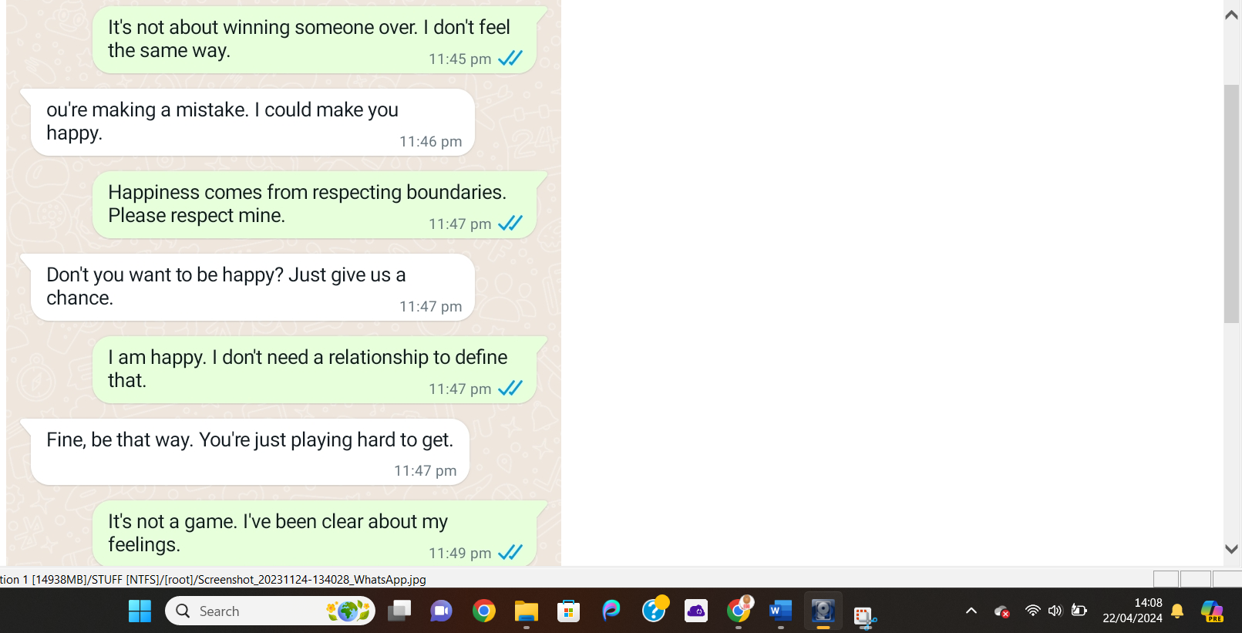
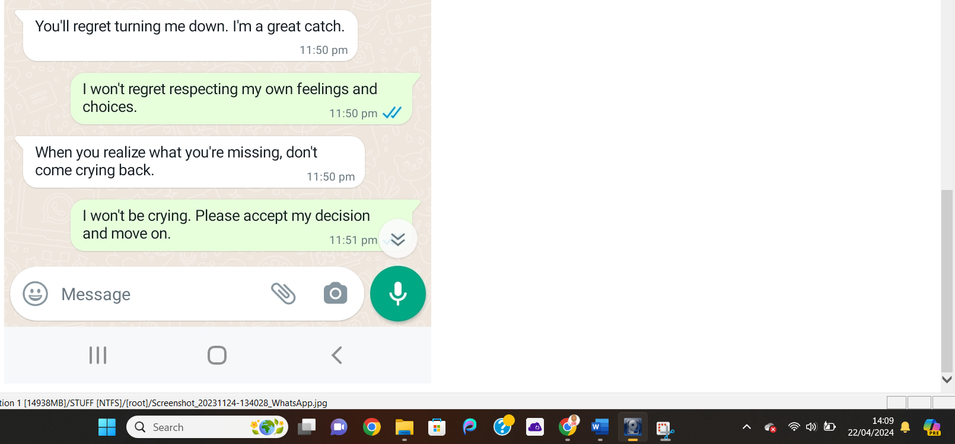
Shown above are text conversations between someone called Justine Elias and a potential victim of Online harassment. The conversation revolves around Justine not respecting the other person’s wishes to stop pursuing a relationship with them. These messages could be seen as cyberbullying or harassment but are not concrete evidence on their own.

Image 2:
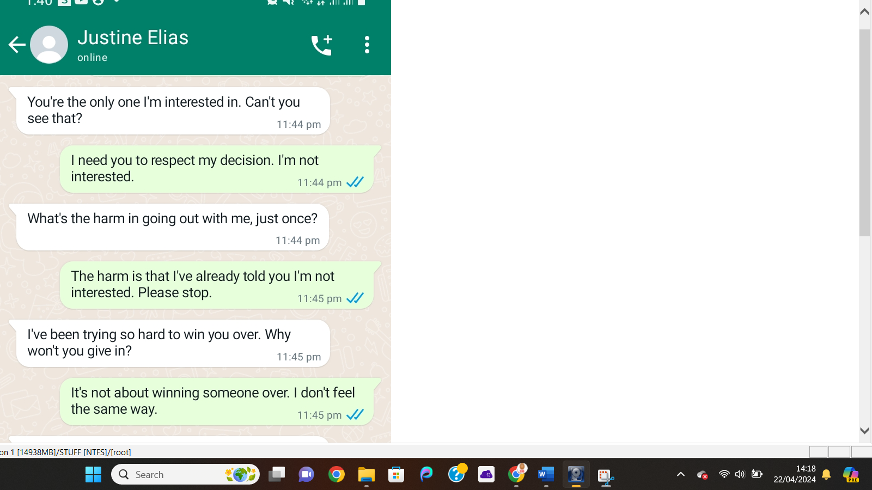
The image above shows another section of the conversation mentioned previous. This seems to have been one long continuous conversation so far, however if similar topics of conversation are found in these messages a case for harassment could be made as the recipient to these messages has stated multiple times that they are not interested in a romantic relationship with Justine.
Image 3:
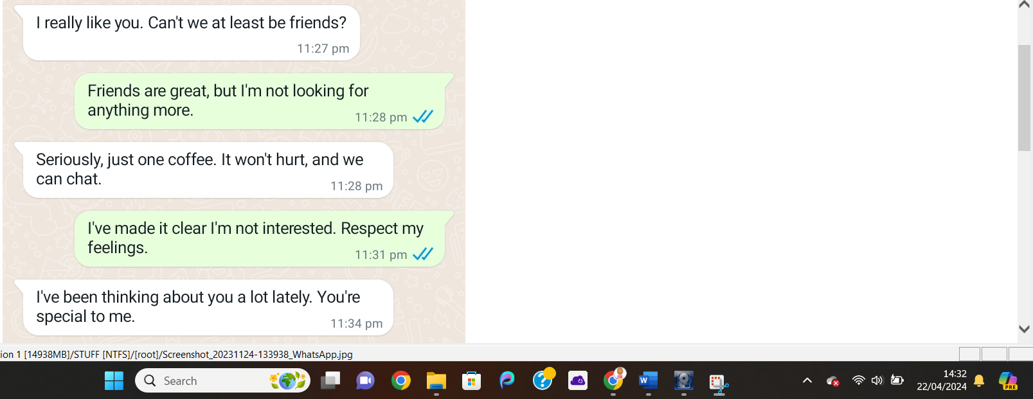
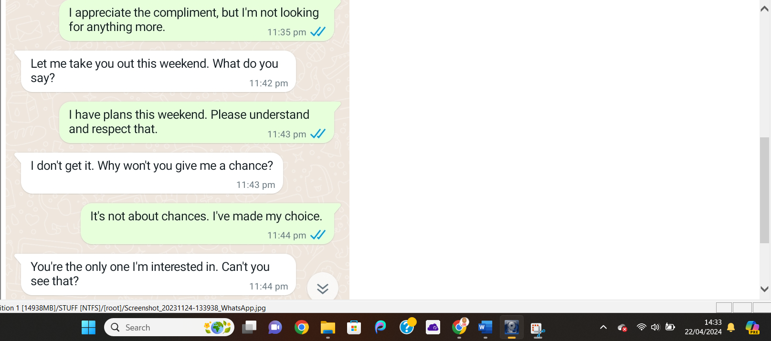
More snippets from the same conversation. Shows that Justine is unable to realize that his advancements are unwanted. Further evidence required to draw conclusions.

Text conversation 2 Images (Seer Musta):
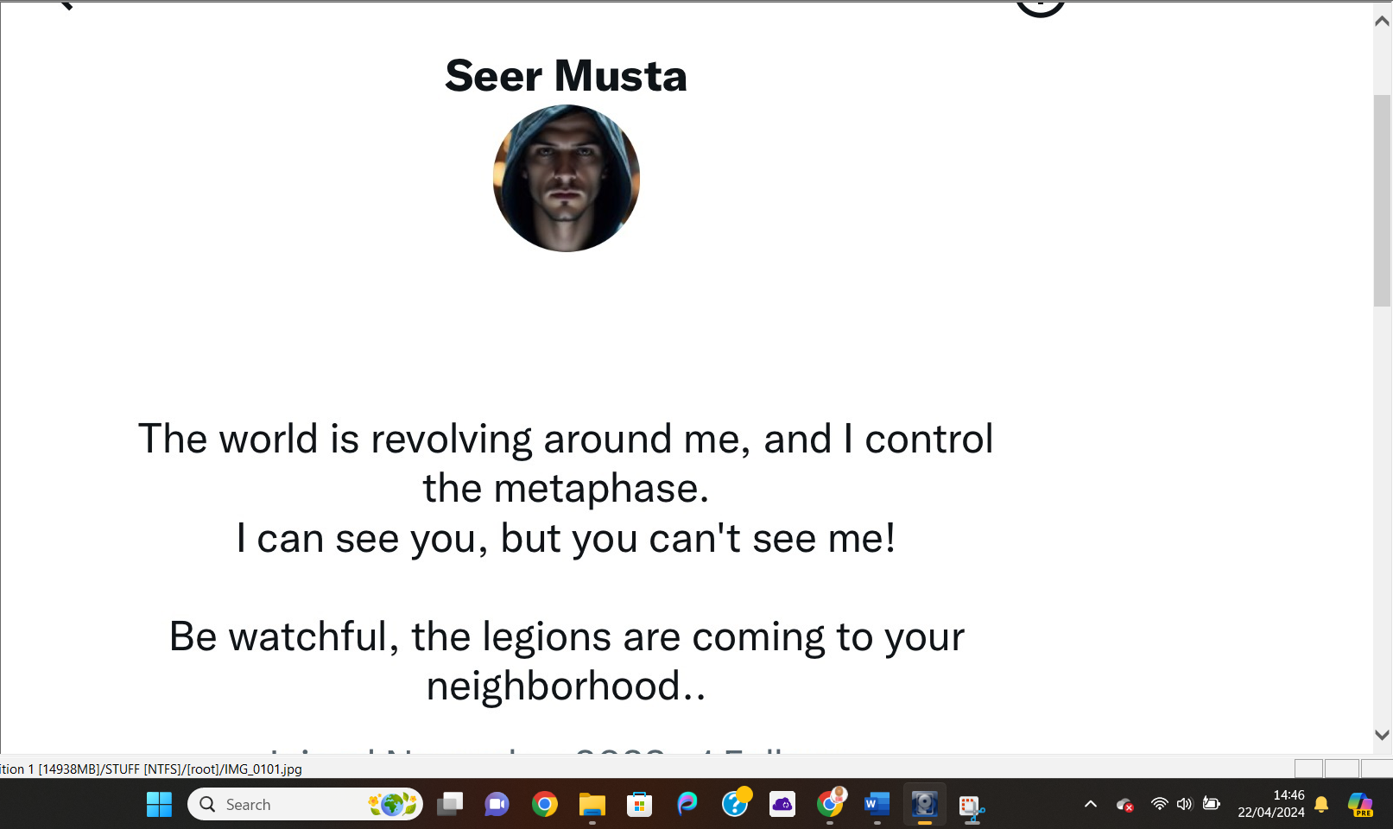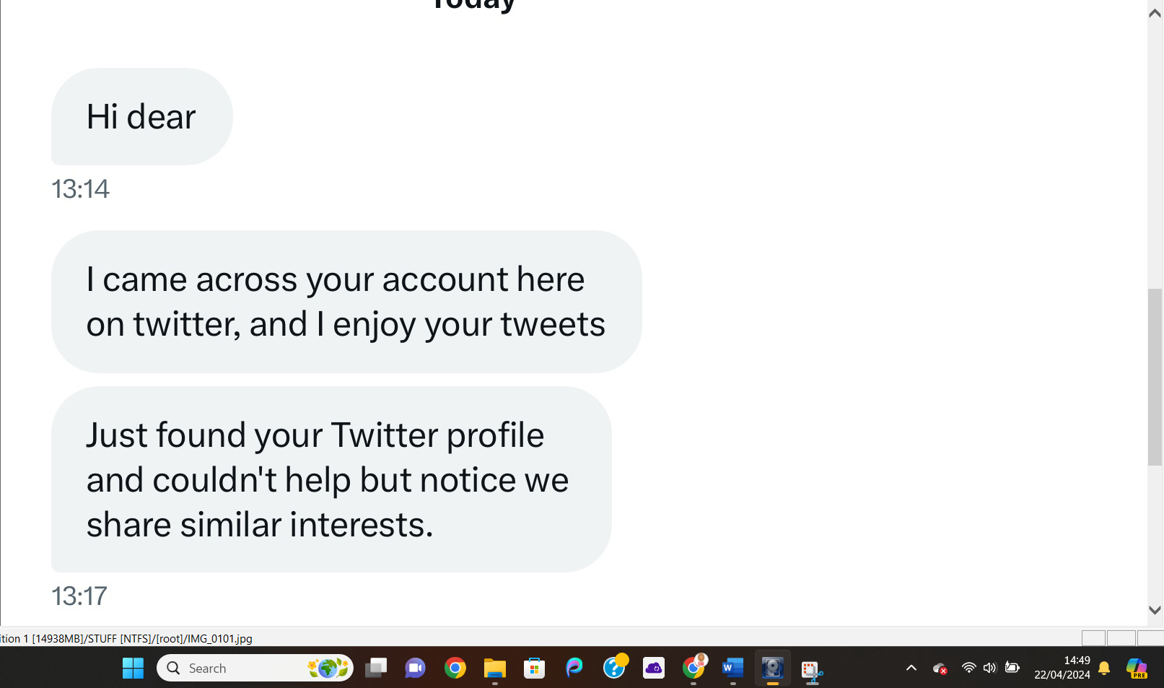
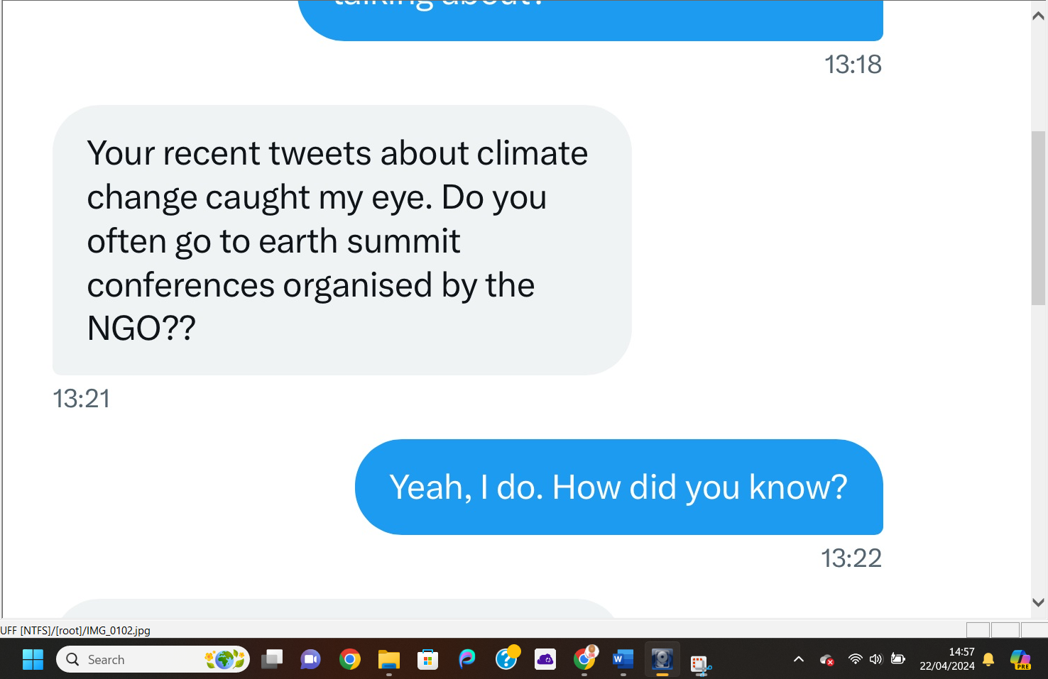
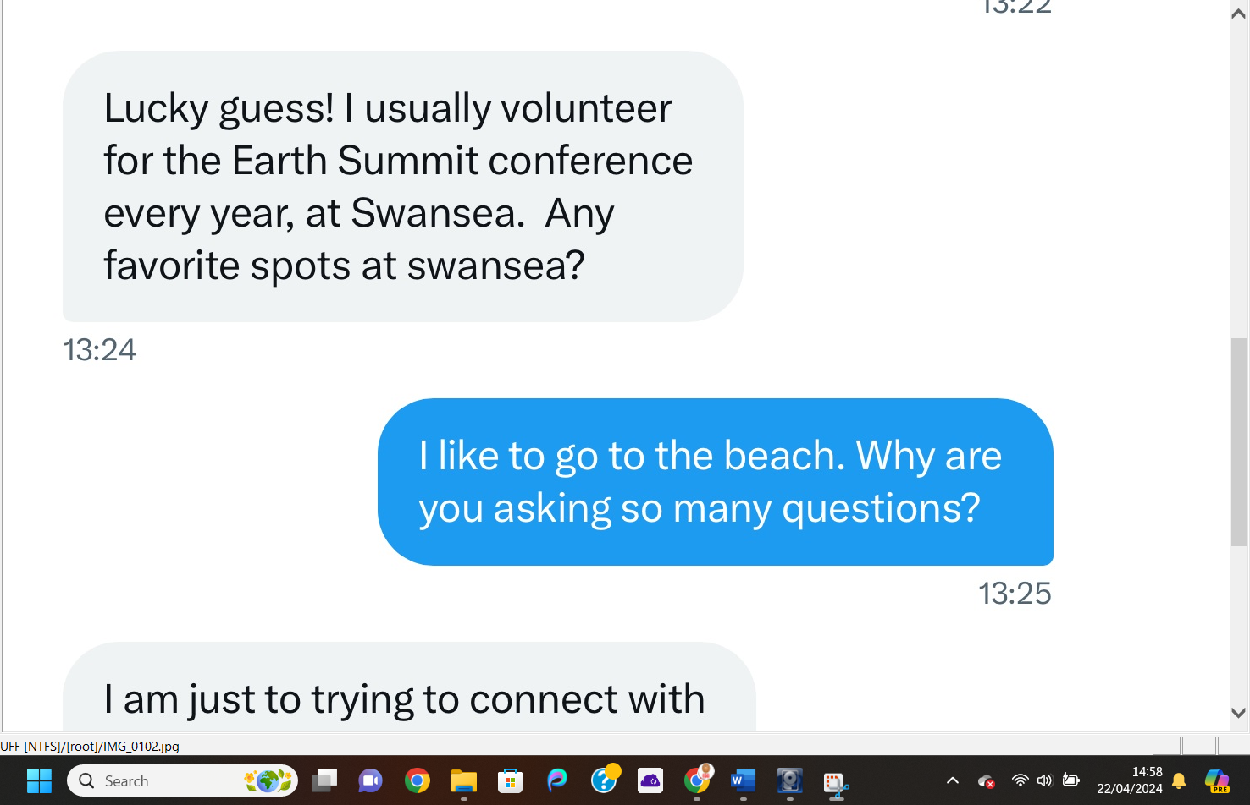
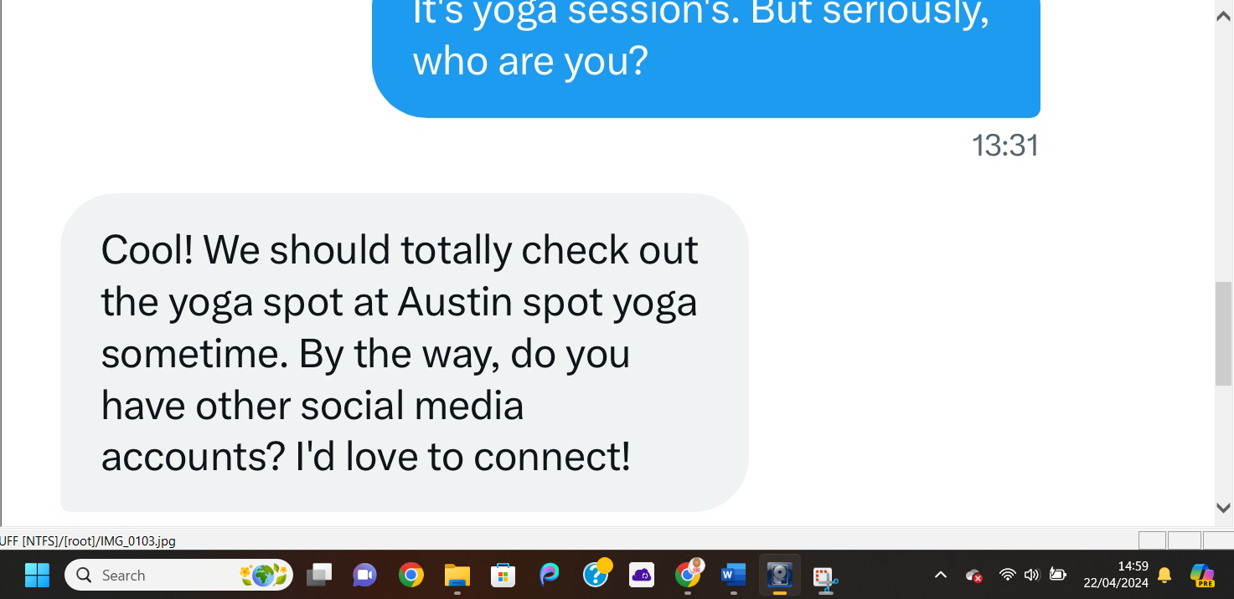
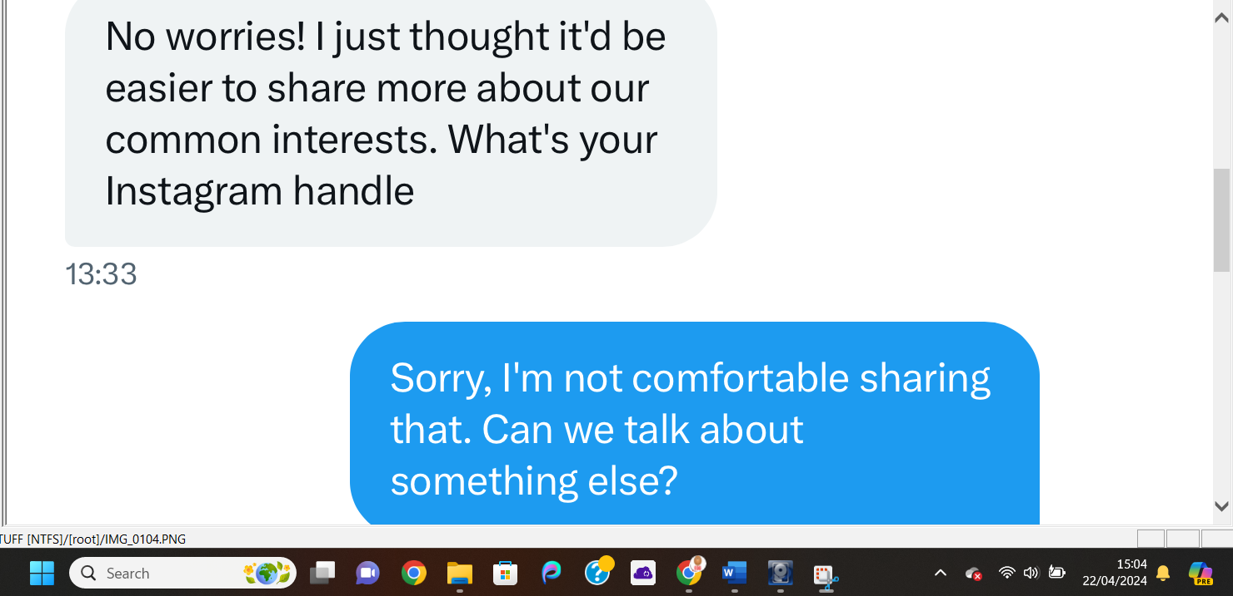
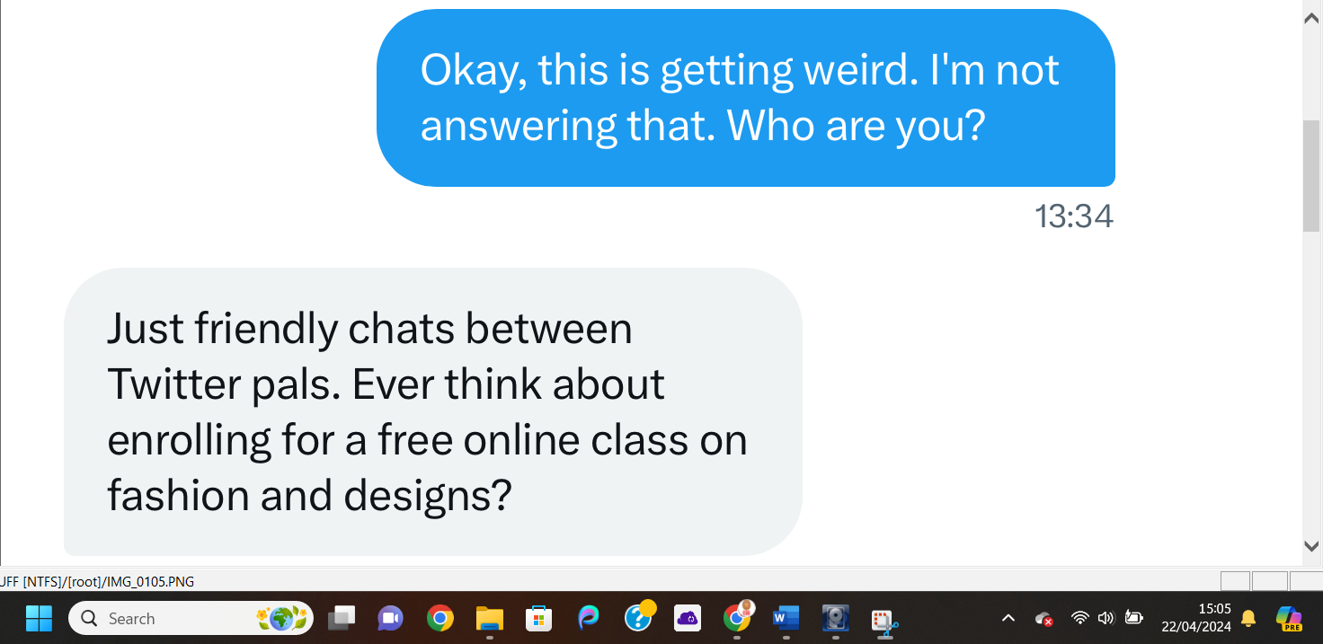
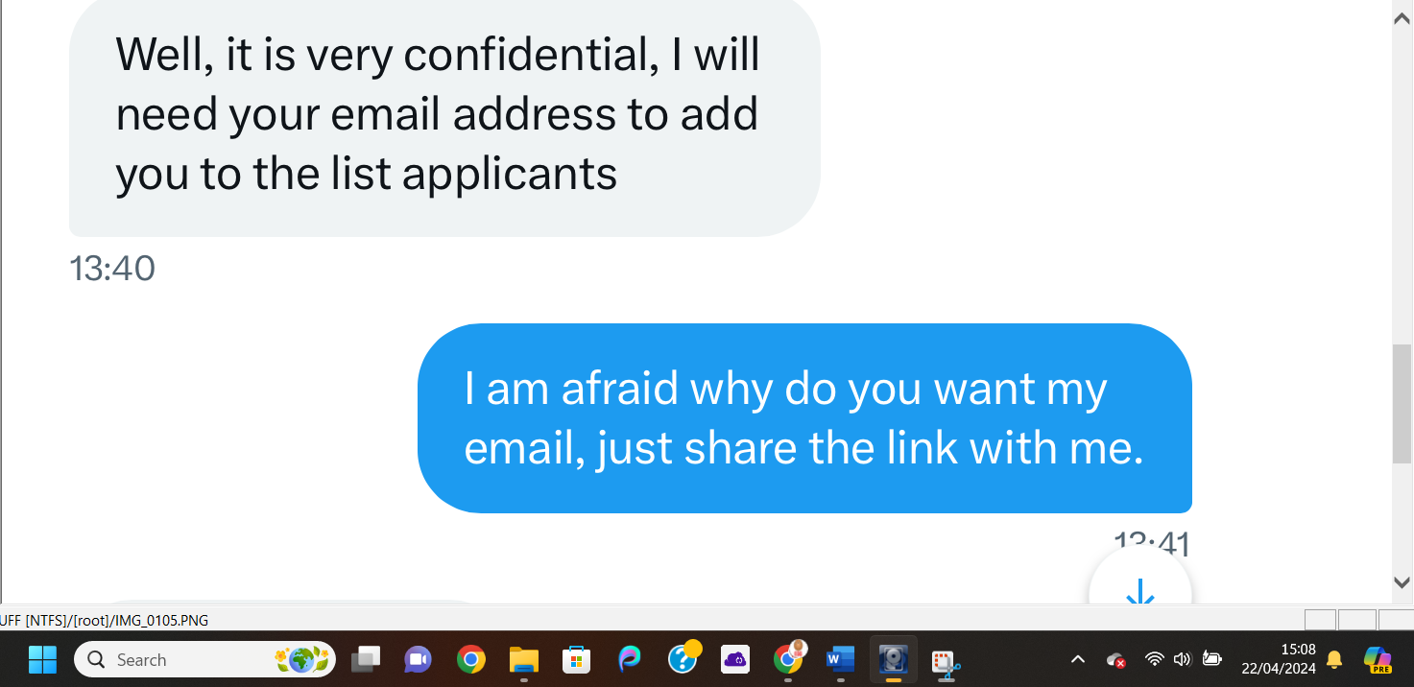
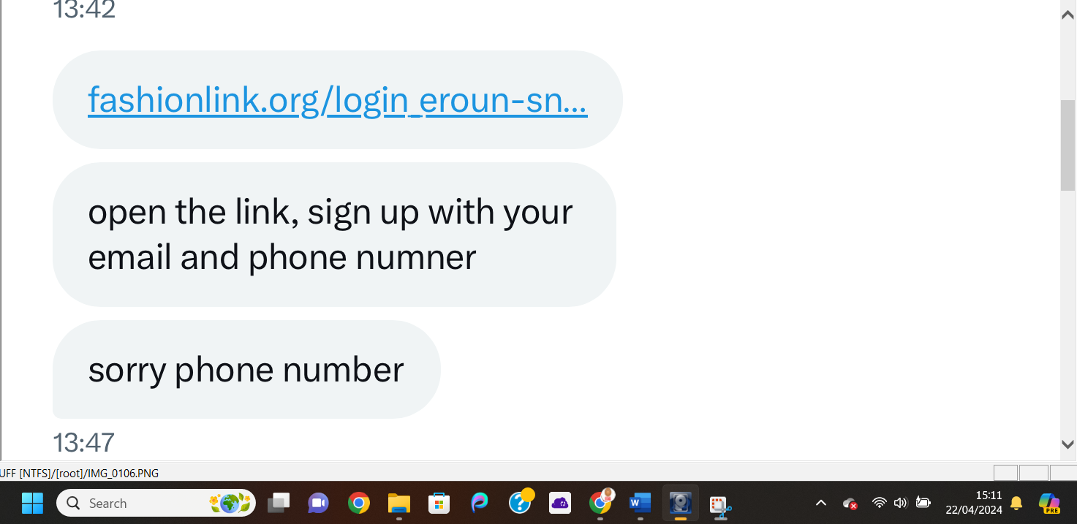
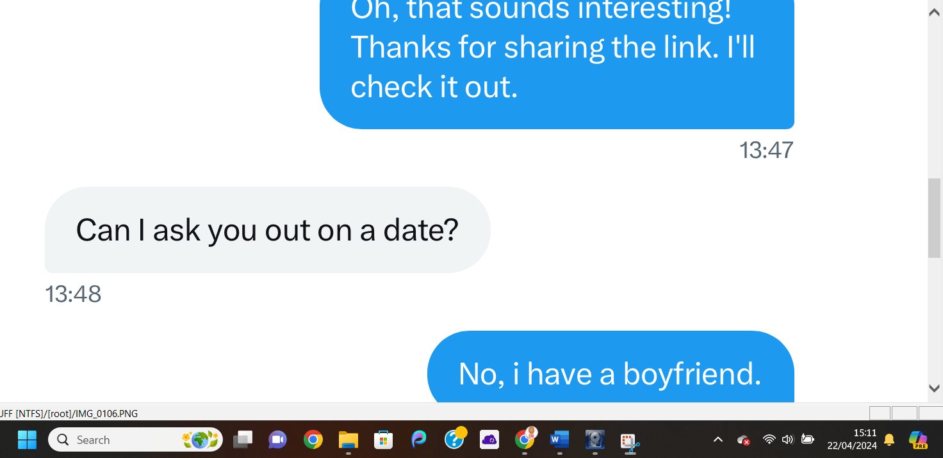
The screenshots shown above display a conversation that is held between an unknown twitter user (Seer Musta) and our potential victim. As we can see in the conversation the unknown twitter user seems to know a lot of details about the user’s life without them disclosing any of this information. This could allude to Seer cyber stalking the user’s social media accounts. Seer Musta also attempts to gain the users email details and phone number multiple times throughout this conversation. This could be an attempted phishing scam to gain access to the users accounts to gain access to their personal or financial information.

Text conversation 3:
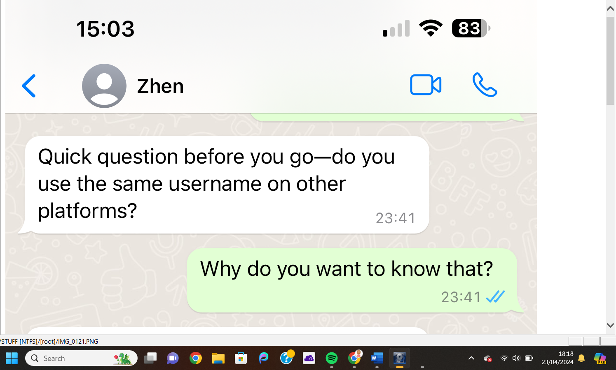
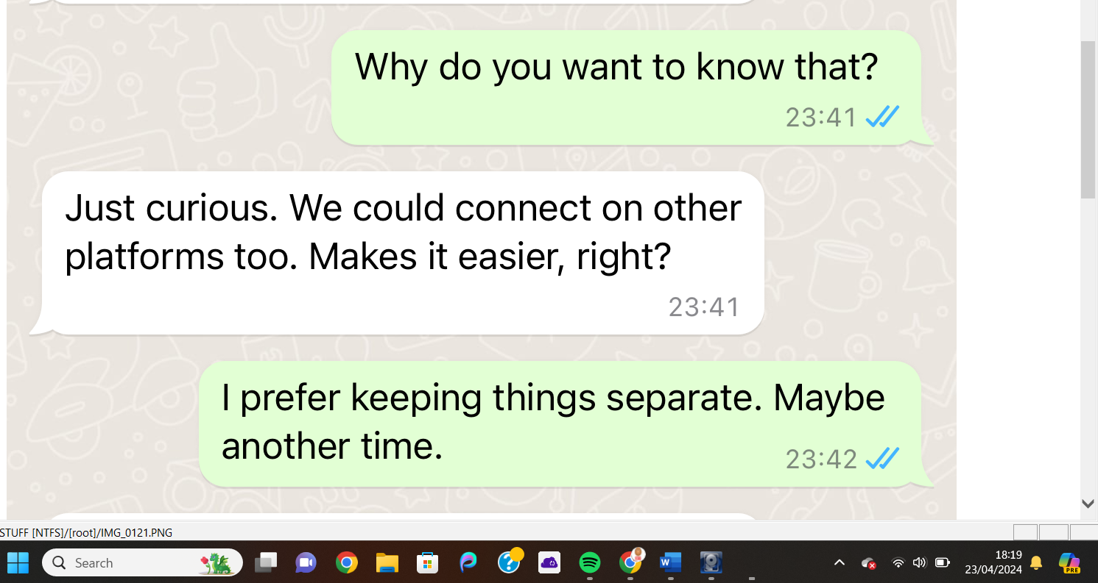
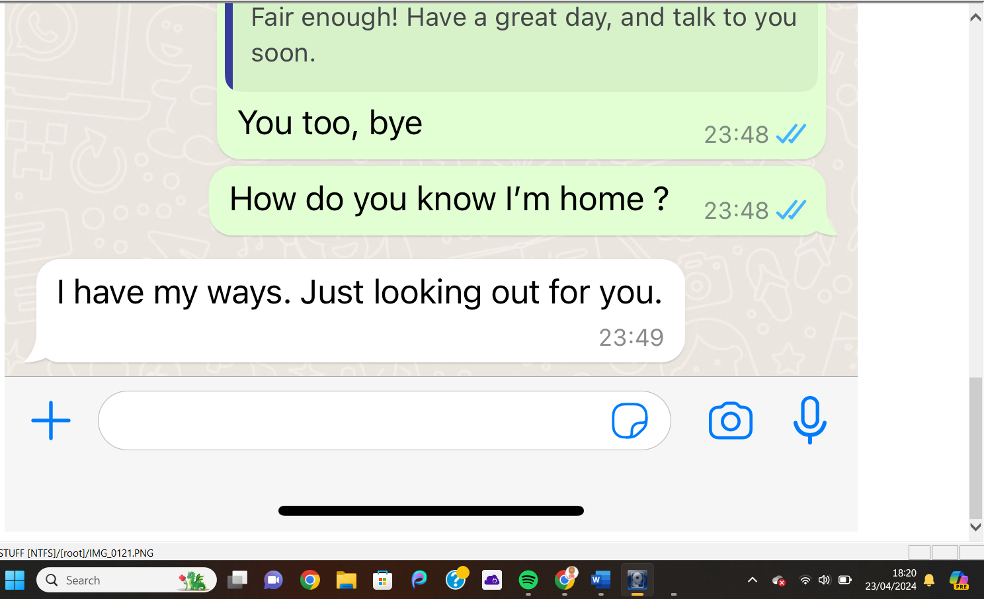
The conversation shown above takes place on WhatsApp between our potential victim and an unknown online user called Zhen. The conversation is innocent enough up until Zhen asks our user if she uses the same username details on every other platform. This could be an innocent question or could be Zhen’s attempt to gain more information on the user. This is later backed up by the fact that Zhen knows the user arrives home without the user divulging that knowledge. This points to Zhen being a cybercriminal of some sort potentially stalking our user or gaining access to their accounts to uncover their location.

Email Retrieved:
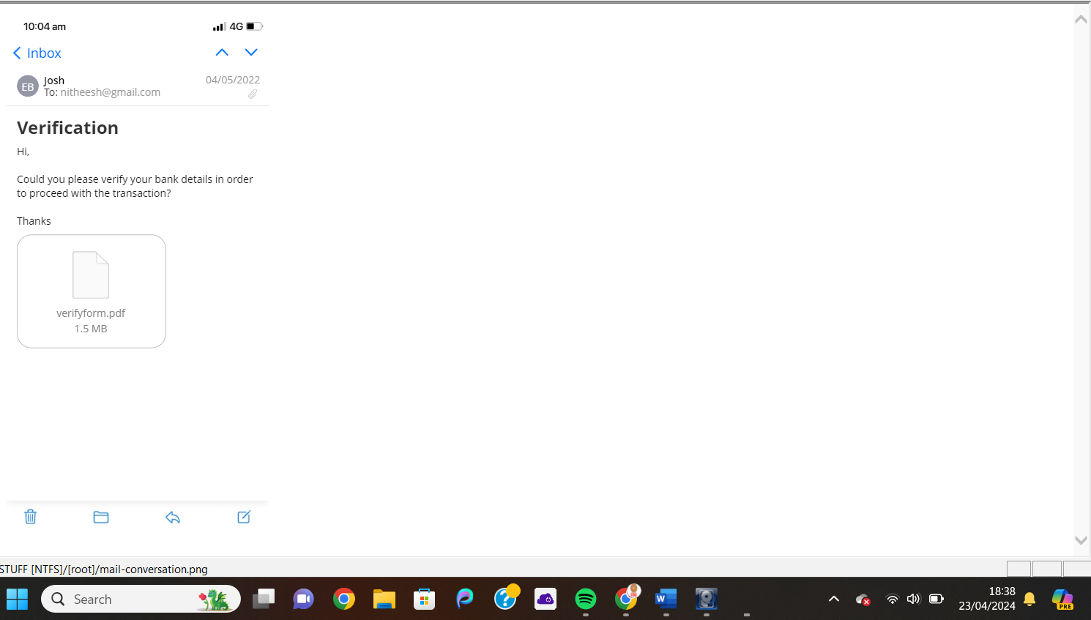
It is not standard practice for an online vendor to ask for bank detail verification after a purchase. This leads me to believe this email I recovered is an attempted phishing scam.

Data Artifacts:
After using Autopsy to analyze the files I retrieved I was able to look at the data artifacts recovered from these files.
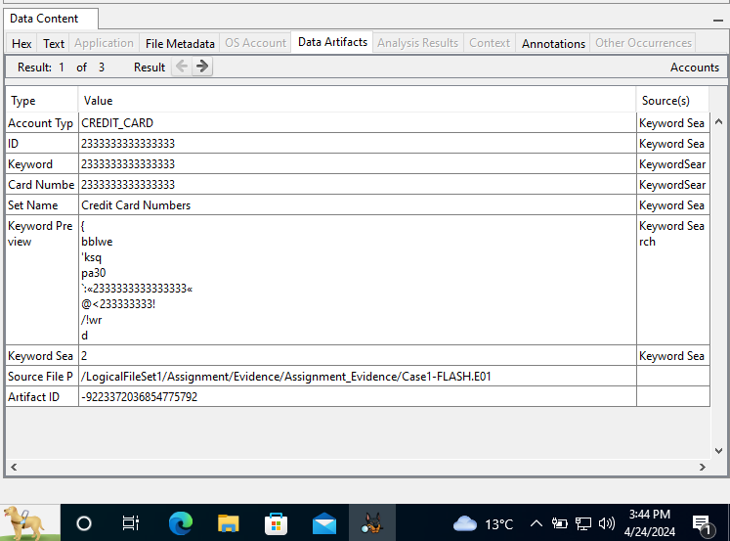
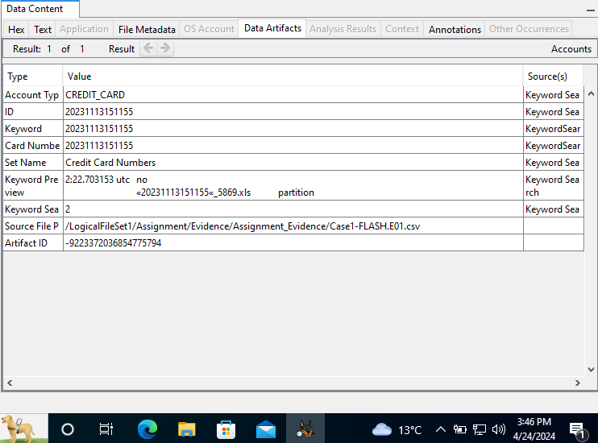
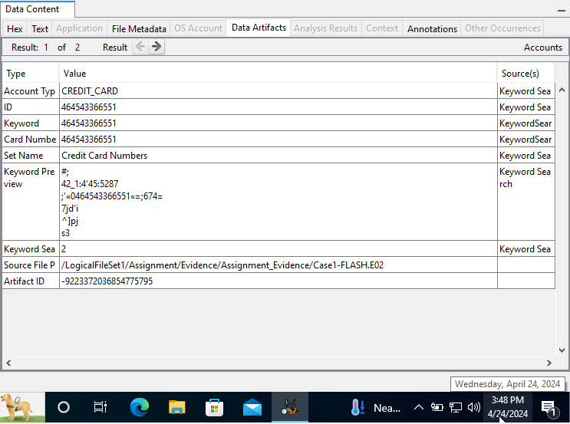
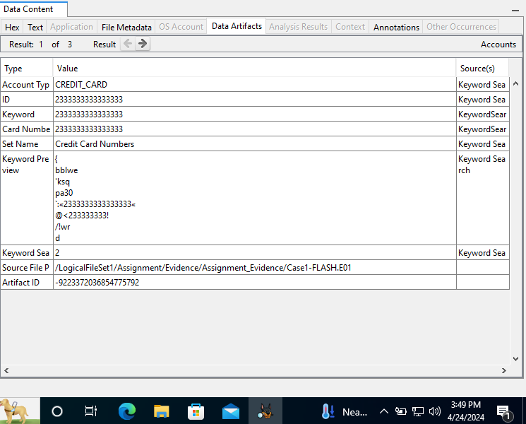
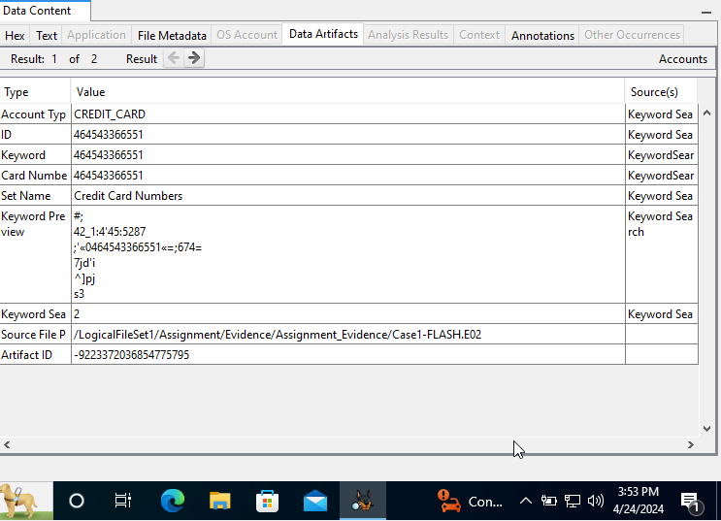
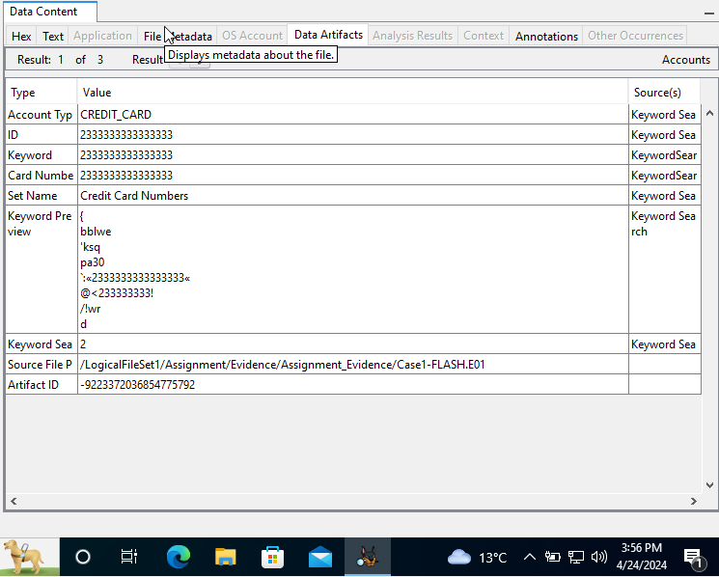
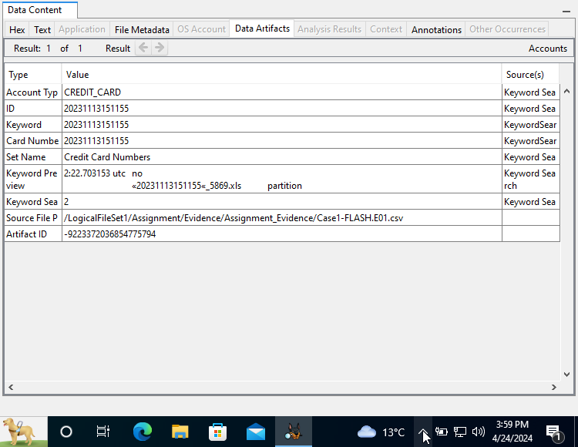
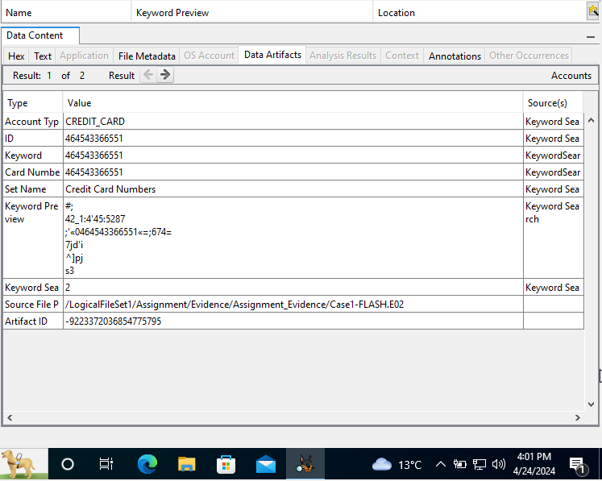
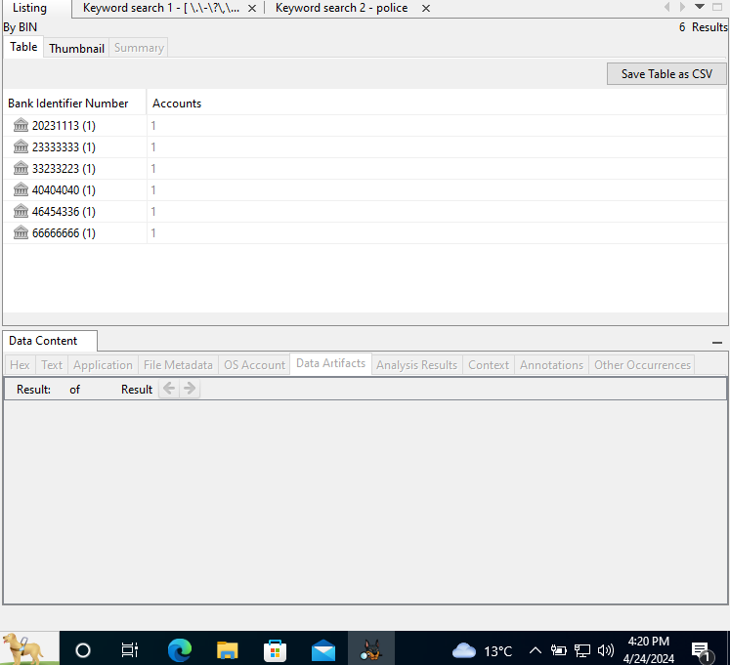
The images above show what data artifacts were recovered from the evidence files by Autopsy. The data artifacts shown above all contain different payment card/bank card details. This evidence combined with the suspicious email shown previously points towards there being a more serious crime than cyber bullying taking place. I believe this evidence displays that there is a phishing scam operation taking place.

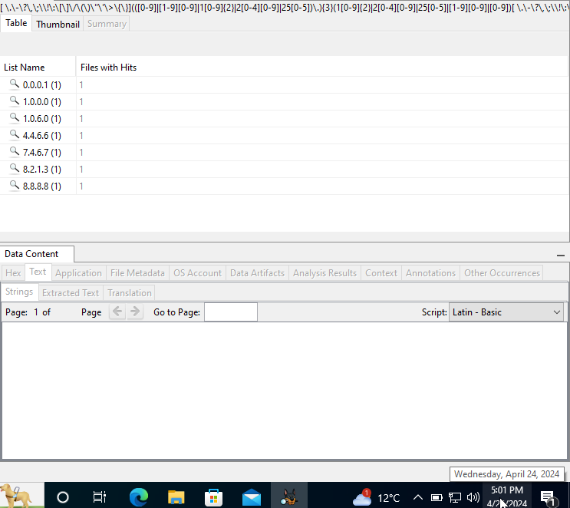
Using Autopsy to analyze the files retrieved I was also able to find numerous Ip addresses. This could explain how the person in the WhatsApp text conversations was able to know that the user arrived home without them stating as such. This could be because the unknown WhatsApp user was tracking the location of the user using their Ip Address.

Real-Time Demonstration
Demonstration of FTK Imager:
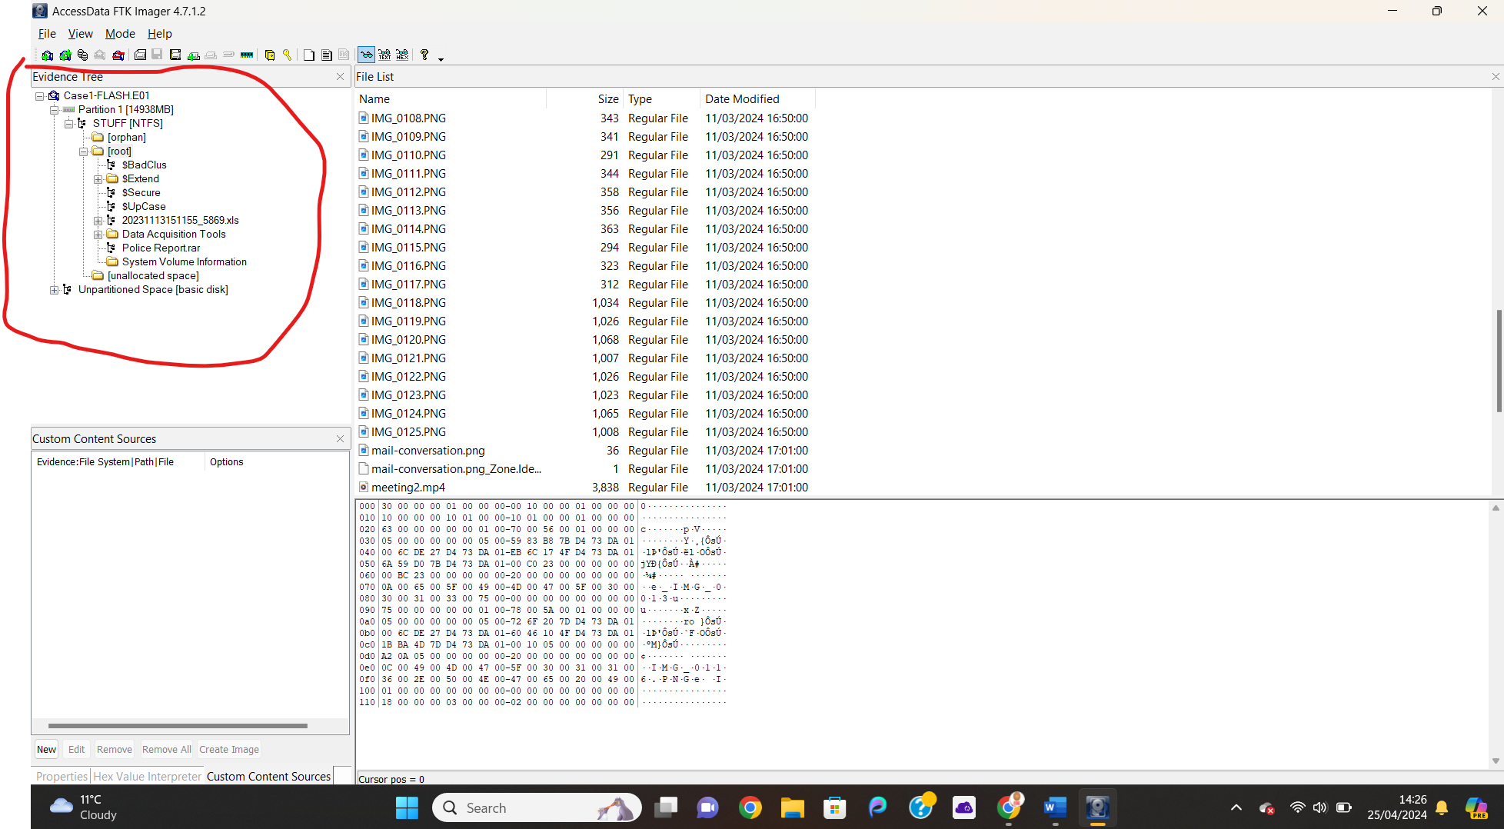
Open FTK imager and load the first file found in evidence as an image file. Navigate the evidence tree on the left hand of the screen, open the root folder which contains numerous images of text and email exchanges which some of which were used in
Demonstration of Autopsy:
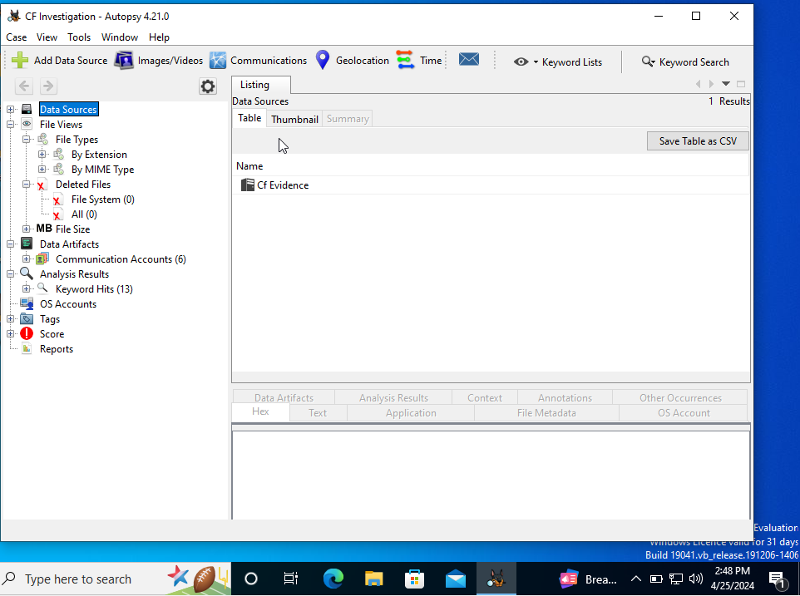
Load the folder containing the evidence files onto Autopsy then using the evidence tree on the left-hand side of page. The evidence tree contains different segments that focus on different key important things to look for in an investigation. Autopsy also allows for a keyword search to help find specific data such as card details and IP addresses. Use autopsy data artifacts tool search through files data artifacts.

Contingency Plans
Risk 1: Investigation being combated in court due to procedure not being followed getting findings thrown out of court.
Solution: During investigation ensure all procedures are followed with only signed in investigators allowed into the crime scene and new evidence. Ensure that anyone who handles evidence is logged into chain custody.

Risk 2: Personal information leaks due to investigation.
Solution: During the investigation ensure that all pieces of evidence that contain personally identifying information are only able to be viewed by people on the investigation team and court officials.

Risk 3: Technical challenges such as tools being unable to uncover evidence from certain files.
Solution: If the investigation hits a brick wall before the deadline is complete and the two selected tools can not uncover evidence from certain files, research must be conducted into finding a more reliable forensics tool that can perform the tasks needed. If there is not enough time to do so the investigators must work with the evidence already collected.

Conclusion
To conclude this investigation, it is my belief that there was a more serious crime than cyber bullying occurring in this case. With the bank details recovered from the evidence files combined with the suspicious email recovered leads me to believe that there was a phishing scam operation active. I believe the suspects in this investigation were running an operation where they would attempt to collect a user’s sensitive information such as, banking details, email addresses, phone numbers and Ip address after reaching out to victims via messing services such as WhatsApp and Facebook Messenger. I believe that the harassing messages shown earlier were also a part of this operation as frequently in these conversations the users attempt many times to get users information such as phone numbers, usernames, and email addresses. Finally, I would like to conclude that the owners of the accounts with the usernames “Seer Musta”, “Zhen” and “Justine Alias” are members of a group that perform phishing scams on unsuspecting online users.

5.0 References

[1] | F. H. P. A. D. Liu Qian, "Computer Forensics," Uppsala University, Uppsala, Sweden, 2007.
[2] | A. Årnes, Digital Forensics, N/A: John Wiley & Sons, 2017.
[3] | Coursera Staff, "What Is Computer Forensics? Types, Techniques, and Careers," Coursera, 29 November 2023. [Online]. Available: https://www.coursera.org/in/articles/computer-forensics. [Accessed 28 March 2024].
[4] | Interpol, "Digital forensics," Interpol, N/A N/A N/A. [Online]. Available: https://www.interpol.int/en/How-we-work/Innovation/Digital-forensics#:~:text=Digital%20forensics%20is%20a%20branch,reporting%20on%20data%20stored%20electronically.. [Accessed 28 March 2024].
[5] | R. Awati, "computer forensics (cyber forensics)," TechTarget, N/A Febuary 2024. [Online]. Available: https://www.techtarget.com/searchsecurity/definition/computer-forensics#:~:text=Digital%20evidence%20is%20useful%20in,run%20accidents%2C%20and%20even%20murder.. [Accessed 28 March 2024].
[6] | J. Semakula, ""Digital Forensics Demystified: Tools, Significance, and Real-world Applications," LinkedInn, 17 October 2023. [Online]. Available: https://www.linkedin.com/pulse/digital-forensics-demystified-tools-significance-john-semakula-ibhvf#:~:text=Criminal%20Investigations%3A,crime%20or%20to%20identify%20suspects.. [Accessed 28 March 2024].
[7] | ERM PROTECT , "5 Notable Digital and Crypto Forensics," ERM PROTECT , N/A N/A N/A. [Online]. Available: https://ermprotect.com/blog/5-notable-digital-and-crypto-forensics-investigations-of-2022/#:~:text=A%20hacker%20steals%20cryptocurrency.,the%20prosecution%20of%20the%20perpetrators.. [Accessed 16 April 2024].
[8] | McNee Soloutions , "4 Cases Solved With Digital Evidence," McNee Soloutions , 17 January 2020. [Online]. Available: https://precisedigital.com/4-cases-solved-with-digital-evidence/. [Accessed 16 April 2024].
[9] | K. Nagaraj, "FTK Imager: A Comprehensive Guide to Forensic Imaging and Analysis | 2023," Medium, 22 July 2023. [Online]. Available: https://cyberw1ng.medium.com/ftk-imager-a-comprehensive-guide-to-forensic-imaging-and-analysis-2023-4eca04272614#:~:text=FTK%20Imager%20allows%20forensic%20investigators,of%20the%20original%20storage%20media.. [Accessed 22 April 2024].
[10] | CCS Learning Academy, "What is Autopsy in Cyber Security? Features, Benefits & Use Cases," CCS Learning Academy, 6 December 2023. [Online]. Available: https://www.ccslearningacademy.com/what-is-autopsy-in-cybersecurity/#:~:text=Answer%3A%20In%20cyber%20security%2C%20Autopsy,history%2C%20and%20file%20access%20logs.. [Accessed 20 April 2024].
[11] | ADF, "The Future of Digital Forensic Software Advancements and Innovations," ADF, 23 September 2023. [Online]. Available: https://www.adfsolutions.com/adf-blog/the-future-of-digital-forensic-software-advancements-and-innovations-to-look-out-for#:~:text=Artificial%20Intelligence%20and%20Machine%20Learning,with%20greater%20accuracy%20and%20speed.. [Accessed 1 April 2024].
[12] | icssindia.in, "Future Trends in Cyber Security and Digital Forensics," icssindia.in, 13 Febuary 2024. [Online]. Available: https://icssindia.in/blog/future-trends-in-cyber-security-and-digital-forensics/#:~:text=The%20future%20of%20digital%20forensics,decrypting%20data%20and%20extracting%20evidence.. [Accessed 1 April 2024].
[13] | R. Olatona, "VOLATILITY IS AN ESSENTIAL DFIR TOOL—HERE’S WHY," Booz Allen Hamilton Inc, N/A N/A N/. [Online]. Available: https://www.boozallen.com/insights/cyber/tech/volatility-is-an-essential-dfir-tool-here-s-why.html#:~:text=Volatility%20is%20a%20command%2Dline,contains%20critical%20clues%20for%20investigators.. [Accessed 20 April 2024].
[14] | Elsevier B.V., "Concealed Data," Elsevier B.V., N/A N/A N/A. [Online]. Available: https://www.sciencedirect.com/topics/computer-science/concealed-data#:~:text=StegExpose%20is%20a%20steganalysis%20tool,6.8).. [Accessed 20 April 2024].

