Reflective Thinking Report

Name: Corina - Elena Gherasimescu
Student number: 1905894
Module: Community Engagement Resit
Lecturer name: Tanja Nathan

Introduction

Judging by the title alone, one can easily assume a personal touch is to be expected in writing such a piece. My understanding of the requirement for this essay is a parallel between the expectations one might have before taking on an activity of great proportions and the conclusions one would reach after a chapter of said activity comes to pass. To this end I will refer to a specific part of the whole university in the UK experience, namely, a first group presentation, a team effort, or lack thereof.
Using the Gibbs reflective cycle method I will try and narrate the events that, as far as I can tell, led to the big gap between expectations and reality in this matter; I am very much hoping the Gibbs structure will also help me get a better understanding of what happened and how to move forward. Therefore, I will do my best to follow the proposed stages:
- Description of the experience
- Feelings and thoughts about the experience
- Evaluation of the experience, both good and bad
- Analysis to make sense of the situation
- Conclusion about what you learned and what you could have done differently
- Action plan for how you would deal with similar situations in the future, or general changes you might find appropriate.

Description

16/12/2019, the one date I cannot forget or change at this point. My first group presentation experience. Normally we would all be nervous and excited at the same time. However, it was soon that all the excitement turned to fear, insecurity and sudden awareness of own lack of preparation. Not to name any names or point a potential reader towards a specific project or character, the Academic skills presentation on the first University term is the focus of my essay.
Our group had already been divided into six teams and the order in which we would present our work had already been established, to avoid any surprises or unnecessary nervousness on the day. It had only been less than an hour but it felt like eons had been at our disposal and we somehow wasted it.
Clearly, each team would go to the front of the classroom and present their previously submitted project and take turns talking about their contribution to it, all adding up to 10 minutes per team on average, in front of new teachers and the whole group.
Sadly our group was not ready and would not have been ready that day anyway, as we were the ones who thought we could hold an oral presentation without written and visual support, or proof of preparation, whatsoever.

Feelings

Personally I do not like surprises, never have and never will; and as simple and straight forward as it may sound, drama turned up quite early on the day of the presentation. The prevailing feeling was that of confusion rather than nervousness, not just for myself and my team, but for the entire group. The new assistant came into the classroom early to make sure we were ready and up for the task, but ended up providing brand new information and requirements, quite relevant bits of it, literally minutes before the session stood to begin.
All in all, it turned out to be the exact opposite of what we knew and expected, so I believe everyone felt blind-sided by the whole thing; I personally felt let down and cheated of a wonderful opportunity.
Needless to say we were all apprehensive and extremely nervous. The second team needed some extra time to prepare, so the assessor called my team, (third in line) to present our project. This gave us no time to even come up with a plan and formulate an explanation as to why we were the only team without a PowerPoint presentation for the day; in fact it did not even allow us any time to come to terms with the updates and the way this will influence and affect us. Although we were clearly not ready, to begin with, the extra ten minutes we were robbed of may have made a difference in our overall ability to collect ourselves and control our behaviour in front of colleagues and new teachers, which we should have tried our best to impress in a different manner.
Feeling blind-sided yet again, the presentation proved to be a fiasco all around, there were awkward pauses, figurative hiccups and nervous attempts to read off personal notes while trying not to fall apart. Given the pressure we all felt, we had trouble following simple steps required by such a presentation and got stuck briefly before answering a follow-up question. Although said question was not aimed at myself, my help suddenly became necessary; I obliged gladly thinking it would gain me some extra confidence points that I might even be able to share with the group and maybe try and save face a bit.
It was only later that I learned that would not be the case and my mark will in fact show less than satisfactory feedback; clearly that has taught me to refrain from always trying to help, voluntarily or otherwise.

Evaluation

Thinking on how it all went, I would have to say that evaluating this specific presentation, strictly for my team, one would be forced to use the term “fiasco” repeatedly.
My reaction, as opposed to others was that I have to salvage whatever I can and be the only one speaking freely; I briefly explained our lack of preparation and tried to shine a positive light on our project without dwelling on the fact that some of us couldn’t be asked to participate in due time.
Unfortunately, in my opinion the situation was not diffused afterwards either, as the assistant came back to provide some feedback and stated that one of the teams may face a big “Fail” in our group, then somewhat confirmed without using words that it would be my team; turns out body language sufficed.
In hindsight, I’m afraid the overall experience has put off the most of us from working in a team again or maybe just myself. It showed us that it truly is a hard thing to do and assuming the role of team leader in order to save the team or to make sure one maximises the potential of the group might be the hardest, almost impossible task ever, requiring a very strong personality.
Taking into consideration the first experience, as far as presentations go, the Community Engagement session set a different tone altogether. In my opinion it went great, no nerves, no reason to feel intimidated or put on the spot, but it probably seems this way because it was an individual presentation, role play, that removed the weight of other people’s fate from one’s shoulders.
Unfortunately, the Academic Skills team effort proved to come with unpleasant surprises and the opposite of what I thought it would reflect, it felt horrible thinking we would fail, even though we all worked on our bit of the project and showed commitment to the task to some extent.

Analysis

Sadly we don’t get a second chance to make an impression on a fresh audience and make up for the mistakes of the past. The worst part about it is that the point of the exercise is to prepare us as future graduates for real presentations meant to increase or help business take off and we failed dramatically. As mentioned in the Sage journals “even though students learn oral communication skills in an academic setting, they lack the confidence to apply them in more stressful, high-stakes environments” and we had one chance to prove this theory wrong but managed quite the opposite for the simple fact that it involved a team effort and we might not be ready for that just yet.
The lesson I’ve learnt is that one should always expect the unexpected, as much as it may sound like a cliché and be as prepared as possible for anything, especially if one has taken on such studies, hoping a managerial career would follow.
This means that we will individually have to deal with our own shortcomings while conducting a self-criticism session over our team failure and refusal to communicate freely. Also, at the risk of repeating myself, I do not cope well with surprises of any kind; this is clearly one of my battles that I must carry and try to overcome.
Owning up to this failed attempt at greatness, in my perspective is a challenge as we are all human and it is difficult to admit defeat or being in the wrong. However, given the overall performance throughout the term, it seems like a steep price to pay for mistakes that can be easily predicted and avoided.

Conclusion

Being unable to completely blame the whole thing on nerves, circumstances and all other contributing factors, the experience is a lesson in itself. While team work is compulsory throughout academic years and well after that, as per previous instructions and logical expectations, our future success depends mostly on our own actions and abilities to learn from past mistakes.
I believe we were all to blame, all responsible for what we managed to do with the options we had at the moment of the presentation. I’m not saying it was a matter of choice but a more of a question of response time required to save a desperate situation and rise above the prejudice of prone to fail.

Action Plan

On a personal level, considering the factors contributing to this fiasco and the fact that at the beginning of the term I expressed my desire to become more organized, I will admit to not having it all in a row, to still trying and working on the organizational skills I’m missing and to growing, fortunately with every experience of such. To this end I’m attaching the peer feedback in the appendix at the end. Lesson to be learnt here: I can take charge, I am allowed to feel disappointed and I have to allow all the other parties involved to have their own feelings about the matter.
I haven’t fashioned a plan in writing yet but I know I will not play it by ear and hope for the best.I personally experienced a great fall and it is more than just unpleasant. I will take the resit if necessary, I will own up to my mistakes and try my best to fix it all, but I will, at the same time, never take a member of my team saying “if we fail, we fail” as if the individual failure falls into the category of team responsibility.
My action plan consists of personal growth as far as saying “no” every now and again, taking matters into my own hands and assuming leading roles as often as possible. I’m proud to say it has already started and will keep going, hopefully to the extent where being assertive and productive at the same time will become the norm.
I will also assume more engaging roles in future group work situations as part of my action plan; the above story may have temporarily put me off working in a group or at least expect my group to work, but in order for things to change, given a second chance, I would have to take on a leading role and grow thicker skin gradually.
In conclusion, thinking back to the first few days of University, when we were all getting to know each other and everyone was willing to communicate, I would sadly say we took at least one step back. It might seem like it’s a negative narration of the above mentioned events, but in honesty, the lesson is there, awaiting its students to understand and learn it, to put it into practice and turn it into a skill, a strength to play on in future and develop it into a resource.
No one said it would be easy and I’m sure no one expected it to be. The first term proved to be a challenge, just when some of us were getting a bit more comfortable being there and being a part of something big and important, meaningful and fruitful. The potential exists in all of us, we all have it, and we just need the right environment to have our eyes and minds opened to what we can be and what we can do.
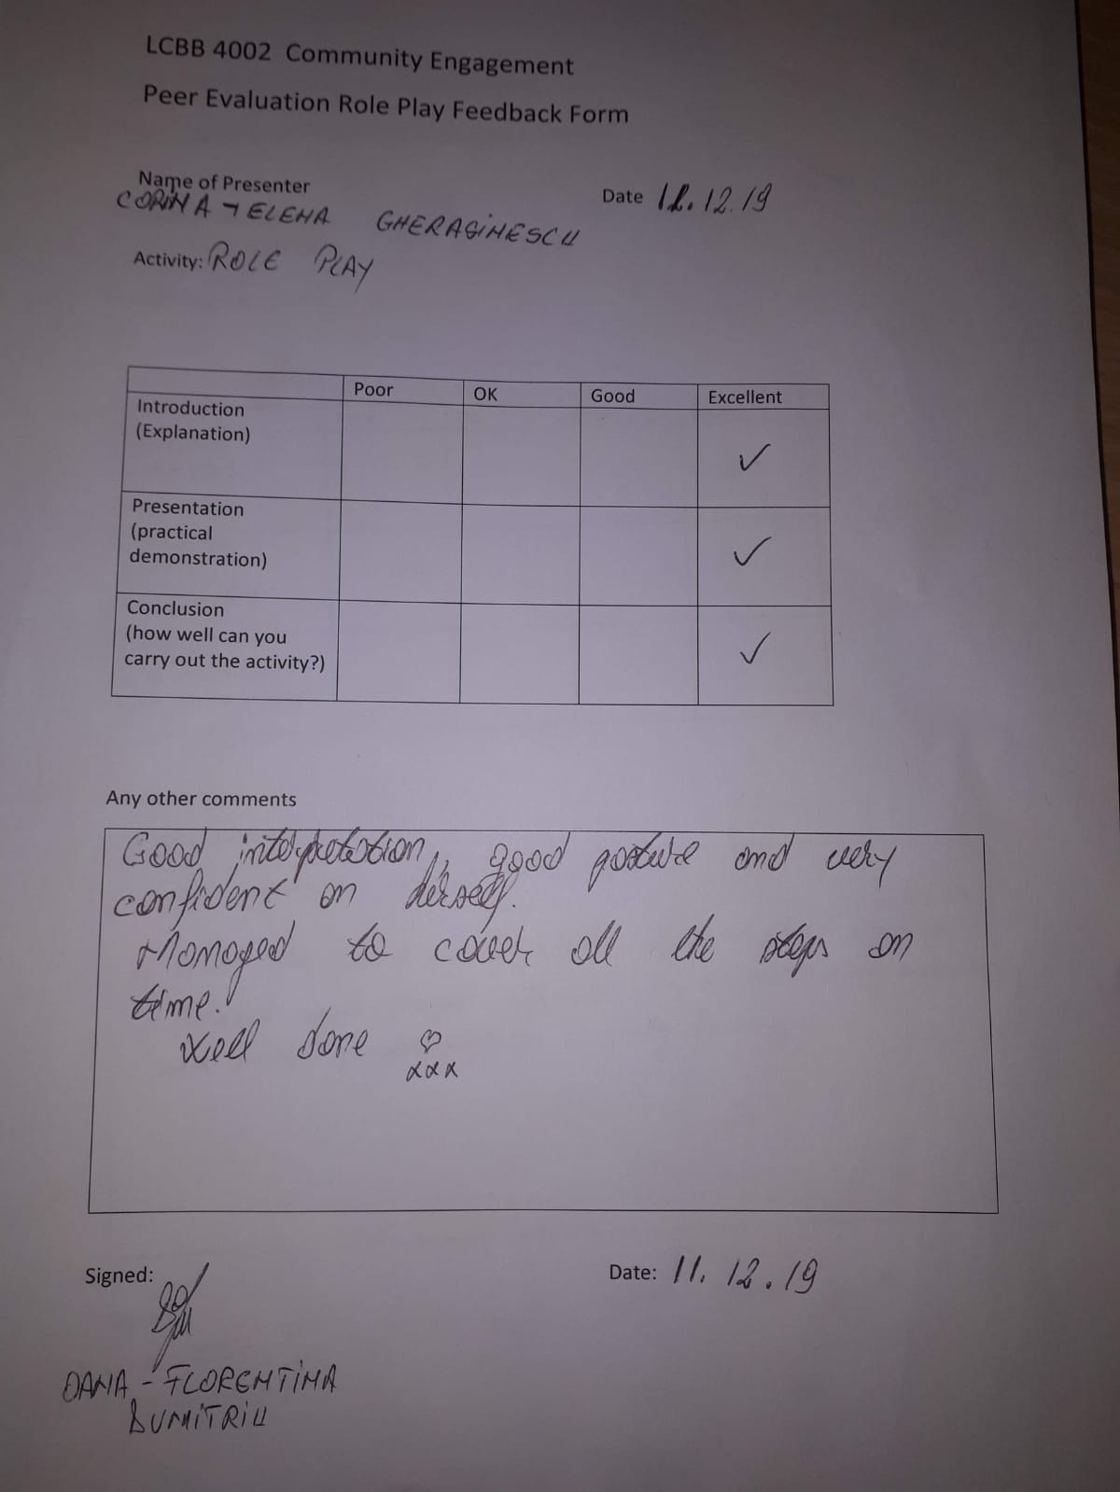

References :
https://www.ed.ac.uk/reflection/reflectors-toolkit/reflecting-on-experience/gibbs-reflective-cycle, visited on 29/04/2020
https://journals-sagepub-com.ezproxy.uwtsd.ac.uk/doi/full/10.1177/2329490619853242, visited on 06/01/2020 Cavanagh, page 440-457,

