Appendices

Appendix 1
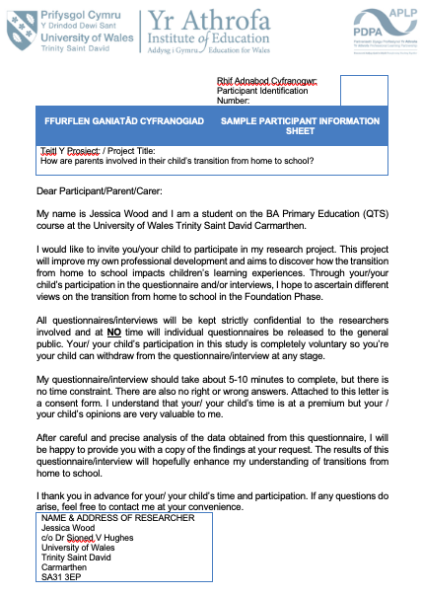

Appendix 2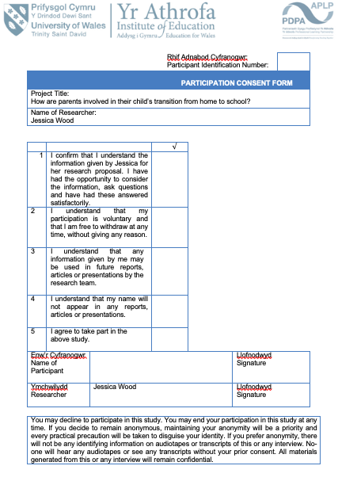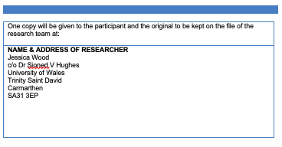
APPLICATION FOR ETHICAL APPROVAL
Appendix 3

In order for research to result in benefit and minimise risk of harm, it must be conducted ethically. A researcher may not be covered by the University’s insurance if ethical approval has not been obtained prior to commencement.

The University follows the OECD Frascati manual definition of research activity: “creative work undertaken on a systematic basis in order to increase the stock of knowledge, including knowledge of man, culture and society, and the use of this stock of knowledge to devise new applications”. As such this covers activities undertaken by members of staff, postgraduate research students, and both taught postgraduate and undergraduate students working on dissertations/projects.

The individual undertaking the research activity is known as the “principal researcher”.

Ethical approval is not required for routine audits, performance reviews, quality assurance studies, testing within normal educational requirements, and literary or artistic criticism.

Please read the notes for guidance before completing ALL sections of the form.

This form must be completed and approved prior to undertaking any research activity. Please see Checklist for details of process for different categories of application.

Delete the Guidance Notes at the end of the form BEFORE submitting your application

SECTION A: About You (Principal Researcher)
Full Name: |  | Jessica Kate Wood
Tick all boxes which apply: |  | Member of staff: | ☐ | Honorary research fellow: | ☐
Undergraduate Student | ☒ | Taught Postgraduate Student | ☐ | Postgraduate Research Student | ☐

Faculty/School/Centre: | ITE: Yr Athrofa, University of Wales Trinity St David
Campus: | Carmarthen
E-mail address: | 1702128@student.uwtsd.ac.uk
Contact Telephone Number: | 07896643729
For students:
Student Number: | 1702128
Programme of Study: | BA Primary Education with QTS.
Director of Studies/Supervisor: | Dr Sioned V Hughes

SECTION B: Approval for Research Activity
Has the research activity received approval in principle?  (please check the Guidance Notes as to the appropriate approval process for different levels of research by different categories of individual) |  | YES | ☒ | NO | ☐
 |  |  |  | Date
If Yes, please indicate source of approval (and date where known): Approval in principle must be obtained from the relevant source prior to seeking ethical approval | Research Degrees Committee |  | ☐
 | Faculty Research Committee |  | ☐
 | Other (write in) Module Lead |  | ☒ | 06.02.20

SECTION C: Internal and External Ethical Guidance Materials
Please list the core ethical guidance documents that have been referred to during the completion of this form (including any discipline-specific codes of research ethics, and also any specific ethical guidance relating to the proposed methodology). Please tick to confirm that your research proposal adheres to these codes and guidelines.
UWTSD Research Ethics & Integrity Code of Practice | ☒
UWTSD Research Data Management Policy | ☒
BERA (British Educational Research Association) guidelines – Ethical Guidelines for Educational Research, (2018). | ☒
The research is within the bounds of the normal classroom and in accordance with the ATHROFA guidelines for parental consent as per ATHROFA letter. | ☒
Education Workforce Council (EWC) Research and Ethics Guidelines (2019) | ☒

SECTION D: External Collaborative Research Activity
Does the research activity involve collaborators outside of the University? |  | YES | ☐ | NO | ☒
If Yes, please provide the name of the external organisation and name and contact details for the main contact person and confirmation this person has consented to their personal data being shared.as part of this collaboration.
Institution
Contact person name
Contact person e-mail address

Has this individual consented to sharing their details on this form? |  | YES | ☐ | NO |  |  | ☒
Are you in receipt of a KESS scholarship? |  | YES | ☐ | NO |  |  | ☒
Is your research externally funded |  | YES | ☐ | NO |  |  | ☒
Are you specifically employed to undertake this research in either a paid or voluntary capacity? | Voluntary | YES | ☐ | NO |  | ☒
 | Employed | YES | ☐ | NO |  | ☒
Is the research being undertaken within an existing UWTSD Athrofa Professional Learning Partnership (APLP) | If YES then the permission question below does not need to be answered. | YES | ☒ | NO |  |  | ☐
Permission to undertake the research has been provided by the partner organisation | (If YES attach copy)  If NO the application cannot continue | YES | ☐ | NO |  |  | ☐

Where research activity is carried out in collaboration with an external organisation
Does this organisation have its own ethics approval system? | YES | ☐ | NO | ☒
If Yes, please attach a copy of any final approval (or interim approval) from the organisation

SECTION E: Details of Research Activity
Indicative title: | How are parents involved in their child’s transition from home to school?
Proposed start date: | 10/02/20 | Proposed end date: | 01/07/20
Introduction to the Research (maximum 300 words)
Ensure that you write for a Non-Specialist Audience when outlining your response to the three points below:
- Purpose of Research Activity
- Proposed Research Question
- Aims of Research Activity
- Objectives of Research Activity
Demonstrate, briefly, how Existing Research has informed the proposed activity and explain
- What the research activity will add to the body of knowledge
- How it addresses an area of importance.
Purpose of Research Activity
- To explore how parents are involved/ engaged with their child’s transition from home to school.
- To further develop professional knowledge and understanding and future practice.

(this box should expand as you type)
Research Question
How are parents involved in their child’s transition from home to school?

(this box should expand as you type)
Aims of Research Activity

- The research aims to capture the views of our current generation of practitioners and students in order to contribute to an informed dissertation regarding the true value of parental engagement in the transition to school. Existing research such as that by Baker et al. (2018) suggests that parental engagement helps children with adjustment, attainment and behaviour in school.
- The primary research that I wish to undertake will provide an insight into how it complements and effects children’s learning within the classroom and improve professional practice.

(this box should expand as you type)
Objectives of Research Activity
- To explore how transitions from home to school effect children.
- To interview parents and teachers to capture their views about transitions to school.
- To interview 3-4-year olds to capture their views about transitioning to school.
- To observe how children, deal with everyday transition from home to school.
- To critically reflect on findings and consider how I can use this to improve and transform my professional practice.
(this box should expand as you type)
Proposed methods (maximum 600 words)
Provide a brief summary of all the methods that may be used in the research activity, making it clear what specific techniques may be used. If methods other than those listed in this section are deemed appropriate later, additional ethical approval for those methods will be needed.
Interviews – a group of children from the Nursery class will be involved in a semi-structured interview where they will be invited to respond to key questions. For example, how did you feel about starting school for the first time? Did you meet your Nursery teacher before starting school? Do you like coming to school and why? The children will be in an informal setting and I will make notes of their responses. The children will not be forced into participating and no direct individual questioning will take place if a child does not wish to respond. Exit: All children will be asked if they wish to take part. The children will use their traffic light cards and if at any point they wish to leave the interview or withdraw then they may do so. I will check on the children’s feelings regularly. No names will be used in the writing.
I will interview different teachers in Foundation Phase (FP) and the headteacher to see how they involve parents in transitions and how they ensure the children feel safe and comfortable starting school.
I will also interview parents in a semi-structured interview where they will be invited to respond to key questions. For examples, how much information did you receive from the school about your child starting Nursery? Did you feel prepared for your child starting school? How did the school support you in preparing your child to start school? The parents will be in an informal setting and I will make notes of their responses. The parents will not be forced into participating and no direct individual questioning will take place if a parent does not wish to respond. Exit: All parents will be asked if they wish to take part. If at any point they wish to leave the interview or withdraw then they may do so. No names will be used in the writing.

Observations/ Field notes – I will observe different children arriving at school in the morning and this will enable me to observe how the children feel coming into school. I will make a note of the children’s engagement during this period and record the information in my observational book/diary. Both the children and the teacher will have access to the diary. Exit: following the observation I will share the notes with the class teacher and each child. The child can place a tick or cross on a post-it note to let me know if the data can be used.

Video or Audio Taping – I will record sessions within the class to observe and record the children’s level of engagement. I will also record different groups of children answering questions in the informal interview. Photographic evidence may also be used but I will ensure that none of the children’s faces are in the pictures and that a consent form is singed before this is done. Recording of good practice and interviews with the class teachers will also be done as evidence to reflect and look back on. I will ask permission from all participants fore recording before doing so.

Questionnaire – Depending on the children’s and parents’ responses throughout the research period I may create and administer a questionnaire if I believe this will assist me to gather quality data. Throughout the creation of the questionnaire, I will adhere to and follow the training provided by the university during my second year of study when the design and distribution of a questionnaire was necessary for a specific module. The questionnaire may focus on qualitative or quantitative data, or both, depending on focus. Furthermore, the questionnaire may be administered to learners, staff or both. If a questionnaire is necessary, then participants will not be required to list their name or personal information. However, they may be asked to share their status in the school (i.e. pupil or teacher) if the questionnaire is completed by bother learners and staff and a participant’s role is significant to the analysis.
A cover letter will accompany the questionnaire which will explain to the participant the reason for and nature of the research questionnaire. The questionnaire will be disturbed via physical means only. Once participants have completed their questionnaire, their response will be gathered and placed within the response pool for analysis. For the questions posed within the questionnaire, there will be numerous ways for the individual to respond. This includes provided answers to questions to gather quantitative and qualitative data with the option, if necessary, for the individual to further comment their opinion or experience. Exit: before the participant submits their questionnaire, they have the right to retain their response. However, once I receive the participant’s response and it is added to the pool there will be no fair means of identifying their response in order to return it to them. This will be explained in the cover letter.

Learning walk – To support my research I may conduct a learning walk through the school to observe displays and discuss certain aspects of provision with members of staff or pupils. These learning walks may be self-directed or facilitated by a learner, group of learners or member of staff. Prior to conducting the learning walk Exit: I will obtain consent from a member of staff. Prior to evidencing the walk (by means of written, photographic or audio methods) I will ask the participant who hosted the walk for their consent to use the information they provide in my research.

Examples of pupils’ work – Where I feel examples of pupils’ work would support my research, I will may request samples. Exit: Prior to gathering samples of work, I will ensure that I have the class teacher’s consent and the consent of the pupil to which the work belongs. Upon gathering samples, I will take responsibility of the work and ensure that confidentially and security is upheld.

(this box should expand as you type)

Location of research activity
Identify all locations where research activity will take place.
The proposed research activity will be conducted in aPrimary School within the Athrofa.
(this box should expand as you type)
Research activity outside of the UK
If research activity will take place overseas, you are responsible for ensuring that local ethical considerations are complied with and that the relevant permissions are sought. Specify any local guidelines (e.g. from local professional associations/learned societies/universities) that exist and whether these involve any ethical stipulations beyond those usual in the UK (provide details of any licenses or permissions required). Also specify whether there are any specific ethical issues raised by the local context in which the research activity is taking place, for example, particular cultural and/or legal sensitivities or vulnerabilities of participants.
N/A

(this box should expand as you type)
Use of documentation not in the public domain: Are any documents NOT publicly available? | NO | ☒
 | YES | ☐
If Yes, please provide details here of how you will gain access to specific documentation that is not in the public domain and that this is in accordance with prevailing data protection law of the country in question and England and Wales.

(this box should expand as you type)

SECTION F: Scope of Research Activity
Will the research activity include: | YES | NO
Use of a questionnaire or similar research instrument? | ☒ | ☐
Use of interviews? | ☒ | ☐
Use of diaries? | ☒ | ☐
Participant observation with their knowledge? | ☒ | ☐
Participant observation without their knowledge? | ☐ | ☒
Use of video or audio recording? (interviews) | ☒ | ☐
Access to personal or confidential information without the participants’ specific consent? | ☐ | ☒
Administration of any questions, test stimuli, presentation that may be experienced as physically, mentally or emotionally harmful / offensive? | ☐ | ☒
Performance of any acts which may cause embarrassment or affect self-esteem? | ☐ | ☒
Investigation of participants involved in illegal activities? | ☐ | ☒
Use of procedures that involve deception? | ☐ | ☒
Administration of any substance, agent or placebo? | ☐ | ☒
Working with live vertebrate animals? | ☐ | ☒
Other primary data collection methods, please explain in this box  For example, ‘focus groups’. Please indicate the type of data collection method(s) in this box and tick the accompany box. | ☒ | ☐
Details of any other primary data collection method:  Learning walk  Examples of pupils’ work  (this box should expand as you type) | ☒ | ☐
If NO to every question, then the research activity is (ethically) low risk and may be exempt from some of the following sections (please refer to Guidance Notes).

If YES to any question, then no research activity should be undertaken until full ethical approval has been obtained.

SECTION G: Intended Participants
Who are the intended participants: | YES | NO
Students or staff at the University? | ☐ | ☒
Adults (over the age of 18 and competent to give consent)? | ☒ | ☐
Vulnerable adults? | ☐ | ☒
Children and Young People under the age of 8? (Consent from Parent, Carer or Guardian will be required) | ☒ | ☐
Prisoners? | ☐ | ☒
Young offenders? | ☐ | ☒
Those who could be considered to have a particularly dependent relationship with the investigator or a gatekeeper? | ☐ | ☒
People engaged in illegal activities? | ☐ | ☒
Others (please identify specifically any group who may be unable to give consent) please indicate here and tick the appropriate box. | ☐ | ☒
Other – please indicate here:  (this box should expand as you type) | ☐ | ☒

Participant numbers and source
Provide an estimate of the expected number of participants. How will you identify participants and how will they be recruited?
How many participants are expected? | About 40 participants in a primary school  (this box should expand as you type)
Who will the participants be? | Approx, 30 pupils from Nursery in a primary school 1 headteacher, 3 teachers  (this box should expand as you type)
How will you identify the participants? | Prior to conducting the research, I will discuss and seek advice from the head teacher or senior mentor in the school setting.  (this box should expand as you type)

Information for participants: | YES | NO | N/A
Will you describe the main research procedures to participants in advance, so that they are informed about what to expect? | ☒ | ☐ | ☐
Will you tell participants that their participation is voluntary? | ☒ | ☐ | ☐
Will you obtain written consent for participation? | ☒ | ☐ | ☐
Will you explain to participants that refusal to participate in the research will not affect their treatment or education (if relevant)? | ☒ | ☐ | ☐
If the research is observational, will you ask participants for their consent to being observed? | ☒ | ☐ | ☐
Will you tell participants that they may withdraw from the research at any time and for any reason? | ☒ | ☐ | ☐
With questionnaires, will you give participants the option of omitting questions they do not want to answer? | ☒ | ☐ | ☐
Will you tell participants that their data will be treated with full confidentiality and that, if published, it will not be identifiable as theirs? | ☒ | ☐ | ☐
Will you debrief participants at the end of their participation, in a way appropriate to the type of research undertaken? | ☒ | ☐ | ☐
If NO to any of above questions, please give an explanation
(this box should expand as you type)

Information for participants: | YES | NO | N/A
Will participants be paid? | ☐ | ☒ | ☐
Is specialist electrical or other equipment to be used with participants? | ☐ | ☒ | ☐
Are there any financial or other interests to the investigator or University arising from this study? | ☐ | ☒ | ☐
Will the research activity involve deliberately misleading participants in any way, or the partial or full concealment of the specific study aims? | ☐ | ☒ | ☐
If YES to any question, please provide full details
(this box should expand as you type)

SECTION H: Anticipated Risks

Outline any anticipated risks that may adversely affect any of the participants, the researchers and/or the University, and the steps that will be taken to address them.

If you have completed a full risk assessment (for example as required by a laboratory, or external research collaborator) you may append that to this form.
Full risk assessment completed and appended? |  | Yes | ☐
 |  | No | ☒
Risks to participants
For example: emotional distress, financial disclosure, physical harm, transfer of personal data, sensitive organisational information
Risk to Participant:  - May affect self-esteem through not being chosen as a participant in the research;  - Pupils may feel under pressure to give the ‘correct’ answer to the questions;  - Safeguarding issues could arise during the research;  - Anonymity  (this box should expand as you type) | How will you mitigate the Risk to Participant  - All potential participants will give in consent forms. Pupils will not be told that there will be a selection of children chosen at random. All pupils will be involved in the lesson.  - Pupils will be told that there is no consequence for anything that they say. We will make it clear that we want open and honest answers. We will make it clear that the answers they give will affect their education in no way and there will be no repercussions for their actions and answers in regard to the research.  - If any safeguarding issues arise during the research, I will inform the safeguarding officer at the school, immediately.  - Pupils will be made aware that all data will be anonymised and will remain confidential. They will be aware that no pupil will be able to be identified from the research.  (this box should expand as you type)
If research activity may include sensitive, embarrassing or upsetting topics (e.g. sexual activity, drug use) or issues likely to disclose information requiring further action (e.g. criminal activity), give details of the procedures to deal with these issues, including any support/advice (e.g. helpline numbers) to be offered to participants. Note that where applicable, consent procedures should make it clear that if something potentially or actually illegal is discovered in the course of a project, it may need to be disclosed to the proper authorities
N/A

(this box should expand as you type)
Risks to investigator
For example: personal safety, physical harm, emotional distress, risk of accusation of harm/impropriety, conflict of interest
Risk to Investigator:  - Allegations from pupils in the classroom whilst completing the research.  - Possibility of being accused of favouritism by pupils who are not part of the focus group.  - Accusation of fabrication or falsification of data.  - Possible power imbalance with myself as a teacher researcher.  (this box should expand as you type) | How will you mitigate the Risk to Investigator:  - The majority of the research is during a normal classroom activity. During the interview, there will be another researcher in the room.  - All potential participants will give in consent forms. Pupils will be told that there will be a selection of children chosen at random. All pupils will be involved in the lesson.  - I will ensure that I follow the UWTSD and BERA ethical guidelines when conducting this research.  - Pupils will be made aware that participation is voluntary, they have the right to withdraw at any time, without consequence. Consent will be obtained from parents and carers.  (this box should expand as you type)
University/institutional risks
For example: adverse publicity, financial loss, data protection
Risk to University:  - The need to uphold the good name of the University.  - Not falsifying any data which could impact the representation and standards of the university.  - Not behaving in a way that could impact the relationship between school and university.  (this box should expand as you type) | How will you mitigate the Risk to University:  - I will make sure that I follow the UWTSD and BERA ethical guidelines when conducting my research task.  - I will behave in a professional manner, at all times.  (this box should expand as you type)

Disclosure and Barring Service
If the research activity involves children or vulnerable adults, a Disclosure and Barring Service (DBS) certificate must be obtained before any contact with such participants. | YES | NO | N/A
Does your research require you to hold a current DBS Certificate? | ☒ | ☐ | ☐

SECTION I: Feedback, Consent and Confidentiality
Feedback
What de-briefing and feedback will be provided to participants, how will this be done and when?
I will not be providing feedback to participants as it is not relevant for the research. If the participants request feedback from the response then I, as the author, will provide a summary of the data collected.

(this box should expand as you type)
Informed consent
Describe the arrangements to inform potential participants, before providing consent, of what is involved in participating. Describe the arrangements for participants to provide full consent before data collection begins. If gaining consent in this way is inappropriate, explain how consent will be obtained and recorded in accordance with prevailing data protection legislation.
Participation consent – children
I will converse with my class teacher and senior mentor and inform them of the research I will be undertaking, providing reason and rationale behind the research. However, I will verbally ask children identified to participate whether they wish to participate, e.g. use traffic light fans to support the children. If they show the green face, then I know they are happy to take part. If they show the red face, then I know they are not willing. This will be an individual exercise so that children are encouraged to respond honestly with their interest and well-being in mind. Children will also be informed that they can approach me at any time and discuss their contribution to the research project and explain whether they wish to participate.

Participation consent – teachers, parents
For the class teachers and parents, I will ask them to sign a document if they agree to take part in the research. If they are not willing to sign this document, then I shall not use them in my research. The consent form will include a box for the participant to tick if they agree with the statements, e.g. I confirm that I have read and understand that my participation is voluntary and that I am free to withdraw at any time, without giving any reason. I understand that any information given by me may be used in future reports, articles or presentations by the research team. I understand that my name will not appear in any report, articles or presentations. I agree to participate in the above study.

(this box should expand as you type)
Confidentiality / Anonymity
Set out how anonymity of participants and confidentiality will be ensured in any outputs. If anonymity is not being offered, explain why this is the case.
I will ensure that no individual data (raw scores, individual identifiable performance outcomes) are made available to Schools/Parents etc. Only non-identifiable summary/aggregate data can be provided in this way.

I will also place a statement on the consent form indicating that ‘if you decide to remain anonymous, maintaining your anonymity will be a priority and every practical precaution will be taken to disguise your identity/ if your prefer anonymity, there will not be any identifying information on audiotapes and transcripts without your prior consent. All materials gathered from this or any interview will remain confidential.’

(this box should expand as you type)

SECTION J: Data Protection and Storage
In completing this section refer to the University’s Research Data Management Policy and the extensive resources on the University’s Research Data Management web pages (http://uwtsd.ac.uk/library/research-data-management/).
Does the research activity involve personal data (as defined by the General Data Protection Regulation 2016 “GDPR” and the Data Protection Act 2018 “DPA”)? | YES | NO
“Personal data” means any information relating to an identified or identifiable natural person (‘data subject’). An identifiable natural person is one who can be identified, directly or indirectly, in particular by reference to an identifier such as a name, an identification number, location data, an online identifier or to one or more factors specific to the physical, physiological, genetic, mental, economic, cultural or social identity of that natural person. | ☐ | x
If YES, provide a description of the data and explain why this data needs to be collected:
(this box should expand as you type)
Does it involve special category data (as defined by the GDPR)? | YES | NO
“Special category data” means sensitive personal data consisting of information as to the data subjects’ –  (a) racial or ethnic origin,  (b) political opinions,  (c ) religious beliefs or other beliefs of a similar nature,  (d) membership of a trade union (within the meaning of the Trade Union and Labour Relations (Consolidation) Act 1992),  (e) physical or mental health or condition,  (f) sexual life,  (g) genetics,  (h) biometric data (as used for ID purposes), | ☐ | X
If YES, provide a description of the special category data and explain why this data needs to be collected:
(this box should expand as you type)
Will the research activity involve storing personal data and/or special category data on one of the following: | YES | NO
Manual files (i.e. in paper form)? | ☒ | ☐
University computers? | ☐ | ☒
Private company computers? | ☐ | ☒
Home or other personal computers? | ☒ | ☐
Laptop computers/ CDs/ Portable disk-drives/ memory sticks? | ☒ | ☐
“Cloud” storage or websites? | ☒ | ☐
Other – specify: | ☐ | ☒
For all stored data, explain the measures in place to ensure the security of the data collected, data confidentiality, including details of password protection, encryption, anonymisation and pseudonymisation:
Confidentiality will be upheld by not requesting participant names on any piece of data collected. Data will be stored in a locked cupboard and password protected computer. Any correspondence between my tutor and myself will be through a password protected e-mail account.

(this box should expand as you type)
All Data Storage
Will the research activity involve any of the following activities: | YES | NO
Electronic transfer of data in any form? | ☐ | ☒
Sharing of data with others at the University? | ☒ | ☐
Sharing of data with other organisations? | ☐ | ☒
Export of data outside the European Union or importing of data from outside the UK? | ☐ | ☒
Use of personal addresses, postcodes, faxes, emails or telephone numbers? | ☐ | ☒
Publication of data that might allow identification of individuals? | ☐ | ☒
Use of data management system? | ☐ | ☒
Data archiving? | ☐ | ☒
If YES to any question, please provide full details, explaining how this will be conducted in accordance with the GDPR and DPA (and/or any international equivalent):
Raw data will be available to the university module lead and external examiner, on request. All data will be stored until the relevant research assignment goes through the university exam board. After this point, the data will be destroyed.
All data will be archived on the university one drive and password protected in line with the UWTSD data management guidelines.

(this box should expand as you type)
List all who will have access to the data generated by the research activity:
Research, Jessica Wood, tutor, marker

(this box should expand as you type)
List who will have control of, and act as custodian(s) for, data generated by the research activity:
Researcher, Jessica Wood

(this box should expand as you type)
Give details of data storage arrangements, including security measures in place to protect the data, where data will be stored, how long for, and in what form. Will data be archived – if so how and if not why not.
Any electronic data will be held on a password protected USB stick. Only I will have access to the USB stick. Any hard copies of work or data will be stored in a locked drawer. Only I will have access to the key. All data will be stored until the relevant research assignment goes through the university exam board. After this point, the data will be destroyed. All data will be archived on the university one drive and password protected in line with the UWTSD data management guidelines.

(this box should expand as you type)
Please indicate if your data will be stored in the UWTSD Research Data Repository (see https://researchdata.uwtsd.ac.uk/ ). If so please explain. (Most relevant to academic staff)
N/A

(this box should expand as you type)
Confirm that you have read the UWTSD guidance on data management (see https://www.uwtsd.ac.uk/library/research-data-management/) | YES | ☒
 | NO | ☐
Confirm that you are aware that you need to keep all data until after your research has completed or the end of your funding | YES | ☒
 | NO | ☐

SECTION K: Declaration
The information which I have provided is correct and complete to the best of my knowledge. I have attempted to identify any risks and issues related to the research activity and acknowledge my obligations and the rights of the participants.

In submitting this application I hereby confirm that I undertake to ensure that the above named research activity will meet the University’s Research Ethics and Integrity Code of Practice
Signature of applicant: | JKWOOD | Date:  06.02.20

For STUDENT Submissions:
Director of Studies/Supervisor: | Dr Sioned V Hughes | Date:  07.02.20
Signature: | S.V.Hughes | Date:  07.02.20

For STAFF Submissions:
Head of School/Assistant Dean: |  | Date:
Signature: |  | Date:

Checklist: Please complete the checklist below to ensure that you have completed the form according to the guidelines and attached any required documentation:
☒ | I have read the guidance notes supplied before completing the form.
☒ | I have completed ALL RELEVANT sections of the form in full.
☒ | I confirm that the research activity has received approval in principle
☐ | I have attached a copy of final/interim approval from external organisation (where appropriate)
☐ | I have attached a full risk assessment (and have NOT completed Section H of this form) (where appropriate) ONLY TICK IF YOU HAVE ATTACHED A FULL RISK ASSESSMENT
☒ | I understand that it is my responsibility to ensure that the above named research activity will meet the University’s Research Ethics and Integrity Code of Practice.
☒ | I understand that before commencing data collection all documents aimed at respondents (including information sheets, consent forms, questionnaires, interview schedules etc.) must be confirmed by the DoS/Supervisor, module tutor or Head of School.
☒ | I have deleted the guidance notes before submitting the PG2 for consideration

Appendix 4
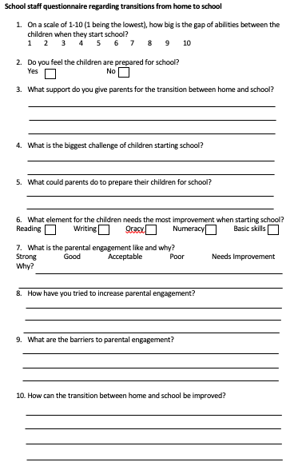

Appendix 5
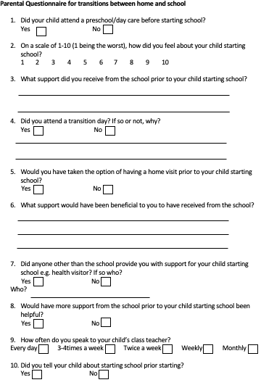

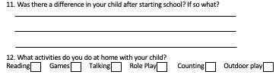

Appendix 6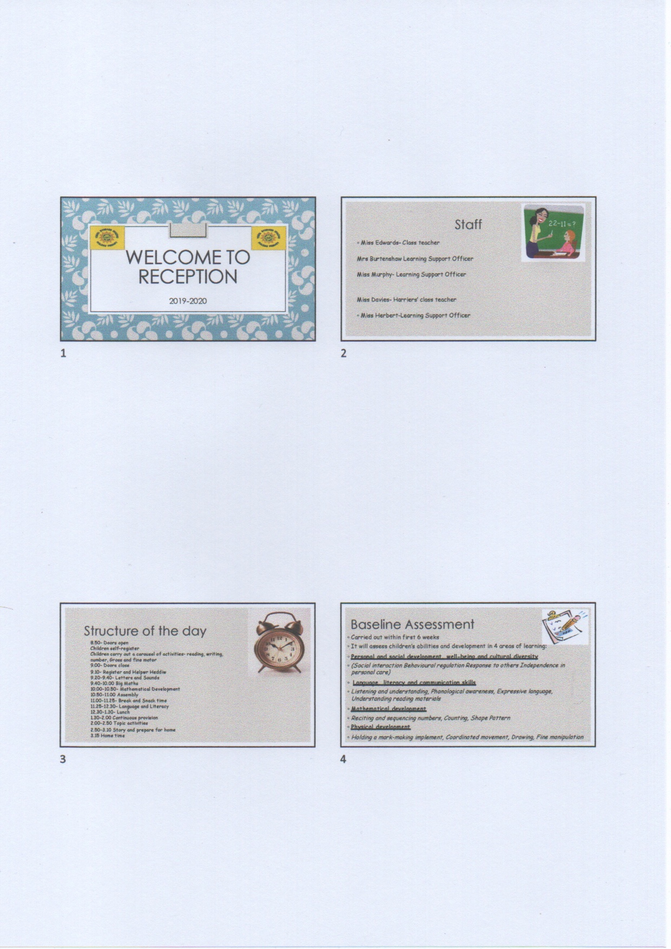

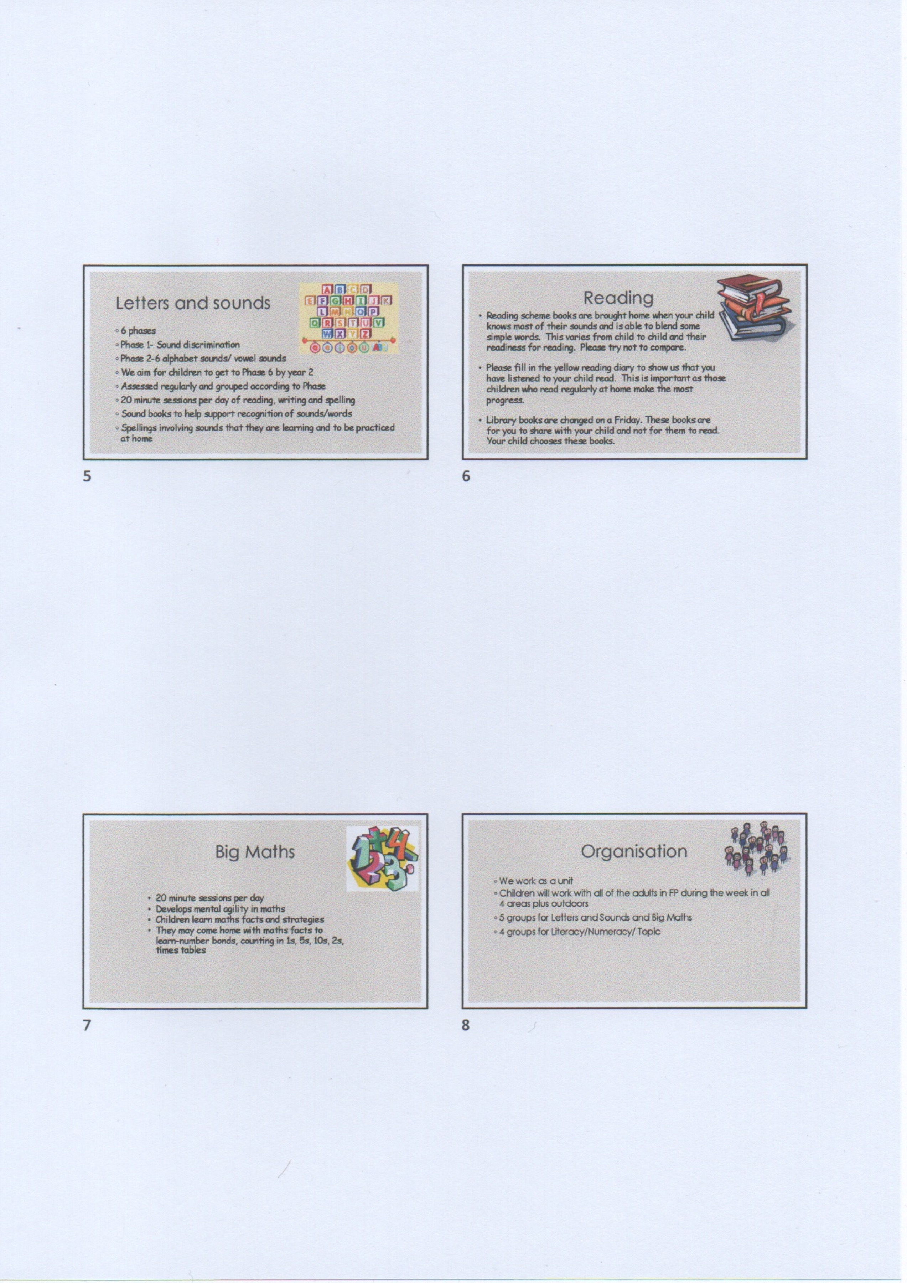

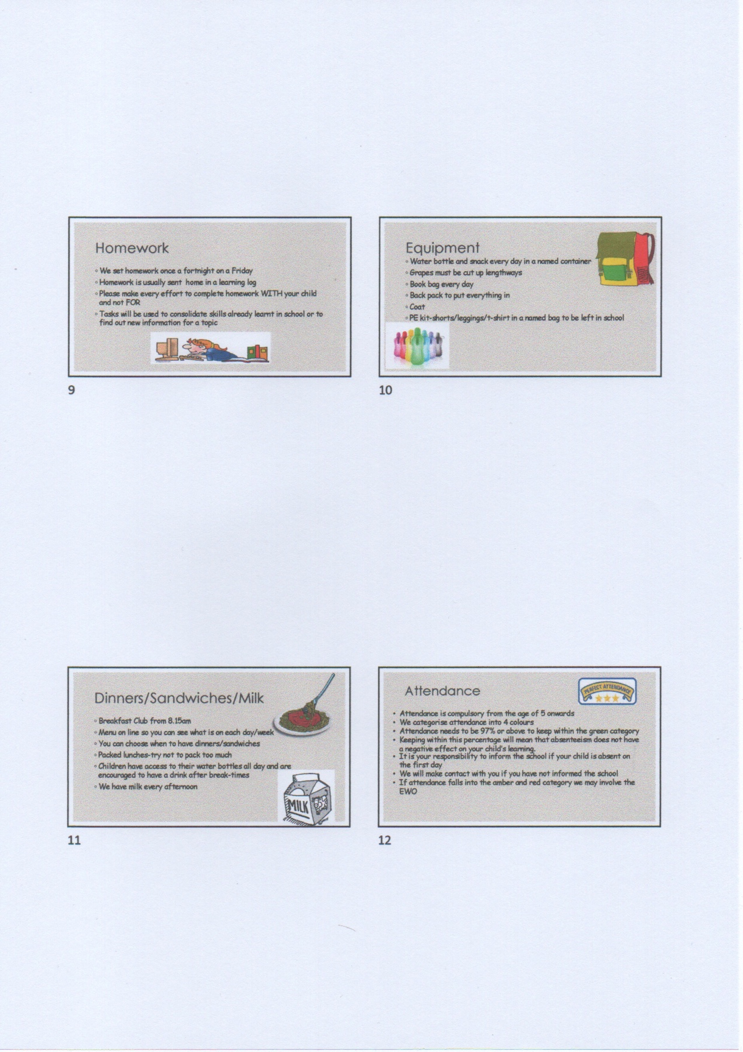

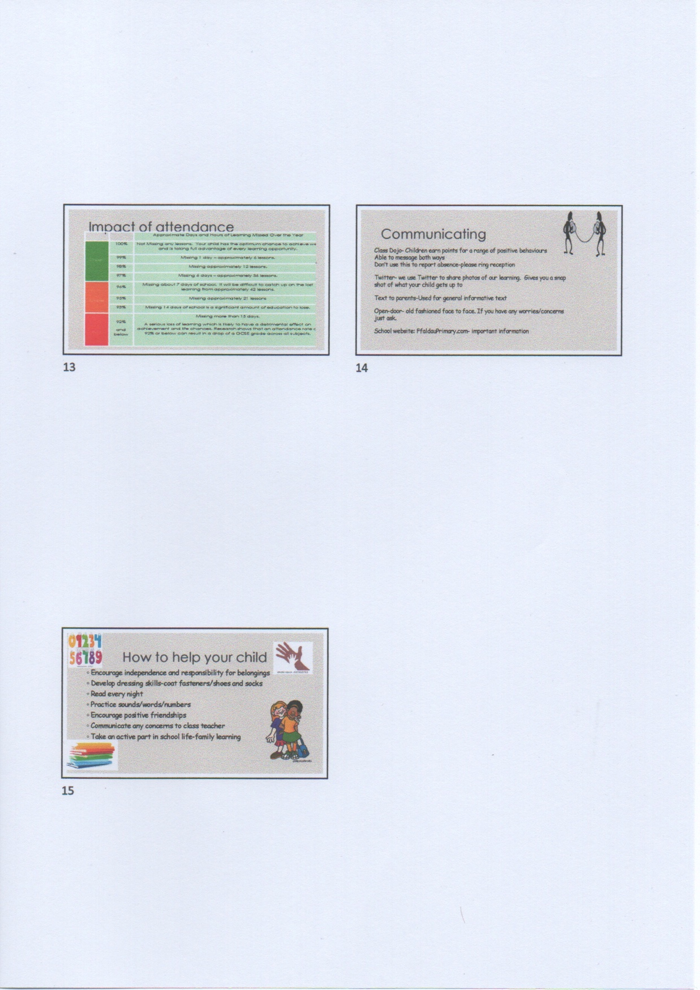

Appendix 7


