Assignment #5 – Transcription Exercise
Past Peoples, Present Society
Rhiannon Walker
Introduction:
For this assignment I decided to transcribe the first few pages of text in Sloane ms. 1977. It is a late 13th-early 14th century French medical manuscript and can be accessible in person or online through the British Library website. The manuscript contains a number of different medical texts translated into Old French: it begins with the Surgery of Roger Frugard, followed by a few folia of vernacular French medical recipes, a pharmaceutical treatise called Circa Instans, and ends with a few medical recipes attributed to Galen and Hippocrates. What differentiates it from the majority of other medieval medical manuscripts, however, is the luxury and decoration that adorns its many pages and is best known for the 21 full page miniatures which accompany the two major treatises.
Despite its apparent luxury, not much is known about its provenance or the circumstances surrounding its creation. It is believed the manuscript was illustrated in Northern France, with scholars proposing Laon and Amiens as two possible places of origin. The medical nature of the texts suggests to me that it would have been made for either a medical professional or someone interested in medicine. The wealth and decoration suggest that this person would have had access to a good amount of wealth, an idea further emphasized by its impeccable condition to date. The texts’ pages are largely undamaged and have few yellowed pages. It’s writing is evenly spaced in a clean and easy to decipher script with a relative lack of abbreviations or notes, particularly when compared to a large number of other medical texts. All this suggests that the text was not used (or at least used much) by its owner and perhaps served another purpose to whoever desired its creation.
When it comes to the transcription of the manuscript, I decided to do the first three pages of text: fol.1r, 1v, and 10r, given that ff. 2r-9v are pages of full-page miniatures with no textual content. Before even approaching the transcription, I began by first just looking at the pages to take note of what I had to work with. I like doing this before starting transcriptions because it gives me an opportunity to familiarize myself with the script, abbreviations, and note any similarities in the formation of letters. After this, I began an initial transcription on paper where I left open parentheses wherever there was an abbreviation and started a new line whenever a new line started in the document. If ever I wasn’t sure what a letter was, I would either write my guesses in capitals so that it would stand out when I reread it or left a line for each letter I couldn’t decipher if I couldn’t work it out at all.
I then reread my work a few times, leaving the abbreviations open to double check what I had written down. I also made notes for myself about the scribe’s hand/characteristics as well as any noteworthy features on the page. For example, I might take note of the many different versions of a letter the scribe had, in this case, the letters ‘r’ and ‘s’ had two to three different forms depending on where it was in the word. I also looked for any instances where there seemed to be an erased letter or if the hand seemed to change (it didn’t). I also highlighted in the same colour the instances where I struggled with the same letter or letter combination.
Finally, I began expanding the abbreviations using Capelli’s dictionary of Latin abbreviations as well as Raymond Clemens and Timothy Graham’s Introduction to Manuscript Studies. Once I had my parentheses filled out, I typed out my work onto the word document and then did a few more side-by-side readings of my transcription and the original text before making the conclusion. In the transcription, I put in bold the rubricated portions of the text all expansions are in square brackets. There were also some little designs to fill the space on the lines if the text didn’t fill up the columns. I tried to replicate this in the transcription with little lines. The link for the manuscript will be found in the bibliography at the end of the paper and images of the manuscript can be found there (unfortunately the photos at the end of the paper are not very clear).
Transcription:
(f. 1r.)
Cist liures est apelez ; Post
mundi fabricam. En francois.
Selonc le latin. entierement.
LI conmencement de cest liure
prions dieu quil soit tous pre
merains. uoire en nois. Liq[u]ier
est peres. 7 Fiex. 7. sainz. esperiz.
Et uoille nos cuers endoctriner de
La science de quoy cis liures p[ar]ole.
Par quoy nous puissons seurem[en]t
aidier a curer les accidens. Et que nous puissons entendre.
7 sauoir as pourfit de nos ames. Les. iiij . p[ar]ties de Cyrrurgie.
qui sunt ci apres deuisees 7 escriptes. Li premiere partie
Si est quant li chief est plaies. Li seconde du col Li
tierce. des espaules. Et li quarte des hanches desous.
Ceste Cyrurgie est li Cyrurgie. Mestre rogier de salerne.
Puis li fenist. 7 [con]mence une autre cyrurgie. Li p[ri]miers–

(f. 1v.)
Chapitres est contre sauxe
flame.-----------------------------
De morsure de chien q[u]i
Est enragiez. ------------
De morsure de serpent.
De ceus qui ne puent
Pissier. -------------------
De boiure a plaie -----------------
Dour oster espine de plaie
Et cist chapistre darrieneme[n]t
No[m]me sont en rime b[o]n p[ur]pre.
Explicit.
Apres uient .uns. liures li q[ui]s
Est apelez. Circa instans es–
trais en francois selonc le lati[n].
Apres uient uns autres
liures de Cyrurgie urais
7 esprouues. 7 certains pour
garir de toutes maladies cer–
tainement. 7 est li liures q[uae]
on apelle. Galien. 7 ypocas.
qui furent li millor clerc du
monde de par fisique.
Apres est la cyrurgie des
Dysians. Par chapistres.
Ce sont li liures.
Post mundi fabricam.
Maistre rgier de salerne.
Circa instans estrait du lati[n].
Galien .7. ypocras . . . .
Des disyans Cyrurgie

Pour mules ----------------------
Pour sanc oster des yex
Afieure quartainne -------------
Du syroines ---------------------
Contre dertres -------------------
Amauuaise char me[n]gier. ---
Pour estuuer seiches ------------
Du syrop -------------------------
Pour recuirier --------------------
Quia le uisaige farineux --------
Pour roigne. Explicit ------------
Quia tenres les yex cest
li remede 7 li garisons.
Le premier chapite
Lui a tenres les yex.
A pres des seirons
Des yex.
De uermine. -----------------------
De charcie -------------------------
De la maille en luoel. ------------
De goute chaine ------------------
De ho[m]me eschaude ou cuit
A mal de me[m]bres ------------
Contre dent -----------------------
Pour glandes ----------------------
Pour uers --------------------------
De clos 7 dapostumes.
(f.10r)
Cil sonnerains mires uolt
a soi retenir la cure de la
p[ar]tie p[er]dnrable cest de lame et
nos deguerpir. et nos laissa la
cure de la chetinete t[er]rienne cest
du cors a curer si co[m]me sont des
plaies et des ant[e]s enfermetes.
~ Des q[ue]les theoriq[ue] qui est n[ost]re
mestresse et pantri q[ue] en est mi–
nistresse. ~ De la q[ue]le partiq[ue] li
offices est a curer les accidens.
~ Et les maladies qui aniene[n]t
a cors humain dedens et defors.
~ Et pa[r]ce que en cest livre sont
co[n]tenues les cures des maladi
es. qui anienent en di[ui]nis cors.
par defors sico[m]me plaies qui s[on]t
apelees en fisiq[ue] solucion de co[n]ti–
nuite. pa[r]ce q[ue] p[er] plaie est dep[ar]tie
la co[n]tinuite des membres. Cest
la ioint[ur]e de lune char a lantre.
Ent liures recoit la dignece 7
Le no[m] de cirurgie. Le ql liure n[os]
auons t[ra]nslate et mis en escrit
a la priere et a la req[ue]ste de noz
conpaignes nobles et sages. en
tel man[er]e et en tel entente q[ue]
il le puissent retenir et enten–
dre et p[or]fiter et q[ue] diex n[os] otroit

Ci commence post mundi fabri
cam en francois------------------
Apres ce que diex ot le
monde crie. et il lot en
leli de sustance t[er]rien
ne. Et il ot forme ho[m]–
me et mis en lui esp[er]it de uie.
Et li plnt q[uam] ho[m]me fust formes
de vil mate et de froissable et
q[uae] li esp[er]is fust de glorieuse susta[n]–
ce et de esp[er]ituel . et p[er]dnrable . 7
mist en ho[m]me et len beli glori–
euseme[n]t de forme et de sapie[n]ce.
Et li donna entendem[en]t de faire
b[o]n et mal. et enseignem[en]t et q[om]–
mandeme[n]t de faire le b[o]n et lais–
sier le mal. Et acens q[u]i trespasse[n]t
son q[om]mandem[en]t il ap[er]eille diuers
tormens selonc les di[ui]nis max.
Et p[ur] la science quil lor a do[n]nee
il aront ignorance et iront de
regne a essil. et de lumieres
en tenebres et de delices en che–
tinete. et de sonner aine ioie a
gut[era] tritece. si co[m]me il ont des[s]–
ui. Et cil qui ont fait le b[o]n et
laissie le mal. il iront en ioie
p[er]dnrable. La q[ue] le diex n[os] otroit
a deseruir. Amer. ----------------------------
Conclusion
Overall, the pages transcribed above were quite clear and easy to decipher. There were a couple of letters, such as the letters ‘r’, ‘s’ that had many different forms, but apart from that the letters were well defined and evenly spaced. As mentioned in the footnote, there may have been an attempt at an erasure on fol. 1r where the author attempted to erase the ‘u’ and turn it into an ‘I’. My only issue with this is that every instance following that the scribe wrote the word, he spelled it with a ‘u’. I am not sure then if it was an error or something that happened later on.
When it comes to the text itself, folio 1r and 1v appear to be an introduction to the whole manuscript and a brief table of contents, highlighting the different texts and subjects that will be included. Folio 10r marks the beginning of Surgery of Roger Frugard, introducing the text to come. One thing that continued from the general introduction of the whole manuscript and the start of the first tract was the continued mention of the texts being translated into French. It mentions it at the start of fol.1r and in the title of the text on fol.10r, as well as in the table of contents on fol. 1v where it more specifically mentions that both Circa Instans and the extracts from Galen and Hypocrates are translated into Old French based on the Latin versions. While it is by no means abnormal or special that was copied from a Latin exemplar, I do find it interesting that it was mentioned as often as it was. I think that it would be interesting to look into the appearance of vernacular literature particularly in medieval medical literature to see if this can provide any clarification on the manuscripts origins.
Furthermore, apart from a few pages of medical recipes between The Surgery of Roger Frugard and Circa Instans, the manuscript follows what is laid out in the table of contents. There are no pages left open for future entries to this table of contents or between the tracts in the text, nor are there any changes in script between this section of the text and the rest of the manuscript. The only difference is that the table of contents mentions the last text as being “Des dysian cyrurgie” which I believe may be the Old French medical recipes that are found between the two major tracts rather than at the end of the manuscript. All of this leads me to believe that the manuscript was written out in its entirety by one scribe and completed what it set out to include.
In other words, rather than being a text that had space left for additions over time, it was created for a very specific moment in time. From the outset, this manuscript had a very specific intention and scope that it laid out in its first two pages. This is quite important because it provides a hint as to what the purpose of the manuscript may have been and insight into its history. As mentioned above, very little is known about the circumstances surrounding its creation. Though these remarks are not much in and of themselves, they do provide avenues through which we can explore the history of this fascinating manuscript and perhaps provide a more rounded glimpse into its past and the people that shaped it.

Folio 1r :
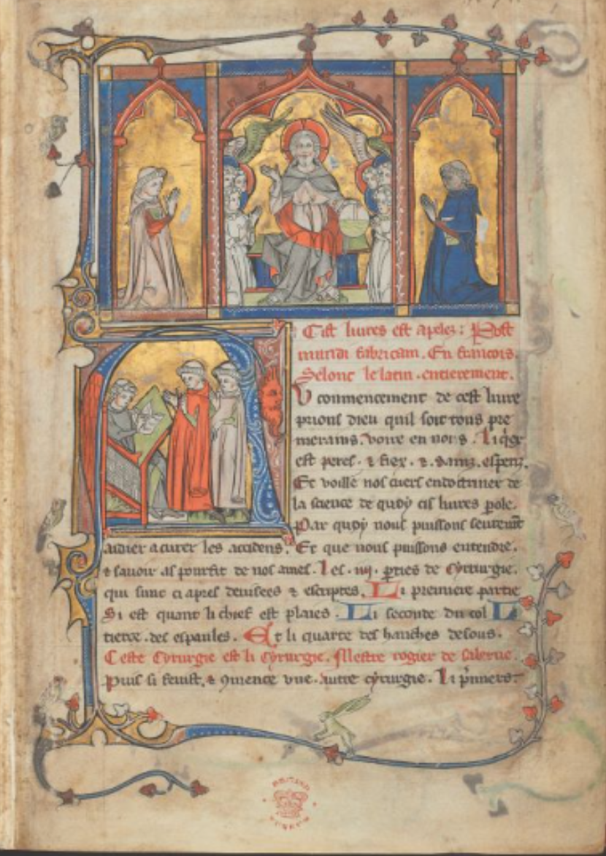

Folio 1v :
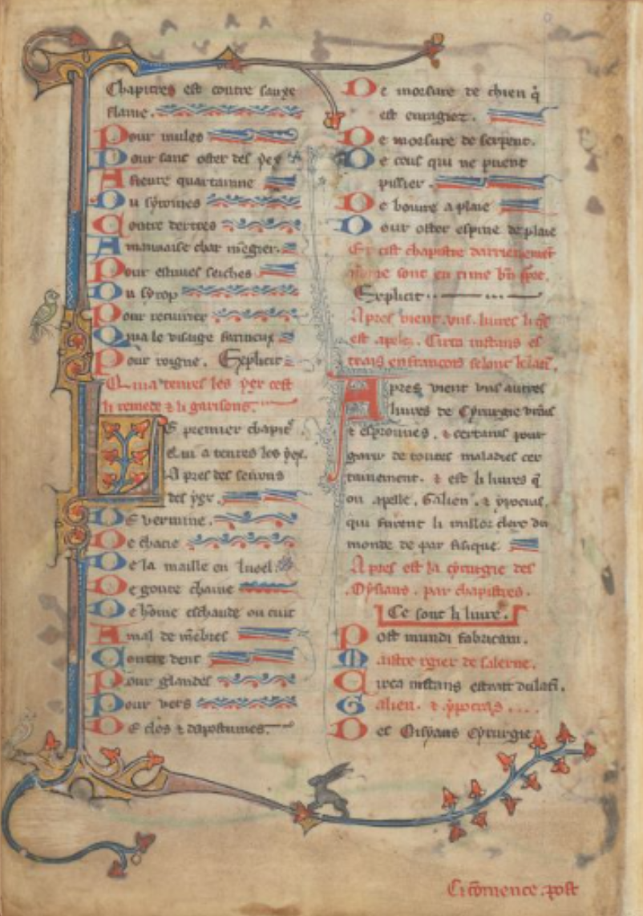

Folio 10r :
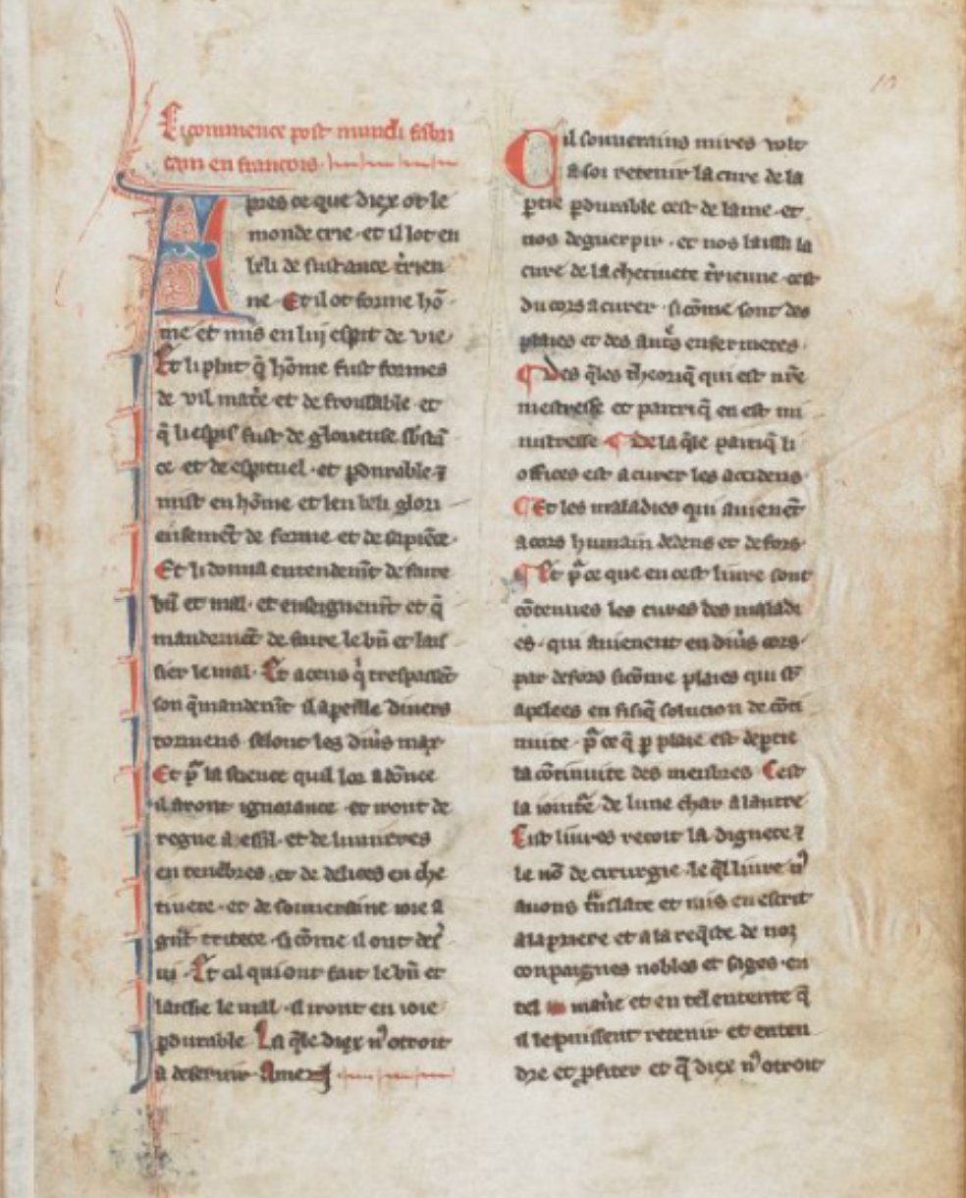

Bibliography

Capelli, Adriano. The Elements of Abbreviation in Medieval Latin Paleography. Trans. by Heimann, David & Kay, Richard. Kansas: University of Kansas Library, 1982. Accessed 22/01/23.
Clemens, Raymond & Timothy Graham. Introduction to Manuscript Studies. Ithaca and London: Cornell University Press, 2007. Pp. 90-94.
London. British Library (Online). Sloane Ms. 1977. Accessed 22/01/23. URL: https://www.bl.uk/manuscripts/Viewer.aspx?ref=sloane_ms_1977_fs001r

I believe there was an attempt at an erasure in this word where the scribe had originally written the word as ‘nous’ and then erased part of the second minim of the ‘u’ away to turn it into an ‘I’. That being said, the scribe did leave a little of the top of the ‘u’ behind so it is hard to tell is this is meant to be ‘nous’ or ‘nois’. It is subsequently written word as ‘nous’ for the rest of the transcription so perhaps it was an accident or later damage. For this exercise, however, I decide to spell it as an ‘I’ to keep with what is written on the page and avoid correcting it myself.
This is the number 4, as seen in Raymond Clemens & Timothy Graham, Introduction to Manuscript Studies (Ithaca and London: Cornell University Press, 2007), p. 91.

