Whatever happened to Berlin’s deserted ‘ghost’ airport?
Not a single passenger has used this hi-tech European airport yet. Will they ever arrive?
By Emily Schultheis
6th November 2018 (https://www.bbc.com/worklife/article/20181030-what-happened-to-berlins-ghost-airport)

Dozens of gates are ready for aeroplanes to pull in. Information screens display simulated real-time flight information. Gleaming terminals stand waiting for passengers to walk through them.
Earlier in 2018 planners said the current estimated costs would reach €7.3bn.
Berlin’s Brandenburg Willy Brandt Airport (BER) looks exactly like every other major modern airport in Europe, except for one big problem: more than seven years after it was originally supposed to open, it still stands empty. There are no passengers using it.
Germany may be known for its efficiency and refined engineering, but when it comes to Berlin’s new ghost airport this reputation could not be further from the truth. Plagued by comically long delays, perpetually mismanaged and expected to cost more than three and a half times the initial budget, the airport has become something of a running joke among Berliners - and a source of frustration for local politicians, business leaders and residents alike.

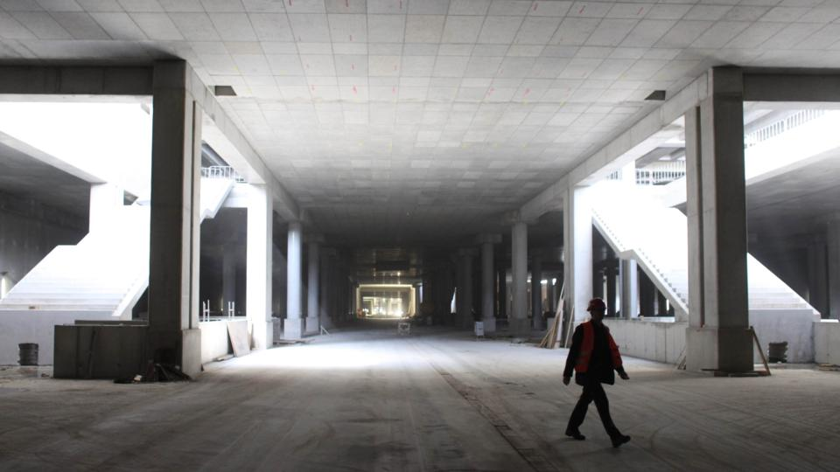
Empty 'ghost' trains run into the airport’s station every weekday to keep it properly ventilated (Credit: Getty Images)
The city, state and federally funded airport was originally expected to cost €2bn. Earlier this year, however, planners said the current estimated costs would reach €7.3bn, a number that could rise further depending on how long it takes to finish. And every month the airport sits unopened, it racks up millions of euros in maintenance and upkeep costs.
“There was, in a sense, a spiral of major errors which contributed to the final result,” Jobst Fiedler, a professor emeritus at Berlin’s Hertie School of Governance and the author of a 2015 case study on the airport, told BBC Capital. “It should have opened in June 2012 - at that time already there was a considerable cost and time overrun - but the story has been going on.”
Planning for the new airport began after the fall of the Berlin Wall in 1989. At the time, it became clear that the newly-reunified capital would need a modern airport with far greater capacity than its pair of Cold War-era airports, Tegel (in former West Berlin) and Schönefeld (in former East Berlin). The city broke ground on the new airport in 2006, with the understanding that both Tegel and Schönefeld would close when it opened.
The first major sign something was wrong came in summer 2010, when the corporation running construction, the state- and federally-controlled Flughafen Berlin-Brandenburg, pushed the opening from October 2011 to June 2012. In 2012, it really did look like the airport would open: the city planned a ceremony which would have been attended by Chancellor Angela Merkel. But less than a month beforehand, inspectors found significant problems with the fire safety system and pushed the opening back again to 2013.
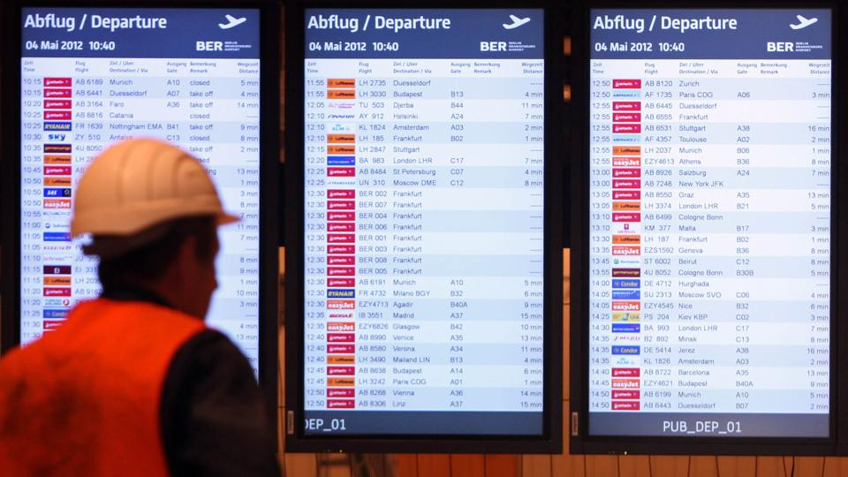
All 750 of the monitors showing flight information had to be replaced earlier in 2018 - at a cost of €500,000 (Credit: Getty Images)
It wasn’t just the smoke system: a series of other major problems subsequently emerged. More than 90 metres of cable were incorrectly installed; 4,000 doors were wrongly numbered; escalators were too short. There was such a shortage of check-in desks the planners proposed some airlines check their passengers in at tents in front of the terminal - a move that airlines naturally opposed.
The city broke ground on the new airport in 2006, with the understanding that both Tegel and Schönefeld would close when it opened
Jörg Stroedter, the centre-left Social Democrats’ spokesman for the airport committee in Berlin’s parliament, told BBC Capital that errors such as these - and the decision to push forward with fixing them, rather than starting over - are why costs have skyrocketed. The failed opening of the airport in 2012 “should have led to the decision to totally gut the building and dismantle all the complicated facilities,” he said. “If that had happened, the airport would have already been in operation for a long time, with newer and less complicated facilities.”
So is Stroedter's right: why, once so many problems were discovered, didn't Berlin's airport corporation decide to ditch the project and start over? In many ways, it's a classic example of the so-called sunk cost fallacy: people (or in this case, organisations) are often hesitant to cut their losses when they've already invested time or resources into something, even if it might make logical sense to do so. This is a phenomenon not just in high-profile, high-cost projects such this one, but a way of thinking that can often come up in everyday working life as well.
The longer the delays continued, the more problems inspectors found. Leadership of the planning corporation has changed hands nearly as many times as the opening date has been pushed back. Initially, rather than appointing a general contractor to run the project, the corporation decided to manage it themselves despite not having experience with an undertaking of that scale - a move Fiedler said was the first big mistake that contributed to all the later ones. “It was a one-in-your-lifetime project for them: they had never dealt with a project of that complexity,” he said. “And in that case, the supervisory council staffed with politicians of course … couldn’t do the job.”
To compound the delays, the unused airport is racking up massive costs. Every month it remains unopened costs between €9m and €10m, Engelbert Lütke Daldrup, head of the committee running the construction, said earlier this year in response to a parliamentary request. According to the airport corporation, these costs include “construction, technical maintenance, facility management and security services”. Approximately 300 to 500 people work regularly in the main terminal building depending on the construction schedule, spokeswoman Kathrin Westhölter said.
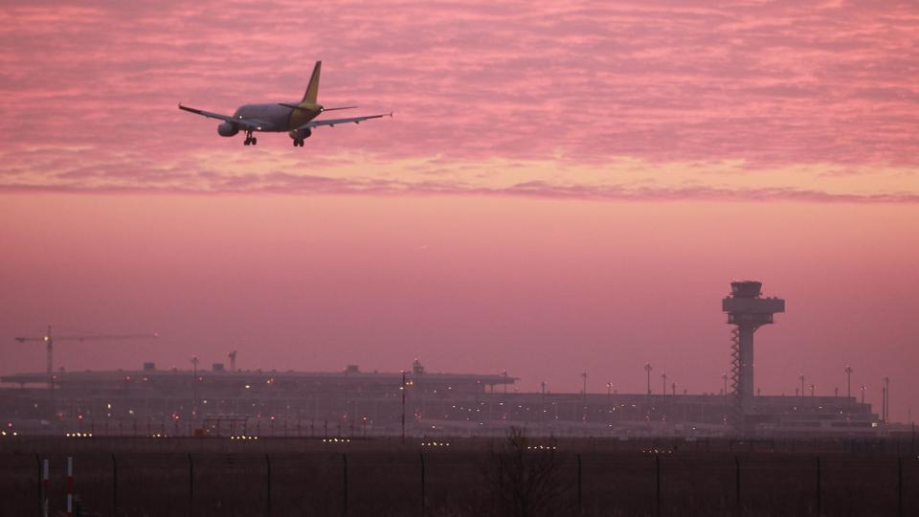
The cost of cleaning, maintenance, repairs and energy for the empty terminals has sky-rocketed (Credit: Getty Images)

The cost of cleaning, maintenance, repairs and energy for terminals no passengers have ever flown through is so high that the headlines about it are almost comical. Earlier this year, for example, all 750 of the monitors showing flight information had to be replaced - at a cost of €500,000 - because they had burned out after years. For months in 2013, a computer glitch meant planners couldn’t turn off the lights in the terminal (this has since been fixed). And empty trains run into the airport’s station every weekday to keep it properly ventilated.
Westhölter says they try to minimise costs wherever possible, but that some ongoing costs are necessary for safety reasons. “As we are most concerned about minimising costs, we run all equipment on as low [an] energy-level as possible.”
Some have suggested Berlin should simply call it quits and start over. Earlier this year, one Lufthansa executive even predicted the airport would never actually open. “My prognosis: the thing will be torn down and built anew,” said Thorsten Dirks, head of the airline’s Eurowings budget subsidiary. (Around the same time, German broadcaster Deutsche Welle ran an op-ed saying the same: “Tear down Berlin’s unfinished airport and start over!”)
Assuming all goes well, the airport should open in October 2020. The airport’s planning corporation stood by that estimate as recently as October 2018, despite acknowledging that there are still a “variety of defects” with the power cable system, as well as power and lighting for the security system. The airport will also have to undergo extensive inspections, slated to begin next year, before it can be opened. “All the experts tell me there are no shortcomings at BER Airport we can’t fix,” Daldrup told Berlin’s local government in a hearing. “I am convinced that BER will be put into operation in October 2020.”
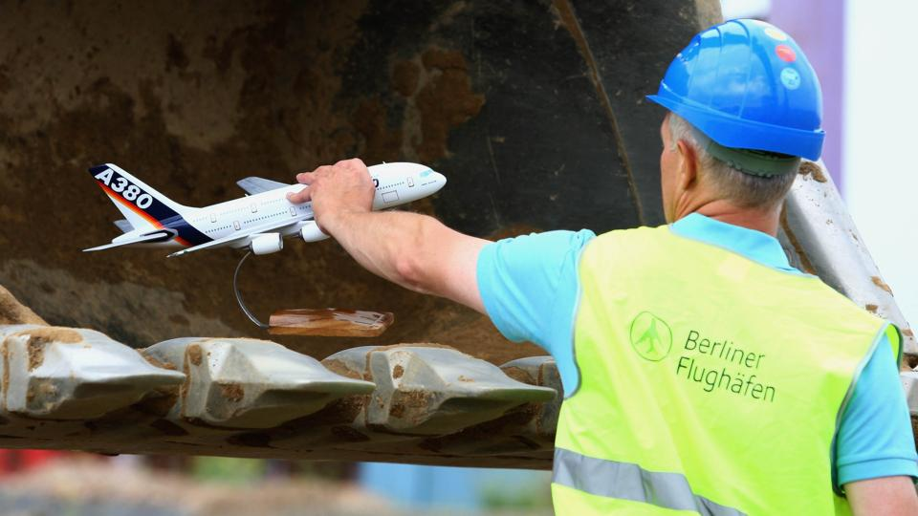
For months in 2013, a computer glitch meant planners couldn’t turn off the lights in the terminal (Credit: Getty Images)
This isn’t the only major infrastructure project that’s gone way over deadline and budget in recent years. In Hamburg, the concert hall Elbphilharmonie cost a whopping €700m more than expected (€789m instead of €77m); Stuttgart’s new main train station was announced in 1995 but won’t be finished until at least 2021.
But the still-empty airport, experts say, stands as the biggest embarrassment to Germany’s reputation for efficiency - and a continuing drain on city and state resources. “It is not easy in one project to combine so many errors,” Fiedler said. “It is a major blunder, this project.”

