Hidden Gods: Hatshepsut’s Red Chapel and Processional Barques
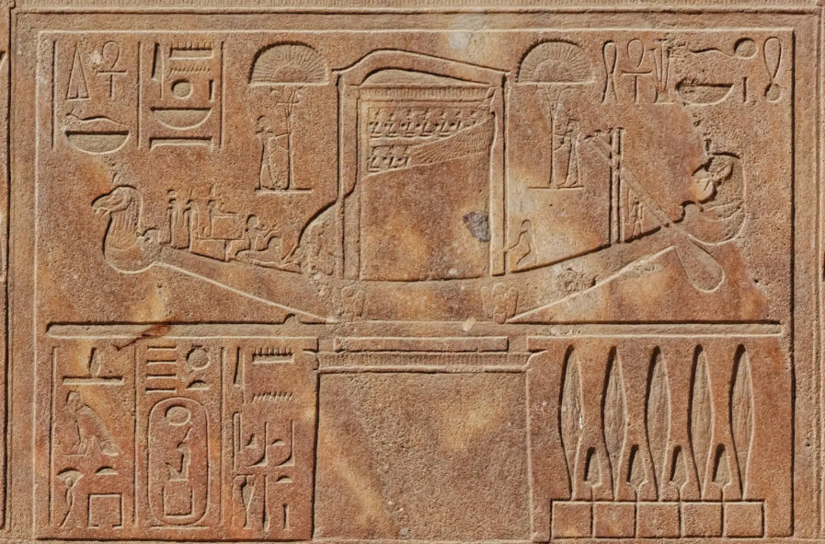
Egypt Museum
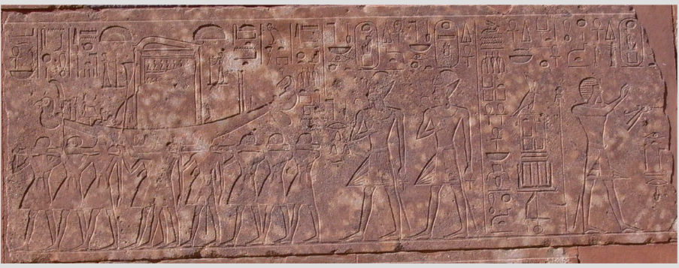
Fig. 1. Opet procession scene, Red Chapel, South Wall, Block 26 (maat-ka-ra.de).
In ancient Thebes, religious festivals such as the Opet Festival, played a key role in connecting humans with the divine. This case study examines the way processional barques such as the Barque of Amun, took the invisible nature of the gods and transformed this into a controlled sensory encounter, focusing on visual evidence from the Red Chapel of Hatshepsut at Karnak. Rather than making the god visible, these processions framed divine presence through concealment, movement and sensory stimulation.
The processional barque was more than a physical means of transporting the statue of the god; it was a symbolic and theological construct. This dual role is clearly illustrated in the Red Chapel reliefs, where the barque is shown richly decorated and carried in procession by priests, its shrine enclosed, emphasising both its radiant exterior and its hidden divine occupant. Assmann (2001) argues that Egyptian religion has two levels, a cosmic one, defined by the principle of Ma’at, and a cultic level involving direct interaction with the gods. The barque embodies both dimensions. Its gold surfaces evoked the radiance of the sun god, while inscriptions and imagery decorating the exterior reinforced the inhabitant’s divine identity. The movement of the barque along prescribed routes - often paved in white limestone to symbolise a heavenly space – further embedded the procession within a cosmic setting. In this way, the god did not simply travel from one place to another, the procession enabled a symbolic merging of heaven and earth.
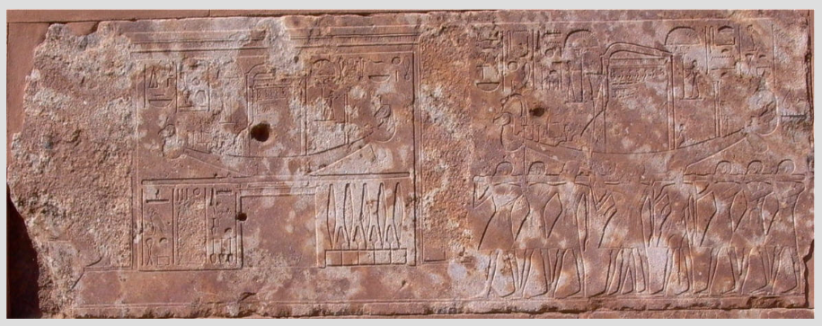 Fig. 2. Opet procession scene approaching a way-station, Red Chapel, South Wall, Block 305 (maat-ka-ra.de).
Despite this visibility, the god itself remained fundamentally inaccessible. As Hornung (1982) notes, Egyptian divine imagery does not represent literal appearance but attributes of power. Animal-headed forms expressed certain attributes, but no single image could encompass the complexity of the god’s divinity. Instead, the experience of the god was mediated through sensory elements. The participating crowd at the festivals encountered the divine through the gleam of gold, the sound of music and hymns and the smell of incense which created what Hornung describes as ‘a divine aroma’. These elements allowed worshippers to feel the presence of the god without direct visual access. This idea is reflected in the Red Chapel reliefs, by rather than focusing the attention on the god, it focuses on the surrounding ritual activity, priests, and offerings, and the ‘censing’ of the god visually suggesting the sensory environment through which the divine was experienced.
A key relief from the South Wall of the Red Chapel depicts the sacred barque of Amun carried in formal procession by priests. The barque is shown as an elaborate, enclosed shrine, heavily ornamented but inaccessible, emphasising that the divine occupant is not visible. In front of the barque, Hatshepsut is depicted performing ritual offerings, reinforcing her mediatory role between God and society.
Ultimately, festivals in Thebes blurred the boundaries between human and divine realms by restricting sight but amplifying sensory experience. The reliefs of the Red Chapel of Hatshepsut demonstrate this dynamic visually: the god remains hidden, yet powerfully present through ritual movement, collective participation and sensory engagement. In this way, processional barques constructed a religious experience centred not on seeing the divine but on experiencing its presence.
Bibliography
- Hornung, E. (1982). Conceptions of God in ancient Egypt: The one and the many. Cornell University Press.
- Assmann, J. (2001). The search for God in ancient Egypt. Cornell University Press.

