
Module Name: Introduction to Physiology
Module Number: BMHP5023
Assessment Title: Component 1: Written Assignment (Case Study Report)
Assessment Number: 1
Student Name: Liliana Tofan
Student ID:2008331
Total words: 2046

Table of Contents
a. Introduction 2
b. Explaining how blood sugar levels are maintained at safe and effective levels 3
c. Role of oxygen and glucose in energy production 4
d. Importance of recording and tracking blood sugar levels with type 2 diabetes 6
e. Evidence-based recommendations 7
f. Conclusions 9
g. Reference lists 10

CASE STUDY 1

a. Introduction
Diabetes Mellitus seems to be a chronic metabolic condition that has been characterised by the continuous elevation of the blood sugar levels, resulting from the secretion of impaired insulin. Moreover, the health issues regarding diabetes have created a serious and long-term vascular damage for the individual. In context, the occurrence of Type-2 Diabetes (T2D) has been defined as high within the UK, where approximately 70.6% of people were diagnosed with T2D in 2024 from 38.4% in 2020 (GOV UK, 2025). The lifestyle-related risk factors, including obesity, physical inactivity, poor dietary patterns, and smoking, have been strongly associated with the development of diabetes. Therefore, an increasing number of patients attending the GP surgery, diagnosed with diabetes, have reflected the necessity of patients’ understanding regarding lifestyle conditions and activities.
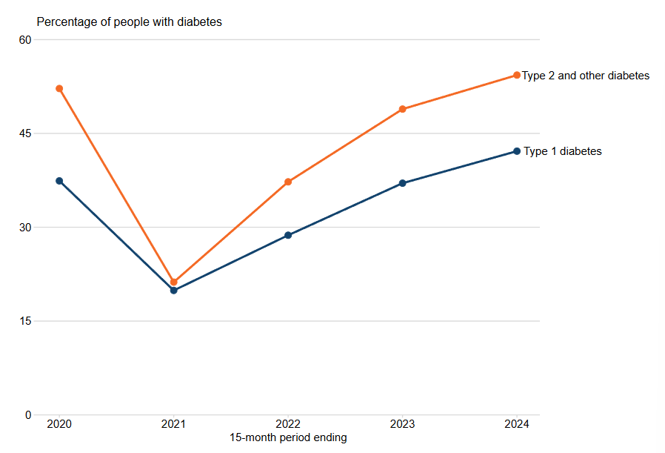
Figure 1: Increasing rate of type-2 diabetes in the UK
(Source: GOV UK, 2025)
The risk factors of diabetes within an individual patient seem to be high when issues like being overweight, genetics, family history, abnormal cholesterol, poor diet, and physical inactivity have not been properly addressed or treated. The high prevalence of the disease in the GP surgery has strongly concentrated on scenarios like understanding and evaluating one's own conditions, and tracking blood sugar levels can help to get rid of the disease. In context, the study has reflected the process in maintaining blood sugar levels (BSL) associated with the usage of oxygen and glucose in producing energy in the human body. Moreover, the process of recording and tracking BSL and the evidence-based recommendations in the improvement of health conditions has also been thoroughly demonstrated in the assignment.

b. Explaining how blood sugar levels are maintained at safe and effective levels
The blood sugar levels within the human body have been maintained through the perfect alignment of dietary intake, cellular glucose uptake, and hormonal regulation. From the perspectives of Waugh and Grant (2010), within the human body, the organs are made up of different types of tissues in terms of carrying out specific functions. In context, the pancreas within the human body has released insulin that significantly leads to lower high blood sugar levels. The fact is that the pancreatic beta cells have released a proportion of insulin, which has acted as the essential key and allows glucose to enter the cells for the production of energy. In context, the perfect balance between diet, exercise, and monitoring of the organs has created better options to ensure the health stability and lower BSL in a more effective way.
Individuals with Type 2 Diabetes have faced issues like insulin resistance and production within their bodies. As commented by Korsah and Agyeman‐Yeboah (2023), the number of people with diabetes is increasing globally, which has affected the processes of the body turning food into energy. As a consequence, the factors of glucose have significantly remained in the bloodstream and fail to be efficiently taken up by the cells. The persistent issues concerning hyperglycaemia have led to significant damage to the organs and vessels. The occurrence and increasing risks, such as cardiovascular diseases, kidney failure, and neuropathy, as long-term complications, have negatively impacted the lifestyle as well. Therefore, as its solutions, the perfect diet intake by the individual has performed a critical role in the regulation of blood glucose levels. As stated by Sabarathinam (2023), consuming food that possesses a low glycaemic index helps to prevent the spike of blood sugar levels. Moreover, maintaining physical activities has also created better support regarding glucose regulation through the process of increasing insulin sensitivity. Thus, the process seems to be highly beneficial for T2D patients, where concentrating on regular exercise significantly reduces insulin resistance and makes a positive impact on the overall metabolic control mechanisms.
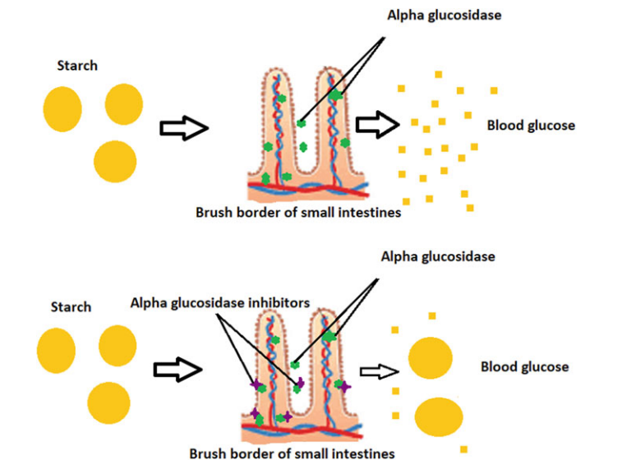
Figure 2: Essential mechanisms for Alpha-Glucosidase Inhibitors
(Source: Bhatnagar and Mishra, 2022)
Besides this, within the context of local GP surgery, the proper medication has also been required in order to support the regulation of blood glucose. Moreover, as stated by Bhatnagar and Mishra (2022), the Alpha-Glycosidase Inhibitors have blocked the enzymes and significantly stopped the breakdown of glucose, which has positively impacted reducing the blood sugar levels. The insulin therapy seems to be beneficial in some cases, which significantly reduces the issues of glucose production by the liver. Concerning the Health Belief Model, the necessary understanding of the patients has been regarded as essential (Subedi et al., 2025). Taking actions like monitoring of the blood glucose levels allows the patients to assess their lifestyle choices and manage BSL perfectly. Hence, as an individual more likely to adhere to the diet, medication, and also exercises, this tends to accelerate the positive health outcomes in a more effective way.

c. Role of oxygen and glucose in energy production
Oxygen and glucose have been defined as the essential components of cellular respiration, where energy is produced through the metabolic processes. Within this context, glucose has acted as the primary fuel source within the body, where oxygen has enabled the efficient release of energy during the process of aerobic respiration. From the perspectives of Peate and Evans (2020), human health problems are directly caused by the influence of genes or genetics. This significant health issue has accelerated the necessity of maintaining oxygen and glucose levels for the production of energy. The fact is that within the mitochondria, the presence of oxygen has broken down the glucose, which further leads to the production of “adenosine triphosphate”. Therefore, the process of maintaining the supply of energy has helped to manage vital cellular processes in a more effective way.
Individuals with Type 2 Diabetes have issues regarding insulin resistance, which has reduced the uptake of glucose and limited its availability within the cells. This metabolic dysfunction has also triggered health consequences such as fatigue, weakness, and reduced physical endurance. For its solubility purposes, the oxygen levels maintained within the human body have maximised energy yields during the process of glucose metabolism. From the perspectives of Hasina et al. (2023), maximising oxygen supply and also refreshing the body have helped to reduce negative energy possession. The psychological perspectives have also highlighted the factors regarding the effectiveness of oxygen and glucose utilisation, which seem to be fundamental in maintaining normal bodily function. Maintaining glycaemic controls has also supported sufficient energy production at the cellular level.
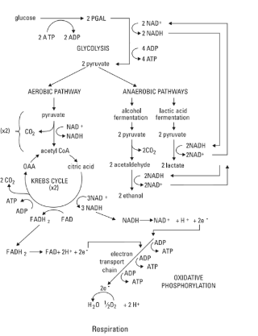
Figure 3: Processes of converting energy into ATP
(Source: Odya and DuPree, 2018, p.30)
In context, the key stages of the oxygen-based energy production have mainly included “glycolysis and Krebs cycle”, “electron transport chain”, and also “oxidative phosphorylation”. Therefore, the limitation of maintaining oxygen leads to a drastic reduction in ATP production, which significantly forces the cell into less efficient anaerobic metabolism. Similarly, the factors of glucose have produced energy through incorporating the stages like “glycolysis in cytoplasm”, “oxidative phosphorylation”, and “Krebs cycle in the mitochondria” as well. As stated by González et al. (2023), the necessity of maintaining oxygen and glucose has been proven as essential within the human body in terms of energy production. In this case, enhancement of the patient’s understanding associated with diabetic control measures is highly required to perfectly maintain the energy production rates. The acceptance of healthier behaviours and an increase in physical activities can improve the utilisation of oxygen and uptake of glucose as well. Hence, taking necessary measures to maintain the controlled blood glucose levels has helped to efficient energy production and stabilising daily functions in a systematic process.

d. Importance of recording and tracking blood sugar levels with type 2 diabetes
The effectiveness of the process of maintaining recording and tracking has mainly concentrated on managing T2D safely for individuals. Putting more emphasis on the regular monitoring processes has helped to properly understand the dietary charts, physical activities, and also detect episodes of hypoglycaemia as well. Concerning the report published by the WHO, a record of 130 million people required humanitarian assistance in promoting health and well-being (WHO, 2025). As per the case scenario, encouraging the patients to seek medical advice has further led to the acceleration of knowledge regarding quitting smoking, focusing on exercise, and also designing a dietary chart helps to reduce the occurrence of the diseases.
In essence, the inclusion of self-monitoring practices has also enabled patients in order to make more informed decisions about lifestyle choices and medication. In context, the healthcare organisation NHS has also designed the device for continuous glucose monitoring as a closed-loop system for checking the sugar levels at any time (NHS, 2025). Thus, tracking the BSL has also reduced the risks regarding acute complications and enabled the processes of early interventions. As stated by Subedi et al. (2025), the application of the Health Belief Model seems to be essential within this domain due to its capabilities of studying individual perceptions and explaining health behaviours to them. The analysis of the cognitive factors, like providing ideas about the consequences of the diseases and perceived severity, seems to be proven as effective for screening diabetic patients.
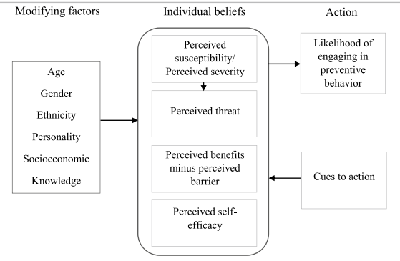
Figure 4: Factors of the Health Belief Model
(Source: Subedi et al., 2025)
The technological advancements, such as the integration of non-invasive AI-driven systems, have also helped to improve the management and prediction of T2D. In context, the health guidance from NICE has also been demonstrated on using “scanned glucose monitoring device” (isCGM) by using insulin therapy or finger prick testing for the children affected by T2D as well (NICE, 2025). The advancement of technologies and monitoring apps in providing real-time data to adjust medication and optimal health management has contributed to effectively managing health-conditions. Therefore, overall recording and tracking of the BSL has helped to support patients' safety, promoting independence and accelerating health outcomes of the Type-2 Diabetic patients.

e. Evidence-based recommendations
The evidence-based recommendations to treat diabetic patients have been strongly emphasised within the UK healthcare policies. In context, the adaptation of the “National Service Framework” has effectively designed national standards, on the basis of which care services are provided to diabetic patients (Publishing UK, 2025). NHS, aligning with the partner organisations have also concentrated more on reviewing the local strategies to improve the diet, accelerating physical activities awareness, reducing the issues of overweight and obesity to handle the situations, especially among the minority ethnic groups.
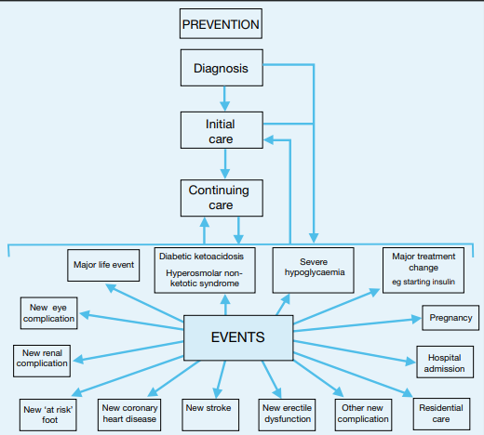
Figure 5: Prevention and management of diabetes
(Source: Publishing UK, 2025)
The proper dietary management for individuals, as per the NICE guidelines has also recommended the balanced intake of fruit, vegetables, lean protein, and refined sugars. Organising the diabetes prevention programs by the NHS has also promoted the information regarding low-glycaemic index foods in order to reduce blood glucose levels (Kentcht, 2025). The diets in fibre and dietary education can be helpful to make sustainable food intake changes and support the process of stable BSL.
Besides, smoking cessation can be strongly recommended for diabetic people as it increases the risk of issues concerning insulin resistance and cardiovascular disease. As per the NCSCT data, smoking has been strongly associated with a 35-45% higher risk of mortality in diabetic patients as compared to non-smoking ones (NCSCT, 2025). In context, the behavioural counselling and offering strategies like nicotine replacement therapy can help to support both glycaemic control and ensure the positive health outcomes of the individual. Moreover, taking up self-monitoring activities for ensuring the weight management interventions and physical activities can be proven as a means of diabetic management. The initiation of structured education programmes concerning DESMOND can also enhance awareness of the optimal management of diabetes as well (Diabetes UK, 2025). Therefore, holistic and patient-centred approaches in improving awareness and proactive strategies by the care seeker can improve health outcomes in a positive way.

f. Conclusions
The above discussion has concluded that effective management of diabetes significantly relies on maintaining safe blood glucose levels, improving energy metabolism, and also actively engaging people in self-monitoring activities. In contexts, the UK evidence-based guidance has also reflected that putting more emphasis on the areas of lifestyle modifications, cessation of smoking, and consuming healthy diets reduces the ongoing issues of diabetes perfectly. The role of the care seekers and practice nurses regarding empowering the patients in developing self-management skills and effective care plans reduces the global health problems. Therefore, the adoption of the holistic and patient-centred approaches for the improvement of the glycaemic control ensures the positive long-term health outcomes in a more effective way.

g. Reference lists
Bhatnagar, A. and Mishra, A., (2022) ‘α-Glucosidase inhibitors for diabetes/blood sugar regulation. In Natural products as enzyme inhibitors: An industrial perspective (pp. 269-283)’, Singapore: Springer Nature Singapore. Available at: https://doi.org/10.1007/978-981-19-0932-0
Diabetes UK (2025) Diabetes education: learning to look after your diabetes. Available at: https://www.diabetes.org.uk/about-diabetes/looking-after-diabetes/education (Accessed: 20 January 2026).
González, P., Lozano, P., Ros, G. and Solano, F., (2023) ‘Hyperglycemia and oxidative stress: an integral, updated and critical overview of their metabolic interconnections’, International journal of molecular sciences, 24(11), p.9352. Available at: https://doi.org/10.3390/ijms24119352
GOV UK (2025) Diabetes profile: statistical commentary. Available at: https://www.gov.uk/government/statistics/diabetes-profile-update-march-2025/diabetes-profile-statistical-commentary-march-2025 (Accessed: 21 January 2026).
Hasina, S.N., Shodiq, M., Ikwan, M., Putri, R.A., Noventi, I. and Setianto, B.S., (2023) ‘The effect of ergonomic exercise based on spiritual care on distress levels in elderly with diabetes mellitus’, Bali Medical Journal, 12(3), pp.2930-2935. Available at: http://dx.doi.org/10.15562/bmj.v12i3.4358
Kentcht (2025) Glycaemic Index (GI). Available at: https://www.kentcht.nhs.uk/leaflet/glycaemic-index-gi/ (Accessed: 20 January 2026).
Korsah, K.A. and Agyeman‐Yeboah, J., (2023) ‘Narratives of type 2 diabetes mellitus patients regarding the influence of social issues on diabetes self‐management: implications for patient care’, Nursing open, 10(8), pp.5741-5748. Available at: https://onlinelibrary.wiley.com/doi/abs/10.1002/nop2.1825
NCSCT (2025) The clinical case for smoking cessation for diabetic patient. Available at: https://www.ncsct.co.uk/library/view/pdf/CC%20diabetes%20Final.pdf (Accessed: 24 January 2026).
NHS (2025) Continuous glucose monitoring and hybrid closed loop for diabetes. Available at: https://www.nhs.uk/tests-and-treatments/cgm-and-hcl-for-diabetes/ (Accessed: 23 January 2026).
NICE (2025) Hundreds of children with type 2 diabetes to be offered choice of two life changing technologies. Available at: https://www.nice.org.uk/news/articles/hundreds-of-children-with-type-2-diabetes-to-be-offered-choice-of-two-life-changing-technologies (Accessed: 20 January 2026).
Odya, E. and DuPree, P., (2018) Anatomy & Physiology Workbook For Dummies with Online Practice. John Wiley & Sons.
Peate, I. and Evans, S. eds., (2020) Fundamentals of anatomy and physiology: For nursing and healthcare students. John Wiley & Sons.
Publishing UK (2025) National Service Framework for Diabetes. Available at: https://assets.publishing.service.gov.uk/media/5a7ad8cb40f0b66a2fc03365/National_Service_Framework_for_Diabetes.pdf (Accessed: 21 January 2026).
Sabarathinam, S., (2023) ‘A glycemic diet improves the understanding of glycemic control in diabetes patients during their follow-up’, Future Science OA, 9(3), p.FSO843. Available at: https://www.tandfonline.com/doi/full/10.2144/fsoa-2022-0058
Subedi, S., Leal Filho, W. and Adedeji, A., (2025) ‘An assessment of the health belief model (HBM) properties as predictors of COVID-19 preventive behaviour’, Journal of Public Health, 33(6), pp.1329-1339.Available at: https://doi.org/10.1007/s10389-023-02109-7
Waugh, A. and Grant, A., (2010) Ross & Wilson Anatomy and physiology in health and illness E-book. Elsevier Health Sciences.
WHO (2025) WHO guideline on self-care interventions for health and well-being, 2022 revision. Available at: https://www.who.int/publications/i/item/9789240052192 (Accessed: 22 January 2026).

