Module Name: Independent Project
Module Code: BMTP6015
Element: Element 2
Student Name: Charlie Macdonald
Student Number: 2304849
Lecturer: Scott James

Content Page
Page 3- Introduction
Page 3-6 – Planning and Preparation
Page 6-8 - Pre-Event Readiness & Implementation Plan
Page 8-9 - Reflection and Next Steps
Page 10-16 – Appendix
Page 17-19 – Reference list

Independent Project Element Two

Introduction
The event I am running, as part of a team, was the Institute of Travel and Tourism Future You Wales, this event will take place on the 10th of March in the Swansea Building Society Arena (www.swansea-arena.co.uk, 2026). The event is a conference and careers fair aimed at the wider tourism, events, hospitality and business industry (ITT Future You, 2026). Since the bid pitch in element one a lot has happened, for example all the planning has now been completed and we have finalised all the exhibitors and speakers. From element one the main aim was to inspire students and graduates to get involved in the tourism, events, hospitality and business industry. The main objectives were to deliver engaging key note speakers from industry professionals, and also facilitate interactive workshops to equip students with practical career tools.
During the planning leading up to the event the main roles I did were emailing potential exhibitors, undertaking the risk assessment and also being responsible for the roles of students who were volunteering at the event. These roles relate to the wider element of the event, as a big part of the event was the exhibition and contacting companies to be stall holders. Also, the risk assessment is very important to the event as the arena couldn’t host the event without an appropriate risk assessment. Finally, the staffing roles for volunteers will be important as we will need to divide people to help out in different areas of the event and give them specific tasks to do and follow (Event Academy, 2019).
This portfolio demonstrates the planning that has gone into running this event and all the knowledge gained from this experience of running an event as part of a team. It will also outline the theoretical knowledge that was applied in the planning of this event.

Planning and Preparation
The planning for this event started in October and we set out different deadlines to ensure we finished all the planning in time before the event. For example, the deadline for sending out emails to potential exhibitors was the start of December and we asked if they could let us know by January, however as it was Christmas time we didn’t get many responses and so we sent a follow up email in January with a deadline for exhibitors to confirm at the end of February. As for the presentation for the conference we originally set a deadline to complete this a week before the event, but due to circumstances out of our control we had to push back the deadline as people didn’t send their content over until a few days before the event. As for the social media and marketing side we started posting content in January to really push the event during February and March. Between December and February, we also started sending invitations to schools and colleges to invite them to the event as we wanted to give them sufficient time to plan, if they were interested in attending the event (University of Waterloo, 2025). (Evidence in Appendix A-B)
Leading up to the event we had to create a risk assessment document to identify and mitigate potential risks, whilst creating the risk assessment during the planning stage we had to outline the different areas of the event that could be classed as a risk and different parts of the arena that could cause injury or any risk. The risk assessment includes risks such as first aid incidents, crowd control, adverse weather, exhibitor risks and so much more. The risk assessment is a very important part of the planning and running of any event as it shows you have thought about the potential risks and what could go wrong, and have put plans in place for the worst-case scenario (HSE, 2015). (Appendix F-G)
Whilst creating the risk assessment we had to have clear communication with the arena to ensure that we had thought of everything and that there were plans in place in-case of an emergency and to ensure that there was first aid trained staff in place. Also, if there was an accident or injury the arena asked us to let them handle it as they were trained to do so (Jean-Paul Potron, 2019).
Communication with stakeholders and the members of the group running the event is very important and as a group we have been very good at that. We were in regular contact with our stakeholders as well as having regular meetings to ensure that everyone was kept up to date on the progress and to ask any questions or advice if and when we needed it. During these meetings we discussed all the different aspects of the event such as potential exhibitors and potential guest speakers as well as the layout of the event, which finally ended up with two separate conferences one in the morning and the other in the afternoon. During these meetings we also discussed which schools and colleges it would be possible to invite and also what the theme of the event would be and how all the logistics will work (Freeman, 1984). Having regular meetings has helped us a lot during the planning stage as it ensures that we are keeping on top of things and that everything is under control. Also emailing exhibitors to keep them updated has been important as they have all the information they need before attending the event, we have given them the timings for setting up as well as what they need to bring and the number of guests we are expecting (BBC Bitesize, 2024). (Appendix C-D)
Also, during our planning and preparation decision making has been very important as it requires us to think about the best option not only for ourselves but for the event and all the people involved in the event. As a group we have been very good at making decisions as we all respect each other’s opinions and listen to what everyone has to say regarding the matter. This has led to decisions being made quickly and smoothly and hopefully leads to the right decision being made between the group and the stakeholders (University of Massachusetts Dartmouth, 2021).
The specific elements I chose to work on for this event are the exhibition and risk management. Whilst planning for the event I have been sending emails out to potential exhibitors and also passing on information to exhibitors who have already confirmed they are attending. I also created the risk assessment for the event following the format of the risk assessment provided by the university to ensure that it was a correct assessment and that it covered everything needed (Oxford College of Management, 2026). Whilst emailing the exhibitors it is important to keep them up to date with all the information they require, and also to be very professional whilst inviting them and explaining thoroughly what the event is and how attending the event would benefit them. During the planning stage when the exhibitors were contacted they were sent a form to fill in regarding the event asking questions about how many employees would be attending and if they needed electricity for their stall. This helped us with the planning as we then knew which stalls needed power and need to be located in a specific area of the hall. We will also know what day to expect people to set up as we have given them two options either the day before or the morning of the event. We are expecting the majority to arrive the day before and currently on the Monday we can focus on the decorations on laying out the tables (The, 2024).
For the strategic decision making we have evidence of emails showing our decision making such as emails to exhibitors, stakeholders and to the other members of the team. In these emails it clearly shows the decisions that have been made, for example in one email the marketing team are asking how many posters we want and we had to think logically about how many we needed to promote the event but also where we would put them up to advertise the event. Another example of emails is between the organisers and the stall for the VR headsets. As organisers we decided to see if it was possible to have a stall from the University with the VR headsets. Whilst we were in our planning meetings we decided to have some workshops at the event and we believed the VR would make a good workshop and these emails show the decision to ask for the headsets and the communication between us (Creators Academy, 2025). (Appendix A-D)
As a team we also have prototypes and draft materials ready for the event. We have prototypes of decorations, the layout of the exhibition and also for our treasure hunt we have a prototype of a passport ready. We also have some drat materials ready, for example we have a draft of the staff list for the day to ensure that we don’t create pressure for ourselves having to deal with that on the day of the event, and to ensure that people know what they are doing on the day of the event without having to keep asking questions to us organisers (ICC Belfast, 2025). We have also created a draft of the running plan for the day of the event that includes the timings of the conference and exhibition. This also includes the order for the guest speakers in the conference. We are trying to find the best order to put the speakers as our current plan is to have two conference sessions the first one in the morning aimed at more of the tourism side and speakers who relate to that part of the industry and the second session in the afternoon aimed more at the events and hospitality side of the industry (Light Fantastic Production Services, 2025). (Appendix H & J)
During our planning for our event as organisers we have been collaborating and coordinating with each other well through emails and group chats to discuss the important matters. We set up a group chat with the six members of the team when we originally started planning back in November and then created a new group chat with Jacqui as the main stakeholder closer to the event in case we had any questions we needed answering quickly (NCVO, 2023). The group chat shows that we have been in constant communication with each other during the planning process and we have all been supporting each other with the different roles and responsibilities. Having this group chat has been very important for us as organisers as it has been easy to contact each other and organise meetings to plan for the event as well as having a platform to ask the rest of the group for their opinions and to make decisions together (Middleton, 2024). (Appendix K)
Another way we coordinate as part of a team was by email. As a team we set up an ITT Future You email account for companies to email if they were interested in either attending the event as exhibitors or as sponsors (Sass and Keil, 2025). This email account has made it easier to contact these companies as all the emails go to one place and it keeps it organised so we can see if we need to reply to them with more information. Also, if they send us an email it’s easy for us all to see the email and keep track of the number of companies who have confirmed that they are attending the event. As a team we also have an event planning spreadsheet with all the information we need for the event. On this document is a list of exhibitors who have confirmed their attendance and which companies we need to follow up with. This document also includes the list of schools and colleges that have confirmed they are attending and other potential schools we could contact to invite to the event. As all the organisers have access to this document it makes it easy to keep updating the information when required. It also ensures that we know which companies have been contacted so there’s no cross over with multiple people emailing the same company (Trust, 2024). (Appendix I)
Pre-Event Readiness & Implementation Plan
During the day of the event I will be managing the check-in area as well as being in the team welcoming everyone as they enter the arena. I will also be assisting with the exhibition and also as a group we will all be helping each other out when required (BIMA, 2024). As part of this role I will be located at the entrance level of the arena and will set up a check-in area to give out our gift bags and programs for the event, as well an ensuring that everyone either has a ticket or to get them to register for a ticket. As the manager of this area there will also be a team of volunteers working alongside me to ensure the process runs smoothly and to make sure people won’t be waiting a long time to enter the event (UCD Professional Academy, 2024). The check-in area will be open the whole time the event is running but obviously the busiest time will be in the morning once the doors open and people start arriving for the event. The team working on the check-in will also be used as guides when the conference doors open, to guide people into the auditorium to watch the conference, as everyone should be in the auditorium at this time. Some members of this team will also be assigned to guiding schools and colleges, that are arriving by bus, up to the entrance of the arena so that they can check-in before heading downstairs to explore the exhibition (Vale, 2024). As a group of organisers, we all know that we will all support each other. If certain people require assistance at certain points or if people have additional tasks, we will be able to cover each other if needed (The Guardian Jobs, 2024).
The main roles and responsibilities for my team will be running the check-in area, handing out the gift bags and programs, guiding schools and collages to the check-in area, guiding the guests when the conference is about to start and answering any questions the guests may have. The University’s marketing team will also be working alongside us at the check-in area as they are the only ones who have access to the list of who have tickets. This means they will need to scan the tickets before the guests enter the exhibition. One of the main responsibilities for me and my team is to ensure that the guests feel welcomed as soon as they walk through the door and to ensure we greet them with a smile and be as helpful as possible if they have any questions or issues. Another responsibility for the team will be to ensure that everyone who enters the event has a ticket as it will be important, in case of an emergency, that we have the exact number of guests in the building. We will also need to ensure that the guests know where they are going and to guide them if they don’t, to ensure that the experience for the guest is as good as possible (Bbc.co.uk, 2022).
We will need to ensure that we have contingency or backup plans in case there is a potential issue. As the leader of the team I will ensure that people are aware of the contingency plans and if they have any major issues I will be around to help deal with the problem. One of the main problems we could face is that some of the schools and colleges attending have registered all the tickets under the teacher’s name. To deal with this issue we will have to ask for the names of the pupils or ask them to register for tickets under their own names just in case there is an emergency so we will know if there is someone missing. Another issue we could face is people turning up as exhibitors who we might not have on the list or potentially exhibitors dropping out last minute. For the exhibitors showing up who we are not expecting we will try to facilitate them and find space for them in the exhibition and potentially replace the stalls that have dropped out. As for the exhibitors who might drop out we will have a backup plan for something else to fill in the gap. We could give some companies an extra table or find a new company to replace them. However this could be difficult close to the event, but also it could be a good opportunity for a company to promote their business who we had not thought about during the original phase of sending out invites (Beard, 2016).
During the planning stages all the organisers have been coordinating well together regarding the different aspects of the event, we have also been helping each other out when needed and been to meetings together to ensure that all the areas are kept up to date. We have been in constant contact through messages and emails to keep everything running smoothly and if someone could not make it to a meeting we would pass on the information to them so that everyone is on the same page. During the event we will also be working closely with all the different teams to ensure that the event runs smoothly. We will be using radios and phones to keep in contact, which will allow us to communicate easily and be able to respond quickly to help out the other teams. During the event we will also have a group chat with all the volunteers so that we can pass on any messages that we have for them. It will also make it easy to re-assign people to different areas if they are busier in certain areas compared to others at some point during the day. We have also been coordinating with the team in the arena leading up to the event to ensure that they have all the information they need before the event takes place, this also helps us get another opinion in case we have forgotten about something as they are experts on running and organising events (High Growth, 2024).
Reflection and Next Steps
During the planning phase of our event I feel like I have grown personally and professionally. My skills of time management have improved, but I do feel like there is still room for improvement on that part. Another aspect that has made me grow personally is the team work, as this event has relied heavily on team work it has given us good skills of working in a team and respecting every member of the team and be willing to help each other out whenever needed. Personally I feel more confident in my own abilities to plan an event as it makes you think of everything you need to do and it has made me realise how much work goes into planning big events. Another aspect I have learnt both personally and professionally is that it’s fine to ask for help from your team and stakeholders if you are having difficulties on any part, as they will always be willing to help and explain the next steps. Another thing I have learnt professionally is how to communicate properly through emails and with stakeholders as you need to be professional whilst also being clear about what you are asking. After reflecting back during the planning phase it’s all been about teamwork, time management and confidence as it shows that with the right people around you even the hardest challenges become slightly easier (Mardock, 2024).
A lot of aspects have gone well during the planning phase but we still have some things to iron out before we deliver the event. One of the main things to go well during this stage is how well we have worked as a team. There have been no arguments between the team and we have all got on with the tasks we have been given and we always ask each other for opinions and come to the best conclusions together. Another thing we have done well on is communication within the team, with stakeholders and the exhibitors, we have held regular meetings and if we get an email we respond quickly to ensure the exhibitors are kept happy. Finally another positive is the quick decision making we have made as a group, if a problem arises we discuss it as a group and come up with a solution that works for everyone. We still have some things to improve before the event. We are still waiting for some people to send their content over for the presentation and also the communication with the business students who are helping hasn’t been as good as the communication between the six organisers. We need to iron out the final plans for the day of the event just to ensure that we put all the volunteers in the right place and that we have all the exhibitors on the list to make sure that we don’t forget anyone whilst we are setting up the exhibition (DeakinCo, 2023).
During the event we will be identifying key success indicators such as the engagement from the audience as well as the engagement from the companies in the exhibition and guest speakers. Another aspect we will be monitoring is the efficiency of the event and how smoothly things run as we hope to create a smooth event for the guests with clear instructions on the timings of everything, and to ensure they are aware of everything that is going on during the event. It will be important for us as organisers to monitor if the event is a success as we can then give advice to the organisers next year about things that could be done better or what worked well. It will also be important for us to see the reactions of people as if it’s a success it will give us confidence to start our careers after university. We will also be sending out surveys after the event to gage the reaction from the guests, exhibitors and volunteers about how the event went (Twin, 2025).
This stage of planning will be a big help when it comes to evaluating the event in the next element of the project, as we will have plenty of recommendations to mention as well as hopefully plenty of positive feedback to discuss. It also ensures that we think about the next phase whilst still focusing on planning as we still have to plan for the evaluation after the event to ensure we do not forget that key component. The surveys we will be sending out will be a very beneficial for the next phase as it gives us feedback from guests who attended the event as well as experts from the industry who attended the event as guests, or as part of the exhibition. Having feedback form these experts will help us understand what we could do better next time and also what aspects they enjoyed. Overall the planning phase has gone well and there is not that much that we would do differently next time. Hopefully this means that the event will go well and the evaluation will be able to help us improve even more the next time we run an event (warwick.ac.uk, 2023).

Appendix
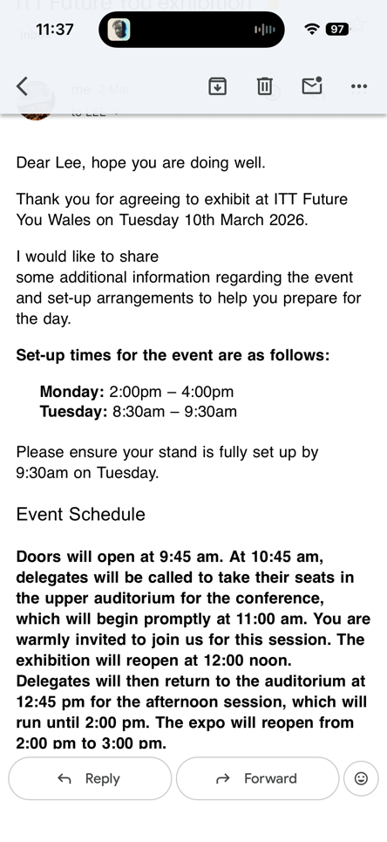

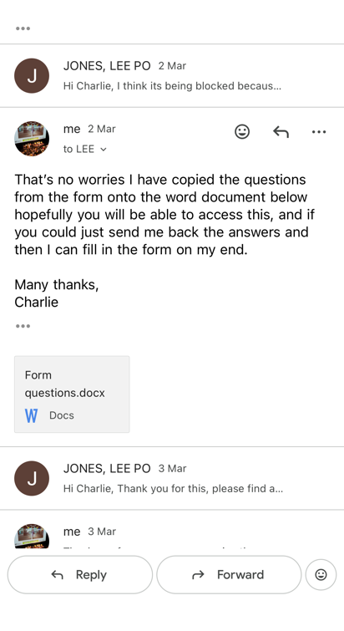
B.

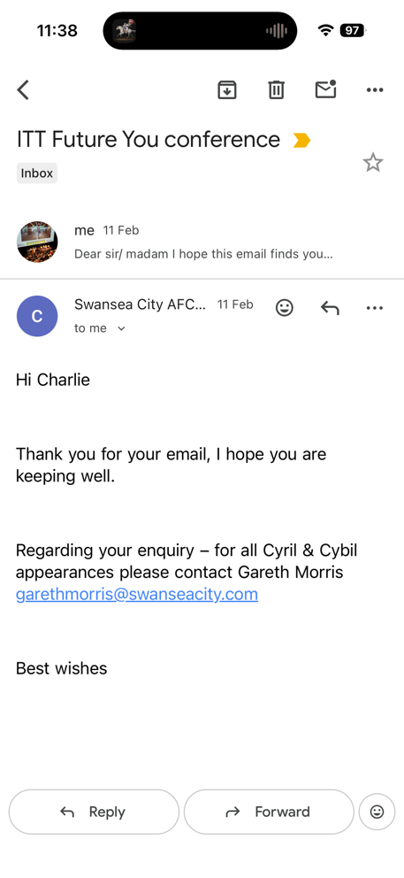
C.

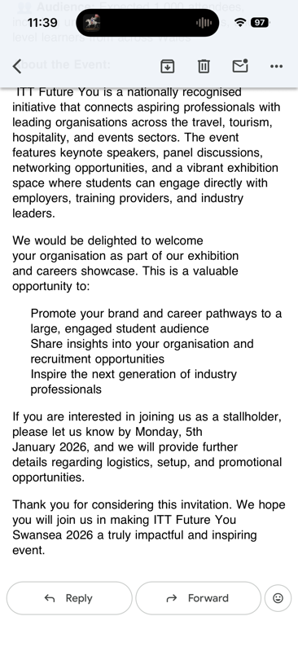
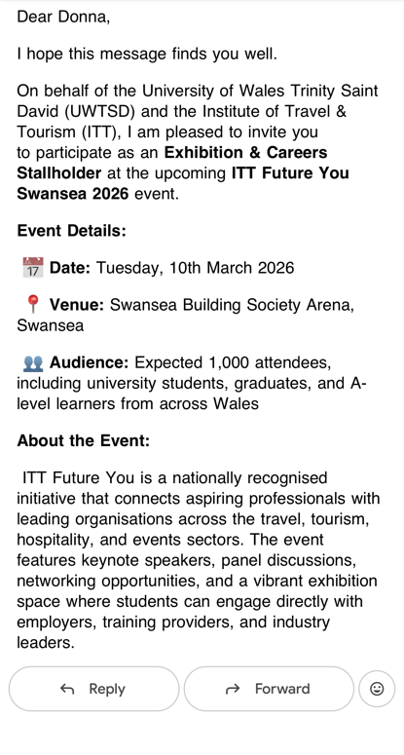
D.

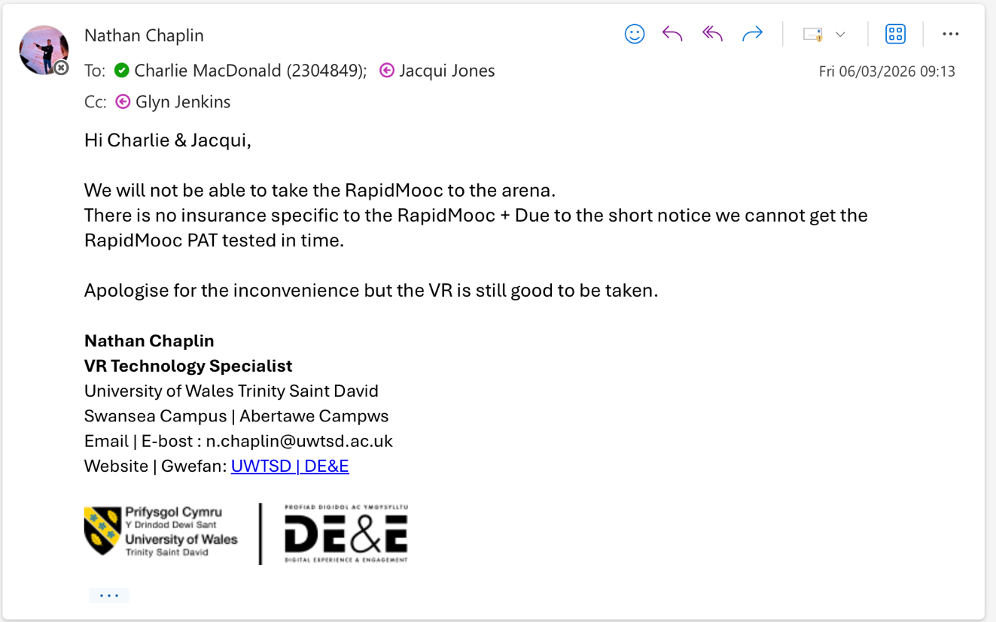
E.

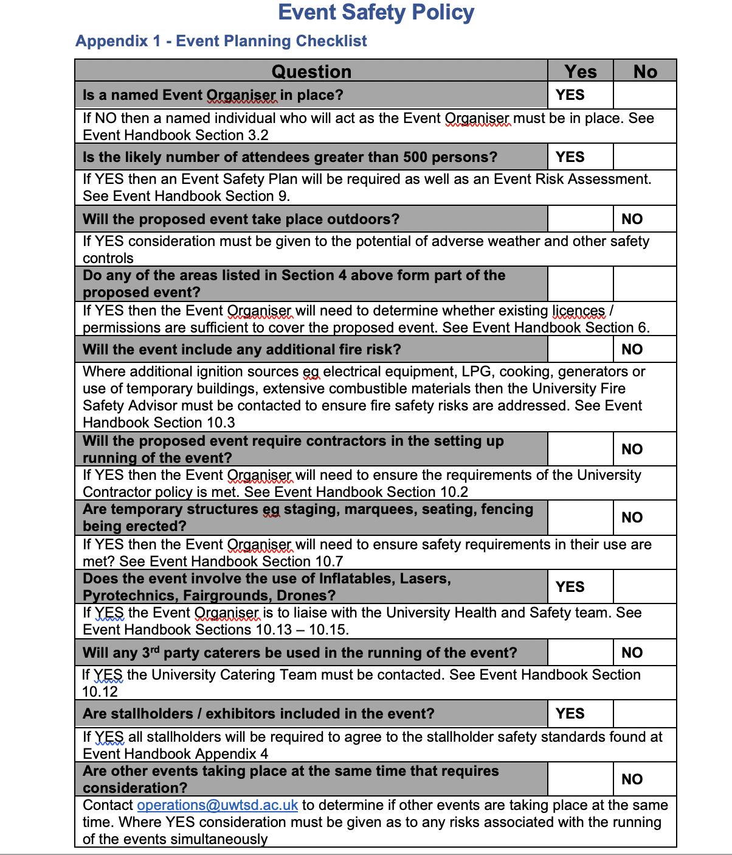
F.

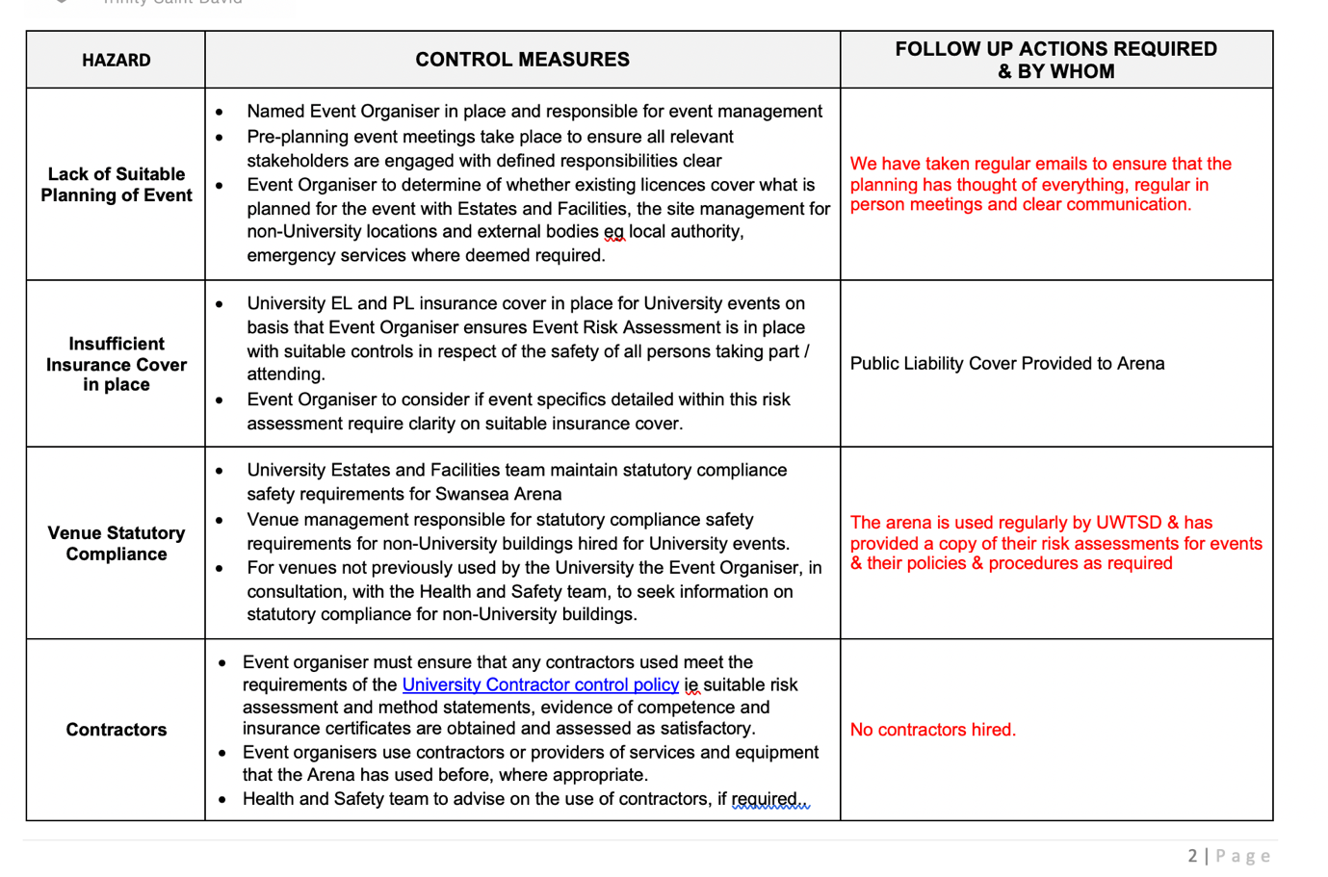
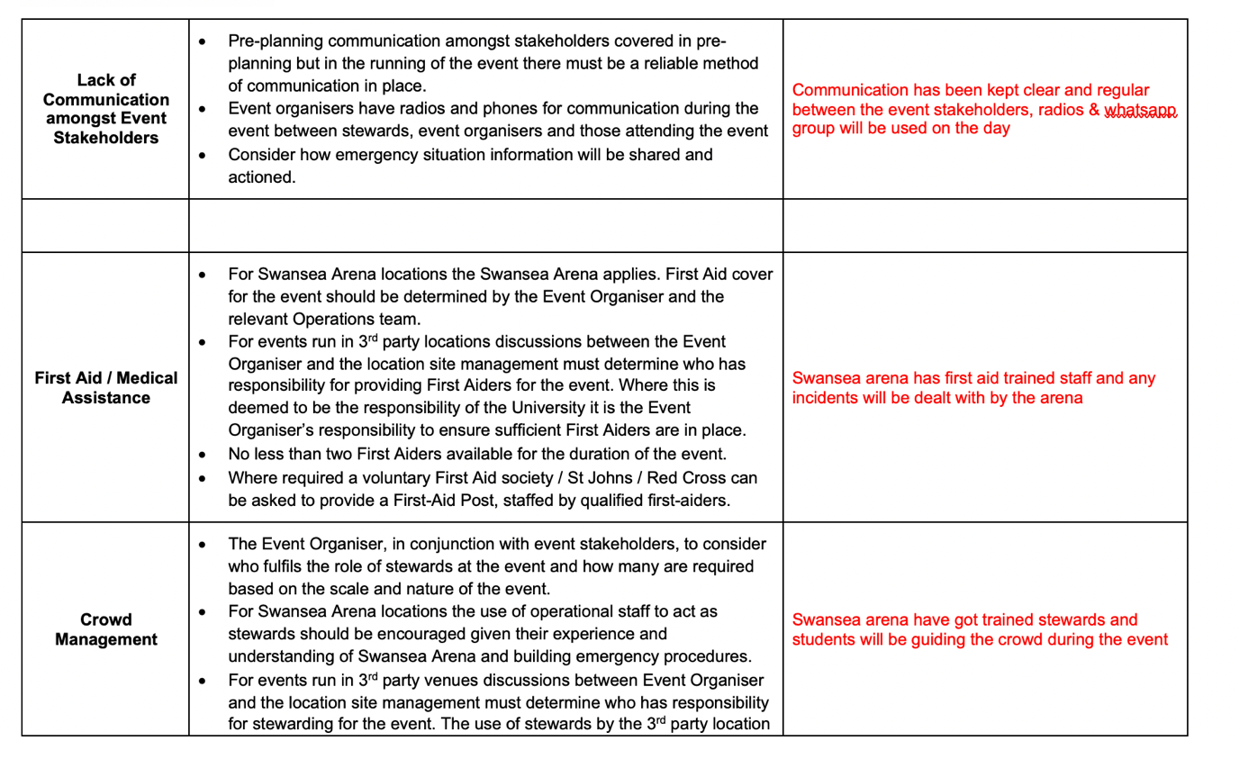
G.

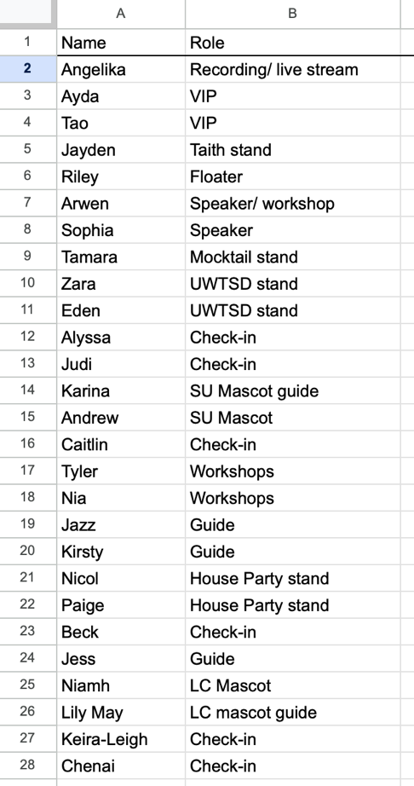
H.

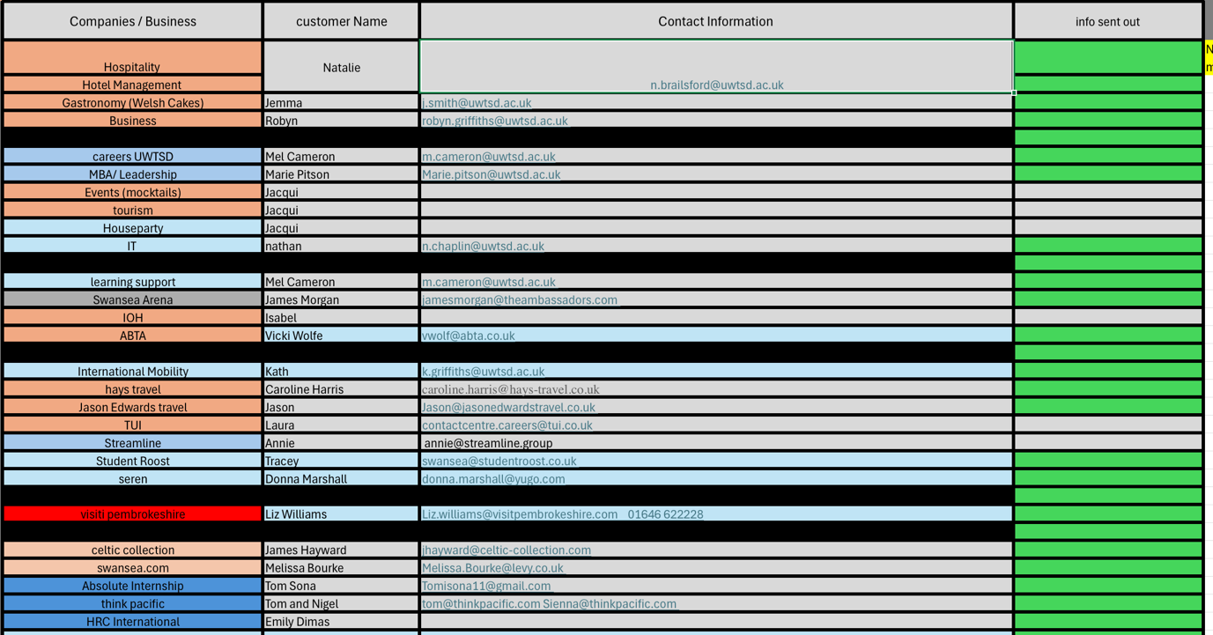

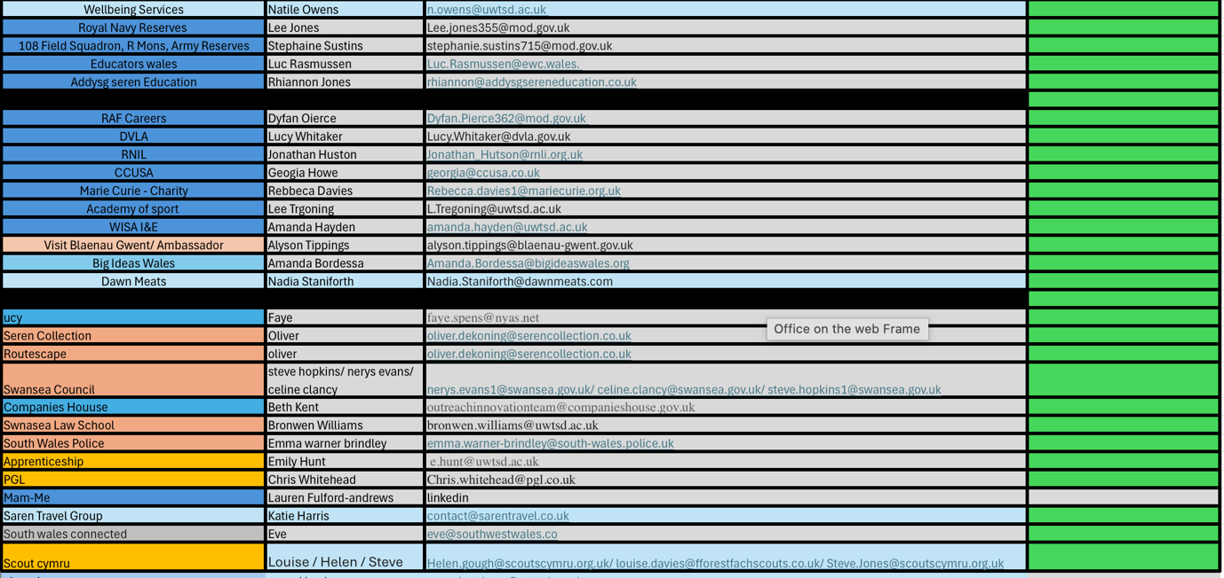
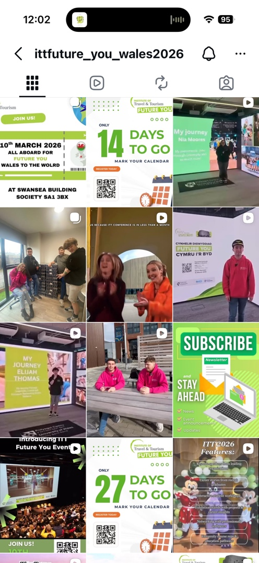
J.

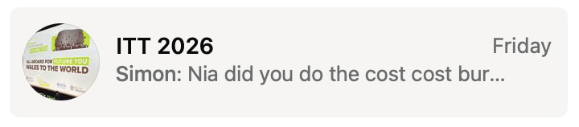
K.

Reference List
BBC Bitesize (2024). What are stakeholders? - BBC Bitesize. [online] BBC Bitesize. Available at: https://www.bbc.co.uk/bitesize/articles/zyvkh4j.
Bbc.co.uk. (2022). Events: Responsibilities. [online] Available at: https://www.bbc.co.uk/safety/resources/aztopics/event-responsibilities.
Beard, A. (2016). Making a Backup Plan Undermines Performance. [online] Harvard Business Review. Available at: https://hbr.org/2016/09/making-a-backup-plan-undermines-performance.
BIMA. (2024). How To Manage a Crowded Event or Large Corporate Function | BIMA. [online] Available at: https://bima.co.uk/how-to-manage-a-crowded-event-or-large-corporate-function/.
Creators Academy. (2025). Teams Academy - Creators Academy. [online] Available at: https://creators-academy.co.uk/teams-academy/?utm_source=google&utm_medium=cpc&utm_campaign=creative_team_training&gad_source=1&gad_campaignid=23600011403&gbraid=0AAAABAcEwWbY6vPB_twF8SG6IElC0Gv2r&gclid=Cj0KCQjwm6POBhCrARIsAIG58CItqK6BSBpLL5x2AM6CJloNXqC3vNzpGOcx2Sqi4YvQvT0oW1tgWG0aAjlGEALw_wcB [Accessed 29 Mar. 2026].
DeakinCo (2023). Key Elements of Effective Teamwork. [online] DeakinCo. | Powering workplace performance. Available at: https://deakinco.com/resource/key-elements-of-effective-teamwork/.
Event Academy. (2019). Event Planning Guides - Event Academy. [online] Available at: https://eventacademy.com/guides/?utm_source=google&utm_medium=cpc&utm_campaign=1671136316&gad_source=1&gad_campaignid=1671136316&gbraid=0AAAAADwBtpL6G4f2VxdwgWtAe_Cwa88UQ&gclid=Cj0KCQjwm6POBhCrARIsAIG58CKCN5jZpKnx-VNE1yl1OT1gtay1HggGbNAmdr-TyHIYoFOAxvNsn9gaAoqMEALw_wcB [Accessed 29 Mar. 2026].
Freeman, R.E. (1984). Stakeholder theory. [online] Stakeholdertheory.org. Available at: http://stakeholdertheory.org/about/.
High Growth (2024). Why Have a Strategic Planning Meeting? [online] High Growth. Available at: https://highgrowth.com/resources/why-have-a-strategic-planning-meeting [Accessed 29 Mar. 2026].
HSE (2015). Event safety - Managing an event. [online] Hse.gov.uk. Available at: https://www.hse.gov.uk/event-safety/managing-an-event.htm.
ICC Belfast. (2025). The Complete Guide to Planning Events. [online] Available at: https://iccbelfast.com/blogs/event-planning-guide.
ITT Future You (2026). Institute Of Travel And Tourism Future You 2026. [online] Institute Of Travel And Tourism Future You 2026. Available at: https://ittfutureyou-2026-d4kf.squarespace.com [Accessed 29 Mar. 2026].
Jean-Paul Potron (2019). Auron, Saint-Etienne-de-Tinée.
Light Fantastic Production Services. (2025). Light Fantastic | Creative Event Production & Live Experiences. [online] Available at: https://lfps.co.uk/?gad_source=1&gad_campaignid=23663018856&gbraid=0AAAAA-HQ_UnFR57OTpvif3WYsV7vSwGBi&gclid=Cj0KCQjwm6POBhCrARIsAIG58CIhYNyLoEe1Vz1DUreqUcBnHTXtZauVzw866gJDNWuu1JRp_pBdy6QaAup6EALw_wcB [Accessed 29 Mar. 2026].
Mardock, K. (2024). Reflection as a Tool for Professional Growth. Imagine | Johns Hopkins University. [online] doi:https://doi.org/10T141315.814-32x32.
Middleton, T. (2024). The importance of teamwork. [online] Atlassian. Available at: https://www.atlassian.com/blog/teamwork/the-importance-of-teamwork.
NCVO (2023). Why teamwork is important. [online] NCVO. Available at: https://www.ncvo.org.uk/help-and-guidance/running-a-charity/employing-managing-staff/managing-developing-staff/developing-effective-teams/why-teamwork-is-important/.
Oxford College of Management. (2026). Oxford College of Management. [online] Available at: https://www.oxfordcollegeofmanagement.com/apm-courses/project-fundamentals-qualification/?gad_source=1&gad_campaignid=1444384704&gbraid=0AAAAAC-82WkNMxUILMjPBhKcAAnJrUAVF&gclid=Cj0KCQjwm6POBhCrARIsAIG58CIi85Je536JIVHTLHpNbme6Hqasy1lXua1InEjH7pAcAtGRhgb27_AaAtkHEALw_wcB [Accessed 29 Mar. 2026].
Sass, M. and Keil, A. (2025). Essential Communication Skills for Leaders. [online] Center for Creative Leadership. Available at: https://www.ccl.org/articles/leading-effectively-articles/communication-1-idea-3-facts-5-tips/.
The Guardian Jobs (2024). Why is team building important in the workplace? [online] Why is team building important in the workplace? Available at: https://recruiters.theguardian.com/advice/team-building-in-the-workplace.
The, P. (2024). Exhibition Planning: The Ultimate How-to Guide. [online] Exhibition Planning: The Ultimate How-to Guide. Available at: https://www.exhibitioncentreliverpool.com/resources/exhibition-planning-the-ultimate-how-to-guide/.
Trust, L. (2024). Employee Communication Techniques for a Harmonious Workplace. [online] Leadership Trust. Available at: https://leadershiptrust.co/employee-communication-techniques/.
Twin, A. (2025). KPIs: What Are Key Performance Indicators? Types and Examples. [online] Investopedia. Available at: https://www.investopedia.com/terms/k/kpi.asp.
UCD Professional Academy. (2024). Why Is Leadership Important. [online] Available at: https://www.ucd.ie/professionalacademy/resources/why-is-leadership-important/.
University of Massachusetts Dartmouth (2021). Decision-making process. [online] Umassd.edu. Available at: https://www.umassd.edu/fycm/decision-making/process/.
University of Waterloo (2025). Writing Professional Emails in the Workplace | Writing and Communication Centre. [online] uwaterloo.ca. Available at: https://uwaterloo.ca/writing-and-communication-centre/writing-professional-emails-workplace.
Vale, M. (2024). 5 Event Check-in Best Practices - Learn From Our Experiences. [online] Just Attend. Available at: https://justattend.com/blog/5-event-check-in-best-practices-learn-from-our-experiences [Accessed 29 Mar. 2026].
warwick.ac.uk. (2023). 5 ways to measure your event’s success. [online] Available at: https://warwick.ac.uk/services/conferences/content-corner/measure-success/.
www.swansea-arena.co.uk. (2026). What’s On | Swansea Arena Official Website. [online] Available at: https://www.swansea-arena.co.uk/whats-on.

