Executive Summary
Assessment of management needs and strategies for a global destination: Spain
1700776 | UWTSD
Global Tourism and Destination Management
Molly Thomas
2020
This paper will analyse the effectiveness of the tourism policies, strategies and management implemented by the national and regional Spanish tourism boards. By analysing historical, current, and future strategies the strength of the Spanish tourism industry is evident, as highlighted by its positioning within the global destination rankings. By comparing with other countries, it can be seen that there are areas of strategy in which Spain is proactive and areas in which it is reactive, this balance allows for recommendations that will help secure the stability of Spain’s tourism industry in the future. This relates to the assignment brief of “Assessing the management needs and strategies for a global destination.”

Table of Contents
Executive Summary 0
Introduction 3
Strategy 3
Destination Management 3
Tourism Policy 4
Conceptualisation 4
National Strategies 4
Historical Spanish Tourism Strategy 4
Recent Spanish Tourism Strategy -Plan Renove 2009 4
Recent Spanish Tourism Marketing Strategy- Horizon 2020 4
Future Spanish Tourism Strategy- Sustainable 2030 5
Regional Tourism Strategies 6
1992 Olympics 6
Overtourism 6
Conclusion 7
Appendix 8
Bibliography 12

Introduction
This paper will evaluate the destination management, strategies, marketing, campaigns, and policies within Spain. With tourism’s contribution to Spain’s Gross Domestic Product rising 4.75% from 9.85% in 2009 (OECD, 2017) to 14.6% in 2018 (Knoema, 2018) since the financial crisis in 2008, a detailed analysis will highlight the importance of strong strategies, policies and destination management to the recovery and success of the industry. Located in southwestern Europe, Spain shares boarders with Portugal and France (Carr & Smith, 2020). Due to the vast size of Spain it has three climates, Mediterranean, maritime and semi-arid, which allows for a variety of travel experiences (World Travel Guide, 2020). In the UNWTO’s (2019) International tourism highlights Spain is ranked second in the number of international arrivals it receives, holding an 11.7% share of all worldwide arrivals, which contributed 73,765 million dollars to the Spanish economy. Whilst Spain has a huge draw for sun and beach tourism, with 8,000km of coastline and over 230 beaches having received prestigious awards by the Spanish Tourism Quality Institute for excellent facilities, clean and safe beaches with environmentally friendly approaches (Spain.info, 2020), it also has a lot to offer the business and culture tourism markets. According to a recent SWOT analysis (See appendix 4) Spain has extraordinary natural, historical and cultural resources, a prime example would be that 15 Spanish cities have been declared World Heritage Sites by UNESCO (UNESCO, 2020). In 2018 the tourism industry in Spain overtook construction as an employment driver, with more than two million employed within the industry (Salvatierra, 2018).

Strategy
Mintzberg (1987) states that strategy is “A pattern or plan that integrates an organisations major goals, policies and action sequences into a cohesive whole” Having a tourism strategy will help a destination avoid business drift, survive any industry instability, avoid organisational fragmentation and support collaboration and coordination both internally and externally of the industry, this all ultimately helps the industry to stay proactive rather than become reactive. According to Tribe (2010) strategic decisions should be “complex rather than simple, integrated rather than isolated, proactive rather than reactive, involve major rather than minor change”. The strategic management process has four stages, strategic intent which concerns establishing a vison, designing a mission and setting objectives, strategic formulation this looks at potential strategies and analyses the environment through SWOT or PEST, strategy implementation is the stage that develops and manages new systems and structures and the strategic evaluation analyses the performance of the new strategy (Business Jargon, 2020), see appendix 1. This will be contextualized within the example of Spain.

Destination Management
According to Visit England (2020) “A Destination Management Plan (DMP) is a shared statement of intent to manage a destination over a stated period of time, articulating the roles of the different stakeholders and identifying clear actions that they will take and the apportionment of resources.” and is a form of strategy that encompasses, planning, development, finances, marketing, and operations. These plans are implemented to benefit the destinations tourism economy by effectively managing resources through identification and prioritisation of areas of need, strengthening the quality of visitor experience, management of social and environmental impacts and increasing the support and funding to the industry, but also to make it a better place to live through incentives such as strengthening the amenities available to both the locals and tourists, such as restaurants, public transport or leisure facilities or by increasing the accessibility to jobs (Visit England, 2020).

Tourism Policy
“Tourism policy represents a means by which local, regional, national and supranational institutions and organisations and accomplish the adopted goals of tourism development” (Vucetic, 2009). With tourism affecting economic, socio-cultural, and environmental aspects of the destination, policies are in place to protect and effectively manage the effects of tourism on those areas (LinkedIn, 2015).

Conceptualisation
These theoretical frameworks can be used to analyse the use and effectiveness of historical, current and future Spanish tourism strategies on a national and regional scales.

National Strategies

Historical Spanish Tourism Strategy
The Spanish national stabilization plan (1959) and development plan (1963) was the beginning of its tourism industries growth (O’Callaghan, 2020) During what is commonly known as the Fordist phase (1951- 1975) Spain’s tourism strategy was to become a mass package holiday destination (Garcia, 2014). This strategy aligns with Porter’s (1985) generic competitive strategies. During this time period the international package holiday was relatively new, Thomas Cook & Son began promoting packages to Italy, Spain and Switzerland during the 1950’s (Leadbeater, 2019). Spain’s focus on becoming known as ‘the’ package destination was a competitive focus strategy aimed at a smaller tourist segmentation that in the process excluded other areas of the tourism market to allow for a singular focus that would ultimately become the destinations brand (Nedelea, 2014). In a recent SWOT analysis (See appendix 4) it is suggested that the package holidays “dependence on the sun and beach product” could be a weakness for the tourism industry.

Recent Spanish Tourism Strategy -Plan Renove 2009
To combat the devastating impact of the 2008 Spanish financial crisis the ‘Plan Renove’ strategy (2009) was implemented. This was a program that offered tourism businesses low interest rate loans to improve the industry by supporting small businesses and enhancing their offerings to the tourist, a set of requirements were laid out to make a business eligible for this loan, many of which regarded to creating an environmentally sustainable industry, see appendix 1 for complete list (OEDC, 2010). Plan Renove was deemed a success in 2011 as reports suggested the recovery of the industry heavily relied on the 300 million euros available to businesses over the previous years.

Recent Spanish Tourism Marketing Strategy- Horizon 2020
The ‘Spanish Tourism Plan Horizon 2020’ was developed in 2008 with the goal to “Make the Spanish tourism system the most competitive and sustainable by 2020, contributing the maximum level of social well-being” (España, 2008). This plan aimed to develop new economic advantages, improve product value to the tourist, stabilise the sustainability of the tourism model and improve the destinations competitiveness. Each objective lays out ways in which it ca be achieved, an example would be that to improve value Spain needed to emphasize the quality of what they have to offer in service, equipment and infrastructure, specifically developing an attention to detail culture regarding service, see appendix for further information.
Spain faced several challenges during the span of this strategy to become more sustainable (TURESPANA, 2012). Spain discovered it needed to reduce the seasonality of tourism demand and to overcome this they introduced the Europe Senior Tourism Program that ran between October and April to produce active holiday experiences for over 55’s as a package deal, receiving over 31,000 booking, the success of this is still seen in 2020 with current statistics showing 150,000 seniors have taken part since (EST, 2020). They also faced challenges regarding conserving and giving value to natural and cultural heritage tourism, this was tackled with the ‘Cultural Tourism Promotion’ (2010-2012), which aimed to promote cultural products including museums, performing arts, world heritage sites, the Spanish language and traditional Spanish lifestyles (IBP, 2020). On the official Spanish tourism website, the diversity of cultural experiences available ranges from a ‘Picasso Walking Tour’ in Barcelona to Doñana National Park (España,2020). This is another huge success as between 2012 and 2018 cultural tourism sites and attractions saw a 23% increase in attendance (Gerrad, 2018).
As the year 2020 is here, Spain is now expected to release a review of it’s Horizon strategy, as this document is not yet available it is paramount to this paper that the researcher is able to review the strategy from a personal standpoint, using the Visit Wales (2016) strategy progress review of it’s Partnership for Growth strategy as guidance. Regarding the Horizon 2020 goal to improve Spain’s competitiveness, it should be acknowledged that whilst there has only been a small percentage share increase (+0.3%) of tourist arrivals between 2009 – 2019 it has remained a key competitor within the top 5 worldwide destinations for ten years (UWNTO, 2020). They also showcase the increase in value available to tourists traveling to Spain through the diverse range of tourism products, which was one of their main objectives when the strategy was initiated.

Future Spanish Tourism Strategy- Sustainable 2030
The next strategy Spain’s tourism industry is developing is the ‘Sustainable Tourism Strategy 2030’, addressing the medium- and long-term challenges regarding socioeconomic, environmental and territorial aspects of sustainable tourism. Spain has recognised that it is no longer feasible to measure the success of its tourism model solely on the number of arrivals and that the sustainability of the model will ultimately keep the Spanish tourism industry alive (Gobierino de España, 2020). With a set goal of “laying the foundations for the transformation of Spanish tourism towards a model of sustained and sustainable growth, which allows it to maintain its position of world leadership. The new model will be supported by capacity improvement competitiveness and profitability of the industry, in the natural and cultural values destination differentials, and in the equitable distribution of benefits and the burdens of tourism.” (Goierino de España, 2019). The secretary of state for tourism has moved onto stage two of strategy development, strategy formulation and has produced a SWOT analysis of the current tourism industry, see appendix 4.
This strategy sets out five foundational objectives:
- Collaborative governance
- Sustainable growth
- Competitive Transformation
- Tourist space, companies and people
- Product marketing and tourist intelligence.

It could be argued that this is a reactive strategy following in the footsteps of Nordic countries ‘Plan for Nordic Tourism Co-Ordination 2019-2023’ which sets out similar objectives including sustainable growth and collaboration of governments. This plan has a shorter span and has already reached the implementation stage (Nordic Council of Ministers, 2019). However recent reports suggest Germany has some of the worlds leading sustainable tourism practices (Climate Action, 2018). In 2016 Germany launched a national competition to highlight its most sustainable tourism destination, with the objective to raise the industries awareness of its impacts as well as to encourage and support development of sustainable practices (One Planet, 2018). The criteria included assessment of the economic, environmental, social and management of sustainability issues. The finalists were rewarded with the opportunity to feature in a national advertising campaign. This helped the country to gain strategic coherence regarding their move towards becoming a sustainable tourism destination (DMU, 2017). The Spanish stratgegy aligns itself with the European sustainable development goal for 2030 (European Commision, 2020), highlighting the value and importance Spain as a country places on a sustainable future.

Regional Tourism Strategies
Due to the vast size of Spain, regional strategies, policies and marketing schemes are key to successful destination management, this has been conceptualized for this paper in Barcelona, Spain. In 2019 Barcelona received 9.12 million arrivals, which was an increase of 8 million since 1990 (Statista, 2020).

1992 Olympics
The 1992 Barcelona Olympics provided the city with significant investment of $11.4 billion funding new roads, sewage systems and the development of a 78% increase in beaches and green areas within the city. The benefits to Barcelona’s tourism industry were exponential boosting it from the eleventh best city in Europe to the sixth (Taylor, 2012). As a tourism strategy by hosing the Olympics Barcelona expanded its tourist capacity and put its name out there to the world as a leading tourist destination, during the planning for the Olympics it saw the creation of the Tourism de Barcelona consortium, which still governs the tourism industry there today. In the years following the games Barcelona boosted its marketing towards sporting events as the infrastructure was now in place to support them and marketed itself as the only major urban, sand and sun destination, due to this the city predicted a 150% rise in hotel beds between 1990- 2004 (84% rise between 1990- 2002) and between 1992-2001 an increase of 147% cruise dockings boosting it to the position of leading Mediterranean port (Duran, 2002). The success of the destination management during this period is what has shaped Barcelona to become the destination it is today.
When compared with the effects on tourism of the London Olympics in 2012 the success of Barcelona’s use of the games to increase its tourism positioning is incomparable. Whilst similarly to Barcelona, London received a boost to the number of tourist arrivals during the Olympic year, costs as high as 14.6 billion dollars occurred , and it has been suggested that no profit was made in relation to the Olympics (International Olympic Committee, 2013), whereas in Barcelona costs of 9.3 billion dollars were spent predominantly on infrastructure and they ultimately made a profit of 10 million dollars(Flyvbjerg & Stewart, 2012). London followed in the footsteps of Barcelona and also ran a post-Olympic sporting event marketing strategy including a 90 million dollar conversion of the stadium to a football ground for their ‘Gold Event series’ that was equally as successful (Bond, 2013), cementing Barcelona as a proactive leader in regards to its utilisation of the Olympics to boot tourism.

Overtourism
During the diagnosis stage of preparation for Barcelona’s tourism strategy for 2020, it was identified that the city was suffering from ‘overtourism’ (Barcelona Tourism Department, 2017). This suggests the city has passed Butlers product lifecycle stagnation stage and unless it is addressed could lead towards the decline of Barcelona as a tourism destination. Overtourism is not a sustainable practice as it impacts on all three pillars of sustainability, by addressing this issue Barcelona are already working towards the 2030 sustainability strategy. To help rejuvenate the city it was proposed that the number of tourists need to be curbed, and the 2020 tourism policy addresses this through the accommodation sector. New policies include not issuing licences for new accommodations and regulations which reduce the number of short-term lets within the city (Responsible Travel, 2020). Theoretically this will reduce the provision of accommodation to tourists and therefore limit tourist numbers, however this could also lead to illegal lettings and accommodations that aren’t regulated which could ultimately impact the destination image and cause it to fall from 5th highest ranked tourist city in the world (Catalan News, 2019). This plan has a number of other programs that aim to return Barcelona to being a sustainable tourist destination that values the social, economic and environmental on an equal plane, see appendix 5.

Conclusion
The future of Spanish tourism was threatened by the 2017 terror attacks in Barcelona and Cambrils, in which fourteen people died (Zhou, 2017), leading to Spain raising its treat level to severe and travel advise warned tourists to avoid high risk areas, in response they released a 2017 National Security Strategy and an updated Counter- Terrorism Strategy in 2019 which centres around preventing, protecting, persecuting and preparing a response for any future terrorist attacks (Gobierno De Espana, 2019). In early 2020 the invisible attack of COVID-19 threatened the worldwide tourism industry. Whilst it is still too early to comment on the specific impact on Spain’s tourism industry, in April 2020 Spain lost 90% of air connectivity, which accounted for a loss of 11.5 million seats and saw a 87% drop in flight searches to Spain (Rokou, 2020). With tourism and hospitality businesses slowly re opening with much lower capacities the economic impact for European countries including Spain that heavily rely on tourism may be devastating (Henley, 2020).
The author has made the following recommendations to improve the strength and resilience of Spain’s tourism strategies, policies, and destination management.
- Whilst the package holiday put Spain on the map it has so much more to offer and it may strengthen its destination management to further focus on its niche tourism products including its golf tourism which has already been part of a successful marketing strategy and its religious festivals as Spain has so much to offer including its world renowned Semana Santa celebrations.
- With the significant loss of tourism levels due to COVID-19, in the future Spain may need to implement similar strategies that were used in the 2009 plan renvoe to bail out businesses that are damaged by the loss of tourism.
- With so much money being spent on Barcelona’s infrastructure in preparation for the Olympics they may now want to look at the technological advances available to the industry as their base product is well established, specifically the use of social media within its marketing strategy as current offerings are minimal, perhaps a campaign similar to the Visit Wales #EPIC (Inspiretec, 2020).
- With plans already in place to combat overtourism within Barcelona through accommodation, they may also benefit from evaluating other options including limiting flights and reducing seasonality by marketing the highlights of out of season events. They may also wish to look to Amsterdam for inspiration on creative solutions that aren’t prohibitive strategies, such as the ‘Discover the City’ app which notifies the tourist when a certain attraction is very busy and offers lesser known alternatives, to diversify the tourist attractions (Caffey, 2017).
- To further their future sustainability program, it might be advisable to assess the policies and competition that took place in Germany to improve awareness of their tourism industry as discussed above.

The worldwide future of tourism is currently in an unstable position but proactiveness and cohesiveness of National and Regional tourism boards in Spain will ensure a swift and stable return to normalcy through effective policies, strategies, and management.

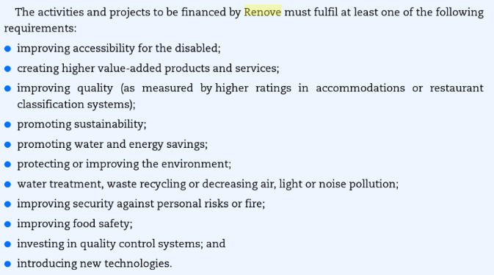
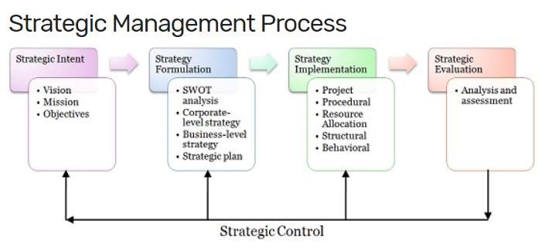
Appendix
Appendix 2
Appendix 1
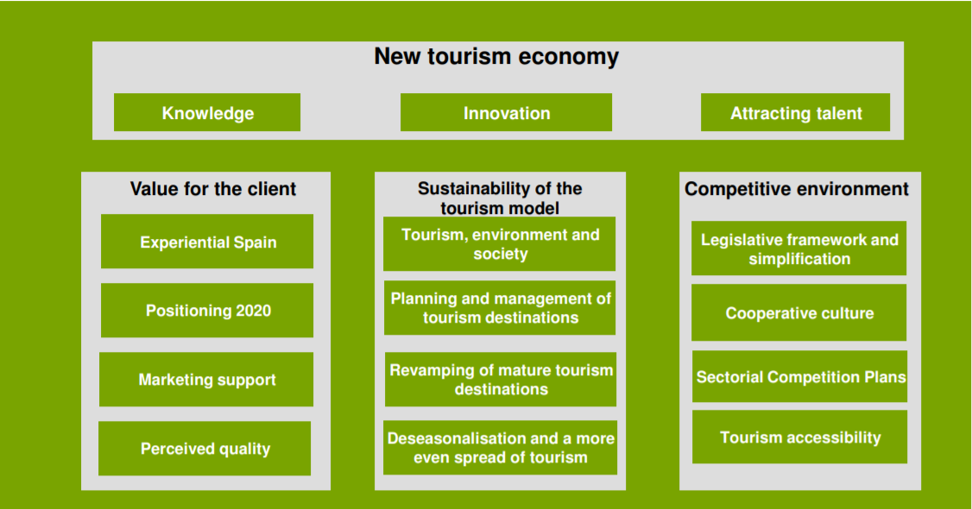
Appendix 3
Appendix 4
STRENGTH  - Extraordinary tourist, natural and historical and cultural heritage resources. Spain is the leader in the number of blue flag beaches, the second country in the world in declared cultural historical heritage protected by UNESCO (World Heritage humanity). It is also the European leader in protected natural areas adhering to the European Charter for Sustainable Tourism; and leader in Biosphere Reserves.  - An excellent sun and beach product, in which Spain enjoys a magnificent positioning in its natural markets in Europe. World leader in tourism vacation.  - Excellent climatology, geographical proximity and high connectivity (especially air) with the main issuing markets.  - A very appropriate lifestyle for the tourist experience. Wide offer of entertainment and leisure.  - High fidelity of international tourists with a repetition rate in their holidays to Spain higher than 80%.  - High levels of quality and service of the tourist offer. Good value for money.  - Critical infrastructure such as airports, roads, trains and ports adapted to use tourist recognized for its quality.  - High levels of security throughout the territory and quality public services. Very especially health care.  - Public-private ecosystems highly experienced in the exercise of their responsibilities.  - Great professionalism of the workers in the sector.  - Large and medium-sized cities consolidating as short break destinations , with good internal connection and with Europe | WEAKNESS  - The dependence on the sun and beach product. A product that works extraordinarily well and it should be empowered to make it more efficient in the face of possibility of losing profit margins.  - The great dependence on certain markets. The United Kingdom, France, and Germany they represent more than 50% of international visitors. Currently, they are developed plans to attract other markets, with positive results, but proportionally small.  - The high seasonality in the consumption of the Spanish tourist offer, derived, largely measure, from previous dependencies.  - The saturation of the citizen space of some urban destinations. According to the INE, of the total of 1,800,000 hotel beds throughout the territory, 330,000 are in cities, a number that has remained stable in recent years against the growth of the 50% per year experienced by the supply of tourist homes. In the main cities in the country, the number of places in housing for tourist use may exceed that of hotel beds since 2016.  - The obsolescence of some pioneering holiday destinations that affects their competitiveness.  - The untapped potential of tourism in rural areas, despite the fact that Rural accommodation companies have tripled in the last 15 years, to 17,000 tourism continues unconsolidated as a viable economic alternative for many inland territories.  - The digital divide, which excludes many SMEs from tourism, either because they do not are visible in the digital space, either because they are unable to meet the demands of the new connected client.  - The new platforms, which have pulverized the tourist models of our cities and destinations.  - And finally, the progressive precariousness of working conditions in the sector, which they especially affect women.
OPPORTUNITY  - The increase in international and national demand.  - Improved connectivity.  - The appearance of new highly experiential demand segments.  - The development of new tourist products and the developed digital environment for your promotion and consumption. A powerful tourist offer has been developed in cities and in the rural environment, with high levels of quality, but its weight in the tourist balance is still little.  - Market diversification with the incorporation of emerging markets such as Asians, who prefer alternative products to the sun and beach, and for whom Spain is an attractive proposal, with a capacity for improvement in its positioning.  - The importance of the tourism sector as a vector for the development of the SDGs 2030 and the call from the international community to join them as a strategy. | THREATS  - Brexit, which will involve a change in the legal situation of residents in our main tourist market.  - The tourist recovery of competing destinations in the Mediterranean.  - The foreseeable pressure of demand on infrastructure, natural resources and destinations as a result of its growth.  - Competition in the allocation of resources, mainly economic, for attend to the necessary modernization of the system.  - Climate change, and its impact on water resources, coastal destinations and climatology.  - The progressive depopulation of rural areas, and the education and training of people who have to attend the tourist sector.

Appendix 5
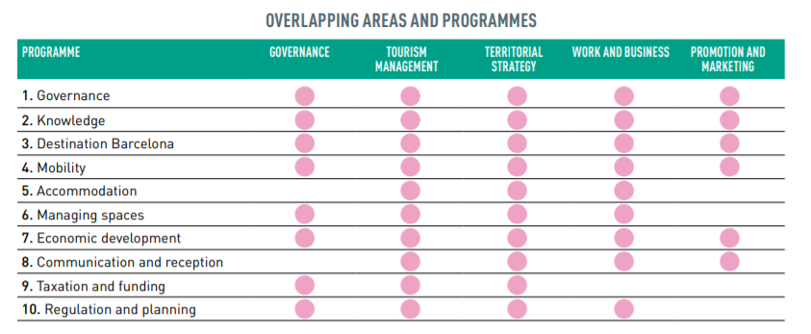

Bibliography
Barcelona Tourism Department. (2017) A Collective Strategy for Sustainable Tourism. [Online] Available at: https://ajuntament.barcelona.cat/turisme/sites/default/files/barcelona_tourism_for_2020.pdf (Accessed on: 04/06/2020)
BMU. (2017) Sustainable Tourism Destinations. [Online] Available at: https://www.bmu.de/download/nachhaltige-tourismusdestinationen/ (Accessed on: 02/06/2020)
Bond, D. (2013) West Ham get Olympic Stadium after government ups funding. [Online] Available at: https://www.bbc.co.uk/sport/football/21889864 (Accessed on: 02/06/2020)
Business Jargon. (2020) Strategic Management. [Online] Available at: https://businessjargons.com/strategic-management.html (Accessed on:28/05/2020)
Carr, R. and Smith, C.D. (2020) Spain. [Online] Available at: https://www.britannica.com/place/Spain (Accessed on: 29/05/2020)
Catalan News. (2019) Barcelona rises to fifth place in World’s Best Cities Ranking. [Online] Available at: https://www.catalannews.com/life-style/item/barcelona-rises-to-fifth-place-in-world-s-best-cities-ranking#:~:text=The%20ranking%20published%20at%20the,)%20and%20Sydney%20(23rd). (Accessed on: 04/06/2020)
Climate Action. (2018) European Countries Lead New Rankings in Sustainable Tourism. [Online] Available at: http://www.climateaction.org/news/european-countries-lead-new-rankings-in-sustainable-tourism (Accessed on: 02/06/2020)
Coffey, H. (2017) Amsterdam has a new solution for Overtourism. [Online] Available at: https://www.independent.co.uk/travel/news-and-advice/amsterdam-overtourism-solution-tourists-technology-van-gogh-museum-canal-boat-rides-a8015811.html (Accessed on: 08/06/2020)/
Duran, P. (2002) The Impact of the Olympic Games on Tourism. [Online] Available at: https://www.academia.edu/34902125/The_impact_of_the_Olympic_Games_on_tourism (Accessed on: 02/05/2020)
España. (2008) Spanish Tourism Plan Horizon 2020. [Online] Available at: https://www.modul.ac.at/uploads/files/research/tourmis/2008/International_Seminar_Spanish_Tourism_Plan__de_Paz_.pdf (Accessed on: 01/06/2020)
España. (2020) Arts and Culture. [Online] Available at: https://www.spain.info/en_GB/que-quieres/arte/ (Accessed on: 01/06/2020)
EST. (2020) Objectives. [Online] Available at: http://www.europeseniortourism.eu/en/queesest/objetivos/ (Accessed on: 01/06/2020)
European Commission. (2020) Sustainable Development Goals. [Online] Available at: https://ec.europa.eu/info/strategy/international-strategies/sustainable-development-goals/eu-approach-sustainable-development-0_en (Accessed on: 08/06/2020)
Flyvbjerg, B. and Stewart, A. (2012) Olympic Proportions: Cost and Cost Overrun at the Olympics 1960-2012. [Online] Available at: https://eureka.sbs.ox.ac.uk/4943/1/SSRN-id2382612_(2).pdf (Accessed on: 02/06/2020)
Garcia, F.A. (2014) A Comparative Study of the Evolution of Tourism policy in Spain and Portugal. [Online] Available at: file:///C:/Users/molly/Downloads/ArtculoResearchGate.pdf (Accessed on: 28/05/2020)
Gerrad, J. (2018) Cultrual Tourism Continues to Rise in Spain. [Online] Available at: https://www.euroweeklynews.com/2018/08/19/cultural-tourism-continues-to-rise-in-spain/ (Accessed on: 01/06/2020)
Gobierino de España. (2019) General Guidelines of the Sustainable Tourism Strategy of Spain 2030. [Online] Available at: https://turismo.gob.es/es-es/estrategia-turismo-sostenible/Documents/directrices-estrategia-turismo-sostenible.pdf (Accessed on: 02/06/2020)
Gobierino de España. (2020) Sustainable Tourist Strategy of Spain 2030. [Online] Available at: https://turismo.gob.es/en-us/estrategia-turismo-sostenible/Paginas/Index.aspx (Accessed on: 02/06/2020)
Gobierno De Espana. (2019) Government of Spain publishes National Counter-terrorism Strategy for the first time. [Online] Available at: https://www.lamoncloa.gob.es/lang/en/gobierno/news/Paginas/2019/20190226terrorismstrategy.aspx (Accessed on: 04/06/2020)
Henley, J. (2020) COVID-19 Throws Europe’s Tourism Industry into Chaos. [Online] Available at: https://www.theguardian.com/world/2020/may/02/covid-19-throws-europes-tourism-industry-into-chaos (Accessed on: 04/06/2020)
IBP. (2020) Spain: Electoral, Political Parties Laws and Regulations Handbook. [Online] Available at: https://books.google.co.uk/books?id=8xatDwAAQBAJ&pg=PA69&lpg=PA69&dq=Promotion+Plan+2010-2012+for+Cultural+Tourism&source=bl&ots=JHdQ683Jyj&sig=ACfU3U0njRbK7iLUIl0iPJ1JWsJAoqaWgw&hl=en&sa=X&ved=2ahUKEwiHwqjfweDpAhWHY8AKHYYAD4gQ6AEwAHoECAkQAQ#v=onepage&q=Promotion%20Plan%202010-2012%20for%20Cultural%20Tourism&f=false (Accessed on: 01/06/2020)
Inspiretec. (2020) #FindYourEpic. [Online] Available at: https://www.inspiretec.com/case-studies/find-your-epicAccessed on: 08/06/2020)
International Olympic Committee. (2013) London 2012 Facts and Figures. [Online] Available at: https://stillmed.olympic.org/media/Document%20Library/OlympicOrg/Games/Summer-Games/Games-London-2012-Olympic-Games/Facts-and-Figures/Factsheet-Facts-and-Figures-London-2012.pdf#_ga=2.161354744.439864709.1591109732-985090964.1591109732 (Accessed on: 02/06/2020)
Knoema. (2018) Spain- Contribution of Travel and Tourism to GDP as a share of GDP. [Online] Available at: https://knoema.com/atlas/Spain/topics/Tourism/Travel-and-Tourism-Total-Contribution-to-GDP/Contribution-of-travel-and-tourism-to-GDP-percent-of-GDP (Accessed on: 26/05/2020)
Leadbeater, C. (2019) The history of Thomas Cook, from tours for teetotallers to boozy packages in Spain. [Online] Available at: https://www.telegraph.co.uk/travel/tours/history-of-thomas-cook/ (Accessed on: 28/05/2020)
LinkedIn. (2015) Slide Share- Tourism Policies. [Online] Available at: https://www.slideshare.net/tellstptrisakti/tourism-policy?next_slideshow=1 (Accessed on: 28/05/2020)
Nedelea, A. (2014) Business Strategies in Tourism. [Online] Available at: file:///C:/Users/molly/Downloads/BusinessTourism.pdf (Accessed on: 28/05/2020)
Nordic Council of Ministers. (2019) Plan for Nordic Tourism Co-Operation 2019-2023. [Online] Available at: https://norden.diva-portal.org/smash/get/diva2:1330360/FULLTEXT02.pdf (Accessed on: 02/06/2020)
O’Cllaghan, J.F. (2020) Franco’s Spain 1939-75. [Online] Available at: https://www.britannica.com/place/Spain/Francos-Spain-1939-75#accordion-article-contributors (Accessed on:28/05/2020)
OEDC. (2010) Tourism Trends and Policies. Paris: OEDC Publishing [Online] Available at: https://books.google.co.uk/books?id=UC7WAgAAQBAJ&pg=PA251&lpg=PA251&dq=spain%27s+tourism+plan+renove&source=bl&ots=pRB7NqDiQC&sig=ACfU3U3dkEi0O3YO_u_ahIp2A2meqspJJw&hl=en&sa=X&ved=2ahUKEwjWgs2R3NHpAhUfQhUIHXwLDA0Q6AEwAHoECAcQAQ#v=onepage&q=spain's%20tourism%20plan%20renove&f=false (Accessed on: 26/05/2020)
OEDC. (2017) Tourism GDP. [Online] Available at: https://data.oecd.org/industry/tourism-gdp.htm (Accessed on: 26/05/2020)
One Planet. (2018) Germany’s Federal Competition for Sustainable Tourism Destinations. [Online] Available at: https://www.oneplanetnetwork.org/initiative/germanys-federal-competition-sustainable-tourism-destinations (Accessed on: 02/06/2020)
Responsible Travel. (2020) Overtourism in Barcelona. [Online] Available at: https://www.responsibletravel.com/copy/overtourism-in-barcelona (Accessed on: 04/06/2020)
Rokou, T. (2020) Effects of the COVID-19 Crisis in Spain. [Online] Available at: https://www.traveldailynews.com/post/effects-of-the-covid-19-crisis-in-spain (Accessed on: 04/06/2020)
Salvatierra, J. (2018) Tourism replaces construction as Spain’s main employment driver. [Online] Available at: https://english.elpais.com/elpais/2018/08/20/inenglish/1534753732_181559.html (Accessed on: 04/06/2020)
Spain.info. (2020) Beaches with the Q for Quality Award. [Online] Available at: https://www.spain.info/en_GB/reportajes/playas_con_q_de_calidad.html (Accessed on: 01/06/2020)
Statista. (2020) Number of Tourists in Hotels in Barcelona City from 1990-2019. [Online] Available at: https://www.statista.com/statistics/452060/number-of-tourists-in-barcelona-spain/ (Accessed on: 02/06/2020)
Taylor, A. (2012) How the Olympics Changed Barcelona Forever. [Online] Available at: https://www.businessinsider.com/how-the-olympic-games-changed-barcelona-forever-2012-7?r=US&IR=T (Accessed on: 02/05/2020)
TURESPANA. (2012) Annual Tourism Reporting Template. [Online] Available at: http://aei.pitt.edu/53093/1/spain__2012_.pdf (Accessed on: 01/06/2020)
UNESCO. (2020) Presentation of the Group. [Online] Available at: http://www.ciudadespatrimonio.org/presentaciondelgrupo/index.php?idioma=en (Accessed on: 01/06/2020)
UNWTO. (2019) International Tourism Highlights. [Online] Available at: https://www.e-unwto.org/doi/pdf/10.18111/9789284421152 (Accessed on: 29/05/2020)
UNWTO. (2020) ELibrary. [Online] Available at: https://www.e-unwto.org/ (Accessed on: 08/06/2020)
Visit England. (2020) Principle for Developing Destination Management Plans. [Online] Available at: https://www.visitbritain.org/sites/default/files/vb-corporate/Documents-Library/documents/England-documents/dm_plans_guiding_principles.pdf (Accessed on: 26/05/2020)
Visit Wales. (2016) Strategy Progress Review: Partnership of Growth: Strategy for Tourism 2013-2020. [Online] Available at: https://gov.wales/sites/default/files/publications/2019-07/partnership-for-growth-strategy-for-tourism-2013-to-2020-strategy-progress-review.pdf (Accessed on: 08/06/2020)
Vucetic, A. (2009) Influence of Travel Agencies on Selective Tourism Development in Montenegro. [Online] Available at: https://papers.ssrn.com/sol3/papers.cfm?abstract_id=3166303 (Accessed on: 28/052020)
World Travel Guide. (2020) Spain Weather, Climate and Geography. [Online] Available at: https://www.worldtravelguide.net/guides/europe/spain/weather-climate-geography/ (Accessed on: 29/05/2020)
Zhou, N. (2017) Timeline of terror in Spain: how Barcelona and Cambrils attacks unfolded. [Online] Available at: https://www.theguardian.com/world/2017/aug/18/terror-timeline-of-barcelona-and-cambrils-attacks-and-other-terror-raids (Accessed on: 04/06/2020)

