Sample Assignment for guidance purpose only!
Mergers and Acquisitions
Table of Contents
Executive summary 1
Mergers and acquisition 1
The secret of success in M&A 1
International Harmonization in M&A 3
Organization structure and employee 4
Taxation 4
Accounting and funding 4
Conclusion 4
Reference 5

Merges & Acquisitions

Executive summary
Mergers and acquisitions activities are quite active across countries especially in the UK and USA compared with German and Japan. This paper discusses the trends and success of mergers and acquisitions in these four countries. The debates argue that most mergers and acquisitions fail but they are still popular. The report discovered that M&A activities are still active according to negative financial performance. However, the reports found out that the motives of M&A are not only financial performance but also other motives such as purse market power. In addition, this paper also discovered possibilities of international harmonization in the mergers and acquisitions field. The main research method of this paper is secondary research use reliable resource such as BBC News, Financial times and some other journal articles.

Mergers and acquisition
Coyle. B (2000) defined that ‘mergers & acquisition (M & A) occur when two or more organization join together all or part of their organization.’ To differentiate merge and acquisition is focus the elements of the relative size of individual companies and ownership of management control.
He supported that in narrow terms, merges mean that two companies joint together and become one company to share their resources. Acquisition mean that one company takes over another company. Mergers occur when two companies has roughly same size, similar structure and neither company needs acquired. Acquisition is one company buys another company stocks and assets. Acquisition is paid by cash often. Acquisition can be paid partially to fully from 50%-100%.
The reason for buyer of M&A activities is to seek financial opportunities and business growth. When two companies joint together, they share the resources include material and human resources, and it will reduce the cost of expenses. M&A also gains market share and reputations. The joint companies can share the risks as well. The reason for selling is that the company may suffer financial difficulties and partially unprofitable. Business considers that it will be more profitable for stockholders if they sell some part of business. The following is going to give some trends and examples of M&A activities in UK, USA, Japan and Germany.

The secret of success in M&A
According to statistics below, it shows the trends of merges and acquisitions of the USA. Since 1985, there are more than 300,000 mergers & acquisition transactions. The number of M&A activities reached the highest in 1998 which is about 15,000. The peak value of the transaction is 2,380 billion USD in 2015.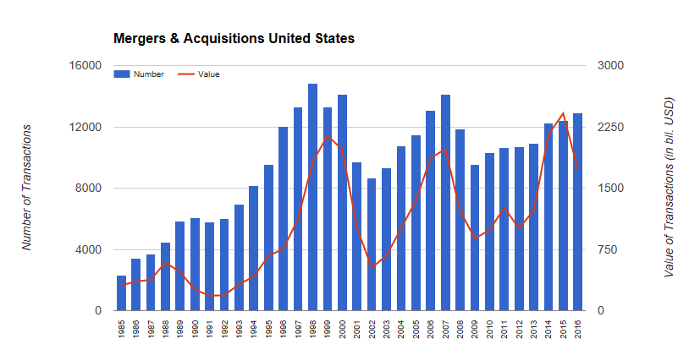
(Chart 1, Source: IMAA-Institute (2017), https://imaa-institute.org/m-and-a-us-united-states/)
UK is also an active country in M &A Show in chart 2 as below. In 1999, the value of the transaction reached peak which is around 450 billion. In 2000, the number of the transaction is the biggerst which is about 4700. From 2013, M&A activities has an continuous growth to 2015 and then dropped in 2016. The IMAA forecast that it is going to increase a little bit in the 2017.
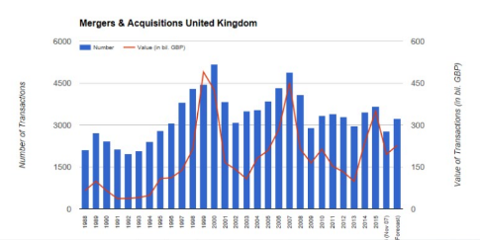
(Chart 2, source: IMAA-Institute (2017), https://imaa-institute.org/m-and-a-uk-united-kingdom/)
Compare with industries countries such as German and Japan. It indicates the less active transactions as below. The highest value of the transaction is in 1999 which reach to over 450 billion. This was competitive with UK in 1999. However, after 1999, M&A values drop dramatically in German.
.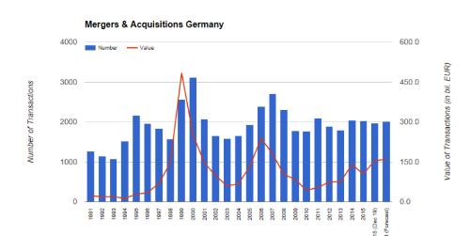
(Chart 3, source: IMAA-Institute (2017), available at: https://imaa-institute.org/mergers-acquisitions-germany/))
Before 1998, Japan has low awareness on M&A. Since 1998, a lot of firms started merge and take over, the number of the mergers was not big in 1999 but it reached highest value in the country which is around 230billion dollars.
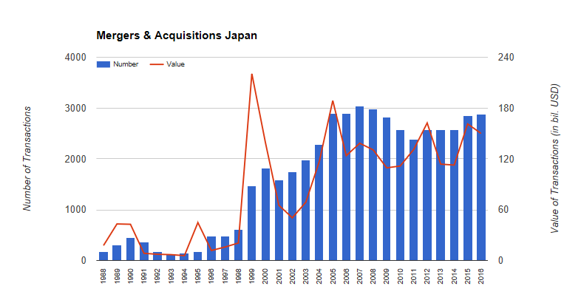
(Chart 4, IMAA-Institute, (2017) https://imaa-institute.org/m-and-a-statistics-countries/)
The statics shows that M&A transaction is active and there is a lot of value in the transaction. However, Hope K. (2014) in BBC news demonstrated that many merges are not profitable. It is reported that German carmaker Daimler and US firm Chrysler was merged 10 years ago and now Daimler sell of Chrysler and loss billions of dollars. Unsuccessful performance is similar to eBay and Skype. EBay paid 2.6 billion to skype and after 4 years it lost 0.6 billion. Steve Tappin reported that 80-20 rules apply to merges and acquisitions which is 80% failure and 20% success.
He said, In 2012, Walgreens buy 45% stake of Alliance Boots. Mr Pessina states that mergers is long term strategy and not rushing relationship. It should allow giving time for two companies working together. He believes that M&A create more such as finding right partners and sharing individual cultures rather than financial performance.
Adidas- Rebook mergers is the success to indicate that M&A gain the market share. BBC news (2005) reported that Adidas have stronger position in the US market after M&A with rebook. The market share of Adidas-rebook was 20% and Nike was 36%. The profit was rose by 1.5bn compare with 1.4bn previous year.
Financial times, McLannahan B. & Fontanella-Khan J. (2016) reported that “Japan was the most active buyers in terms of value for the third quarter with 69 deals worth 44 billion.’ It reported that Toshiba bought US nuclear group Westinghouse in 2006 and paid 5.4 billion and Toshiba loss 290million USD.
From the news and status above, as seen that a lot of business failure in M&A field in financial performance. However, the statistic shows that the growing M&A activities across the world. The question is that why firms still want to merge when they know there are high risks of financial losses?
Brouthers, Hastenburg and Ven (1998) demonstrated that financial elements is just one of the motivates for the M&A. The table below shows 12 motivates and performance for the companies. According to the table, purse market power is ranking top and some other non-financial elements are taken account. These are acquire competitor, risk spreading, create entry barrier and so on.
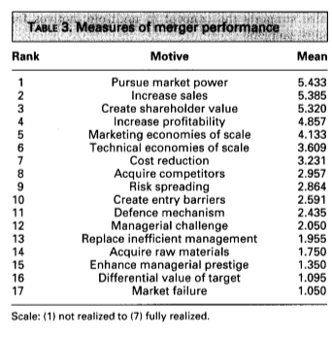(Source: Long Range Planning, 1998)
Therefore, it seems reasonable that M&A activities are popular. Some firms have different measurements of success. Financial performance is one of the measurement and some firms are more likely to improve their market share and power in M & A. As seen the example of Adidas-rebook, Woodsgreen- Alliance Boots. For long term strategic planning, M&A has high possibilities lead companies into success. In this case, success is broad but not narrow to financial elements.

International Harmonization in M&A
Mergers & acquisitions play an important role in international business. Organizational structure, employee and leadership, taxation, accounting and funding systems may be different when two companies are from different countries. These possibilities become issues for international M&A. Therefore, international harmonization and standard has high possibilities occurring in M&A field.

Organization structure and employee
Culture, organization structure, employee and leadership become issues for the international M&A. Harmonization focus on engaging people working together and understand organizational culture. When two companies joint together internationally, there is also culture difference.
Tower Watson (2013) supported that majority of M&A is a people business. The deal will not complete until business process, workforce and organization structure be integrated.

Taxation
The other international harmonization possibility can be tax harmonization. This is regarding to different corporation tax in different countries.
Merle, R. and Johnson, C. (2016) via Washington Post reported that “Pfizer and Allergan call off 160 billion USD merger after US moves to block inversions.” Pfizer US company and Allergan Dublin company scrap 160 billion merger. President Obamma announced to stop taxed avoiding merge which Pfrizer&Allegan take advantages of no corporation tax in Dublin-based Allengan. This is called tax inversion. There are increasing number of inversion because companies consider to avoid tax and make more profit. Therefore, a lot of international merges transactions were taken over 20 years.
Houlder V., Boland V. and Politi J. (2014) reported in financial times that “no tax makes Ireland more difficult to defend its system in a international climate.” Ireland is very attractive country for corporations. However, for the international business climate, other countries do not want tax avoidance because of M&A activities.

Accounting and funding
According to Shil, Das and Pramanik (2017) in International business research, they supported that harmonization of accounting should be used across the nations because it benefits organizations in the way of standard information; minimizing exchange costs, improving sharing information. International harmonization should occur in M&A according its benefits.
It could help regulators and auditors receive same information globally. Therefore, investors can make valuable decision and use resources effectively.
“Daimler Benz, who was the first German To secure stock market listing in the united states, reported a net profit of DM 158m for the six months while US GAAP reported loss 949m”
Without harmonization, information is different provided in different countries. It is very challenged for investors to analyze a company information and performance. It is more risky for the mergers to make transactions due to different information in different countries.

Conclusion
Debates on M&A demonstrates positive and negative impacts in the international business. Statues quo shows that majority M&A fails in financial performance. However, M&A activities are popular because its success upon on non-financial factors. It is challenged mergers because of differences of joint companies globally. It has high possibilities of International harmonization should occur in M&A field in international business in order to manage global organization more effectively.

Reference
Brouthers K.D., Hastenburg P. and Ven J. (1998), Long Range Planning, Vol. 31, No. 3, pp. 347 to 353, Great Britain: Elsevier Science Ltd.
Coyle, B. (2000), Mergers and acquisitions, 1st edition, Chicago: Glenlake Pub. Co.
Hope, k. (2014), When firms get together: The secret of success - BBC News, [online] BBC News. Available at: http://www.bbc.co.uk/news/business-27204716 [Accessed 7 Jan. 2017]
Houlder V., Boland V. and Politi J., (2014), Tax avoidance: The Irish inversion. [Online] Available at: https://www.ft.com/content/d9b4fd34-ca3f-11e3-8a31-00144feabdc0 [Accessed 7 Jan. 2017].
IMAA-Institute, (2017), M&A UK - Mergers and Acquisitions United Kingdom, England, [Online] Available at: https://imaa-institute.org/m-and-a-uk-united-kingdom/ [Accessed 7 Jan. 2017]
IMAA-Institute, (2017), M&A US - Mergers & Acquisitions in the United States,[Online] Available at: https://imaa-institute.org/m-and-a-us-united-states/ [Accessed 7 Jan. 2017]
IMAA-Institute, (2017), Mergers & Acquisitions - M&A Germany, [Online] Available at: https://imaa-institute.org/mergers-acquisitions-germany/ [Accessed 7 Jan. 2017]
IMAA-Institute, (2017), M&A Statistics by Countries - IMAA-Institute, [online] Available at: https://imaa-institute.org/m-and-a-statistics-countries/ [Accessed 7 Jan. 2017]
McLannahan B. & Fontanella-Khan J., (2016) Japan M&A acquirers take the long view. [Online] Available at: http://ft.com/content/770e7814-8185-11e5-a01c-8650859a4767 [Accessed 7 Jan. 2017]
Merle, R. and Johnson, C., (2016), Pfizer, Allergan call off $160 billion merger after U.S. moves to block inversions. [Online] Washington Post, Available at: https://www.washingtonpost.com/business/economy/pfizer-allergan-call-off-160-billion-merger-after-us-moves-to-block-inversions/2016/04/06/4fd55446-fc11-11e5-80e4-c381214de1a3_story.html?utm_term=.b027995aba99 [Accessed 7 Jan. 2017].
News.bbc.co.uk, (2005), BBC NEWS | Business | Adidas agrees to buy rival Reebok. [Online] Available at: http://news.bbc.co.uk/1/hi/business/4740755.stm [Accessed 7 Jan. 2017].
Shil, N., Das, B. and Pramanik, A. (2017), Harmonization of Accounting Standards through Internationalization, [online] Ccsenet.org., Available at: http://www.ccsenet.org/journal/index.php/ibr/article/view/1149/1145 [Accessed 7 Jan. 2017]
Towers Watson (2013) TW-AP-Perspective-Harmonising-Benefits-Post-MnA. [PDF], Towers Watson, Available at: https://www.towerswatson.com/DownloadMedia.aspx?media=%7BF580EB4B-4136-47BD-99F7-FA7B8D965C01%7D [Accessed 7 Jan. 2017].

