DIGITAL SKILLS AND RESEARCH METHODS
(BMSK 4003_SWAN)

Student Name: Yen Yen Lai
Student Number: 1710668 Date: 05/12/2018
Google Account: yenlai1710668@gmail.com
Team Name: Team Sparkle
Team member: Dragos Carbunaru, Kim Hai Chin, Nehar Begum-miah, Sabia Begum, Yen Yen Lai (Team Leader)
Business name: Grab a Pizza! Café
Gmail name: grabapizzacafe@gmail.com
Password: Italy4003

Student Topic: Group Task Contribution Report on Google Form Questionnaire and Weebly Website Design

Google Form:

Google Forms is a free tool from Google Suite that can help me to conduct primary research. The advantages of using it are that I can log in using my Google account which is linked to my Google Drive, where I can organise all my Gmail, create research Forms, documents, event calendar, etc.

Google Forms can be used for: business primary market segmentation research, finding out business market positions, and setting pricing strategy. Once a Form is created, I can share it easily with others, invite them to complete the form online, collect their responses and analyse the answer pattern.

As the team leader I am the main design and editing person for this Google Form about the Questionnaire research for my business plan: Grab a Pizza! Café. I would like to use the survey results to analyse topping varieties and the side dish and dessert preferences of my customers. This allows me to amend my Menu and leaflet designs and select the right choices to suit their needs.

We have discussed in a group and each member provided a few questions. After much debate we selected ten questions that related to our product and what else is important to our customers. We have used Buying pattern questions (1, 5, 7), List questions (3, 4, 6, 8, 9), Ranking question (2), Rating questions (10), and Open questions for customer to fill in extra information that they were willing to provide.

My contribution:
I started the Form and gave it a title: “Rectangular Pizza Market Research”. I put in the further description regarding the purpose of this questionnaire.
“We would love to hear your thoughts or feedback on how we can select a really tasty and enjoyable menu that can enhance your pizza experience.”
As the business is using Italy flag colour as the theme colours, I selected the customized theme in green and uploaded bright colour pizza image on top to attract attention.
I have edited all the pictures on all the questions. All the images have been downloaded from free template site such as pexels.com and unsplash.com, resized and cropped then uploaded next to the appropriate questions.

I created the end part which contains the business Gmail address, Weebly site name, café location address, telephone number, GDPR data protection law, and business logo.

I shared the completed form with the team members and sent out invitations to various people to respond to it. I kept track on responses to ensure that I have more than 20.

I analysed the Responses chart and pie chart I received back, selected carefully a variety of choices for Menu design and content, which have included halal meat, gluten free base, vegetarian & vegan cheese, joe’s ice cream and chocolate cookies.

Link: Rectangular Pizza Market Research
Menu Leaflet attached.

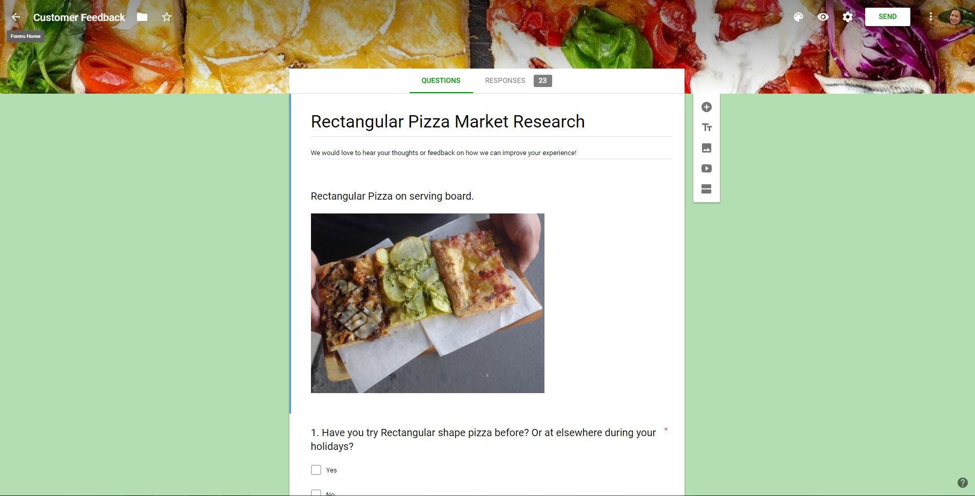

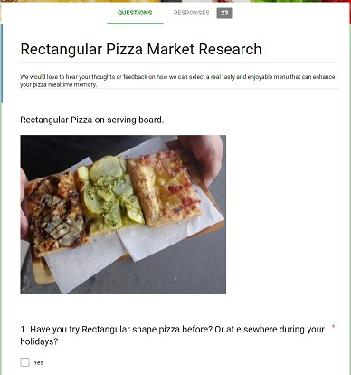

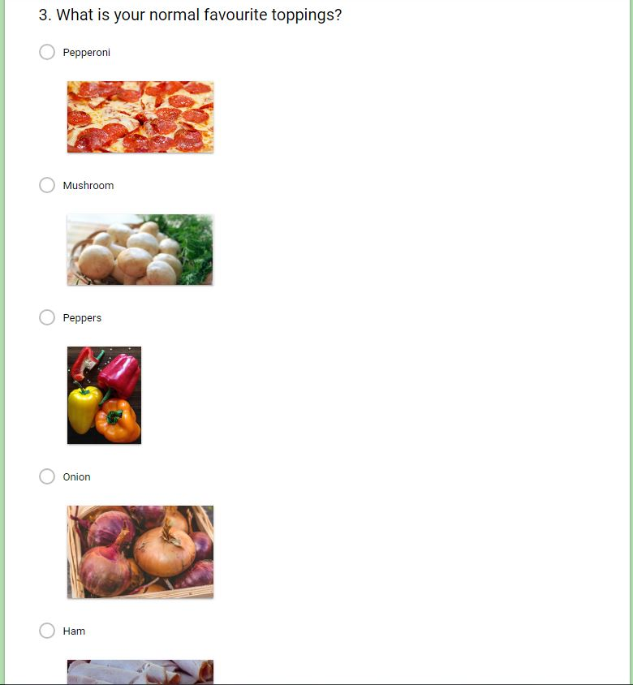
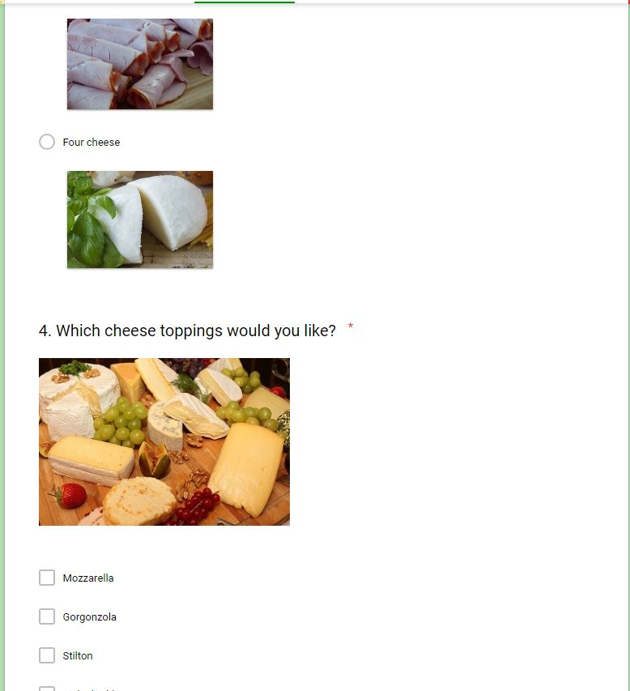

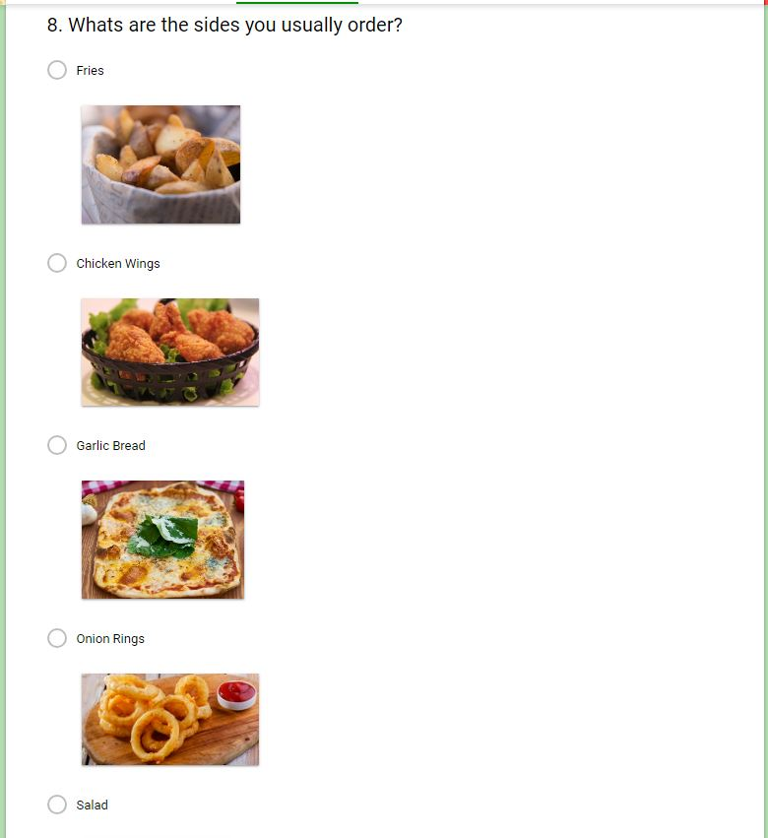
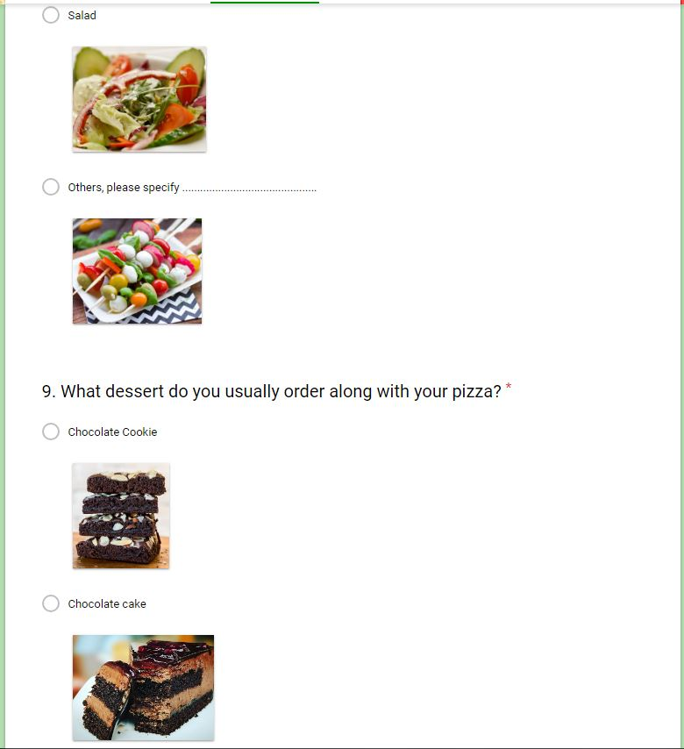
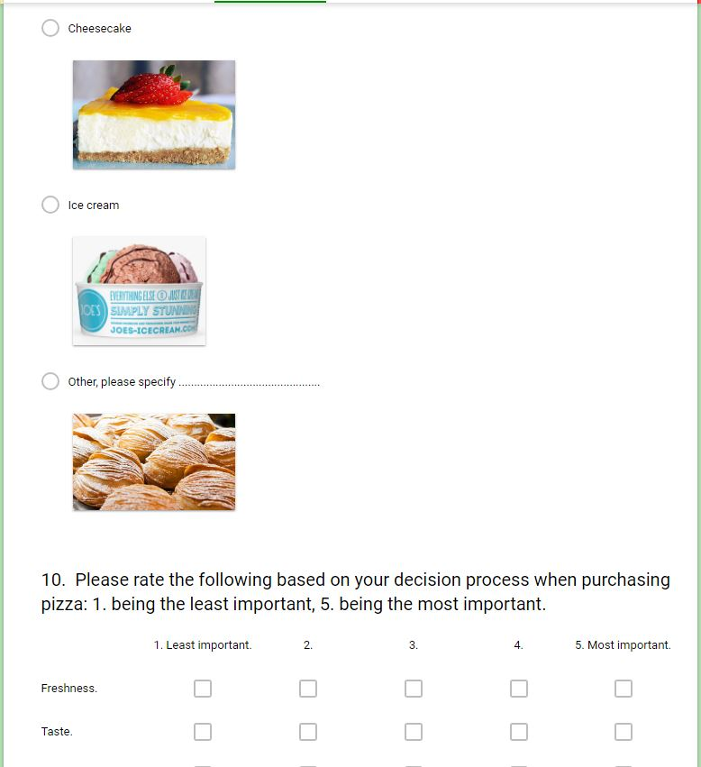

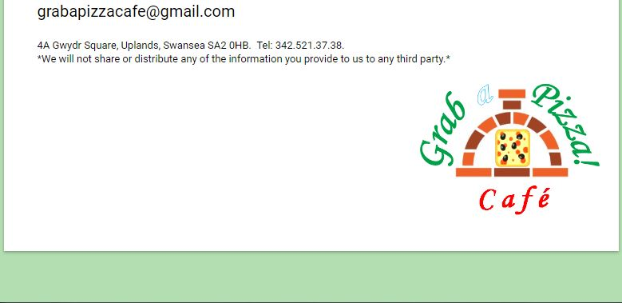
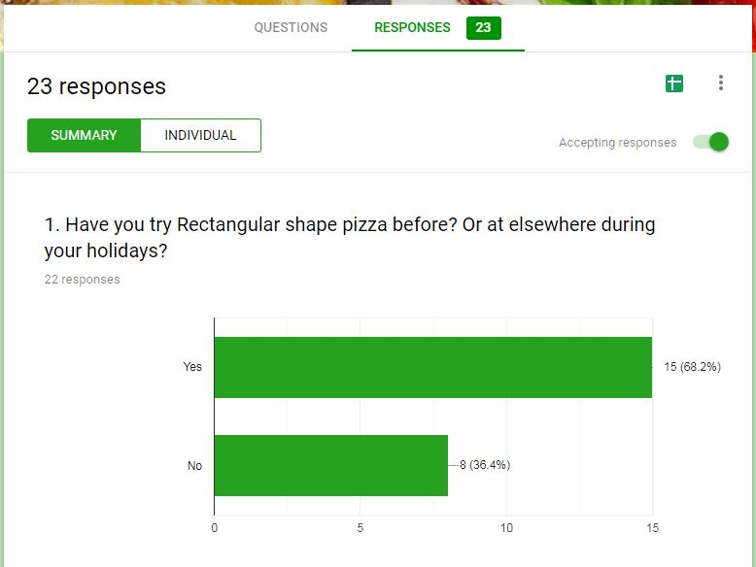
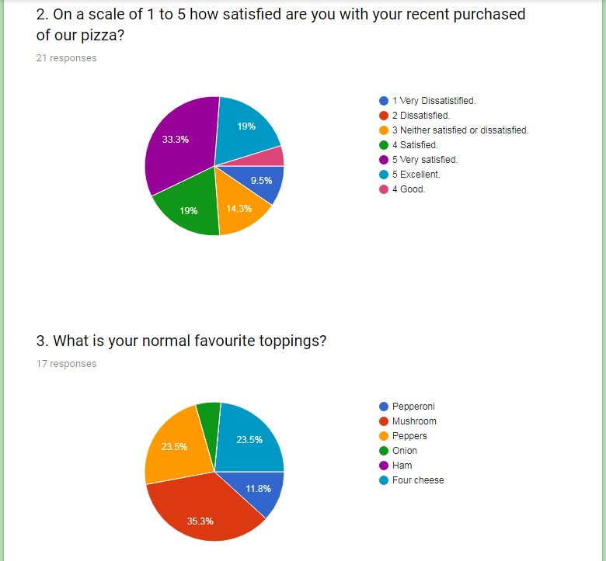
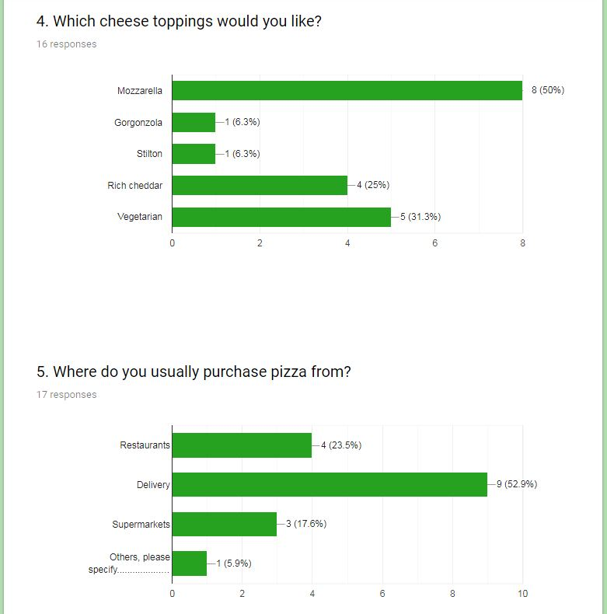
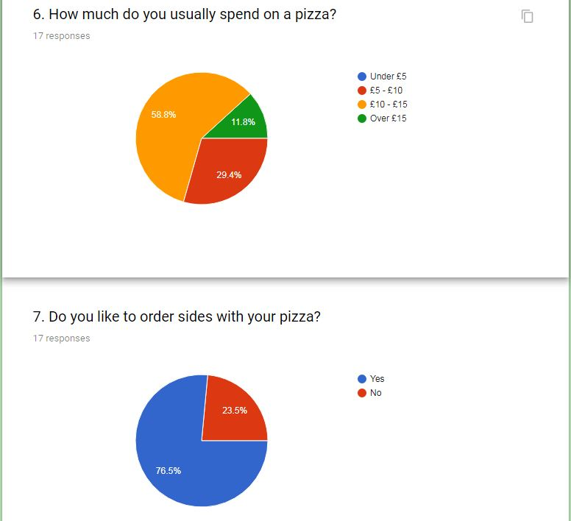
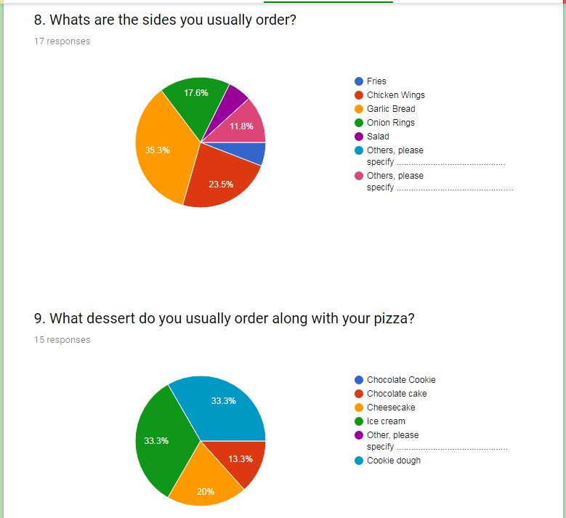

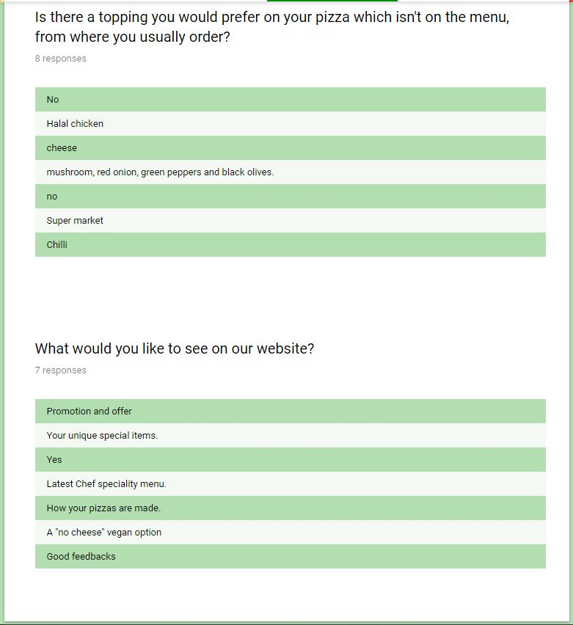

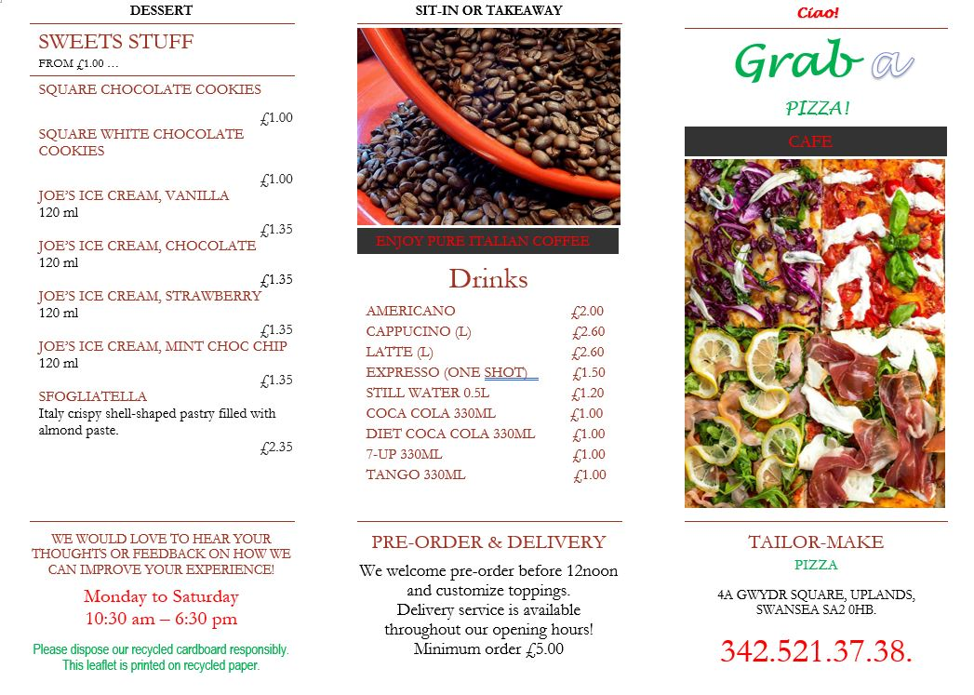

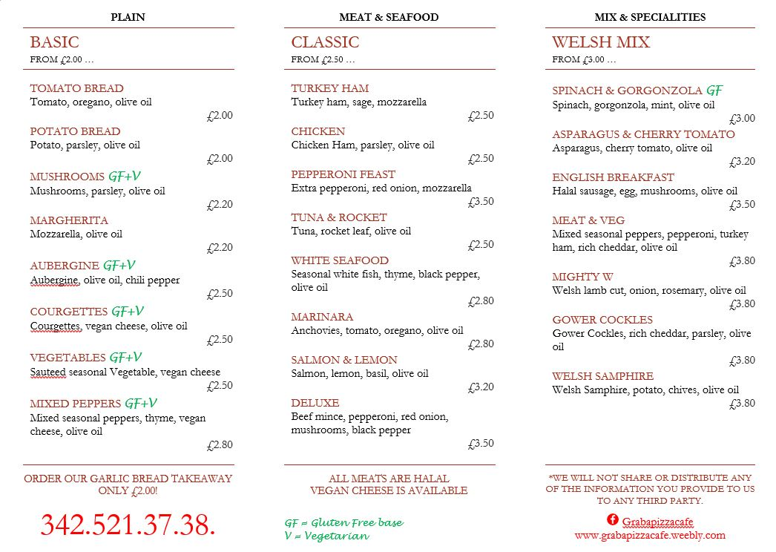
Website Design:

It is important for a small new business to own a website to connect with its customers. The website is available 24 hours which means low operating costs to advertise the business. It can help to reach a wider range of customers, track where customers come from, or what is the bestselling product.

I have completed targeted market research in the module Managing Enterprise in the 21st Century, therefore I know my product will attract a “younger crowd” of customers. It is vital that the website looks colourful, with clear images, a simple narrative, and links to other social media sites (Facebook) to engage customers and improve their experience.

Before building a website for business, there are a lot of factors I need to consider to get it started such as: company logo and brand name display, colour theme, layout, product narrative and images, price list etc. There are a few easy website builder apps on the market now like: Wix.com, GoDaddy.com, Weebly.com and Simple Site.

I have divided different tasks to each member to contribute for this website. I used the business Gmail address to register for an account at Weebly.com, but not to publish it on public site yet.

My contribution:
Dragos and I have started building in the tabs, Home, Menu & Price, Contact Us, Facebook. I mainly built up Home and Facebook links. I have written the business Mission Statement, and Our Pizza Philosophy narrative.

On the Menu & Price tab, I uploaded the business main menu page to showcase our tasty variety of pizza choices for our customers to see. I also uploaded a photo of rectangular pizzas serve on a wooden board. This is for potential customers that have never tried a rectangular pizza before but wanted to know what it looks like.

I suggested a smiley group photo to input next to the “Come and Meet Our Team” narrative. I organised and took the photo, uploaded it on right side of the narrative, and sent a copy of group photo to all team members.

I added the GDPR data protection law narrative to ensure our customers their data is safe with us. ​*We will not share or distribute any of the information you provide to us to any third party. *

I inserted a Facebook link to the last tab, to draw our customers to a site where they can communicate directly with us.

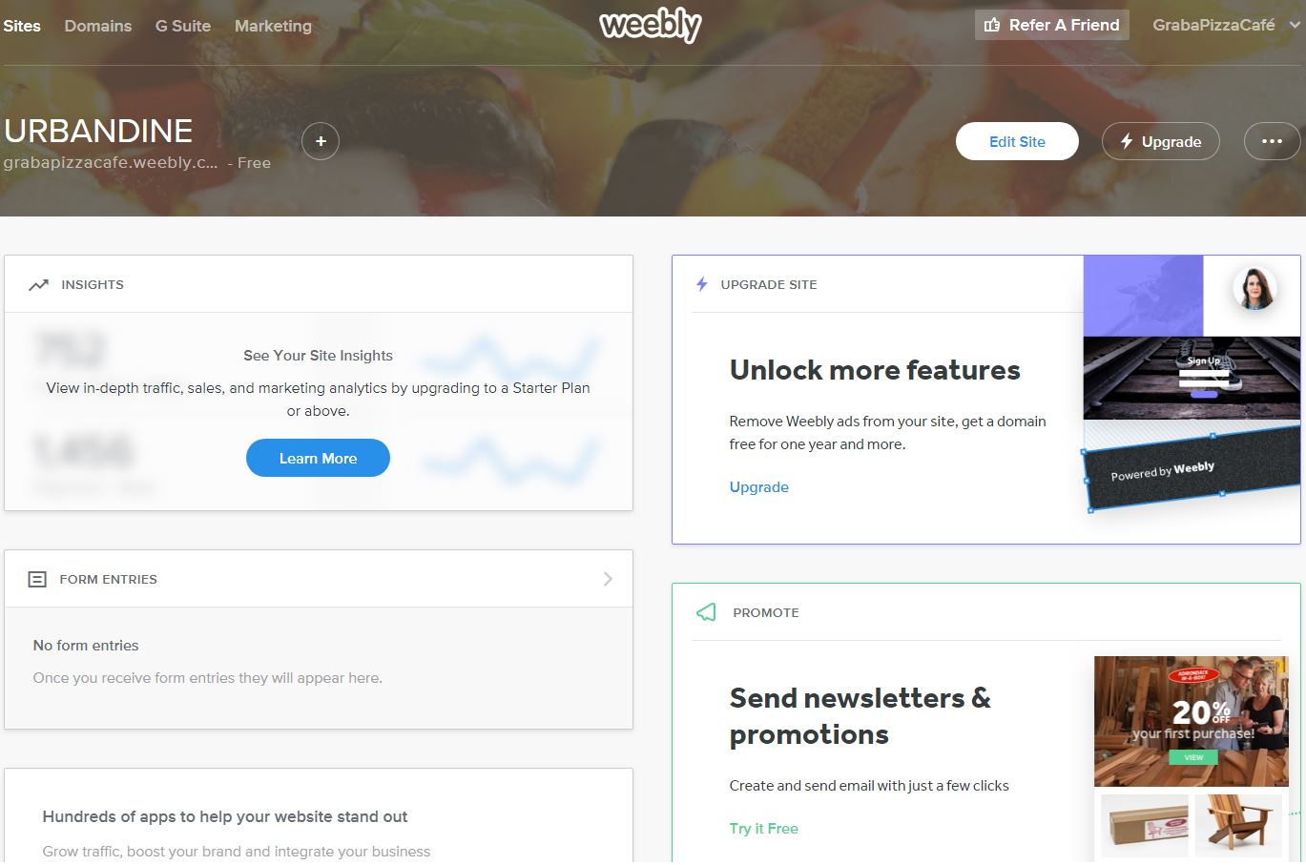

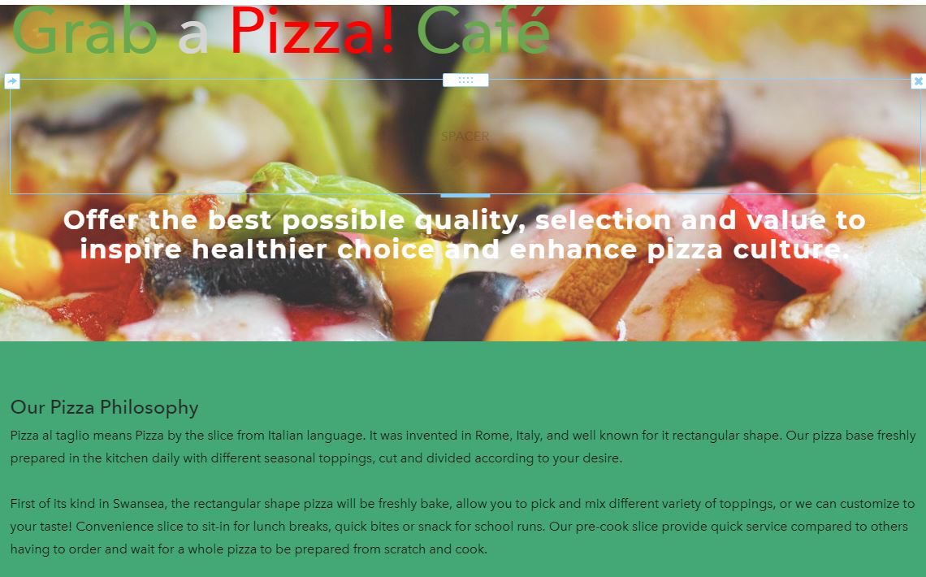

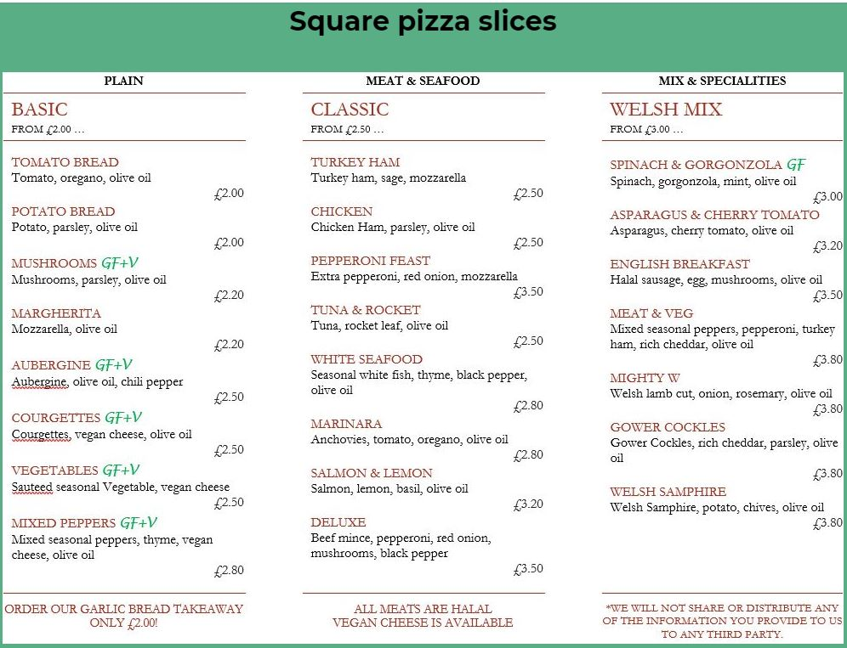

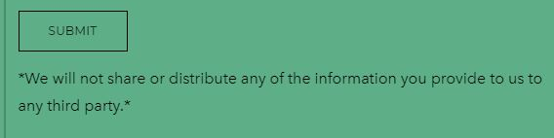

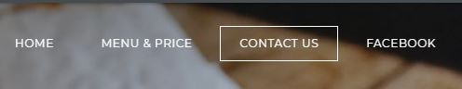

Reference:
Curts, E. (2016) Using Google Forms [online]
Available at: https://docs.google.com/document/d/15i1AamaA_47cI-9Wc9Rw_A-Tr7h6yM0lp-xofJImgzI/mobilebasic?pli=1#h.xq7m6nvltz90 (Accessed 5 December 2018)

Merry, L. (2017) 10 things you must consider before building a website [online] Available at: https://www.telegraph.co.uk/branded-content/marketing-guides/things-to-know-before-building-website/ (Accessed 6 December 2018)

Pexels.com (2018) Available at: https://www.pexels.com/(Accessed 5 December 2018)

Unsplash.com (2018) Available at:https://unsplash.com/ (Accessed 5 December 2018)

Weebly.com (2018) Available at: https://www.weebly.com/home (Accessed 5 December 2018)

