Callum Evans

2116012

BSC2 - PT Computing (Computer Networks & Cybersecurity)

Introduction to Web and Database Concepts

02/05/2022

Table of Contents:
- Introduction & Requirements
- Implementation
- Evaluation
- References
- Appendices

Introduction and Requirements
The website I will be making is about something not a lot of people know about and that is eSports. For someone that doesn’t know what eSports is. eSports or Esports is short for electronic sports. eSports is multiplayer competitions between professional or amateur players, as individuals or as a team. In the 2000’s there wasn’t really a professional gamer as it was still very early on everyone was considered an amateur unless they were winning tournaments. By the 2010’s esports was a big factor in the gaming industry, with many developers designing and providing funding in tournaments and other events. There are so many esports now that I’ve only chosen to focus on only three esports which are, Call of Duty, Valorant, and Formula 1 Esports Series. Some of the most popular franchises include League of Legends, Dota, Counterstrike, Valorant, Overwatch, Call of Duty, and Rocket League. eSports has always been looked down on my mainstream media but over the last couple of years they are slowly starting to admit the fact that eSports is a massive thing in today’s society. In Asia eSports has been featured alongside traditional sports with the International Olympic Committee also having discussions about if there is a place in the Olympics in the future. The Olympics are keen to bring it into the event, but you can imagine that people aren’t very happy about this because people still don’t class eSports as a sport and there isn’t really any physical exercise involved. On the website I will be focusing on only the 3 eSports and the history behind them, Ill be talking about Prize Pools, how to watch, and will be focusing on the events that have been run in the games. For Call of Duty, I will be talking about a brief history of the competitive side of the game. I will be talking about how the competitive side of COD used to be run by MLG and then later got bought out by Activision. How they transitioned from the CWL (Call of Duty World League) to the CDL (Call of Duty League) and how that change the prize pools and what Covid-19 done to the events and how that changed. I would have to say Call of Duty is the eSport I have been following since 2014 and I have played a lot of competitive COD in my past. So, my knowledge is a lot more compared to the other two. Next up is an eSport is still very new, Valorant. This game is only around two years old with the eSport basically being born with the game is the game was catered towards becoming an eSport. Talking about the background of the game is going to be where I start with the information, I will then talk about how to win a game whereas Call of Duty has different game modes, Valorant is one game mode, but a game can take up to 1 hour plus. I will talk about the three biggest events since the eSports started and the Prize pool of each event. Then onto the last eSport I will be talking about is F1 eSports Series, the F1 Series works very differently compared to the others. Instead of gaming organizations being apart of it, the real life F1 teams are involved within it. I will be talking about how the series grew over the last 5 years and how differently it is now compared to 2017. I will be talking stats on how many people have watched and how many people have tried to become 1 of the 24 drivers on the circuit. I will be talking about the two drivers with the most wins in the series, Jarno Opmeer a guy from the Netherlands and Brendon Leigh a guy from the UK. The objective of the website is to show and tell people about how big they three eSports are and how they become what they have become. Considering these aren’t the biggest eSports out there. The intended target audience are the people that want to know about these three games or even people that want to get a broader knowledge about the games competitive scene. But the intended target audience is the “noobs” of the competitive world.

Implementation
Page 1: Home
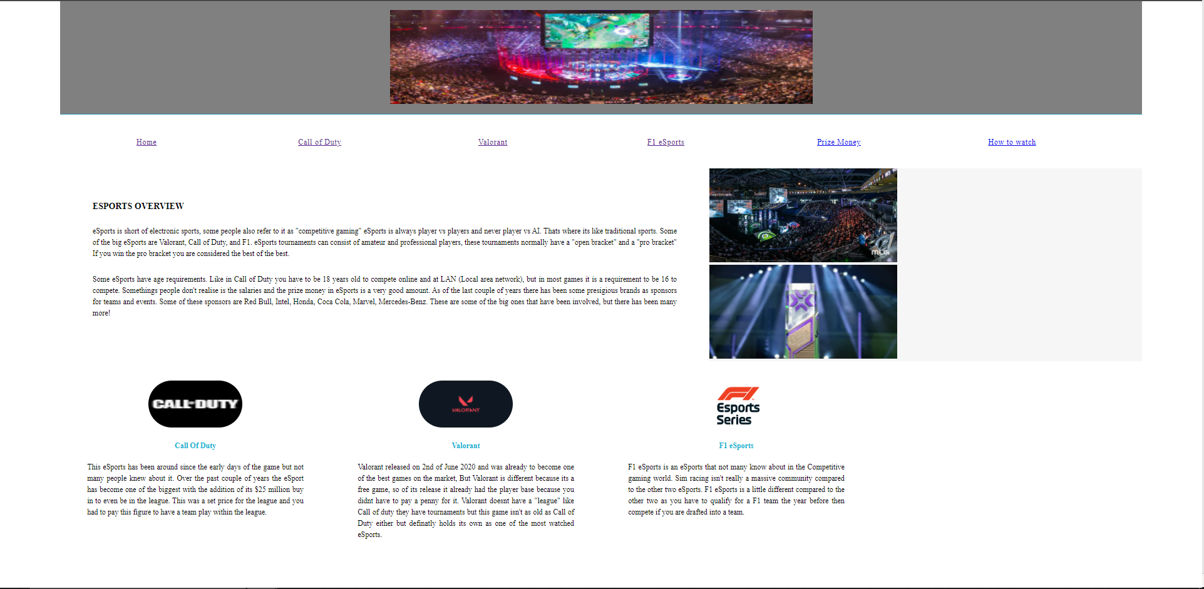
Page 2: Call of Duty
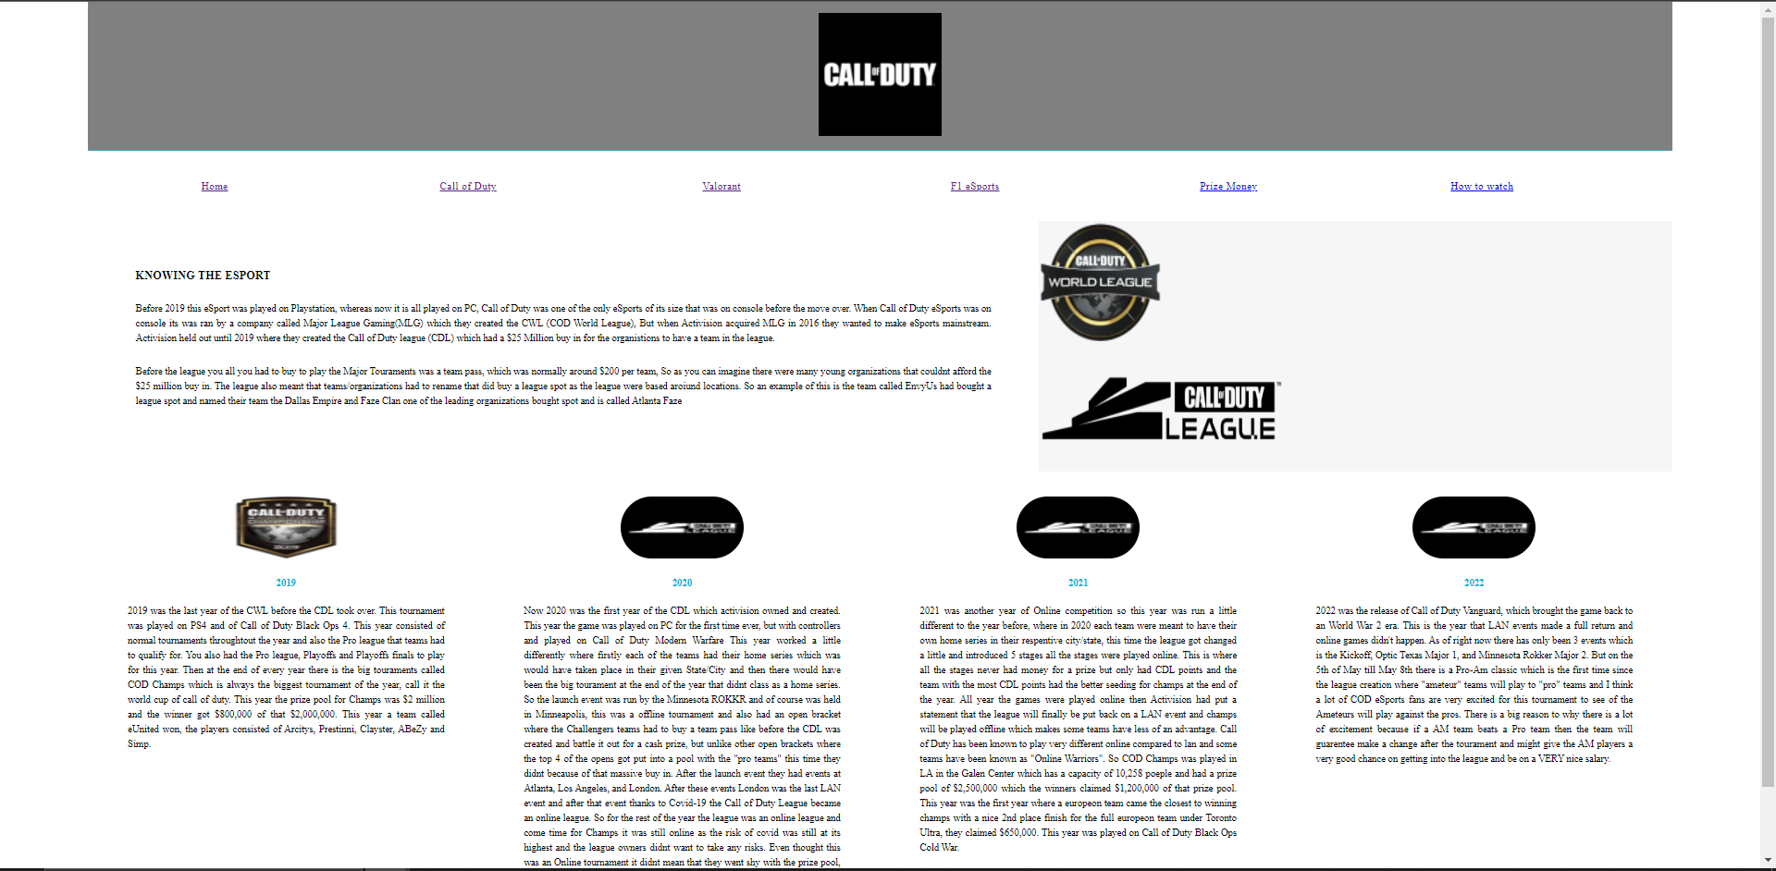

Page 3: Valorant
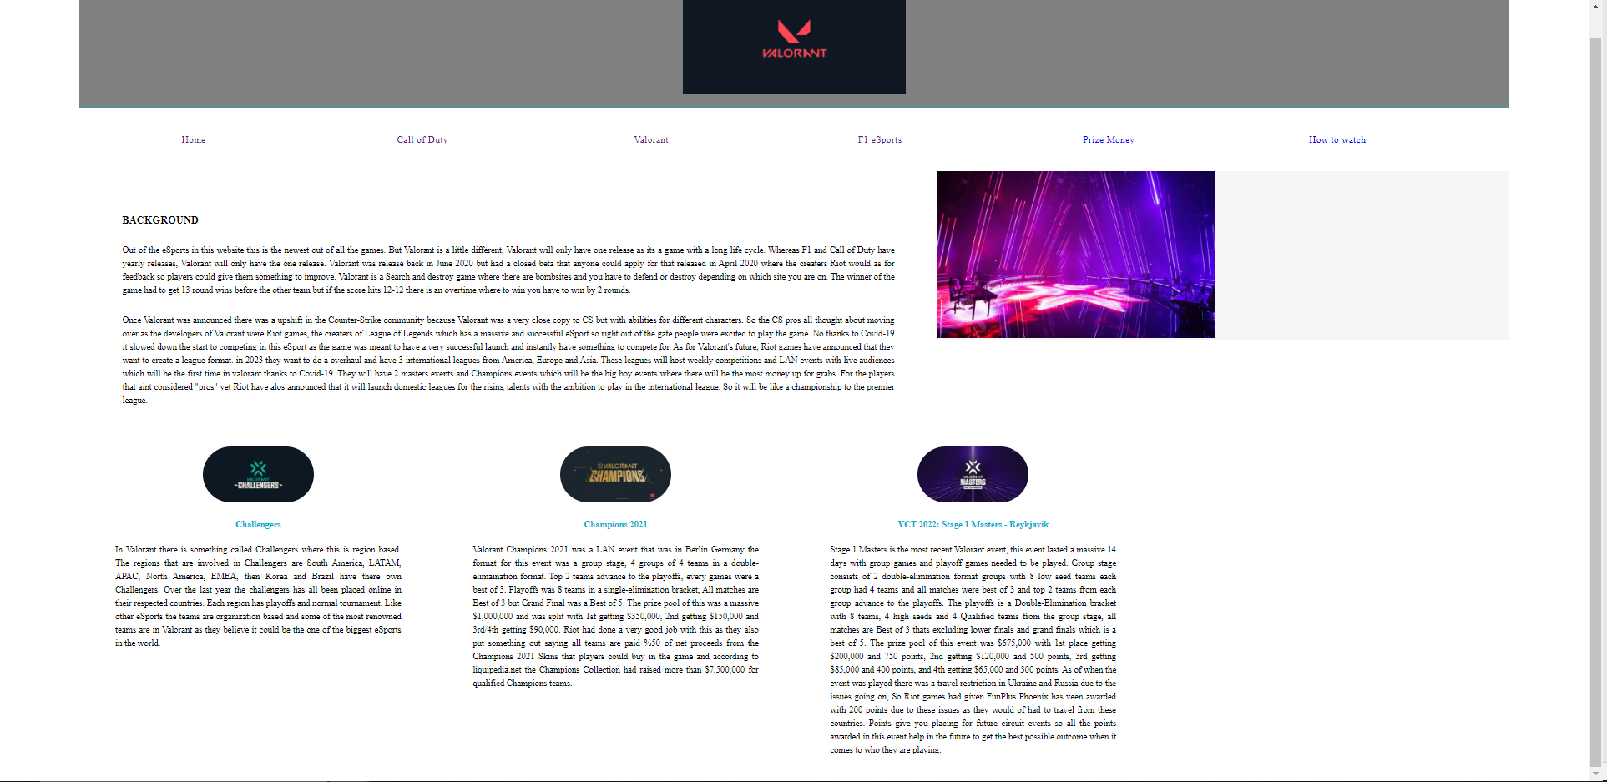
Page 4: F1 Esports Series
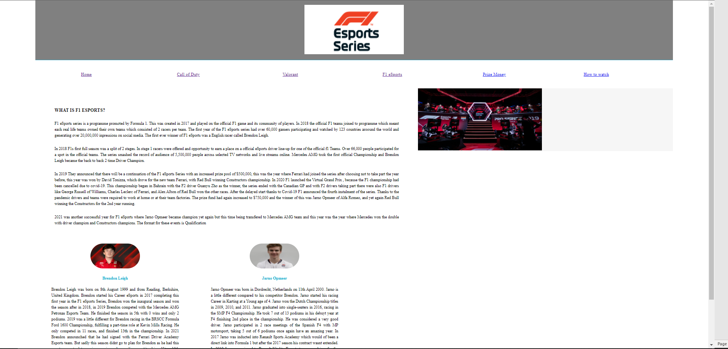
Page 5: Prize money
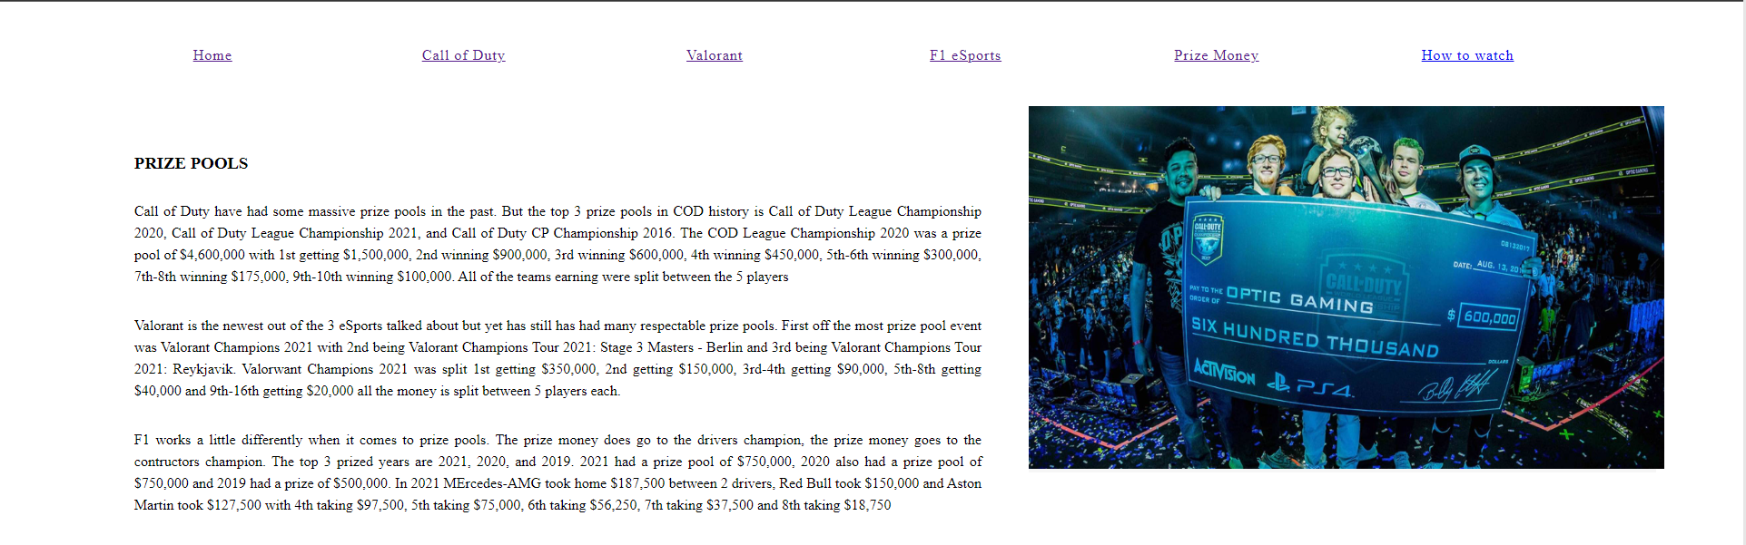

Page 6: How to Watch
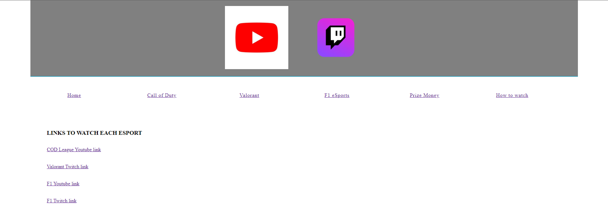

Validation
HTML:
Fixed by making <html> to <html lang =”en”>
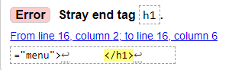
Removed stray end tag
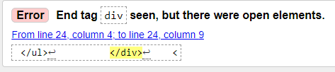
Moved </div> to correct line underneath </header>
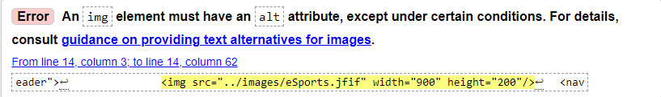
Can’t seem to find a fix for this error!
There are many errors on every HTML page, but they seem to work. So, the errors seem to be more of a formatting thing.

CSS:
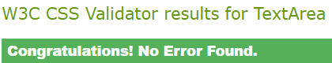

Evaluation
After Validating my HTML code and correcting some of the error its change the layout of my website. I can’t figure out what to do to change it back to the correct layout this has only happened to the home page, but every other page has changed. So, the other pages have the correct layout out of the webpages I’ve tested my website on, chrome works perfectly fine. Firefox also works the way the website should be on IE far left image on the Call of Duty page seems like it doesn’t load properly and the far-right image on the Valorant page doesn’t seem to work. I’m not sure how to fix this issue I feel like it might just be an Internet Explorer issue more than HTML code issue. The website is very easier to use for any user. There are hyperlinks at the top of the page that allow the user to jump between each page. The hyperlinks on the ‘How to Watch’ page all work perfectly as well they all take you to the correct pages of the stream on where to watch the selected eSports. The accessibility of the website is also great. It’s easy to read the details on the website and the images are easy to see. I haven’t had it, so the text is hard to see because I’ve put it all on a white background, so it doesn’t make it difficult to see.
I’ve made the website useable and there aren’t any hidden buttons and is easy to jump between each page and look of the website I would say is very basic but then you could argue that it makes it easier to read when the website is being used. There aren’t any fancy animations and nothing that really wows you on the website. The information on the website is up to date and is accurate I think for future improvement I would make the website more pleasing to look at and use I would add animation when jumping from page to page and I would make the menu more pleasing to use, maybe add a sidebar to hide away the pages and give it a more good-looking menu page.
I’ve talked about how the website seems to work the way it is meant to when on Firefox and Chrome but doesn’t when using Internet Explorer. I was unable to test if safari would have worked as I don’t have a virtual machine with safari or I don’t own any apple products to test it. The website works both landscape and portrait on both of the working search engines.
I chose to use notepad++ because it is what I have been practising my HTML and CSS on and the only time I have ever used visual studio for HTML and CSS. I have only used visual studio for C++ and C# in the past, so it just wouldn’t have made sense to use it. According to https://contrastchecker.com/ my ratio for my website is 21 which is a pass on AA, AAA, AA18pt, Colors PASS, and Color DIFF 765. I tired to use the browser extension but I can’t get them to work. When clicking on the extensions nothing happened so I just moved on with the Evaluation.

References
https://abounaja.com/blogs/world-of-esports-and-intellectual-property
https://nerdstreet.com/news/2021/9/valorant-masters-berlin-preview-everything-you-need-to-know
Photo courtesy MLG
https://www.youtube.com/callofduty
Created by Riot Games
https://cod-esports.fandom.com/wiki/CWL/2018_Season/Anaheim_Open
https://liquipedia.net/callofduty/Call_of_Duty_League
https://cod-esports.fandom.com/wiki/Call_of_Duty_World_League_Championship_2019 CWL 2019

https://www.youtube.com/channel/UCbLIqv9Puhyp9_ZjVtfOy7w
https://firstsportz.com/top-5-best-players-in-vct-masters-3-berlin-players-who-showed-top-tier-valorant-gameplay/
https://in.ign.com/valorant/170725/news/russia-ukraine-crisis-riot-postpones-valorant-champions-tour-emea-challengers-week-3-games
https://www.formula1.com/en/latest/article.f1-new-balance-esports-pro-series-tonizza-roars-into-championship-lead.1u20enyYpXIGfR9JFFZv0w.html
https://traxion.gg/f1-esports-pro-why-brendon-leigh-is-so-content-at-ferrari/
https://the-race.com/gaming/mercedes-signs-f1-esports-champion-opmeer-from-alfa-romeo/
https://www.youtube.com/user/youtube
https://www.twitch.tv/downloads

Appendices
Index:
<!doctype html>
<html lang="en">
<head>
<meta charset="utf-8">
<meta http-equiv="X-UA-Compatible" content="IE=edge">
<meta name="viewport" content="width=device-width, initial-scale=1">
<title>eSports</title>
<link href="../css/css.css" rel="stylesheet" type="text/css">
</head>
<body>
<div class="container">
<header>
<div class="primary_header">
<img src="../images/eSports.jfif" width="900" height="200"/>
<nav class="secondary_header" id="menu">
<ul>
<li><A href="Index.html">Home</A></li>
<li><A href="COD.html">Call of Duty</A></li>
<li><A href="VAL.html">Valorant</A></li>
<li><A href="F1.html">F1 eSports</A></li>
<li><A href="Prize.html">Prize Money</A></li>
<li><A href="Watch.html">How to watch</A></li>
</ul>
</nav>
</header>
</div>
<section>
<h2 class="noDisplay">Main Content</h2>
<article class="left_article">
<h3><font color="Black">eSports overview</font></h3>
<p><font color="Black">eSports is short of electronic sports, some people also refer to it as "competitive gaming" eSports is always player vs players and never player vs AI. Thats where its like traditional sports. Some of the big eSports are Valorant, Call of Duty, and F1. eSports tournaments can consist of amateur and professional players, these tournaments normally have a "open bracket" and a "pro bracket" If you win the pro bracket you are considered the best of the best. </font></p>
<p><font color="Black">Some eSports have age requirements. Like in Call of Duty you have to be 18 years old to compete online and at LAN (Local area network), but in most games it is a requirement to be 16 to compete. Somethings people don't realise is the salaries and the prize money in eSports is a very good amount. As of the last couple of years there has been some presigious brands as sponsors for teams and events. Some of these sponsors are Red Bull, Intel, Honda, Coca Cola, Marvel, Mercedes-Benz. These are some of the big ones that have been involved, but there has been many more!</font></p>
</article>
<aside class="right_article"><img src="../images/COD champs.jpg" alt="" width="400" height="200"/> </aside>
<aside class="right_article"><img src="../images/Val masters.jpg" alt="" width="400" height="200"/> </aside>
</section>
<div class="row">
<div class="columns">
<p class="thumbnail_align"><img src="../images/Call of Duty logo.jpg" alt="" class="thumbnail"/></p>
<h4>Call Of Duty</h4>
<p><font color="Black">This eSports has been around since the early days of the game but not many people knew about it. Over the past couple of years the eSport has become one of the biggest with the addition of its $25 million buy in to even be in the league. This was a set price for the league and you had to pay this figure to have a team play within the league.</font></p>
</div>
<div class="columns">
<p class="thumbnail_align"><img src="../images/Valorant logo.png" alt="" class="thumbnail"/></p>
<h4>Valorant</h4>
<p><font color="Black">Valorant released on 2nd of June 2020 and was already to become one of the best games on the market, But Valorant is different because its a free game, so of its release it already had the player base because you didnt have to pay a penny for it. Valorant doesnt have a "league" like Call of duty they have tournaments but this game isn't as old as Call of Duty either but definatly holds its own as one of the most watched eSports.</font></p>
</div>
<div class="columns">
<p class="thumbnail_align"><img src="../images/f1 esports.jpg" alt="" class="thumbnail"/></p>
<h4>F1 eSports</h4>
<p><font color="Black">F1 eSports is an eSports that not many know about in the Competitive gaming world. Sim racing isn't really a massive community compared to the other two eSports. F1 eSports is a little different compared to the other two as you have to qualify for a F1 team the year before then compete if you are drafted into a team.</font></p>
</div>

</div>
</body>

COD:
<!doctype html>
<html>
<head>
<meta charset="utf-8">
<meta http-equiv="X-UA-Compatible" content="IE=edge">
<meta name="viewport" content="width=device-width, initial-scale=1">
<title>Call of Duty eSports</title>
<link href="../css/css.css" rel="stylesheet" type="text/css">
</head>
<body>
<div class="container">
<header>
<div class="primary_header">
<h1 class="title"><h1 class="title"><img src="../images/Call of Duty logo.jpg" width="200" height="200"/>
</div>
<nav class="secondary_header" id="menu">
<ul>
<li><A href="Index.html">Home</A></li>
<li><A href="COD.html">Call of Duty</A></li>
<li><A href="VAL.html">Valorant</A></li>
<li><A href="F1.html">F1 eSports</A></li>
<li><A href="Prize.html">Prize Money</A></li>
<li><A href="Watch.html">How to watch</A></li>
</ul>
</nav>
</header>
<section>
<h2 class="noDisplay">Main Content</h2>
<article class="left_article">
<h3><font color="Black">Knowing the eSport</font></h3>
<p><font color="Black">Before 2019 this eSport was played on Playstation, whereas now it is all played on PC, Call of Duty was one of the only eSports of its size that was on console before the move over. When Call of Duty eSports was on console its was ran by a company called Major League Gaming(MLG) which they created the CWL (COD World League), But when Activision acquired MLG in 2016 they wanted to make eSports mainstream. Activision held out until 2019 where they created the Call of Duty league (CDL) which had a $25 Million buy in for the organistions to have a team in the league. </font></p>
<p><font color="Black">Before the league you all you had to buy to play the Major Touraments was a team pass, which was normally around $200 per team, So as you can imagine there were many young organizations that couldnt afford the $25 million buy in. The league also meant that teams/organizations had to rename that did buy a league spot as the league were based aroiund locations. So an example of this is the team called EnvyUs had bought a league spot and named their team the Dallas Empire and Faze Clan one of the leading organizations bought spot and is called Atlanta Faze </font></p>
</article>
<aside class="right_article"><img src="../images/CWL logo.jpg" alt="" width="200" height="200"/> </aside>
<aside class="right_article"><img src="../images/CDL logo.png" alt="" width="400" height="200"/> </aside>
</section>
<div class="row">
<div class="columns">
<p class="thumbnail_align"> <img src="../images/COD champs 2019.jpg" alt="" class="thumbnail"/> </p>
<h4>2019</h4>
<p><font color="Black">2019 was the last year of the CWL before the CDL took over. This tournament was played on PS4 and of Call of Duty Black Ops 4. This year consisted of normal tournaments throughtout the year and also the Pro league that teams had to qualify for. You also had the Pro league, Playoffs and Playoffs finals to play for this year. Then at the end of every year there is the big touraments called COD Champs which is always the biggest tournament of the year, call it the world cup of call of duty. This year the prize pool for Champs was $2 million and the winner got $800,000 of that $2,000,000. This year a team called eUnited won, the players consisted of Arcitys, Prestinni, Clayster, ABeZy and Simp.</font></p>
</div>
<div class="columns">
<p class="thumbnail_align"> <img src="../images/CDL logo 2.jpg" alt="" class="thumbnail"/> </p>
<h4>2020</h4>
<p><font color="Black">Now 2020 was the first year of the CDL which activision owned and created. This year the game was played on PC for the first time ever, but with controllers and played on Call of Duty Modern Warfare This year worked a little differently where firstly each of the teams had their home series which was would have taken place in their given State/City and then there would have been the big tourament at the end of the year that didnt class as a home series. So the launch event was run by the Minnesota ROKKR and of course was held in Minneapolis, this was a offline tournament and also had an open bracket where the Challengers teams had to buy a team pass like before the CDL was created and battle it out for a cash prize, but unlike other open brackets where the top 4 of the opens got put into a pool with the "pro teams" this time they didnt because of that massive buy in. After the launch event they had events at Atlanta, Los Angeles, and London. After these events London was the last LAN event and after that event thanks to Covid-19 the Call of Duty League became an online league. So for the rest of the year the league was an online league and come time for Champs it was still online as the risk of covid was still at its highest and the league owners didnt want to take any risks. Even thought this was an Online tournament it didnt mean that they went shy with the prize pool, it was a COD record breaking event with $4,600,000 on the line where the winner got $1,500,000 between 5 players! Where the Dallas Empire had won this event!</font></p>
</div>
<div class="columns">
<p class="thumbnail_align"> <img src="../images/CDL logo 2.jpg" alt="" class="thumbnail"/> </p>
<h4>2021</h4>
<p><font color="Black">2021 was another year of Online competition so this year was run a little different to the year before, where in 2020 each team were meant to have their own home series in their respentive city/state, this time the league got changed a little and introduced 5 stages all the stages were played online. This is where all the stages never had money for a prize but only had CDL points and the team with the most CDL points had the better seeding for champs at the end of the year. All year the games were played online then Activision had put a statement that the league will finally be put back on a LAN event and champs will be played offline which makes some teams have less of an advantage. Call of Duty has been known to play very different online compared to lan and some teams have been known as "Online Warriors". So COD Champs was played in LA in the Galen Center which has a capacity of 10,258 poeple and had a prize pool of $2,500,000 which the winners claimed $1,200,000 of that prize pool. This year was the first year where a europeon team came the closest to winning champs with a nice 2nd place finish for the full europeon team under Toronto Ultra, they claimed $650,000. This year was played on Call of Duty Black Ops Cold War. </font></p>
</div>
<div class="columns">
<p class="thumbnail_align"> <img src="../images/CDL logo 2.jpg" alt="" class="thumbnail"/> </p>
<h4>2022</h4>
<p><font color="Black">2022 was the release of Call of Duty Vanguard, which brought the game back to an World War 2 era. This is the year that LAN events made a full return and online games didn't happen. As of right now there has only been 3 events which is the Kickoff, Optic Texas Major 1, and Minnesota Rokker Major 2. But on the 5th of May till May 8th there is a Pro-Am classic which is the first time since the league creation where "ameteur" teams will play to "pro" teams and I think a lot of COD eSports fans are very excited for this tournament to see of the Ameteurs will play against the pros. There is a big reason to why there is a lot of excitement because if a AM team beats a Pro team then the team will guarentee make a change after the tourament and might give the AM players a very good chance on getting into the league and be on a VERY nice salary. </font></p>
</div>
</div>

</div>
</body>

Valorant:
<!doctype html>
<html>
<head>
<meta charset="utf-8">
<meta http-equiv="X-UA-Compatible" content="IE=edge">
<meta name="viewport" content="width=device-width, initial-scale=1">
<title>Valorant eSports</title>
<link href="../css/css.css" rel="stylesheet" type="text/css">
</head>
<body>
<div class="container">
<header>
<div class="primary_header">
<h1 class="title"><h1 class="title"><img src="../images/Valorant logo.png" width="400" height="200"/>
</div>
<nav class="secondary_header" id="menu">
<ul>
<li><A href="Index.html">Home</A></li>
<li><A href="COD.html">Call of Duty</A></li>
<li><A href="VAL.html">Valorant</A></li>
<li><A href="F1.html">F1 eSports</A></li>
<li><A href="Prize.html">Prize Money</A></li>
<li><A href="Watch.html">How to watch</A></li>
</ul>
</nav>
</header>
<section>
<h2 class="noDisplay">Main Content</h2>
<article class="left_article">
<h3><font color="Black">Background</font></h3>
<p><font color="Black">Out of the eSports in this website this is the newest out of all the games. But Valorant is a little different, Valorant will only have one release as its a game with a long life cycle. Whereas F1 and Call of Duty have yearly releases, Valorant will only have the one release. Valorant was release back in June 2020 but had a closed beta that anyone could apply for that released in April 2020 where the creaters Riot would as for feedback so players could give them something to improve. Valorant is a Search and destroy game where there are bombsites and you have to defend or destroy depending on which site you are on. The winner of the game had to get 13 round wins before the other team but if the score hits 12-12 there is an overtime where to win you have to win by 2 rounds. </font></p>
<p><font color = "Black">Once Valorant was announced there was a upshift in the Counter-Strike community because Valorant was a very close copy to CS but with abilities for different characters. So the CS pros all thought about moving over as the developers of Valorant were Riot games, the creaters of League of Legends which has a massive and successful eSport so right out of the gate people were excited to play the game. No thanks to Covid-19 it slowed down the start to competing in this eSport as the game was meant to have a very successful launch and instantly have something to compete for. As for Valorant's future, Riot games have announced that they want to create a league format. in 2023 they want to do a overhaul and have 3 international leagues from America, Europe and Asia. These leagues will host weekly competitions and LAN events with live audiences which will be the first time in valorant thanks to Covid-19. They will have 2 masters events and Champions events which will be the big boy events where there will be the most money up for grabs. For the players that aint considered "pros" yet Riot have alos announced that it will launch domestic leagues for the rising talents with the ambition to play in the international league. So it will be like a championship to the premier league.
</article>
<aside class="right_article"><img src="../images/Masters stage.jpg" alt="" width="500" height="300"/> </aside>
</section>
<div class="row">
<div class="columns">
<p class="thumbnail_align"> <img src="../images/Challengers logo.jpg" alt="" class="thumbnail"/> </p>
<h4>Challengers</h4>
<p><font color="Black">In Valorant there is something called Challengers where this is region based. The regions that are involved in Challengers are South America, LATAM, APAC, North America, EMEA, then Korea and Brazil have there own Challengers. Over the last year the challengers has all been placed online in their respected countries. Each region has playoffs and normal tournament. Like other eSports the teams are organization based and some of the most renowned teams are in Valorant as they believe it could be the one of the biggest eSports in the world. </font></p>
</div>
<div class="columns">
<p class="thumbnail_align"> <img src="../images/Champions.jpg" alt="" class="thumbnail"/> </p>
<h4>Champions 2021</h4>
<p><font color="Black">Valorant Champions 2021 was a LAN event that was in Berlin Germany the format for this event was a group stage, 4 groups of 4 teams in a double-elimaination format. Top 2 teams advance to the playoffs, every games were a best of 3. Playoffs was 8 teams in a single-elimination bracket, All matches are Best of 3 but Grand Final was a Best of 5. The prize pool of this was a massive $1,000,000 and was split with 1st getting $350,000, 2nd getting $150,000 and 3rd/4th getting $90,000. Riot had done a very good job with this as they also put something out saying all teams are paid %50 of net proceeds from the Champions 2021 Skins that players could buy in the game and according to liquipedia.net the Champions Collection had raised more than $7,500,000 for qualified Champions teams. </font></p>
</div>
<div class="columns">
<p class="thumbnail_align"> <img src="../images/Masters iceland.jpg" alt="" class="thumbnail"/> </p>
<h4>VCT 2022: Stage 1 Masters - Reykjavik</h4>
<p><font color="Black">Stage 1 Masters is the most recent Valorant event, this event lasted a massive 14 days with group games and playoff games needed to be played. Group stage consists of 2 double-elimination format groups with 8 low seed teams each group had 4 teams and all matches were best of 3 and top 2 teams from each group advance to the playoffs. The playoffs is a Double-Elimination bracket with 8 teams, 4 high seeds and 4 Qualified teams from the group stage, all matches are Best of 3 thats excluding lower finals and grand finals which is a best of 5. The prize pool of this event was $675,000 with 1st place getting $200,000 and 750 points, 2nd getting $120,000 and 500 points, 3rd getting $85,000 and 400 points, and 4th getting $65,000 and 300 points. As of when the event was played there was a travel restriction in Ukraine and Russia due to the issues going on, So Riot games had given FunPlus Phoenix has veen awarded with 200 points due to these issues as they would of had to travel from these countries. Points give you placing for future circuit events so all the points awarded in this event help in the future to get the best possible outcome when it comes to who they are playing. </font></p>
</div>

</div>
</body>

F1:
<!doctype html>
<html>
<head>
<meta charset="utf-8">
<meta http-equiv="X-UA-Compatible" content="IE=edge">
<meta name="viewport" content="width=device-width, initial-scale=1">
<title>F1 eSports</title>
<link href="../css/css.css" rel="stylesheet" type="text/css">
</head>
<body>
<div class="container">
<header>
<div class="primary_header">
<h1 class="title"><h1 class="title"><img src="../images/f1 esports.jpg" width="400" height="200"/>
</div>
<nav class="secondary_header" id="menu">
<ul>
<li><A href="Index.html">Home</A></li>
<li><A href="COD.html">Call of Duty</A></li>
<li><A href="VAL.html">Valorant</A></li>
<li><A href="F1.html">F1 eSports</A></li>
<li><A href="Prize.html">Prize Money</A></li>
<li><A href="Watch.html">How to watch</A></li>
</ul>
</nav>
</header>
<section>
<h2 class="noDisplay">Main Content</h2>
<article class="left_article">
<h3><font color="Black">What is F1 eSports?</font></h3>
<p><font color="Black">F1 eSports series is a programme promoted by Formula 1. This was created in 2017 and played on the official F1 game and its community of players. In 2018 the official F1 teams joined to programme which meant each real life teams owned their own teams which consisted of 2 racers per team. The first year of the F1 eSports series had over 60,000 gamers participating and watched by 123 countries aroound the world and generating over 20,000,000 inpressions on social media. The first ever winner of F1 eSports was a English racer called Brendon Leigh.</font></p>
<p><font color="Black">In 2018 F1s first full season was a split of 2 stages. In stage 1 racers were offered and opportunity to earn a place on a official eSports driver line-up for one of the official f1 Teams. Over 66,000 people participated for a spot in the official teams. The series smashed the record of audience of 5,500,000 people across selected TV networks and live streams online. Mercedes AMG took the first official Championship and Brendon Leigh became the back to back 2 time Driver Champion. </font></p>
<p><font color="Black">In 2019 They announced that there will be a continuation of the F1 eSports Series with an increased prize pool of $500,000, this was the year where Ferrari had joined the series after choosing not to take part the year before, this year was won by David Tonizza, which drove for the new team Ferrari, with Red Bull winning Constructors championship. In 2020 F1 launched the Virtual Grand Prix , because the F1 championship had been cancelled due to covid-19. This championship began in Bahrain with the F2 driver Guanyu Zho as the winner, the series ended with the Canadian GP and with F2 drivers taking part there were also F1 drivers like George Russell of Williams, Charles Leclerc of Ferrari, and Alex Albon of Red Bull won the other races. After the delayed start thanks to Covid-19 F1 announced the fourth instalment of the series. Thanks to the pandemic drivers and teams were required to work at home or at their team factories. The prize fund had again increased to $750,000 and the winner of this was Jarno Opmeer of Alfa Romeo, and yet again Red Bull winning the Constructors for the 2nd year running.</font></p>
<p><font color="Black">2021 was another successful year for F1 eSports where Jarno Opmeer became champion yet again but this time being transfered to Mercedes AMG team and this year was the year where Mercedes won the double with driver champion and Constructors champions. The format for these events is Qualification </font></p>
</article>
<aside class="right_article"><img src="../images/F1 stage.jpg" alt="" width="500" height="250"/> </aside>
</section>
<div class="row">
<div class="columns">
<p class="thumbnail_align"> <img src="../images/Brendon Leigh.jpg" alt="" class="thumbnail"/> </p>
<h4>Brendon Leigh</h4>
<p><font color="Black">Brendon Leigh was born on 8th August 1999 and from Reading, Berkshire, United Kingdom. Brendon started his Career eSports in 2017 completing this first year in the F1 eSports Series, Brendon won the inaugural season and won the season after in 2018, in 2019 Brendon competed with the Mercedes AMG Petronas Esports Team. He finished the season in 5th with 0 wins and only 2 podiums. 2019 was a little different for Brendon racing in the BRSCC Formula Ford 1600 Championship, fulfilling a part-time role at Kevin Mills Racing. He only competed in 11 races, and finished 13th in the championship. In 2021 Brendon announched that he had signed with the Ferrari Driver Academy Esports team. But sadly this season didnt go to plan for Brendon as he had this worst season to date scoring no wins and no podiums, getting himself to a 10th place finish in the drivers standings. </font></p>
</div>
<div class="columns">
<p class="thumbnail_align"> <img src="../images/Jarno Opmeer.jpg" alt="" class="thumbnail"/> </p>
<h4>Jarno Opmeer</h4>
<p><font color="Black">Jarno Opmeer was born in Dordrecht, Netherlands on 11th April 2000. Jarno is a little different compared to his competitor Brendon. Jarno started his racing Career in Karting at a Young age of 4. Jarno won the Dutch Championship titles in 2009, 2010, and 2011. Jarno graduated into single-seaters in 2016, racing in the SMP F4 Championship. He took 7 out of 13 podiums in his debuyt year at F4 finishing 2nd place in the championship. He was considered a very good driver. Jarno participated in 2 race meetings of the Spanish F4 with MP motorsport, taking 5 out of 6 podiums once again have an amazing year. In 2017 Jarno was inducted into Renault Sports Academy which would of been a direct link into Formula 1 but after the 2017 season his contract wasnt extended. In 2019 Jarno was signed to Renault-Vitality Esports team as a driver for the third season of the F1 eSports Series. The Dutchmam finished his first season in 4th place and help secure 4th for this team in the constructors. For 2020 Jarno signed for Alfa Romeo Orien Esports Team. He was the best racer that year taking 4 wins and the drivers championship, he won with 22 points clear of 2nd place. In 2021 Jarno signed to Mercedes AMG Esport Team and won the drivers championship once again. </font></p>
</div>

</div>
</body>

Prize:
<!doctype html>
<html>
<head>
<meta charset="utf-8">
<meta http-equiv="X-UA-Compatible" content="IE=edge">
<meta name="viewport" content="width=device-width, initial-scale=1">
<title>Prize Pool</title>
<link href="../css/css.css" rel="stylesheet" type="text/css">
</head>
<body>
<div class="container">
<header>

<nav class="secondary_header" id="menu">
<ul>
<li><A href="Index.html">Home</A></li>
<li><A href="COD.html">Call of Duty</A></li>
<li><A href="VAL.html">Valorant</A></li>
<li><A href="F1.html">F1 eSports</A></li>
<li><A href="Prize.html">Prize Money</A></li>
<li><A href="Watch.html">How to watch</A></li>
</ul>
</nav>
</header>
<section>
<h2 class="noDisplay">Main Content</h2>
<article class="left_article">
<h3><font color="Black">Prize Pools</font></h3>
<p><font color="Black">Call of Duty have had some massive prize pools in the past. But the top 3 prize pools in COD history is Call of Duty League Championship 2020, Call of Duty League Championship 2021, and Call of Duty CP Championship 2016. The COD League Championship 2020 was a prize pool of $4,600,000 with 1st getting $1,500,000, 2nd winning $900,000, 3rd winning $600,000, 4th winning $450,000, 5th-6th winning $300,000, 7th-8th winning $175,000, 9th-10th winning $100,000. All of the teams earning were split between the 5 players</font></p>
<p><font color="Black">Valorant is the newest out of the 3 eSports talked about but yet has still has had many respectable prize pools. First off the most prize pool event was Valorant Champions 2021 with 2nd being Valorant Champions Tour 2021: Stage 3 Masters - Berlin and 3rd being Valorant Champions Tour 2021: Reykjavik. Valorwant Champions 2021 was split 1st getting $350,000, 2nd getting $150,000, 3rd-4th getting $90,000, 5th-8th getting $40,000 and 9th-16th getting $20,000 all the money is split between 5 players each. </font></p>
<p><font color="Black">F1 works a little differently when it comes to prize pools. The prize money does go to the drivers champion, the prize money goes to the contructors champion. The top 3 prized years are 2021, 2020, and 2019. 2021 had a prize pool of $750,000, 2020 also had a prize pool of $750,000 and 2019 had a prize of $500,000. In 2021 MErcedes-AMG took home $187,500 between 2 drivers, Red Bull took $150,000 and Aston Martin took $127,500 with 4th taking $97,500, 5th taking $75,000, 6th taking $56,250, 7th taking $37,500 and 8th taking $18,750 </font></p>
</article>
<aside class="right_article"><img src="../images/OG wins.jpg" alt="" width="700" height="400"/> </aside>
</section>

</div>
</body>

Watch:
<!doctype html>
<html>
<head>
<meta charset="utf-8">
<meta http-equiv="X-UA-Compatible" content="IE=edge">
<meta name="viewport" content="width=device-width, initial-scale=1">
<title>How to watch</title>
<link href="../css/css.css" rel="stylesheet" type="text/css">
</head>
<body>
<div class="container">
<header>
<div class="primary_header">
<h1 class="title"><h1 class="title"><img src="../images/yt.jpg" width="200" height="200"/><img src="../images/twitch.png" width="300" height="200"/>
</div>
<nav class="secondary_header" id="menu">
<ul>
<li><A href="Index.html">Home</A></li>
<li><A href="COD.html">Call of Duty</A></li>
<li><A href="VAL.html">Valorant</A></li>
<li><A href="F1.html">F1 eSports</A></li>
<li><A href="Prize.html">Prize Money</A></li>
<li><A href="Watch.html">How to watch</A></li>
</ul>
</nav>
</header>
<section>
<h2 class="noDisplay">Main Content</h2>
<article class="left_article">
<h3><font color="Black">Links to watch each eSport</font></h3>
<p><font color="Black"><a href=" https://www.youtube.com/c/CODLeague">COD League Youtube link</a></font></p>
<p><font color="Black"><a href=" https://www.twitch.tv/valorant">Valorant Twitch link</a></font></p>
<p><font color="Black"><a href=" https://www.youtube.com/c/F1">F1 Youtube link</a></font></p>
<p><font color="Black"><a href=" https://www.twitch.tv/formula1">F1 Twitch link</a></font></p>
</article>
</section>

</div>
</body>

CSS:
@charset "UTF-8";
.container {
background-color: white;
width: 90%;
margin-left: auto;
margin-right: auto;
border-bottom-width: 0px;
padding-left: 0px;
padding-top: 0px;
padding-right: 0px;
padding-bottom: 0px;
}
.row {
width: 100%;
margin-top: 0px;
margin-right: 0px;
margin-bottom: 0px;
margin-left: 0px;
padding-top: 0px;
padding-right: 0px;
padding-bottom: 0px;
padding-left: 0px;
display: inline-block
}
.row.blockDisplay {
display: block;
}
.column_half {
width: 50%;
float: left;
margin-top: 0px;
}
.columns {
width: 25%;
float: left;
font-family: "Source Sans Pro";
color: lime;
line-height: 24px;
padding-top: 10px;
padding-bottom: 10px;
text-align: justify;
margin-top: 15px;
margin-bottom: 15px;
padding-left: 0px;
padding-right: 0px;
margin-left: 0px;
margin-right: 0px;
}
.row .columns p {
padding-left: 10%;
padding-right: 10%;
}
.container .columns h4 {
text-align: center;
color: #01B2D1;
}
.primary_header {
width: 100%;
background-color: grey;
padding-top: 10px;
padding-bottom: 10px;
clear: left;
border-bottom: 2px solid #2C9AB7;
font-size: 6px;
}
.secondary_header {
width: 100%;
padding-top: 50px;
padding-bottom: 50px;
background-color: white;
clear: left;
}
.container .secondary_header ul {
margin-top: 0%;
margin-right: auto;
margin-bottom: 0px;
margin-left: auto;
padding-top: 0px;
padding-right: 0px;
padding-bottom: 15px;
padding-left: 0px;
width: 100%;
}
.secondary_header ul li {
list-style: none;
float: left;
margin-right: auto;
margin-top: 0px;
font-family: "Source Sans Pro";
font-weight: normal;
color: lime;
letter-spacing: 1px;
margin-left: auto;
text-align: center;
width: 16%;
transition: all 0.3s linear;
}
.secondary_header ul li:hover {
color: #717070;
cursor: pointer;
}
.left_article {
background-color: white;
width: 60%;
float: left;
font-family: "Source Sans Pro";
color: white;
padding-bottom: 15px;
}
.noDisplay {
display: none;
}
.container .left_article h3 {
padding-left: 5%;
padding-right: 5%;
margin-top: 5%;
color: #717070;
font-weight: bold;
text-transform: uppercase;
}
.container .left_article p {
padding-left: 5%;
padding-right: 5%;
text-align: justify;
line-height: 24px;
margin-top: 30px;
margin-bottom: 15px;
color: #B3B3B3;
}
.right_article {
width: 40%;
float: left;
background-color: #F6F6F6;
}
.container .right_article ul {
margin-top: 0px;
margin-right: 0px;
margin-bottom: 0px;
margin-left: 0px;
padding-top: 0px;
padding-right: 0px;
padding-bottom: 0px;
padding-left: 0px;
}
.right_article ul li {
font-family: "Source Sans Pro";
list-style: none;
text-align: center;
background-color: #B3B3B3;
width: 90%;
margin-left: auto;
margin-right: auto;
margin-top: 10px;
margin-bottom: 10px;
padding-top: 15px;
padding-bottom: 15px;
color: #FFFFFF;
font-weight: bold;
border-radius: 0px;
transition: all 0.3s linear;
border-left: 5px solid #717070;
}
.right_article ul li:hover {
background-color: #717070;
cursor: pointer;
}
.footer {
background-color: lime;
}
.title {
font-weight: bold;
font-style: normal;
font-family: "Source Sans Pro";
text-align: center;
color: #FFFFFF;
letter-spacing: 2px;
}
.placeholder {
/* [disabled]max-width: 400px;
*/
/* [disabled]max-height: 200px;
*/
width: 100%;
padding-top: 30px;
/* [disabled]padding-left: 19px;
*/
padding-bottom: 30px;
height: 100%;
}
.left_half {
background-color: lime;
}
.container .column_half.left_half h2 {
color: #FFFFFF;
font-family: "Source Sans Pro";
text-align: center;
}
.right_half {
background-color: lime;
color: #FFFFFF;
font-family: "Source Sans Pro";
text-align: center;
font-weight: bold;
}
.column_title {
padding-top: 25px;
padding-bottom: 25px
}
.copyright {
text-align: center;
background-color: #717070;
color: #FFFFFF;
text-transform: uppercase;
font-weight: lighter;
letter-spacing: 2px;
border-top-width: 2px;
font-family: "Source Sans Pro";
}
body {
margin-top: 0px;
margin-right: 0px;
margin-bottom: 0px;
margin-left: 0px;
}

@media (max-width: 320px) {
.secondary_header ul li {
float: none;
margin-top: 28px;
margin-left: 0px;
width: 100%;
}
.container .secondary_header ul {
margin-top: 0px;
margin-right: 0px;
margin-bottom: 0px;
margin-left: 0px;
padding-top: 0px;
padding-right: 0px;
padding-bottom: 0px;
padding-left: 0px;
height: auto;
width: 100%;
text-align: center;
}
.secondary_header {
margin-top: 0px;
margin-right: 0px;
margin-bottom: 0px;
margin-left: 0px;
padding-top: 1px;
padding-bottom: 40px;
}
.left_article {
width: 100%;
height: auto;
}
.right_article {
width: 100%;
height: auto;
}
.placeholder {
width: 100%;
margin-top: 22PX;
margin-right: 0px;
margin-bottom: 22PX;
margin-left: 0px;
padding-top: 0px;
padding-right: 0px;
padding-bottom: 0px;
padding-left: 0px;
max-width: 400px;
max-height: 200px;
height: auto;
}
.container .left_article h3 {
margin-top: 30px;
}
.social .social_icon img {
width: 80%;
}
.container .secondary_header {
}
}

@media (min-width: 321px) and (max-width: 768px) {
.secondary_header ul li {
float: none;
margin-top: 28px;
margin-left: 0px;
width: 100%;
}
.container .secondary_header ul {
margin-top: 0px;
margin-right: 0px;
margin-bottom: 0px;
margin-left: 0px;
padding-top: 0px;
padding-right: 0px;
padding-bottom: 0px;
padding-left: 0px;
height: auto;
width: 100%;
text-align: center;
}
.secondary_header {
margin-top: 0px;
margin-right: 0px;
margin-bottom: 0px;
margin-left: 0px;
padding-top: 1px;
padding-bottom: 40px;
}
.left_article {
width: 100%;
height: auto;
}
.right_article {
width: 100%;
height: auto;
padding-bottom: 25px;
}
.placeholder {
margin-top: 0px;
margin-right: 0px;
margin-bottom: 0px;
margin-left: 0px;
padding-top: 0px;
padding-right: 0px;
padding-bottom: 0px;
padding-left: 0px;
width: 100%;
max-width: 100%;
height: auto;
max-height: 100%;
}
.columns {
width: 100%;
margin-top: 6px;
margin-right: 0px;
margin-bottom: 6px;
margin-left: 0px;
padding-top: 0px;
padding-right: 0px;
padding-bottom: 0px;
padding-left: 0px;
}
.columns p {
padding-left: 14px;
padding-right: 14px;
}
.column_half.left_half {
width: 100%;
}
.column_half.right_half {
width: 100%;
}
}

@media (min-width: 769px) and (max-width: 1000px) {
.secondary_header {
overflow: auto;
padding-top: 30px;
padding-bottom: 30px;
}
.secondary_header ul li {
margin-top: 10px;
margin-right: 7%;
margin-bottom: 10px;
margin-left: 7%;
}
.left_article {
height: auto;
}
.right_article {
height: auto;
padding-bottom: 27px;
}

.columns {
width: 50%;
float: left;
padding-left: 0px;
padding-top: 0px;
padding-right: 0px;
padding-bottom: 0px;
}
.container .columns p {
padding-left: 25px;
padding-right: 25px;
}
}

@media (min-width: 1001px) {
}
.thumbnail {
width: 200px;
border-radius: 200px;
height: 100px;
margin-left: auto;
}
.thumbnail_align {
text-align: center;
}

