
EMERGENT LEADERSHIP SKILLS IN THE WORKPLACE
BMSW6101

Student Name: Costel-Alexandru Crap
Student ID: 2132995
Teacher Name: Charles Nwaogwugwu

Table Of Contents
Part 1 – Academic Report 4
Introduction 4
Importance Of Effective Leadership Skills And Their Contribution To A Healthy Workplace 4
Importance Of Effective Leadership Styles And Their Contribution To A Healthy Workplace 6
Tackling Barriers To Effective Leadership In The Workplace 8
The Importance Of Ethical Leadership In The Workplace 11
Recommendation To End The Leadership Crisis At ABC Inc. 12
Conclusion 14
Part 2 – Reflective Essay 16
Reflection On Leadership Styles And Traits 16
Impact Of Emergent Leadership Skills On My Leadership Development 16
Influence Of Leadership Concepts On My Personal Leadership Style 17
Reflecting On Leadership Development Using Gibbs' Reflective Cycle 17
Reference List 20

Part 1 – Academic Report

Introduction
ABC Inc., a leading firm in its industry, is currently facing a significant leadership crisis, with five CEOs having been appointed in the past three years. These manage mint dynamics make it very difficult for organizations to experience stability with their employees; morale drops low, direction is shaken up; shareholders, customers and trade unions lose confidence in the company. In a world which is experiencing hybrid changes of various degrees in the business world, leadership plays an important role for stability, employees’ engagement, and organizational success. However, the continuity problem in leadership has affected the operational efficiency of the company and developed a toxic organizational culture.
The challenge for ABC Inc. is not only to select a new CEO but to find a leader who can break the cycle of instability and restore confidence across all levels of the organization. This report will also explain the rationale behind effective leadership in organizations, the factors that hinder leadership and the part that ethical leadership plays for fixing those vices. It will also offer the guidance for the procedure of choosing the new CEO, who can successfully steer the company, deliver a consistent and ambitious course, and overall help ABC Inc begin the process of reconstruction of its position in the industry and become the solid and reputable company once again.

Importance of Effective Leadership Skills and Their Contribution to a Healthy Workplace
Leadership is a crucial determinant of strategic management and sustainable organizational performance especially when dealing with issues like those of ABC Inc., in a volatile business world. Leadership goes beyond organizational work, an authoritative administrative act to influence people, provide directions and guidance. ABC Inc is one organization that is facing leadership issues that include high rates of management change with most CEOs being frequently replaced, low morale, and low employees’ productivity all of which should be addressed by practicing sound leadership.
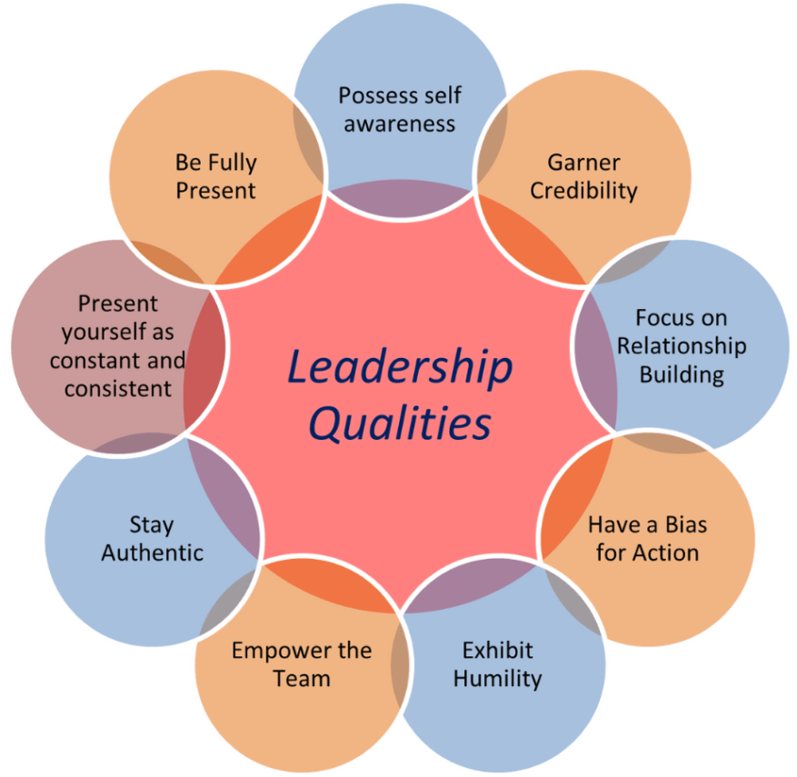
Figure 1: Leadership Qualities
(Source: protouchpro.com, 2024)
It may also be noted that one attribute of leadership performance is indeed the capacity to cope with ambiguity. During turbulence, the leaders must show flexibility and promptness when giving direction to the public. Such leadership clears the air for employees since they know what to expect hence relieving a lot of uncertainty. This paper’s findings also show that, over the years, ABC Inc. has been unable to complete change initiatives mainly because the company lacks the stability and visionary leadership that is required to support change initiatives while at the same time avoiding and reducing adverse impacts of disruption.
There is match between leadership styles and workplace health and productivity relationship because leadership greatly influences all these factors. The element of inspirational communication to promote change and generate new ideas is even more efficient in revitalizing organizations during crises with transformational leadership. This paper will also show that by having a clearly articulated shared vision, the goals set by the organization and personal objectives of each member of the organization can be made to match, thereby increasing motivation and commitment. On the other hand, a strict and autocratic leadership style hampers moral and conflicts such as those seen at ABC Inc. Involving participants in arriving at decisions also keeps the employees focused and empowered to work, which helps to build a strong force.
Ethical practices come from the top; hence managers who mimic ethical standards encourage the rest of the organization to mimic the conduct. Concerning ABC Inc., ethical leadership is the solution to stakeholder complaints, the restoration of trust, and the company’s image. Ethical practice also concerns itself with fairness, enforcing the aspect damps strain in the workplace and boosts teamwork. When the Employee’s view their leaders as ethical, obeying principles in business they in turn feel obligated to work harder with less conflicts in the company.
Leaders seeking to establish healthy working culture cannot afford not to promote development of emotional intelligence. Emotional intelligence deliver an ability in leaders to understand or feel what employees are going through in the workplace, what they need and how to deal with issues arising. Appreciation of cultural differences as well as admission of cultural differences results in approval of leaders to come up with effective styles that embrace difference and expertise thus resulting in innovation and respect. For ABC Inc., one of the possible benefits of improving organizational leadership climate is that leadership turmoil can be transformed from being a problem into a solution by teaching management leaders with high levels of EIS, so they regain harmony in the organization.
Due to the challenges that inhibit the achievement of effective leadership in organizations, leadership development programs need to be funded to impart important skills of communication, problem solving and flexibility. Another important practice is also suited in the areas of the professional growth of managerial personnel, such as mentoring and coaching of young leaders for the effective management of potential problems. For ABC Inc., leadership development is crucial as it enables the company to create solid leadership pool without the overflow of changes at the leadership levels.
Ultimately, effective leadership contributes to a healthy workplace by enhancing job satisfaction, reducing turnover, and promoting organizational resilience. Leaders who empower employees, champion ethical practices, and exhibit emotional intelligence lay the foundation for sustainable success. For ABC Inc., addressing its leadership crisis with a renewed focus on these competencies will not only stabilize the business but also create an environment where employees and stakeholders can thrive. In doing so, the company can regain its position as an industry leader, demonstrating the transformative power of effective leadership.

Importance of Effective Leadership Styles and Their Contribution to a Healthy Workplace
Effective leadership styles are fundamental to cultivating a productive and harmonious workplace, particularly in times of uncertainty and organizational instability (Dawes and Topp, 2022). Leadership styles shape how leaders communicate, make decisions, and inspire employees, thereby influencing workplace culture and overall organizational success. In the context of ABC Inc., where frequent CEO turnover and incomplete change initiatives have destabilized the company, adopting effective leadership styles is critical for restoring stability, enhancing morale, and fostering a healthy workplace.
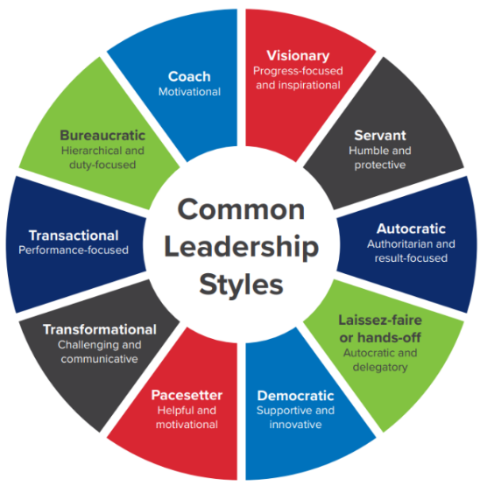
Figure 2: Common Leadership Styles
(Source: linkedin.com, 2024)
One of the most impactful leadership styles is transformational leadership, which emphasizes inspiring and motivating employees through a shared vision. Transformational leaders focus on the personal and professional development of their team members, fostering a sense of purpose and commitment. This style is particularly relevant for ABC Inc., as it can address low morale and disengagement among employees. By encouraging innovation, recognizing contributions, and building a culture of trust, transformational leadership can rejuvenate the workforce, improve productivity, and strengthen organizational cohesion.
In contrast, transactional leadership, which is based on structured tasks and performance rewards, can also be effective in certain scenarios. This style works well in maintaining order and ensuring adherence to processes, especially in routine operations (Jeffryes, 2022). For ABC Inc., elements of transactional leadership include the use of rewards and punishment can help to create order and set some standards in a chaotic world. However, over-use of this kind of leadership may result to restrictiveness and slow down creativity; therefore, there is need to balance this performative flexibility.
Situational leadership is the other style that is quite valuable in the contemporary business environment. This approach involves adapting leadership methods to the specific needs of employees and situations. In a company like ABC Inc., which faces dynamic challenges, situational leadership can help address diverse employee expectations and foster inclusivity (Stuber et al., 2021). For example, experienced employees may benefit from a more delegative approach, while newer or struggling employees might require additional guidance and support. This flexibility ensures that leaders remain responsive to individual and collective needs, thereby promoting a healthier work environment.
The role of ethical leadership cannot be overlooked in creating a healthy workplace. Ethical leaders prioritize fairness, transparency, and integrity, which are essential for building trust and credibility. At ABC Inc., where employees and stakeholders have witnessed instability and abandoned initiatives, ethical leadership can serve as a stabilizing force. Ethical practices encourage accountability, reduce workplace conflicts, and establish a culture of mutual respect. Employees who perceive their leaders as ethical are more likely to feel valued and engaged, contributing to a more collaborative and motivated workforce.
Another vital aspect of leadership is emotional intelligence, which enhances a leader's ability to connect with employees on a personal level (Garcia Zea et al., 2023). Leaders with high emotional intelligence can effectively manage conflicts, demonstrate empathy, and inspire loyalty. For ABC Inc., cultivating leaders with strong emotional intelligence can mitigate the negative effects of past leadership turmoil, fostering a supportive and inclusive workplace. Emotional intelligence also helps leaders navigate the complexities of organizational change, ensuring that transitions are handled with sensitivity and care.
Barriers to effective leadership, such as resistance to change, lack of communication, and inadequate leadership development, must be proactively addressed (Kohntopp and McCann, 2020). For ABC Inc., investing in leadership development programs can equip current and future leaders with the necessary skills to manage challenges effectively. Workshops, coaching, and mentorship initiatives can enhance leaders' ability to adopt diverse leadership styles, adapt to changing circumstances, and inspire their teams. By prioritizing leadership development, the company can create a robust pipeline of competent leaders who are prepared to address organizational needs.
Leadership development, fostering a culture of collaboration and empowerment is crucial. Leaders who actively involve employees in decision-making processes and provide opportunities for growth encourage a sense of ownership and engagement. For ABC Inc., empowering employees through participatory leadership can counteract the effects of past instability and build a resilient workforce. Empowerment not only boosts morale but also enables employees to contribute meaningfully to the organization’s success.

Tackling Barriers to Effective Leadership in the Workplace
Barriers to effective leadership can hinder organizational success, employee morale, and productivity. Addressing these barriers is critical for organizations like ABC Inc., which has faced significant leadership instability. Management must implement targeted strategies to foster effective leadership and create a healthy workplace.
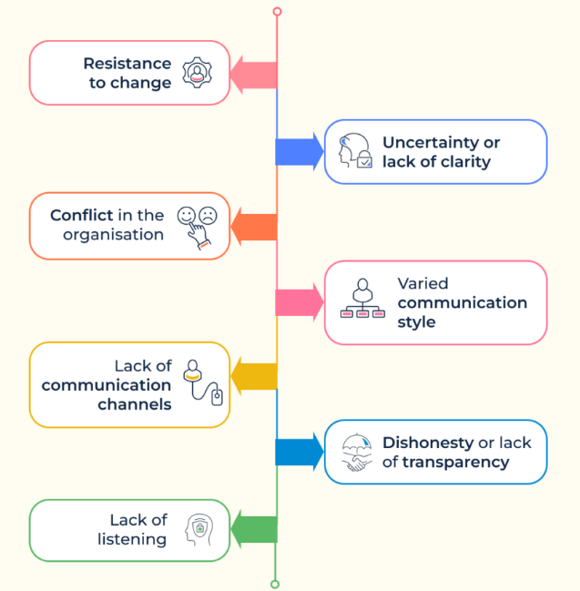
Figure 3: Common Barriers in Leadership Communication
(Source: hrone.cloud, 2024)
1. Addressing Resistance to Change
Resistance to change often arises from fear, mistrust, or past failures. Employees may hesitate to embrace new leadership styles or organizational adjustments (Jones, 2022). Management must tackle this by fostering open communication and transparency about the need for change. Involving employees in decision-making and providing platforms for feedback can mitigate resistance. Training programs focused on change management equip employees and leaders with tools to adapt effectively.
2. Improving Communication
Ineffective communication can lead to misunderstandings and disengagement. Leaders must be trained to communicate expectations clearly, provide constructive feedback, and foster collaboration. Management should establish regular channels for open dialogue, encouraging leaders to listen actively and build trust with their teams. Strong communication bridges gaps and enhances team cohesion, driving productivity.
3. Developing Emotional Intelligence
Leaders lacking emotional intelligence often struggle with conflict resolution and employee engagement. Management can prioritize emotional intelligence training, helping leaders recognize and regulate emotions, empathize with employees, and navigate interpersonal challenges (Goens & Giannotti, 2024). This approach fosters a positive and inclusive workplace culture, enhancing team morale and motivation.
4. Establishing Leadership Development Programs
A lack of structured leadership training can hinder adaptability and effectiveness. Management should invest in comprehensive development programs, including mentoring, coaching, and ongoing education. These initiatives equip leaders to address modern challenges such as remote work, diverse teams, and innovation (Boateng, 2023). Nurturing high-potential employees ensures a steady pipeline of capable leaders, securing organizational stability.
5. Building Trust and Credibility
Trust is essential for effective leadership. Employees are more likely to follow leaders they perceive as honest, fair, and accountable. Management should promote ethical practices and transparency in leadership roles (Fianko et al., 2020). Recognizing employee contributions and ensuring consistency in actions build trust and strengthen workplace relationships.
6. Encouraging Adaptability
Inflexible leadership styles can limit effectiveness in dynamic environments. Management must encourage situational leadership practices, where leaders adapt their approaches based on team needs and specific situations. Training leaders to be flexible and responsive helps organizations navigate uncertainty more effectively.
7. Promoting Diversity and Inclusion
Homogeneous leadership teams may struggle to address diverse employee needs. Management should actively promote diversity in leadership positions through equitable recruitment and promotion policies. Training leaders to value diverse perspectives fosters creativity and drives innovation, contributing to organizational growth.
8. Providing Resources and Support
Leaders require adequate resources, such as time, budgets, and tools, to succeed. Management must ensure leaders have access to these essentials and set realistic expectations (Cardiff et al., 2020). Peer support networks and leadership forums provide valuable opportunities for learning and growth, enabling leaders to overcome challenges collaboratively.
9. Cultivating a Feedback-Oriented Culture
A lack of feedback prevents leaders from recognizing areas for improvement. Management should establish systems like 360-degree feedback and regular performance evaluations. These practices encourage constructive critique, helping leaders refine their skills and adapt to workplace needs.
By addressing these barriers, management can foster effective leadership and create a thriving workplace. Through improved communication, emotional intelligence, adaptability, and trust-building, organizations like ABC Inc. can empower leaders to drive success and navigate challenges with confidence.

The Importance of Ethical Leadership in the Workplace
Ethical leadership is crucial for maintaining a positive workplace culture, especially in organizations like ABC Inc., which has experienced leadership instability and ongoing challenges. Ethical leaders serve as role models, shaping the values and behaviors of employees and ensuring that the organization operates with integrity, fairness, and responsibility (Wilson, 2022). The importance of ethical leadership in the workplace cannot be overstated, particularly in times of uncertainty and change.
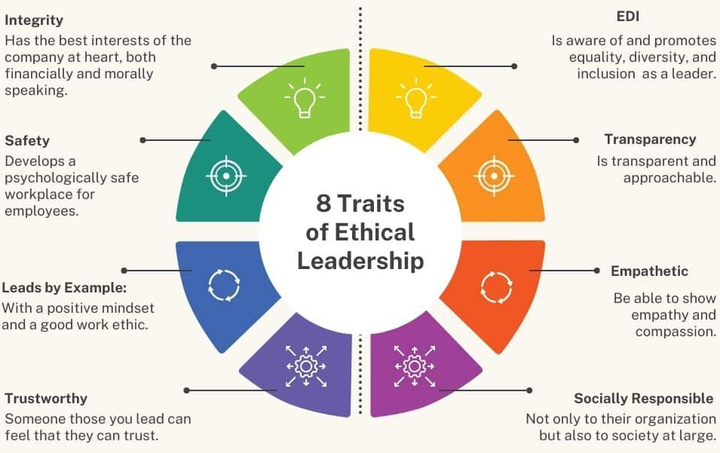
Figure 4: Ethical Leadership Qualities
(Source: symondsresearch.com, 2024)
1. Building Trust and Credibility
At the heart of ethical leadership is the ability to build trust. Employees are more likely to follow and respect leaders who act with honesty, fairness, and transparency. In organizations like ABC Inc., where there have been multiple leadership changes, the presence of ethical leadership helps to restore credibility and establish long-term trust between leadership and employees. This trust is essential for creating a stable work environment, where employees feel valued, secure, and motivated to contribute their best efforts.
2. Promoting Organizational Integrity
Ethical leaders establish and uphold a clear set of values and principles that guide decision-making. By consistently adhering to ethical standards, they set expectations for the entire organization. This commitment to integrity ensures that all business practices, whether internal or external, are conducted in a manner that respects both legal standards and moral obligations (Mironko et al., 2022). At ABC Inc., where there has been uncertainty in leadership, ethical leadership can act as a stabilizing force, ensuring that the organization operates ethically despite past challenges.
3. Enhancing Employee Morale and Engagement
When employees see their leaders acting ethically, they are more likely to exhibit positive behaviors such as honesty, accountability, and respect. Ethical leadership creates a work environment where employees feel respected and empowered. In a company like ABC Inc., where leadership transitions have led to low motivation and workplace unrest, ethical leadership can rejuvenate employee morale by fostering a culture of fairness and open communication. Employees are more likely to be engaged and productive when they trust their leaders and believe in the organization's values.
4. Strengthening Long-Term Success
Ethical leadership contributes to long-term success by aligning business goals with societal and environmental responsibilities. Organizations led by ethical leaders are better positioned to navigate complex challenges and build strong reputations with customers, regulators, and the public (Choi et al., 2021). For ABC Inc., ethical leadership can help repair the company's reputation and create sustainable growth by focusing on practices that benefit not only shareholders but also employees and the wider community.
5. Mitigating Risks and Legal Issues
Ethical leadership reduces the likelihood of legal and regulatory violations. By adhering to ethical principles, leaders help ensure that the organization remains compliant with laws and avoids actions that could lead to costly legal battles or damage to the company's reputation. In uncertain times, such as those experienced at ABC Inc., ethical leadership can act as a safeguard, preventing the company from making hasty, unethical decisions that could have long-term repercussions.

Recommendation to End the Leadership Crisis at ABC Inc.
Hence, the need to have a more elaborate process of choosing the next CEO especially given the continued political instability at ABC Inc. CEO replacement has been frequent hence leading to organizational instability, demoralized employees and reduced stakeholder trust.
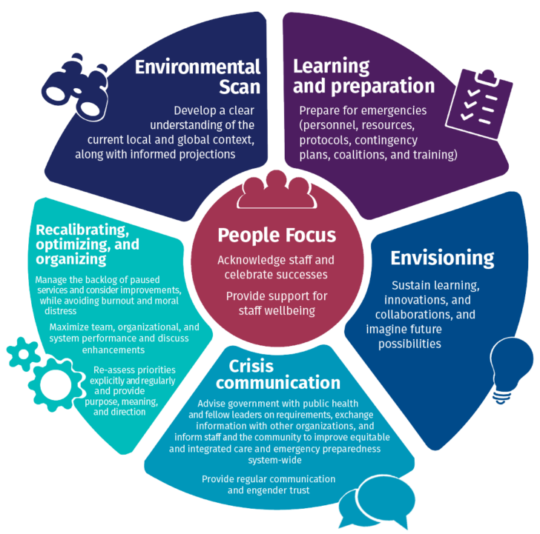
Figure 5: Solutions Leadership Crisis
(Source: cchl-ccls.ca, 2024)
To effectively end this crisis and establish a strong leadership foundation, the following recommendations are proposed for the Chairman and board members of ABC Inc.:
1. Prioritize Leadership Stability and Continuity
The next CEO needs to be chosen for the solutions that he or she will provide in the long term, not for the quick results. The frequent changes in leadership have created a sense of insecurity among employees and stakeholders. Therefore, the board should focus on hiring a leader who demonstrates a commitment to the company’s vision and is prepared to stay for an extended period. A transparent commitment to long-term goals will signal to employees and stakeholders that the company values stability and is prepared to invest in its leadership for the future (Wallo et al., 2022).
2. Assess Leadership Qualities Beyond Technical Expertise
While technical expertise is essential, the next CEO should also exhibit strong emotional intelligence, ethical leadership, and the ability to navigate complex organizational dynamics. Given the low motivation and unhealthy workplace conditions observed under previous leadership, it is essential to choose a leader who can rebuild trust, foster a positive organizational culture, and motivate employees. The CEO must possess strong interpersonal and communication skills to bridge the gap between management and employees, engage in active listening, and address concerns proactively.
3. Focus on Alignment with Company Values and Vision
The selected CEO must have a deep understanding of ABC Inc.'s values and be aligned with its long-term strategic vision. This will enable the leader to guide the company through the uncertainties it faces and implement sustainable change (Jayanagara, 2024). The CEO should embrace a leadership style that encourages collaboration, transparency, and inclusivity, aligning with the needs of employees and stakeholders alike.
4. Involve Employees in the Selection Process
To restore confidence in leadership, the board could consider involving employees in the selection process. This could be done through surveys or focus groups to understand the leadership traits and qualities employees value most. Engaging employees in this way not only demonstrates transparency but also allows the organization to select a leader who will resonate with and inspire the workforce.
5. Implement a Leadership Development Plan
So, the board should provide a perspective leadership development map which should aim at nurturing internal talent for leadership roles in the future (Li et al., 2020). Thus, ABC Inc. investments in the development of its employees will not only guarantee ready access to qualified leaders but also create conditions for increasing satisfaction and, consequently, staff turnover.
Therefore, having a CEO who will ensure stability, shares ABC Inc.’s corporate values, and has leadership skills, independence will bring an end to leadership crisis to ABC Inc. and help in coming up with a stable, motivated, and productive employees’ environment.

Conclusion
In conclusion, the crisis in leadership that the paper has harmonized on from ABC Inc, has had unidentified implications on the human resource, shareholders and operational outcomes of the firm. After the high rate of turnovers of the CEOs, the organizations can end up having low morale and low productivity levels due to the social subculture. Leadership is crucial to not only guide the business through the tumultuous environment but also to enhance the organizational climate, increase employees’ confidence in managers and encourage the workforce pursue the corporate objectives.
To overcome this crisis ABC Inc. must select the right CEO to bring long term order to this company and must ensure that whoever is selected must uphold the company’s esteem and its vision. Ideally, this leader should be emotionally intelligent, ethical, and accountable to the employees as well as focused on increasing transparency. Namely, the company needs to intensify its efforts aimed at minimizing such barriers to effective leadership as inadequate communication and low employee engagement in the selection and training of leaders.
All in all, ABC Inc. must decide on the suitable CEO and enroll a profound leadership program to resolve existing leadership issues and establish a meaningful and stable growth plan. Ethical-moral values and people’s commitment, supported by leadership that remains stable, will help the company to restore and develop.

Part 2 – Reflective Essay

Reflection on Leadership Styles and Traits
From this Leadership and Management Skills for the Workplace module, I have garnered skills in understanding of various leadership features and approaches that define leadership. Wales 2021 opines that leadership is not just about issuing directions but about creating change in and cultivating people as a means of getting things done. From the leadership concepts of this course, transformational leadership, servant leadership, and emotional intelligence has influenced my thinking. Over the course of this program, I have identified the need to be flexible and understand both myself and other people, as well as the ability to exercise my verbal communication skills in order to encourage the team.
In the cases and discussions during this course, leadership has been illustrated and I have thought about how it can occur and how a good leader adapts his behavior to the situation, the group and the company. This learning has impacted my personality in a way that helped me develop my EQ, refine my problem-solving skills and create a culture of teamwork. Herein, they are positioned to empower we into engaging more in leadership capacities as well as help other people in several ways concerning their professional lives.

Impact of Emergent Leadership Skills on My Leadership Development
From this module, I understand different emergent leadership skills and how they impact leadership growth and organizational leadership. The description of emergent leadership and efficacy of enhancing the typical personal qualities such as emotional intelligence, adaptability, and communication has allowed me to evaluate my leadership ability (Sherwood et al., 2023). These skills are central for the construction of a leadership personality oriented to self-reflection, which is useful given the new requirements that are currently being set in the global economy.
For instance, I have understood the importance of effective listening courtesy of which I have established good rapport in groups. The flexibility used in decision-making has improved on how I address change and tight situations. Endeavoring all these skills has a positive impact on organizational performance besides enhancing my leadership skills and improving the workplace environment. If I am to keep on developing these skills then I believe that the overall leadership competencies of clear, trusting and visionary leadership will experience positive change.

Influence of Leadership Concepts on My Personal Leadership Style
The two theories I have embraced in my leadership practice are transformational leadership and emotional intelligence. In my last assignment, I was a team leader in a volunteer project, so I have worked on transformational patterns of leadership and encouraged other team members to move towards the shared vision (Lane and Roberts, 2022). I emphasized on helping the people around me, being helpful and creating opportunities to innovate. The proved useful to foster ownership and commitment from the team that was working on the project.
Emotional intelligence has been a critical factor in the way I relate to other people and how I get them to willingly work to achieve common goals. Developing skills according to the present theory helped me increase self-awareness and adjust to others’ emotions, which led to every team’s improved communication. This has been particularly useful especially when dealing with difficult bearing in mind that everyone is unique requiring a sensitive touch when handling them.

Reflecting on Leadership Development Using Gibbs' Reflective Cycle
In the process of writing this leadership journey, I have decided to consider Gibbs’s Reflective Cycle to gain a deeper understanding of how my leadership capabilities have evolved and how I might assess my leadership strategies for other people (Miller et al., 2020). The reflective model is structured into six stages: Description, Feelings, Evaluation, Analysis, Conclusion, and Action Plan, which helps to structure reflective thinking in a way that enables one to learn from experiences.
An example that comes to my mind is a group assignment I had when volunteering for a local charity organization. The objective set for the class was to plan a fundraising event, and I was to act as a project manager. In the Description stage, I outlined the situation this involved managing the volunteers and assigning them duties, getting to know everyone and being able to communicate with them and get the job done for the event.
At Feelings stage I experienced combination; both happiness and fear. Excited for this challenge, I felt that there were times of uncertainties for example in handling intra personnel conflicts and coming up with solutions while keeping an eye on the good of the company (Henderson et al., 2022). My anxiety came from not wanting to disappoint the team, which sometimes caused me to avoid difficult conversations when certain issues arose, such as a lack of communication from some members.
Moving to the Evaluation stage, I considered the outcome of the project. Overall, the event was successful, and we raised a significant amount of funds. There were areas of improvement. While we worked well as a group, there were moments of miscommunication, and I could have been more proactive in addressing minor conflicts within the team sooner (Wang et al., 2021).
The Analysis stage allowed me to identify key learning points. Emotional intelligence and empathy played a vital role in maintaining team morale. I realized that I tend to shy away from conflict, which in some instances delayed resolution and caused unnecessary tension (Hilal, 2021). This highlighted the importance of direct communication and setting clear expectations from the outset.
In the Conclusion stage, I understood that to grow as a leader, I must work on handling conflict more assertively, without sacrificing the team's cohesion. To do this, I need to develop better communication skills, particularly in difficult situations, and ensure I don’t avoid uncomfortable conversations.
Finally, the Action Plan for my personal development as a leader includes enrolling in conflict resolution workshops and practicing open communication techniques with my peers and team members in future projects (Koukpaki and Adams, 2020). By doing so, I believe I will be able to develop a more balanced leadership style that incorporates both empathy and assertiveness.
This reflective approach, through the Gibbs' model, has allowed me to assess my growth as a leader, understand my strengths and weaknesses, and make concrete plans for future improvement. It is a valuable tool in my ongoing leadership development.

Reference List
blog.proactioninternational.com, 2024. Leadership Styles and Traits [Online]. Accessed from: https://blog.proactioninternational.com/en/types-of-leadership-approaches-guiding-teams. [Accessed on: 19.11.2024]
Boateng, P.A., 2023. Analyzing the Relationship Between Psychopathy and Leadership Effectiveness: Moderating Role of Emotional Intelligence. European Journal of Business and Management, 1594, pp.1-12.
Cardiff, S., Sanders, K., Webster, J. and Manley, K., 2020. Guiding lights for effective workplace cultures that are also good places to work. International Practice Development Journal, 10(2).
cchl-ccls.ca, 2024. Solutions Leadership Crisis [Online]. Accessed from: https://cchl-ccls.ca/resource/leadership-in-a-crisis/. [Accessed on: 19.11.2024]
Choi, W.S., Kang, S.W. and Choi, S.B., 2021. Innovative behavior in the workplace: An empirical study of moderated mediation model of self-efficacy, perceived organizational support, and leader–member exchange. Behavioral Sciences, 11(12), p.182.
Dawes, N. and Topp, S.M., 2022. Senior manager leadership competencies for quality residential aged care: an Australian industry perspective. BMC Health Services Research, 22(1), p.508.
Fianko, S.K., Jnr, S.A.J.S.A. and Dzogbewu, T.C., 2020. Does the interpersonal dimension of Goleman's emotional intelligence model predict effective leadership?. African Journal of Business and Economic Research, 15(4), p.221.
Garcia Zea, D., Sankar, S. and Isna, N., 2023. The impact of emotional intelligence in the military workplace. Human Resource Development International, 26(1), pp.85-101.
Goens, B. and Giannotti, N., 2024. Transformational leadership and nursing retention: An integrative review. Nursing Research and Practice, 2024(1), p.3179141.
Henderson, L., Nuttall, J., Wood, E. and Martin, J., 2022. The potential of ‘leading identity’as an analytic concept for understanding Educational Leadership development in early childhood education. Teachers and Teaching, 28(7), pp.875-889.
Hilal, Y.Y., 2021. De-domesticating reflection: the role of school leadership within a colonized lifeworld. International Journal of Leadership in Education, pp.1-23.
hrone.cloud, 2024. Common Barriers in Leadership Communication [Online]. Accessed from: https://hrone.cloud/blog/barriers-leadership-communication/. [Accessed on: 19.11.2024]
Jayanagara, O., 2024. THE EVOLUTION OF LEADERSHIP IN THE MODERN PROFESSIONAL LANDSCAPE: SHIFTING PARADIGMS AND THEIR IMPACTS. Feedforward: Journal of Human Resource, 4(1), pp.61-71.
Jeffryes, J., 2022. Using Popular Culture Resources to Build Affective Leadership Skills. Library Leadership & Management, 36(2).
Jones, J., 2022. Effective leadership in the 21st century. Radiology management, 44(6).
Kohntopp, T. and McCann, J., 2020. Leadership in virtual organizations: Influence on workplace engagement. The Palgrave handbook of workplace well-being, pp.1-26.
Koukpaki, A.S.F. and Adams, K., 2020. Enhancing professional growth and the learning and development function through reflective practices: an autoethnographic narrative approach. European Journal of Training and Development, 44(8/9), pp.805-827.
Lane, A.S. and Roberts, C., 2022. Contextualised reflective competence: a new learning model promoting reflective practice for clinical training. BMC Medical Education, 22(1), p.71.
Li, Y., Chen, W., Liu, C. and Deng, M., 2020. Nurses’ psychological feelings about the application of Gibbs reflective cycle of adverse events. American Journal of Nursing, 9(2), pp.74-78.
linkedin.com, 2024. Common Leadership Styles [Online]. Accessed from: https://www.linkedin.com/pulse/what-leadership-style-do-you-feel-comfortable-quick-overview-larios-25e9c. [Accessed on: 19.11.2024]
Miller, J.M., Ford, S.F. and Yang, A., 2020. Elevation through reflection: closing the circle to improve librarianship. Journal of the Medical Library Association: JMLA, 108(3), p.353.
Mironko, A., Muriungi, R.M. and Scardino, A.J., 2022. The changing technology use and its impact on leadership and hierarchy structure in the virtual workplace. In Business Advancement through Technology Volume II: The Changing Landscape of Industry and Employment (pp. 87-108). Cham: Springer International Publishing.
protouchpro.com, 2024. Leadership Qualities [Online]. Accessed from: https://www.protouchpro.com/guest-posts/9-leadership-qualities/. [Accessed on: 19.11.2024]
Sherwood, G., Cherian, U.K., Horton-Deutsch, S., Kitzmiller, R. and Smith-Miller, C., 2023. Reflective practices: meaningful recognition for healthy work environments. Nursing Management, 30(6).
Stanley, D., 2022. Reflection and emotional intelligence. Clinical Leadership in Nursing and Healthcare, pp.323-336.
Stuber, F., Seifried-Dübon, T., Rieger, M.A., Gündel, H., Ruhle, S., Zipfel, S. and Junne, F., 2021. The effectiveness of health-oriented leadership interventions for the improvement of mental health of employees in the health care sector: a systematic review. International archives of occupational and environmental health, 94, pp.203-220.
symondsresearch.com, 2024. Ethical Leadership Qualities [Online]. Accessed from: https://symondsresearch.com/ethical-leadership/. [Accessed on: 19.11.2024]
tsw.co.uk, 2024. Gibbs Reflective Cycle [Online]. Accessed from: https://www.tsw.co.uk/blog/leadership-and-management/gibbs-reflective-cycle/. [Accessed on: 19.11.2024]
Wales, T., 2021. The view from within: A personal reflection on library strategy development in three academic libraries. In Positioning the Academic Library within the University (pp. 234-248). Routledge.
Wallo, A., Kock, H., Reineholm, C. and Ellström, P.E., 2022. How do managers promote workplace learning? Learning-oriented leadership in daily work. Journal of Workplace Learning, 34(1), pp.58-73.
Wang, Q., Lai, Y.L., Xu, X. and McDowall, A., 2021. The effectiveness of workplace coaching: a meta-analysis of contemporary psychologically informed coaching approaches. Journal of Work-Applied Management, 14(1), pp.77-101.
Wilson, A., 2022. Effective Leadership Strategic Use of In-House Corporate Social Media (Master's thesis, The College of St. Scholastica).

