STUDENT NAME: | NURJAHAN BEGUM
STUDENT ID NUMBER: | 1912210
PROGRAMME: | BA LEADERSHIP AND MANAGEMENT
MODULE: | UNDERSTANDING AND ENGAGING IN CUSTOMER EXPERIENCE
MODULE CODE: | BMSW 5103
ASSIGNMENT TITLE: | CUSTOMER RELATIONSHIP MANAGEMENT EMERGING THEMES
LECTURER:

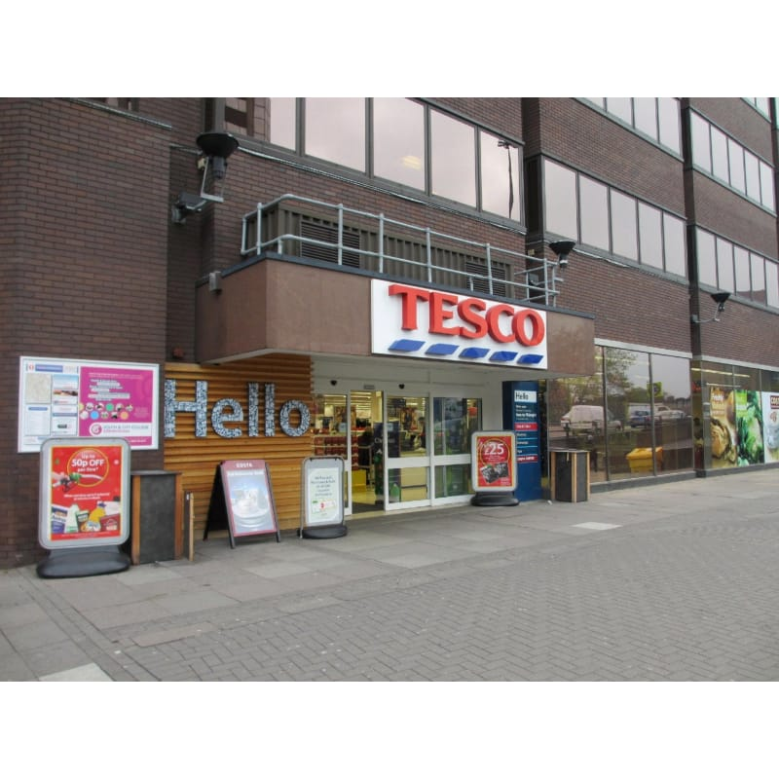
CUSTOMER RELATIONSHIP MANAGEMENT EMERGING THEMES

REPORT

2021

CONTENTS
Introduction………………………………………………………………………………………………………….4
Investigating Tesco’s theme based on Tech Touch versus human touch and the impacts on customer experience………………………………………………………………………………………….….5
Tesco’s theme of Customer experience and Brand Experience and its impact on customer’s…………………………………………………………………………………………………………5-6
Customer relationship and management policies at Tesco and how it impacts customer’s………………………………………………………………………………………………………...6-7
sustainability policies of at Tesco and how it impacts customers………………………………….…8
The concept of ‘quality’ and its components and its link in improving and measuring CRM………………………………………………………………………………………………………………...8-9
Analysing Deming (PDCA) cycle and theories that may assist in improving the customer relationship management (CRM) at Tesco………………………………………….…9-10-11
Analysing Juran’s Trilogy cycle and theories that may assist in improving the customer relationship management (CRM) at Tesco’s………………………………………….12-13-14
Conclusions…………………………………………………………………………….…….15
Recommendations……………………………………………………………………….….15
References…………………………………………………………………………………………………16-17-18

INTRODUCTION
My report will be based on investigating the current themes of a supermarket and how it has an impact on customer experience. My chosen retail will be Tesco supermarket established through Jack Cohen in 1919 starting after his marketplace stand inside London, his business grew and developed operating in over fourteen countries and employing around 500,000 employees at Tesco plc. In My report my investigation and discussion will be based on Tech Touch versus Human Touch, Customer Experience and Brand Experience. And a discussion created on the sustainability in customer relationship management (CRM) at Tesco, and how it impacts on their customers experience, and will be going into depth about sustainability in customer services, its components, and sustainability policies at Tesco supermarket, and how it impacts customers. And finally, my report will be rounded upon two quality models / theories, that will assist in improving customer relationship management (CRM) at Tesco supermarket.

Investigating Tesco’s theme based on Tech Touch versus human touch and the impacts on customer experience.
Tesco supermarket have always been known to be at the forefront of technology using it to deliver customer value, improving and transforming customers experience and maintaining customer loyalty, Tesco believe that the customers main key drivers is satisfaction, by providing them with high quality, value for money products and services. one of them being a heat sensing technology to monitor ques at tills, providing self-service and checkout to make it a swift and happy experience for the customer. As well as Online shopping with free delivery, a comfort and convenience for the customers from home or the office. Also, the” scan as you shop technology”, helps customers to scan their items, track on their spending and go to the till and pay without having to unload any items out of the basket, nobody likes to load and unload shopping which is why this is a good experience for the customer to shop with ease and have comfort to know that the end experience is easy and swift.
Tesco has also created a technology called ‘GETGO’ to improve shopping experience for their customers allowing them to shop and pay without scanning a product and no checkouts involved, instead customers shop through the tesco.com app on their phones check in store and pick up there shopping. Tesco’s cameras and weight sensors monitor customers shopping and charge them for their products through the app after leaving the store with a full receipt on the customers phone. Tesco’s technology gives customers access to quick and convenient live chats to communicate and resolve any issues saving time and money. Technology impacts customers in decision making, quicker purchasing decisions, analysing customer behaviour, technology helps customers with their spending habits when shopping, making it an overall happy experience. The impact of Live chats allows customers to have that one to on personal experience saving long hours of waiting time on the phone Which leads to. Customers engaged, satisfied long term loyal customers. Fan, A, (2016) verify that (Collier & Sherrell, 2010) suggest that “When technology is used to deliver service, customers focus on whether the technology is able to deliver desired service outcomes.” Tesco’s human touch strategies are human staffed checkouts for basket shopping a privilege and convenience for shoppers who still want to opt for interaction and small talk.

Tesco’s theme of Customer experience and Brand Experience and its impact on customer’s.
Katherine n et al (2016) verify that “Pine and Gilmore (1998, p. 3) conceptualized the idea of “experiences” as distinct from goods and services, noting that a consumer purchases an experience to spend time enjoying a series of memorable events that a company stages to engage him in an inherently personal way.” Other researchers, however, have argued for a much broader view of the customer experience”. Tesco have always stayed on top of improving its customers' experience by improving in store shopping and online shopping by adding brand new customer service counters and altering its operating hours and adding smaller Tesco express, Tesco extra with longer opening hours. Also adding 3,000 customer-facing staff since February 2016. product marketing and retail has had an increase around 80% of product awareness which is run within the shop experience and the experience received online, rather than some advertising communication. Tesco’s promoting attempt goes in the direction of sharing that experience or enhancing the overall experience in the store itself.
Tesco’s own brand products and Tesco’s loyalty Clubcard are the main key drivers and impacts customers experience with satisfaction and loyalty, as customers behavioural pattern for repurchase is implemented, as they come to believe they are receiving value for money. Anni Isotalo and Samu Watanen (2015) state that Solomon (2010) suggests that.” Attitudes and brand image can be positively affected through a brand experience that provides consumers with pleasure by how the product makes them feel or the fun experiences the brand can provide” (Solomon, 2010. p. 277-280).

Customer relationship and management (CRM) policies at Tesco and how it impacts customer’s.
Khan h.u. et al (2016) suggests that “Customer relationship management (CRM) is a system that helps manage a company’s relations with its customers, clients, and sales prospects”. CRM is a contraction for Customer Relationship Management helping organizations to engage and contact customers accurately by using the data provided by the individual through the journey they have with organisations it helps recognise brand new trends offer profits for existing and upcoming investments. It’s a method used to build and manage customer relationships and helping organisations bond, and get to know their customers through CRM platform, their likes and dislikes are then recorded, and the activity customers engage in are tracked. Each individual customer is recognised when they need to talk to someone, that way the customer receives a customised personal experience. According to Tien, et al (2021) “Provide customers with better services, improve call centre efficiency, help salespeople fulfil orders faster, simplify marketing and sales processes, develop present new customers, increase revenue from customers.” Lower version is an approach a model of implementing CRM.

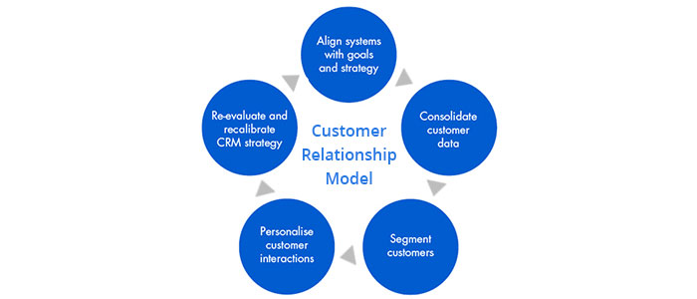
Source: REVE chat (2021)
CRM model can be categorised into stages such as:
Awareness – Starting off with main touchpoint usually where prospects learn about the brand. Discovery – Identifying the requirements of the prospects and delivering info to fulfil the obligation. Evaluation - assessing and estimating goods/service sector with rivals. Intent – A prospect is assured, and a judgment is put together to buy. Purchase –Once payment is made an agreement is put in place, the prospect alters into your customer. Faithfulness – Is after a purchase is made a follow up is made to see if customer satisfaction was made with the product by asking for referrals, to be able to enhance customer relationships, proper focus needs to be evaluated through each and individual communication felt by clients through the product itself.

The research focuses on understanding emerging themes in customer experience and the impact of emerging themes on policies and practices of the quality systems to enhance the customer relationship management with reference to Tesco supermarket. Tesco’s CRM program consist of segregation of their consumers corresponding to their instore shopping and expenditures. This allows Tesco to prioritize the customers on basis of the company they offer to the store. Tesco Clubcard was announced in 1995. This helps the loyal and consistent clients to add up more value points on the cards during every buy, points are therefore collected. Soon after a while those points are presented as discounts and deals for all customers that are card owners. This impacts the customers and enhances their preference and loyalty towards the store as they become regular customers at Tesco, shopping and being able to save every time they make a purchase, in return their loyalty is awarded with a variety of incomparable deals as well as reductions with Quite a lot of exclusive privileges only available and presented to members who are card holders. This impacts the customers as satisfied, committed and are more likely to recommend Tesco’s to their friends and family.

sustainability policies at Tesco and how it impacts customers
Iqbal, q et al (2018) confirms that according (Dubois and Dubois, 2012). “Sustainability refers to the way to meet present needs without compromising the ability of future generations to fulfil their own needs. The sustainability model is based on three pillars – economic, social and environment. It is also referred to as triple bottom line of profit, people, and planet. These are basically the long-term interests of an organization that encompasses environmental sustainability, but short-term goals are only about economic profit.”
One of Tesco’s sustainability policies is The Little Helps Plan, a framework with four pillars: The people pillar is taking care of colleagues, diversity and inclusion, and human rights. The product pillar is looking after healthy sustainable products, packaging, and food waste. The planet pillar is looking after the environment and farming and sustainable agriculture. And the fourth pillar places looking after the community, charity partnerships and food redistribution this strategy is used to shape their long-term approach to sustainability and monitoring, demonstrating, and improving performance on the subjects that are of concern such as diversity and inclusion, maintainable diet that is healthy and beneficial, Shortage in food and poverty and the change that occurs during climate. Tesco food waste saving initiative is looking after the environment, their mission is to help save half of global food waste with a scheme named perfectly imperfect, providing customers with wonky fruit and vegetables that would normally go to waste but saved by Tesco’s scheme and are just as fresh and tasty as your normal looking food and good value for money. Tesco are committed to minimising the environmental impact working with suppliers to tackle climate change to reduce waste. This strategy heavily impacts customers into being contributors in being part of preventing food waste and is also affordable for customers who can’t afford to buy the more expensive products and are more likely to be part of the scheme and buy more of the wonky food and vegetables products and remain long term loyal customers at Tesco.
Concept of quality is and its components and its link in improving/measuring CRM at Tesco.
Androniceanu, A., 2017, suggests that According to J. M. Juran, an American expert of Romanian origin, quality means "suitable for use" (Juran and Gryn, 1973) Defines quality as the property of a product to be suitable for consumption in terms of design, conformity to the specifications, reliability, market availability and scope of use". Quality management confirms an organizations product, service is reliable and meets the requirement of stakeholders. It has four main components: quality planning, quality assurance, quality control and continuous improvement. Quality planning Clarifies which quality requirements should be needed therefore provides assistance to investors on the way quality management is accomplished on the project. Quality assurance can be assessed as Quality reviews as a crucial tool for the requirement of quality assurance and can be applied as quality control. The approach conducted can then be placed ready in the Quality Plan.
Quality assessment is usually the assessment, the evaluation performed, could be direct or indirect, a manufactured goods assessment clearly focuses on the value of the project. when faults are detected, initiated through the management of the project process being inadequate. The review is therefore indirectly assessing the process! This should be recognised and documented. Quality control consists of inspection, testing and quality measurement verifies that the projects deliverables conform to specification, is fit for purpose, and meet stakeholder’s expectations. Quality control techniques are varied, and the technique used should be driven by the nature of the project. The most obvious example of quality control is the inspections and tests that are done to check whether a product meets is specification. The exact inspection method used depends entirely on the technical nature of the product being developed by the project. Overall, the objective of a lot of businesses is to offer goods to satisfy clients’ needs and requirements through staff and management who are responsible for accomplishing top quality and value.
Quality management is constantly centred around on customers' requirements and prospects. When a customer is assured about the goods or customer services. Success of managing quality comes only when implementing a new approach of client relationship management. Tesco should consider on ensuring, planned key methods and procedures to offer clients with unique top quality as well as value. Implementing Quality is a strong marketing tool for Tesco to be able to recognize that the advantages developing from quality are related with implementing positive working strategies in a specific market and effectiveness of the production and delivery procedure and trade. In order for Tesco’s to measure customer satisfaction and understand, whether or not customers are content with the quality of the goods and services. Tesco would need to analyze their conclusions over the market research practices, for instance client satisfaction reviews, instore feedback, online response etc. The satisfaction feedback form survey should be individual’s buying behaviour and attitude towards buying the Tesco products should be measured which should result in proving or disproving hypothesis. This will give Tesco feedback in understanding the customers on what factors influence the customers to do repeated shopping and remain loyal.

Analysing Deming (PDCA) cycle and theories that may assist in improving the customer relationship management (CRM) at Tesco’s supermarket.
During the 1950’s Dr William Edwards Deming a management consultant identified and developed a method in why particular products and processes didn’t work as one would expect. Chakraborty, (2016) states that" Deming in 1950s adopted PDCA. The Japanese eagerly embraced PDCA cycle and other quality concepts and to honour Deming for his contribution, they refer to the PDCA cycle as the Deming cycle”. He developed the Deming cycle (Plan, Do, Check, Act) a methodology for constant progress formerly named the Shewhart cycle established by Walter A Shewhart. The PDCA Cycle is an organized sequence of stages for acquiring important understanding and information for the frequent development of a produce or procedure. Many organisations use his method as a strategy tool, permitting them to create concepts about applying a difference and analysing them in a continuous feedback loop. According to Jagusiak, (2017)” PDCA is contained in a circle and endless which allows to consider all the implemented and applied solutions an indicator for further improvement activities”. PDCA is a successive cycle and would benefit Tesco as its procedure starts off small to test potential effects on processes, but then gradually leads to larger and more targeted change. Though the method is applicable to process, business and organization as generally utilized by the industry, Tesco should try and adopt the same at an individual level to bring productivity improvement in individuals which will trigger an improvement in process and quality for Tesco at a bigger level.
Tesco’s should start with the cycle Plan this stage recognises the situation, creating a belief, distinguishing achievement metrics, therefore placing a ground plan into activity. These actions are incorporated in the Do step, in which the components of the idea are applied through a trial run. Thirdly the check stage, overall outcome is examined Tesco could then check the authenticity of the ground plan for improvement and accomplishment, or challenges and spaces for development. Once Tesco implement the Act step it will then complete the phase of the finishing plan integrating the understanding created by the full procedure, which be able to be utilised to accomplish the goal line, adjust processes, or at the same time redevelop a concept entirely. All four stages are then a continual repetition, a process a cycle that never ends, only to benefit from a frequent development. According to Jagtap, Tel, (2015) “PDCA is a never-ending cycle in an organization devoted to Quality [10]. Sometimes an investigation cycles between steps several times before implementing a change [8]. At other times, the data collection methods may need several rounds of Trial and error before they are effective.” The PDCA cycle make sure of two kinds of corrective activity. The temporary act, which happens when attempting and resolving a situation which occurs as a problem. Then the second act, which is a long-lasting, permanent corrective act, that comprises of inquiry and removing the main reasons, targeting the sustainability of the advanced and improved development.
Below is a Deming’s (PDCA) cycle and its different stages on making improvement and successfully achieving the desired goal
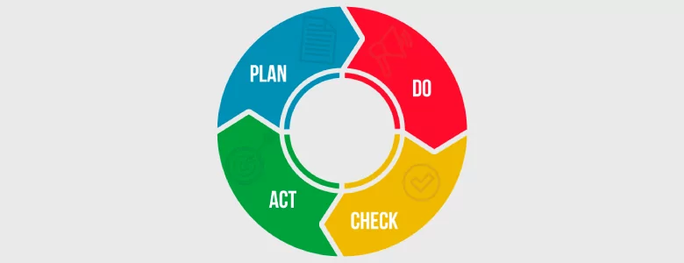
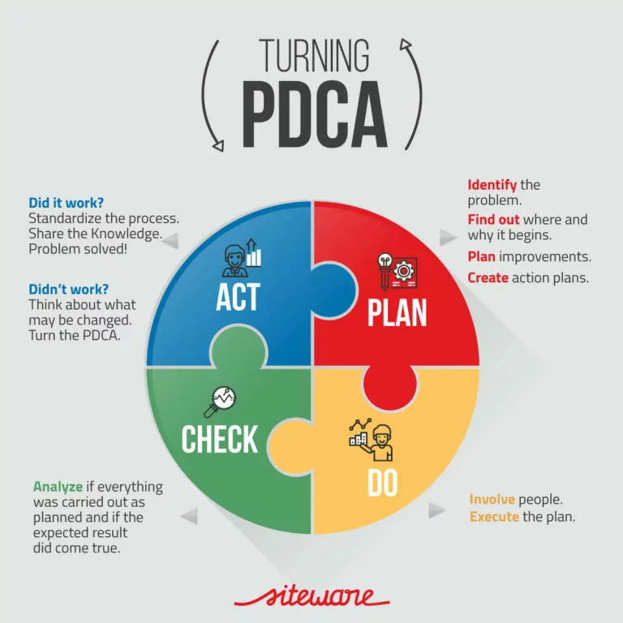

Source: (Site ware, (2019)
The Deming cycle PDCA would benefit Tesco’s CRM as it will help identify where they need to improve measures on a smaller scale before updating procedures and working practices.
A s long as they continuously follow the cycle of planning, doing, checking, and acting will help the CRM avoid problems in advance and implement solutions quickly and effectively, saving them time and money and making an improvement in customer service.

Juran’s trilogy cycle and theories that may assist in improving the customer relationship management (CRM) at Tesco’s supermarket.
Anastasia SD, (2015) suggests that” Juran believes that the definition of quality is interwoven with “sustainability” of a product or a service to be used and is directly connected with customer satisfaction (Juran, 1974).” DR Joseph Moses Juran a pioneering architect of the science of managing quality well known to have been the father of quality management techniques a Romanian American engineer and management consultant and a writer. Born in 1904 Contributed to the mission of developing the Juran trilogy quality management as an improvement cycle that helps decrease the price of bad value by planning quality into the product/procedure, an approach to cross functional management philosophy embraced by businesses, around the world making sure the customers need is met. Juran theory is that one should take a holistic approach to quality as his approach to quality is based around the Juran quality trilogy, composed of three elements accomplished through the management philosophy which are quality planning, quality control, and quality improvement.

Kumar et al (2016) suggests. Quality planning starts with a question, for whom you are planning? It’s simply a customer. Quality planning this phase is crucial for Tesco’s (CRM) to distinguish and understand who the customers are and implement any requirements for the customers wishes. And assess and distinguish the needs for the produce and service and then improve it. In addition to any proposals that may be assigned to operatives or further key investors they would need to be make in the course of the planning stage. Organize events through a group of multidisciplinary professionals from a group of organisations working together as a team, with every one of key investors represented. And then Quality control Through the control stage, which establishes anything that must to be measured by Tesco’s (CRM), evaluating whatever sort of information is required to assess if the procedure is working out, and then setting a target line for the final operation. Through comment and feedback in measuring actual accomplishment, acting on the gap among accomplishment and the essential goal line. Kumar et al (2016) states that “quality control” which is concerned with the assessing, appraising, and ascertaining the process parameters or performance.”
Final part of Juran’s trilogy is Quality improvement. Tesco’s (CRM) must create a brand-new idea at other levels of performance by getting rid of wastes and defects to reduce the expenditure of quality that is bad. The second stage is quality improvement which are placed to recognise the required development. Acknowledging the development projects, establishing project progress teams, and Supplying project teams with resources. According to Popescu, M and Mandru, l (2016)” Quality term is also defined as” the degree to which a set of inherent characteristics fulfils a set of requirements”.
Below is a brief look at Juran’s trilogy diagram.
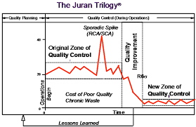
Source: Facebook (2018)

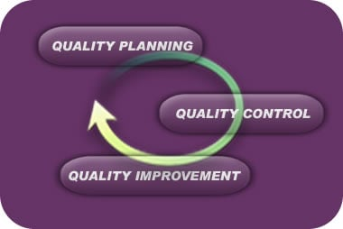
Source: Michigan technological university (2021)
The Juran Trilogy is a development cycle, once implemented by Tesco (CRM) it can assist in reducing the expense of bad quality through preparing quality into the product/procedure. (CRM) should prepare planning stage and distinguish who and what the clients expectations are by listening to the voice of the customer. Juran’s trilogy cycle can benefit and improve customer relationship management (CRM) at Tesco supermarket if they implement Juran’s trilogy improvement cycle through each stage, it will benefit management practices in managing and improving quality and reduce the cost of poor-quality products, services and implementing quality in the overall process by understanding and defining who the consumers are, their expectations and requirements.

CONCLUSION
In conclusion to my overall report based around customer relationship management (CRM) and emerging themes at Tesco plc, I can say that after Investigating Tesco’s theme based on Tech Touch, versus human touch and how it had an impact on customer experience. I would say that Tesco supermarket have used their technology, to deliver customer value and have improved and transformed customers experience, improved customers thinking and decision making and spending habits when shopping. By keeping customers happy and engaged through short swift shopping experiences, less ques with self-checkouts, online shopping, the” scan as you shop technology”, and the ‘GETGO’ shopping experience through tesco.com app. Tesco’s human touch strategies are human staffed checkouts for basket shopping a privilege and convenience for shoppers who still want to opt for interaction and small talk. In relation to Tesco’s theme of customer experience and brand experience and its impact on customers have improved by adding in store shopping and online shopping and adding brand new customer service counters and altering its operating hours to suit all customers, with a twenty-four-hour opening time at some of the smaller Tesco expresses.
My analysis and understanding of customer relationship and management policies, and the impact on customers overall is that Tesco’s CRM program monitor segregation of their consumers corresponding to their instore shopping and expenditures. Tesco then prioritize the customers on basis of the company they offer to the store. With Tesco Clubcard an advantage money saver helps the loyal and consistent clients to add up more value points on the cards This impacts the customers and enhances their preference and loyalty towards the store as they become regular customers at Tesco. The sustainability policies at Tesco and how it impacts customers suggests that” The Little Helps Plan”, framework with four pillars: The people pillar, taking care of colleagues, diversity and inclusion, and human rights pillar, heavily impacts customers engage into being contributors and apart of the scheme. My Analysis on Deming (PDCA) cycle and theories that may assist in improving the customer relationship management (CRM) at Tesco’s supermarket is that they would benefit from the cycle as it will help identify where they need to improve measures on a smaller scale before updating procedures and working practices.
A s long as they continuously follow the cycle of planning, doing, checking, and acting will help the CRM avoid problems in advance and implement solutions quickly and effectively, saving them time and money and making an improvement in customer service. And my analysis on Juran’s trilogy cycle can benefit and improve (CRM) at Tesco supermarket if they implement Juran’s trilogy improvement cycle through each stage, it will benefit management practices in managing and improving quality and reduce the cost of poor-quality products, services and implementing quality in the overall process.by understanding and defining who the consumers are, their expectations and requirements.

Recommendations
The developments points highlighted, within my findings and conclusion sections of the report I would say technology innovations at Tesco’s is evolving and helps speed up workflow store and, organise data of clients and being able to communicate and response to customers effortlessly and speeds up response time in emergencies. However, technology cannot replace face to face interaction that builds the trust and engagement of a customer. So, it is important that Tesco’s keep a balance between technology and face to face instore communication. I would recommend that they continue to use surveys, questionnaires as well as instore face to face communication for feedback to keep customers happy whether it is online shopping or instore shopping. I would also recommend that Tesco do a once a month, drink, and biscuit invite for customers who like interaction face to face communication for the customers who prefer to give feedback face to face as this will help improve the overall customer satisfaction and loyalty. The ethical sustainability policies of Tesco like heir Little helps Plan have made commitments to the customers and communities economic as the environment by making a change for the better. The” scan as you shop technology”, and the ‘GETGO’ shopping experience through tesco.com app. Tesco’s human touch strategies, for human staffed checkouts for basket shopping and their Tesco Clubcard, all these policies are key factors for CRM and impacts the quality of CRM, as it will be able help them map out the dissimilar phases a client has from step to step from the actual product item, customer service and resolution, onto the product accepting and buying, and purchase stages’ will be able to identify customer retention. Customer loyalty, and then evaluate and analyse through different strategies of marketing, management of the customer experience. Overall CRM will be able to provide a sustainable growth by maintaining regular updates of customer data and helping in the growth of sales and customer loyalty.

References
Anastasiadou, S.D, (2015). The roadmaps of total quality management in the Greek education system according to Deming, Juran, and Crosby in light of the EFQM model. Procedia Economics and Finance, 33, pp.562-572. [Google scholar], Available at: The Accessed: (16th October 2021).
Androniceanu, A., 2017. The three-dimensional approach of Total Quality Management, an essential strategic option for business excellence. Amfiteatru Economic, 19(44), pp.61-78. [google scholar] Available at: https://www.econstor.eu/bitstream/10419/169057/1/aej-v19-i44-p061.pdf.Accessed: (17th October 2021).
Anni Isotalo and Samu Watanen (2015). The impact of brand experience on attitudes and brand image (Solomon, 2010. p. 277-280). [online] Available at: https://www.diva-portal.org/smash/get/diva2:838481/FULLTEXT01.pdf Accessed:( 12th October 2020).

Chakraborty, A., 2016. Importance of PDCA cycle for SMEs. SSRG International Journal of Mechanical Engineering, 3(5), pp.30-34.[google scholar] Available at:https://www.researchgate.net/profile/Abhijit-Chakraborty-14/publication/306363428_Importance_of_PDCA_cyc Accessed: (20th October 2021).
Facebook, (2018) The Juran trilogy diagram,[online image] Available athttps://www.google.co.uk/search?q=juran+trilogy+diagram&tbm=isch&chips=q:juran+trilogy+diagram,online_chips:joseph+juran Accessed: (20th October 2021).
Fan, A., 2016. Touch vs. Tech in Service Encounters. The Pennsylvania State University. [Google scholar] Available at: Microsoft Accessed: (12th October 2021).
How to do PDCA step by step, (2019) [ online image] Available at:https://www.siteware.com.br/methodologies/how-to-do-pdca-step-by-step/ Accessed (:22nd October 2021).
Iqbal, Q., Ahmad, N.H. and Ahmad, B., 2018. Enhancing sustainable performance through job characteristics via workplace spirituality: A study on SMEs. Journal of Science and Technology Policy Management Available at: Iqbal_et_al.__2018_JSTPM20200513-113848-iyvkkb-with-cover-page-v2.pdf (d1wqtxts1xzle7.cloudfront.net)Accessed:(25th October 2021).
Jagtap, M. and Teli, S.N., 2015. PDCA Cycle as TQM Tool-continuous improvement of warranty. International Journal on Recent Technologies in Mechanical and Electrical Engineering (IJRMEE), 2(4), pp.1-5.{google scholar] Available at:https://www.researchgate.net/profile/S-Teli/publication/317872778_P-D-C-A_Cycle_As_TQM_Tool-Continuous_Improvement_of_Warranty/links/594fdd63458515433839ccd6/P-D-C-A-Cycle-As-TQM-Tool-Continuous-Improvement-of-Warranty.pdfAccessed(:28th October 2021).

Jagusiak-Kocik, M., 2017. PDCA cycle as a part of continuous improvement in the production company-a case study. Production engineering archives, 14. [google scholar] Available at:file:///C:/Users/infam/Downloads/pea.Vol.%2014,%20No%201%20-%2005.2017.pdfAcccessed: (1st November 2021).

Khan, H.U., Fournier-Bonilla, S.D., Jinugu, A. and Madhavi Lalitha, V.V., 2016, March. possible challenges of the successful implementation of CRM in the service sector: a case study of Saudi Arabia. In Northeast Decision Sciences Institute Conference (Vol. 31).[Google scholar]Available at: Possible-Challenges-of-the-Successful-Implementation-of-CRM-in-the-Service-Sector-A-Case-Study-of-Saudi-Arabia.pdf (researchgate.net) Accessed: (10th October 2021).

Kumar, P., Raju, N.V.S. and Kumar, M.V., 2016. Quality of quality definitions-an analysis. International Journal of Scientific Engineering and Technology, 5(3), pp.142-148. [Google scholar] Available at: https://d1wqtxts1xzle7.cloudfront.net/46219203/IJSEAccessed:( 5th November 2021).
Lemon, K.N. and Verhoef, P.C., 2016. Understanding customer experience throughout the customer journey. Journal of marketing, 80(6), pp.69-96[Google scholar], Available at:113134-2016-customer-journej-verhoef.pdf (umcs.pl) Accessed: 14th October 2021.
Patel, Snigdha, (2021) eight examples of customer relationship management (CRM) [online image] Available at: https://www.revechat.com/blog/customer-relationship-management-examples/ Accessed: (8th November 2021).
Popescu, M. and Mandru, L., 2016. Relationship between quality planning and innovation. Bulletin of the Transilvania University of Brasov. Economic Sciences. Series V, 9(2), p.203.[google scholar] Available at:https://scholar.google.co.uk/scholar?hl=en&as_sdt=0%2C5&as_ylo=2015&as_yhi=2021&q=juran%27s+quality+planning&btnG= Accessed: (15th November 2021).
Tien, N.H., Diem, P.T., Van On, P., Anh, V.T., Van Dat, N., Hung, N.T. and Tam, B.Q., 2021. The formation and development of CRM system at Thien Hoa electronics supermarket in Vietnam. International journal multidisciplinary research and growth evaluation, 2(4), pp.752-760.[Google scholar]Available at: https://www.researchgate.net/profile/Hung-Nguyen-232/publication/354065365_The_formation_and_development_of_CRM_system_at_Thien_Hoa_electronics_supermarket_in_Vietnam/links/612305fd169a1a01031c6ec4/The-formation Accessed(:15th November 2021).

Michigan tech (2021) The Juran trilogy [ online image] Available a:The Juran Trilogy - Continuous Improvement Blog (mtu.edu) Accessed:( 14th November 2021).

Ramlawati, R. and Kusuma, A.H.P., 2018. Total Quality Management as the Key to the Company to Gain the Competitiveness, Performance Achievement and Consumer Satisfaction. International Review of Management and Marketing, 8(5), p.60. [google scholar]Available at:. (researchgate.net)Accessed: (14th November 2021).

