Student Name: Mojnu Miah
Student ID: 2233687
Module Code: BMIH4005
Module name: Marketing Plan
Word Count: 1574
Contents
Introduction 3
Organization Details 4
Marketing Plan 4
Purpose of the marketing plan 4
Situation Analysis 5
SWOT analysis 5
Figure 1: SWOT analysis 5
Segmentation and Targeting 5
Perceptual positioning map 6
Figure 2: Perceptual Positioning Map 6
Bowman's strategy clock 6
Figure 3: Bowman’s Strategy Clock 7
B2B Relationships with Partnerships and Franchises 7
PESTLE Analysis 8
Figure 4: PESTLE analysis 8
Similar Web 9
Figure 5: Similar Web 1 9
Figure 6: Similar Web 2 9
Figure 7: Similar Web 3 10
Figure 8: Similar Web 4 10
Objectives 10
SMART target 11
Strategy 11
Tactics 12
Marketing Mix 12
Figure 9: Marketing Mix 12
Action Plan 13
Figure 10: Gantt Chart 13
Control 14
Conclusion 15
References 16
Appendix 18

Introduction
Six Senses Hotel is a premium hotel brand with a strong emphasis on health and sustainability. This marketing plan contains a thorough communication strategy to establish Six Senses Hotel as an industry leader in eco-friendly luxury. By using multiple communication channels such as social media, influencer collaborations, and targeted advertising, the company intends to reach its upscale target demographic and convey its unique value proposition of sustainability and well-being. The communication strategy will also contain metrics for measuring the efficacy of the message and adjusting techniques as necessary to guarantee the success of the entire marketing campaign.

Organization Details
Six Senses is a premium hotel and resort management and development firm that focuses on environmentally friendly methods. It owns and runs 16 hotels and resorts across the globe (Six Senses, 2019).

Marketing Plan
Using the SOSTAC framework, I will organize the communications plan for Six Senses Hotel around a Situation analysis, Objectives, Strategy, Tactics, Actions, and Controls. In addition, I will use Bowman's Strategy Clock to assess and choose competing tactics based on price and perceived value, as well as the 4 Ps (Product, Pricing, Promotion, Place) framework for designing successful marketing mix strategies.

Purpose of the marketing plan
The purpose of Six Senses Hotel's communications strategy is to successfully connect and engage the target audience, reinforce the hotel's unique selling offer, and accomplish particular communication goals such as boosting brand recognition, reservations, and customer loyalty (Michopoulou, 2020). The strategy also seeks to discover marketing possibilities that capitalize on the hotel's strengths and appeal to various types of guests.

Situation Analysis

SWOT analysis
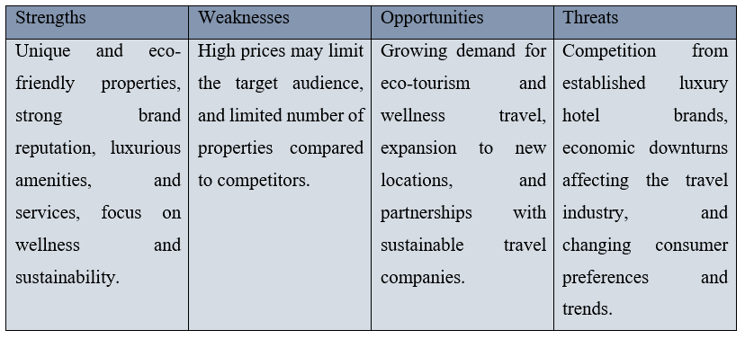

Figure 1: SWOT analysis
(Source: Zarei, 2019)

Segmentation and Targeting
A well-defined customer profile will allow Six Senses Hotel to focus its marketing efforts on a select group of people who are most likely to become interested in its services. Customers at Six Senses Hotel are likely to be well-heeled globetrotters who place a premium on eco-friendly pampering (Buzza and Mosca, 2019). The hotel's eco-friendly policies, health programs, and high-end facilities might be a selling point for many different types of guests, from honeymooners to conference attendees. For Six Senses Hotel, a segmentation strategy based on psychographics like lifestyle and values might be an option. For instance, you may aim your marketing efforts toward eco-conscious vacationers who are interested in off-the-beaten-path excursions. Eco-tourism and wellness vacations are popular in several regions, so targeting such areas might be another strategy (Overstreet, 2017). Six Senses Hotel may then use this information to create a profile of its ideal client based on their demographics, actions, interests, and preferences. Customers with disposable money who like outdoor activities, places of natural beauty, real cultural experiences, and high standards of living may be ideal clients.

Six Senses Hotel can increase reservations, strengthen customer loyalty, and communicate more effectively with its target demographic by developing a deep understanding of its clientele (Wise, 2015).

Perceptual positioning map
The hotel's perceived strengths and shortcomings in comparison to its rivals, as well as potential points of distinction, may be revealed via a perceptual positioning map. The Six Senses Hotel, for instance, might be compared to similar establishments on the map based on factors like sustainability, wellness offerings, and Luxuary
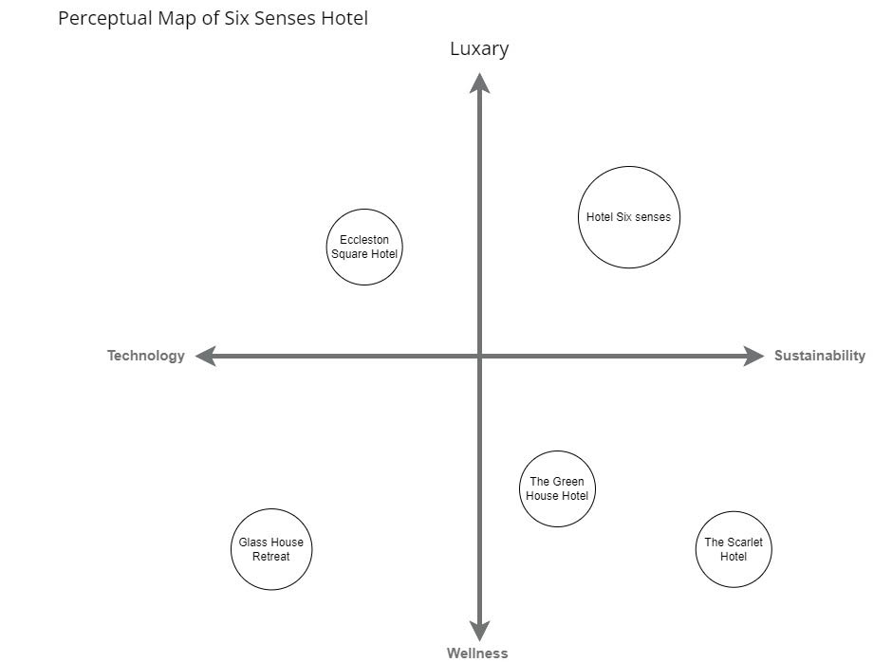.

Figure 2: Perceptual Positioning Map
(Source: Author)

Bowman's strategy clock
Bowman's Strategy Clock classifies Six Senses Hotel as operating under a differentiation strategy. As compared to the price, the value it provides is rather great. Six Senses Hotel can successfully implement this approach because it caters to consumers who are prepared to pay a higher price for high-end amenities, individualised care, and environmentally responsible business policies. This approach fits well with the Six Senses Hotel's brand positioning and helps it stand out from rivals offering cheaper alternatives. (Rosenbaum, Otalora, and Ramírez, 2017).
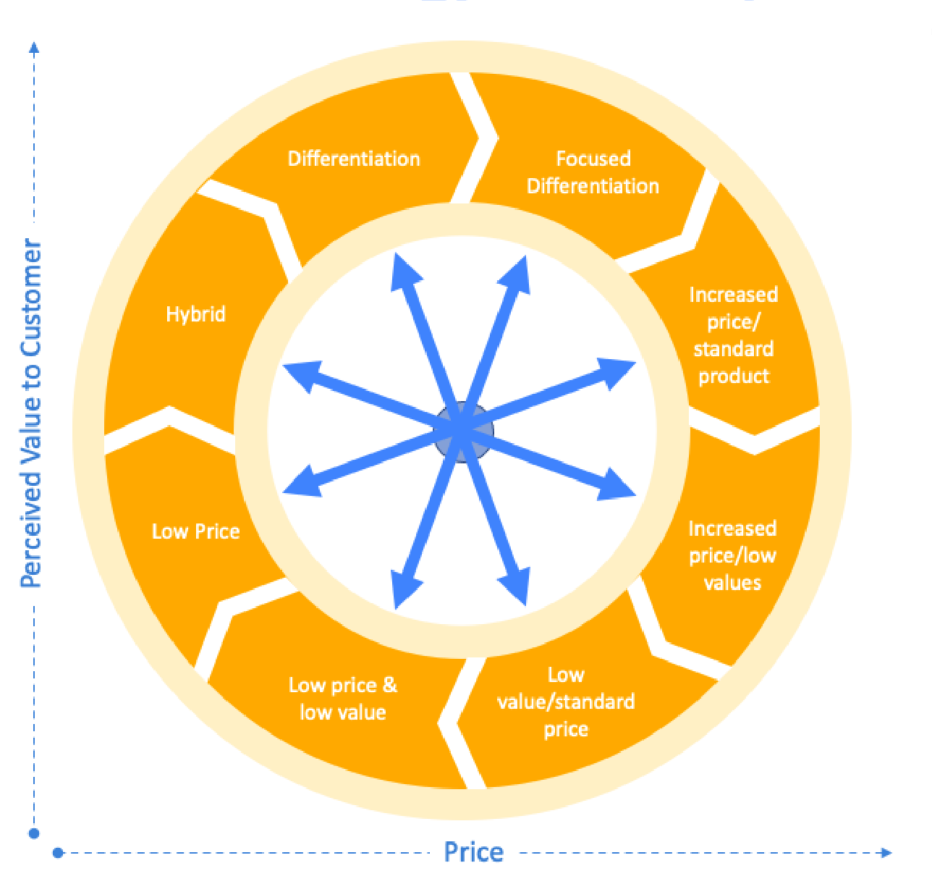

Figure 3: Bowman’s Strategy Clock
(Source: Author)

B2B Relationships with Partnerships and Franchises
Six Senses Hotel recognizes the importance of its business partnerships, franchises, and other forms of collaboration in achieving its goals. One such partnership is between the Six Senses Hotel and Fiji Airlines, which provides guests with perks like priority boarding and additional checked luggage. The hotel has also teamed up with prominent figures in the health industry, including Dr. Steven Gundry, to provide guests with individualized wellness programs and unique experiences (Schilit, 2019). More than that, Six Senses Hotel has franchise agreements with property owners, such as the one that led to the opening of the Six Senses Fort Barwara in India. Six Senses Hotel can broaden its customer base, enter new areas, and set itself apart from the competition because of its many B2B agreements, collaborations, and franchisees. The firm may provide one-of-a-kind and unforgettable experiences for its clients, build its brand, and boost its bottom line by using these partnerships (Slattery, 2013).

PESTLE Analysis
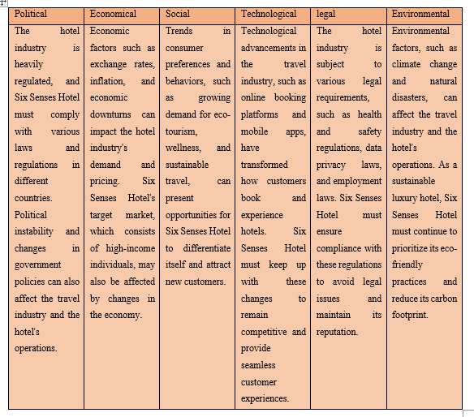

Figure 4: PESTLE analysis
(Source: Author)

Similar Web
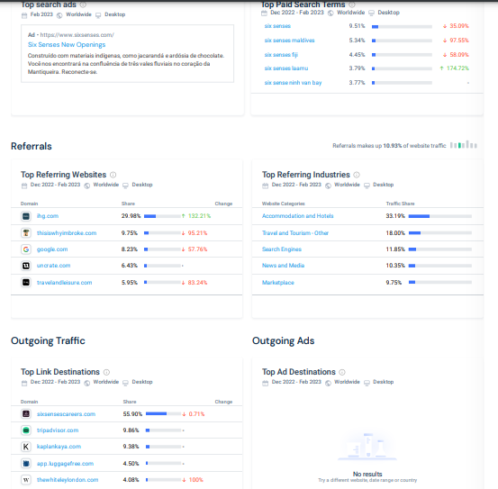

Figure 5: Similar Web 1
(Source: Six Senses, 2019)

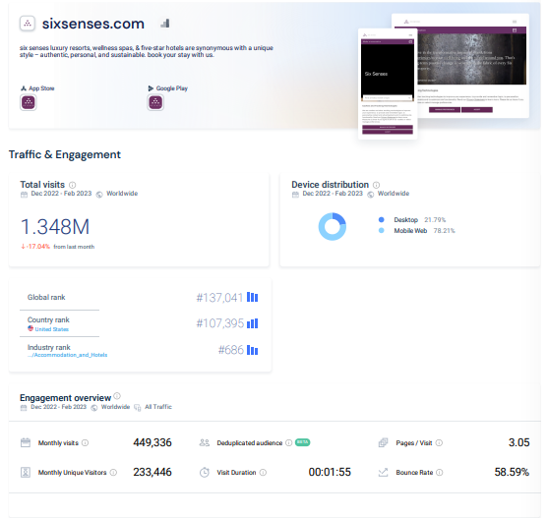

Figure 6: Similar Web 2
(Source: Six Senses, 2019)

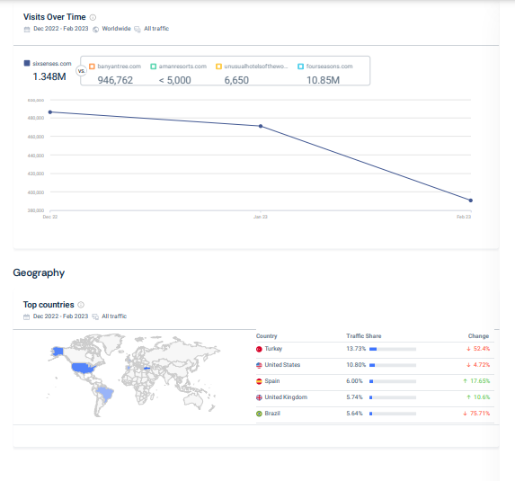

Figure 7: Similar Web 3
(Source: Six Senses, 2019)
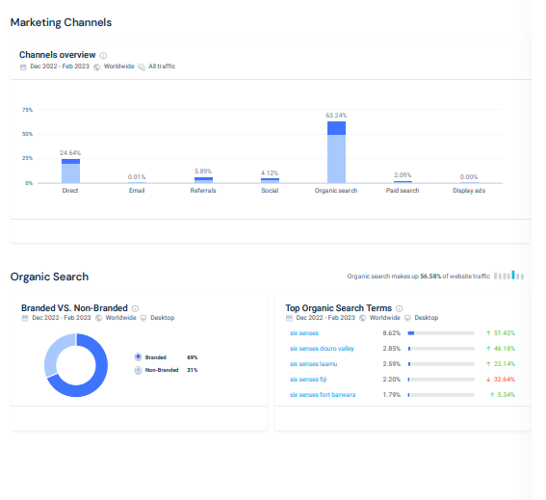

Figure 8: Similar Web 4
(Source: Six Senses, 2019)

Objectives
The Six Senses Hotel might set SMART goals like growing social media engagement by 20% in six months or producing 100 new leads monthly via focused email campaigns.

SMART target
The marketing strategy for Six Senses Hotel is geared toward expanding the hotel's customer base via the acquisition of new guests and the retention of current ones through the promotion of the hotel's unique value proposition and commitment to environmentally responsible service.

Strategy
The Six Senses Hotel's selling point is how it combines high-end service with concern for the environment. The company stands apart from the competition by delivering high-end experiences to customers while also stressing eco-friendly practices like utilizing organic materials, cutting down on waste, and giving back to the local community (Singh, 2017). The Six Senses Hotel may employ social media, email campaigns, and influencer marketing to spread the word about its unique selling offer. To show potential guests the value they may anticipate from a stay at the Six Senses, the hotel should emphasize its eco-luxury services, display client testimonials, and provide details about its sustainability procedures. This promise may be fulfilled by Six Senses Hotel by creating unique, tailor-made experiences for each guest (Shepherd, 2016). Hotels may cater to their visitors' needs by providing individualized wellness programs, regionally inspired menus, and culturally engaging events. When the value proposition is tied to certain demographics of customers, it may have a significant impact on the company's marketing strategy. The eco-friendly Six Senses Hotel is a great option for anyone looking for a combination of sustainable services, high-end amenities, and memorable excursions (Cahill, 2020). This would set the hotel apart from its rivals and appeal to consumers who value eco-friendly vacations and high-end amenities. Six Senses Hotel can cement its position as an industry pioneer in eco-friendly luxury travel and win the devotion of its clientele by successfully conveying and delivering on its value offer.

Tactics

Marketing Mix
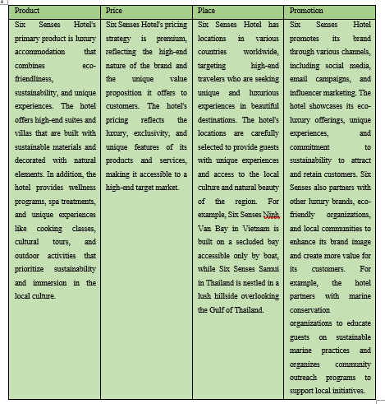

Figure 9: Marketing Mix
(Source: (Pakpahan, Ernawati and Suja, 2022)

Action Plan

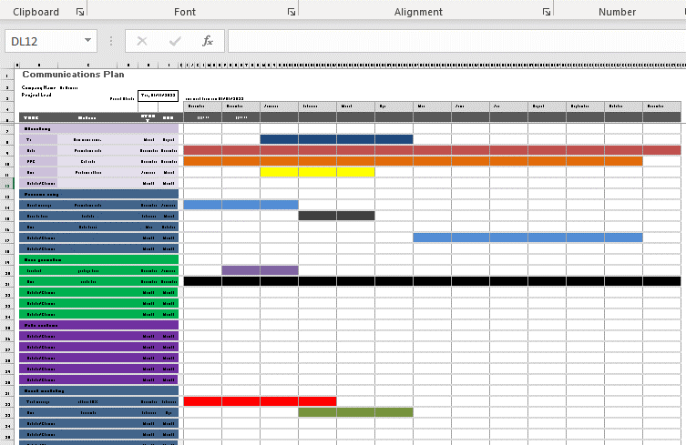

Figure 10: Gantt Chart
(Source: Author)

Control
Many criteria will be utilized to assess the efficacy of the Six Senses Hotel's advertising strategy. Such things might include: A key indicator of the success of the hotel's marketing initiatives in luring new guests will be the number of new consumers it welcomes (Miklian, 2016). How consumers feel about the brand and whether or not the advertising is getting through may be determined by polling and monitoring brand mentions and reviews on social media. The result of the marketing strategy is an increase in the hotel's bottom line (Arseculeratne and Yazdanifard, 2013). Thus, it would be crucial to monitor financial measures of performance including revenue growth, profit margins, and return on investment (ROI). The marketing team may make data-driven judgments on the marketing plan's effectiveness by closely monitoring and evaluating the aforementioned KPIs regularly.

Conclusion
Six Senses Hotel's marketing strategy is to portray the company as a pioneer in sustainable luxury travel, targeting a high-end target demographic looking for unique experiences and eco-friendly rooms. Yet, various problems, such as tough rivalry, shifting customer tastes, and global economic uncertainty may occur. To overcome these obstacles, the marketing team should constantly monitor market trends and consumer preferences, use data analytics to measure the effectiveness of marketing strategies, and seek collaborations with other eco-friendly brands and organizations to strengthen the brand's value proposition. Moreover, the team should prioritize providing outstanding client experiences, implementing creative and sustainable features into their goods and services, and establishing a strong online presence via focused social media campaigns and influencer collaborations.

References
Arseculeratne, D. and Yazdanifard, R. (2013). How Green Marketing Can Create a Sustainable Competitive Advantage for a Business. International Business Research, 7(1). doi:https://doi.org/10.5539/ibr.v7n1p130.
Buzza, J. and Mosca, J.B. (2019). Create The Plan, Work The Plan: A Look At Why The Independent Business Owner Has Trouble Calling A Franchisee A True Entrepreneur. American Journal of Business Education (AJBE), 2(7), pp.113–118. doi:https://doi.org/10.19030/ajbe.v2i7.4590.
Cahill, D.J. (2020). How consumers pick a hotel: strategic segmentation and target marketing. New York: Routledge/Taylor & Francis Group.
Michopoulou, E. (2020). ‘The future of global hospitality: What is going to matter?’ – Neil Jacobs, the CEO of Six Senses Hotel Resorts Spas. International Journal of Spa and Wellness, 1(1), pp.1–2. doi:https://doi.org/10.1080/24721735.2020.1790236.
Miklian, J. (2016). Mapping Business-Peace Interactions: Five Assertions for How Businesses Create Peace. SSRN Electronic Journal, 1(1). doi:https://doi.org/10.2139/ssrn.2891391.
Overstreet, G.A. (2017). Profiles in Hotel Feasibility. Cornell Hotel and Restaurant Administration Quarterly, 29(4), pp.8–19. doi:https://doi.org/10.1177/001088048902900407.
Pakpahan, A., Ernawati, N.M. and Suja, I.K. (2022). Best Practices of Sustainable Development to Make Six Senses Uluwatu a Green Hotel. Jurnal Bali Membangun Bali, 3(1), pp.75–98. doi:https://doi.org/10.51172/jbmb.v3i1.227.
Rosenbaum, M.S., Otalora, M.L. and Ramírez, G.C. (2017). How to create a realistic customer journey map. Business Horizons, [online] 60(1), pp.143–150. doi:https://doi.org/10.1016/j.bushor.2016.09.010.
Schilit, W. Keith. (2019). How to write a winning business plan. Business Horizons, 30(5), pp.13–22. doi:https://doi.org/10.1016/0007-6813(87)90074-7.
Shepherd, J.W. (2016). Marketing practice in the hotel and catering industry. London: Batsford.
Singh, S. (2017). How to market orientation and outsourcing create capability and impact business performance. Thunderbird International Business Review, 51(5), pp.457–471. doi:https://doi.org/10.1002/tie.20283.
Six Senses (2019). Luxury Resorts, Five Star Hotels, Luxury Spa Resorts | Six Senses. [online] Sixsenses.com. Available at: https://www.sixsenses.com/en.
Slattery, P. (2013). The economic ascent of the hotel business. Oxford: Goodfellow Publishing.
Wise, R. (2015). Run out of steam? Here’s how to create a growth action plan. Journal of Business Strategy, 26(1), pp.10–12. doi:https://doi.org/10.1108/02756660510574998.
Zarei, E. (2019). Hotel marketing. Lulu Com.

Appendix

