Module Name:
Digital Skills for Personal and
Professional Growth (BMSW4008)
Module Lead: Philippa Fitzgerald
Date:28.03.2025
Student Name: Andreea Lilea (2126939)

Contents
Task 1 2
Questionnaire Development and Data Collection: 2
Analysis of Key Findings 3
Trends and Patterns. 5
Applying Findings for Company Improvements: 5
Marketing Strategy 5
Customer Experience 6
In conclusion 6
Task 2 6
Using Survey Data to Improve Website and Marketing Design for Romanian Creperie & Pastry Heaven by Andreea 6
Figure 1 7
Figure 3 7
Figure 4 8
Figure 5 9
Target Audience Strategy and Segmentation 9
Menu Design and Product Curation 10
Figure 1 10
Figure 2 11
Value Perception and Pricing Strategy 12
Digital visibility and SEO 13
Figure 1 13
Figure 2 13
Branding and Cultural Storytelling 14
Customer Experience and Convenience Design 14
In conclusion 14
Task 3 16
The Importance of Excel in the Digital Era: An Entrepreneurial Success Tool 16
Excel as a Fundamental Business Instrument 16
Supporting Forecasting and Financial Planning 16
Improving Data-Driven Decision Making 17
Operational Planning and Digital Marketing 17
Entrepreneurs' Accessibility 18
Digital Proficiency and Educational Value 18
Conclusion 18
Task 4 20
Storytelling 20
References 21

Task 1

Questionnaire Development and Data Collection:

The market research questionnaire was prepared using Microsoft Forms specifically for a Romanian pastry company in Merthyr Tydfil's town centre. The primary goal was to gain a deeper understanding of consumer demographics, tastes, and purchasing patterns, as well as their familiarity with Romanian pastries. This would help to develop and validate the business idea so that it appeals to the local market.
The questionnaire's ten questions covered several topics, including age group, preferred pastry varieties, spending capacity, knowledge of Romanian food, taste preferences, and dietary limitations. Microsoft Forms generated graphical outputs for trend analysis and identification, and data was gathered from fellow students to approximate responses from the population targeted for the study.

Analysis of Key Findings
- Which variety of pastry do you prefer?

Figure 1
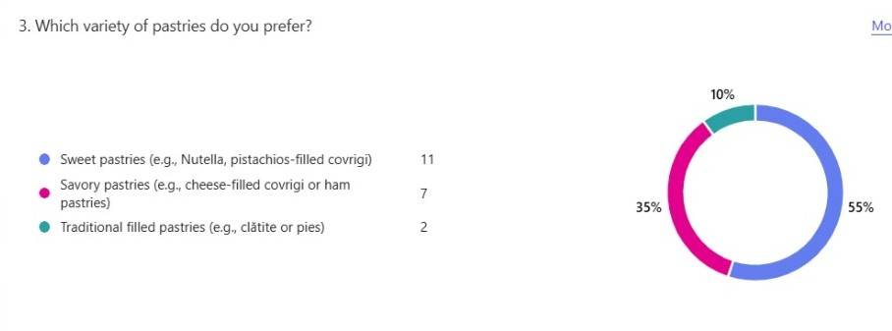
Findings: Strong preference for sweet pastries, notably Nutella or Pistachios-filled covrigi, which emerged as the most popular alternative. Cheese or Ham-filled treats were also popular among older respondents. While interest in traditional Romanian desserts such as clătite was lower overall, younger people were more eager to try new cultural experiences.
Insights: Kotler, Keller, and Chernev (2021) suggest that understanding consumer preferences is essential for developing a successful marketing plan. This research emphasises the importance of prioritising sweet goods while also making savoury items available to appeal to a wider range of customers. Targeting certain demographic groups with unique marketing techniques allows the company to maximise appeal throughout its audience base.

- What is the average amount you are willing to spend on pastries?

Figure 2
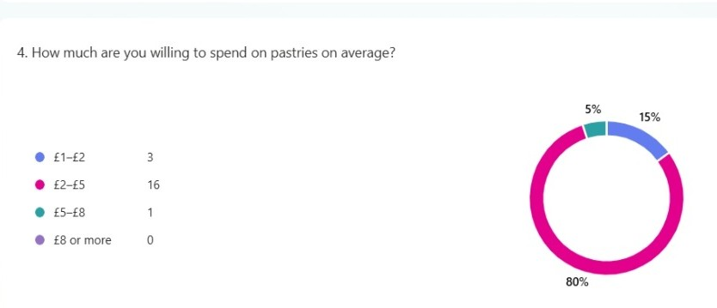
Findings: Most respondents said they would be ready to spend £2-£5 on pastries, while a smaller percentage preferred the lower range of £1-£2. The consumer market represented by this data is moderately priced, and decisions about what to buy are heavily influenced by perceived value and affordability. Insights: Pricing is essential to a brand's effective positioning. According to Smith and Albaum (2020), selecting the appropriate pricing can considerably impact consumer perceptions of value and quality. Providing high-quality pastries that fall between £2 and £5 would guarantee that they meet the expectations of most clients. Furthermore, loyalty discounts or package offers may attract cost-conscious clients, increasing customer retention and satisfaction.

- Do you have any experience with Romanian pastries?
Figure 3
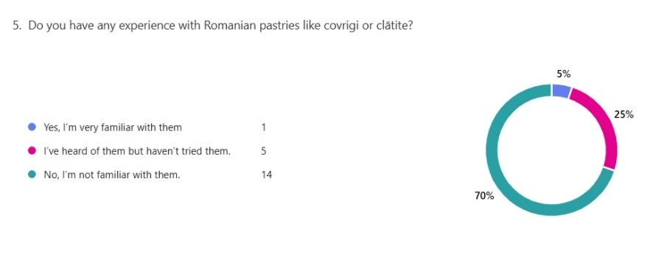

Figure 4
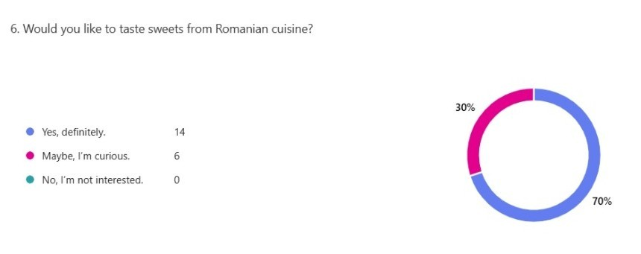
Findings: Although many respondents had never heard of Romanian pastries, a sizable proportion expressed an interest in and desire to try them. This study highlights the possibilities for introducing Romanian food to the local market and using its uniqueness as a competitive advantage.
Insights: According to Hollensen (2019), cultural diversity is required to maintain a strong position in the marketplace. Through storytelling, social media advertising, and in-store tasting events, the brand may generate customers' interest and drive foot traffic. This cultural teaching may help the brand stand out in the town centre as a one-of-a-kind, authentic, and unforgettable experience.

- Which flavour combinations are your favourites?

Figure 5
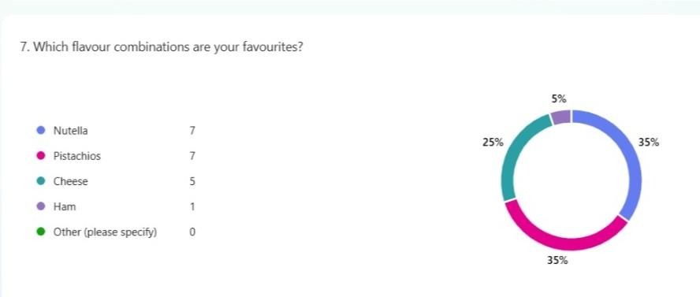
Findings: Nutella and Pistachios were the most appealing flavours. Overall preferences were dominated by sweet pairings, but Cheese flavours attracted considerable interest. Additionally, respondents expressed a willingness to attempt new flavour combinations, which may offer an original approach for developing new products.
Insights: In competitive markets, Riesz (2022) underlines the value of providing niche flavours to draw in customers. According to this data, concentrating on consumer favourites like Nutella while experimenting with special seasonal or limited-edition products can spark interest and encourage repeat visits to the business. Creating inventive combinations can also help set the company apart from other local pastry businesses.

Trends and Patterns.
Data analysis revealed three significant tendencies:
- Preference for Recognisable Flavours: Sweet and familiar alternatives, such as
Nutella is a popular choice and should be included on the main menu.
- Pricing is also important. Mid-range pricing (£2–£5) ensures accessibility while preserving perceived quality.
- Interest in Romanian pastries can promote cultural understanding through storytelling and participation.
These developments are consistent with Payne and Frow's (2017) focus on understanding client tastes and developing long-term connections with customers by serving their changing demands.

Applying Findings for Company Improvements:
Menu Development: Make popular selections like Nutella and cheese-filled pastries constants, while also offering seasonal or unique options to keep customers interested (Kotler et al., 2021). Traditional Romanian products, such as clătite, should also be prominently displayed to demonstrate the brand's distinct cultural identity.
Pricing Strategy: Sell the pastries in the mid-range (£2-£5), with periodic discounts or special bundles for budget-conscious clients (Smith and Albaum, 2020).
Marketing Strategy: Utilise online channels and in-store interactions to bring Romanian food to the community. Cultural interest and brand familiarity can be enhanced by initiatives like storytelling, sample events, and instructional social media campaigns (Hollensen, 2019).
Customer Experience: To suit people's busy lives in the town centre, create a welcoming shop setting with excellent customer service and takeaway alternatives (Wirtz, 2020).
In conclusion, the Romanian Creperie and Pastry Heaven company may gain a firm footing in the Merthyr Tydfil market by addressing these findings, guaranteeing sustained success and client loyalty.

Task 2

Using Survey Data to Improve Website and Marketing Design for Romanian Creperie & Pastry Heaven by Andreea

Figure 1 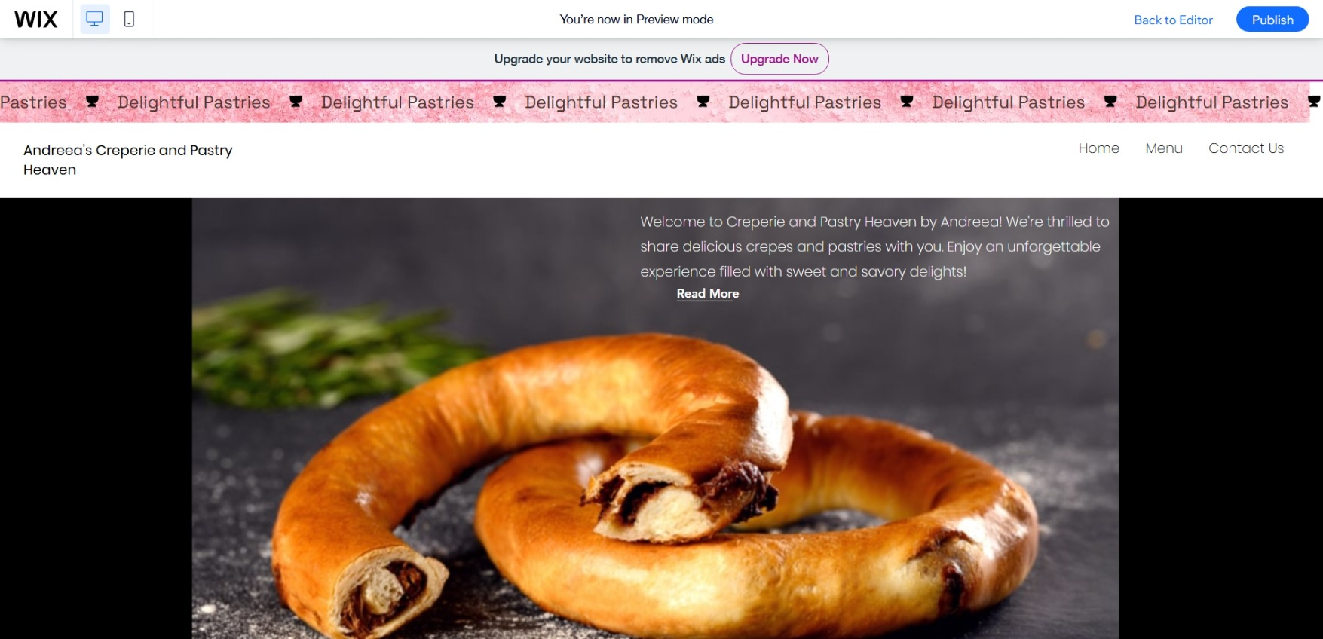Figure 2 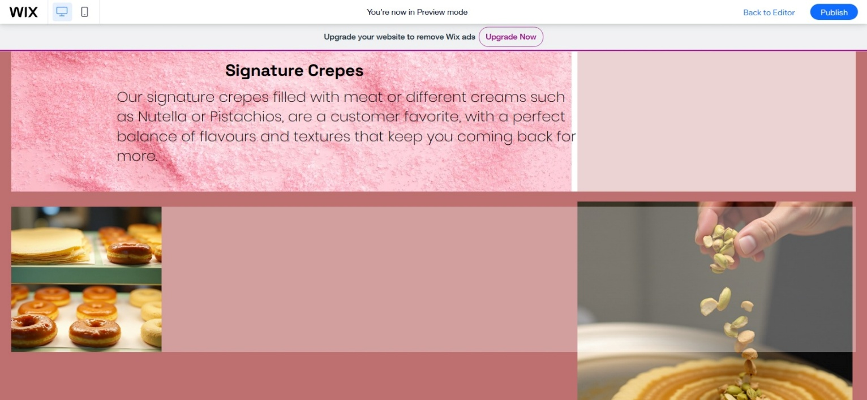
Figure 3
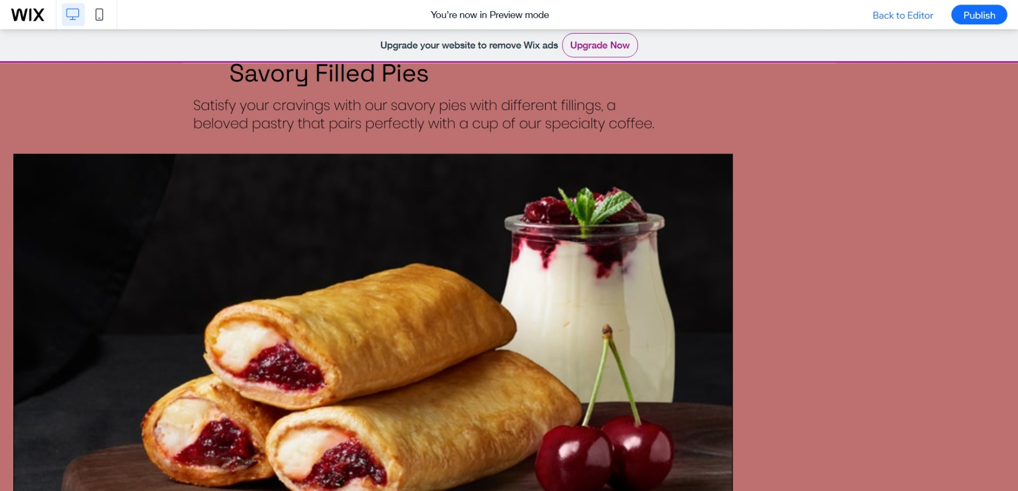

Figure 4
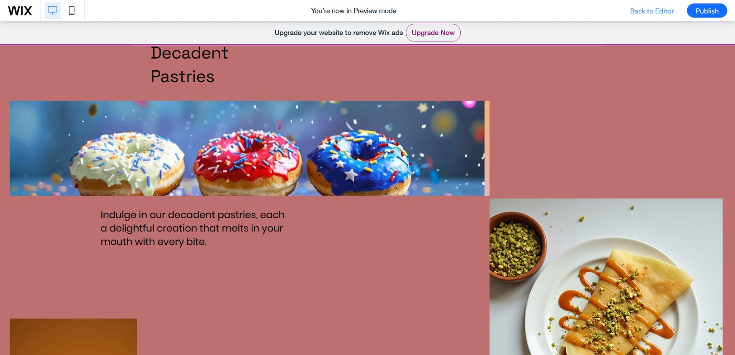

Figure 5
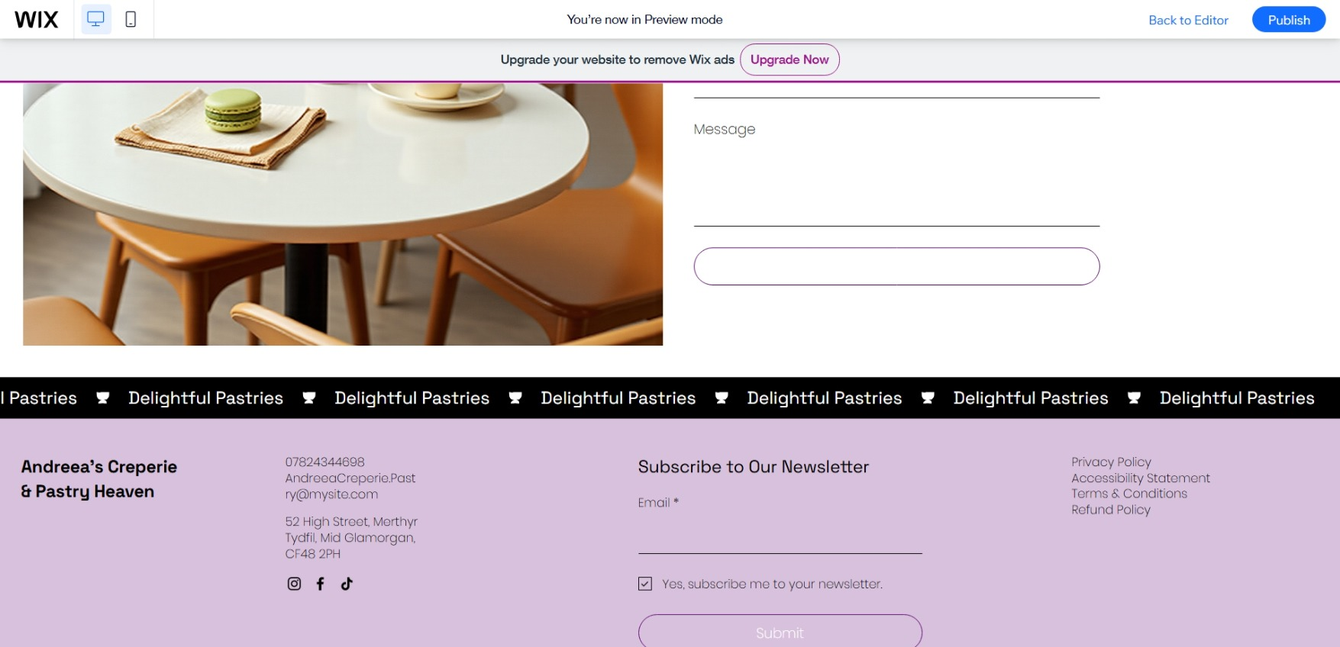

Figure 6


Any start-up project's effective positioning is dependent on the fast conversion of market research findings into a feasible design and communication strategy. Andreea used a structured questionnaire for Romanian Creperie & Pastry Heaven, a proposed food business in Merthyr Tydfil's town centre (Fig. 5), to collect key consumer information on demographics, taste preferences, price expectations, and knowledge of Romanian pastries. The insights gained helped influence the creation of a two-page website and related marketing materials. With a focus on audience segmentation, price strategy, search engine optimisation (SEO), menu composition, and cultural branding, the following summary shows how those findings were implemented during the development process. (Fig. 1,2,3,4)
Target Audience Strategy and Segmentation
Market segmentation was based on demographic and behavioural data, which are critical in creating a brand's communication style, product range, and promotional emphasis. The investigation revealed three key client subgroups: younger consumers (18-30), middle-aged customers (31-50), and seniors (51+). Each of these groups has distinct tastes and is willing to try new meals. Younger people were enthusiastic about new products and encounters from other cultures, particularly tasty treats like Nutella-filled croissants. Middle-aged respondents, on the other hand, exhibited more balanced tastes and improved price sensitivity, whilst elderly respondents preferred more well-known food profiles, such as ham and cheese.
Businesses can customise offerings that closely match the expectations and lifestyle of each subgroup by using segment-specific marketing, suggest Armstrong et al. (2019). To attract the interest of younger, digitally engaged customers, the website was created with a visually dynamic and mobile-optimized layout. At the same time, it included classic signals and clear written descriptions that appeal to older audiences. In order to connect with these diverse audiences, promotional materials like posters and social media banners used subtle variations in language and graphics.

Menu Design and Product Curation
Figure 1
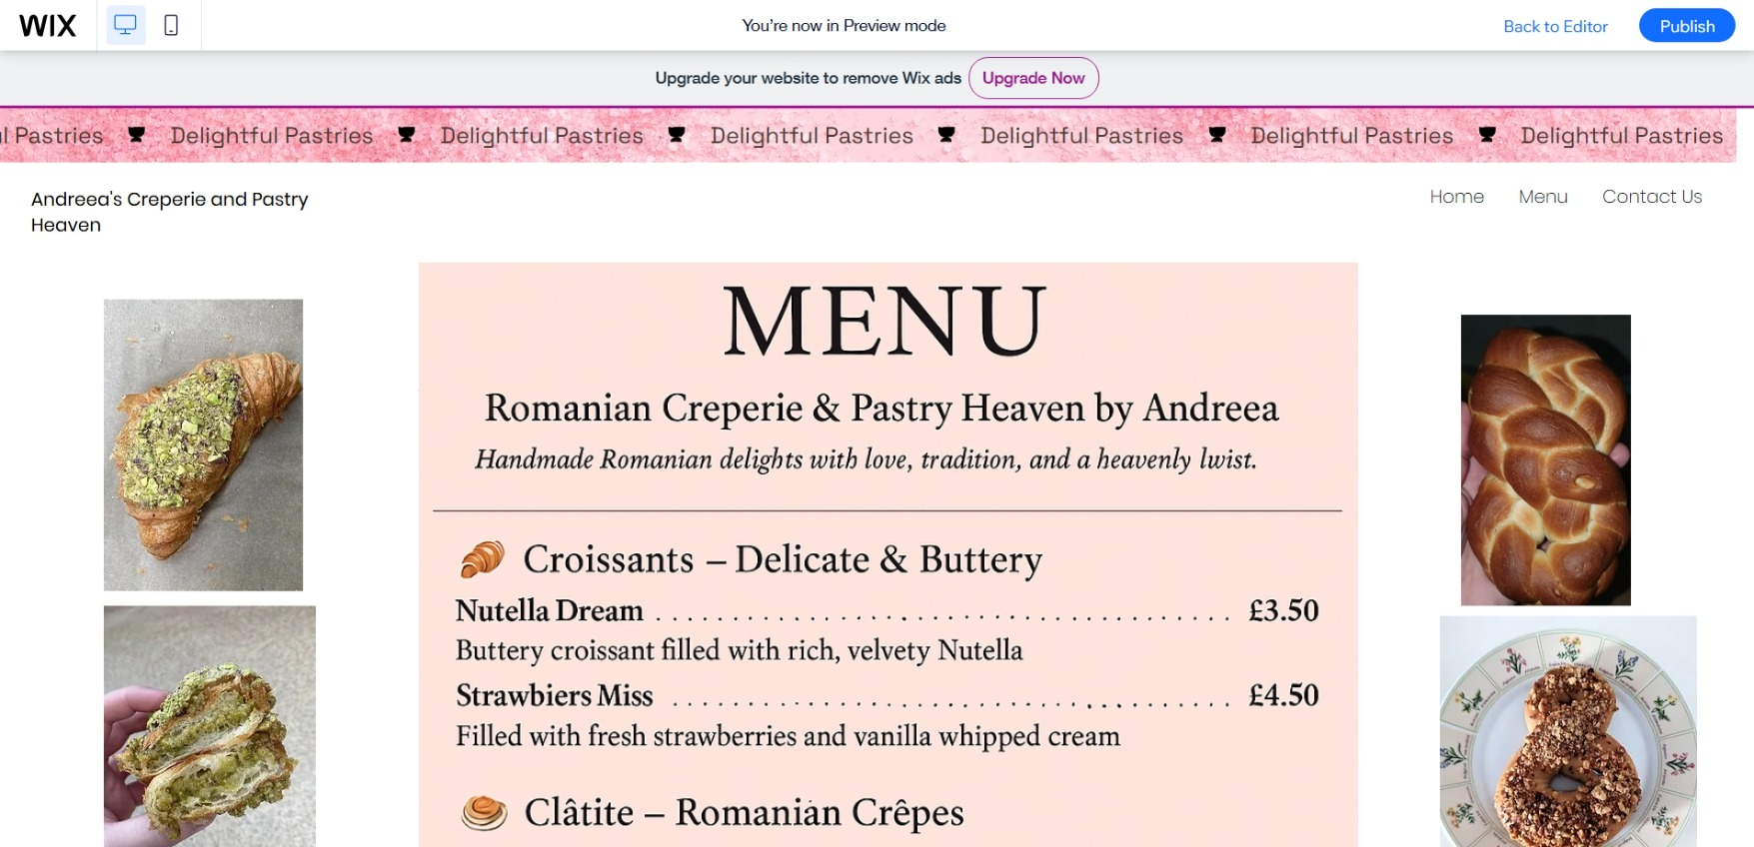

Figure 2
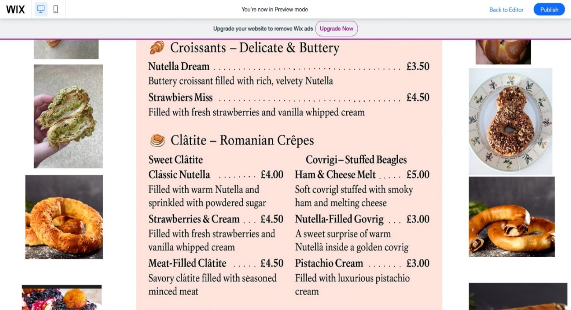Figure 3
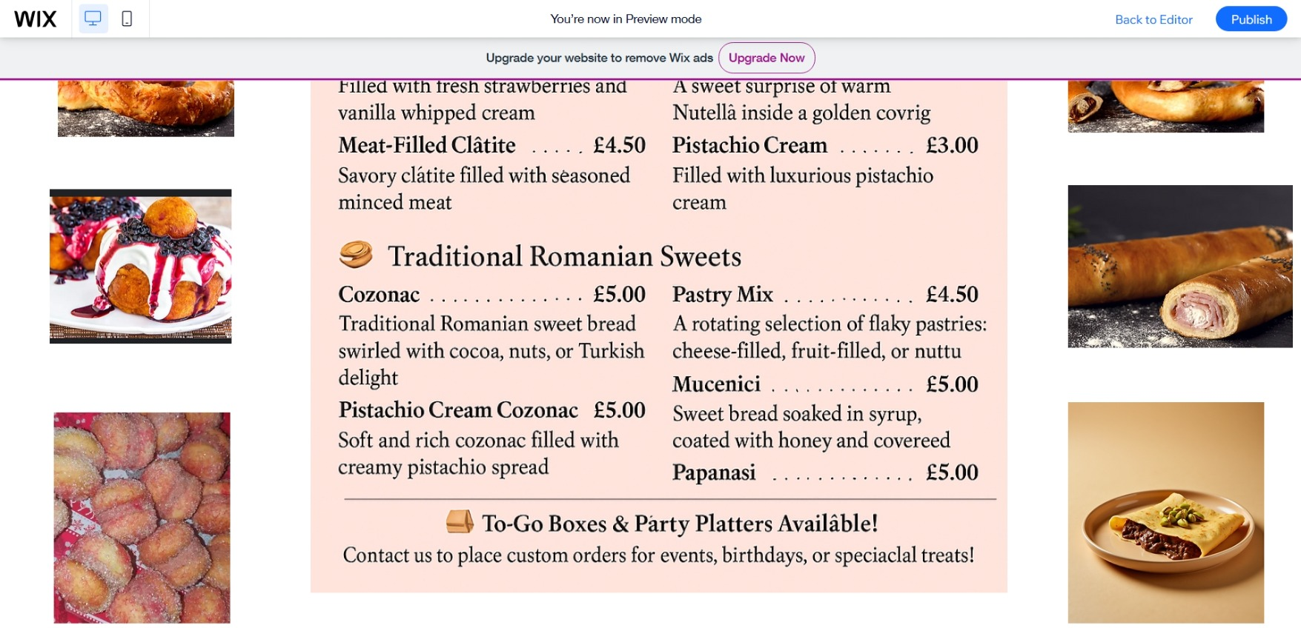
One important finding from the survey was the significant consumer affinity for particular flavours and classic sweets. The most sought-after products were sweets, especially ones containing Nutella, pistachios, and cheese. Respondents were also excited to try new Romanian desserts. This made it evident that there was a chance to combine traditional authenticity with popular flavours in the product line. (Fig.1)
Papanasi and mucenici, two traditional Romanian desserts that also serve as teaching tools for customers who are not familiar with the cuisine, were included in the menu as a direct reaction to their preferences. Furthermore, cozonaci stuffed with pistachios or Nutella were added as distinctive confections that complement the brand's cultural background and the consumer need for decadent flavours. The menu also offers meat-filled salted clătite to satisfy those who like savoury options, making it a well-rounded selection that suits a greater variety of palates. (Fig. 2 & 3)
This strategic approach reflects Solomon et al.'s (2019) concepts, which emphasise the need of combining product offerings with sensory appeal and cultural relevance. Moreover, adding seasonal and traditional products keeps customers interested and encourages repeat visits—a approach recommended by Baines et al. (2017) for maintaining product engagement in shifting food markets. In a competitive local market, the company boosts accessibility and differentiation by blending well-known flavours with less-known traditional goods.
Value Perception and Pricing Strategy
From responses on their willingness to pay, the majority of consumers were ready to spend between £2 and £5 per item, with others opting for more affordable options in the £1-£2 range. This mid-range pricing expectation reflects both the local economic condition and the consumer's value-sensitivity.
Therefore, the website's price and marketing materials were carefully constructed to represent cost without sacrificing quality. Integrating loyalty rewards, package discounts (such as "any 3 for £6"), and explicit pricing on product listings reinforced value and encouraged volume buying. According to Jobber and Ellis-Chadwick (2020), perceived value is an important element in predicting purchase intention, particularly in the food retail market, which has numerous low-cost competitors.

Digital visibility and SEO
Figure 1
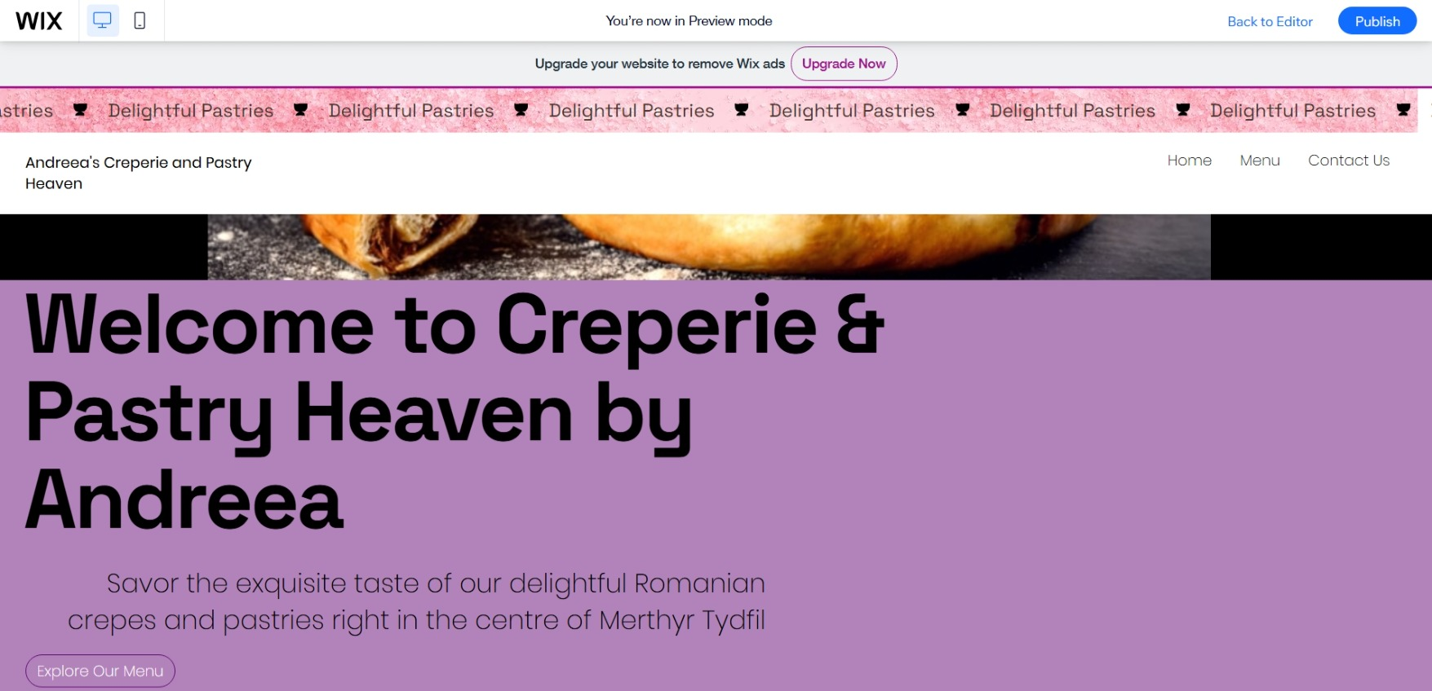
Figure 2
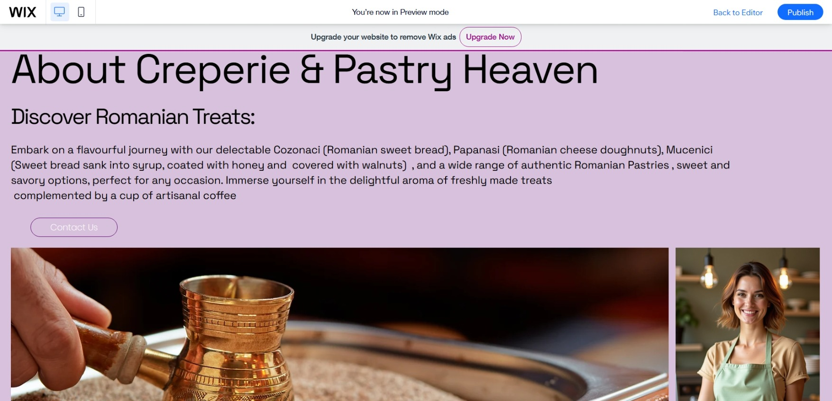
Because most survey respondents were unfamiliar with Romanian cuisine, the website's design prioritised digital exposure and discoverability. An SEO plan was implemented to support the website's instructional goal and attract organic search traffic. Meta titles, alt text, and content blocks used key terms such as "authentic Romanian desserts UK," "Nutella crepes near me," and "Romanian creperie and pastries in the centre of Merthyr Tydfil." (Fig.1)
As stated by Chaffey and Ellis-Chadwick (2019), effective SEO covers more than just generating traffic; it also includes tailoring content to the informational needs of potential clients. Ryan (2016) agrees and emphasises the importance of content-driven engagement and search intent optimisation in successful digital marketing. As a result, a separate "Discover Romanian Treats" section was created, which provides brief, keyword-optimized histories of each dish. This acted as both a cultural introduction and a method of enhancing organic search relevancy, resulting in greater interaction and foot traffic to the area. (Fig. 2)
Branding and Cultural Storytelling
Despite having little prior knowledge, the questionnaire findings revealed that participants were highly interested in Romanian pastries. This realisation provided an opportunity to leverage cultural storytelling as a distinct branding technique. Lindgreen and Beverland (2021) argue that including history and narrative into product marketing improves the brand experience and strengthens emotional bonds with customers. Fill and Turnbull (2019) support this technique by claiming that in competitive markets, brand narrative promotes recall, trust, and differentiation.
Customer Experience and Convenience Design
The business's physical position in a bustling town centre necessitated a focus on user convenience and speed of service. As a result, the website's structure prioritises clarity and minimalism, with a fixed navigation bar, rapid menu access, and integrated contact and ordering functions. This is consistent with the concepts presented by Rosenbaum et al. (2017), who emphasise that customer experience design must allow ease of access while reducing cognitive friction.
Takeaway and pre-order functionality were highlighted in both digital and print materials.
In conclusion
A focused questionnaire was used to collect structured data on consumer preferences and behaviours, which inspired the design of the website and marketing materials for Romanian Creperie & Pastry Heaven by Andreea. Through audience segmentation, pricing optimisation, culturally relevant content curation, and digital visibility, the company is positioned to meet local market demands while launching a unique gastronomic experience. Academic theory and actual data were combined to create a strong foundation for turning discoveries into workable, marketable tactics.

Task 3

The Importance of Excel in the Digital Era: An Entrepreneurial Success Tool
In today's digital economy, data has emerged as one of the most valuable resources available to all types of organisations. Among the several tools available to aid in data management and analysis, Microsoft Excel remains a versatile and indispensable tool. Its applicability extends beyond industries and roles, providing solid solutions for data administration, financial planning, performance monitoring, and decision-making. Excel's readability and accessibility make it an effective tool for both new and established businesses navigating the challenges of the digital age.
Excel as a Fundamental Business Instrument
Businesses can easily manage data, carry out calculations, and show outcomes utilising Microsoft Excel. Its versatility, which supports operations, finance, marketing, and human resources tasks, accounts for its widespread usage. According to Horngren et al. (2013), Excel can improve accuracy and control by facilitating result tracking, simulations, and structured models. Without using pricey software, users can anticipate revenue, estimate expenses, and test "what-if" scenarios using its built-in features.
This feature is very useful for small enterprises and entrepreneurs. Excel offers them a low-cost, high-performance tool for handling complicated activities like payroll, inventory planning, and customer data analysis.

Supporting Forecasting and Financial Planning
Excel's most important corporate uses include expense tracking and financial forecasting. Excel was used to construct a 12-month financial overview during Romanian Creperie and Pastry Heaven's entrepreneurial journey. This entailed estimating revenue, calculating total costs, and identifying expected profit and loss patterns. The owner was able to assess financial sustainability and prepare for future expansion by employing functions such as =SUM() and =IF(), which were critical in modelling various business scenarios.
Effective budgeting tools, suggested by Garrison, Noreen, and Brewer (2015), help organisations stay informed and flexible. Excel helps with this by enabling companies to compare planned and actual performance and dynamically modify forecasts. Using graphs and charts to display this data improves comprehension and aids in strategic planning.

Improving Data-Driven Decision Making
Excel is more than just a financial tool; it is also an excellent analytical instrument that helps departments make decisions. It enables firms to combine information from various sources and convert raw data into meaningful insights. Managers may track consumer trends, campaign effectiveness, and productivity indicators in a centralised and user-friendly style.
As stated by Hodge et al. (2006), clear data visualisation improves decision-making and communication. Stakeholders can quickly comprehend corporate performance due to Excel's usage of conditional formatting, pivot tables, and graphs. These skills will be essential for Romanian Creperie & Pastry to analyse sales data and modify marketing plans as necessary.

Operational Planning and Digital Marketing
Excel also plays an important role in digital marketing. Even though there are dedicated campaign management solutions, Excel continues to be beneficial for organising content schedules, updating SEO keyword lists, and tracking engagement metrics. Tiago and Veríssimo (2014) found that Excel's templates and automation promote organisation and consistency in digital marketing.
Operationally, Excel helps with company tasks including supplier tracking, supply control, and scheduling. It provides formulas and layouts that can be altered to meet the demands of certain businesses. Based on Hill, Jones, and Schilling (2014), technologies that enable real-time modifications and scenario planning improve operational agility, which is crucial in the digital economy.

Entrepreneurs' Accessibility
Excel is very helpful for small business owners because of its low cost and user-friendliness. Excel doesn't require expensive subscriptions or sophisticated training like more complicated data platforms do. According to Brynjolfsson and McAfee (2014), these easily accessible technologies democratise innovation by putting smaller businesses on an equal footing with larger ones.
Excel offers a crucial basis for planning and management for a developing company such as Romanian Creperie & Pastry. The proprietor of the company plans to keep using Excel to inform financial and operational choices in the future, from monitoring sales to controlling supplier costs.

Digital Proficiency and Educational Value
Excel serves as a basic platform for the development of digital skills in addition to being a business tool. It is frequently used to teach financial analysis, modelling, and reporting in academic settings, including enterprise courses. As stated by Wiersema (2013), strategic leadership increasingly requires digital competency, and Excel is essential for developing that competency.
Excel is a great way for aspiring business owners to learn about data analysis because of its simplicity and versatility. Effective Excel usage fosters evidence-based planning and improves critical thinking, two abilities crucial to the growth of a sustainable business.

Conclusion
Microsoft Excel, which combines adaptability, accessibility, and analytical capability, is still an important instrument in the digital age. It assists companies with data management, marketing, financial planning, and strategic decision-making. As Romanian Creperie and Pastry Heaven expand, Excel will remain an essential instrument, having previously assisted the business's owner in creating a financial overview. Excel is an essential component of every business toolset since it gives entrepreneurs the means to remain well-informed, flexible, and competitive in a world that is becoming more and more data-driven.

Task 4

Storytelling
In my video for Romanian Creperie and Pastry Heaven by Andreea, I used important storytelling strategies to evoke strong feelings in the audience. The story starts with a personal recollection of my early years spent in the kitchen with my mother and sister. By establishing relatability and appealing to nostalgia, this kind of personal narrative grounds the brand in authenticity (Fog et al., 2010). I used the circle structure—a return to the beginning—to highlight continuity and tradition by showcasing my son and me now preparing Romanian doughnuts and papanasi together (McKee & Fryer, 2003). This structure demonstrates how my familial passion is carried down through the generations. Visually, the video highlights not just the items but also the passion and memories infused into them by fusing live footage with a montage of previous productions. "Stories are the emotional glue that connects your audience to your message," as Duarte (2012) states, and this video does precisely that. It turns desserts into representations of love, tradition, and fulfilled dreams. I create more than simply a brand pitch by fusing visual, memory, and emotion; I allow viewers to feel like they are a part of something significant.

https://youtu.be/lkcucIIgqqc?feature=shared

References
- Armstrong, G., Adam, S., Denize, S. and Kotler, P. (2019) Principles of Marketing. 7th edn. Melbourne: Pearson Australia.
- Baines, P., Fill, C. and Page, K. (2017) Essentials of Marketing. 6th edn. Oxford: Oxford University Press.
- Brynjolfsson, E. and McAfee, A. (2014) The Second Machine Age: Work, Progress, and Prosperity in a Time of Brilliant Technologies. New York: W.W. Norton & Company.
- Chaffey, D. and Ellis-Chadwick, F. (2019) Digital Marketing. 7th edn. Harlow: Pearson Education.
- Duarte, N. (2012). Resonate: Present visual stories that transform audiences. Wiley.
- Fill, C. and Turnbull, S. (2019) Marketing Communications: Discovery, Creation and Conversations. 8th edn. Harlow: Pearson Education.
- Fog, K., Budtz, C., & Yakaboylu, B. (2010). Storytelling: Branding in Practice. Springer.
- Garrison, R.H., Noreen, E.W. and Brewer, P.C. (2015) Managerial Accounting. 15th edn. New York: McGraw-Hill Education.
- Hill, C.W.L., Jones, G.R. and Schilling, M.A. (2014) Strategic Management: Theory: An Integrated Approach. 11th edn. Boston: Cengage Learning.
- Hodge, F., Kennedy, J.J. and Maines, L.A. (2006) ‘Does search-facilitating technology improve the transparency of financial reporting?’, The Accounting Review, 81(3), pp. 657–683.
- Hollensen, S. (2019) Marketing Management: A Relationship Approach. 4th edn. Harlow: Pearson.
- Horngren, C.T., Sundem, G.L., Stratton, W.O., Burgstahler, D. and Schatzberg, J. (2013) Introduction to Management Accounting. 16th edn. Pearson.
- Jobber, D. and Ellis-Chadwick, F. (2020) Principles and Practice of Marketing. 9th edn. London: McGraw-Hill Education.
- Kotler, P., Keller, K.L. and Chernev, A. (2021) Marketing Management. 16th edn. Boston: Pearson.
- Lindgreen, A. and Beverland, M. (2021) Storytelling in Marketing: Theory, Practice and Cases. London: Routledge.
- McKee, R., & Fryer, B. (2003). Storytelling That Moves People. Harvard Business Review.
- O'Sullivan, D. and Abela, A.V. (2007) ‘Marketing Performance Measurement Ability and Firm Performance’, Journal of Marketing, 71(2), pp. 79–93.
- Payne, A. and Frow, P. (2017) Strategic Customer Management. Cambridge: Cambridge University Press.
- Riesz, P. (2022) ‘Consumer Preferences in Niche Markets’, Journal of Food and Beverage Studies, 45(3), pp. 214-227.
- Rosenbaum, M.S., Otalora, M.L. and Ramírez, G.C. (2017) ‘How to create a realistic customer journey map’, Business Horizons, 60(1), pp. 143–150.
- Ryan, D. (2016) Understanding Digital Marketing: Marketing Strategies for Engaging the Digital Generation. 4th edn. London: Kogan Page.
- Smith, S.M. and Albaum, G.S. (2020) Basic Marketing Research: Volume 1. London: Cengage Learning.
- Tiago, M.T.P.M.B. and Veríssimo, J.M.C. (2014) ‘Digital marketing and social media: Why bother?’, Business Horizons, 57(6), pp. 703–708.
- Wedel, M. and Kamakura, W.A. (2012) Market Segmentation: Conceptual and Methodological Foundations. 2nd edn. Springer.
- Wiersema, M.F. (2013) ‘Strategic leadership and the board’s role in navigating big data’, The Conference Board Review, 50(3), pp. 36–43.
- Wilson, A., Zeithaml, V., Bitner, M.J. and Gremler, D.D. (2016) Services Marketing: Integrating Customer Focus Across the Firm. New York: McGraw-Hill Education.
- Wirtz, J. (2020) Services Marketing: People, Technology, Strategy. 9th edn. Singapore: World Scientific Publishing.

