Module Code: BMSE4010 / BMSE4010D
Title: Sustainable Enterprise
EcoWrap Solutions
A Business Plan for a Sustainable Agricultural-Waste Packaging Enterprise
Business plan
Name of the student: Somerda Iancu
Student ID: 2519996
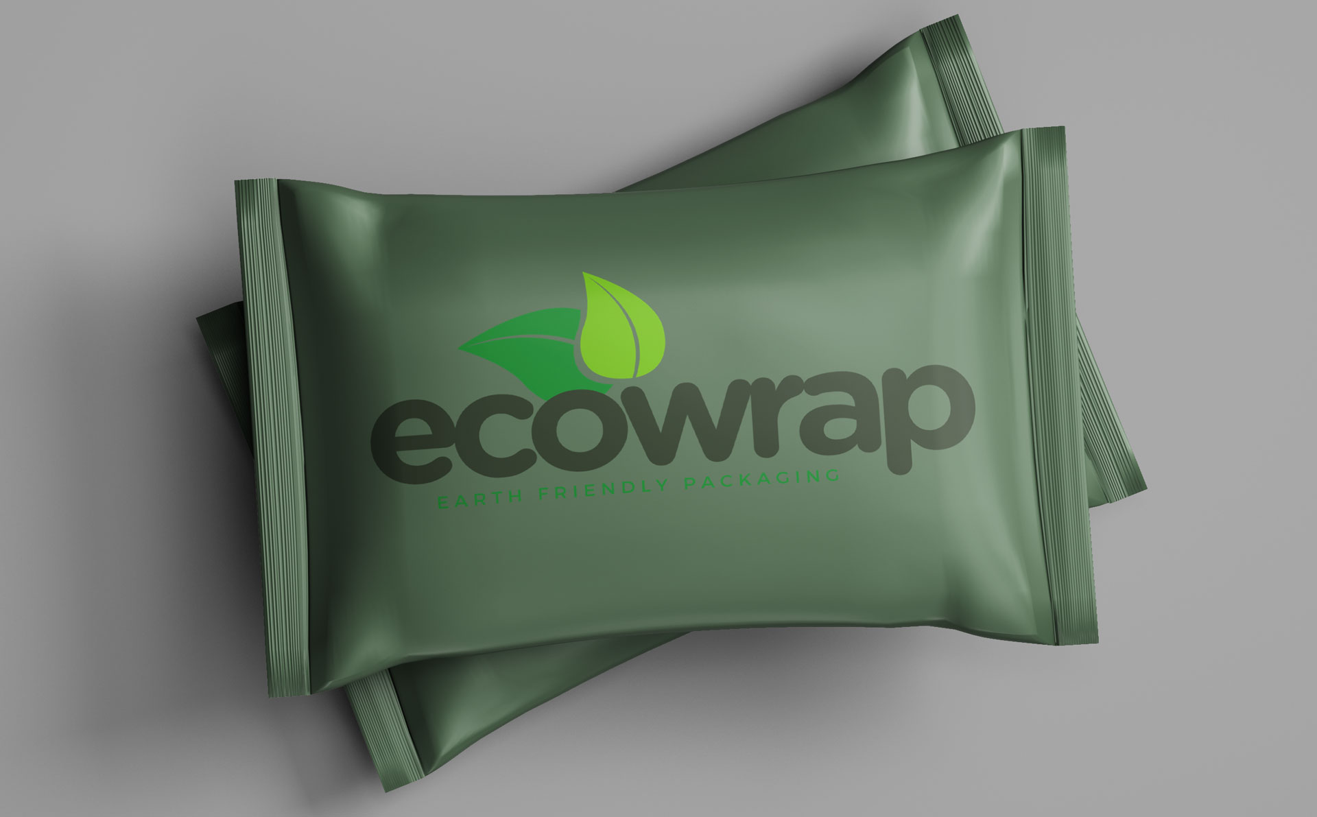

1. Introduction

Figure 1: EcoWrap Solutions biodegradable and compostable food-service packaging
EcoWrap Solutions will be a start-up sustainable business that will produce and supply fully biodegradable and compostable food-service packaging from waste wheat straw and rice husk from arable farms in South East England. Based in a small pilot production plant, EcoWrap will serve cafés and restaurants, as well as food-delivery operators, to provide them with an alternative to single-use packaging materials that is truly circular, using plant-based materials. Today, understanding of sustainable enterprises does not refer to adding environmental dimensions to a traditional value chain, but it is seen as organisations that from the very beginning have the creation of economic, social and environmental value built into their purpose and operational systems (Edgeman and Eskildsen, 2014). In this plan, EcoWrap defines its objectives, the rationale for its sustainability, the resources needed, its pathway to market, an analysis of the external and internal environment, a short-term cash flow forecast and a contingency plan to address key start-up risks. In all, sustainability is positioned as a principle of organisation, of strategy and of operations and one that is viewed as being inextricably linked to social and environmental performance; indeed, a principle that is also seen to operate in how companies resource, how they market and how they plan their finances (Edgeman and Eskildsen, 2014; Rahmana and Bawono, 2020).

2. Goals and Objectives
EcoWrap aims to be the first step towards a commercially viable and environmentally regenerative supply chain from farm to packaging, becoming the biggest independent supplier of food packaging made from agricultural waste in South East England in 5 years. Its mission is to eliminate single use plastic packaging in the local foodservice and to generate an extra income for arable farmers and less burning of arable crop residues in open fields.
The SMART goals for the first 3 years of EcoWrap has been set purposefully with a solid foundation that can be measured and monitored, which aligns with the belief that sustainable businesses need clear somewhat measurable performance objectives in all aspects, economic, social, and environmental as well as to have some sort of bottom line all in one case (specifically financial) (Edgeman and Eskildsen, 2014; Rahmana and Bawono, 2020):
- Fully install the pilot line, and start commercial production within six months of incorporation.
- Secure supply contracts with a minimum of 50 independent food businesses, by the end of Year 1.
- By end of Year 2 divert at least 500 tonnes of agricultural residue annually off burn and land fill.
- Implement composting and/or take-back programs for more than 80% of active customer base by Year 2.
- Operate at break-even by month 18 and go carbon neutral by Year 3.
- Proximity to a living wage policy and invest a percentage of the annual surplus in farmer partnerships and local communities.

3. How the Enterprise Is Sustainable
Based on the triple-bottom-line principle that sustainable value creation of enterprises can be secured not by a mere consequence of the economic value creation, but by jointly pursuing the economic, social and environmental performances (Rahmana and Bawono, 2020), EcoWrap is designed. Environmentally, the company uses as its raw timber a by-product of an already existing ecologically open process of food production, which is normally destroyed by combustion, leaving no material loop opened; virgin wood pulp and plastic are no longer needed (Saravanan et al., 2025). All finished packaging material is home- or industrially-compostable; the pilot plant itself makes use of an on-site solar array to reduce solar exposure during the packaging, and the material used is also environmentally friendly.
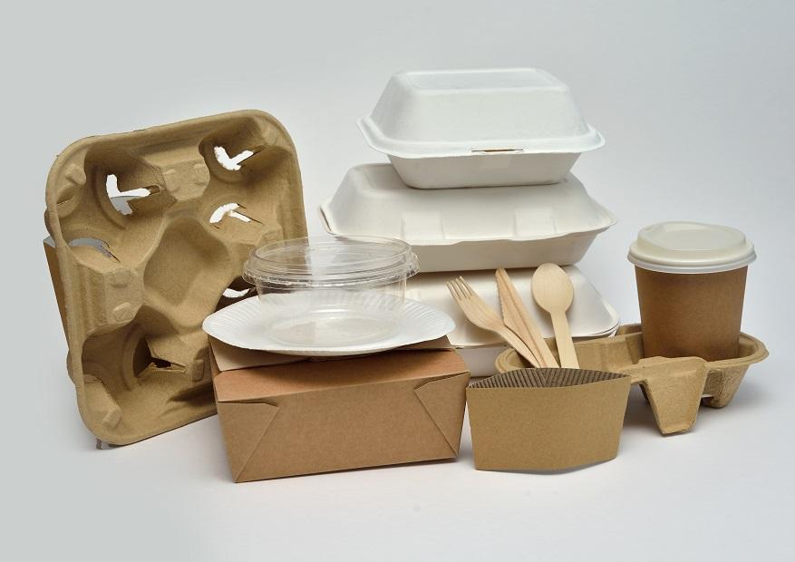
Figure 2: Food-service packaging
Socially the enterprise follows the argument that to create social value is not a by-product of being profitable but the business model must be designed from the outside in, in order to create social value. (Thompson, 2010). Through residue purchase agreements, EcoWrap opens a second income frontier for the engaging farms, takes social responsibility in regard to jobs and job creation in the production process as well as logistics, and always aims to offer a fair, transparent contract to the small farmer suppliers. Stakeholder engagement will be regarded as a management technique, and not one of communication: using the model of stakeholder engagement common in large-scale agricultural sustainability initiatives (like ITC's), EcoWrap will keep regular and systematic communication with farmers, local governments, composting companies, customers and investors, co-creating sustainability agendas with them instead of on their behalf (Anbarasan, 2018).
The sustainability is economically integrated operationally, as a lightweight, cloud-based enterprise resource planning (ERP) system will be implemented from the outset to record data on the material flows, energy usage, waste and carbon as well as classic financial and inventory data (Ibrahim Umut Yuzgenc and Erdal Aydemir, 2023). Integrating sustainability indicators into existing business information systems (and not retrofitting them after having been implemented) is proposed to enhance the visibility, audibility and availability of sustainability information and make them a key factor in day-to-day decision-making (Chofreh, 2018). This enables EcoWrap to substantiate their sustainability claims to customers and funders - moving sustainability claims from ‘assertions’ to verified data - including in tonnes of diverted residue, packaging units sold and avoided emissions.

4. Resources Required

4.1 Physical Resources
EcoWrap estimates a leased industrial unit to be around 500m² to accommodate fibre-pulping and moulding equipment, a hot press packaging line, drying racks, quality-control equipment and end product storage. The key capital equipment include straw/husk shredder and pulper, a semi-automatic tray-moulding press, rainwater and greywater recycling to reduce the use of process-water and two small electric delivery vehicles for local delivery.

4.2 Human Resources
For the enterprise to run, Year 1 needs to employ six full-time-equivalent workers: a founder/managing director who will oversee strategy and stakeholder relationships; a production manager; two machine operators; a sales and marketing manager; and a sustainability/operations coordinator, who will keep an eye on supplier relationships, ERP data and compliance. Part time (flexible) engagement of a bookkeeper and logistics driver. In keeping with thinking in terms of stakeholder engagement, farmer suppliers and partners in composting are not just a point of contact in the value chain, but part of the value chain as an extended human resource with a stakeholder being an owner of the relationship (Allali et al., 2024).

4.3 Financial Resources
Total startup capital of around £185,000 includes around £95,000 for machinery and fit-out, £40,000 for installing the solar and water recycling system and £30,000 for initial working capital (raw materials, wages, overheads, break even), and £20,000 for marketing, certification and contingency. A capital funding plan is being put in place involving a combination of funding sources: Founder equity (£45,000), a small business loan with an environmental element (£90,000) and a grant or crowdfunding round for environmentally-focused local investors (£50,000). As lenders have increasingly sought out validation that start-ups resourcing their businesses (as well as marketing) are sustainable businesses, this blended structure is put in place keeping gearing manageable and thereby indicating to lenders and any potential customers that it is a credible business (Lazopoulos, 2025) .

5. Marketing Strategy
Independent cafés and restaurants, food-delivery and takeaway providers and event caterers throughout South East England are the main target market for eco-friendly packaging firm, EcoWrap, who offer a wide variety of takeaway solutions to the industry, as customer and regulatory pressures mount on their sector to phase out single-use plastic (Mollaei, 2026). The value proposition not only features a truly compostable material, but also serves as a sustainability-claiming tool since the enterprise can provide transparent information on the sustainability of the materials to its customers as end consumers through a tool developed on its own ERP (Chofreh, 2018).
On product, the initial formats will be the most-popular formats: clamshells, trays and cups with the additional formats to be added based on validated demand. Prices will be slightly higher than traditional plastic packaging but lower than the cost of imported premium compostables and fair, not ‘posh’(Yang, Nayga and Fang, 2025). The distribution will be business to business with short delivery routes in the local area to keep the cost and emissions down as well as wholesale-distribution partnerships when the volume increases (Jiménez et al., 2025). Promotions would comprise a mix of targeted digital marketing, food-trade media coverage, and directly fostering deeper customer-stakeholder relationships at local food-trade events and through price discounts for bulk sales of reusable single-use plastic (SUP) items with guarantees of annual usage (Kumar et al., 2025).

6. PESTLE Analysis
Factor | Analysis
Political | UK and devolved government policy increasingly restricts single-use plastics in food service, creating regulatory tailwind; local council procurement policies favour compostable alternatives ( Department for Environment, Food & Rural Affairs, 2024).
Economic | Rising energy and raw-material costs pressure margins, but growing willingness among food businesses to pay a sustainability premium; access to green finance is improving (Zhang and Xie, 2022).
Social | Consumer and business demand for visible sustainability credentials is rising, particularly among younger consumers, supporting premium positioning (Sadiq et al., 2025).
Technological | Advances in agri-fibre moulding and compostable-material technology continue to improve durability and reduce production cost; cloud ERP tools make sustainability tracking affordable for small enterprises (Chofreh, 2018).
Legal | Compostability and food-contact packaging are subject to certification standards; extended producer responsibility and plastic-tax regulation increasingly favour compostable substitutes (Johnson et al., 2024).
Environmental | Strong alignment between the business model and environmental policy goals (waste reduction, circular economy, emissions reduction), though the enterprise remains exposed to weather-driven variability in agricultural residue supply (Enock Siankwilimba et al., 2025).
Table 1: PESTLE analysis
(Source: Self-created)

7. SWOT Analysis
Strengths | Weaknesses
- Genuinely circular input material  - low-cost local sourcing; strong  - verifiable sustainability story  - founder relationships with local farms and food businesses  - ERP-based impact data supports credible marketing claims. | - Small scale limits initial bargaining power with buyers  - A single production site creates operational concentration risk  - a new brand with no trading history reliant on external funding for start-up capital.
Opportunities | Threats
- Regulatory momentum against single-use plastics  - growing council and corporate sustainable-procurement mandates  - potential to expand into adjacent regions and product categories  - export potential as compostable-packaging demand grows across Europe. | - Larger, better-capitalised compostable-packaging  - competitors volatility in agricultural residue supply due to weather or crop prices possibly  - slower-than-planned customer adoption rising interest rates increasing the cost of debt finance.
Table 2: SWOTanalysis
(Source: Self-created)
Combined, the SWOT analysis points to EcoWrap's primary strengths being authenticity, traceability of its circular supply chain and its vulnerabilities with scale and funding dependence are directly dealt with in the resourcing plan and contingency plan below.

8. Financial Cash Flow Forecast
(£) | Month 1 | Month 2 | Month 3 | Month 4 | Month 5 | Month 6
Sales income | 0 | 0 | 3,500 | 9,000 | 15,500 | 22,000
Capital introduced (equity/loan/grant) | 135,000 | 50,000 | 0 | 0 | 0 | 0
Total income | 135,000 | 50,000 | 3,500 | 9,000 | 15,500 | 22,000
Equipment & fit-out | 95,000 | 40,000 | 0 | 0 | 0 | 0
Raw materials | 0 | 1,200 | 2,800 | 4,500 | 6,200 | 7,800
Wages & overheads | 6,500 | 6,500 | 8,200 | 8,200 | 8,200 | 8,200
Marketing & certification | 3,000 | 2,500 | 1,500 | 1,500 | 1,000 | 1,000
Total costs | 104,500 | 50,200 | 12,500 | 14,200 | 15,400 | 17,000
Net cash flow | 30,500 | -200 | -9,000 | -5,200 | 100 | 5,000
Closing balance | 30,500 | 30,300 | 21,300 | 16,100 | 16,200 | 21,200
Table 3: Financial forecast
(Source: Self-created)
An indicative cash flow forecast for the first 6 months of trading and pre-launch a manufacturing start-up is likely to require a lot of up-front capital investment, with the sales being built up as customer contracts are won. Assumes costs of £200 per hectare were applied and that there were no other revenue streams. Assuming Costs of £200/ha and no other revenue streams. The forecast features a positive closing cash balance in all months due to front-loaded equity and loan funding (months 1 & 2) followed by a sales income ramp as customers' contracts convert (month 3 onwards). The funding plan provides for a working capital buffer which is most restrictive in month 3 after major capital spending projects have been finished but before sales have increased.

9. Contingency Plan
There are four risks that are deemed most likely to pose a serious threat to EcoWrap's early trading performance; a mitigation response is called out for each of these.
- Raw material supply disruption (poor harvest or farmer pull-out) and mitigate by having multiple farm suppliers geographically each covering at least 30% of total requirements, and ensuring we keep at least 2 months buffering stock of dried fibres.
- Shortfall of cash flow or lower than expected sales overcome by the fact that an agreed overdraft facility of £15,000 is in place to be used at the back of the bench and a flexible cost base, like reducing operator hours prior to hiring more operators.
- Competitive entry from larger compostable-packaging suppliers defended by the local story of sourcing and transparency, and with long contracts focussed on first customers to help fund the expansion (Thapliyal et al., 2024).
- Regulatory delay and certification neutralised by launching the composability certification process early and simultaneously as equipment is installed and by using a specialist certification consultant, so as not to experience a delay to launch (Pal, 2025).
- These contingencies are rechecked every quarter as compared to actual data from the ERP system and as such it identifies the emerging contingencies from operational data and not once, they are material to cash flows.

10. Conclusion
A small enterprise could be developed and created based on economic, social and environmental value rather than as an added sustainability feature, as can be seen from the EcoWrap Solutions examples (Edgeman and Eskildsen, 2014; Rahmana and Bawono, 2020). The enterprise's unique combination of a truly circular raw-material supply chain, intentional connection with farmers and local partners (Anbarasan, 2018), a social-enterprise business model to create community impact in addition to profit, and a process of capturing sustainability metrics in place of core business systems (Chofreh, 2018), will enable it to expand profitably while also demonstrably reducing plastic waste and supporting agricultural livelihoods in the surrounding community.

References
Allali, T., Colabianchi, M., Moretti, M. and Brunori, G. (2024). Towards a new framework to assess agri-food value chains’ sustainability – the case of chestnut value chain. Heliyon, 10(7), p.e27836.https://www.cell.com/heliyon/fulltext/S2405-8440(24)03867-2?uuid=uuid%3A16f68635-254e-476c-96eb-5fda064f0f65
Anbarasan, P. and Sushil (2017). Stakeholder engagement in Sustainable enterprise: Evolving a conceptual framework, and a case study of ITC. Business strategy and the environment, [online] 27(3), pp.282–299. https://onlinelibrary.wiley.com/doi/abs/10.1002/bse.1999
Chofreh, A.G., Goni, F.A. and Klemeš, J.J. (2018). Sustainable enterprise resource planning systems implementation: A framework development. Journal of Cleaner production, [online] 198(18), pp.1345–1354. https://www.sciencedirect.com/science/article/pii/S0959652618320699
Department for Environment, Food & Rural Affairs (2024). Single-use plastics bans and restrictions. [online] GOV.UK. Available at: https://www.gov.uk/guidance/single-use-plastics-bans-and-restrictions [Accessed 24 July 2026].
Edgeman, R. and Eskildsen, J. (2013). Modeling and assessing sustainable enterprise excellence. Business strategy and the environment, 23(3), pp.173–187. https://www.researchgate.net/profile/Rick-Edgeman/publication/258770372_Sustainable_Enterprise_Excellence/links/5b708447299bf14c6d9ad205/Sustainable-Enterprise-Excellence.pdf
Enock Siankwilimba, Hoque, M.E., Femiana Gapsari, Afifah Harmayanti, Gunawan, P. and Hang’ombe, B.M. (2025). Exploring agricultural circular economy models in Emerging bioecosystems: Opportunities and challenges. Sustainable futures, 18(15), pp.100723–100723. https://www.sciencedirect.com/science/article/pii/S2666188825002898
Ibrahim Umut Yuzgenc and Erdal Aydemir (2023). Sustainable ERP systems: A green perspective. International conference on pioneer and innovative studies, 1(18), pp.533–538. https://ieeexplore.ieee.org/abstract/document/11031036/
Jiménez, P., Garrido, L., Gomez, J. and Vassallo, J.M. (2025). Environmental and operational impact of freight urban delivery: In-store, home and locker. Transportation research part d: Transport and environment, [online] 149(18), p.105026. dhttps://www.sciencedirect.com/science/article/pii/S1361920925004365
Johnson, H., Keane, K., McGillivray, L., Afshin Akhtar-Khavari, Chambers, L., Barner-Kowollik, C., Lauchs, M. and Blinco, J. (2024). Reforming plastic packaging regulation: Outcomes from stakeholder interviews and regulatory analysis. Sustainable production and consumption, 18(15). https://www.sciencedirect.com/science/article/pii/S2352550924003609
Kumar, P., Amarjeet Singh Mastana, Sasithorn Phonkaew and Pair Sajampun (2025). Digital marketing approaches and their role in fostering healthy eating behaviors: A systematic literature review. Edelweiss applied science and technology, 9(9), pp.817–832. https://www.researchgate.net/profile/Amarjeet-Singh-48/publication/395530028_Digital_marketing_approaches_and_their_role_in_fostering_healthy_eating_behaviors_A_systematic_literature_review/links/68dacbc6220a341aa1509ae6/Digital-marketing-approaches-and-their-role-in-fostering-healthy-eating-behaviors-A-systematic-literature-review.pdf
Lazopoulos, G.G. (2025). Navigating startup financing challenges: Impact on economic growth and job creation. [online] https://www.researchgate.net/profile/Gus-Lazopoulos/publication/394356437_Navigating_Startup_Financing_Challenges_Impact_on_Economic_Growth_and_Job_Creation/links/6893d1209a3902639b86eb99/Navigating-Startup-Financing-Challenges-Impact-on-Economic-Growth-and-Job-Creation.pdf
Martin, F. and Thompson, M. (2010). Social enterprise. Palgrave.
Mollaei, S. (2026). A scoping review of research-based sustainability-oriented interventions across restaurants and cafes. Frontiers in sustainable food systems, 10(18). https://www.frontiersin.org/journals/sustainable-food-systems/articles/10.3389/fsufs.2026.1821627/pdf
Pal, A. (2025). Why it takes a decade to get compostable flexible packaging right. [online] Pakka. Available at: https://pakka.com/blog/10-years-of-research-how-pakka-perfected-flexible-packaging-materials/ [Accessed 24 July 2026].
Rahmana, F. and Bawono, A. (2021). Sustainable development toward sustainable enterprise. Management science letters, 18(15), pp.657–668. https://pdfs.semanticscholar.org/6ed4/7e6077fd43eab1cc8851709674494da6888f.pdf
Sadiq, M., Fazal-e-Hasan, S.M., Ahmadi, H., Mortimer, G., Murdy, S. and Dann, S. (2025). Consumer hope and sustainable consumption: Integrating structural and configurational insights. Journal of Retailing and consumer services, [online] 88(18), p.104514. https://run.unl.pt/bitstreams/7f24deb2-d482-482b-b5c5-4ccb93061443/download
Saravanan, A., Ragini, Y.P., Karishma, S., Hemavathy, R.V. and Jyotsna, M. (2025). A review on advancing sustainable energy: The role of biomass and bioenergy in a circular economy. Sustainable futures, 10(15), p.100835. https://doi:10.1016/j.sftr.2025.100835 .
Thapliyal, D., Karale, M., Diwan, V., Kumra, S., Arya, R.K. and Verros, G. D (2024). Current status of sustainable food packaging regulations: Global perspective. Sustainability, [online] 16(13), pp.5554–5554. https://doi:10.3390/su16135554 .
Yang, W., Nayga, R.M. and Fang, Di (2025). Do consumers value biodegradable plastic packaging? Journal of the agricultural and applied economics association, 18(15). https://doi:10.1002/jaa2.70020 .
Zhang, D. and Xie, Y. (2022). Customer environmental concerns and profit margin: Evidence from manufacturing firms. Journal of Economics and business, [online] 120(18), p.106057. https://doi:10.1016/j.jeconbus.2022.106057.

