

Student name: Paulina Slowik
Student ID: 2332439

Module name: Building your Personal Brand for Sustainable Employment
Module code: BMHP5015_LON
Lecturer name: Caroline Salami

Table of Contents
Introduction 3
REFLECTION ON UNIT 1 3
Screenshots: 4
REFLECTION ON UNIT 2 5
Screenshots: 7
REFLECTION ON UNIT 3 7
Screenshots: 9
REFLECTION ON UNIT 4 10
Screenshots: 11
Conclusion 12
REFERENCES 13

Introduction
In an increasingly dynamic and unpredictable labour market, individuals are required to take proactive responsibility for their career development by cultivating adaptable skills and a strong professional identity. The Changemakers: Building Your Brand for Sustainable Employment course has provided a structured framework for understanding how to navigate these evolving demands. Throughout the programme, four key themes were explored: personal branding, boundaryless careers, networking strategies, and emotional intelligence (Capela, 2021). These areas collectively highlight the importance of self-awareness, continuous learning, and strategic relationship-building in achieving long-term employability.
The concept of personal branding emphasises the intentional communication of one’s values, skills, and professional identity, while the idea of boundaryless careers reflects the shift away from traditional, linear career paths towards more flexible and self-directed trajectories (Bridgstock, 2009). Additionally, effective networking techniques were presented as essential tools for accessing opportunities and fostering professional growth. Emotional intelligence further underpins these competencies by enabling individuals to manage interpersonal relationships and adapt to diverse workplace environments (Capela, 2021).
This reflective report critically examines the knowledge and insights gained from the course, evaluating how these concepts have enhanced my understanding of career development and identifying practical strategies for future professional advancement.

REFLECTION ON UNIT 1
In Unit 1, I developed a deeper understanding of personal branding, self-awareness, and identifying strengths within the context of a healthcare environment. I realised that personal branding in healthcare is not simply about self-promotion, but about demonstrating professionalism, compassion, ethical behaviour, and competence in clinical practice (Capela, 2021). During lectures and activities, I developed an understanding of how my communication style, attitudes, and behaviours contribute to how patients, colleagues, and multidisciplinary teams perceive me. This is particularly important in healthcare settings, where trust, credibility, and professional reputation directly influence patient care and teamwork. This aligns with personal branding theory, which highlights the importance of authenticity and consistency in building a strong professional identity (Peters, 1997).
Furthermore, I reflected on the importance of self-awareness in delivering safe and effective patient care. I realised that understanding my emotions, biases, and limitations is essential for maintaining professionalism and improving decision-making in high-pressure clinical environments. Through reflective exercises, I developed an understanding of how feedback from peers and supervisors can enhance my self-awareness. This learning can be linked to the Johari Window, which demonstrates how self-disclosure and feedback contribute to personal growth (Luft and Ingham, 1955). Applying this model in a healthcare context emphasises the importance of reflective practice and openness to feedback, which are key requirements outlined by professional regulatory bodies such as the Nursing and Midwifery Council (NMC, 2018).
In addition, I focused on identifying my strengths and understanding how these can be applied within healthcare practice. I realised that recognising strengths such as empathy, communication, and teamwork can enhance patient outcomes and collaboration within multidisciplinary teams. This perspective is supported by strengths-based approaches, which suggest that focusing on individual strengths can improve performance, engagement, and wellbeing (Clifton and Harter, 2003). I also developed an understanding of how aligning my strengths with specific healthcare roles can support long-term career satisfaction and resilience (Bridgstock, 2009). Additionally, I developed an appreciation of professional autonomy in healthcare, recognising the importance of independent clinical judgement within scope of practice while balancing accountability and collaborative decision-making (Deci and Ryan, 2000).
Overall, Unit 1 enhanced my ability to critically reflect on my personal and professional development within a healthcare context. I developed greater awareness of how my identity, behaviour, and strengths influence patient care and professional relationships, providing a strong foundation for my future career in healthcare.

Screenshots:
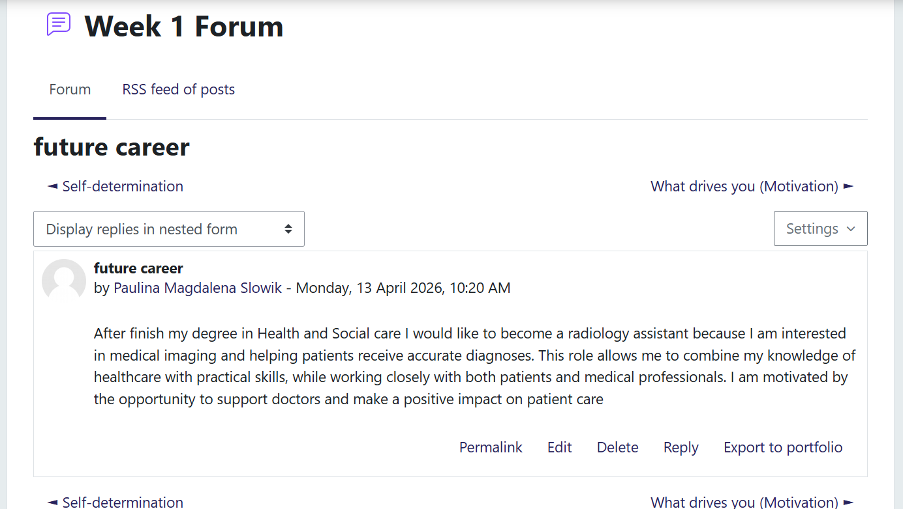
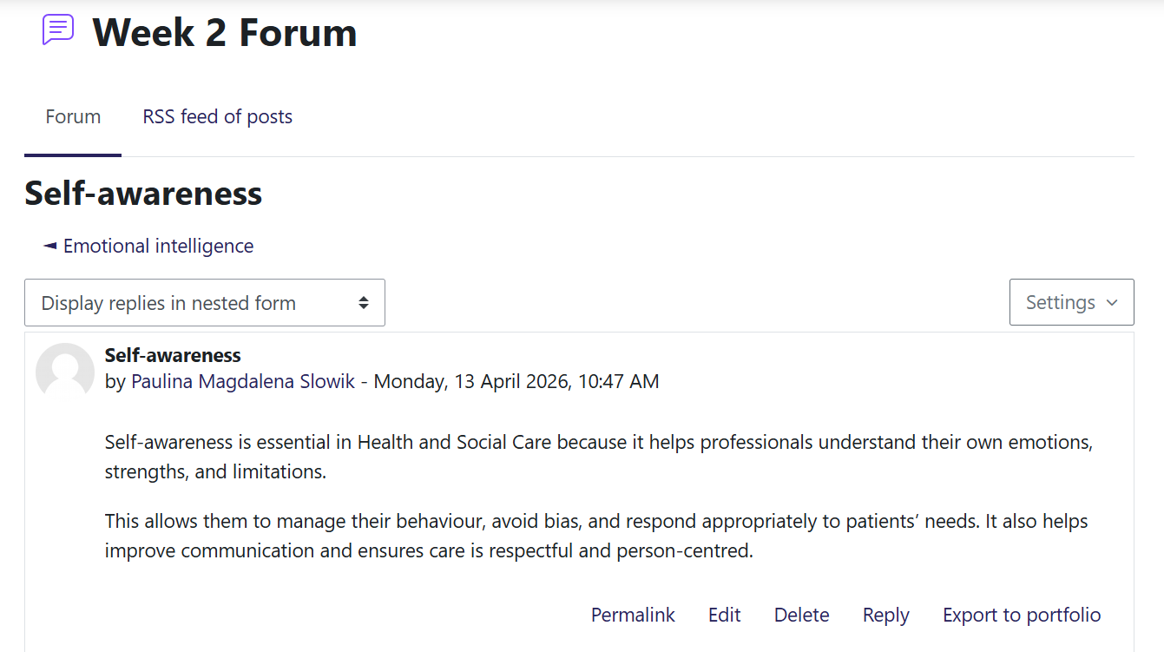
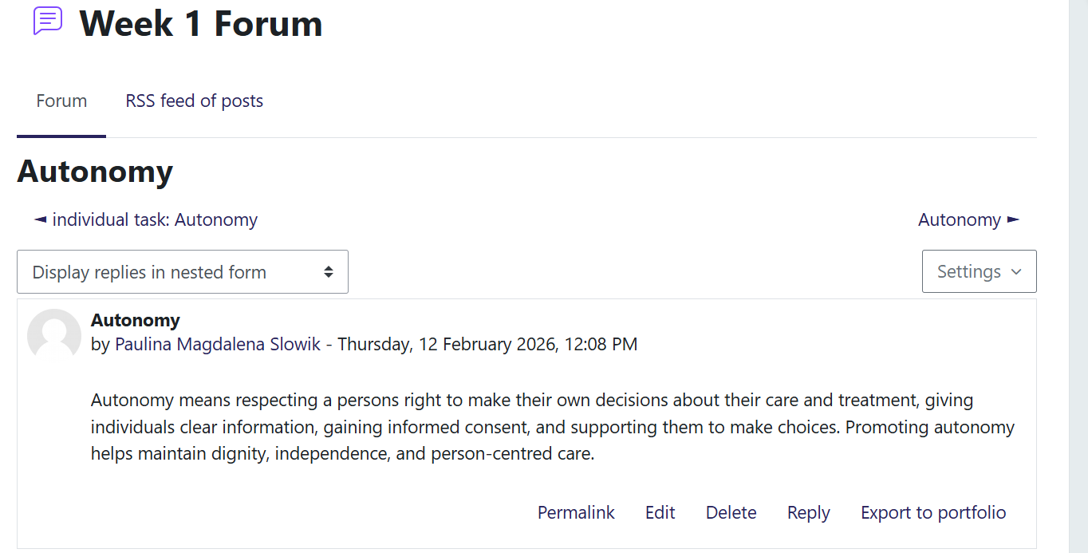

REFLECTION ON UNIT 2
In Unit 2, I developed a broader understanding of cultural competence, diversity, networking, and evaluation within the context of health and social care. I realised that cultural competence is a critical skill for healthcare professionals, as it enables the delivery of person-centred care that respects patients’ diverse backgrounds, beliefs, and values. Through lectures and case-based activities, I developed an understanding of how cultural differences can influence health behaviours, communication styles, and attitudes towards care. This learning shaped my awareness of global health inequalities and the importance of adapting care practices to meet the needs of diverse populations. This can be linked to Hofstede’s Cultural Dimensions, which helped me understand how cultural values such as individualism, power distance, and uncertainty avoidance may impact patient interactions and healthcare delivery (Hofstede, 2001).
I also reflected on the importance of diversity in health and social care settings. I realised that embracing diversity not only improves patient satisfaction but also enhances team performance and innovation within multidisciplinary teams. I developed an understanding that inequality in healthcare access and outcomes is often shaped by social determinants such as ethnicity, socioeconomic status, and education (Marmot, 2010). This strengthened my awareness of global issues in health and social care, including health disparities and the need for inclusive practices.
Furthermore, I explored the role of networking in professional development within healthcare. I realised that building professional relationships with colleagues, mentors, and external organisations can support knowledge sharing, collaboration, and career progression. Through practical activities, I developed an understanding of how effective networking contributes to improved healthcare delivery by facilitating interdisciplinary teamwork and the exchange of best practices (Bridgstock, 2009).
Finally, I reflected on the importance of evaluation in improving healthcare practice. I realised that continuous evaluation of services, interventions, and personal performance is essential to ensure quality care and patient safety. I developed an understanding of how reflective practice and evidence-based evaluation support ongoing improvement and accountability in healthcare settings. This aligns with the principles of reflective practice proposed by Schön (1983), which emphasise learning through experience and critical reflection.
Overall, Unit 2 enhanced my understanding of how cultural competence, diversity, networking, and evaluation are interconnected in addressing global challenges in health and social care. I developed greater awareness of the need for inclusive, reflective, and collaborative approaches to provide effective and equitable care in diverse healthcare environments.

Screenshots:
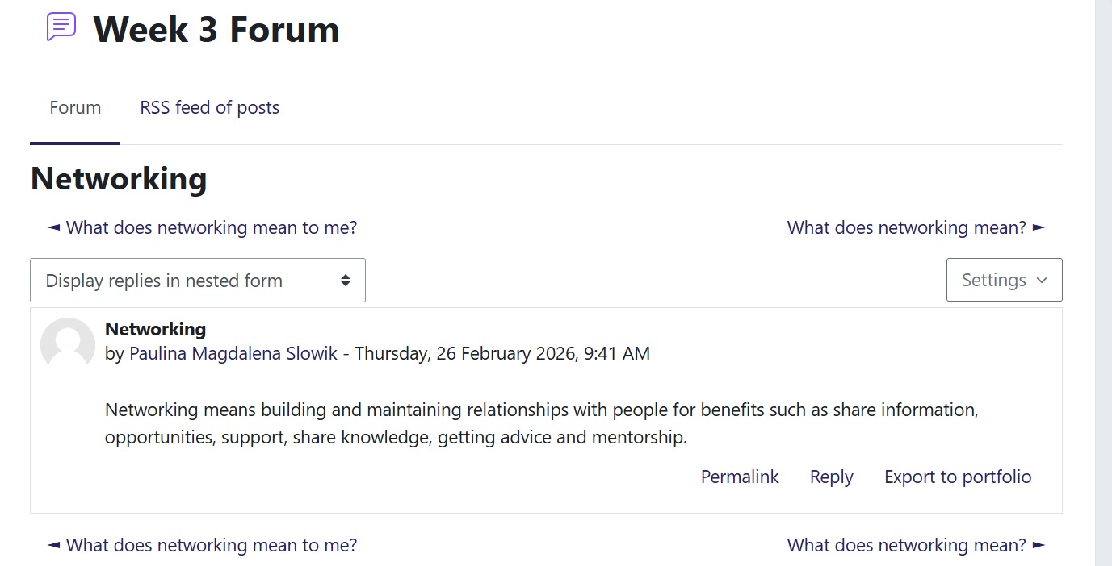
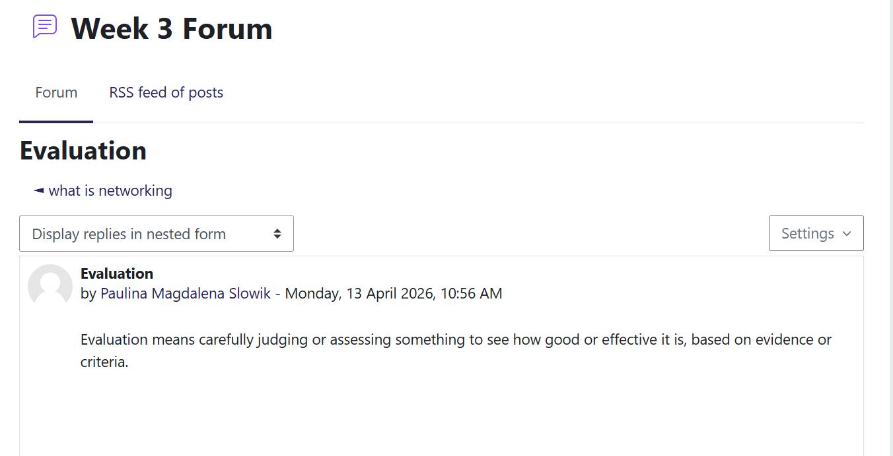

REFLECTION ON UNIT 3
In Unit 3, I developed a clearer understanding of how to identify and use opportunities for career progression within the health and social care sector. The key topics covered included spotting opportunities, goal setting, and personal development planning. I found that these concepts were particularly useful in helping me structure my career aspirations and translate them into realistic and achievable steps. By reflecting on my career goals, I learned to think more strategically about my future as a radiology assistant and how to progress within this field.
I learned to identify opportunities by analysing both my current skills and the requirements of my desired role. For example, I recognised the importance of gaining practical experience through placements or volunteering in healthcare settings, as this would enhance my understanding of patient care and professional responsibilities. This process helped me realise that opportunities are not always immediately visible, but can be developed through proactive engagement and continuous learning (Bridgstock, 2009).
Goal setting was a key aspect of my learning in this unit. I developed short-term, medium-term, and long-term goals based on my ambition to become a radiology assistant. In the short term, I focused on completing my course successfully and improving my knowledge in communication, and patient care. In the medium term, I aimed to secure a role in a clinical environment, while in the long term, I planned to progress further by gaining additional qualifications and potentially becoming a qualified radiographer. This approach aligns with the SMART goals framework, which emphasises the importance of setting goals that are Specific, Measurable, Achievable, Relevant, and Time-bound (Doran, 1981). Using this model helped me structure my goals more clearly and made them more achievable.
Additionally, I developed an understanding of personal development planning as an ongoing and reflective process and also an understanding of a serendipity mindset, recognising the value of remaining open to unexpected opportunities that may positively influence career development and progression (Krumboltz, 2009). I learned to evaluate my progress, identify areas for improvement, which is essential in healthcare where continuous professional development is required. This can be linked to Gibbs’ Reflective Cycle, which encourages individuals to reflect on experiences, evaluate outcomes, and plan future actions (Gibbs, 1988). By applying this model, I was able to critically reflect on my learning and identify practical steps to achieve my career goals.
Overall, Unit 3 enhanced my ability to recognise and act on opportunities, set structured career goals, and engage in continuous personal development. This has strengthened my confidence in planning my future career in health and social care and provided me with practical tools to achieve my professional aspirations.

Screenshots:
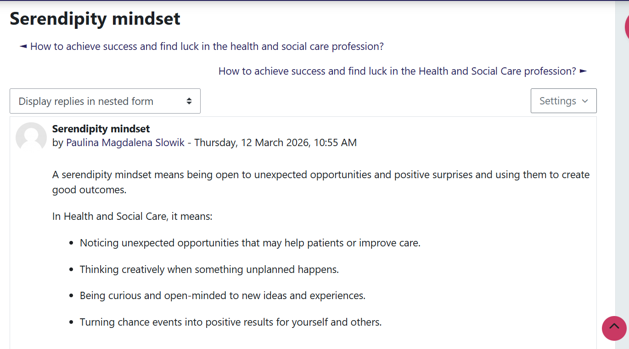
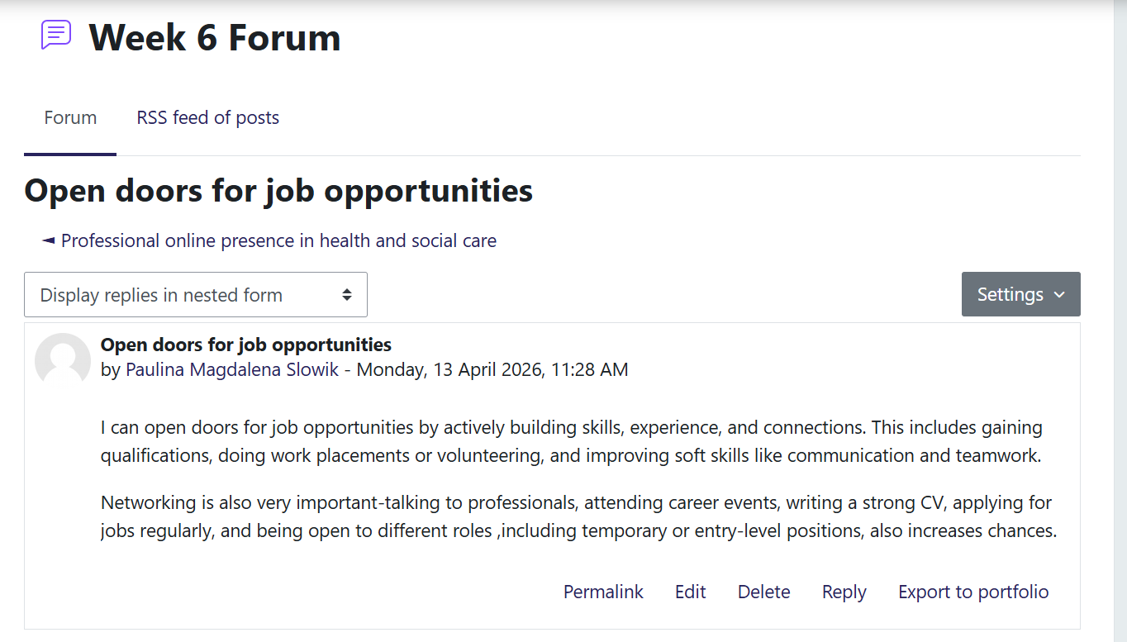

REFLECTION ON UNIT 4
In Unit 4, I developed a deeper understanding of wellbeing, resilience, and work–life balance, and how these concepts are essential for both personal and professional development within health and social care. I realised that maintaining wellbeing is not only important for my own health, but also for delivering safe, compassionate, and effective care to patients. Through lectures and reflective activities, I learned that wellbeing involves a combination of emotional, psychological, and social factors, all of which influence how individuals function in demanding environments such as healthcare settings.
I found that resilience is essential in health and social care due to high stress, emotional demands, and workload pressures. I understand that resilience is a developable skill supported through reflection and coping strategies rather than a fixed trait (Fletcher and Sarkar, 2013). I also explored the 4S model of resilience (Situation, Self, Support, Strategies), which helped me recognise how challenges can be managed by understanding the context, using personal strengths, accessing support, and applying effective strategies. This approach has strengthened my ability to adapt positively and maintain professionalism in clinical settings.
Work–life balance was another key area that shaped my learning. I realised that balancing academic responsibilities, personal life, and future professional demands is essential to prevent burnout and maintain long-term career satisfaction. In healthcare, poor work–life balance can negatively impact both staff wellbeing and patient outcomes. I learned to value time management, self-care, and setting boundaries as strategies to maintain balance and sustain my performance over time (Dyrbye et al., 2017).
I also recognised the impact of limiting beliefs on my confidence and career progression, such as doubting the ability to succeed in a demanding healthcare role. By identifying these thoughts, I will challenge them and replace them with more constructive and realistic thinking patterns. I developed an understanding that positive self-talk can enhance motivation, resilience, and performance, particularly in high-pressure healthcare environments (Seligman, 2011).
This learning can be linked to PERMA model, which highlights five key elements of wellbeing: positive emotion, engagement, relationships, meaning, and accomplishment (Seligman, 2011). I developed an understanding of how these elements apply to my own life, particularly in finding meaning in helping others and building positive relationships within healthcare teams. Applying this model helped me reflect on how I can actively improve my wellbeing and maintain motivation in my studies and future career.
Overall, Unit 4 enhanced my awareness of the importance of wellbeing, resilience, and balance in sustaining a successful career in health and social care. I developed theoretical strategies to manage stress, maintain motivation, and support my overall wellbeing, which will be essential for my future role in a demanding healthcare environment.

Screenshots:
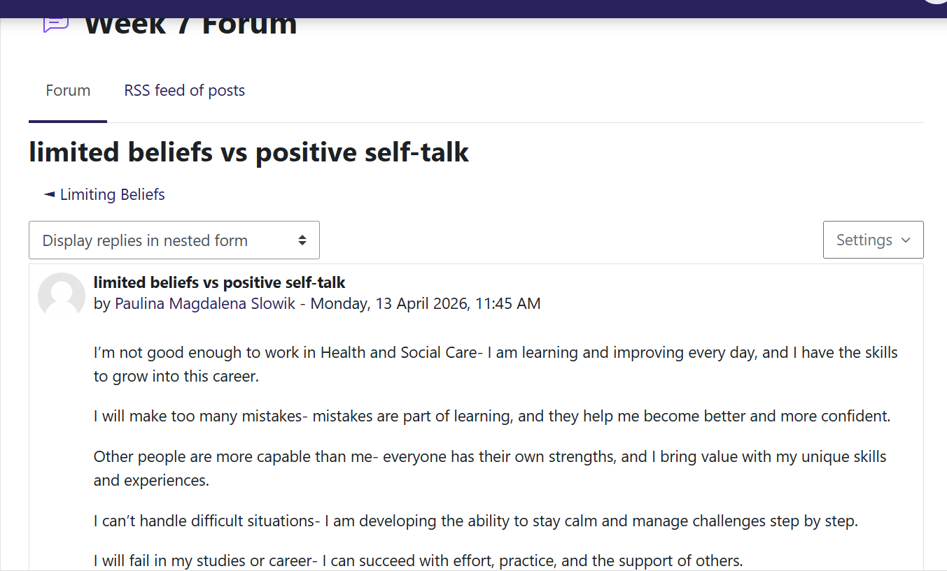
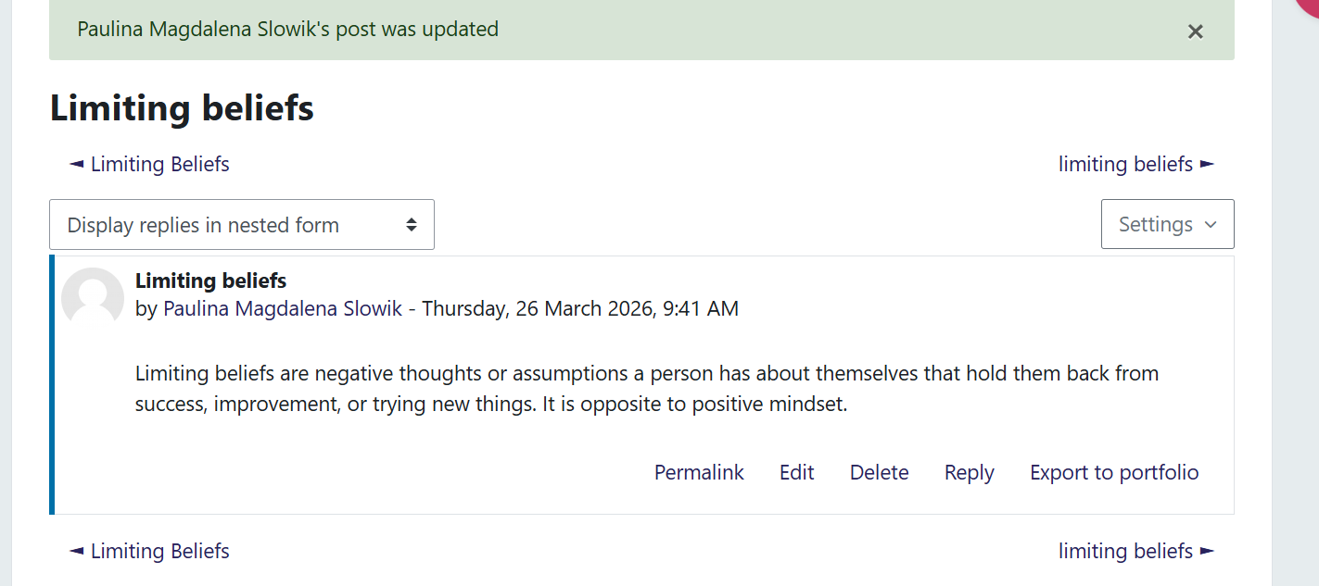

Conclusion
In conclusion, this reflective assignment has shown how each unit has contributed to my personal and professional development within Health and Social Care. I have learned the importance of personal branding and self-awareness in understanding my strengths and improving how I present myself professionally. I have also developed a better understanding of global connections, cultural competence, and diversity, which are essential for providing inclusive and respectful care to service users from different backgrounds.
Additionally, I have learned how to identify and use opportunities through effective goal setting and personal development planning, which has helped me become more organised and focused on my future career goals. The final unit has strengthened my understanding of wellbeing, resilience, and work-life balance, showing me how important it is to maintain my own mental and emotional health in order to provide effective care to others.
Overall, this module has helped me develop key skills such as reflection, communication, adaptability, and self-management. These skills will support me in future Health and Social Care roles by helping me work more effectively with others, manage challenges, and continue developing both personally and professionally.

REFERENCES
Bridgstock, R. (2009) ‘The graduate attributes we’ve overlooked: Enhancing graduate employability through career management skills’, Higher Education Research & Development, 28(1), pp. 31–44.
Capela, C. (2021) Changemakers: Building Your Brand for Sustainable Employment.
Clifton, D.O. and Harter, J.K. (2003) ‘Investing in strengths’, in Cameron, K.S., Dutton, J.E. and Quinn, R.E. (eds.) Positive Organizational Scholarship. San Francisco: Berrett-Koehler.
Deci, E.L. and Ryan, R.M. (2000) ‘The “what” and “why” of goal pursuits: Human needs and the self-determination of behavior’, Psychological Inquiry, 11(4), pp. 227–268.
Doran, G.T. (1981) ‘There’s a S.M.A.R.T. way to write management’s goals and objectives’, Management Review, 70(11), pp. 35–36.
Dyrbye, L.N., Shanafelt, T.D. and Sinsky, C.A. (2017) ‘Burnout among health care professionals: A call to explore and address this underrecognized threat to safe, high-quality care’, NAM Perspectives, 7(7).
Fletcher, D. and Sarkar, M. (2013) ‘Psychological resilience: A review and critique of definitions, concepts, and theory’, European Psychologist, 18(1), pp. 12–23.
Gibbs, G. (1988) Learning by Doing: A Guide to Teaching and Learning Methods. Oxford: Oxford Polytechnic.
Hofstede, G. (2001) Culture’s Consequences: Comparing Values, Behaviors, Institutions and Organizations Across Nations. 2nd edn. Thousand Oaks: Sage.
Krumboltz, J.D. (2009) ‘The happenstance learning theory’, Journal of Career Assessment, 17(2), pp. 135–154.
Luft, J. and Ingham, H. (1955) ‘The Johari Window: A graphic model of interpersonal awareness’, Proceedings of the Western Training Laboratory in Group Development.
Marmot, M. (2010) Fair Society, Healthy Lives (The Marmot Review). London: The Marmot Review.
Nursing and Midwifery Council (NMC) (2018) The Code: Professional standards of practice and behaviour for nurses, midwives and nursing associates. London: NMC.
Peters, T. (1997) ‘The brand called you’, Fast Company, 10, pp. 83–90.
Schön, D.A. (1983) The Reflective Practitioner: How Professionals Think in Action. New York: Basic Books.
Seligman, M.E.P. (2011) Flourish: A Visionary New Understanding of Happiness and sWell-being. New York: Free Press

