Workshop and practice technical report
Produced by, Iestyn Jones, student number – 2401101
Module – Workshop and Practice, ACHA4011
Submission date – Sunday 1st December

Contents

Title 1
Contents 2
Chapter 1 3
Chapter 2 4
Chapter 3 6
Chapter 4 7
Chapter 5 10
Chapter 6 12
Chapter 7 13
References 14

Chapter 1
Introduction
The task for this report is to conduct relevant research about different areas of engineering. the report will be looking into; health and safety, risk assessments, an engineer’s role in society, problem solving and team structure. The report will also contain a personal development plan. During the report I will be referencing different websites that are relevant to what I am stating, most of the report is written in third person with the exception of the team structure chapter and the personal development plan which is written in first person.

Chapter 2
Health and safety
Task completed in university since I started my course– removing and measuring the gearbox on the MCR in the university workshop
Removing a gearbox from a car requires a certain level of skill and respect to health and safety the always needs to be a top priority. Since gearboxes can be heavy to lift and move around, the factors of safe lifting should be considered.
As stated by the HSE government safe lifting operations, there are many factors that need looking at before engineers begin work, these include visibility of the part, its location, the amount of people to lift the part and the integrity of equipment. (HSE, gov)
After these factors have been considered the engineers should plan a risk assessment to minimise accidents, a risk assessment is a process that involves identifying all hazards and risks on the area of work, it also involves implementing procedures to lower these risks as much as possible
PPE is also a very important factor of safe working and health and safety, PPE is vital for whenever engineers are in a workshop or factory to ensure that they are as safe as possible, usual PPE contains; boots, overalls, safety glasses, hand protection (gloves or barrier cream), ear protection (headphones or ear plugs) and head protection (hard hat).
Selecting the correct PPE for the workers is very important. It’s important to consider what workers are exposed to, how long they’re exposed to it, and how much of it are they exposed to. For example, gearboxes are lubricated with oil, and before removing the gearbox its essential to drain the oil first, so workers must wear overalls to protect they’re body from the oil, gloves or barrier cream to protect their hands and safety glasses in case the oil splashes. If the workers are fully covered with PPE, the risk of harm towards them are as minimal as possible.

Managing risks and risk assessment at work – Overview -HSE
Risk Assessment and Management: A Complete Guide | British Safety Council

Chapter 3
Engineers’ role in society
An engineer has a very important role in society since they are the backbone of industry. There of course is a certain code of conduct that every engineer should follow and use consistently. In this code of conduct there are certain areas and practices to follow.
As stated in the IMechE website, these include maintaining professional knowledge and continue professional development. An engineer should also keep maintaining up to date information and practices, this will help the engineer be of more use in different situations. An engineer should also respect other workers and always maintain integrity, having respect for other engineers helps them work together and keep a good relationship within the career. Sustainability is also a large and growing factor of engineering, with everything going on in the world in terms of being sustainable, it’s vital for engineers to be sustainable in every aspect too. An example of engineering being more sustainable is formula 1, the motorsport has changed drastically in the last few years in order to be more sustainable and more environmentally friendly, the use of smaller engines has improved their emissions and the cars are being designed with a lower budget in order to be more efficient and less wasteful, parts are now having to be made in a veery sustainable manner otherwise the teams will be without certain parts and out of the races.
Sustainability in engineering is growing progressively now with different companies pushing the production lines and transport of parts to be more effective.
Code of Conduct explained - IMechE

Chapter 4
Problem solving
Problem solving is what an engineer is made for, an engineer goes through their career solving problems on countless parts or workpieces. Because of this it is very important that an engineer knows the best ways to problem solve in order to be efficient at their job.
(Pivot International, 2015) Solving problems whilst still developing products is a great way to minimise recalls on products especially if they are customer based. Since the product is still in development, the size of the problem isn’t as important, the key to solving these problems is to start small, solutions to these smaller problems can then be used and implemented into the bigger problems down the line.
It’s also important to take time when it comes to problem solving, trying to rush resolving issues can lead to making less progress, so taking time to think about the problem and acting on it in a larger time scale is the most effective way.
Another good way to solve problems is to research other areas where the problems are similar, this will help the engineer make right decisions right away. “When you begin to realize that the problem you’re trying to solve has been solved over and over again by people in other areas, you can look at the solutions they came up with to help you solve your own.” (Art Markman)
Another great way of problem solving is to think about improving the product in any way, and not focusing on improving it by x percent, revisiting the problem repeatedly and improving each slight issue at the time will help progress and minimise making the problem worse
Flow diagrams are an excellent way to solve problems, using the six-sigma protocol is an excellent method especially when developing the product, it includes, defining the problem, measuring the weight of the problem, analysing what can be done to resolve the problem, improving the product and controlling the progress ensuring the problem doesn’t come up again.
Flow diagrams are an excellent way to solve problems, using the six-sigma protocol is an excellent method especially when developing the product, it includes, defining the problem, measuring the weight of the problem, analysing what can be done to resolve the problem, improving the product and controlling the progress ensuring the problem doesn’t come up again. The six sigma protocol is used by many engineers and is proven to be a successful protocol for designing a product.
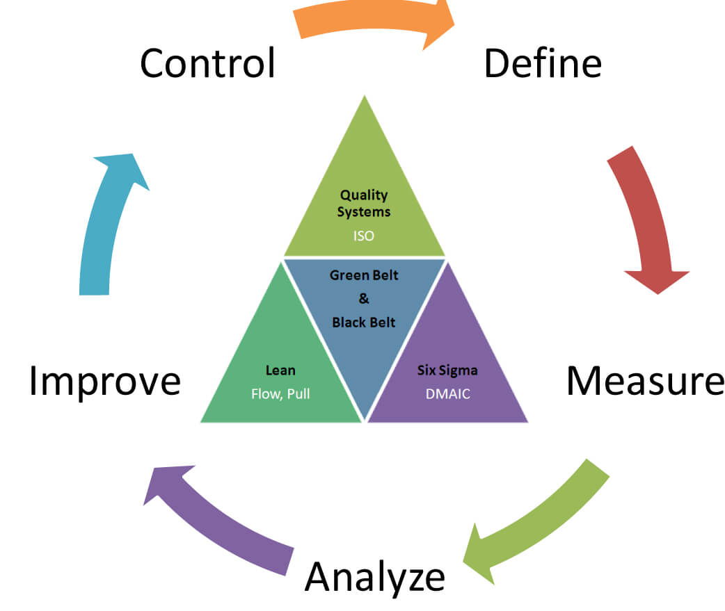
Online Lean Six Sigma Certificate - Ohio University
4 Ways to Problem-Solve During Product Development » Pivot International

Chapter 5
Team structure
Team structure plays a crucial role in the success of engineering projects, particularly in environments like motorsports, where time and precision are of the essence. In such high-pressure situations, clear roles and responsibilities ensure that each team member contributes effectively. In the context of a rally team, assigning roles based on individual strengths—such as engine mechanics, tire specialists, and fuel handlers—ensures that everyone is working within their area of expertise. This not only reduces the likelihood of errors but also speeds up the process, which is essential in motorsports where every second counts.
servicing with a rally team
servicing with the team was a brilliant team effort. We had a head mechanic which handed out different roles and ensured everything was ready before the car went out for the stages. With a group of 6 mechanics we all were assigned different parts of the car to focus on: engine, wheels and tyres, suspension, body, fuelling/ liquids, driver/ co-driver. The head mechanic ensured that we were all confident in the areas we were assigned to work on, this ensured him to be able to spend less time checking over everything before the car went out for the stage.
With these different areas assigned it was easier for us to focus solely on one part of the car which would lower any mistakes. This also ensured that we all had time to get everything done. Considering that time is vital whilst servicing, making sure we could get the work done as quick as possible was our number one priority.
On the other hand, the cons for this structure were that sometimes certain mechanics needed to be in two spaces at once and when the service is only 15 minutes long it ended in the mechanics having to rush at some points. For example, the car once needed oil but also needed a new coil pack so both mechanics were under the bonnet at the same time without much space.
Another con we had was a slight lack of communication, this pushed us back with timing during the service because things were getting over checked unnecessarily, if the teams communication was to improve we would have been able to be much more effective during our work.
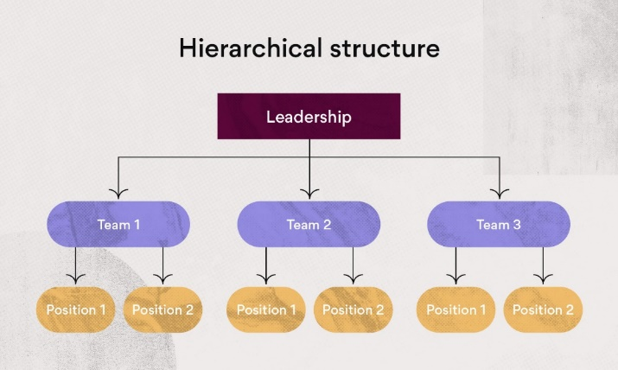
With the structure above, it separates the mechanics into teams instead of being alone, this would potentially be a better decision since two mechanics could cooperate and work together meaning it would eliminate 2 people in the same area and be more efficient during the service.
https://asana.com/resources/team-structure
Chapter 6
Personal plan development

Name - Iestyn Jones
Degree – Motorsport Engineering HND
Previous Qualifications – level 3 mechanical engineering
Previous Experience –
Long Term Goals (5 to 10 years)
Career in world rally team
Short Term Goals (0 to 5 years)
Graduate my degree with the highest grade possible

Goal | Objective | Resources Required | Measurement | Target Date
Finish building my rally car | Obtain all parts, build the engine and tune it | Workshop, tools, parts | Half way through | March 2025
Pass first year | Pass all assignments and modules | N/A | start | May 2025
Join WRC team | Graduate course | Degree in motorsport engineering | start | 2027/2028

chapter 7
conclusion
concluding this report, I have researched into different areas of engineering and have found certain websites backing what I’ve said. Through this report I have referenced these websites and included a reference list at the end. From everything I have paraphrased or quoted, I have ensured that there is a reference to it.

references
Managing risks and risk assessment at work – Overview -HSE
Risk Assessment and Management: A Complete Guide | British Safety Council
Code of Conduct explained - IMechE
Online Lean Six Sigma Certificate - Ohio University
4 Ways to Problem-Solve During Product Development » Pivot International
https://asana.com/resources/team-structure

