Student Name: Florentina Raluca Iamandi
Student Number: 2246151
Assignment 2: Planning and Delivering an International Meeting/Event.
BMIH6007 International Meetings Management for the Hotel Industry
Lecturer Name: Kathryn Roberts

Contents
Introduction 3
The Event Cycle 4
Event Concept 6
Aim and Objectives of the Meeting / Event 8
Event Management 9
Event Budget 10
Industry Trends / Issues / Impacts 10
Situational and Cultural Considerations 11
References 13

Introduction
Event planning always has a constructive behind, either to meet current needs or tailor it to future requirements. Behind an event, planning and detailing are important to understand how it will be managed and executed, meeting the deliverables (Getz and Page, 2019). The event 'Visit Wales’ Year of Croeso' is planned to be hosted in 2025 to purely differentiate Wales in the crowded marketplace with a strong emphasis on the language and the sense of place (GOV.WALES, 2025). Hence, it will be a good opportunity to host a music event named ‘UniLand’ with the strapline of ‘Celebrating Music of the World’. This event will be conducted for a time frame of 24-hour event where dine-in experiences will also be provided to the guests and the travellers. The venue is Cardiff since the population itself accounts for about 372,089, which in itself is large in segment (GOV.WALES, 2025).
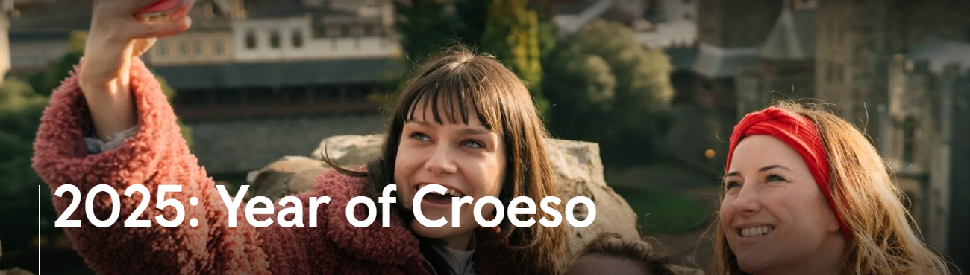
Figure 1: The Year of Croeso
(Source: Visit Wales, n.d.)
According to Mohamed et al. (2022), the strategic approach of using campaigns for promotions specifically for tourism, is considered to be enriching and even announcing the cultural heritage of a country. In this music event, there will be a dine-in experience too, where the travellers can come and experience multi-cuisine dishes, vegan diets and sugar-free drinks aligned to diverse health requirements of users. Moreover, for the lighting purpose, solar energy would be used to indicate the sign of zero emission being integrated in the event and meet the Sustainable Development Goals (SDGS). This event would take place in August, 2025 representing Spring blossoms felt with music. Keeping in mind the waste to be generated from the event, a third party like S L Recycling Ltd will be collaborated with to recycle the waste and ensure that the event is a pollution-free opportunity.

The Event Cycle
The tourist area life cycle as a model has existed in the literature for more than 4 decades and has been determined to be one of the most cited areas of tourism knowledge, which has led to growth and expanding tourism culture (Butler, 2024). Richard Butler developed this model to associate with core theoretical underpinnings in the area of tourism. \
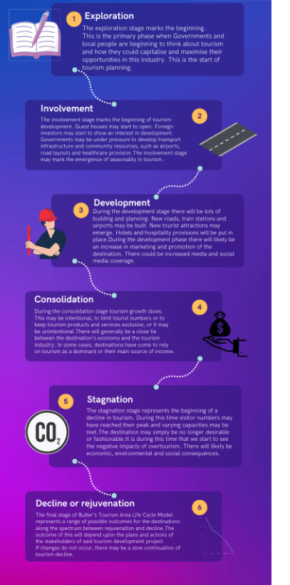
Figure 2: Butler’s Cycle
(Source: Tourism Teacher, 2023)
Aligning the Croeso event campaign through the Cycle will help to understand the concept behind the launch of the event.
Exploration: With the launch of the event, major events and media activities could increase, which would help create awareness of the destination. The event will give a vibe of welcoming the visitors in Welse style and presenting the culture too. In line with the Tourist Typology by Cohen, the travellers carrying the trait of 'Explorer' could fulfil their adventurous desires while being a part of the campaign or even visiting Wales in 2025. From the experience of the canal across the Pontcysyllte Aqueduct, the quality offered by Penderyn Welsh Whisky added to the dishes, to the enjoyment of the fastest zip line located at Zip World Penrhyn Quarry, tourists would be offered with exploring opportunities to explore across Wales (TravelTrade, n.d.). The culture of Male Voice Choir or the Welsh Culture, like the vibrant language do also touches the inner feelings of the tourists, which will be the main focus of UniLand.
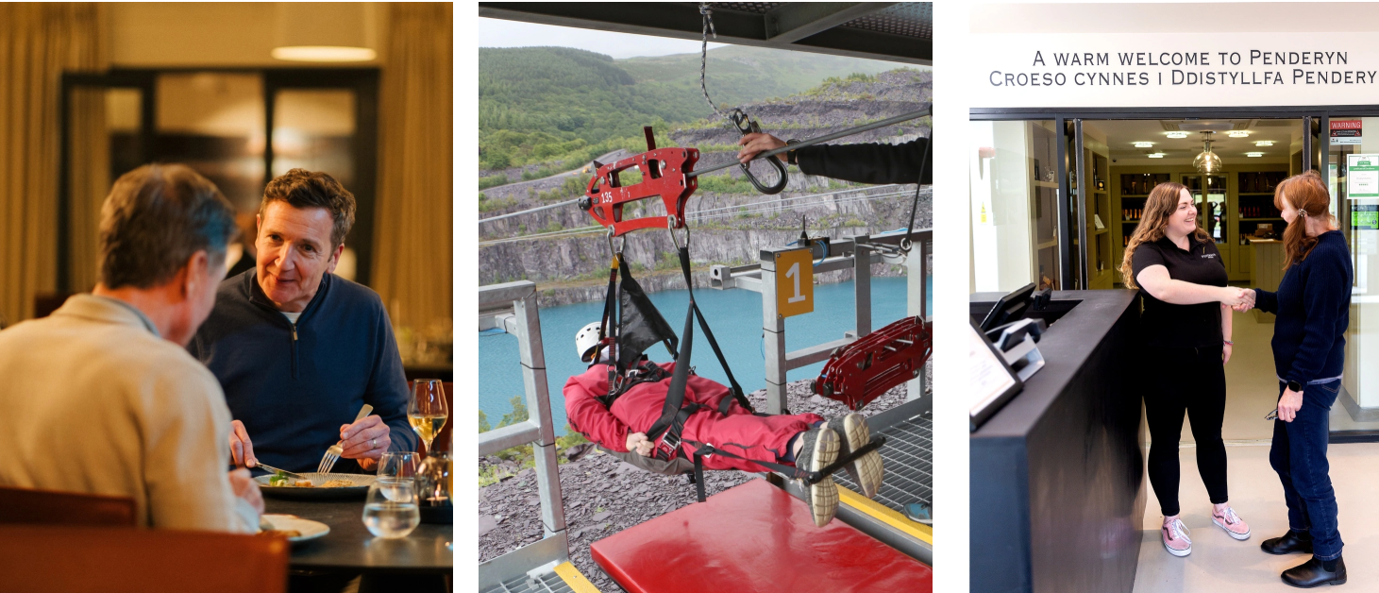
Figure 3: The exploration opportunity to be given by Wales in 2025
(Source: TravelTrade, n.d.)
Involvement: The stakeholders who will be involved to participate in the event can share their feedback to arrange for the resources as well. The industry stakeholders with their feedback over the past few years' experiences or the planning from the audience’s end have been catered to in the event. Through the engagement of the stakeholders, the plan has been clear and concise. It has been consistent in its efforts to develop the vision of Wales with all the essential qualities (Cymru Wales Brand, n.d.). The musicians who will perform at the event will be the key stakeholders to uplift the culture and entertain the tourists. S L Recycling Ltd will be another stakeholder to be involved in the event, who will be there for recycling the waste generated from the event.
Development: For the developmental activity, in this stage, the event will arrange for funds to be granted for tourist attractions. Visit Wales is reported to run capital grant funds for the year 2025-2026 for the support of businesses and invest in the sector in weather-proofing measures (Welsh Government, 2025). Hence, the specific event could place their proposal for bidding on the budget required for the hosting of the music event and highlight the significance of the event aligned to a sustainable agenda. For the promotion, Facebook and Instagram would be the chosen platforms to share reels on the launch of the music festival, with a caption of what interesting travellers could get from attending the event. From the offers to the venue selection, the timings of the event, like it will be for 24 hours, everything will be promoted on the social media channels.
Consolidation: Along with the close-knit communities to give a warm Welsh welcome, international conglomerates like Kaiser Chiefs, Becky Hill, and James Morrison will be engaging in the delivery of epic music festivals to make the event successful (Bowden, 2025).
Stagnation: As the year 2025 has been marked for the event, the decline is yet to arrive, and it has more than 6 months for the outcome to be obtained.
Decline or, as known, Rejuvenation: The project outcomes are expected to be about boost in social engagement, economic growth, and tourism profits to be gained along with collaboration with international agents at the same time for uplifting the Welsh culture. As identified by Fox et al. (2014), an event is developed on a proper plan and research work, enabling effectiveness. In the event, the campaign is also developed with proper plans, involvement of the Welsh Government, local communities and stakeholders from international conglomerates.

Event Concept
Location of the event: Bute Park, Cardiff
Duration: 24-hour event
Theme: Sound of the Universe representing Welsh culture
Time: 12 at Noon.
Day 1: Opening Ceremony of “UniLand event”
- Start the day with the Traditional Welsh Choir
- Welcome the Dignitaries and Ministers
- Live performance of James Morrison interacting with the audience
Time: 1:30 p.m. – 3:00 p.m. Lunch Arrangements
- Street foods of Welse represent the culture
- Enjoy the lunch with local musicians
Time 3:00 P.M.
- Storytelling through folk songs
- Workshops of the Kaiser Chiefs and local communities selling their handcrafted machines
Time 4:00 P.M.
- Enjoy Mocktails and Cocktails, famously offered with Welsh beverages and snacks.
- Penderyn Welsh Whisky (Optional)
Time 5:30 P.M.
- Youths representing the Urban Culture
- Diverse nations' cultures are being presented through artists
Time: 7 P.M.: The Main Event of Croeso Stage
Time 10: 30: Dinner Bouffe
- Poetry sessions
- Singers singing the Welsh anthem to end the day

Day 2: Venue: Bute Park, Cardiff
Starts From Midnight to noon.
Time midnight.
- Storytelling through music of Mountains, coasts, by artists
- Unplugged music arrangements around a bonfire
Time: 4 A.M.
- Guided Meditation with early morning surroundings
Time 6 A.M. Dawn Experiences
- Sunrise Symphony by Welsh Youth Orchestra
Time: 8 A.M Community Hours
- Mass audience participation in music creation
- Audiences invited to share their music tastes and rhythms
Time: 10 A.M: Closing Episode
- Invite the youths and live audiences to share their experience
- Crowdsourced anthem of Welsh\
- Farewell speech given by the Ministers attending the program
Time: Noon - Official Closure
- To offer a letter of appreciation to the artists
- Provide complimentary soft drinks to guests

Aim and Objectives of the Meeting / Event
Overall Aim of the event
The event's overarching aim is to uplift the tourism culture of Wales, enhancing domestic social and economic benefits within 1 year.
Objectives
Objective 1: To increase the profit margin of the event by around 25% within 24 24-hour time frame hosting the music festival event
Specific | To apply for a minimal entry fee for guests to enjoy the music festival and dine-in experience
Measurable | With the number of guests that have visited the event within the 24-hour time frame
Attainable | Through the promotion of the event in social media channels and announcing all information related to the event (specialities, the dine-in experiences, the USP of the events)
Relevance | To boost the social and economic development of Wales' tourism
Time bound | Within the time frame of 24 hours

Objective 2: To increase the social media customer base within 24 24-hour by around 15% with comments, likes and reviews on the music festival
Specific | This event would also be featured live on the Facebook channel of the
Measurable | Through the likes and comments received on the Facebook page live
Attainable | Through the hosting of a live event, which will also be featured on social media platforms
Relevance | Social media is an integrated tool for campaigns being organised and uplifting tourism.
Time bound | 24 hours
Table 1: SMART objectives
(Source: Learner)

Event Management
Resources Required for the Event:
Resources Required | Kind and important
Financial resources | To build on the infrastructure for the music festival, which will be a part of the Year of Croeso 2025 event
Technology | IT skills and software for broadcasting the event to the followers on the Facebook page after the live event is over
Human Resources | The manpower, like volunteers to assist the guests and the artists at the event.
Infrastructure | For the hosting of the music festival on a stage, and even arrange for the dine-in experience.
Table 2: Resources Required for the Event
(Source: Learner)
Skills Required for the Event:
Event management is a crucial task with diverse requirements and effective skills utilised for the success of the event (Smith, 2012). In the management of the event, the first and foremost skill required will be project management skills. Through project management skills, it is efficient to allocate the resources for the project, the milestones to be set, along with the measures to be taken for the project goals to be accomplished (George, 2020). With the hosting of the event, it will be necessary to identify the goals and train the volunteers on how to handle the situation. Communication skills are vital for carrying out a project which is in the shape of an event and interacting with the volunteers for the event to be hosted successfully (Kitchen, 2024). With the efficiency in communication skills, it is identified that clarity and understanding of tasks are constructed well (Sumaiya et al., 2022). For example, the event manager will need to communicate the project goals to the volunteers, discuss important meetings with the stakeholders, and communicate to the artists what the purpose of the event is and how it will be designed.
Problem-solving skills too is required for the successful carrying out of the event and navigating any issues that are encountered (Parent and Ruetsch, 2020). For example, in the current event, it is bound that there would be waste generation; hence, to solve the issue, a third party named S L Recycling Ltd will be collaborated with and the recycling of the waste, thus indicating that a sustainable agenda is being aligned.

Event Budget
Resources for the events | Budget (£)
Manpower be hired | 300
Social media platforms are being used. | No cost will be charged since Facebook is a cost-effective tool.
Design of the website for the music festival to be broadcast | 150
Dine in Cost | 200
Use of carpets in the entrance gate | 75
Funding Sources | Grants which have already been a part of the main Year of Croeso
Income generation | From the guests registering online and offline for the event, to participate.
Table 3: Budget allocation
(Source: Learner)

Industry Trends / Issues / Impacts
Tourists demanding innovation and exploration of culture: According to Maxine Hughes, being a journalist, did wanted to feature the reasons why tourists should choose Wales to enhance their experiences. It has been a multi-platform campaign that has utilised real sounds from and across the destination rather than just diving only into music to ensure that the campaign is an engaging one and has an immersive sensory feeling associated with it.
Sustainable Agenda: Sustainable Development Goal 11 promotes sustainable cities and communities through the enhancement of services by tourism (United Nations, 2025). Thus, with the hosting of the music event, it would cater to the ongoing issue of sustainability, the need for addressing the wrong perception created with the 182-day rule and welcome the travellers to cherish the Welsh culture and boom in the tourism sector. Moreover, with the idea of recycling the waste generated from the event, it would adhere to SDG 11 and help Wales to become a part of the sustainable cities and communities.

Situational and Cultural Considerations
Political | The political factors, like geopolitical tensions or the Russian invasion of Ukraine, are likely to impact the tourism sector by lowering the number of tourists and impacting the tourism benefits too. Previously, COVID-19 caused an impact on the tourism industry with the restrictions on travel that impacted the performance of companies in the hospitality sector. The policy, particularly the ‘182 days’ rule, did create an impression on the visitors that tourists are not being welcomed in Wales (GOV.WALES, n.d.).
Economic | The growing inflation has raised a question on the cost-of-living crisis in UK. It is found that the rising cost and the stringent market conditions has affected the business performance in recent times. It has been found that with the lack of disposable income did deprive many visitors to make tourism purchase decisions (GOV.WALES, n.d.).
Social | The growing demand of innovation and emphasizing on adventures in tourism have been driving tourism sector to embrace digitalisation and advances in performances. It has been even found that the cost-of-living crisis has squeezed the purchase intention of the users. In 2023, it has been reported too that Wales have been failing to attract the presence of the overseas visitors (Hoskin and Phelps, 2023).
Technology | The digital innovation has brought in disruption where right from creating awareness to comfortable services to users have been possible. The way tourism sector in UK has been utilising the digital presence is worth noticing.
Legal | The legal policies that are designed by the Government as evidenced during the time of the pandemic do impacts the tourism operations.
Environment | The net zero emission from the companies, or the adhering of the sustainable agenda like SDGs Goal 11 “Sustainable Cities and Communities” have been motivating tourism sector to incur changes and embrace innovation for the socio-economic benefits.
Table 4: PESTLE analysis
(Source: Learner)
With the hosting of the Music Event titled "UniLand", it would certainly change the perceptions of the tourists regarding the Welsh culture and bring close to the communities. For instance, the perception created with the 182-day rule could now be relaxed by welcoming the tourists to explore their adventurous needs and accustom themselves to the Welsh culture.

References
Bowden, G. (2025) 2025. Join us for the Year of Croeso, Neath Port Talbot Destinations. Available at: https://dramaticheart.wales/blog/2025-join-us-for-the-year-of-croeso/ (Accessed: 11 May 2025).
Business Wales. (n.d.) Visit Wales Marketing Webinar – Year of Croeso 2025. Available at: https://businesswales.gov.wales/news-and-blog/visit-wales-marketing-webinar-year-croeso-2025 (Accessed: 11 May 2025).
Butler, R. (2024) ‘Tourism destination development: the tourism area life cycle model’. Tourism Geographies, pp. 1-9.
Cymru Wales Brand. (n.d.) Home: Visit Wales Brand Hub, Home | Visit Wales Brand Hub. Available at: https://assets.wales.com/ (Accessed: 11 May 2025).
Fox, D., Gouthro, M.B., Morakabati, Y. and Brackstone, J. (2014) Doing events research: From theory to practice. London: Routledge.
George, C. (2020) ‘The use of project management skills to overcome organisational challenges’, International Journal of Innovative Science and Research Technology, 5(3), pp. 340-344.
Getz, D. and Page, S. (2019) Event studies: theory, research and policy for planned events. 3rd Edition. London: Routledge.
GOV.WALES. (2025) Visit Wales invites the world to feel the 'hwyl' in 2025. Available at: https://www.gov.wales/visit-wales-invites-world-feel-hwyl-2025 (Accessed: 14 May 2025).
GOV.WALES. (n.d.) Tourism Barometer: February wave 2025. Available at: https://www.gov.wales/tourism-barometer-february-wave-2025-html (Accessed: 14 May 2025).
Hoskin, S. P. and Phelps, S. (2023). Tourism: Wales failing to attract overseas visitors - MPS. Available at: https://www.bbc.com/news/uk-wales-66171190 (Accessed: 14 May 2025).
Kitchen, E. (2024) ‘Building event management skills through authentic assessment’, Educational Studies, pp.1-17.
Mohamed, G.A., Alakhras, H.A., Khalil, R.A. and Mohamed, M.A. (2022) ‘Role of tourism advertising campaigns in improving destination image’, Journal of Sustainable Tourism and Entrepreneurship, 3(2), pp. 91-104.
Parent, M.M. and Ruetsch, A. (2020) Managing major sports events: Theory and practice. London: Routledge.
Smith, A. (2012) ‘Events and urban regeneration: the strategic use of events to revitalise cities’, London: Routledge.
Sumaiya, B., Srivastava, S., Jain, V. and Prakash, V. (2022) ‘The role of effective communication skills in professional life’, World Journal of English Language, 12(3), pp. 134-140.
Tourism Teacher. (2023) Butler’s Tourism Area Life Cycle Model: A Simple Explanation. Available at: https://tourismteacher.com/butlers-tourism-area-life-cycle-model/ (Accessed: 11 May 2025).
TravelTrade. (n.d.) Wales is celebrating a Year of Croeso, a Welsh welcome for visitors. Available at: https://traveltrade.visitwales.com/useful-information/toolkit/year-of-croeso (Accessed: 11 May 2025).
United Nations. (2025) Goal 11 | Department of Economic and Social Affairs. Available at: https://sdgs.un.org/goals/goal11 (Accessed: 11 May 2025).
Visit Wales. (n.d.) Year of Croeso. Available at: https://industry.visitwales.com/get-involved/visit-wales-themed-year-campaigns/year-croeso (Accessed: 12 May 2025).
Welsh Government. (2025) Tourism Industry Update. Available at: https://content.govdelivery.com/accounts/UKWALES/bulletins/3de1cc7#:~:text=Year%20of%20Croeso%20Weather%2DProofing,invest%20in%20weather%2Dproofing%20measures. (Accessed: 11 May 2025).

