+

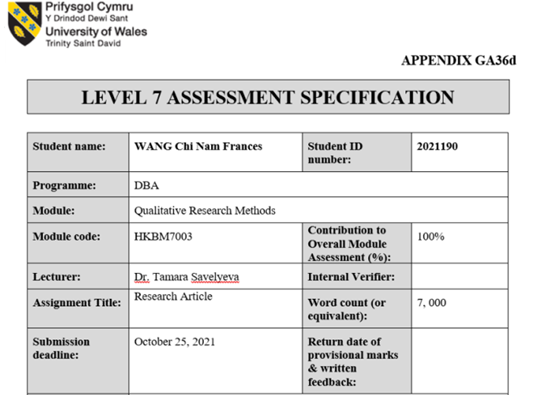


School of Business

Qualitative Research Methods
HKBM7003
By
Dr. Tamara Savelyeva

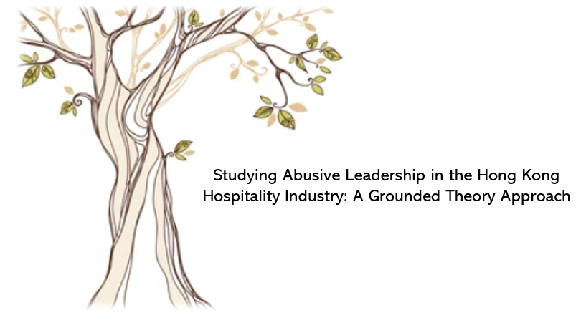

Student Name: Chi Nam Frances WANG
Student Number: 2021190
Word Count: 7,000 words
Date: 24th October, 2021
Table of Contents
Abstract 4
Keywords 5
Critique of a Research Article 6
Introduction 6
Assessment of the Article 7
Strength of the study 7
Weakness of study 8
Discussion of the Article 10
Summary 12
Research Proposal 14
Introduction 14
Theoretical Background 15
Problem Statement 16
Purpose Statement 16
Methodology 17
Research Questions 17
Justifications of Suitable Qualitative Methods 17
Research Design 18
Data Collection Procedures 19
Data Analysis Procedures 19
Practical Considerations 19
Role of the Researcher 20
Ethical or Practical Issues 20
Implications and contributions to knowledge 20
Theoretical Implications 20
Practical Implications 21
Preliminary Pilot findings & Expected Outcomes 21
Research Time Line and Proposed Budget 22
References 23
Appendices 26
Figure 1 – Interview Questions (Sample) 26
Figure 2 – Research Consent Form (Sample) 27
Research Time Line 29

Abstract

This research proposal consists of two main sections: an evaluation of a recent research article and a research proposal. Immediately following the abstract, this proposal will feature
a critical appraisal of Hight et al. (2019), a study of bad managers' profiles from co-workers’ perspective and the root causes of poor manager behaviour. This proposal is to establish ways to address the research gaps left by Hight et al. (2019) after the assessment. The attempt to test the findings under a geographic research gap that was conducted in the west but is now focusing on the east. The title of this research is: Studying abusive leadership in the Hong Kong hospitality industry: a grounded theory approach.

An extended study on abusive leadership is proposed as a focus of this research proposal. Researcher will investigate abusive leadership in Hong Kong's hospitality industry due to its unique cultural setting and special feature of its organizational structures. Multi-layers of management, seniority of service and high turnovers is common of this business and contributors to abusive supervision in a workplace. It is worth noting the importance of Chinese faith in Confucian beliefs and the city's strong power distance index in making this topic interesting. The theory construct may address different issues from what has been found in the West regarding how people see, feel, and react to supervision and abusive supervision.

Participant information includes taking a purposive sample from hospitality practitioners and recruited with assistance from Hong Kong's largest vocational educational institution, the Vocational Training Council (VTC). Researchers will recruit interview subjects in pairs. Participants are encouraged to invite their supervisor or previous supervisor to take part in the study. Researcher will prepare semi-structured questions to encourage discussions of the topic. Interactive inquiry with participants is intended to gather information reflective of the research questions. A total of fifteen questions will be posed to the subjects to explore how respondents describe, perceive and respond to abusive leadership and abusive behaviour categorised by Tepper (2000).

To explore this psychological and sociological phenomenon, this study will use a qualitative research methodology construct on grounded theory approach. The purpose of this design is to conduct a more in-depth study based on this methodology. The study will examine the topic by rewriting the questions into an open-ended semi-structured interview based on Tepper's fifteen confirmatory factor analyses. Data collected through a systematic approach will be analysed through memoing, open coding, axial coding, and theoretical analysis. In grounded theory, data are collected and analysed using comparative analysis to discover or construct theories which explain the designed research questions. First, how do hospitality practitioners in Hong Kong describe abusive leadership? Second, how will respondent react in a certain way under abusive leadership? Third, where does this reaction comes from or the reasoning behind this action?

This study aims to provide both theoretical and practical contributions to current literature. Theoretical contributions include theories to describe the perceptions, reasons and reactions of abusive leadership in an industry characterised with a strong hierarchy structure and high-power distance. Consider if there is new evidence suggesting that people influenced by Confucian beliefs in the east have different views on abusive leadership. A practical contribution is that the study may also provide policy options and demonstrate how specific changes should be made.

This study does not present any significant ethical issues and is expected to be a practical study. The expected challenge is to translate scholarly concepts from English to Chinese or vice versa, and conduct a proper interpretation using appropriate words and phrasing. Limitations may include language bias, translation bias, and researcher bias. The study is a self-funded project and scheduled to be completed in two years.

Keywords
Abusive Leadership, Toxic Leaders, Dark Side Leadership, Power Distance, Organisational Culture, Hospitality Industry, Reverse Study

Critique of a Research Article
Hight, S.K., Gajjar, T. and Okumus, F. (2019). Managers from “Hell” in the hospitality industry: How do hospitality employees profile bad managers? International Journal of Hospitality Management, 77, pp.97-107.

Introduction
Hight et al.(2019) conducted a study on how employees would describe abusive managers in hospitality in the article “Managers from ‘Hell’ in the hospitality industry: How do hospitality employees profile bad managers?” The aim in this study was to identify bad managerial personalities in the hospitality industry and explored the cause-and-effect of these attributes. There was evidence from the study that poor managers have six characteristics and were categorised as: unprofessional, autocratic management style, poor leadership skills, unethical, poor operational and technical skills, and poor decision and delegation skills. Researchers concluded that poor managers are caused by four underlying factors, which were identified by respondents of the study: company culture and structure, personal characteristics, unqualified, and tenure and comfort zone. In the article, practical and theoretical implications, limitations, and suggestions for future research were addressed.

The paper aimed to conduct an exploratory research with a qualitative method. Researchers used grounded theory approach to examine research questions in the field of hospitality through a qualitative lens. A clear description of the major findings and implications were provided in the article. All data were collected from respondents through an online interview and analysed by the researchers to discover a theory that were grounded in the collected data. Open-ended structured interviews were conducted by using asynchronous online interviews (AOI). Six themes emerged from the findings about the characteristics of bad managers and researchers identified four major factors underlying bad managers through data analysis and coded them into related themes. The systematic process was clearly described, themes and subthemes were created, and an explanation of the analysis was provided. The researcher provided clear answers to the two research questions regarding the characteristics and causes of poor hospitality managers. By choosing a qualitative approach, the researchers looked at a deeper examination of their topic and the process of developing a theory by using inductive inquiry to answer research questions. Researchers' paradigms were reflexive in the analysis process where themes and subthemes were constructed in the coding process.
The research setting was the hospitality industry, and the subjects were 300 hospitality practitioners from the southeast of the United States. Participants were recruited from alumni of major universities in the southeast of the United States who also provided referrals to participate in the study. Data collected on a purposive sampling of participants working in hospitality including servers, front desk staff, golf professionals, bartenders and mostly front-line workers. AOI with open-ended structured questions were used to collect respondents’ data, and the questions were clearly described in the article. Demographic information was clearly recorded, including gender, age in years, education, annual income, race, tenure in the hospitality industry, tenure in the current position. Some interesting protocols from the study, such as female workers outnumbered male workers; other than white (68%), Hispanics, Asian, and African Americans were all included in the study.

The thesis statement of this study was to identify the characteristics of poor managers in order to assist firms in training their managers in order to reduce turnover and hire appropriately to reduce costs. This study clearly identified a literature gap in the literature regarding general management theory, a reverse study on leadership in a hospitality workplace. In addition, the study encouraged universities as well as firms to promote favourable management qualities by education and training. Although the article provided a clear thesis statement, well-defined research questions and a solid research design, the study had limitations that suggest further exploration.

Assessment of the Article

Strength of the study
The description of materials and methods of this study was present clearly and concisely follow with well-defined theoretical models and tables. Grounded theory qualitative approach was used to conduct this exploratory study and provide insight to the phenomenon of poor manager theory. The objectives were to prove existing theories related to a naturally existing phenomenon. Researcher chosen a systemic research technique, with a goal to develop a theory about a phenomenon, and applied to qualitative data analysis identified by grounded theory (Creswell and Poth 2018). A major strength of grounded theory, based on analysis of the data, concerns theories and relationships that can be proven by the data rather than derived from assumption.
An explanation of the research problem was evidently provided in the introduction of the article. Background information and rationale for the study were apparently described. Researchers had examined other literature as part of their research and not simply a description of other works, but a critical assessment. This study was designed to fill a gap in the literature, and the practical implications of the thesis were solid. Recommendations on training, effective structures and cultures of organizations, and employing better corporate policies were made. Limitations and future research were explained clearly and logically.
Research findings were consistent, clearly presented, and coherent with the stated purpose of the study. The study identified the characteristics of a bad manager and the causes. The themes and subthemes were explained and stated clearly. To answer the first research question, six themes and twenty sub-themes of characteristics of bad managers were presented. For the second research question, four themes and fourteen subthemes were identified. Visual methods were presented properly in the structure of tables and figures. Findings were presented in a manner that can be understood by an average reader. A purposeful sample was chosen and only from the frontline hospitality practitioners and field of practice was also described in the report. The practical implications were strong by identifying characteristics and the root causes of bad managers from the perspective of coworkers, prevention measures could be taken. In order to reduce the negative outcomes, additional measures such as recruitment, training, and organization restructuring were needed to improve the working environment and reduce turnover were suggested by the report.

Weakness of study
The article had a strong title that captures the reader's attention by using an argumentative word “Hell” manager. The content of the research was clearly defined with a precise question: "How do hospitality employees profile bad managers?" The choice of using a sensitive word might catch attention, but it could be seen as a weakness as well. Despite its negative connotation, the word “Hell” was not corresponded to any terminology currently used in the field such as abusive leadership, abusive supervision or toxic manager. Moreover, as grounded theory was chosen as a qualitative study method that had been well-designed throughout the research, the method of study was recommended to be mentioned at the beginning of the title to facilitate understanding and enable peers to find the item easily.
Keywords are important in all research articles, and each keyword should describe the topic being discussed. The chosen phrase or words must serve the purpose of summarizing the study to enable readers and peers to find and understand the article (Barzun, J. et. al 2007). This article chose a total of seven keywords and most of them were between two and three words, except for "Leadership". Although using a single word is acceptable, it may result in mismatches against readers’ expectations. To improve a stronger search for citation, it would be helpful to rephrase this single word to make it more relevant to the topic.
Evidence of an adequate review of others’ work appeared in this research article while a literature review section was missing. The citations were relevant but not too recent. Academics generally agreed that it was ideal to source articles published within five to ten years of a research (Wolf 2019). Research quality depended greatly on the choice made by the researcher when determining inclusion and exclusion criteria (Snyder 2019). The year of publications review should also be taken into consideration. A total of 38 papers were cited in this study, fifty percent of which appeared over ten years before the study. Although limiting research on literature based on publication years may possibly create bias and errors, it is recommended to provide more recent researches as a reference (Wolf 2019).
There was a careful documentation of sample size, response rate, instrument used and specific specifications of selection criteria. Sampling with purpose and criteria of working in hospitality field for twelve months. Responses were taken from South-Eastern United States University alumni. A purpose sampling was chosen by the researcher to reach alumni of university, however, the reason of this was not explained. Respondents included servers of restaurants, front office agents, golf professionals, bartenders in clubs, etc. The participants were engaged in front-line of hospitality industry and back-of-the-house employees were not invited. The rationale of selection criteria was not clearly explained. However, there might be insufficient generalization since respondents did not represent the blue-collar segment of the hospitality industry because of the selection criteria for respondents was based on university alumni.
Researchers purposely chosen to conduct AOIs as an instrument to collect data from respondent direct interviews. As respondents were working on shifts, AOIs were advantageous because they allowed interviews at any time and avoided embarrassment during negative remarks about managers. Noteworthy, the report did not mention whether there were any interactions with the respondents during the interviews, even though the interviews were structured and open-ended questions were arranged. While the report mentioned 300 respondents but the sample size or response rate was not specified. Saturation of data was achieved at 67 interviews, and a safe guard of 5 additional interviews were included in the analysis. In the course of analyzing the feedback of 72 respondents, the saturation level of data was reached, and it seemed impossible that no additional information could be found since it was less than twenty five percent of the entire sample size. Until data collection became accountable for the results of the study, gaps in the results were not mentioned. When interpreting the data in the context of the researcher paradigm, there might be a bias in the interpretation where the data revealed was shallow and unable to explain in a deeper manner. For instance, “lack of formal training” was grouped under “unqualified”, which was a cause of poor managers under co-workers’ perspective.
The article intended to provide insight into current literature findings in abusive supervision and toxic leadership. The significance of the research findings was to expand existing management studies. It was acknowledged by Tepper (2000) that supervisory abuse was subjectively perceived by respondents. Based on subjective assessments of respondents, the study concluded that poor managers lack hard skills. The study stated that there was a need to understand how poor managers could negatively affect employee engagement. The theoretical implications of this research were insufficient based on subjective feelings. There was not much theoretical contribution to the current literature on abusive supervision and toxic leadership in the findings. Results of the study indicated that the objectives were achieved to some extent. However, theoretical implications were limited.

Discussion of the Article
There was an overlook to address several issues raised by the researchers at the beginning of the article and not addressed at the end. First, as the researcher explained, hospitality practitioners have a different profile from other fields. A professional practitioner should possess strong business acumen, self-sufficient abilities, and communication skills. The characteristics of bad managers were therefore expected to differ from other industries. However, the article did not provide any discussion in relation to this discipline. The overlook on this statement would provide a research gap to be filled in the future.
Second, researchers stated that hard skills, mostly technical skills, were needed for managers, and managers might be seen as incompetent without the hard skills. These skills may vary depending on the role of the practitioner. Front-line positions generally require more soft skills than hard skills to perform their duties such as problem-solving, teamwork, attention to details, patience, etc. (Indeed Editorial Team 2021). Alternatively, back of the house employees may require a higher level of technical expertise in the day-to-day operations. In this study, the sample was drawn mainly from front-line workers and did not include a sample of back-of-the-house employees. It is insufficient to support the statement lacking sample data, and no conclusions can be drawn. A recommendation was also made by the researchers to include a wider and more complex sample as part of future studies.
Third, the article cited from other literature that management competencies are a moderator to decrease rather than increase turnover. There are other competencies that impact the perceptions of employees towards their managers. The attributes of management competencies were grounded in the collected data and the study was primarily based on what the data suggested rather than what the data explained. In future studies, the construct competencies should be further elaborated and covered in more detail to fill in the gaps not currently addressed.
The article examined abusive leadership practices encountered in the hospitality industry and contribute a new aspect of the current literature. This is the first study exploring this topic in hospitality industry and previous literature covering this topic in field is absent. Researchers of abusive leadership, including Professor Tepper (2000), suggested similar research can be performed in a different cultural setting since this and many previous studies only studied the United States or Western countries. It would have been useful to explore this case under a separate lens. In casual practice there are some industries that accept abusive leaders. The military, the sports industry, the entertainment industry, and some others believe that abusive supervision will enhance positive performance (Tepper 2000; Woolston 2018). In other setting, employees may profile, react and reason differently. Other researchers can take advantage of the industry gap or geographical research gap to gain insight into this topic.

Summary
In the light of globalisation, there is a pragmatic need to examine this research topic. In the midst of anti-globalisation events, such as Brexit, and the COVID-19 pandemic, some researchers believe the world is de-globalising (Tang 2020); yet, most businesses are facing the challenge of working with multicultural teams and race diversity. Hofstede (2011) presents six dimensions of national culture in his Cultural Dimension Theory. It is possible that culture shapes how individuals perceive things differently and that unexpected paradigms are produced. Studies of this topic, abusive leadership or toxic leaders, are especially valuable if they are conducted in settings other than United Kingdom and United States research centres. Comparing existing management literature with findings from future studies in other geographic locations will allow business practitioners to create a working environment that takes cultural diversity into account. For that reason, future studies on the same topic will be appreciate ed for the depth and breadth.
The purpose of this study was a reverse management theory and studied leadership concepts on toxic or abusive leaders. A qualitative lens was considered a better approach given that most previous studies in the area employed a quantitative method. This complicated topic is both physiological and sociological and best described by a grounded theory approach. The two research questions were answered, but there was little contribution to the current literature. Further exploration and a broader view of the topic is suggested. Several research gaps were identified such as:
- There was no explanation of how the characteristics of bad managers in the hospitality sector are different from those of managers in other industries in this article.
- For a better generalization and validity of the study, the researchers further recommended conducting future studies with a larger and more diverse sample of participants.
- It would be helpful to elaborate the construct competencies of managerial skill and provide more information to fill in the research gaps not being addressed currently.
- Research of the same topic can be conducted by other researchers by examining different industry beliefs and geographic gaps.
As a conclusion, while it was appreciated that Hight et al. (2019) conducted a study of abusive leadership in the hospitality industry, the reverse study on leadership and management theories were undertaken, researchers can explore the same topic in greater depth in future studies and add perspectives not covered by this study.

Studying Abusive Leadership in the Hong Kong Hospitality Industry:
A Grounded Theory Approach

Research Proposal

Introduction
Research on leadership and management includes studies of transactional leadership, transformational leadership, laissez-faire leadership (Nawaz et al.2016; Harris and Deflaminis 2016), and most recently popular servant leadership (Cable 2019). There is substantial empirical evidence that certain models of leadership can contribute to positive organizational change, thus contributing to the growing attention paid to positive and normative aspects of leadership (Leithwood et al. 2008). Furthermore, positive leadership and management strategies are discussed in numerous research articles.

Over the past two decades, research on abusive leadership has gained significant attention (Martinko et al.2013). Initially discussed by Tepper in 2000, abusive leadership is one of the dark sides of contemporary leadership (Tepper 2000) that bears huge hidden costs (Xu et al.2015). Studies on abusive leadership have been inadequately conducted outside the United States, and cultural differences, such as power distance and masculinity, may affect the way people react to abusive leadership. (Tepper et al.2007). Recently, there are studies exploring abusive leadership, conducted outside the United States, using samples from Australia, Canada, China, Philippines, South Korea, Taiwan (Martinko et al.2013), and Macau (Xu et al.2015). The definitions and results are not significantly different from findings in western contexts (Martinko et al.2013).

As a holistic study on leadership literature, exploiting the dark side of leadership is essential for better understanding abusive leadership. The study by Professor Tepper on his MBA students showed that hostile leaders are viewed as heroes if they are capable of overseeing business operations without being seen as abusive, an observation that reflects the reflexivity of business culture today (Woolston 2018). Researchers in China have found that subordinates who have higher power distances (Lian et al.2012) or who believe in Chinese traditions (Liu et al.2010) are less likely to notice unfairness after abusive behaviour or perceived abuse. In other words, it is subjective to define abuse by an individual, as Tepper (2000, et al.2007) raised and some industries embraced abusive approaches such as America Football, where both coaches and players believe hostility will generate results (Woolston 2018). While some may argue that abusive leadership leads to better performance, a phenomenon that is more prevalent in certain industries or countries with cultural difference with the west. The study of abusive leadership is a reverse study of general management literature which is imperative because abusive approaches are seldom noticeable by action takers, is genuinely a moderator to destructive performance, staff disengagement and greater employee turnover.

Theoretical Background
The definition of abusive leadership is “subordinates’ perceptions of the extent to which supervisors engage in the sustained display of hostile verbal and nonverbal behaviours, excluding physical contact” (Tepper 2000) and “operational abusive supervision by asking employees to report the frequency with which their immediate supervisors perform various hostile acts (e.g., “tells me my thoughts or feelings are stupid,” “Puts me down in front of others.” “blames me to save himself/herself embarrassment)” (Tepper et al.2017).

Studies show workplace bullying and abusive leadership are different in their definitions. While bullying can be perpetrated by co-workers, superiors, and subordinates alike and abusive leadership can only be committed by a supervisor to a subordinate. Moreover, bullying is a social phenomenon that brings in multiple offenders and targets, and this can affect the dynamics of the mistreatment by shifting it to a group phenomenon (Henle and Gross 2014). Whereas abusive leadership is often not intended and is usually unaware between a perpetrator and a victim, in argument, consequences can sometimes motivate and enhance performance, even when it is not a prosocial act (Tepper et al.2007). Yet, in majority of research findings, abusive leadership has adverse consequences, including job resignations and turnover, stress or physiological problems, job frustrations and disengagements, and organizational deviances (Xu et al. 2021).

While some managers may embrace abusive approaches (Woolston 2018), most studies discovered that abusive approaches in the workplace are expensive. For instance, in a restaurant, more food is wasted than stolen due to abuse of staff by managers (Detert et al.2007). Despite the fact that the consequences of inappropriate leadership are unknown, the hidden costs can be substantial. The capacity of research on abusive leadership in the past two decades is encouraging, but the impact of cultural differences remains unexamined in terms of reactions, perceptions and reasons (Martinko et.al 2013). In other words, little is known about the differences between beliefs on this topic and further research is recommended.

Problem Statement
This research proposes to conduct a study on abusive leadership in the hospitality industry in Hong Kong due to the hierarchical organisational structure and strong power distance of the industry members, which are influenced by Confucian beliefs (Humborstad 2008). This grounded theory study explores perceptions, reactions and reasons under Hong Kong's unique cultural background which have not been answered by other researchers. In this study, interpretivism is applied to understand data gained from practitioners and researchers by understanding their perceptions (Charmaz 2016).

Purpose Statement
A study conducted by Hight et al. (2019) claims to be the first to examine the attributes and causes of bad managerial behaviour in the hospitality field. A critical review stated in previous chapter concluded that several limitations could lead to future research needs to fill in the gaps. The purpose of this proposal is influenced by Tepper (2000) and Hight (2019) and this research's findings in order to determine whether abusive leadership is perceived, reacted to, and reasoned differently in a different cultural setting. The cultural dimension of power distance (Hofstede 2011), suggested by Tepper (2000) as a factor of abusive leadership, is stronger in Asia than in the west. This research proposes to extend the analysis conducted by Hights et al. (2019) a study of abusive leadership in the hospitality industry and to explain research questions related to this study. It is expected that both practical and theoretical contributions will be made at the end of the study.

Furthermore, is due to the researcher's experience and passion in the hospitality industry and the desire to provide insight into leadership practices that are inappropriate, in order to reduce risks and the cost of losing talent and maintain healthy working environment. Considering the unique cultural setting in Hong Kong, where east meets west with cultural diversity and globalisation, it is a strong motivation to look deeper into the research questions.

Methodology

Research Questions
Professor Charmaz contends that grounded theory is not centred on “why”, but on how to interpret the data by the interpretive stance of the researcher (Charmaz and Gribbs 2015). The method consists of a flexible strategy and interactive approach to studying processes (Charmaz 2012). As a result, this study will focus on the following research questions:
- How do hospitality practitioners in Hong Kong describe abusive leadership?
- How will respondent react in a certain way under abusive leadership?
- Where does this reaction comes from or the reasoning behind this action?

Justifications of Suitable Qualitative Methods
A qualitative research method is selected for exploring insights from the chosen samples in order to examine the research questions. In the definition of qualitative research methods, assumptions and interpretive frameworks are used to study social or human problems with the intention of understanding the meaning implicate in the findings from an individual or a group (Creswell and Poth 2018, p35). Many researchers used quantitative research method in the past to examine this research topic. The nature of abusive leadership can be traced to sociological and psychological elements that numbers and statistical methods cannot fully explain. This research is designed to answer the research questions introduced by Professor Tepper under an Asian influence that is still not fully explained. Examining whether there is a different definition of abusive leadership under a purposive sampling of an industry and under a unique culture. The ground theory approach is the method this research plan will use and will provide the data required for answering the research question. Based on an inductive analysis of the data collected from purposive sampling, this study takes a constructivist position in generating theories (Charmaz 2014, p.13) and by studying participants' experiences, researchers aim to better understand social phenomena (Sebastian 2019).

Research Design
In this study, following the argument from Professor Tepper's abusive leadership research, the main purpose is to answer three research questions based on the constructivist of Hong Kong hospitality industry. The research is going to be structured and conducted in a systematic approach. First, the researcher will recruit participants and contact the largest vocational educator in Hong Kong, the Vocational Training Council (VTC). The council operates various schools, colleges, and institutes that provide qualifications to more than 250,000 students annually (www.vtc.edu.hk). An invitation will reach out to alumni in the hospitality industry through VTC and invite them to participate in the research. Participants will also be encouraged to invite a supervisor or previous supervisor to join the research. This study will be conducted on two research subjects. A target of 30-50 pairs of research subjects. As a backup, researcher will recruit from online chat rooms or ask participants for referrals. No compensation is planned at this stage. Second, the researcher will prepare semi-structure interview questions based on Professor Tepper’s 15-point checklist on inappropriate manager behaviours (Tepper 2000; Woolston 2018). The questions will be restructured into open-ended versions instead of using a five-point Likert scale (refer figure 1). The purpose is to obtain information reflective of the research questions through interactive inquiry with participants. The fifteen questions will focus on how the pair subject experienced, reasoned, and an overall perception on abusive behaviour. To avoid concerns about disclosing information, interviews will be conducted separately to assure confidentiality and anonymity. Participants in general position and leadership roles are interviewed but are not limited to using their current immediate referees as a sample to answer the questions. Third, following the collection of data from semi-structured interviews, the researcher will analyse information provided to produce a theory through the process. However, if information is not sufficient, the researcher may arrange a follow-up meeting with research subject to look for more data until iterative and a theory-building emerge through the process. Forth, the study should include participants' voices, the researcher's reflexivity, an interpretation of the problem, and a theory grounded in the data as well as its contribution to current literature.

Data Collection Procedures
When the settings and participants are appropriate for the study, the data collection process will begin. Interviews will be conducted by phone, in-person, via Zoom, or through other online devices under the choice of research subject. Researcher prefers interviews to take place via Zoom, where it can provide automatic records and transcripts. Interviews will use Cantonese or English as a medium to communicate, choice is subject to interviewee. Automatic speech-to-text translation is not available at Zoom, and language as a barrier, the researcher is looking for options on asynchronous online interviews (AOI) to overcome language barriers on speech-to-text functions. At this time, a few apps are being selected and will test as part of a pilot project. An interview is scheduled to last between 45 to 90 minutes, and will be recorded. Both Chinese and English transcripts of the interview will be audited by researcher. Respondents will receive a copy for validation under the language selection.

Data Analysis Procedures
The original data are gathered from semi-structured interviews, which are then converted to transcripts. Analysis and coding of the transcript will be carried out initially in line-by-line, open, axial, and selective coding (Creswell and Poth 2018) The criteria for grounded theory coding involve analysing the data collected prior to coding. Efforts will engage in a focused coding process and select what seems to be the most useful initial code, and then we will test it against extensive data. The process consists of comparing data with data, followed by data with codes (Charmaz 2014). Grounded theory is rooted in methodological self-consciousness (Charmaz 2016), as such, the use of coding as an instrument to improve understanding in depth and make discoveries (Charmaz and Gribbs 2015) of the research topic. The findings will then be validated by the research subjects to reflect openness, truthfulness, and credibility of this study. An analysis of the data will answer the research questions and form a theory that explains the identified relationships.

Practical Considerations
Practical considerations include time constraints, a large amount of research data, and anticipated limitations of this study. The limitations are language, translation bias, and researcher bias. The interviews will be conducted in Cantonese, and the transcripts will be in two languages. There is a significant amount of work to be done when translating transcripts. This can be resolved with technology such as speech-to-text capabilities and Google Translate. There is a possibility of translation and researcher bias in interpretation. It is believed that this can be solved by obtaining confirmation and validate from the research subject at the end of the interview. There may be obstacles to recruiting respondents in pairs. There are backup plans that include snowball sampling, recruitment from online chat groups, and connections of researchers in the field despite the source from VTC.

Role of the Researcher
Research quality is influenced by a researcher's worldview and paradigm (Creswell and Poth 2018). This study is built upon constructivism, according to which researchers gain insights into the experience by interpreting practitioners' sharing (Creswell and Báez 2020). The researcher will remain objective throughout the process, remain open to different perspectives, and assert different values and beliefs (Creswell and Poth 2018). In order to develop a theory based on emerging data, this study will take all aspects of the analysis with a holistic view, from an equal position, and focus on all issues relevant to the research topic.

Ethical or Practical Issues
There are no significant ethical issues or anticipate practical issues associated with this study. Before research interview, researcher will arrange participants to sign an interview consent agreement to confirm the consent given (refer figure 2). Information about research subjects will remain anonymous and not be disclosed. All data collected will be kept and saved properly.

Implications and contributions to knowledge

Theoretical Implications
This study aims to provide two important theoretical contributions. First, a theory to describe the perceptions, reasons and reactions of abusive leadership in a special industry setting with a strong hierarchy structure and high-power distance. This study will attempt to develop a theory through the process of comparing data gained from the interviews under inductive procedures. Second, consider if there is new evidence suggesting that people influenced by Confucian beliefs in the east have different views on abusive leadership. This study will use the fifteen points of abusive leadership factors proposed by Professor Tepper (2000) to develop semi-structured questions to examine abusive leadership. Tepper used a quantitative approach, but this study will use a qualitative approach based on ground theory to explain and understand phenomena. In addition to extending existing knowledge within critical bounds, findings from the study should concentrate on improving existing theoretical framework.

Practical Implications
Qualitative methods examine responses by examining more details about insights revealed by data. The written report of this study should include recommendations to hospitality industry members, corporations, businesses, or other industries to recognise abusive leaders. While some studies indicate abusive leaders can be toxic and certain industries embrace abusive leaders to achieve higher levels of performance. The issue is about how team players see, think, and react and the relations are important. By understanding the attributes of abusive leadership, this should improve company culture, understanding, communication, and performance. Findings can also provide policy options or demonstrate the need for specific changes. This study represents a call for action or a commitment to change and embrace cultural differences in a professional setting. The use of leadership development programs, assistance with supervisorial training, and closer attention to employee feedback are ways to improve organisational culture aim at reducing the incidence of abusive supervision at work.

Preliminary Pilot findings & Expected Outcomes
Preliminary findings identify some cultural traits that might influence perceptions, reasons, and reactions of abusive leaders, among other aspects. For example, in Tepper’s study silence is considered as abusive treatment. In contrast, Chinese believe that keeping silence is a form of wisdom from Confucius. From the Analects, Master Kong said, “speak only rarely and less often.” (Ames and Rosemont 2010, p79-80). Asian cultures consider silence to be respectful. Silence is an indication that someone is accepting or accepting. This study will explore how people see, react, and reason, in comparison to what has been found by other scholars in an attempt to provide a theory that can explain the phenomenon.

According to Lian et al. (2012), managers will adjust abusive management practices even if they were practicing abusive supervision in their country with a high-power distance understanding that will not be tolerated. This theory implies that abusive acts will and can change as a result of different beliefs. This study will investigate this theory in more detail, and we believe the findings are both practical and theoretically meaningful.

Research Time Line and Proposed Budget
It is expected that the research will commence in January 2022 and be completed in December 2023 with a written report on its findings. Please refer to the Appendix for details. This is a self-funded research study, except for translation costs and some software costs, expenses will be less than $10,000.

- Close with a comment about the significance of the research or a statement of future research needed in the field.

References

Ames, R.T. and Rosemont Jr, H. (2010). The analects of Confucius: A philosophical translation. Ballantine books.
Barzun, J., Becker, H., Bielstein, S., Biguenet, J., Schulte, R., Booth, W., Colomb, G., Williams, J., Eckersley, R., Angstadt, R., Ellerston, C., Hendel, R., Pascal, N. and Scott, A. (2007). A Manual for Writers of Research Papers, Theses, and Dissertations On Writing, Editing, and Publishing Permissions, A Survival Guide: Blunt Talk about Art as Intellectual Property. [online] Available at: http://jcs.edu.au/wp-content/uploads/2016/09/A-manual-for-writers-of-research-papers-theses-and-dissertations.pdf.
Cable, D.M. (2019). Alive at work: The neuroscience of helping your people love what they do. Harvard Business Press.
Charmaz, K. (2012). The power and potential of grounded theory. Medical sociology online, 6(3), pp.2-15.
Charmaz, K. (2014). Constructing grounded theory. (2nd Ed) London: Sage.
Charmaz, K. and Gibbs G. R, (2015). A Discussion with Prof Kathy Charmaz on Grounded Theory. [online] YouTube. Available at: https://youtu.be/D5AHmHQS6WQ. [Accessed 06 Oct 2021]
Charmaz, K. (2016). The power of constructivist grounded theory for critical inquiry. Qualitative inquiry, 23(1), pp.34-45.
Creswell, J.W. and Poth, C.N. (2018). Qualitative inquiry & research design: Choosing among five approaches (Fourth Ed). London: Sage.
Creswell, J.W. and Poth, C.N. (2018). Qualitative inquiry and research design: Choosing among five approaches. Sage publications.
Creswell, J.W. and Báez, J.C. (2020). 30 essential skills for the qualitative researcher. Sage Publications.
Deen, C., Graham, K.A., Kim, J., Mawritz, M.E. and Park, H.M. (2020). New Ways of Understanding the Dark Side of Leadership. In Academy of Management Proceedings (Vol. 2020, No. 1, p. 13305). Briarcliff Manor, NY 10510: Academy of Management.
Detert, J.R., Trevino, L.K., Burris, E.R. and Andiappan, M. (2007). Managerial modes of influence and counterproductivity in organizations: A longitudinal business-unit-level investigation. Journal of Applied Psychology, 92(4), p.993.
Gabler, C.B., Nagy, K.R. and Hill, R.P. (2014). Causes and consequences of abusive supervision in sales management: A tale of two perspectives. Psychology & Marketing, 31(4), pp.278-293.
Harris, A., and DeFlaminis J. (2016). “Distributed Leadership in Practice: Evidence, Misconceptions and Possibilities.” Management in Education 30 (4): 141–146. doi: 10.1177/0892020616656734
Henle, C.A. and Gross, M.A. (2014). What have I done to deserve this? Effects of employee personality and emotion on abusive supervision. Journal of Business Ethics, 122(3), pp.461-474.
Hight, S.K., Gajjar, T. and Okumus, F. (2019). Managers from “Hell” in the hospitality industry: How do hospitality employees profile bad managers?. International Journal of Hospitality Management, 77, pp.97-107.
Hofstede, G. (2011). Dimensionalizing cultures: The Hofstede model in context. Online readings in psychology and culture, 2(1), pp.2307-0919.
Humborstad, S.I.W., Humborstad, B., Whitfield, R. and Perry, C. (2008). Implementation of empowerment in Chinese high power-distance organizations. The International Journal of Human Resource Management,, 19(7), pp.1349-1364.
Indeed Editorial Team (2021). Hospitality Skills: Definitions and Examples. [online] Available at: https://www.indeed.com/career-advice/resumes-cover-letters/hospitality-skills.
Leithwood, K., Harris, A. and Hopkins, D. (2008). Seven strong claims about successful school leadership. School leadership and management, 28(1), pp.27-42.
Lian, H., Ferris, D.L. and Brown, D.J. (2012). Does power distance exacerbate or mitigate the effects of abusive supervision? It depends on the outcome. Journal of Applied Psychology, 97(1), p.107.
Liu, J., Kwong Kwan, H., Wu, L.Z. and Wu, W. (2010). Abusive supervision and subordinate supervisor‐directed deviance: The moderating role of traditional values and the mediating role of revenge cognitions. Journal of Occupational and Organizational Psychology, 83(4), pp.835-856.
Marek, M. (2015). Re: Which is more appropriate, phenomenology or grounded theory? Retrieved: https://www.researchgate.net/post/Which_is_more_appropriate_phenomenology_or_grounded_theory/557441d45dbbbdee5f8b45b8/citation/download.
Martinko, M.J., Harvey, P., Brees, J.R. and Mackey, J. (2013). A review of abusive supervision research. Journal of organizational behavior, 34(S1), pp.S120-S137.
Marshall, G (2005). ‘Critiquing a Research Article’, Radiography, vol. 11, pp. 55-9.
Miller, R. T. and Pessoa, S. (2016) ‘Where’s Your Thesis Statement and What Happened to Your Topic Sentences? Identifying Organizational Challenges in Undergraduate Student Argumentative Writing’, TESOL Journal, 7(4), pp. 847–873. doi: 10.1002/tesj.248.
Nawaz, A., Khan I. U., Zakeer A.K. (2016). Leadership theories and styles: A literature review. Leadership, 16(1), pp.1-7.
Park, H., Hoobler, J. M., Wu, J., Liden, R. C., Hu, J., & Wilson, M. S. (2017). Abusive Supervision and Employee Deviance: A Multifoci Justice Perspective. Journal of Business Ethics. doi:10.1007/s10551-017-3749-2
Sebastian, K. (2019). Distinguishing between the types of grounded theory: Classical, interpretive and constructivist. Journal for Social Thought, 3(1), pp.1-9.
Simon, L.S., Hurst, C., Kelley, K. and Judge, T.A. (2015). Understanding cycles of abuse: A multimotive approach. Journal of applied psychology, 100(6), p.1798.
Snyder, H. (2019). Literature review as a research methodology: An overview and guidelines. Journal of business research, 104, pp.333-339.
Tang, H. (2020). Globalization in Crisis Lessons from the Past Two Centuries with Some Thoughts on the Current Events. [online] Available at: http://www.hwtang.com/uploads/3/0/7/2/3072318/tang_agi_paper_short.pdf [Accessed 12 Oct. 2021]
Tepper, B.J. (2000). Consequences of abusive supervision. Academy of Management Journal, 43(2), pp.178–190.
Tepper, B.J., Moss, S.E., Lockhart, D.E. and Carr, J.C. (2007). Abusive supervision, upward maintenance communication, and subordinates' psychological distress. Academy of Management Journal, 50(5), pp.1169-1180.
Tepper, B. J., Simon, L., & Park, H. M. (2017). Abusive Supervision. Annual Review of Organizational Psychology and Organizational Behavior, 4(1), 123–152. doi:10.1146/annurev-orgpsych-041015-062539
University of Texas at Dallas (2018). Research explores workers’ response to abusive supervision: Subordinate deviance differs based on level of cultural power distance. ScienceDaily [online] Available at: https://www.sciencedaily.com/releases/2018/02/180208131718.htm.
(Accessed on September 29, 2021)
Wolf, E. (2019). How old should or can a source be for my research? - SNHU Library Frequently Asked Questions. [online] Snhu.edu. Available at: https://libanswers.snhu.edu/faq/215024.
Woolston, C. (2018). Bad bosses: Dealing with abusive supervisors. Knowable Magazine.
Xu, A.J., Loi, R. and Lam, L.W. (2015). The bad boss takes it all: How abusive supervision and leader–member exchange interact to influence employee silence. The Leadership Quarterly, 26(5), pp.763-774.
Xu, J., Wang, X. and Yan, L. (2021). The Moderating Effect of Abusive Supervision on Information Security Policy Compliance: Evidence from the Hospitality Industry. Computers & Security, p.102455.
Zhang, Y. and Liao, Z. (2015) ‘Consequences of abusive supervision: A meta-analytic review’, Asia Pacific Journal of Management, 32(4), pp. 959–987. doi: 10.1007/s10490-015-9425-0.

Appendices

Figure 1 – Interview Questions (Sample)

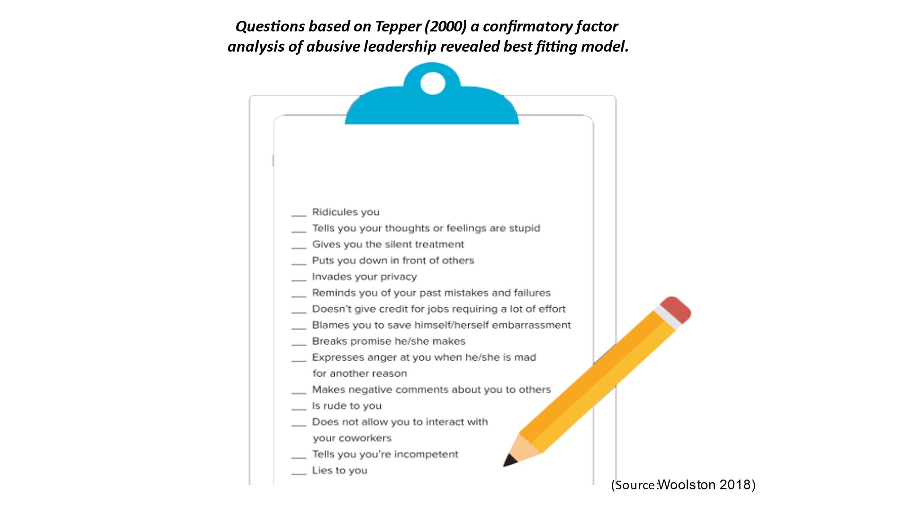
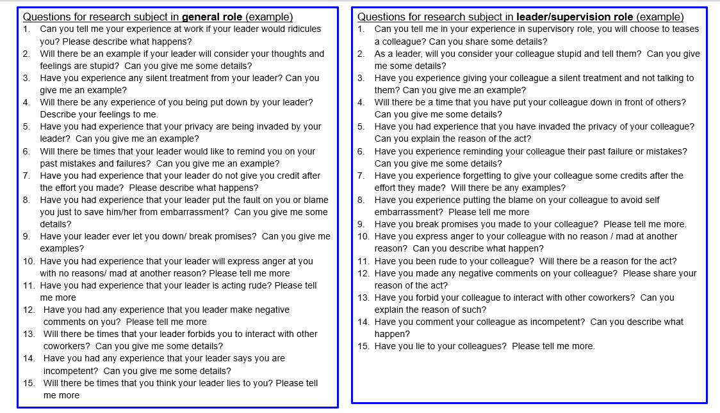

Figure 2 – Research Consent Form (Sample)

Abusive Leadership Study in Hong Kong Hospitality Industry
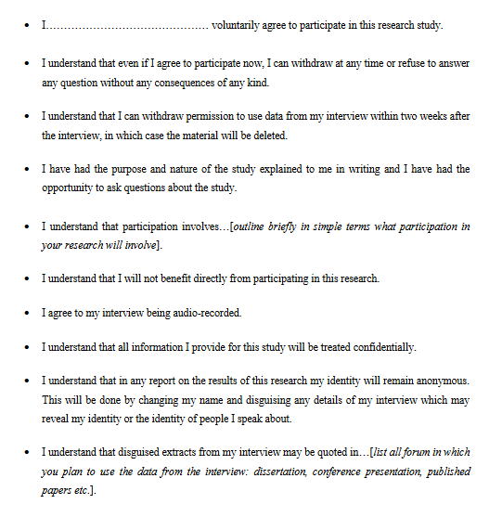
(Source: https://www.tcd.ie/swsp/assets/pdf/Participant%20consent%20form%20template.pdf)

Abusive Leadership Study in Hong Kong Hospitality Industry
Consent Form (Sample)
(page 2)
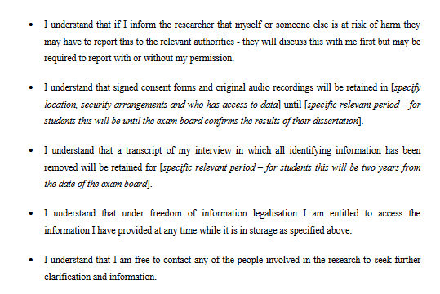
Researcher Name:
Researcher’s School:
Researcher’s Contact: (Mobile) /(email)

Signature of research participant

Sign Date

Signature of researcher
I believe the participant is giving informed consent to participate in this study

Sign Date
(Source: https://www.tcd.ie/swsp/assets/pdf/Participant%20consent%20form%20template.pdf)

Research Time Line
A 2-year research starting from 1st January 2022 to 31st December 2023
Research phase | Task | Deadline
Pilot Stage | Design Interview | Jan, 2022
 | Pilot Interview | Feb, 2022
 | Choose and test interview equipment | Feb, 2022
Recruitment Stage | Contact VTC | Feb-Mar, 2022
 | Recruit Participants | Mar – Apr, 2022
Data Collection Stage | Arrange interview appointment | Apr – Sep, 2022
 | Prepare transcript & validation | May – Oct, 2022
 | Memoing | Always
Analysis Stage | Coding | May – Dec, 2022
 | Building Theories | Jan - Feb, 2023
Production Stage | Report writing | Feb - Sep, 2023
 | Report editing | Oct - Nov, 2023
Final Stage | Report presentation | Dec, 2023

The power index of Hong Kong is 68 and higher than US and UK which is 40 and 35 respectively (http://clearlycultural.com/).

