

A Study of Recommender System based on Mahout

by
Hang Zuo

Supervisor: Michael Dacey
Second Marker:

Project submitted as part of the requirements for the award of MSc Software Engineering (Web Development)

November 2020

Declaration and Form of Consent

DECLARATION

I, ..................................Hang Zuo.………………………………… declare that I am the sole author of this Project; that all references cited have been consulted; that I have conducted all work of which this is a record, and that the finished work lies within the prescribed word limits.

This work has not previously been accepted as part of any other degree submission.



Signed : ............................................

Date : .......2020-11-10......................

FORM OF CONSENT

I ________Hang Zuo____________________ hereby consent that my Project, submitted in candidature for the M.Sc. Applied Computing, if successful, may be made available for inter-library loan or photocopying (subject to the law of copyright), and that the title and abstract may be made available to outside organisations.

Signed __________________________

Date _____2020-11-10______________

Where necessary replace M.Sc. Applied Computing with your named award.

Contents
Declaration and Form of Consent 2
ABSTRACT 5
CHAPTER 1: INTRODUCTION 7
CHAPTER 2: LITERATURE REVIEW 9
2.1 Collaborative filtering methods 12
2.1.1 Memory based collaborative filtering algorithm 14
2.1.2 Comparing user-based and item-based collaborative filtering methods 14
2.1.3 Complexity and side effect 15
2.2 Model based collaborative filtering algorithm 15
2.3 Content based methods 16
2.4 Summary for previously mentioned methods 17
2.5 Recommendation in Mahout framework 18
2.5.1 The principle of Taste 18
2.5.2 Common algorithms in Mahout 19
2.5.3 Implementation of similarities in Mahout 21
CHAPTER 3: RESEARCH METHODOLOGY 24
3.1 Why we should do the major project 24
3.2 Discussion of methodology theory 24
3.2.1 Research philosophy 24
3.2.2 Research Approach 25
3.3 Analysis of advantages and disadvantages and methods adopted 25
3.4 Realization of expectations 27
3.5 Validity of results 27
CHAPTER 4: DEVELOPMENT METHODOLODY 28
4.1 Feasibility analysis 28
4.1 Requirement analysis 29
4.2 Functional and non-functional requirements 30
4.2.1 Functional requirements 30
4.2.2 Non-functional requirements 31
CHAPTER 5: DESIGN AND IMPLEMENTATION 32
5.1 Design of the recommender system 32
5.2 System Overall Architecture 33
5.3 Database Design 33
5.3.1 Experimental data set 33
5.3.2 Logical design of database 35
5.3.3 Recommender System Database Design 35
5.4 Recommendation algorithm module 36
CHAPTER 6: RESULTS 40
6.1 Working status of recommendation system 40
6.1.1 Registration module 40
6.1.2 Film search module 40
6.1.3 User rating module 41
6.1.4 Recommendation algorithm module 42
6.2 Evaluation of recommendation system 42
6.2.1 Prediction-based evaluation 43
6.2.2 IR-based evaluation 44
CHAPTER 7: CONCLUSION 46
7.1 Summary 46
7.2 Deficiencies and Future Prospects 46
Reference 48

ABSTRACT
Now film resources are an important part of network resources. With the increasing number of film resources on the network, it is urgent to design a personalized recommendation system for movies. So the purpose of this article is to recommend movies with high fit with each user's interests.
This movie recommendation system is developed with front-end and back-end separately. The front-end of the system implements movie display module, movie rating module, recommendation algorithm implementation module, login registration module. The back-end of the system completes the recommendation algorithm and connects MySQL database for data processing. Among them, the core of the whole movie recommendation system is the collaborative filtering algorithm, which adopts the collaborative filtering algorithm. Collaborative filtering algorithm is widely used in the field of recommendation. The movie recommendation system uses two kinds of collaborative filtering algorithms to give two kinds of different recommendation results. One is the collaborative filtering algorithm based on users, the other is the collaborative filtering algorithm based on articles. Users can choose the appropriate video more reasonably according to the two kinds of recommendation results. The system uses user-based collaborative filtering algorithm and item-based collaborative filtering algorithm, and improves the calculation of user similarity and item similarity. Finally, the accuracy of the system is evaluated by calculating the average difference between the two algorithms, and the advantages and disadvantages of the two algorithms are compared. Experiments show that the recommended algorithm based on collaborative filtering has good performance and high accuracy. The whole system involves programming languages including Java, Html5, JavaScript, CSS3, and MySQL database programming. The framework used is the heavy web framework Vue, through which the front-end of the system is built. Users need to fill in the user name, password and mailbox registration system before they can log on to the recommendation system.
This paper first describes the research status and significance of the recommendation system, then introduces the related recommendation algorithms, focusing on the collaborative filtering algorithm, and studies the technology required to implement the system, then introduces the implementation of the entire recommendation system, and finally reviews and summarizes the entire project.

Key words: Collaborative filtering algorithm; MySQL; Recommendation

CHAPTER 1: INTRODUCTION
With the rapid development of Internet technology, it has entered the era of big data. The information on the network is growing explosively, and hundreds of millions of data emerge every day. Hitherto unknown ways of accessing information are micro-blog, Facebook, Twitter, WeChat official account and so on. This is a double-edged sword. Although it will bring a lot of convenience to users, it also brings an unprecedented problem - "information overload".
"Information overload" means that it is difficult for users to find the information they are interested in from the huge data. In order to solve the problem of information overload, the first thing to appear is the search engine. However, once the user can not accurately describe the keywords they need, the search engine is powerless, and the search is a passive retrieval. Moreover, the needs of different users vary greatly with the development of science and technology, the recommendation system came into being.
However, the initial automatic recommendation system only recommended the popular, popular products or products that can make the company get the maximum profit to users, and did not analyze and recommend for each user. The effect of such recommendation is very unsatisfactory. Therefore, people hope to have a system and method to automatically recommend items to users, and the system base is Based on the user's preference and the attribute analysis of the recommended products, this is the personalized recommendation system.
Now many websites begin to use recommendation algorithm to provide users with recommendation information. The longer a user uses the recommendation system, the more loyalty it can bring to the site and more benefits it can bring. In recent years, the recommendation system has developed rapidly, thanks to the maturity of Web 2.0 technology. Users have been active in various web pages, so the application of recommendation system in web pages is imminent.
Mahout is an open source machine learning software library from Apache. Mahout has three clear core themes: recommendation engine (collaborative filtering), clustering, and classification.
The movie recommendation function starts from the demand for content retrieval brought by the explosive development of Internet content. With the continuous development of search engines, people's needs are also increasing. Web information search has become the daily content of people. How to make search engines meet people's needs at all times. Initial retrieval was achieved by indexing stations, but there were network robots. However, these universal search engines also have some limitations. Due to different fields and backgrounds, users have different purposes and requirements for retrieval. Mahout framework can solve this problem.
The aim of the major project is to build a web-based movie recommendation system through collaborative filtering algorithm. Users first enter the system by filling in the user name, password, mailbox address registration, and users can rate the movies in the system. After the user has scored, the browser will submit the form containing the rating data to the database. The back-end algorithm of recommendation system gives two kinds of recommendation through user based collaborative filtering algorithm and Project-based Collaborative filtering algorithm. One is based on the similarity between users, the other is based on the similarity between movies.
The main objectives of the major project include:
(1) To investigate recommendation systems and methods for evaluating their characteristics.
(2) To evaluate a recommendation systems performance by building a suitable web application to collect appropriate data
(3) To analyse the performance of the recommendations systems design and accuracy.

CHAPTER 2: LITERATURE REVIEW
The concept of "recommendation system" was first proposed by Resnick in 1997 and has been widely used. In 2007, ACM recommendation system conference was held, which was the first top-level conference with the theme of "recommendation system". It aims to share research results and methods and promote the development of this field. Nowadays, the research of artificial intelligence and data mining promotes the development of recommendation system.
Nowadays, the recommendation system is indispensable for every aspect of people's life. Almost all areas use personalized recommendations, such as e-commerce, book sites, social networking sites, and so on.
Below are the recommended applications in all areas of the system.
- E-Commerce Recommendation
Now I use Amazon as an example to illustrate the application of the recommendation system. When users log in to Amazon e-commerce platform successfully, they will see the "recommend for you" section, which is a recommendation list generated by the background recommendation system of Amazon platform according to the user's historical behavior, as shown in Figure 2-1.

Fig. 2-1 Recommendations for Amazon
Taobao in China is also a typical representative of the application of recommendation systems. For example, the "must-buy list" on the first page of Taobao is actually a product recommendation automatically generated based on user's browsing records, shopping records and other user behavior. When the user has finished purchasing the goods, you can find the "You may like" section below the page, as shown in Figure 2-2, which can achieve the user-specific recommendation and greatly promote the daily transaction volume of Taobao.

Fig. 2-2 Recommendation for Taobao
- Social network recommendation
Zuckerberg's Facebook is a representative of the social network recommendation field, which also uses social network data for related push. For example, the friend recommendation interface is actually to recommend new friends to users based on their existing friends and user behavior records, because if the number of friends of users in social networking sites is very small, they can't experience the advantages of socialization. Therefore, friend recommendation module has become the standard configuration of social network.
- Video Recommendation
Netflix is a representative of the field of movie and video recommendation. It hosts Netflix competitions that have a wide impact on the industry and greatly promotes the research and application of recommendation systems. Video websites like iQIYI, Youku and Mango TV in China all have corresponding movie recommendation modules to recommend videos of interest to users.
- Music Recommendation
Spotify is a very popular music player with recommendations for users in the Home section, as shown in Figures 2-3, which is based on songs that users have heard in their history.

Fig. 2-3 Spotify's recommendations
In China, the more popular music player is Netease cloud music. Open the interface and you can see the "private FM" section, which is all recommended according to the songs the user has heard in history; the "personalized recommendation" section is shown in Figure 2-4, which shows a number of song lists, which are generated according to the songs the user has heard. It also includes the "per Click in to view, as shown in Figure 2–5.

Fig. 2-4 NetEase Cloud "Personalized Recommendation" Plate

Fig. 2-5 NetEase Cloud "Daily Song Recommendation" Plate
Because of the wide use of recommendation systems, scientists have studied personalized recommendation systems. They think that some external factors, such as weather, time, etc., will affect users' preferences. Now basically all the recommendation systems are composed of front-end web pages, recommendation algorithms and databases. Its core is recommendation algorithm. Common recommendation algorithms include collaborative filtering algorithm, content-based recommendation algorithm, model-based recommendation algorithm and hybrid recommendation algorithm.
The purpose of recommendation system is to recommend related items to users. In order to achieve this aim, there are two kinds of methods: collaborative filtering method and content-based method. Before delving into the details of a particular algorithm, let's briefly discuss these two main examples.

2.1 Collaborative filtering methods
First of all, I would like to introduce what is collaborative filtering algorithm. The recommendation system based on collaborative filtering calculation means that the system only needs the interactive data between users and projects, and generates new recommendations based on the interactive data. These interactions are generally represented by "user project interaction matrix". The user project interaction matrix is
shown in Figure 2-6.
Fig 2-6 User-item interactions matrix
Then, the core idea of using a collaborative filtering-based recommendation algorithm is that through past records of user-project interactions, you can find users who are similar to that user or projects that are similar to changed projects, and the recommended results are based on these similarities. It can be understood that similar users may like similar items, or similar items may be liked by similar users. This is the core idea of collaborative filtering algorithm. The table below shows how user interact with an item. Table 2-1 lists the interactions between some common user items。
Table 2-1 Common User Item Interaction Matrix
Users | User-item interactions matrix | Items
readers | Time spent by a reader on an article | articles
buyers | Product buyer clicked but not buy it | products
player | Music type player often listened to often | music

Generally speaking, collaborative filtering algorithms can be divided into two categories. The first is memory based collaborative filtering algorithm, which assumes that there is no model, and directly analyzes and saves the interaction value between users and projects. This method can also be divided into two types: one is based on users, the other is based on articles. The second is model-based collaborative filtering algorithm, which assumes that there is a model, which can describe the interaction between users and projects, and try to make new predictions based on the model.
Fig 2-7 Overview of collaborative filtering methods

2.1.1 Memory based collaborative filtering algorithm
One of the greatest features of Memory-based collaborative filtering algorithms is that this method only requires user item interaction matrix information, and this method does not require models to get new recommendation information.
So the memory-based collaborative filtering method uses the interaction values between user items directly, without assuming the model, but is basically based on the search for the nearest neighbor. Since there are no assumptions of potential models, these methods are theoretically low-biased but high-variance. At present, the classical collaborative filtering methods are commonly used: user-based collaborative filtering algorithm and item-based collaborative filtering algorithm.
Therefore, the memory based collaborative filtering method is the interaction record between the direct user and the project, and does not need to assume any model. The final implementation is the search for neighbors. However, since no model is assumed, this method is theoretically low deviation but high variance. At present, the commonly used collaborative filtering methods are: user based collaborative filtering algorithm and Project-based Collaborative filtering algorithm.

2.1.2 Comparing user-based and item-based collaborative filtering methods
The principle of user based approach is to search for adjacent users according to the interaction records of user projects. Generally speaking, each user only interacts with several projects, so this method will be very sensitive to any records, which will lead to the problem of high variance. On the other hand, because our recommendation results are based on the preferences of similar users, we will get more personalized results, which will also show a low bias.
On the contrary, the principle of the project-based method is basically the same as that of the user based method, which searches for similar items according to the interaction records between users and projects. Usually, different users may interact with the same item, so neighborhood search will be less sensitive to a single interaction, so the variance will be low. In this way, various user interaction records will be considered in the recommendation, which makes the method not personalized. As a result, this approach is less personalized but more robust than the user approach.

2.1.3 Complexity and side effect
One of the biggest drawbacks of memory-based collaborative filtering is that this approach is not scalable. If this approach is applied to large systems, generating new recommendations can be time consuming. In fact, for systems with millions of users and millions of projects, the nearest neighbor search step can also be difficult to handle without careful design. In order to simplify the computational process of a large recommendation system, we can use either the sparsity of the interaction matrix or the approximate nearest neighbor method when designing the algorithm.
In most recommendation algorithms, great care must be taken to avoid the 'rich-richer' effect of popular items and to avoid users falling into so-called 'information-limited areas'. In other words, we do not want our system to be inclined to recommend more and more popular projects, nor do we want our users to receive only suggestions for projects that are very close to what they already like, without the opportunity to know new projects that they may also like (because these projects are not "close enough" to make recommendations).As we have described, this is particularly true for memory-based collaborative algorithms if these problems may arise in most recommended algorithms. Certainly, this phenomenon can be highlighted and observed more frequently due to the lack of a 'normalized' model.

2.2 Model based collaborative filtering algorithm
The model-based approach first assumes a potential "generation" model, explains the user project interaction through the model, and makes new predictions based on this model.
The difference between model-based collaborative filtering algorithm and other collaborative filtering algorithms is that it assumes an interaction model. The model can complete the training according to some characteristics of users and projects themselves. It's hard to explain this, but these features of users and objects have some mathematical meaning. We can assume that there is an interaction model between users and projects. The model-based collaborative filtering algorithm has higher theoretical deviation than other types of collaborative filtering algorithms, but generally speaking, its variance is very small.
Next, I will introduce what is content-based algorithm.

2.3 Content based methods
The content-based algorithm is different from the collaborative filtering algorithm which only depends on the interaction between users and projects. Content based collaborative filtering algorithm needs to use some additional information of users or projects, which can be age, gender and so on. For example, in a movie recommendation system, if age is used as additional information, movies that they may be interested in can be recommended for different age groups. If gender is used as additional information, we can recommend movies (such as love movies) that women may be interested in.
Fig 2-8 Overview of Content-based methods

As shown in the above figure, the core idea of content-based algorithm is to establish a model, which is based on the characteristics of users and projects, which greatly enriches the performance of the model. Here we also use the movie recommendation system as an example. It is undeniable that young women may have a higher opinion of some films than young men. If we can get such a model successfully, it is not difficult to make accurate prediction for a user. Based on this idea, we only need to get a user's personal information, according to the information in the personal data, we can determine what movies to recommend to the user to a certain extent. Compared with the collaborative filtering algorithm, the content-based algorithm is not affected by the cold start. Therefore, this method is used to recommend movies to many new users.

2.4 Summary for previously mentioned methods
In the memory based collaborative approach, there is no hypothesis of a model. These algorithms can get recommendation results directly according to the interaction between users and projects. For example, search for neighbors through the results of user interaction with the project and provide suggestions for those neighbors. Because there is no hypothesis of potential model, the deviation of these methods is small, but the variance is large.
The special feature of the model-based collaborative filtering algorithm is that it assumes a model. Moreover, the model can reconstruct the interaction value between users and projects through training, and then obtain new suggestions according to the model. Because a model is assumed, the variance of the method is small in theory, but the scope of application is too small.
Content-based filtering algorithms recommend items based on the similarity of some underlying information and certain features of the user. This algorithm can be implemented to recommend popular items for new users, and this recommendation system will not be affected by cold startup and data sparseness problems. Collaborative filtering algorithms recommend items of interest based on the user's similarity. However, there are two problems to be solved, one is the sparsity of the system: in the initial stage of the system, due to insufficient evaluation and feedback on system resources, the other is the extensibility: the increase of users and resources may make the system performance worse and worse. The following picture is a summary of some commonly used recommendation algorithms.

Fig 2-9 summary of different types of recommender systems algorithms

2.5 Recommendation in Mahout framework
Mahout is an open source project for Apache. It integrates some common machine learning algorithms in the framework, and improves the development efficiency of developers through the open interface of general algorithm. The main algorithms in this framework are divided into three categories: recommended algorithm module, clustering algorithm module and classification algorithm module.
There are a lot of machine learning algorithms in Mahout framework, such as some common clustering algorithms and recommended algorithms supporting Map Reduce calculation, so we can flexibly choose single machine or Map Reduce for data calculation. The algorithm recommended in this paper is implemented through the Taste interface under the Mahout framework.

2.5.1 The principle of Taste
Taste provides a number of recommended implementation classes, which are open source extensible algorithms developed in the Java language. The recommendation algorithm implemented by Taste includes collaborative filtering algorithm, Slope-One recommendation algorithm and recommendation algorithm based on singular value decomposition, which enables developers to easily implement or rewrite their own recommendation algorithm. The taste is shown here. Taste mainly includes the following interfaces:
(1) Data model: An interface that takes the user's raw data and converts it to the [userId, itemId, pref] data format when transferring data to the interface. It can support extracting user preference information from information in a variety of file formats. User information can be read from a traditional CSV or database.
(2) User Similarity and Item Similarity: User Similarity is used to calculate the similarity between two users (items), which is the core of collaborative filtering recommendation calculation.
(3) User Neighborhood: User's (item's) neighbors are defined by the neighbor algorithm through the similarity calculation above.
(4) Recommender: is the final implementation interface in the recommended algorithm. Pass the results from the above steps as parameters to the Recommender to arrive at the user's recommendation list.
The following picture illustrates the principle of taste from the application layer, recommendation system layer and data storage layer
Fig. 2-10 Taste Working Component Diagram

2.5.2 Common algorithms in Mahout
User-based collaborative filtering algorithm, item-based collaborative filtering algorithm and SlopeOne algorithm are provided in the Mahout framework. A comparison table of the algorithm characteristics obtained by analyzing the above algorithms and the applicable scenarios is shown in the table.
Collaborative filtering recommendation algorithm in personalized recommendation system is based on Mahout framework. It provides a complete set of recommended algorithm tools, standardizes the data structure, and standardizes the program development process. Similarity calculation and neighbor calculation are required in the implementation of Mahout's recommendation algorithm. Different combinations of similarity calculations and neighborhood calculations result in different recommended results. The selection of similarity calculation has a greater impact on the recommended results. This requires us to select an appropriate similarity calculation method based on the data type. Currently, the common recommendation algorithms included in the Mahout framework are user-based collaborative filtering algorithm, item-based collaborative filtering algorithm and slopeOne recommendation algorithm.
The recommendation algorithm based on collaborative filtering is one of the most mature algorithms in the recommendation system. The core idea of recommendation based on collaborative filtering is to extract the features of users by using user behavior data information, and to find out the correlation between new users and items to recommend for current users by calculating the correlation between users and items.
Table 2-2 Summary of recommended algorithms in Mahout
number | Recommendation algorithm | key parameter | Algorithmic characteristics
1 | User-based Collaborative Filtering | User Similarity Measure, Neighborhood Definition and Size | Traditional implementations are relatively fast with fewer users
2 | Item-based Collaborative Filtering | Item Similarity Measurement | Faster when the number of items is relatively small and more effective when there is an external definition of similarity
3 | Recommendation based on slopeOne | Differential Value Storage | Large amount of calculation is required in advance and relatively few items are suitable
Comparing and analyzing the characteristics of the recommended algorithms in the table above shows that:
(1) User-based collaborative filtering is recommended for scenarios where there are fewer users. User similarity matrix calculation requires high performance support when there are more users. Background offline computing is required to produce new recommended changes when new user behavior occurs. For cold start problems, new users have behavioral relationships with fewer items, and the algorithm cannot personalize them right away.
(2) Item-based collaborative filtering is recommended for scenarios where the number of items is significantly smaller than the number of users. If there are more items, high-performance hardware support is required to calculate their similarity. The algorithm is good at discovering long tails and can be an effective change in the recommended results when the user has new and operational behavior. When facing the cold start problem, as long as the new user acts on an item, he or she can recommend the item related to the item. And users can make reasonable explanations of recommendation results to make them more trusted.
(3) The recommended algorithm based on SlopeOne is relatively simple. It is recommended based on the average difference in preference between items. It is a fast computational recommendation algorithm, but its accuracy is lower in the actual application scenario.
Based on the above analysis, the application of this recommendation system to movie recommendation scenarios is considered. Since the number of users is far less than the number of movies, the collaborative filtering algorithm based on users can be used in this case. However, the Project-based Collaborative filtering algorithm is suitable for the case that the number of users is more than the number of items. In addition, the applications, real-time, cold start and interpretability are different. After comprehensive analysis, the user-based collaborative filtering algorithm is selected as the core recommendation algorithm of the system.

2.5.3 Implementation of similarities in Mahout
User-based collaborative filtering recommendation is an important part of user Similar in addition to its basic ideas. User-based collaborative filtering relies heavily on this component. We can imagine that the results of this recommendation are meaningless if the similarity between users is not reliable and valid. Similarity calculation and neighbor calculation are required in the implementation of Mahout's recommendation algorithm. Different similarity algorithms and combinations of neighborhood methods produce different recommendation performance, and the selection of similarity calculation has a greater impact on the reliability of the recommendation results. Following is a description of common similarities and how they are implemented in Mahout.
- Pearson Similarity
Pearson Similarity calculates a value between [-1,1], which measures the linear correlation between two corresponding columns. This similarity shows the possibility that the corresponding values in the two vectors increase or decrease simultaneously. It measures the trend of proportional change in numbers, which is roughly a linear relationship between the two. The larger the value, the stronger the positive correlation, the weaker the correlation when the value tends to zero, while the negative correlation is not meaningful for recommendation. In Mahout, you can calculate it by passing in the DataModel parameter through the PearsonCorrelationSimilarity method. The calculation is as follows
$p\left(x,y\right)=\frac{\sum{x_{i}y_{i}-\overline{n_{xy}}}}{(n-1)s_{x}s_{y}}=\frac{n\sum{x_{i}y_{i}-\sum{x_{i}\sum{y_{i}}}}}{\sqrt{n\sum{x_{i}^{2}-{(\sum{x_{i}})}^{2}}}-\sqrt{n\sum{y_{i}^{2}-{(\sum{y_{i}})}^{2}}}}$ (2.1)
Usually this similarity is more balanced, meaning it does not perform well in some cases, simply because its principles are easier to understand and used more in the initial similarity studies. There are some preconditions for using Pearson linear similarity, such as that the data must be normally distributed and evenly spaced within the range of values.

- Euclidean Similarity
Euclidean similarity is based on the distance between users. We convert the user into points in N-dimensional space (N equals the number of items), and preference values represent the user's coordinates in space. User similarity is calculated by Euclidean formula. The result of the calculation indicates that the distance between users is inversely proportional to the correlation between users. The result of calculating the distance value by 1 /(1 + d) is our common similarity. Data Model parameters can be calculated in Mahoout by entering and exiting the EuclideanDistanceSimilarity method. The similarity calculation is shown in the formula.
$d\left(x,y\right)=\sqrt{\sum{{(x_{i}-y_{i})}^{2}}}$ (2.2)
Similarity S (S = 1 /(1 + d)) is calculated by finding the Euclidean distance D. The smaller the value of S in the range of D from 0 to 1, the greater the correlation that S produces. The advantage of Euclidean similarity is that it can calculate the similarity between any user, but the recommended results are not necessarily reliable, so it is possible to get results that do not correspond to intuitive judgment. Even so, the results from this similarity have great reference value.

- Cosine similarity
We mainly use the above two methods to calculate similarity, which is generally not very useful. Cosine similarity also converts data such as user preferences into corresponding points in space and calculates the similarity using a cosine formula. Connect user points to origins by converting them to points in N-dimensional space. The angle between the two lines is calculated. The similarity between the two is defined by the angle and the direction of the line. Calculations can be made in Mahout by entering and exiting the DataModel parameter using the E CosineDistanceMeasure method. Cosine similarity calculations such as formulas.
$T\left(x,y\right)=\frac{xy}{{||x||}^{2}×{||y||}^{2}}=\frac{\sum{x_{i}y_{i}}}{\sqrt{\sum{x_{i}^{2}}}\sqrt{\sum{y_{i}^{2}}}}$ (2.3)
The cosine similarity value is defined based on the connection between two points in N-dimensional space and the origin. Similarity calculation values are between [-1,1]. The larger the calculated value, the larger the angle, the farther the two points are, the smaller the similarity and vice versa.

CHAPTER 3: RESEARCH METHODOLOGY

3.1 Why we should do the major project
With the rapid development of information technology, the world is becoming digitalization and globalization. While enjoying more and more convenient services, people also transmit and receive a variety of large amounts of data and information. The world has changed from a place of information scarcity to a place of information explosion, where people's access to and selection of effective information is hindered. It leads to a certain dilemma to both information producers and information consumers. In the flood tide of a large number of mixed information, the information of specific information producers is easy to be submerged, and the information receiver is difficult to identify the information that is useful to him. Therefore, how to make an information producer make his information stand out among the numerous information and get the maximum benefit, and let the information receiver get the required information efficiently, is one of the urgent problems to be solved in the digital society. Therefore, this paper stands on the position of film producers, film websites, advertising providers and film lovers, launching a recommendation system for film websites serving multiple targets. The purpose of this website is to provide the most interesting and efficient recommendation service to different users by learning their preferences and demands for watching movies, in order to meet their needs and save their time, and to provide the information producer with the maximum income, such as website click rate, website praise rate and membership registration rate.

3.2 Discussion of methodology theory

3.2.1 Research philosophy
When it comes to research philosophy, it can be divided into three categories: positivism, interpretivism and realism.
The core idea of positivism is that we should use objective methods to measure the attributes of the world instead of feeling, intuition and so on. However, interpretivism is usually associated with social constructivism, which is a criticism of positivism and holds that rich insights into this complex world are necessary. Finally, realism refers to the recognition of the significance of social construction or subjective reality.
In major project, the main philosophical method is positivism. The implementation of the recommendation system depends on our work, we need to spend a lot of time to study the composition of the system, design it, and finally complete the implementation, and because the recommendation results of the recommendation system can be measured by an indicator, finally we should judge whether the system works normally by the measurement index.

3.2.2 Research Approach
In the major project, the research approach is a quantitative and qualitative method. Quantitative research involves the collection of information that can be measured and calculated numerically. However, it includes not only digital data, but also other digital data, which are usually derived from the original research. Qualitative research, on the other hand, usually involves the collection of non-numerical data that can be interpreted, such as customer opinion, in which there is no intention to establish statistical validity.
In this report, we use the methods of quantitative research and qualitative research to collect the rating information of several users on different movies in history, and calculate the user's preference according to the rating information, and calculate the user who is similar to the user through the similarity calculation method, and infer that the user also has similar preferences, so as to get the recommendation result.

3.3 Analysis of advantages and disadvantages and methods adopted
Recommendation system is to use recommendation algorithm to predict and judge the current content or commodity demand of users in specific scenarios according to their personal preferences and past selection records. Therefore, the main problem to be solved in this paper is to provide users with personalized recommendation services. At present, a lot of similar work has been done or is under way, and it is now possible to implement the best recommendations based on specific user populations in different scenarios using different algorithms. Its apps cover all aspects of life, including recommending wake up time for you after setting the alarm for many times, recommending your home and work address after using the map software to navigate for many times, recommending products you are interested in when shopping, and recommending content you may be interested in after watching videos. E-commerce websites, such as Amazon, Tesco and Morrison’s, recommend products for users by analysing their browsing record, collection record, purchase record, evaluation record, shopping cart and other data. Video and audio websites, such as Apple-music and YouTube, recommend film and television works for users by analysing their browsing record, collection record, viewing record, rating record and other data. It not only helps consumers or viewers to choose their target goods or films in a short time, but also promotes the flow of goods or films from sellers or film manufacturers, which is a win-win situation.
The booming development of the above situation depends on the continuous proposal of many scholars of new recommendation algorithm, continuous optimization of recommendation algorithm optimization, recommendation system, and study of applicable scenarios. In 1992, Goldberg proposed the concept of collaborative filtering and first applied it to user E-mail systems to filter out spam. In 1997, GroupLens Research Laboratory recommended probably suitable films for moviegoers by predicting which actors, directors and types of films they might be interested in based on users' rating data. The recommendation algorithm mainly includes: (1) recommendations based on association rules: It mainly looks for correlations among records in the past to specify future strategies, and its representative technology is "supportability - confidence" analysis. The method can be changed flexibly in many fields, but its individuation degree is low. (2) Content-based recommendation, the key is to extract the features of the items in the system and analyse their similarity. The results, though intuitive, depend on existing projects; (3) Collaborative filtering recommendation: The projects with common characteristics are grouped into a group for cross-information recommendation. As time goes by, the recommendation performance of this method improves continuously, and at the same time, it can provide users with new points of interest personalized, which can well solve the problems existing in other methods mentioned above. However, this method requires a lot of user data.

3.4 Realization of expectations
Therefore, collaborative filtering method is adopted as the recommendation algorithm in this paper. For meeting the algorithm's data requirements, we choose the Movielens data set, which contains multiple users' rating data for multiple movies, as well as movie metadata information and user attribute information. At the same time, we not only use user ratings to recommend interest content, but also use multi-indicator comprehensive analysis to recommend interest content for specific users, which further expands the existing data volume. This paper not only avoids the disadvantages of other recommendation algorithms such as dependence on existing data and low personality, but also meets the requirements of collaborative filtering algorithm for large data volume. The ultimate goal of this paper is to use the Collaborative filtering recommendation algorithm and the Movielens data set to make movie recommendations for movie-goers, and use the movie website as the operation and presentation interface. Specific steps include: (1) to determine the recommendation algorithm; (2) Use Mahout framework to build the recommendation algorithm module; (3) Adopt the mode of separating the front end from the back end, build web pages in the front end, and call the data structure provided by IMDB website in the back end to achieve logical interaction function; (4) Completion and evaluation of the recommendation system.

3.5 Validity of results
Evaluation method of this paper is mainly divided into two kinds: one is based on the existing user preference prediction evaluation, mainly by the user favourite movie on another part of the forecast accuracy of quantitative evaluation, the other is based on the evaluation of satisfaction after users use the site, mainly through the user use the qualitative evaluation of the satisfaction after on site, such as the recommended movie seen after really like it or not. In conclusion, for specific users, the smaller the mean square error (MSE) is, the higher the satisfaction degree is, and the closer their real preference is to the predicted preference, the more successful the recommendation system will be. For all users, the greater the proportion of users who are satisfied with the recommendation system, the more successful the recommendation system will be.

CHAPTER 4: DEVELOPMENT METHODOLODY
It is very important and necessary to analyze the requirements of the system before development. In this process, we need to understand the functional and non-functional requirements of the system, and consider as much as possible the necessary functions that the system needs to achieve and the functions that users need. Simulate user actions whenever possible to enhance the real user experience while browsing the website. This chapter will synthesize the previous chapters to analyze and design the personalized movie recommendation system.

Fig 4-1 flowchart for movie recommendation system development

4.1 Feasibility analysis
Feasibility analysis is usually required before system development. The main analysis includes the function content of the system and the software and hardware analysis. The expected effect after system implementation includes economic benefits, user experience and so on. To analyze and judge the necessity of system development, the following is the feasibility analysis of the system.
The movie recommendation system is developed in front-end and back-end separately. Users can log in directly through the browser, which reduces hardware requirements for local hosts and improves the user experience. To optimize and adjust the movie recommendation system, service configuration only needs to be done on the server side. All user data is saved on the server side, which greatly improves the security of the system.
- Front-end development
The front-end page of this system uses Vue framework with Element-ui. Front-end development has been very mature for many years, and there are many tutorials and system sources available on the network for reference. Therefore, the system is feasible in the technology of front-end development.
- Back-end development
The backend was developed using spring boot, written primarily in Java, and relies on Hadoop ecology. The Mahout framework provides algorithm support for the recommended core of this system. These technologies are open source and are officially well documented. With the rapid development of large data technology in recent years, related technologies have become mature. The database uses MySQL, and uses Spring Data JPA to connect to the database to make changes to the database. Backend development is possible.
It is feasible to judge the development of personalized movie recommendation system through the above analysis.

4.2 Requirement analysis
Here I use Agile development method to conduct requirement analysis.
Although user stories are mainly about building shared understanding not developing requirements, I can adopt this method to solve problems that lead to agreement on what to build. Based on this analysis, I can also get the development requirements of this system.
User stories come from the Agile Development scrum and escribes the desired functionality from the user's perspective. It is a stand-alone, complete, directly deliverable online, minimum-granularity product of certain business value. User stories help communicate well with customers because they are contextual descriptive text that customers can easily prioritize based on these situations. User stories give a scenario that describes how users need to operate and use the software. The user story approach makes it easier to communicate with customers. It's easy to understand the language, and it's easy to determine priorities. In order to analyze the requirements, this paper uses the method of user stories to simulate the communication between developers and users, and describes one scenario after another, which can help developers and users reach an agreed goal.
Here are some user stories I've analyzed and written which will help us analyze the system better.
- As a user, I want to see hot movies when I open the movie recommender web application so that I can know which movies are popular recently.
- As a user, I want to login to the recommendation web application so that I can get the recommendation result.
- As a user, I want to register the account of the recommender system so that I can login with the account.
- As a user, I want to score movies so that I can get more precise recommendations.
- As a user, I want to modify my personal information so that I can update my personal information in case of any changes.
- As a user, I want to change my password regularly so that I can keep my account safe.
- As a user, I want to see the picture of the movie in the web application so that I can get a rough idea of what kind of movie this is.
- As a user, I want to see a movie poster on the home page so that I can log on to the website and be the first to learn about popular movies
- As a user, I want to search a specific genre, name, director, rating and so on of the movies so that I can look up movies I'm interested in.
- As a user, I want to get the results of the movie recommendations so that I can pick a movie that I'm interested in.
Through the analysis of User story, functional requirements are obtained and non-functional requirements are analysed.

4.3 Functional and non-functional requirements

4.3.1 Functional requirements
Functional requirements are the necessary functions that must be implemented when developing a system to meet the business needs of users. According to this system function module can be divided into: Web front-end module, back-end module, data storage module three types of function analysis.
- Front-end module
The front-end functions include user registration and login, user information modification, popular movie recommendation, collaborative filtering algorithm recommendation result view, user rating for the movie, viewing the detailed information of the movie and so on.
- Back-end module
The back-end functions include the implementation of movie recommendation, the addition, deletion, modification and query of database, and the realization of some logical functions. One of the most important is the implementation of the recommendation function. The recommendation engine is the core of the system. The quality of the recommendation system will directly affect the user's experience. In this part, we will adopt the collaborative filtering algorithm based on users and the collaborative filtering algorithm based on projects. The recommended results of the calculation are saved in the database.
- Data storage module
The movie recommendation system uses MySQL database. Its main functions include saving the registration and scoring information of front-end users, storing the data of movielens dataset and providing this part of data for the back-end, and getting the recommended results back to the front-end.

4..2 Non-functional requirements
Under the condition that the functional requirements of the system are met, the system should have the following non-functional requirements after considering various situations of system operation:
- Reliability
The core function of the system depends on the user information data, and provides the hardware environment based on Hadoop cluster. When the system cluster fails in the installation, deployment and operation stages, the system itself should have the ability to detect anomalies, fault analysis and short-term restart.
- Security
This system strengthens the security of the system through appropriate security strategies.MD5 encryption is used to encrypt user's password to protect user data security and prevent DDoS attacks. SQL injection is an attack. Provides high concurrent access, identifies malicious access.
- Extensibility
This system should have the ability to expand horizontally. As users continue to grow, we will face the shortage of data storage and computing resources. At the beginning of the design, each module will be divided into service and storage according to its needs.
- Usability
For users, the Web front end should have simple and easy-to-understand interaction logic without complex user actions. Users can easily apply the functions of this system.

CHAPTER 5: DESIGN AND IMPLEMENTATION

5.1 Design of the recommender system

This recommendation system downloads movielens dataset from the Internet, reorganizes and filters the data, and saves the recommendation results to MySQL database based on two recommendation algorithms. The front-end uses Vue framework, Element-UI, and the back-end uses Spring Boot. Users can interact with the content on the website through the browser.
Several programming languages are needed to implement this system:
(1) Java: do background development, write recommendation algorithms, interact with MySQL database, store user's data in the database, and show the generated recommendation list to the front-end page.
(2) Html5: Develop front-end pages.
(3) Css3: Beautify front-end pages, especially the movie classification section.
(4) JavaScript: achieve star rating effect in submission form and home page. The overall architecture design of the system is shown in.

5.2 System Overall Architecture
Fig 5-1 System overall architecture

5.3 Database Design
Database is the most important tool in the process of application development. In this major project, we use the database to save all the information. According to its characteristics, all information will be divided into a table. We use the relational database MySQL, all the data will be saved in different tables, the relationship between each table is represented by foreign keys.

5.3.1 Experimental data set
The data set used in this study is a ml-latest-smal dataset from MovieLens, a movie website, by the GroupLens scientific research team. The dataset contains 671 user ratings of 9125 movies from 1995 to October 2016, totaling 10,000,04 movie ratings. Each user rated no fewer than 20 movies. The ml-latest-small data set was composed of four CSV files: ratings.csv、movies.csv、links.csv and tags.csv. This is described below.
The user rating information table is saved in the file rating.csv. The first line is four Titles: userid, movieid, rating and timestamp. The user rating range is 0.5-5. Table 5-1 shows an excerpt from rating.csv
Table 5-1 Part of the file rating.csv
userId movieId | rating | timestamp
1 59. | 4 | 964983793
1 5060 | 5 | 964984002
1 3527 | 4 | 964982271
2 115713 | 3.5 | 1445714854
3 4518 | 5 | 1306463770
4 162 | 5 | 945078571
Movies.csv is the movie property table, which contains three fields: movieid, title and gene. Table 5-2 shows an excerpts from movies.csv.
Table 5-2 Part of the file movies.csv
movieId | title | genres
1 | Toy Story (1995) | Adventure|Animation|Children|Comedy|Fantasy
2 | Jumanji (1995) | Adventure|Children|Fantasy
3 | Grumpier Old Men (1995) | Comedy|Romance
4 | Waiting to Exhale (1995) | Comedy|Drama|Romance
5 | Father of the Bride Part II (1995) | Comedy

The file links.csv contains three fields: movieid, imdbid and tmdbid. Imdbid is the number of the movie in the movie website IMDB, and tmdbid is the number of the movie in The Movie Database, which can be used to uniquely identify a movie
Table 5-3 Part of the file links.csv
movieId | imdbId | tmdbId
1 | 114709 | 862
2 | 113497 | 8844
3 | 113228 | 15602
4 | 114885 | 31357
5 | 113041 | 11862
The file tags.csv mainly includes the label of the movie, which is suitable for the recommendation system based on the label.

5.3.2 Logical design of database
This section summarizes the relationships among users, movies, user rating scale, links table and genres table.
The following diagram shows the E-R model of the database used by my recommended system.
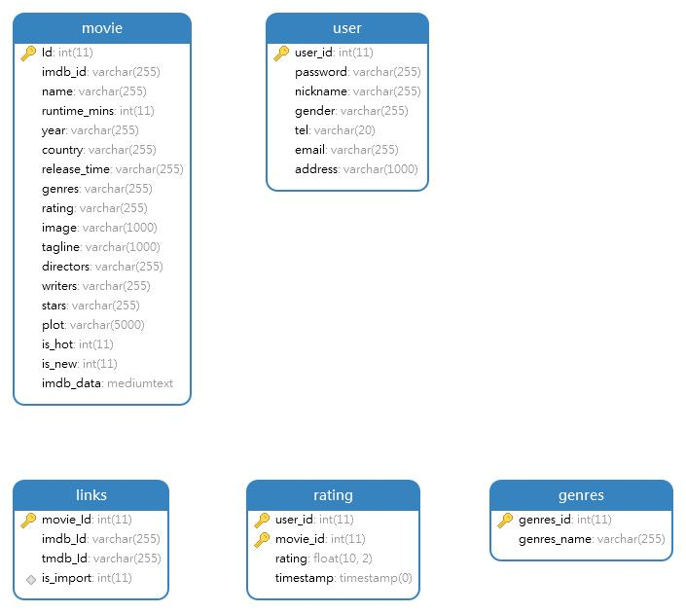
Fig 5-2 E-R diagram of database

5.3.3 Recommender System Database Design
The system uses MySQL database, which includes user table, movie movie table, rating table, links table and genres table. The following describes the structure of a part of these tables.
- Moive table
The movie table is used to save some properties of each movie in the system. The saved fields include imdbid number, name, year, picture, score, director, etc.
Table 5-4 The meaning of some fields in movie table

Field name | Field type | meaning
Imdb_id | Varchar(255) | The number of the movie on the IMDB website
Name | Varchar(255) | The name of the movie
Genres | Varchar(255) | The genre of the movie
Is_hot | Int(11) | The tag to judge whether it is hot
Image | Varchar(1000) | The url of the movie’s image
- Rating table
The table holds content from movielens ratings.csv file, the data in this table is the basis of recommendation results. The algorithm only traverses this table to calculate which users in the table are more similar to the logged-in user, and then give the recommendation results.
Table 5-5 The meaning of fields in rating table
Field name | Field type | meaning
user_id | int(11) | The primary key
movie_id | int(11) | The primary key
rating | float(10,2) | The user’s rating for this movie
timestamp | timestamp(0) | The tag to judge whether it is hot

5.4 Recommendation algorithm module
Based on user-based collaborative filtering algorithm and item-based collaborative filtering algorithm, this system is designed and implemented with Mahout framework.
- User-based collaborative filtering algorithm
User-based collaborative filtering algorithm considers that there is a similarity between users and users, and similar users like the same thing. One person likes A and the other likes A, which is the core idea of the algorithm.
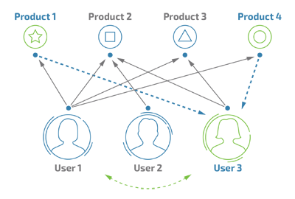
Fig 5-3 User based collaborative filtering algorithm
As shown in the figure above, user1 evaluates all four items, while user2 only evaluates product2 and user3 evaluates product2 and product3, assuming that they all evaluate product5 (the actual evaluation varies from high to low). With user3 as an example, it is not difficult to find that both user1 and user2 have some similarities with user3. Both of them have evaluated the same items, but user1 is significantly more like user3 than user2 because there are more identical evaluations between user1 and user3 (in fact, the consistency of the evaluations also affects the similarity), so we think user1 is a neighbour of user3, and then we selected the items that were rated high by user1 from those that were not rated by user3 and pushed them to user3.

Algorithmic flow:
1. Calculate user similarity based on evaluation data
2. Identify the user's neighbours based on similarity
3. Select neighbourhood items to recommend to target users
Among them, Euclidean distance algorithm and Pearson algorithm are used to calculate similarity.

- item-based collaborative filtering algorithm
Item-based collaborative filtering algorithm is similar to user-based collaborative filtering algorithm, except the theme changes from user to item, where items can be commodities, music, movies, articles, and so on. Use the item itself instead of the user's perspective when calculating the neighbourhood, that is, find similar items based on the user's preferences for the items, and then recommend similar items to the user based on his historical preferences. We also want to calculate the similarity of an item, but we don't need to calculate its neighbours.

Algorithmic flow:
1. Calculate item similarity based on evaluation data
2. Recommend items based on their similarity
Computing similarity algorithm: Euclidean distance algorithm, Pearson algorithm

This module is the core component of the whole system. When a user logs in to the system and scores a movie, the system records the user's ID number. When the user logs in to the system again, the system will get new recommendation results based on the source dataset and the user's previous rating data according to the recommendation algorithm.
Fig 5-4 Flowchart of Movie Recommendation Function

As for how to use mahout, it can be roughly divided into the following two steps:
- Mapping raw data into a DataModel Mahout-compliant.
- Tuning recommender components
Mahout implements interfaces to these key abstractions:
Table 5-6 Recommendation Components

Abstractions | meaning
DataModel | Methods for mapping raw data to Mahout-compliant form
UserSimilarity | Methods to calculate the degree of correlation between two users
ItemSimilarity | Methods to calculate the degree of correlation between two items
UserNeighbourhood | Methods to define the concept of ‘neighborhood’
Recommender | Methods to implement the recommendation step itself

Due to links.csv file, all movies in the file correspond to imdbId. I can get the link of the movie picture, imdb rating, show time, director, actor and so on from Imdb website, and label it as a new movie based on whether it has been shown since 2020. I can judge if it is a popular movie based on whether imdb rating is greater than 8. Finally, the obtained information is saved to the movie table for front-end pages to invoke.

Here I will describe the implementation process of user-based collaborative filtering algorithm in the program.
Basic similarity calculations are provided in Mahout, and they all implement the UserSimilarity interface to calculate user similarity, including the following commonly used:
(1) Pearson Correlation Similarity: Calculates similarity based on Pearson correlation coefficient, which indicates the likelihood that two series of corresponding numbers will increase or decrease together.Is the ratio of the covariance of two sequences to the product of their variances).
(2) Euclidean Distance Similarity: Computing similarity based on Euclidean distance.
Neighbour users are found based on the established similarity calculation method. This method of finding neighbour users includes two methods, fixed number of neighbours and similarity threshold neighbours, which Mahout provides:
NearestNUserNeighborhood: Get a fixed number of N's nearest neighbors for each user.
Based on the DataModel, UserNeighbourhood and UserSimilarity build GenericUserBasedRecommender to implement a user-based recommendation strategy.
The implementation of item-based collaborative filtering algorithm based on project is the same.

CHAPTER 6: RESULTS

6.1 Working status of recommendation system
The system is based on user-based collaborative filtering and item-based collaborative filtering algorithms. The front end uses Vue framework and Element-ui for design, and the back end uses Spring boot. The whole system includes registration module, film search module, user rating module, recommendation algorithm module and recommendation film display module.

6.1.1 Registration module
Only after the user registers and logs in to the system can he submit the score of the film. The registration interface includes the user name, e-mail address and password, etc. The login and registration interface is shown in the following figure.

Fig 6-1 Login page
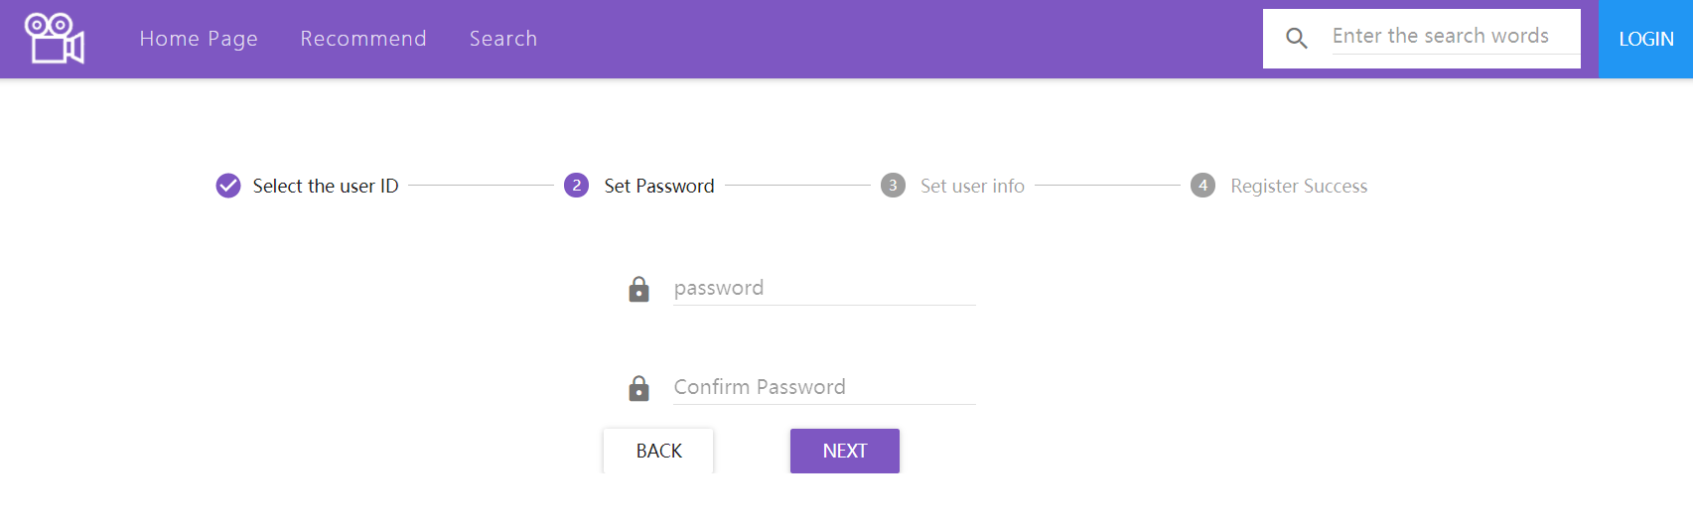
Fig 6-2 Registration page

6.1.2 Film search module
I divide movies into 21 categories according to their categories. The search function can complete the search of movies according to the film name, genre, director, etc. The search module is shown in the following figure.
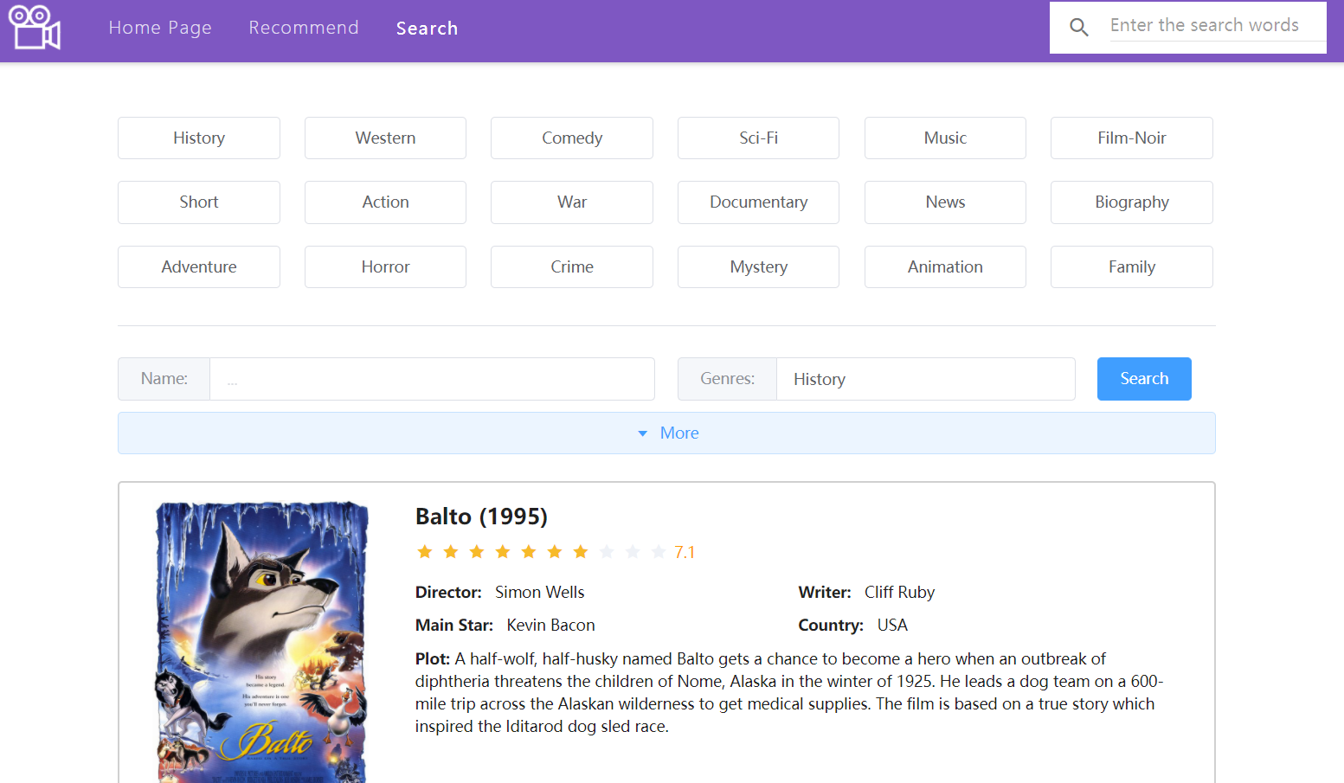
Fig 6-3 Search module

6.1.3 User rating module
When I click on a poster for a movie of interest, I jump to the details of that movie. The comprehensive score of the film can be seen on this page, and the user can also score the film, the result of which will affect the recommended result.
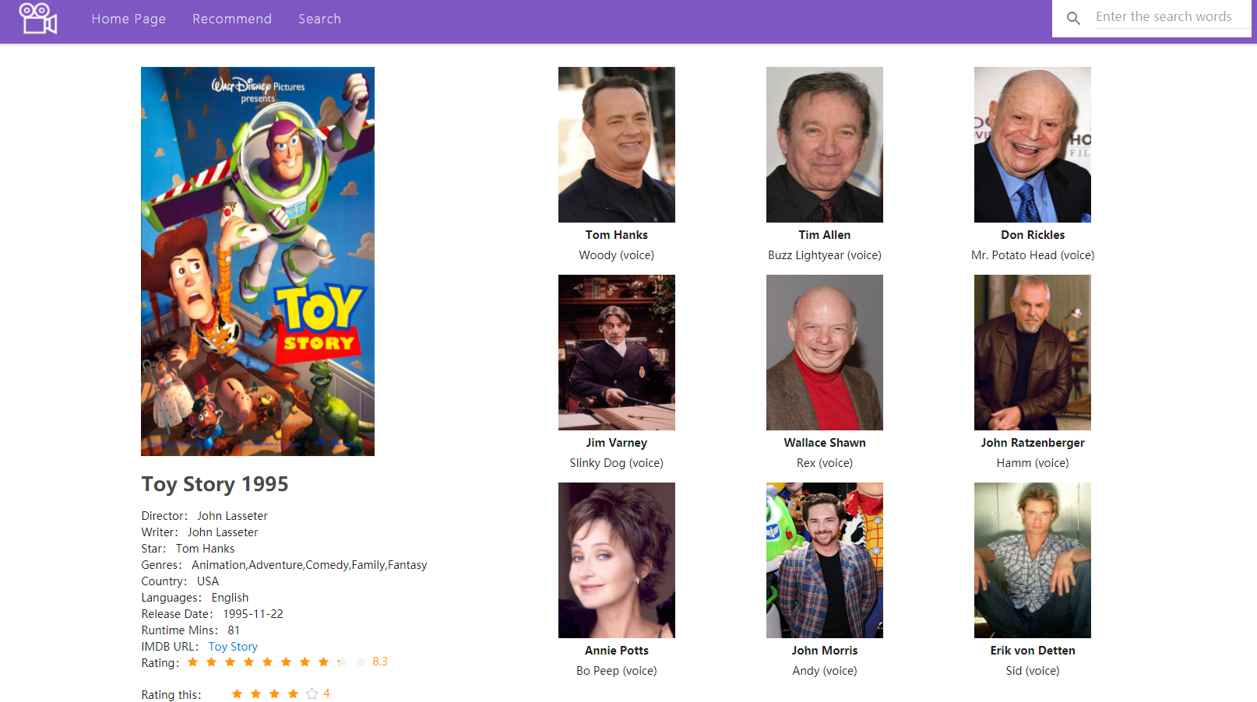
Fig 6-4 Movie details page

6.1.4 Recommendation algorithm module
I designed a recommendation page at the front end, in this page, we will get the recommendation results of the back-end recommendation system. The recommended algorithm uses User base algorithm and Item base algorithm. It can be seen that the recommended results are shown in the following figure.
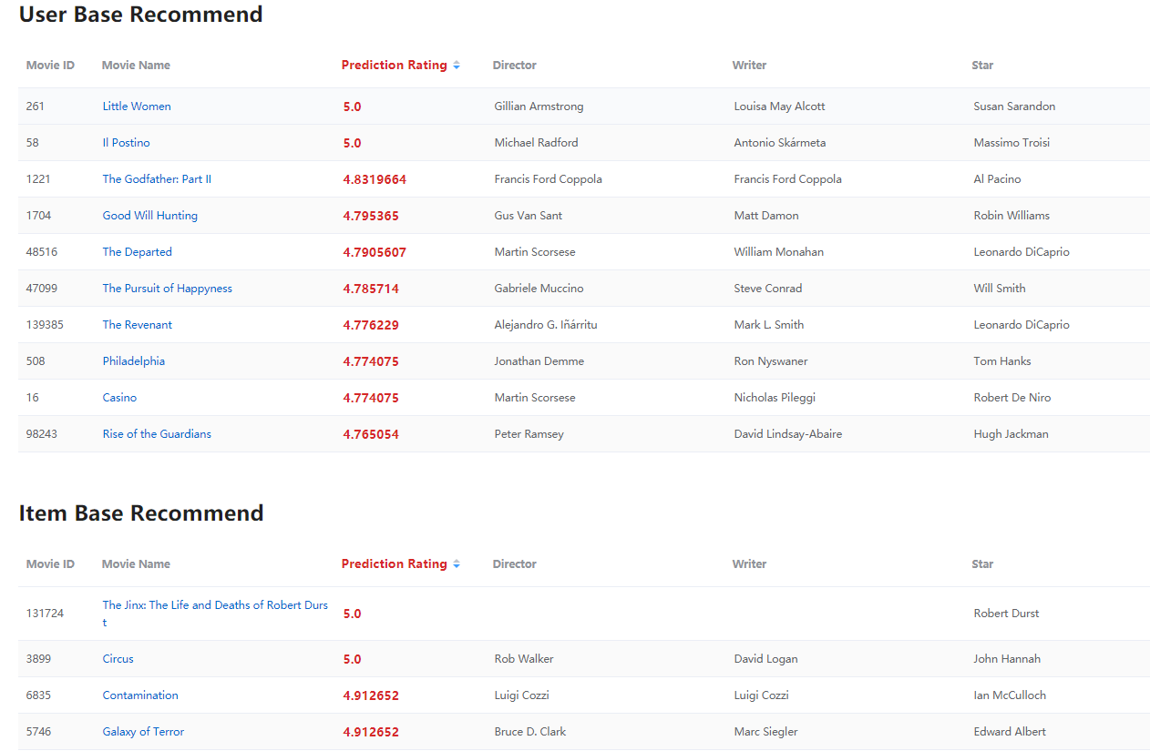
Fig 6-5 Recommendation algorithm module
It can be seen that the movie recommendation system has good functions, various functions can be completed well, and the results of recommendation are valid.

6.2 Evaluation of recommendation system
Normally, the evaluation of a recommendation system is difficult and time consuming. However, the use of Mahout effectively solves this problem. The advantage of mahout is that it can save time to evaluate different combinations of different parameter combinations. Mahout provides many classes for the evaluation of a recommender system. These assessment methods can be broadly divided into Prediction-based evaluation and IR-based evaluation.

6.2.1 Prediction-based evaluation
When using Prediction-based measures, we can use the evaluate method in the AverageAbsoluteDifferenceEvaluator class to evaluate the recommendation system, which is roughly implemented as follows.
(1) Prepare movie score data and load the data into memory
(2) Build evaluator objects that use average differentials
(3) 70% of the data was used to train the recommendation system, and 30% of the data was used to evaluate the system, so as to obtain the difference between the estimated score and the actual score and thus to evaluate the performance of the recommendation system.
The recommendation engine can set a portion of the real data as test data. These test data preferences do not show preference values in the training set, requiring the recommendation system to evaluate these missing preference values and compare the differences between the actual values. It is easy to generate a series of ratings for the recommendation system. For example, calculate the average distance between the estimate and the actual value, in which case the lower the score, the better.
Table 6-1 Example of Average Difference Method in Recommended Evaluation
values | Item1 | Item2 | Item3
True Value | 3.0 | 5.0 | 4.0
Estimate | 3.5 | 2.0 | 5.0
Difference | 0.5 | 3.0 | 1.0
Average difference | (0.5+3.0+1.0)/3=1.5
The main codes for recommender system evaluation are as follows:
- RecommenderEvaluator eva = new AverageAbsoluteDifferenceRecommenderEvaluator();
- double new_score = eva.evaluate(builder, null, dataModel, 0.8, 1.0);
- System.out.println("The resule of AverageAbsoluteDifferenceRecommenderEvaluator: "+ new_score);
Fig 6-6 Main codes for average difference evaluation

Here we use 80 percent of the data training system. The rest of the data is used for testing to get the average difference between the recommended results, which can be used to measure the quality of the system. When I run the code above, after a while, I see the console window of IDEA prompting: The result of Average Absolute Difference Recommender Evaluator: 0.8569474165562307.
The value obtained is the average difference between the real value and the estimated value of the score obtained after the system training. The smaller this value is, the higher the recommendation accuracy of the system will be. Since the interval between user ratings in the recommendation system is at least 1 point, the value of the average difference indicates that the recommendation function of the recommendation system is good and the recommendation result is very accurate.

6.2.2 IR-based evaluation
Before introducing this evaluation method, let me introduce the concepts of recall and precision. In the case of dichotomy (no right or wrong, No 0 or 1):
Precision is how much of the sample you think is right is really right.
Recall is an example of all the right things, how much you've found, or how much you've judged right. The following table explains more clearly what is recall and accuracy and the table covers all possible scenarios
Table 6-2 Example of Average Difference Method in Recommended Evaluation
True situation\Prediction | True | False
True | TP | FN
False | FP | TN

Where, the formula for Precision is shown as follows：
$Precision= \frac{TP}{(TP+FP)}$ (6.1)
The formula for Recall is
$Recall= \frac{TP}{(TP+FN)}$ (6.2)
The code to calculate the recall and precision rates is shown in the figure below.
- RecommenderIRStatsEvaluator evaluator3 = new GenericRecommenderIRStatsEvaluator();
- IRStatistics statistics = evaluator3.evaluate(builder, null, dataModel, null, 10, GenericRecommenderIRStatsEvaluator.CHOOSE_THRESHOLD, 1.0);
- System.out.println("Precision： "+ statistics.getPrecision());
- System.out.println("Recall： "+ statistics.getRecall());
Fig 6-7 Main codes for calculating precision and recall
After running codes of evaluation, the results shows: Precision： 0.039098972922502334, Recall： 0.032842953815448876.
The first data above, 0.039098972922502334, indicates that the proportion of the recommended results is about 4%.The second data, 0.032842953815448876, shows that the proportion of all relevant results included in the recommended results is approximately 3%.Since there are 8751 movies in the library in this recommendation system, the accuracy and recall based recommendation results show that the system works well.
Generally speaking, a thorough search cannot be obtained at the same time, except in some simple tasks. It is well understood that if more positive predictions are made, the recall rate will increase, but the accuracy rate will decrease. On the contrary, the accuracy rate is bound to be high with as few predictions as possible, but the recall rate is much lower.

CHAPTER 7: CONCLUSION

7.1 Summary
The rapid development of the Internet also promotes the application of recommendation system in all walks of life. After that, this paper analyzes the system's function and requirement, and then analyzes the system's function and requirement analysis. The results show that the system can work well and the recommendation results are reliable
The system can be roughly divided into five modules, which are login registration module, search module, scoring module, recommendation algorithm module and front-end display module. This paper introduces each module in detail.
The system uses user based and Project-based Collaborative filtering algorithms, and users can get recommendations based on these two algorithms. Finally, the average difference method is used to evaluate the final results, and the precision and recall are analyzed. The results show that the recommendation system has high reliability and good user experience.
After completing the implementation of the recommendation algorithm, the major project uses Vue framework and element UI to complete the front-end page production. The front-end page works well, the interface is simple and generous, which conforms to the public aesthetic, and increases the user experience.

7.2 Deficiencies and Future Prospects
Although the major project has realized the basic functions of movie recommendation, there are still many shortcomings to be improved in the future, mainly in the following aspects:
- The algorithm may be inefficient. Because the algorithm used in this system is the algorithm proposed in the last century, there may be some problems such as low efficiency and low recommendation accuracy. Later, you can consider discarding the old recommendation algorithms, using newer, more efficient ones, and combining tag-based and content-based ones. It is better to make a preliminary classification and recommendation for filling in information such as age, gender, occupation, etc. when users register, and then make a precise recommendation based on the score.
- The data set used in this recommendation system is the historical rating data provided by movielens. Users who have completed the login may not have seen many movies, which will lead to inaccurate similarity. The number of movies included in the dataset is not too large, which will affect the effect of the recommendation. It can then be recommended with a larger data set, considering traversing millions of score data.
- On the front-end of the Web, we have implemented the basic functions of movie recommendation website, after which we can add social functions based on movie recommendation to the system. Enable users to communicate with users and make recommendations between users. This also helps users bond to the site.

Reference
[1] Zhang J , Yang Y , Zhuo L , et al. Personalized Recommendation of Social Images by Constructing a User Interest Tree With Deep Features and Tag Trees[J]. IEEE Transactions on Multimedia, 2019, PP(99):1-1.
[2] 黄春华, 寇伟. 电子商务个性化推荐系统综述[J]. 商, 2015, 000(043):212-213.
[3] Goldberg D , Nichols D , Oki B M , et al. Using collaborative filtering to weave an information tapestry[J]. Communications of the Acm, 1992, 35(12):61-70.
[4] Konstan J A , Miller B N , Maltz D , et al. GroupLens: Applying collaborative filtering to Usenet news[J]. Communications of the ACM, 2000, 40(3).
[5] Paranjape-Voditel P , Deshpande U . A stock market portfolio recommender system based on association rule mining[J]. Applied Soft Computing Journal, 2013, 13(2):1055-1063.
[6] Iván Cantador, Ro Bellogín, Vallet D . Content-based recommendation in social tagging systems[C]// Acm Conference on Recommender Systems. ACM, 2010 [7] Anil, Robin, “Apache Mahout: Machine Learning on Distributed Dataflow Systems.,” Journal of Machine Learning Research, no. 119–145, pp. 1–7.
[8] 高献卫, “基于 Mahout 的新用户推荐算法的设计与实现.,” Computer Engineering & Science / Jisuanji Gongcheng yu Kexue, vol. 37, no. 8, pp. 1444–1450, doi: 10.3969/.issn.1007-130X.2015.08.005.
[9] Peng, Hua, “Network traffic anomaly detection algorithm using mahout classifier.,” Journal of Intelligent & Fuzzy Systems, vol. 37, no. 1, pp. 137–145, doi: 10.3233/JIFS-179072.
[10] Crawley, Jennie A. H., “Investigating changes within the handling system of the largest semi-captive population of Asian elephants.,” PLoS ONE, vol. 14, no. 1, pp. 1–15, doi: 10.1371/journal.pone.0209701.
[11] S. Bagchi, “Performance and Quality Assessment of Similarity Measures in Collaborative Filtering Using Mahout,” Procedia computer science, vol. 50, pp. 229–234, 2015, doi: 10.1016/j.procs.2015.04.055.
[12] Myftija, Saadi, “CityRec -- A Data-Driven Conversational Destination Recommender System.,” E-review of Tourism Research, vol. 17, no. 5, pp. 808–817.

[13] Malgonde, Onkar, “TAMING COMPLEXITY IN SEARCH MATCHING: TWO-SIDED RECOMMENDER SYSTEMS ON DIGITAL PLATFORMS.,” MIS Quarterly, vol. 44, no. 1, pp. 49–85, doi: 10.25300/MISQ/2020/14424.
[14] Jaimez-González, Carlos R., “DiagrammER: A Web Application to Support the Teaching-Learning Process of Database Courses Through the Creation of E-R Diagrams.,” International Journal of Emerging Technologies in Learning, vol. 15, no. 19, pp. 4–22, doi: 10.3991/ijet.v15i19.14745.
[15] Woo, Dong U, “Database: web application for visualization of the cumulated RNAseq data against the salicylic acid (SA) and methyl jasmonate (MeJA) treatment of Arabidopsis thaliana.,” BMC Plant Biology, vol. 20, no. 1, pp. 1–7, doi: 10.1186/s12870-020-02659-y.
[16] Salas-Rueda, Ricardo-Adán, “Design, Construction and Evaluation of a Web Application for the Teaching-Learning Process on Financial Mathematics.,” International Journal of Emerging Technologies in Learning, vol. 15, no. 8, pp. 100–116, doi: 10.3991/ijet.v15i08.12275.
[17] GUO Jinchao, “Collaborative filtering algorithm based on the improved SVD algorithm and binary K-means clustering algorithm.,” Journal of Light Industry, vol. 35, no. 4, pp. 88–96, doi: 10.12187/2020.04.012.
[18] 孙艳蕊, “基于Timed-HITS与协同过滤的混合推荐算法.,” Journal of Northeastern University (Natural Science), vol. 40, no. 4, pp. 467–474, doi: 10.12068/j.issn.1005-3026.2019.04.003.
[19] Cunha, Tiago, Soares, Carlos, and de Carvalho, André C. P. L. F, “CF4CF: Recommending Collaborative Filtering algorithms using Collaborative Filtering,” in CF4CF: Recommending Collaborative Filtering algorithms using Collaborative Filtering, 2018, doi: 10.1145/3240323.3240378.
[20] Wang, Zhongya, Wang, Zhongya, Liu, Ying, Liu, Ying, Chiu, Steve, and Chiu, Steve, “An efficient parallel collaborative filtering algorithm on multi-GPU platform,” The Journal of supercomputing, vol. 72, no. 6, pp. 2080–2094, 2016, doi: 10.1007/s11227-014-1333-4.

