BUSINESS DECISION MAKING

NAME : DHRUVKUMAR RAMESHKUMAR SHAH
STUDENT ID : 1704816
TUTORIAL NAME : TANJA NATHAN
SUBJECT CODE : SBMA7113_LON
END DATE : 02/05/2018
Table of Contents
- Introduction: 3
- Identification of the decision making problem and how it is affecting the operational process of the business 4
- The implementation of the system for solving the problem: 6
- Procedures used for solving the problem to support the complex decision making process: 8
- Detailed analysis of the procedure to solve the present issue: 10
- Recommendation: 16
- Limitation of the analysis: 17
- Conclusion: 17
- Reference: 17

Introduction:
The significant portion of the business in UK is in the nature of either small or medium scale businesses or the micro business or in the nature of a start-up. Currently there are around 5.4 million SMEs in the country and they accounts almost 99.9% of the private sector of UK. These 5.4 million SMEs of the country employ 60% of the workers of the private sector which covers around 15.6 million workers of the country. These SMEs are generating 1.8 trillion pound from the private sector and has become the backbone of the UK economy as most of the SMEs operate in a small scale, these organization requires a supportive finical fund where from they can get easy finance at the hour of need (Market-inspector.co.uk, 2018).
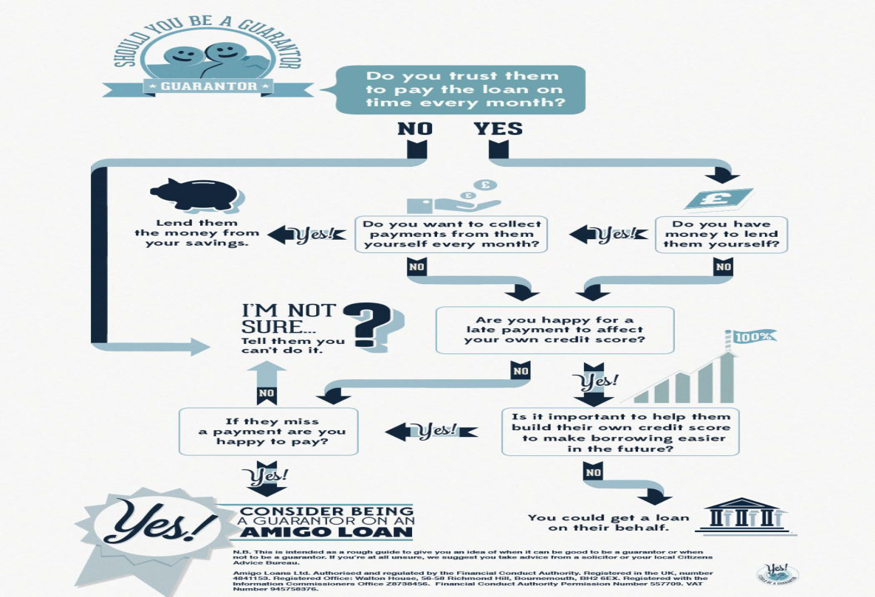
The organization Amigo Loans is an SME of UK which works alternative sources of bank financing for offering easy finance to the SME organizations of the country. The main characteristic of the loan offering framework or the operational framework of the organization is to offer loan to those borrowers who are having a guarantor for the loan that will be offered to
them.

(Source:Amigoloans.co.uk, 2018)

Thus the organization does not reject an applicant whom have applied loan on the basis of bad credit score or if the individual or the organization is having a history of bad debts. In the current assignment a discussion has been made by identifying an operational issue that has been faced by the organization and how the issue can be solved by using the technique of business decision making (Amigoloans.co.uk, 2018).

Identification of the decision making problem and how it is affecting the operational process of the business

“Amigo loan” is a private lending institution that offers to the SMEs and other organizations that are operating at a low scale from the point of view of the helping attitude to the borrowers. Some of the striking features of lending framework of the organization is that the organization does not reject loan application on basis of bad credit report of the borrowers and this organization should be considered as a good borrowing platform for those borrowers who are having bad credit history(Vahlne and Johanson, 2017).
The operational manager of the organization revealed in to a face to face interview that the organization is dealingwith large number of borrowers who have bad credit history in the pastand some of them have failed to return the borrowed loan in near future. The operational manager of the organization is apprehending a rise in default in near future and in such a situation the business will require to keenly track the factors like the number of loan application received, mummer of loan application sanctioned, the average interest charged on loan, the loan income earned by the business,the number of loan defaulted and the related liquidity position of the organization. The current software of the organization is not enough updated to keep track of the above mentioned factors. In such a situation if the business offers more loans than it has recovered and the collection from the interest income of the business become quite low it will be difficult for the business to maintain a good liquidity position and to offer new loans. Thus there is every possibility that due to the lack of proper tracking the business may face operational difficulty. Thus currently the chosen organization is suffering from an operation management problem (POM) which is needed to be solved for the sustainability of the organization. The inefficiency of the organization in tracking the loan recovery performance is really affecting the loan offering decisions of the organization (Ford and Richardson,2013). Thefinancial and technical managers of the organization are working on the issue to chose and implement the most appropriateloan management or loan servicing software for the organization. But again the organization is facing a problem in selecting the most appropriate loan servicing software due to the resource problem.
The problem faced by the organization is affecting the lending operation of the organization and fact for that can be received from financial statements of the organization (Vercellis,2009).
As per the financial highlights of the organization for 31stDecember, 2017 , the amount of loan booked by the organization was around 364.2 million pound in 31st December , 2016 and the loan booked by the organization was around 607.0 million pound in 31st December , 2017 .Therefore the loan booking has increased by 18% over years;whereasthe net asset holding of the organization has decreased from 197 million pound (in 31st December , 2016 ) to 171 million pound (in 31st December , 2017 ) which refers to an overall decrees of net asset holding of the organization by an amount of 13%..This indicates that the holding of total asset to service the total loan liability of the organization has declined which refers to financial weakness of the organization which is working in the loan offering business (Amigoloans.cdn.prismic.io, 2018).
 | 9 months to 31st Dec,17 | 9 months to 31st Dec,16
 | £’000 | £’000
cash in hand | 17280 | 14566
current liability (includes only creditors) | 35410 | 19122
Quick ratio | 0.49 | 0.76
The organization like “Amigo loan” which is in the sole business in offering guarantor loan, it is very essential that the business must have substantial amount of quick asset (that is cash and cash equivalents) so that the quick ratio of the organization remains strong as a strong ratio continuously ensure that the business has sufficient liquid cash in hand for paying creditors and to offer loans to the loan applicants..But so far as the Amigo loan is concerned it can be seen that the quick ratio of the organization is far below the standard ratio of “2”[which indicates that for an organization with strong liquidity position the holding of the most quick assets or cash is twice the holding of the current liability of the organization ] and it has also decline in 2017 over and above 2016 with the nacres in the loan offerings by the organization(Zsambok and Klein, 2014).
Thus the key aspects with respect to which the organization is facing the operation management problem are as follows:
- Tracking the number of loan applications received
- Tracking the possibility of loan that can be offered
- Tracking the loan that has been actually issued
- Tracking the proportion of loan amount debited from the cash balance of the organization
- Tracking and matching the above information with the availability of liquid cash in the hand of the organization
- Updating the liquidity position of the firm from time to time, so that the most appropriate loan decision can be taken(Black, 2009)

The implementation of the system for solving the problem:
The business is thinking of implementing several loan servicing software for solving the PMO and considering the implementation of at least three such software whose implementation is not very costly.
Magill Loan Manager: This is a kind of low cost software that can be implemented by the business for the purpose of loan servicing and credit management. The software runs on a windows based platform that is capable of managing the varieties of loan types[personal, corporate, intercompany loans].The software can be used for loan management in different kind of business whether it is small, large or medium in terms of the scale of operation. The most important reason for which the application of the software is considered to be very appropriate considering the operation of the “Amigo loan” is that the software is capable of handling the amortization, regular and irregular payments, interest-only loans, escrow management, electronic payments, and generating alerts with respect to the shortage of fund and also deliver multicurrency support. Any data information that is summarised by the company in excel formatcan be imported easily in this software environment for further processing of the data for deriving meaningful conclusion. The another advantage of using this software is that if “Amigo loan” scale up their business or diversify the type of loan offered then this software will be able to support the business so far as loan management is concerned (Amigoloans.co.uk, 2018).

Auto Pal: The Auto Pal is another loan servicing software that thebusiness is thinking of implementing alongside as it is also less costly and runs on a cloud based platform. The software is mainly suggested for the small and medium scale businesses for calculating their interest income to be earned from loan offered in different formats. Another most important feature of this software is that it cangenerate audit report with respect to the loan operation of the organization through the application of note tracking system (Amigoloans.co.uk, 2018).
.

Loan Navigator Software:
The management has also implemented the “Loan Navigator Software” that helps the organization to manage the whole lifecycle of a loan along with the presentation of the documentation at each stage of the loan processing procedure. The software helps the management to track loan request from the multiple sources and present documentation of the loan portfolio with respect to each customer of the organization. The software records every other details of the loan processing procedures staring from the application of the loan to the approval so that the managers can monitor how the employees are dealing with the clients(how they are checking on the credibility of the underlying guarantors so that at the event of default the loan can be recovered from the guarantor) and what kind of loan applications they are sending to the loan sanction department for approval of the loan (Amigoloans.co.uk, 2018).
After a thorough analysis of the operational process of thefinancial managers as well as technical managers of “Amigo loans”has narrowed down to the above mentioned two loan servicing software for solving the operation management problem and the managers are keeping all options open for the customization of the above two loan servicing software as required to support the operational process of the organization.
Moreover the Management Information System [MIS] has also been applied by Amigo Loan in order to retrieve data (information related to loan applicant received, loan issued and corresponding changing liquidity situation) and to manage them in a proper manner so that the data information becomes quickly visible to all the relevant department of the organization for the purpose of business decision making (Nowduri, 2011).

Procedures used for solving the problem to support the complex decision making process:
The procedure that is followed by the management of the organization to solve the operational problem faced by the organization in a best possible manner is defined as the problem solving procedure. The procedure involves several steps that are followed sequentially in a systematic manner for the purpose of effective decision making.
Describing the problem:
Proper identification and proper description of the problem is the first and foremost requirement (or step-1) of the problem solving procedure .As per the analysis, the managers of the organization, the main problem is related to the arrangement of the loan operations as the business is failing to keep track of the aspects of how much percentage of the loan to be issued of the loan application received depending upon the liquidity position of the organization. The lack of information regarding the liquidity position is badly affecting the loan offering business of the organization as the business is failing to get a clear vision with the changing liquidity position of the organization. The loan is offered by the organization mainly from the liquid cash held by the organization and due to misallocation of fund the available cash in hand that can be used for servicing the creditors. That is why the quick ratio of the organization has declined from 76% in 2016 to 49% in 2017 as revealed by the annual report of the organization(Bhattacharya, 2014).
Identification of the factors:
At this stage of the problem solving procedure, the management has to identify the factors that responsible for reducing the performance of the business. The in-depth analysis of the issue reveals that the factors like lack of availability of the proper loan servicing software that can process the loan applications of the borrowers and the lack of availability of the management information system is preventing the employees to get a clear view of the changing liquidity position with the loan issued. As a result the employees are failing to get the proper guidance regarding what percentage of loan applicant will be sanctioned while maintaining the good liquidity position of the organization. Besides, lack of employee training and inefficiency in handling the debtors who have already borrowed from the company are the other reasons that are affecting the business operations of the company as guarantor of the loan are not acting as per promise(Loutskina, 2011.).
Alternative Solutions’ that can be applied:
Regarding the implementation of debt servicing software there are several alternatives that were available to the Amigo loan. Along with “Auto Pal”, “Magill Loan Manager” the organization has also made a test application of the different loan servicing software. One of them is “Turnkey Lender” which is cloud best loan management software that is specifically designed for managing loan of types like retail, microfinance, medical, payday loans, lease financing etc. The software also offers the feature of displaying the terms of the loan application and to manage the accounts of the borrowers and to accept the loan applications online. But this software is more costly than the others to buy and implement. The other alternative software that are being checked by the organization are the “The Mortgage Office”, “Loan ledger” etc.
Selection of the most appropriate one:
In order to solve the loan management issue and the resource constraints, the management has narrowed down to the implementation of the loan serving software of “Magill Loan Manager”, “Autopal “and “Loan Navigator Software”. It is expected that the implementation of these software will help the managers as well as employees of the organization to collect and store useful data that will give them a clear vision regarding the different aspects of the loan operation of the organization. Besides, the implementation of the “Management Information System” will help the business to relate the loan related data with the liquidity position of the organization. Thus it can be expected that the business will be able to manage the distribution of the liquid cash between the loan offers and the margin to be kept for servicing the creditors of the organization after making proper calculation of the life cycle of a loan issued and matching them with the requirements of loan so that the business can prevent a situation of cash shortage that can affect the lending operation as well as profitability of the business (Campello et al.,2011).

Detailed analysis of the procedure to solve the present issue:

A discussion of the key aspects of the loan offering business of “Amigo Loan”:
The net loan origination of the business is grown by 85% in 2017 over and above 2016
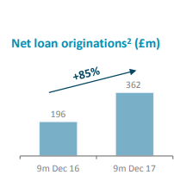
(Source: Amigoloans.cdn.prismic.io, 2018)
As reflected by the picture the volume of the loan origination was 196 million pound for the organization which has increased to 362 million pound in 2017
The rise in the loan origination has driven the growth of loan booking by 67%
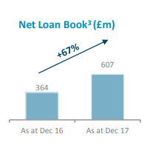
(Source: Amigoloans.cdn.prismic.io, 2018)

As described by the above figure the loan booking has increased from 364 million pound in 2016 to 607 million pounds in 2017.
With the increase in loan booking the percentage of the impaired loan has also increased which are eating up a substantial profit o f the business. The underlying reason of the increase in the impaired loan (that is the loans with respect to which it is not possible to recover the principal amounts of loan and the promised interest on loan) the business has not checked the credibility of guarantors at the time of issuing the loan.
As a result the amount of impaired loan as a percentage of loans booked has increased by an amount of 121% in 2017 compared to 2016
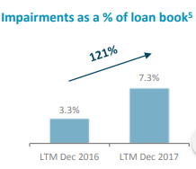
(Source: Amigoloans.cdn.prismic.io, 2018)

The above picture depicts that the volume of the impaired loan was 3.3% of the booked loan in 2016 and the same percentage has become 7.3% in 2017.
Looking at the source of origination of the loan for the last six quarters [staring from Q2 of 2016-2017 to Q3, 2017-2018] it can be seen that the total loan origination has grown at a rate of 60.6% and a substantial portion of these originators are in the nature of the “non –home owner guarantor”. The risk of offering loan to these types of borrowers is that they do not own a home for offering good guarantee against loan and offers other kind of guarantees with respect to which there s high chance of default (Franzoni et al.,2012).
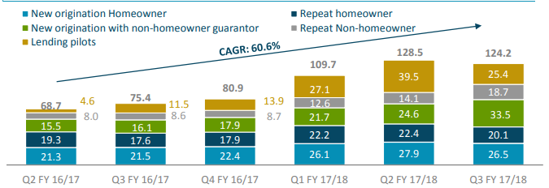
(Source: Amigoloans.cdn.prismic.io, 2018)

Years | 2016-2017 |  |  | 2017-2018
Quarters | Q2 | Q3 | Q4 | Q1 | Q2 | Q3
non –home owner guarantor loan volume,(£,m) | 15.5 | 16.1 | 17.9 | 21.7 | 24.6 | 33.5
Growth rate over years |  | 4% | 11% | 21% | 13% | 36%
Average growth rate |  | 17%

The above picture and the above table depicts that such kind of borrowers has grown at an average rate of 17% during the past 6 quarters and is expected to grow at the same rate in the coming quarters.
The maximum default or impaired loan is also generated by this kind of the borrowers who are failing to offer a good guarantee with respect to the loan taken.
A study from the last quarter of 2015-2016 to the third quarter of 2017-2018 reveals the fact that the proportion of the impaired loan as a percentage of the revenue earned has increased from 10% to 25%; and this fact reflects the presence of inefficiency in the customer operation and loan management of the business.
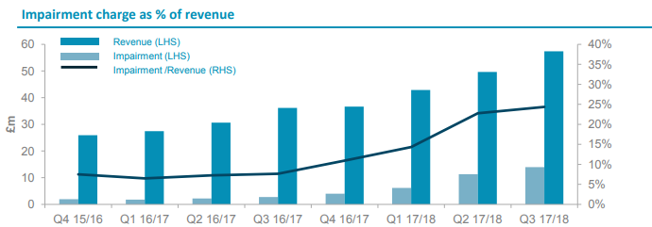
(Source: Amigoloans.cdn.prismic.io, 2018)

The above figure depicts that the impairment charges has grown along with the growth of the revenue earnings and if the business wants to increase the scale of operation there is every possibility that the business may incur more loss(in the form of loan impairment) than revenue earned.
Description of the problem solution procedure:
To solve the issue the business has first studied the growth rate of loan origination and the growth rate of revenue generation.
Years | 2016-2017 |  |  | 2017-2018
Quarters | Q2 | Q3 | Q4 | Q1 | Q2 | Q3
loan origination volume,(£,m) | 68.7 | 75.4 | 80.9 | 109.7 | 128.5 | 124.2
Growth rate over years |  | 10% | 7% | 36% | 17% | -3%
Average growth rate |  | 13%

Years | 2016-2017 |  |  | 2017-2018
Quarters | Q2 | Q3 | Q4 | Q1 | Q2 | Q3
Revenue earned,(£,m) | 22 | 35 | 35 | 40 | 45 | 50
Growth rate over years |  | 59% | 0% | 14% | 13% | 11%
Average growth rate |  | 19%

ratio[revenue earned to loan origination] | 32% | 46% | 43% | 36% | 35% | 40%

- From the study it can be seen that during the period of study the organization amigo loan has managed only to transform on an average 39% of the loan taken in to revenue and this performance must have to be improved and for this the proportion of the impaired loan as a percentage of booked loan has to be reduced.
- More over the business has to maintain a cash reserve which will protect it from cash shortage.
- First of all the business has decided to calculate the volume of free cash in hand that is available for giving loan as well as meeting the liability for each quarter.
- Then for the purpose of maintain the protection reserve the business has decided to put only 70% of the cash reserves in the business and rest 30% will be invested in financial instruments that will fetch secured return for the business.
- While offering loan the percentage distribution of the loan among the different originators will be as follows:
Category of loan originator | portion of liquid cash to be offered as loan to the segment of the loan originators | Justification of preference or non-preference with respect to loan
Home owner | 30% | second most preferred segment for loan offering as they have a house to offer as a secured guarantee
Non home owner Guarantor | 5% | most non- preferred segment as they often offer non stable guarantee
Lending pilots | 15% | moderately proffered segment
Repeat home owner | 40% | Maximum preference will be given as they have a house to offer as a secured guarantee and they have a loan repayment history with the organization
Repeat non-home owner | 10% | Second least preferred segment with respect to loan offerings as they do not own a home for offering a guarantee, but must be given little preference as they have worked before with the organization

- Last of all for each of the segment the issue date of each bunch of loan has to be matched with the repayment of another bunch of loan so that the cash movement of the organization can be done in such a manner so that the liquidity of the business can be strengthen an d the business will be able to maintain a quick ratio of at least “1” or more than “1”.

Recommendation:
Amigo loan is a business that is solely involved in the loan offering business and therefore it is essential that the business should always maintain a strong liquidity position as much as possible so that it can easily absorb the loss of loan impairment and can smoothly pay the creditors of the business without hampering the loan sanction operation of the business. While offering loan, every detail has to be recorded and processed by the use of the loan servicing software[Magill Loan Manager, Auto Pal, Loan Navigator Software] and also the MIS should be applied for the visualisation of the updated liquidity position of the business with every new issue of loan as well as with every new payment of loan(Ratnovski, 2013).
Weakly as well as quarterly report should be generated with respect to loan issue and loan recovery and the corresponding liquidity position of the organization for the overview of the management.
If the business feels that the current liquidity position is not very sound then the management can take any decision regarding the rejection of the several loan offers on the basis of risk involved.

Limitation of the analysis:
The current analysis has failed to through any light over the skill shortage of the employees and to what extent the factor of skill shortage is affecting the revenue generation of the capacity of the organization out of the loan originated(Borio and Disyatat, 2010).

Conclusion:
From the above analysis it can be seen that the management of the loan operation which specifically focus upon the selection of optimum proportion of loan to be issued (out of the loan originated) and how the loan applicant will be chosen for approval on the basis of the guarantee offered. More over the systematization of the loan offering process solely depends upon the updating and visualization of the actual liquidity position along with every receipt and issue of loan. Thus the whole problem related to operation management can be systemised by offering a strong liquidity position to the business with the application of loan service software[Magill Loan Manager, Auto Pal, Loan Navigator Software],MIS and the above mentioned strategies(Pino and Yermo, 2010).

Reference:

Amigoloans.cdn.prismic.io. (2018). [online] Available at: https://amigoloans.cdn.prismic.io/amigoloans%2Fd8dbee3f-e88a-47ae-a06f-3d45b4af8894_dec+17+bond+investor+presentation.pdf [Accessed 18 Apr. 2018].
Amigoloans.cdn.prismic.io. (2018). [online] Available at: https://amigoloans.cdn.prismic.io/amigoloans%2Fcd6c1bbd-dbf5-4c41-8dea-77b41a62538b_final+signed+amigo+results+22+feb+2018.pdf [Accessed 18 Apr. 2018].
Amigoloans.co.uk. (2018). [online] Available at: https://www.amigoloans.co.uk/assets/downloads/Amigo_Loans_Why_Be_A_Guarantor.jpg [Accessed 18 Apr. 2018].
Amigoloans.co.uk. (2018). Guarantor Loans For People With Bad Credit | Amigo Loans. [online] Available at: https://www.amigoloans.co.uk/ [Accessed 18 Apr. 2018].
Bhattacharya, H., 2014. Working capital management: Strategies and techniques. PHI Learning Pvt. Ltd..
Black, K., 2009. Business statistics: Contemporary decision making. John Wiley & Sons.
Borio, C. and Disyatat, P., 2010. Unconventional monetary policies: an appraisal. The Manchester School, 78(s1), pp.53-89.
Campello, M., Giambona, E., Graham, J.R. and Harvey, C.R., 2011. Liquidity management and corporate investment during a financial crisis. The Review of Financial Studies, 24(6), pp.1944-1979.
Ford, R.C. and Richardson, W.D., 2013. Ethical decision making: A review of the empirical literature. In Citation classics from the Journal of Business Ethics (pp. 19-44). Springer, Dordrecht.
Franzoni, F., Nowak, E. and Phalippou, L., 2012. Private equity performance and liquidity risk. The Journal of Finance, 67(6), pp.2341-2373.
Loutskina, E., 2011. The role of securitization in bank liquidity and funding management. Journal of Financial Economics, 100(3), pp.663-684.
Market-inspector.co.uk. (2018). Facts About the Role of SMEs in the UK (infographic) | Market-Inspector. [online] Available at: https://www.market-inspector.co.uk/blog/2017/05/facts-about-small-medium-businesses-in-the-uk [Accessed 18 Apr. 2018].
Nowduri, S., 2011. Management information systems and business decision making: review, analysis, and recommendations. Journal of Management and Marketing Research, 7, p.1.
Pino, A. and Yermo, J., 2010. The Impact of the 2007‐2009 Crisis on Social Security and Private Pension funds: A threat to their financial soundness?. International Social Security Review, 63(2), pp.5-30.
Ratnovski, L., 2013. Liquidity and transparency in bank risk management. Journal of Financial Intermediation, 22(3), pp.422-439.
Softwareadvice.com. (2018). Best Loan Servicing Software - 2018 Reviews & Pricing. [online] Available at: https://www.softwareadvice.com/uk/loan-servicing/ [Accessed 18 Apr. 2018].
Vahlne, J.E. and Johanson, J., 2017. The internationalization process of the firm—a model of knowledge development and increasing foreign market commitments. In International Business (pp. 145-154). Routledge.
Vercellis, C., 2009. Business intelligence (pp. 1-19). John Wiley & Sons, Ltd.
Zsambok, C.E. and Klein, G. eds., 2014. Naturalistic decision making. Psychology Press.

