Q1)a) circuit

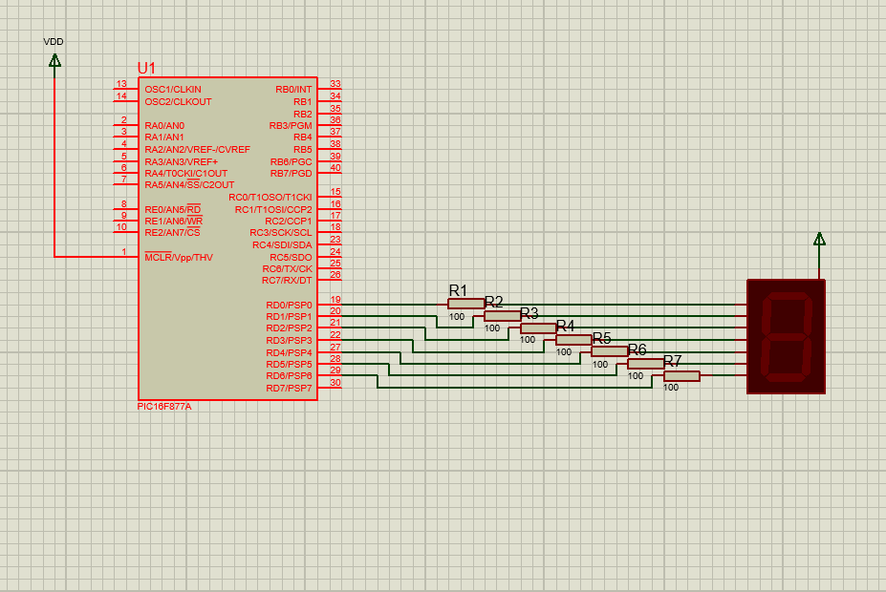

b) code
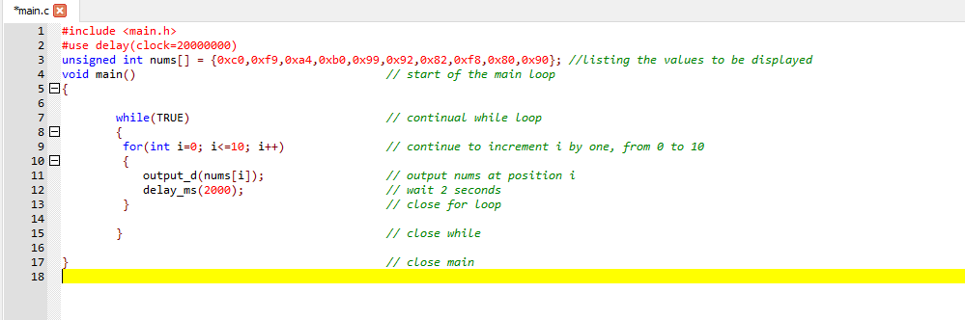
c)
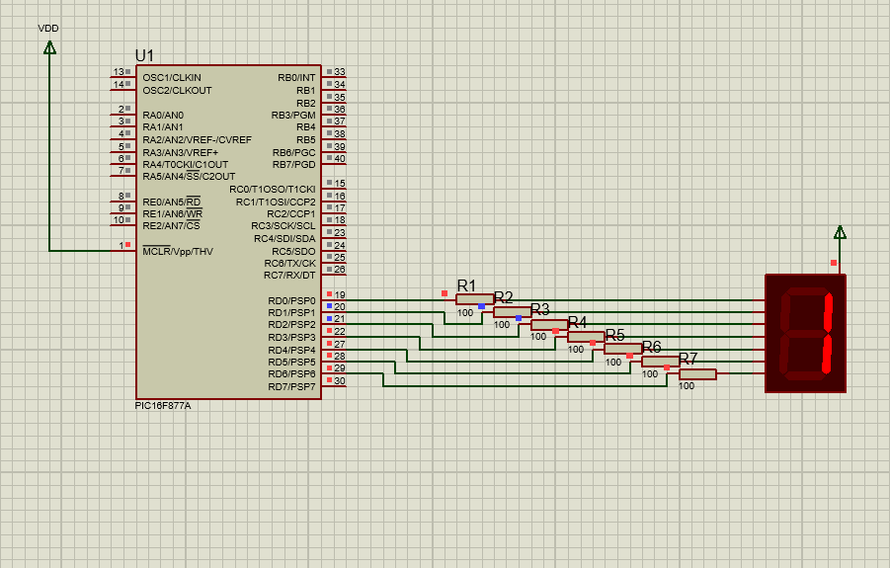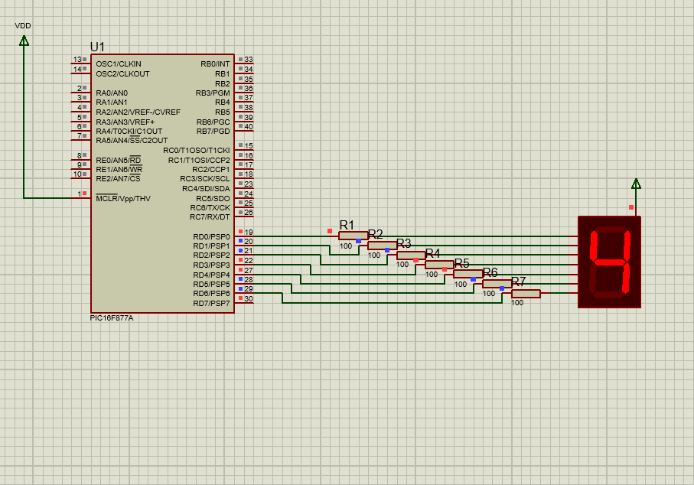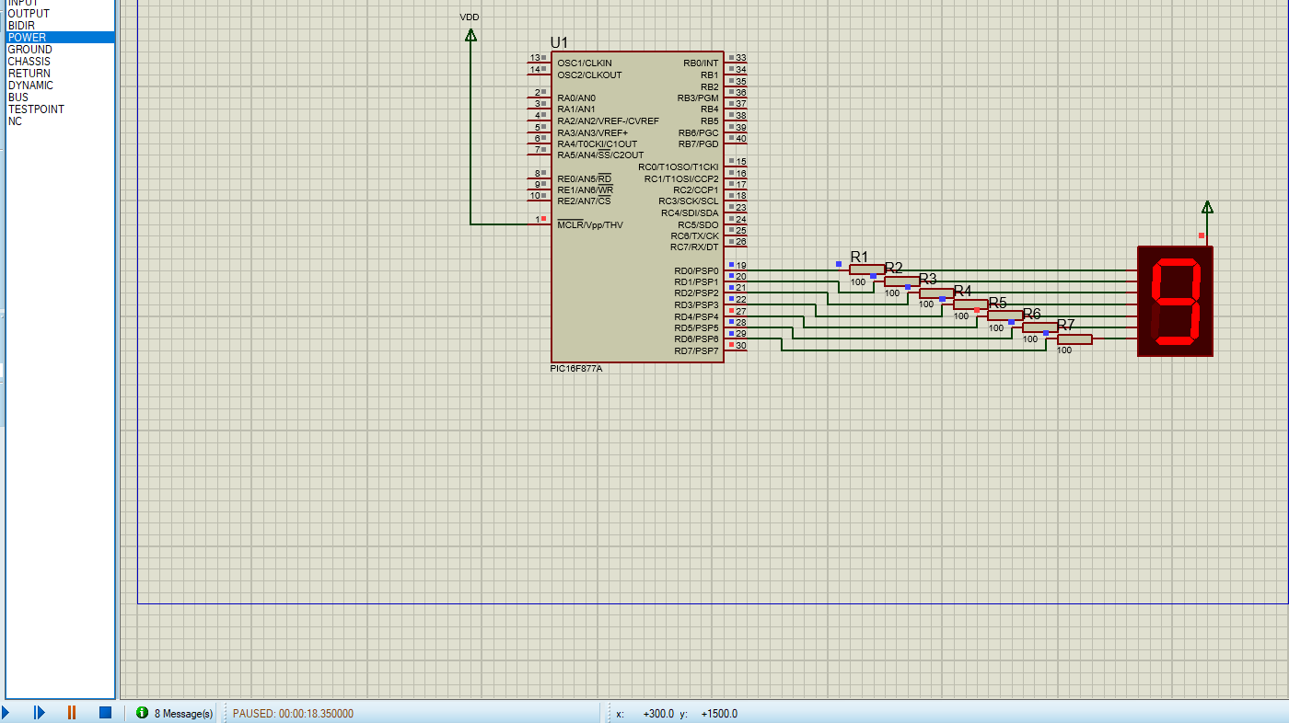

Q2)
A) circuit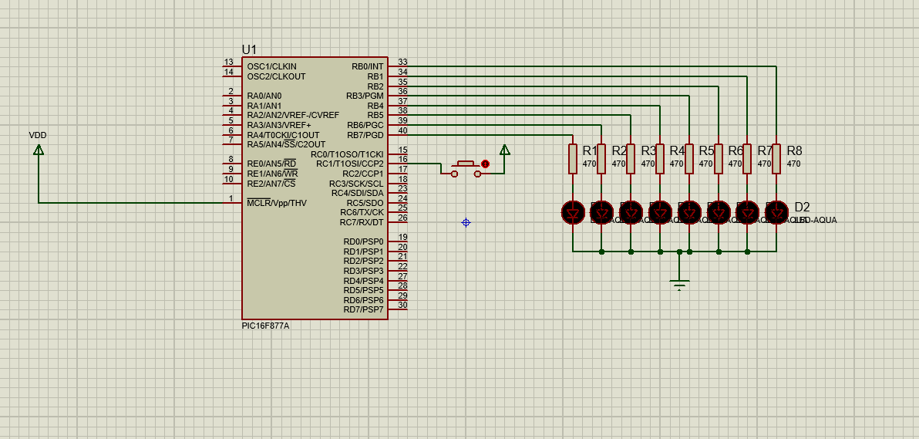
b) code – note C1 is the seconds pin on the PORTC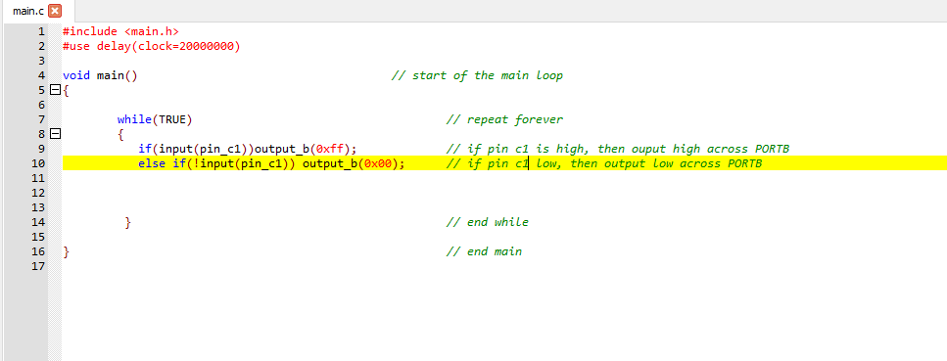
c) simulation – shows leds on when button is pressed, of when it is not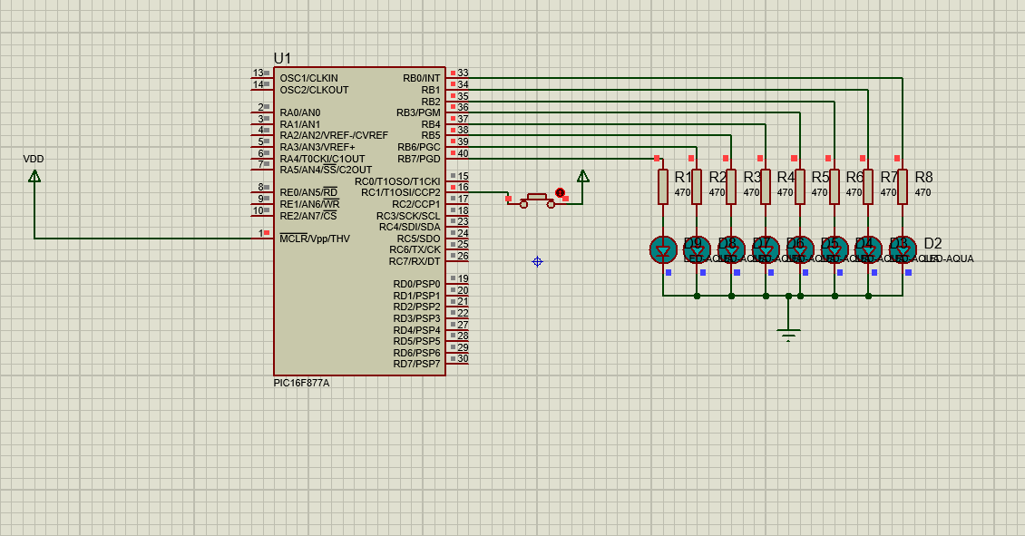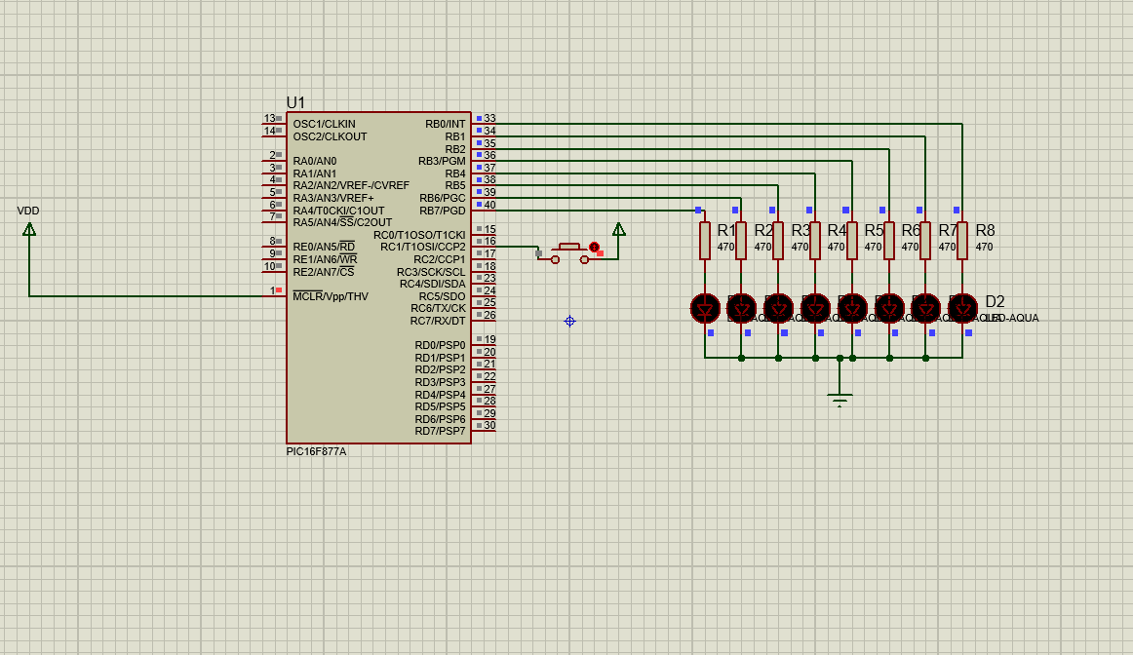

Q3)c) simulation, this shows that when the resistance of RV1 is lower due to less moisture, the voltage is less, and when V+ is less than V-, the led (D1 in my circuit) turns on. The next image shows the reverse, when RV1 resistance is high due to less moisture, then the voltage is higher, and when v+ is higher than V-, the output is pulled to supply.
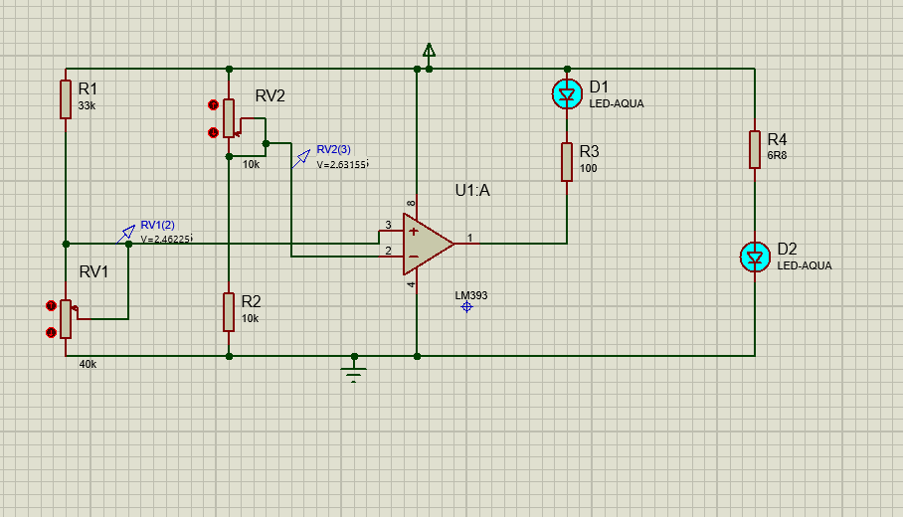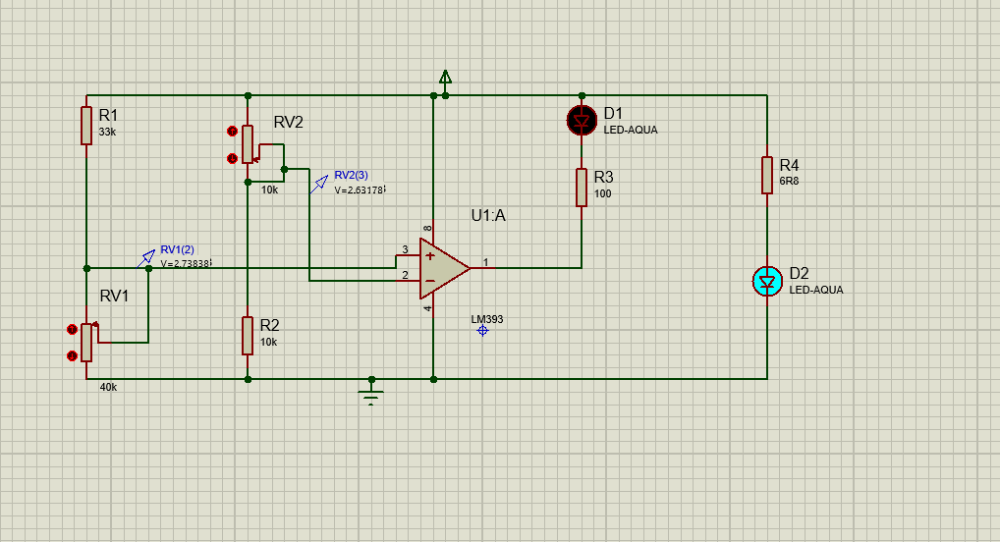

Q4)
c) this shows that the buck converter has taken a 24v dc supply down to 6.8v. in the simulation this dc is from a dc supply, but could also be from a bridge or other rectified ac source.


