BA (Hons) Leadership and Management Skills for the Workplace

UNIVERSITY OF WALES TRINITY SAINT DAVID

Coaching And Mentoring Skills for The Workplace
(BMSW6105_LON)

Reflective Report

Student name: Roman Kadlubiec
Student Id: 1916730

Lecturer: Nishi Ramsurrun

TABLE OF CONTENTS
1.Introduction 3
1.1 Effective coaching skills 3
2. Critical Evaluation of the Purpose of Coaching and Mentoring within a Workplace 4
2.1 Main Purposes of Coaching and Mentoring 4
2.2 Comparison and Contrast of Views 5
2.3. The GROW Model of Coaching 7
2.4. Critical Analysis the GROW model 8
3.Gibbs Reflective Cycle: Coaching Role-Play Exercise 8
3.1. Mentoring role play experience using Gibbs reflective cycle 9
3.2 Individual SWOT Analysis 10
3.2 Individual Skills audit 10
3.4 Action Plan 11
4. Conclusion 11
5.References 12

1.Introduction
This report analyses the complex relationship between mentoring and coaching in the workplace. With the help of Gibbs' Reflective Cycle as the chosen model of reflection, this report's reflective style enables a thorough understanding of these ideas. According to Parsloe and Leedham (2017), mentoring refers to a larger relationship in which an experienced person is offering guidance and sharing knowledge with a less experienced colleague, whereas coaching is essentially a guided process focused on unlocking a person's potential in maximising their own performance. While both mentoring and coaching are still developmental processes, mentoring is more relationship-driven and overall, in nature, whereas coaching is typically more performance-focused and regulated.
(Garvey etal., 2018).
According to Whitmore (2018), effective coaching involves demonstrating critical qualities including active listening, empathy, patience, and the ability to offer constructive feedback. These qualities help the coach effectively facilitate both professional and personal growth. The GROW model and Gibbs Learning Cycle are two important ideas and models in the coaching and mentoring field that are examined in this study. This report offers an in-depth evaluation of these frameworks with the goal of offering an accurate understanding of their uses and advantages in the workplace.

1.1 Effective coaching skills
Figure 1. The top 10 effective coaching skills
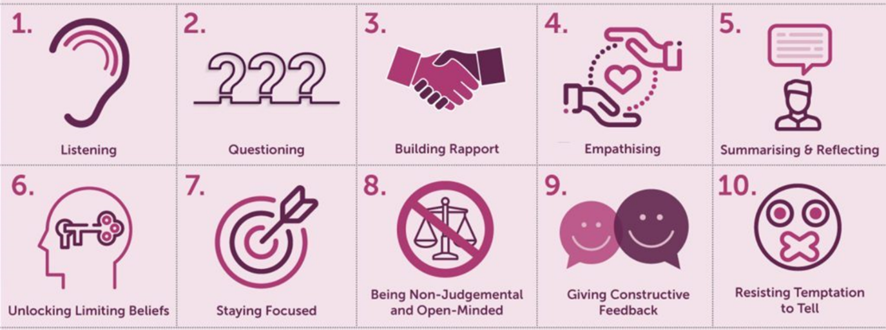
www.makingbusinessmatter.co.uk (2024)

- Active Listening
Active listening is about concentrating fully to understand as well as respond thoughtfully. It enables the coach to see everything from the coachee's perspective and build trust.

- Questioning
This involves asking the right questions which encourages a coachee to explore their thoughts deeper. Questions that are thought-provoking tend to spark insights, driving self-discovery, which is very crucial for personal development.

- Rapport Building
The key to effective coaching lays in establishing a strong connection. With rapport a safe environment is created where coachees can feel valued as well as understood, which enhances good communication and collaboration.

- Empathizing
Being able to understand and share the feelings of others is essential in building a deeper connection, which encourages openness as well as honesty from the coachee.

- Summarizing and reflecting
Reflecting on what a coachee says demonstrates understanding as well as helps in consolidating thoughts, enhancing clarity and focusing on the set goals.

- Unlocking limiting beliefs
Being able to identify and challenge beliefs that are -holding coachees back is vital for thier growth. Such a skill empowers a coachee to overcome self-imposed barriers as well as embrace new possibilities.

- Staying focused
Being able to maintain focus on coaching goals ensures the consistent productivity of the sessions. Thus, preventing unnecessary diversions and keeping the coachee’s objectives at the forefront.

- Being non-judgmental and open-minded
Having an accepting attitude can encourage the coachee to share openly without fear of criticism. Such openness creates a more engaging and enriching coaching environment.

- Giving constructive feedback
The Coach should provide feedback in a positive as well as actionable way to help the coachee to understand their progress and areas for improvement. Constructive feedback given at the right time motivates as well as guides coachees toward achievement of their goals.

- Resisting temptation to tell
Rather than giving direct advice or solutions, an effective coach facilitates the coachee’s thought process, encouraging them to find their own solutions which often turn out to be more empowering as well as effective.

The above skills are crucial in guiding coachees effectively and facilitating their growth, which moves them towards achievement of their goals.

2. Critical Evaluation of the Purpose of Coaching and Mentoring within a Workplace
The implementation of coaching and mentoring in the workplace serves multiple strategic and personal development purposes. The two approaches aim at harnessing individual potential and enhancing organizational performance, yet they do so in unique ways: thus, providing complementary benefits.

2.1 Main Purposes of Coaching and Mentoring
Coaching mainly focuses on the enhancing an individual's performance in their current role. It is a structured process and short-term meaning it aims at the improving specific skills to achieve an immediate objective. According to Whitmore (2002), coaching unlocks a person’s potential at the same time maximizing their performance. It involves the adaption of new technologies, enhancing job-specific skills, and improving personal attributes such as time management, conflict resolution (Garvey et al., 2014). Coaching therefore involves the creation of a focused path towards productivity improvement and skills mastery.
Mentoring, on the other hand, generally involves a long-term relationship which focuses on the holistic development of an individual, including career growth and personal development. It includes the sharing of knowledge, insights and experiences, to help mentees navigate career paths, enhancing their professional networks, and building leadership capabilities (Clutterbuck, 2004). Mentoring usually includes guiding less experienced employees through career transitions to help them understand the corporate culture as well as dynamics (Kram, 1985).

2.2 Comparison and Contrast of Views
Figure 2. mentoring Versus Coaching
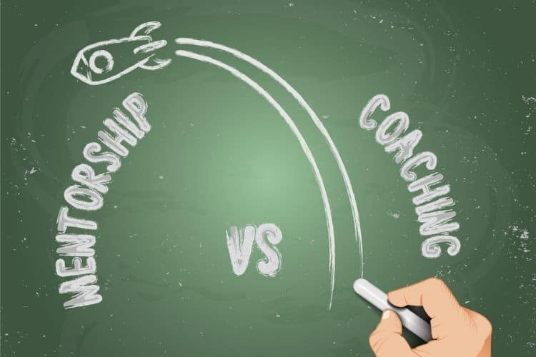

International Coaching Federation (2018)

While both coaching and mentoring are aiming at the development of individuals, they tend to differ in scope, approach, duration and outcomes. Coaching is more of task-oriented, whereby the coach is acting more as a facilitator or a feedback provider helping the coachee to achieve certain organizational goals. Such an approach emphasizing performance is likened to optimization of skills for immediate results. However, mentoring is more relationship-focused and providing broader knowledge with wisdom to support long-term career development as well as personal growth (Parsloe and Leedham, 2009).
According to existing literature, such differences are highlighted based on the target outcomes of each approach. Case in point, coaching's focus is on enhancement of specific competencies in a workplace context, making it highly effective in terms of professional development in skill areas requiring urgent attention (Passmore, 2010). Conversely, mentoring is more beneficial in one’s career trajectory, providing guidance and personal development because it is essential in building on the mentor’s experiences for the provision of a strategic input over time (Clutterbuck, 2004).
Furthermore, other research seems to suggest that while coaching is more transactional with a clearly set goal and outcomes, mentoring remains more transformational, as it fosters deeper changes aligned with the mentee's personal goals as well as values according to Hawkins and Smith (2007). Coaching typically includes a more direct, and sometimes non-directive feedback aimed to eliciting the coaches’ own insights, whereas mentoring mostly relies on a narrative as well as storytelling to convey lessons and advice.

It was suggested that coaching and mentoring move with philosophical similarity. Within the core mentoring both have developmental partnerships, with differences in focus and approach. While coaching typically focuses on specific skills or goals in a short timeframe, mentoring remains holistic, long-term, and focused on long term career as well as personal development of each practice lies the relationship between people. There are differences in methods between coaching and mentoring, but in the end both focus on helping people to achieve their goal through leveraging the experience of either the coach or mentor (Connor, and Pokora, 2017).
In other words, coaching and mentoring are both effective personal and professional development tools. Employees with mentors or coaches tend to show higher job satisfaction, commitment to the organization, attaining compensation and promotions. To decide between coaching and mentoring, it’s important to understand that both provide significant enhancement an employee’s personal as well as professional growth and later, fulfilment at work. Coaching is more of a structured relationship that helps an individual in the improvement of specific skills, enhancing performance and achieving short-term goals. It tends to focus on assisting individuals to navigate their career path and promote career development. An individuals would typically use a coach for need targeted assistance in overcoming specific challenges or accelerating their progress in a particular area (Lancer etal., 2016).
In a nutshell, whereas coaching and mentoring serve distinct purposes in the workplace, they both have effective integration which leads to a more comprehensive development strategy benefiting both the individual and organizations. By thoroughly addressing both immediate performance issues as well as supporting sustainable long-term growth, an organization can foster a more adaptable and skilled workforce that is ready to face both the existing and future challenges (Cushion, 2006).

2.3. The GROW Model of Coaching
Fgure.3 The GROW model of coaching
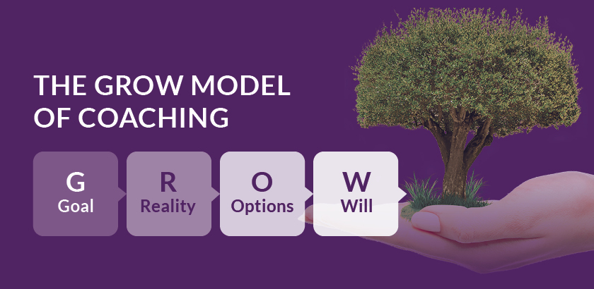
CMS Vocational Training Ltd (2024)
The GROW model is one of the most regarded coaching frameworks that was developed in the 1980s by coaching pioneers Graham Alexander, Alan Fine, and Sir John Whitmore. The model’s acronym GROW stands for Goal, Reality, Options, and Will, which represents all the four stages of the coaching process. The model has become now a staple in coaching, as it focuses on encouraging coachees in the discovery of answers as well as insights using guided questioning, instead of providing direct answers or instructions (Whitmore, 2009).

The grow model defined
- Goal
Here, the coach is helping the coachee in defining clear, achievable goals. The purpose is mainly the establishment of what the coachee wants to accomplish in both the short-term and long-term, which makes these goals as specific enough (Whitmore, 2009).

- Reality
This phase includes examination of the current reality of the situation, providing encouragement to coachees to assess where they are in terms of their goals. This demands an honest and often difficult evaluation of the existing challenges as well as available resources (Alexander, 2006).

- Options
Once the current reality has been established, the coach and coachee begin exploring the various options and strategies for overcoming obstacles and achieving the desired goals. Emphasis here is placed on the generation of a wide range of possibilities instead of providing a quick fix to the existing problem (Fine, 2015)

- Will
The last stage is about commitment. At this stage, the coachee has decided on actions to take in moving towards their goals, they set out what they will do, by when, and consider potential obstacles they might need to overcome (Whitmore, 2009).

2.4. Critical Analysis the GROW model
When critically analyses the GROW model is found to have both advantages and disadvantages.
Advantages of the GROW model
The grow model has the following advantages below.
- The GROW model is simple and very clear, which makes it easy to understand and apply across numerous contexts. The structured approach of the model helps in maintaining focus during coaching sessions (Alexander, 2006).
- The GROW model emphasizes self-reflection as well as self-generated solutions; thus, empowering coaches in taking responsibility for their development and progress. This leads to greater engagement and motivation (Whitmore, 2009).
- The GROW model is versatile making it adaptable to various coaching scenarios, from business settings to personal development contexts. Its universal applicability makes it advantageous for coaches working with diverse coachees (Fine, 2015).

The disadvantages of the GROW Model
The GROW model has the following disadvantages below.
- The GROW model assumes a certain level of self-awareness and capability in coachees that may not necessarily be present. New coaches may require more guidance to use the model effectively (Grant, 2010).
- Although the model’s simplicity is an asset, it can also be a limitation, since complex issues might be oversimplified, which leaves coaches ill-equipped to handle deeper, and more intricate problems faced by coachees (Cunliffe, 2011).
- The effectiveness of the GROW model relies on the coach's ability to ask the right questions and thus, facilitating discussions effectively. The less experienced coaches are likely to struggle with fully exploiting the model’s potential (Passmore, 2010).

3.Gibbs Reflective Cycle: Coaching Role-Play Exercise
Gibbs reflective cycle is made up of the following stages below:

1.Description
During the coaching role-play in class, I was paired with my partner, Ivo. At the beginning of the session, I became nervous and lost my train of thought. I struggled to recall what I was supposed to say, which made me feel momentarily disoriented. However, after regaining my composure, I was able to refocus and continue the coaching session effectively. I successfully completed the role-play, engaging in a meaningful coaching conversation with my partner.

2. Feelings
At first, I felt anxious and flustered when I forgot my lines. This caused me to feel self-conscious and frustrated with myself. However, as I took a deep breath and re-
cantered, I started to feel more confident. I was relieved and proud of myself for overcoming the initial setback and completing the session successfully.
3. Evaluation
The experience had both positive and negative aspects. On the negative side, I initially struggled with nerves, which affected my confidence and performance. On the positive side, I was able to recover quickly and demonstrate resilience by continuing the role-play. The interaction with my partner Ivo was productive, and we managed to complete the coaching interview effectively.
4.Analysis
The momentary loss of focus highlighted the impact of nerves on my performance. However, my ability to recover shows that I am capable of handling unexpected challenges. This experience revealed the
importance of preparation and staying calm under pressure. It also demonstrated the value of persistence and adaptability in coaching scenarios.
5.Conclusion
From this experience, I learned that being momentarily flustered is normal and does not define the overall success of the session. I realized the importance of taking a moment to breathe and refocus when feeling overwhelmed. I also recognized that having a supportive partner, like Ivo, contributed to my ability to recover and complete the role-play.
6.Action Plan
To do better in subsequent coaching sessions, I'll prepare by practicing relaxation methods (such deep breathing) to control my anxiety.
I'll get more ready by practicing important ideas and possible enquiries.
Throughout the session, I'll use quick notes or cues to assist me keep on track.
To improve my coaching even more, I'll ask my teacher and partner for feedback.

3.1. Mentoring role play experience using Gibbs reflective cycle
1. Description
For our second assignment, we had a mentoring role play scheduled at 4:30 PM. I arrived at 1:00 PM to practice before the session. When our supportive lecturer, Nishi, called us in, I felt confident because I had done a coaching role play two weeks ago. Since my partner, Ivo, and I were continuing the same scenario from our previous coaching role play, I believed it would be an easy task. However, during the session, although I started well, I unexpectedly became nervous. As a result, I rushed through the role play. After we finished, Nishi provided feedback, mentioning that I seemed eager to finish quickly and spoke too fast, which I had not realized before.
2. Feelings
At the start, I felt confident and prepared due to my prior experience and practice. However, during the session, my nervousness unexpectedly increased. I became aware that I was rushing but couldn’t control it in the moment. After receiving feedback, I feel much better, because Nishi mentioned I seemed to hurry had not noticed my fast talking. At the same time, I appreciated Nishi’s constructive feedback as it highlighted an area I need to improve.
3. Evaluation
The positive aspect of the experience was that I prepared well and initially started with confidence. I also appreciated that I received feedback to help me grow. However, my nervousness led to me rushing and speaking too fast, which affected the quality of the role play. This was a drawback, as effective mentoring
requires a calm, composed, and patient approach.
4. Analysis
My nervousness seemed to stem from a subconscious pressure to perform well, even though I had practiced. I assumed that because I had done a coaching role play before, the mentoring session would be easy, but I underestimated the subtle differences between the two. When I started feeling anxious, I unconsciously increased my speaking speed, which made it harder to engage effectively. This experience highlighted the importance of controlling my nerves and pacing my speech, especially in professional or assessment settings.
5. Conclusion
From this experience, I learned that even with preparation, unexpected nervousness can affect my performance. I also realized that speaking too fast is a habit that emerges when I feel pressured. In future role plays or real-life mentoring situations, I need to focus on maintaining a calm and steady pace.
6. Action Plan
To improve, I will:
Practice mindfulness or breathing exercises before role plays to reduce nervousness. Record myself speaking to monitor my pace and adjust accordingly. Seek additional feedback from peers or lecturers to track progress. Intentionally slow down my speech during practice sessions to develop better control. Remind myself that I have the skills and preparation needed, reducing unnecessary anxiety. By implementing these strategies, I aim to enhance my ability to communicate effectively and confidently in mentoring and coaching scenarios.

3.2 Individual SWOT Analysis
Strength | Weaknesses | Opportunities | Threat
- Resilience and recovery  - preparation and confidence  - willingness to learn  - Adaptability. | - Nervousness and anxiety  - Rushing through sessions  - Overconfidence in experience | - Skill development  - Feedback Utilization  - Practice and simulation | - Performance pressure  - Habitual responses  - Self-doubt

3.2 Individual Skills audit
Skills I Have | Example
Resilience and recovery | The ability to recover from early fear and continue shows resilience.
Skills I’d Like to Improve | How?
Rushing Through Sessions | Slow Speech Exercises

3.4 Action Plan
Development Objectives | Resources needed | Target start date | Target end date | Review date
Improve public speaking skills | Public speaking classes; practise groups; feedback | 10/05/2025 | 06/06/2025 | 06/07/2025
Enhance time management abilities | Time management tools (apps, planners); online workshops | 12/05/2025 | 24/06/2025 | 12/08/2025
Develop proficiency in a new software program | Networking events; online platforms (LinkedIn); guides | 14/05/2025 | 14/06/2025 | 11/07/2025
Cultivate a healthier lifestyle | Nutrition and exercise resources; meal planning tools; fitness app | 20/05/2025 | 20/06/2025 | 20/09/2025
Learn a new language | Language learning apps; study materials; language partner | 28/05/2025 | 30/07/2025 | 28/10/2025

4. Conclusion

This report explored the dynamics of coaching and mentoring in professional settings. It
emphasized their unique purposes and methodologies. Coaching, as suggested by Whitmore (2002), involves the elevation of an individual’s performance using structured and goal-oriented sessions. The GROW model, is explained as a versatile framework, facilitating this process by providing guidance to coachees using goal setting, reality assessment, exploration of options, and eventual commitment to action (Whitmore, 2009). whereas, mentoring denotes to a more holistic and long-term relationship, where concentration is placed on career growth as well as the transfer of wisdom together with experience, as suggested by Clutterbuck (2004).
Both Gibbs' Reflective Cycle and real-world role-plays provided valuable insights into personal development. Such experiences underscore the vital importance of preparation, resilience, together with adaptability in professional interactions, as explained in my reflective account. My successful comprehension of the emotional and procedural aspects of these roles using reflection and practice, have given me an enriched understanding of the skills required in both coaching and mentoring. These includes active listening, empathy, and the urgency of fostering discussions.
In the future, such insights will inform my future workplace practices, providing guidance in blending coaching's structured approach with the relational depth of mentoring. By embracing feedback, the practice of mindfulness, and improvement in my communication will fortify my ability to facilitate both enhancement of immediate performance and sustainable personal development. Such an integration acknowledges the transformational potential of effective harnessing of both paradigms in cultivating a resilient and competent workforce ready to navigate more complex professional landscapes.

5.References
Alexander, G. (2006). The Secrets of Successful Coaches. Thames Business Forum
Clutterbuck, D. (2004). Everyone Needs a Mentor: Fostering Talent at Work. CIPD Publishing.
Connor, M. and Pokora, J. (2017). Coaching and mentoring at work: Developing effective practice: Developing effective practice. McGraw-Hill Education (UK).
Cunliffe, A. L. (2011). Crafting Qualitative Research: Working in the Postmodern Methodological Tradition. Routledge.
Cushion, C., (2006). Mentoring: Harnessing the power of experience. In The sports coach as educator (pp. 128-144). Routledge.

Fine, A. (2015). You Already Know How to Be Great. Penguin Random House.
Garvey, B., Stokes, P., & Megginson, D. (2014). Coaching and Mentoring: Theory and Practice. SAGE.
Grant, A. M. (2010). Is it time to REGROW the GROW model? Coaching: An International Journal of Theory, Research and Practice, 3(2), 125-134.
Hawkins, P., & Smith, N. (2007). Coaching, Mentoring, and Organizational Consultancy: Supervision and Development. Open University Press.
Kram, K. E. (1985). Mentoring at Work: Developmental Relationships in Organizational Life. Scott Foresman.
Lancer, N., Clutterbuck, D. and Megginson, D. (2016). Techniques for coaching and mentoring. Routledge
Parsloe, E., & Leedham, M. (2009). Coaching and Mentoring: Practical Techniques for Developing Learning and Performance. Kogan Page.
Passmore, J. (2010). Excellence in Coaching: The Industry Guide. Kogan Page.
Whitmore, J. (2002). Coaching for Performance: Growing People, Performance, and Purpose. Nicholas Brealey Publishing.
Whitmore, J. (2009). Coaching for Performance: Growing Human Potential and Purpose - The Principles and Practice of Coaching and Leadership. Nicholas Brealey Publishing.
Cunliffe, A. L. (2011). Crafting Qualitative Research: Working in the Postmodern Methodological Tradition. Routledge.

