Qualification: CIPD Diploma in Applied Human Resources

Module Name:
Contributing to Employee Engagement in the Organisation 5AEEG

Word Count: 2941

Student Name: Isabelle Solomon
Student Number: 1919798
CIPD Membership Number: 56660407

By signing below, I confirm that the work/evidence presented is my own, unaided work. I understand the regulations pertaining to candidate malpractice and the action that may be taken as a result.

Signed: Isabelle Solomon
Date: 2nd March 2022

Candidate name: Isabelle Solomon |  |  |  |  | CIPD Membership/registration No.:  56660407
Qualification title: Applied Human Resources |  |  |  |  | Unique Learner No. (ULN):  1919798
Unit code | Unit title |  | Assessment criteria no. | Evidence description | Evidence reference number |  | Assessor  initials | I/V initials if sampled
5AEEG | Contributing to Employee Engagement in the Organisation |  |  | Survey format | EV 1
 |  |  |  | Survey sample answers | EV 2
 |  |  |  | Staff Handbook | EV 3
 |  |  |  | Company Whatsapp | EV 4
 |  |  |  | Day courses | EV 5
 |  |  |  | Meeting Notes | EV 6
 |  |  |  | Survey sample results | EV 7
Candidate declaration:
- I confirm that the work/evidence presented for assessment is my own unaided work.
- I have read the assessment regulations and understand that if I am found to have ‘copied’ from published work without acknowledgement, or from other candidate’s work, this may be regarded as plagiarism which is an offence against the assessment regulations and leads to failure in the relevant unit and formal disciplinary action.
- I agree to this work being subjected to scrutiny by textual analysis software if required.
- I understand that my work may be used for future academic/quality assurance purposes in accordance with the provisions of the Data Protection Act 1998.
- I understand that the work/evidence submitted for assessment may not be returned to me and that I have retained a copy for my records.
- I understand that until such time as the assessment grade has been ratified through internal and external quality assurance processes it is not final.
Signature: |  | Isabelle Solomon |  |  |  | Date: | 17th February 2022

Contents Page:
- Titles Page
- Evidence Matrix
- Contents page
- Question 1
- Question 1.4
- 2.1 – 2.2
- 2.2 – 3.1
- 3.2
- 3.3
- References
- EV 1
- EV 2
- EV 3
- EV 4
- EV 5
- EV 6

Contributing to Employee Engagement in the Organisation
1.1
To measure the levels of employee engagement within our company, myself and a director discussed what would be the best method. We took into consideration the remote working of employees and the busy workloads. We pay for a survey system within the organisation which we usually use to gather customer feedback but I was given authorisation to use it to give out my employee engagement survey. A survey was picked due to not having everyone in the same location at once so a face-to-face meeting would not be possible. All employees have a company email address also so I knew I could send it to everyone.
We chose to use the GALLUP 12 questions as the survey because it takes a snapshot of where employees are in terms of engagement and covers a range of aspects. It starts with the bare essentials of engagement, moving on to career satisfaction and recognition, the employer/employee fit and ends with prospects (Surveys, n.d.). The advantages of doing this survey are:
- It asks direct questions that inspire honesty
- Specific weaknesses are highlighted (Surveys, n.d.)
- It is free
- Data is easily collated and reviewed
1.2
A director and I have agreed that I can use our survey platform to distribute the survey and to collate the results. I have been given permission to send it to everyone’s email address in the organisation and I am allowed to send it to the self-employed members also. The survey is short and should take no more than 10 minutes to answer so I am allowed to encourage employees to complete the survey during their working hours.
1.3
The survey has been issued using Survey Monkey (EV 1). I have sent the survey to all employees because we are a small organisation and to get a range of different results and perspectives.
1.4
To the 16 people I sent the survey to, I have had 10 responses (EV 2). Results are as follows (EV 7):
Question 1- 9 people answered yes to knowing what was expected of them at work.
Question 2 – I have the materials and equipment I need to do my work right – 7 answered yes.
Question 3 – I have the opportunity to do my best – 7 answered yes.
Question 4- I have received recognition or praise in the last 7 days- 5 answered yes- 1 answered yes from customers.
Question 5 – My supervisor or someone at work seems to care about me as a person- 10 answered yes.
Question 6 – There is someone at work who encourages my development – 8 answered yes.
Question 7 – At work, my opinions seem to count – 5 answered yes.
Question 8 – The mission or purpose of my company makes me feel my job is important – 9 people answered yes.
Question 9 – My associates or fellow employees are committed to doing quality work – 8 people said yes.
Question 10 – I have a best friend at work – 7 people answered yes.
Question 11 – In the last 6 months, someone at work has talked to me about my progression – 9 people answered yes.
Question 12 – This last year, I have had opportunities at work to learn and grow- 8 people answered yes.
Overall at least 50% of people agreed with most of the statements with the worst scoring statement being around praise and recognition and at work my opinions seem to count. I can make an assumption, without carrying out any more research that recognition and praise in the last 7 days does fall short because of the remote working and the nature of the job. I can also add that the main Director is extremely busy and hands on- he does work alongside the boiler engineers and as such is not available to give praise to all on a weekly basis. My opinions seem to count, from a personal perspective I can see how some might feel this. Lorries are extremely expensive to buy and when a drivers breakdown they do suggest getting new ones- but there is a cost to this and also a 2 year wait for a new vehicle to be built and ready, so it’s not so much they don’t count, I think it is the fact that some of the opinions and suggestions are unrealistic if they knew the why and detail behind that decision. Materials and equipment needed to do my work right- this is only 7 answering yes because 1 is the engineer who we need to order parts for specific jobs and sometimes they are out of stock because biomass is such a niche market, and the other 2 are from the HGV drivers, where we have recently had a lot of lorry issues with them breaking down.
2.1
Our organisation is small and consists of 14 employed members of staff and 2 self-employed who work as and when needed. There are four Managers, two Directors and 8 employees. We have 5 HGV employees who operate under the transport manager and 2 engineers who operate under a Manager/Director and myself who operates under the direction of a Director.
The first bit of engaging information an employee is given is the employee handbook, along with their contract of employment. The employee handbook has all the relevant information regarding policies and procedures within it and if an employee wants to find how they request annual leave etc, it is easy to navigate. The opening paragraph in the employee handbook is really the only ‘engaging’ part different to other companies, the rest can be viewed as a standard employee handbook template (EV 3).
The probationary period is when new employees meet everyone, are shown around the premises and receive one-to-one training. They get to know the team and are paired with another employee for two weeks to learn their role and how the organisation as a whole works and operates. Many of our positions are lone working now due to the pandemic and the need for separate offices during this time, also many of our roles have just one person completing them. For this reason engagement is extremely important. Employees need to know what is going on and need to feel that their contribution is making a difference, but if they are never in the same location as their line manager, then it is important that we engage by other means. Currently our employee engagement takes the forms of:
- Daily- We are in constant communication daily with company Whatsapp groups (EV 4). This enables us to share information with everyone quickly. We stay in touch via these groups and communicate orders/issues etc through them.
- We have an office phone system so we can internally call each other as we are working in separate offices and remote working. This works really well as we can just pick up the phone and have a chat whenever.
- We have monthly staff meetings (EV 6). These involve management and HR. The organisations vision and performance is reviewed in these, along with jobs that need doing and feedback/issues which need dealing with. Anyone can speak during these meetings and notes are taken and to do points actioned. The meeting notes are then emailed to all so everyone can review what was discussed and action the to-do points relevant to their departments. The following month then the to-do list is reviewed first to make sure everything has been actioned before moving on.
- We have an internal work email system so everyone can email colleagues and we also have teams set up. Teams is not used often as we mainly use Whatsapp as this is on people’s mobiles.
- Once a year a staff outing takes place where the whole team goes on a day out, karting/shooting etc and then out for a meal. This is all about relaxing and team building rather than what the company is doing/achieving.
- Once a year we also have a Christmas meal out as a whole team also so that all staff members can enjoy each other’s company and gel better as a team.
2.2
A barrier to engagement is lone working and working remotely or in separate office buildings. The HGV driver’s role means arriving on the yard on a Monday before anyone else, and are going before anyone else arrives that day. They do not return then until Friday evenings, when everyone has primarily left. This means that all engagement with them takes place digitally or via phone conversations. The driver job can be very isolating as they do lone work 99% of the time. They are away all week sleeping in their cabs so are not around friends/ family or colleagues. There is nothing we as an organisation can do to change this job role to make sure they touch base with everyone face-to-face.
The engineers do a lot of lone working but they tend to start off on the yard together, grab a cup of tea and have a chat before going off to their different destinations. They all return to the yard at the end of the day, where again they have tea and a catch up. A director is present first thing in the morning and at the end of the day so communication between this group is very good, meaning they are engaged because they know first-hand what is happening.

3.1
There are several definitions for employee engagement. Early definitions of employee engagement is defined by Kahn (1990) which focuses on how employees express themselves ‘physically, cognitively and emotionally’ as they do their job roles (Gifford and Young, 2021). Physical engagement can be expressed through the effort and energy they put into their work. Cognitive engagement can be expressed through focus on ones work and fully submerged in the detail whereas emotional engagement is when the employee shows a sense of pride in their work, feels satisfied and enthusiastic about their job (Taylor and Woodhams, 2016).
Utrecht University group of occupational psychologists narrowly defines work engagement as a state of mind in an employee which is shown by vigour, dedication and absorption in ones work (Gifford and Young, 2021). The CIPD research suggest there are two types of employee engagement, one being emotional engagement where the employee feels emotionally involved or attached to a part of the organisation/their work and the other being transactional engagement. Transactional engagement can be demonstrated in an employee as someone who appears engaged in their work but would happily jump ship for a better offer elsewhere (Taylor and Woodhams, 2016). The emotional engagement happens at a deeper level.
The Institute of Employment Studies (IES) carried out research into 25 ‘engaging managers’ across seven different organisations. They chose these managers because they managed the most engaged teams but their job roles differed, along with their span of control. These managers had nothing in common except that they all had similar behaviours when managing their teams. These managers were put forward because of their teams high engagement scores but it also was apparent that they had performing teams (Taylor and Woodhams, 2016). The reasoning behind their success was that they were not afraid to have the difficult conversations, to manage the poor performance and behaviour, to deal with issues head on and quickly (Taylor and Woodhams, 2016).
Employees of these managers were asked to describe why their managers were engaging. A theme of behaviours emerged of high levels of communication, listening, two-way conversations, a focus on targets rather than processes, generally interested in their employees and are positive role models (Taylor and Woodhams, 2016). Organisations that are engaging have invested time and money into ensuring their management teams have developed the behaviours needed to promote engagement and well-being (Research report -phase 2, 2017). This investment of training in managers, give the manager a sense of engagement and involvement with the company. It makes the manager more competent and confident within their role and their ability to do their job.
There has been evidence that there is a link between employee engagement and organisational success. With this link established, that means that engagement becomes a focus for HR strategies and practice. A Gallup study in 2010 found that business units with the highest levels of engagement had 18% higher levels of productivity than those with the lowest scores of engagement (Research report -phase 2, 2017).
3.2
A barrier to engagement within our organisation is that managers are managers because they hold the relevant certification needed to perform that role, such as the Transport manager has a transport management license, the Health and Safety manager has the NEBOSH certification and the Finance manager has an accountancy degree but none of them have had sufficient training in managing people. The Directors have no qualifications in managing people and have not attended any courses. To manage people and know about engagement practices etc you need to have looked externally at courses or events which will give you knowledge and understanding of these topics. We did start to send the Transport manager on managing people day courses but then the pandemic hit and they were cancelled. He managed to attend a ‘bullying and harassment at work’ course, which improved his knowledge and surprised him regarding what is considered bullying/harassment and unacceptable. There is a lack of knowledge around HR principles, employee engagement, managing people and this does need to be addressed so that we can improve our operation.
Time is a barrier to engagement within our organisation because people work remotely we are never in the same location unless it is the monthly meeting. This is organised a couple of weeks in advance and for us to engage with each other more we would need to allocate time to spend with each other. Communication between us is good with multiple digital platforms available for us to do this, however some employees do not embrace these and will not openly communicate unless asked. The main Director is not a talkative person and has multiple work commitments so his communication needs to be improved, he needs to lead by example.
The findings that the most engaging managers were those who communicated well and dealt with issues quickly, I feel our organisation is extremely slow to address poor performance or poor behaviour with most issues not being dealt with at all. This means the organisation has a culture of not addressing issues, of some employees can do what they want and there are no repercussions. This means employees who are trying their hardest and do want to learn and grow become disengaged because they do not see the point when employee X can behaviour or perform so poorly.
Management support is limited and this hinders engagement. When an issue arises and a manager wishes to discuss with a Director, the Director is not usually available to talk through issues or offer support and guidance. Some managers do like the lack of support because they can get on with making the decisions, but others do want that support, guidance and recognition.
With remote work stations, HGV away jobs and engineers out on different jobs, it is rare that we know where or what jobs our colleagues have on throughout the day.
Confidentiality is not present in our organisation. Some managers communicate too much information regarding sensitive issues around the organisation or its employees. This impacts on the level of trust the employees have in management and hinders engagement.
3.3
Management needs to attend courses on employee engagement and managing people. Redkite and Morgan Le Roche Solicitors offer day courses (EV 5) on specific subjects and these need to be attended as soon as possible. This will involve time out of the normal working week but I feel it will be a good investment.
Weekly catch ups either remotely or in person between management to address issues or to give support and recognition I feel need to take place at least once a week.
Issues of poor performance and behaviour need to be dealt with. There is no point in being held to ransom by employees because of the fear you won’t be able to replace them as this is hindering the culture of the organisation and its overall success. A course for Managers and Directors on managing poor performance will be a good investment.
Confidentiality needs to happen. Employees need to know if they are having their performance addressed, a wage increase or want to talk to a manager about an issue, they need to trust it will go no further. Sensitive company information which also should be confidential should be, without managers communicating this when it is inappropriate to do so. An example would be around supply issues or the risk of redundancies.
HGV drivers need to engage with more employees and not just each other and their line manager. There needs to be a once a week catch up with them collectively which needs to be headed by the Director. Without the HGV drivers there is no company and I feel that we take this for granted. They are the most important group of employees but they are the ones we engage with the least. It will take some organisation to get them all in the same place at the same time every week, but I think if we do this on a Monday or Friday and schedule it the same time every week, this will not be an issue. The highest turnover rate within our company is with HGV drivers- they are also the hardest to replace- and I think if we invest this time each week, then we will engage them better and hopefully hang on to them for longer.

References:
Research report -phase 2. (2017). [online] Available at: https://www.cipd.co.uk/Images/developing-managers-to-manage-sustainable-employee-engagement-health-and-well-being_2017_tcm18-18364.pdf.
Surveys, E.E. (n.d.). What is Gallup’s Q12 Survey and does it still matter? – Employee Engagement Survey Tool – SurveyBot. [online] Available at: https://survey.bot/what-is-gallups-q12-survey-and-does-it-still-matter/.
Taylor, S. and Woodhams, C. (2016). Human resource management : people and organisations. 2nd ed. London: Chartered Institute Of Personnel And Development.
The Big Picture People. (2020). Employee Alignment with Business Strategy. [online] Available at: https://thebigpicturepeople.co.uk/blog/employee-alignment-with-business-strategy/#:~:text=This%20is%20when%20employee%20engagement%20can%20thrive%2C%20and.

EV 1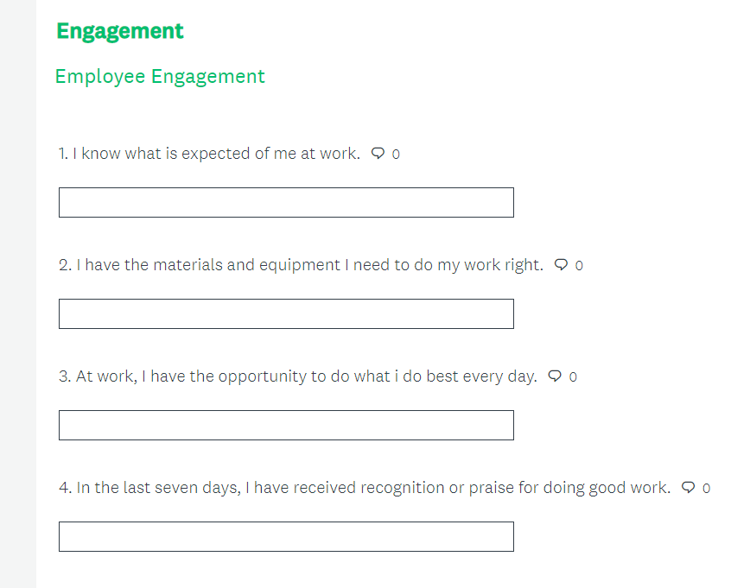
EV 2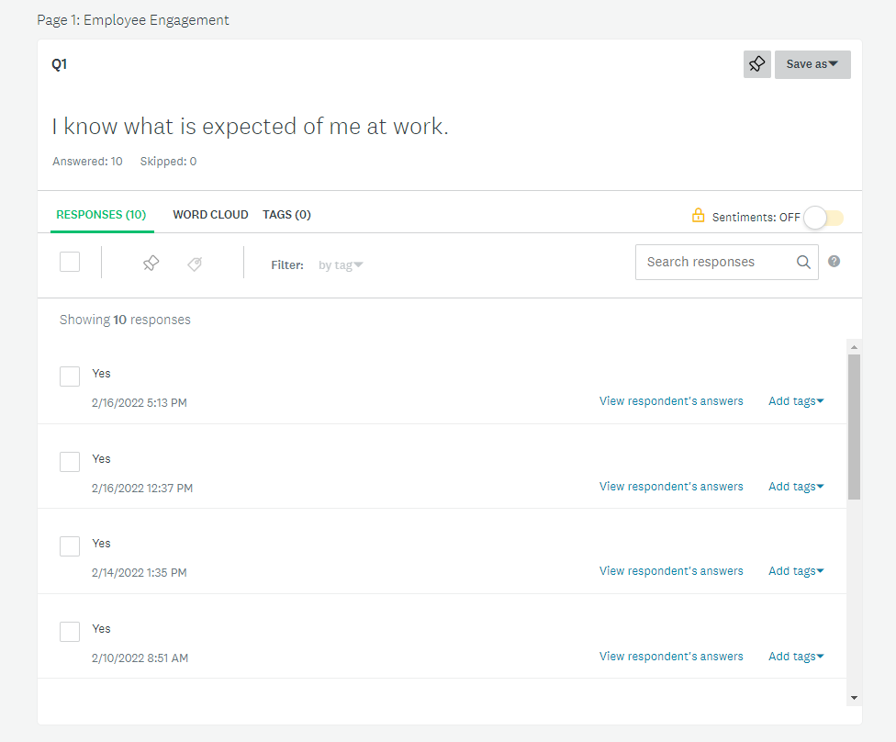
EV 3
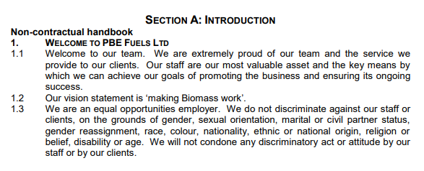

EV 4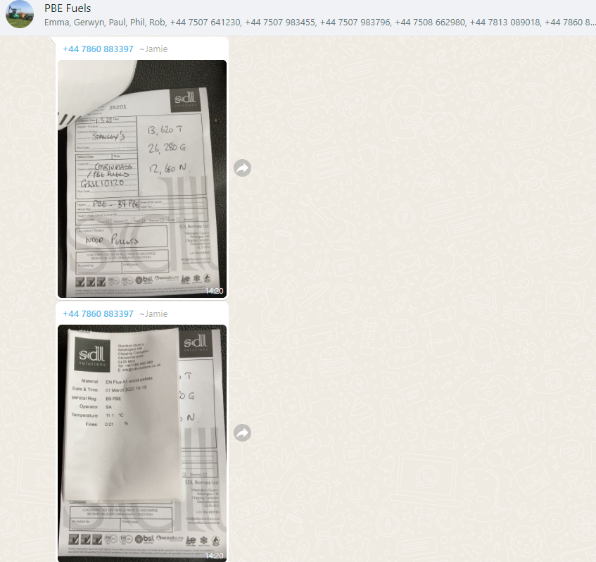
EV 5
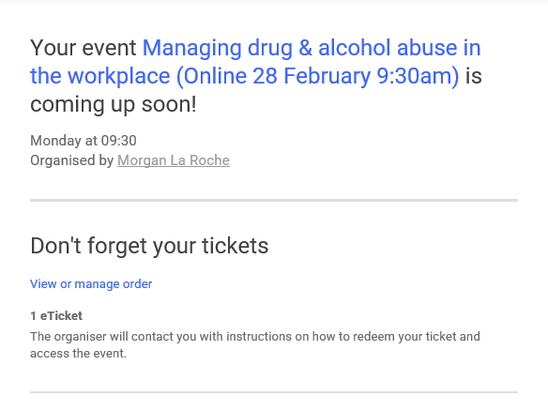

EV 6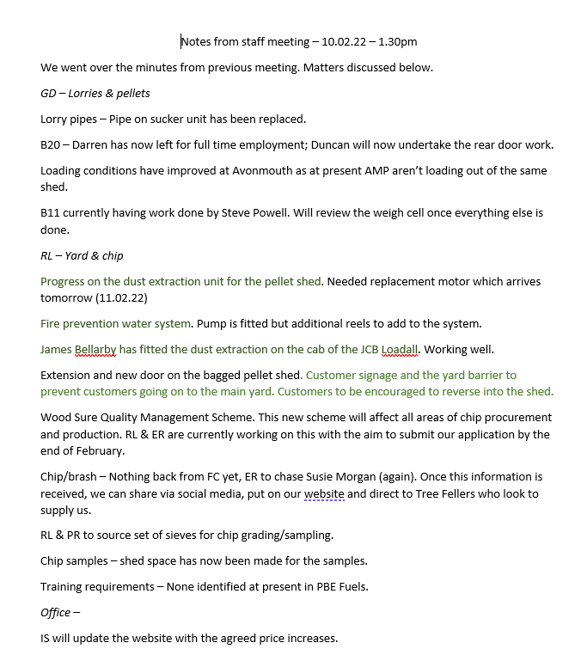
EV 7


