

Student name: Daniel Ifeanyichukwu Odunze
Student ID: 2010426

Module name: Introduction to Physiology
Module code: BMHP5003_LON
Lecturer name: Laila Surani.

Assessment: 2, Report.

Date: 26/04/22

Topic: Type 2 Diabetes.

1. Introduction
Diabetes is a chronic illness that starts with a high amount of glucose in the blood of the human body. It's also known as a metabolic disorder since it affects the body's metabolism. Type 1 diabetes (also known as insulin-dependent diabetes mellitus) and type 2 diabetes are the two types of diabetes that can be seen (also known as insulin resistant diabetes mellitus). Diabetes type 1 is more frequent than diabetes type 2. According to the World Health Organization's most recent figures, around 422 million people worldwide suffer with diabetes.
While at the same time, diabetes claims the lives of more than 1.5 million people worldwide each year (Who, 2021).
Globally, the number of people with diabetes is increasing exponentially, and this is the case everywhere. On the other hand, various public and governmental measures, including those at the international level, are being employed in the fight against the development of diabetes Mellitus and its complications. That group of policies is primarily concerned with reducing the incidence of complications connected with type 2 diabetes over the long run, as well as reducing health inequities related with the occurrence of diabetes type 2 over a long period. This study will cover the anatomy and physiology of the organ responsible for this disease, as well as the daily behaviours and routines that might lead to type 2 diabetic complications. This study will also explore health and social care practises, as well as government policies, in more detail.

2. Anatomy and Physiology of the Pancreas.
Anatomy studies the interior and outer structures of the body, whereas physiology studies how those structures operate. (Blanchard, 2005).

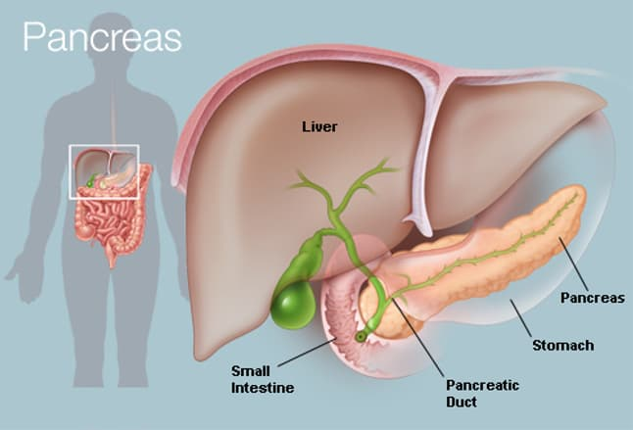
2014 WebMD, LLC.

The pancreas is approximately 6 inches in size and is situated in the middle of the body, across the rear of the abdomen, behind the stomach. It is responsible for digestion. It generates enzymes that aid in the digestion of meals. When you examine your belly, you'll see that the pancreas's top is positioned on the right-hand side and that it is connected to the duodenum (very first segment of the small intestine) by a short tube called the pancreatic duct. The pancreas, which is situated in the belly, is responsible for the production of insulin. The tip of the pancreas is a small section of the organ that runs from the right-hand side of the body to the left-hand side of the belly. It is responsible for digestion. (Hoffman, 2009).
It is called type 2 diabetes when the body develops an inability to respond to insulin, leading to an increase in blood sugar levels. The pancreas progressively loses its capacity to make and release insulin in a timely manner, necessitating the use of synthetic insulin to compensate. (Biga et al., 2021).
Endocrine function refers to the release of insulin (made by beta cells) and glucagon (produced by alpha cells) by the pancreas' endocrine cells inside the pancreatic cells. Insulin and glucagon are the hormones that control how quickly glucose is metabolised inside the body.
Type 2 diabetes is a long-term disorder where the blood sugar level is unusually high. Diabetes type 2 is the most common form of the disease. The least common kind of diabetes is type 1.
Insulin is a hormone that is produced in the pancreas by beta cells, which are insulin-producing cells. Insulin is necessary for sugar transfer into cells. Glucose is retained in the cells and then utilised to produce energy.

Your fat, muscle, and liver cells do not react to insulin as they should if you have type 2 diabetes. Insulin resistance is the medical name for this problem. Consequently, blood sugar is unable to reach these cells, where it may be utilised as a source of energy.
When glucose cannot reach cells, a large amount of sugar builds up in the circulation. Hyperglycaemia is the medical term for this condition. Consequently, the body will not be able to use glucose as a source of energy. Because of this, type 2 diabetes develops.
Type 2 diabetes is usually discovered after a considerable time has passed. Most people who are diagnosed with the disease are overweight or obese. Gaining weight makes it more difficult for your body to properly use insulin.
People who are neither overweight nor obese, as well as those who are, may develop type 2 diabetes. This happens more commonly in the elderly.
Type 2 diabetes is impacted by a person's genetics and family history. Low physical activity, a poor diet, and excess body weight around the waist all increase the risk of developing the disease. (Medline Plus, 2022).

3. Health and Lifestyle routine measures that increases possibilities of getting diabetes type 2.

It can be challenging to maintain your blood sugar levels within the range suggested by your doctor at times. This is because a variety of events can cause your blood glucose levels to vary, often in an unexpected manner. Healthy diet is essential for living a healthy lifestyle, regardless of whether you have type 2 diabetes.
In addition to an increased risk of type 2 diabetes, smoking cigarettes is linked to many other health issues, including heart disease, cancer, and a few others. A "sedentary" lifestyle is defined as one in which you spend a significant amount of time sitting. Type 2 diabetes is linked to lengthy periods of sitting, which are linked to an increased chance of developing the condition.
It has been shown that excessive use of alcoholic drinks relates to a greater risk of acquiring diabetes type 2. The current guidelines state that on a routine basis, no more than 14 units per week should be taken, and that these units should be taken over a period of 3 to 4 days.
Sleep deprivation, as well as sleeping for an extensive length of time, has been associated to an increased risk of cardiovascular disease. We can sleep for longer periods of time and with more efficiency if we consider a range of things.
When you drink a lot of alcoholic drinks on one or two days a week, you raise your chances of acquiring other health concerns, such as some types of cancer. Moderate alcohol use seems to be linked to a decreased risk of type 2 diabetes, according to the evidence presently available. (Diabetes Uk, n.d.).
Individuals who do not participate in physical exercise and are overweight or obese have a higher risk of developing type 2 diabetes than others. (NIDDK, 2019).
The lack of physical exercise is a problem: Physical exercise has several advantages, including the ability to help you prevent type 2 diabetes if you are genetically predisposed to it.
A diet high in fat and poor in fibres which may be contained in cereals, fruits, and vegetables, significantly increases the likelihood of getting diabetes type 2.
Unhealthy weight gain and obesity can be aggravated or hastened by a lack of physical exercise as well as bad food preparation selections. Being overweight is related with increased chances of getting diabetes type 2, which might raise the possibilities of acquiring a range of other health concerns. (M, 2009).
People who drink excessively are more likely to suffer from pancreatitis, which is an inflammation of the pancreas that may be deadly. Alcohol metabolism is believed to damage the pancreatic acinar cells with oxidants and other harmful by products. The pancreas starts to digest itself when enzymes that are typically released into the digestive system and activate when they reach the small intestine become active. Pancreatic tissue that has been wounded causes inflammation, which further impairs the pancreas' ability to perform its normal functions. (Samokhvalov, Rehm, and Roerecke, 2015).
Type 2 diabetes is related with active smoking, which is a risk factor. (Willi et al., 2007).

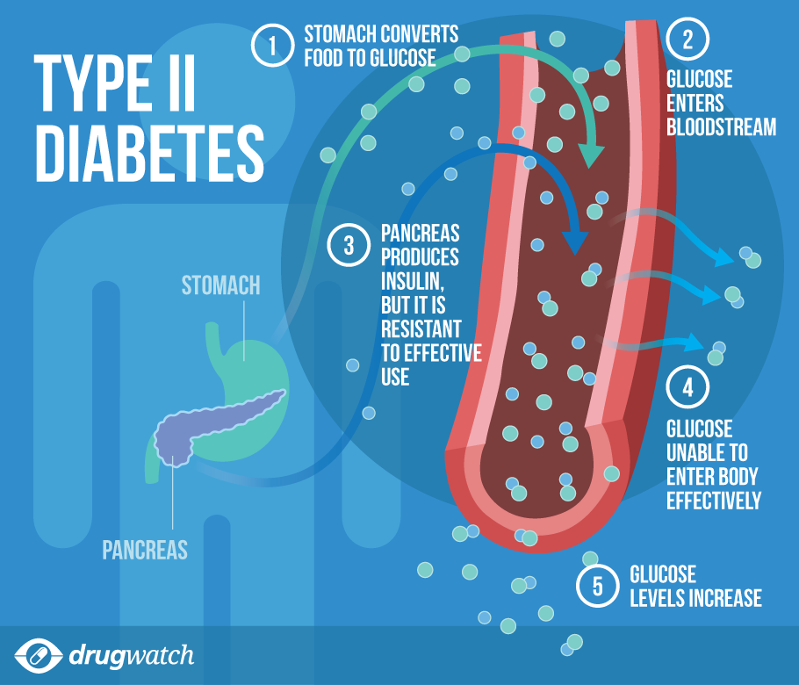
Drug watch google pictures.

4. Health and Social Care practice:

There have been a few laws and regulations put in place to tackle type 2 diabetes in the United Kingdom.
NHS Diabetes Prevention Programme (NHS DPP) is a joint programme led by Public Health England, NHS England, and Diabetes UK that aims to prevent diabetes in the general population. It was planned, when the Scheme was first formed in 2015, to give scientifically proven behavioural therapies to a considerable number of individuals who had been diagnosed as being at major risk of acquiring Type 2 diabetes.
Aims of the NHS Diabetes Prevention Programme are to: reduce the incidence of Type 2 diabetes; reduce the incidence of side effects associated with Type 2 diabetes – such as heart disease, stroke, and kidney failure; reduce the incidence of eye disease and foot problems associated with diabetes; and reduce disparities associated with diabetes cases in the United Kingdom. (Mayo Clinic, 2018).
As a result of public input, the government has responded by regulating the promotion of foods that are rich in fat, sugar, and salt, as well as their availability and price. (Gov.UK, 2021).
To reduce the number of amputations, the National Health Service (NHS) diabetes treatment and care programme has set a goal of providing patients with access to professional multidisciplinary footcare teams to reduce the number of amputations.
To achieve improved quality of diabetic patients' treatment, it is necessary to increase their admission to diabetes inpatient specialised nursing teams in hospitals.
Variation in the accomplishment of three NICE-recommended treatment objectives (HbA1c (blood sugar), cholesterol, and blood pressure), and one treatment target (HbA1c) for children, and the expansion of structured education including digital options to better support patient self-management are top priorities in adults.
According to the National Health Service's Low Calorie Diet Programme, a high priority of experimental research is being conducted to evaluate at scale treatments that have been shown to reverse type 2 diabetes in newly diagnosed individuals. Patients with obesity who also have diabetes, hypertension, or both can benefit from the NHS Digital Weight Management Programme, which assists patients in managing their weight and improving their overall health. (NHS England, 2017).

5. Recommendations

Considering the complications of type 2 diabetes, the following recommendations would be appropriate.
Diabetes is a life-threatening condition. Following your diabetes treatment plan necessitates a commitment.
Find out everything you can concerning diabetes. Create a balanced diet and physical exercise schedule that you can stick to every day. Stay at a healthy weight by exercising regularly.
Maintain a close eye on your blood sugar levels and adhere to the recommendations of your health care professional for controlling your blood sugar level. You should take your prescriptions according to the instructions provided by your health-care provider. When you want assistance, ask your diabetes care team for assistance. If you smoke, try to limit your intake. Cigarette smoking increases the likelihood of acquiring type 2 diabetes as well as a variety of diabetic complications. Maintain healthy blood pressure and cholesterol levels. In conjunction to your annual physical and regular eye examinations, arrange two to four diabetes checks a year to keep your diabetes under control. Maintain your immunisation records since diabetes raises your chance of contracting certain disorders. Vaccines given on a regular basis can help avoid them.
Take good care of your teeth since diabetes might make you more susceptible to gum disease. Take good care of your feet. If you want to consume alcoholic beverages, do so in moderation.
According on how much you consume and whether you eat at the same time, alcohol can result in either high or low blood sugar levels. You should drink only in proportion if you want to do so. For women, this means no more than one glass per day and no more than two drinks per day for males. (Mayo Clinic, 2018).

6. Conclusion

To summarise, diabetes is a hazardous condition that typically results in elevated blood sugar levels. As a result of the disease, the human body gets unable of creating enough insulin in the bloodstream, which can then be utilised by the body
Additionally, the role of many agencies in avoiding diabetes and placing the situation of diabetes into respite is covered in the themes, as well as specific instances of organisations that are actively working to further the cause of diabetes.
Cultivating a good lifestyle activities will enhance and promote healthy living.

References.
Reference list
- Biga, L.M., Dawson, S., Harwell, A., Hopkins, R., Kaufmann, J., LeMaster, M., Matern, P., Morrison-Graham, K., Quick, D. and Runyeon, J. (2012). 17.9 The Pancreas. [online] open.oregonstate.education. Available at: https://open.oregonstate.education/aandp/chapter/17-9-the-pancreas/ [Accessed 22 Apr. 2022].
- Blanchard, S. (2005). 3 - ANATOMY AND PHYSIOLOGY. [online] ScienceDirect. Available at: https://www.sciencedirect.com/science/article/pii/B9780122386626500057 [Accessed 22 Apr. 2022].
- Diabetes Uk (n.d.). Diabetes risk factors. [online] Diabetes UK. Available at: https://www.diabetes.org.uk/preventing-type-2-diabetes/diabetes-risk-factors?gclid=Cj0KCQjwgYSTBhDKARIsAB8KuktZk8OyhqV8yHm_hb9rEMrlS7PT3wvQEc5w2yTwGsvB62wuE_C4jCQaAsrMEALw_wcB [Accessed 22 Apr. 2022].
- Gov.UK (2021). Restricting promotions of products high in fat, sugar and salt by location and by price: government response to public consultation. [online] GOV.UK. Available at: https://www.gov.uk/government/consultations/restricting-promotions-of-food-and-drink-that-is-high-in-fat-sugar-and-salt/outcome/restricting-promotions-of-products-high-in-fat-sugar-and-salt-by-location-and-by-price-government-response-to-public-consultation [Accessed 22 Apr. 2022].
- Hoffman, M. (2009). Picture of the Pancreas. [online] WebMD. Available at: https://www.webmd.com/digestive-disorders/picture-of-the-pancreas [Accessed 22 Apr. 2022].
- M, L. (2009). Type 2 Diabetes Causes. [online] EndocrineWeb. Available at: https://www.endocrineweb.com/conditions/type-2-diabetes/type-2-diabetes-causes [Accessed 22 Apr. 2022].
- Mayo Clinic (2018). Diabetes care: 10 ways to avoid complications. [online] Mayo Clinic. Available at: https://www.mayoclinic.org/diseases-conditions/diabetes/in-depth/diabetes-management/art-20045803 [Accessed 22 Apr. 2022].
- Medline Plus (2022). Type 2 diabetes: MedlinePlus Medical Encyclopedia. [online] medlineplus.gov. Available at: https://medlineplus.gov/ency/article/000313.htm#:~:text=When%20you%20have%20type%202 [Accessed 22 Apr. 2022].
- NHS England (2017). NHS England» Diabetes treatment and care programme. [online] England.nhs.uk. Available at: https://www.england.nhs.uk/diabetes/treatment-care/ [Accessed 22 Apr. 2022].
- NIDDK (2019). Symptoms & Causes of Diabetes | NIDDK. [online] National Institute of Diabetes and Digestive and Kidney Diseases. Available at: https://www.niddk.nih.gov/health-information/diabetes/overview/symptoms-causes [Accessed 22 Apr. 2022].
- Public Health England (2018). Health matters: preventing Type 2 Diabetes. [online] GOV.UK. Available at: https://www.gov.uk/government/publications/health-matters-preventing-type-2-diabetes/health-matters-preventing-type-2-diabetes [Accessed 22 Apr. 2022].
- Rad, A. (2022). Definition and Overview of the organs. [online] Kenhub.com. Available at: https://www.kenhub.com/en/library/education/the-human-anatomy [Accessed 22 Apr. 2022].
- Samokhvalov, A.V., Rehm, J. and Roerecke, M. (2015). Alcohol Consumption as a Risk Factor for Acute and Chronic Pancreatitis: A Systematic Review and a Series of Meta-analyses. EBioMedicine, [online] 2(12), pp.1996–2002. Available at: https://www.ncbi.nlm.nih.gov/pmc/articles/PMC4703772/ [Accessed 22 Apr. 2022].
- Willi, C., Bodenmann, P., Ghali, W.A., Faris, P.D. and Cornuz, J. (2007). Active Smoking and the Risk of Type 2 Diabetes. JAMA, [online] 298(22), p.2654. Available at: https://pubmed.ncbi.nlm.nih.gov/18073361/ [Accessed 22 Apr. 2022].
- World Health Organization (2020). Diabetes. [online] World Health Organization. Available at: https://www.who.int/health-topics/diabetes#tab=tab_1 [Accessed 22 Apr. 2022].

