Learning and Development Blog
Author: Eve Churchward Dated: 14th November 2024.

Student officer wellbeing.
The Police environment can be high paced, stressful and tough at times due to the nature of the work, particularly in public facing roles. Police are held to a higher regard as public servants which means the training must be of the highest quality to prepare the officers for what incidents they face and constant demands placed upon them.
Wellbeing within the Police has vastly improved over the past few years but there is still a way to go to get it right. Student officer wellbeing is now seen as part and parcel of the training programme where sessions are set aside for specific training on wellbeing and trauma management but is also embedded throughout the Student officers time in training. Well being also forms part of the professional standards and to ensure all teaching practitioners:
‘Demonstrate commitment to learners, their learning, safety, and well-being,
• inspiring, supporting and stretching learners, taking account of their starting points and progression options,
• working with others to ensure learners are fully supported’.
(Welsh Government, Professional Standards for further education teachers and work-based learning practitioners in Wales, 2017 p.10).
The College of Policing has developed a national guide to supporting officers and staff with their mental and physical wellbeing, assist with outreach provision and provide training and toolkits for individual forces to utilise. The following link provides more detailed information.
Wellbeing | College of Policing
Oscar Kilo is also available to Police forces in the UK and is an exceptional service that provides many support services to officers and staff who work in Policing. These include ‘clinical governance including occupational health, health living, Operation Hampshire, peer support for wellbeing, psychological and trauma risk management, wellbeing dogs, wellbeing vans.’ (Oscar Kilo National Wellbeing Service).
The National Police Wellbeing Service | Oscar Kilo
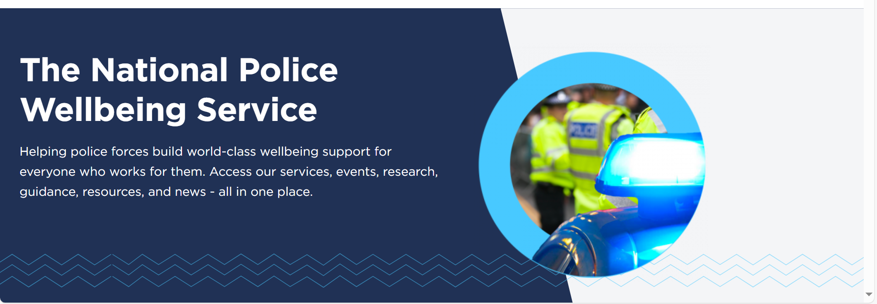

Joining the Police either as a Police Community Support Officer or Police Officer is a big commitment and one that places pressure on them to achieve success and ‘pass out’ at the end of the course. For some the process can be overwhelming with the amount of learning that is required. There is an intense period of learning complicated legislation in addition to the emotionally difficult subjects such as domestic violence, adverse childhood experiences and dealing with sudden deaths. When supporting student officers there are also in house support services available through the wellbeing Team.
The Wellbeing Team was set up approximately 4 years ago and has been embedded within the training programmes. The wellbeing specialists are scheduled to attend new recruit training during the first week to explain what they do and what services they can provide. They also provide some wellbeing information and dyslexia screening during this time which is now part of force policy. The team also return near to the end of the training programme to deliver training on Trauma Management to prepare them for their operational service.
From a Trainers point of view it is essential to have the support of the wellbeing team as they are the specialists in this area however, it is also important to understand how wellbeing can affect the trainee’s, particularly with their mental health.
It is important to recognise that some students may have diagnosed conditions but others may develop anxiety or stress during their training. There are many ways in which practitioners can help;
- Learners with existing conditions:
- Research conditions and strategies
- Talk to experienced colleagues
- Attend awareness training
- Keep up to date with official reports and other specialist publications
- Expect the unexpected, but not the worst
- Consider classroom organisation and management issues
- Promote mental Heath and Wellbeing:
- Allow space for active listening and opportunities for one-to-one interaction to detect issues and refer to appropriate support
- In class, build in anti-stress activities such as relaxation techniques
- Be aware of referral procedures and when and how to make these within the institution and community
- Promoting teachers own mental health
- Find ways to relax and maintain a healthy work-life balance
- Use de-stressing techniques, as listed above
- Be aware of triggers to negative feelings and adopt effective coping strategies
- For all the above seek professional support
- Discuss issues with a line manager, equality and diversity representative, or union official.
(Avis, Fisher and Thompson, 2019, p.73)
Student officers with mental health issues such as stress or anxiety are given additional care and support with their training through many pathways such as VIVUP a confidential helpline, Melo, a confidential mental heath and wellbeing self-help website, referral to occupational health and trained councillors and through trained wellbeing champions and support from the wellbeing specialists that assist with creating an action plan of support. A specific neurodiverse support network is also available.
Trainers also encourage peer support from the training group who are able to support on a daily basis throughout the course and Trainers are also committed to creating open communication with the student to ensure the right support needs are being met and to support the learning.
Inclusivity is also at the heart of wellbeing and a range of support is available to student officers who are struggling financially through the copperpot assistance fund, advice and support. There is support for physical issues such as alcohol addiction, healthy eating and dietary advice, menopause and cancer support amongst many others. There are also support networks available for flexible working, LGBTQ+, disability, spirituality and religion.
It is essential for trainers to incorporate wellbeing into their training through initial and diagnostic assessment but also by having open communication, support mechanisms and by creating an inclusive training environment for effective learning. Furthermore it is important for trainers themselves to seek support from colleagues with regular team meetings.

References:
Avis, J. Fisher, R. and Thompson, R. (2019). Teaching in Lifelong Learning. A guide to Theory and Practice. Open University Press.
College of Policing.(2024) www.police.co.uk/.../health-safety-welfare/wellbeing Accessed 14/11/24
Oscar Kilo National Wellbeing Service www.oscarkilo.org.uk Accessed 14/11/24
Welsh Government.(2017) Professional standards for further education teachers and work-based learning practitioners in Wales www.hwb.gov.wales Accessed 14/11/24

