Please delete the box below and replace it with an “appropriate” passport style photograph that clearly shows your face. Your photo should be roughly the same size as the box:

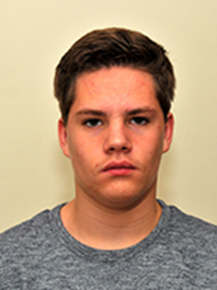

Name: Samuel Sharp

Student number: 1700888

Student email address: 1700888@student.uwtsd.ac.uk

Contact number: 07572127077

Please use the remaining space to give a brief outline of why you have chosen your course of study and any relevant special interests or experiences:

I have decided to choose outdoor and adventure education because I have always enjoyed being outdoors and having fun. I have always been out in the woods with my brothers and friends making dens and just generally having fun. Another reason for choosing this course of study was due to my 6th form course as one of the modules were called outdoor and adventure education, within this course we were able to carry out a few outdoor activities such as rock climbing, caving and kayaking which I very much enjoyed all three. Thanks to this I really wanted to carry on learning about all the outdoor adventurous activities and get the chance to improve any skills I already have and maybe go into teaching at the end of the course.
I am lucky enough to be given the opportunity to carry out some outdoor activities which have been a great experience and have also contributed to my reasons for studying this course. I am also very keen on trying out any other outdoor and adventurous activities that I have never tried before and developing skills that I am yet to gain and already have.

