Name:_____Aled Phillips____________________________

Student Number: ____2507188____________________
__________________________________________________________

WORKSHEET 2 – TESTING (Tiles)

- Original code:

[Copy and paste your original code from Moodle into this box. Do not change it.]

import math

print("Welcome to your tile guide!")

height = int(input("Please enter your wall's height (cm): "))
width = int(input("Please enter your wall's width (cm): "))

tile_length = 20

tile_height = math.ceil(height / tile_length)

tile_widths = math.ceil(width / tile_length)

area_needed = tile_height * tile_widths

print(f"You need {area_needed} tiles!")

- Code Testing

For each test below (i – vii), run your code and enter the values provided. Present a screenshot of the of what happened when the programme ran. Did the programme behave correctly or did it do something unexpected, and if so, why?

Input:

- Enter dimensions of wall: Width 40 Length 45
- Enter dimensions of wall: Width 100000 Length 200000
- Enter dimensions of wall: Width -16 Length -20

Logic:
- Enter dimensions of wall: Width 80 Length 80. The result should be 16 tiles
- Enter dimension of wall: Width 40 Length 45. The result should be 6 tiles
- Enter dimensions of wall: Width 85 Length 90. The result should be 25 tiles.
- Enter dimensions of wall: Width 15 Length 15. The result should be 1 tile.

Note: If you decided to include logic within your program to allow a tile to be cut such that 2 pieces can be used from the same tile where possible (therefore reducing the total number of tiles required), your results may differ from the above. In this case, explain your logic as part of your answer. If you did not, consider adding this logic to your final code.

Fill in a box for each test above. You should present 7 separate boxes, 1 for each test. (Note: the first box is provided as a template)

Test i:
Input i. - Enter dimensions: Width 40 Length 45

Screenshot(s) of output:
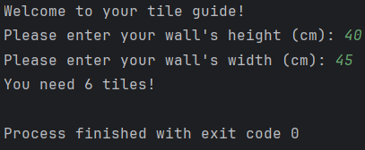

Result: Did the programme behave as expected ie syntactically and logically correct?
YES – The program accepted the valid inputs and performed the correct arithmetic operations to produce the desired output.

Continue the rest of the tests below. (Copy and paste a box for each one)

Test:

Input ii. Enter dimensions of wall: Width 100000 Length 200000

Screenshot(s) of output:
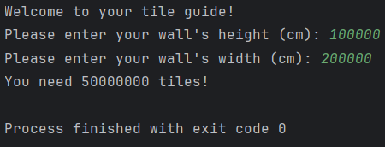

Result: Did the programme behave as expected ie syntactically and logically correct?
YES – The program accepted the valid inputs and performed the correct arithmetic operations to produce the desired output.

Test:

Input iii. Enter dimensions of wall: Width -16 Length -20

Screenshot(s) of output:
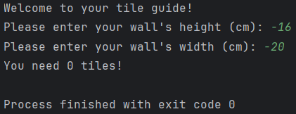
Result: Did the programme behave as expected ie syntactically and logically correct?
NO – As the height and width cannot be a negative number, the program should ask the user to enter a valid input, however, the program in its current form accepts the negative input. A while loop should be used to identify invalid inputs such as negative numbers and ask the user to enter again.

Test:

Logic iv. Enter dimensions of wall: Width 80 Length 80. The result should be 16 tiles

Screenshot(s) of output:
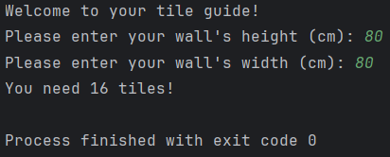
Result: Did the programme behave as expected ie syntactically and logically correct?
YES – The program accepted the valid inputs and performed the correct arithmetic operations to produce the desired output.

Test:

Logic v. Enter dimension of wall: Width 40 Length 45. The result should be 6 tiles

Screenshot(s) of output:
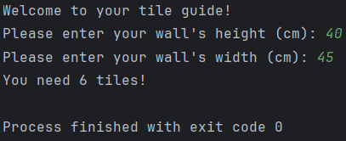
Result: Did the programme behave as expected ie syntactically and logically correct?
YES – The program accepted the valid inputs and performed the correct arithmetic operations to produce the desired output.

Test:

Logic vi. Enter dimensions of wall: Width 85 Length 90. The result should be 25 tiles

Screenshot(s) of output:
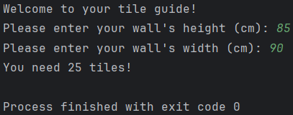
Result: Did the programme behave as expected ie syntactically and logically correct?
YES – The program accepted the valid inputs and performed the correct arithmetic operations to produce the desired output.

Test:

Logic vii. Enter dimensions of wall: Width 15 Length 15. The result should be 1 tile.
Screenshot(s) of output:
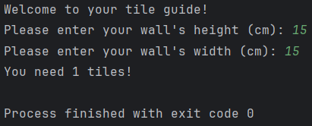
Result: Did the programme behave as expected ie syntactically and logically correct?
YES – The program accepted the valid inputs and performed the correct arithmetic operations to produce the desired output.

- Consider the results of the above tests and revisit your code in order to solve any problems discovered at the testing phase. (Note: you may not be able to solve all of them, but solve as many as you can.)

Paste your revised code here:

[Copy and paste your revised code here – note, do not use a screenshot]

import math
print("Welcome to your tile guide!")
flag = 0
# Adding while loops to account for value errors and if statements to prevent negative numbers being entered
while flag == 0:
try:
height = int(input("Please enter your wall's height (cm): "))
if height < 0:
print("Please enter a valid height (cm)")
else:
flag = 1
except ValueError:
print("Please enter a valid height (cm)")
flag = 0
while flag == 0:
try:
width = int(input("Please enter your wall's width (cm): "))
if width < 0:
print("Please enter a valid width (cm)")
else:
flag = 1
except ValueError:
print("Please enter a valid width (cm)")
tile_length = 20
tile_height = math.ceil(height / tile_length)
tile_widths = math.ceil(width / tile_length)
area_needed = tile_height * tile_widths
print(f"You need {area_needed} tiles!")

