The experiences and impact of engaging with PE classes in secondary education.
Abstract
Physical Education (PE) is compulsory in most secondary schools worldwide, aiming to promote physical activity (PA) and healthy lifestyles among young people. Only 22.9% of children and adolescents in the UK met the recommended amount of PA. This study aims to explore the experiences and impact of engaging with PE classes in secondary education through semi-structured interviews with two female participants. A thematic analysis (TA) (Braun & Clarke, 2006) identified four themes: ¹positive and negative perspectives, ²emotions and sensations, ³mindset and well-being and ⁴behavior modification techniques, cognition and mental health. Suggesting that positive experiences, higher participation, motivational climates and positive environments in PE are significantly related to better PA in adulthood, well-being, and long-term lifestyle habits. This study highlights the importance of creating positive experiences in PE and provides a direction for future research to explore how PE can promote a lifelong habit of PA and better well-being. Through first-hand experiences, the results could also inform guidelines for tailoring PE lessons to suit everyone, ultimately contributing to a more physically active society.
*PE = Physical Education
**PA = Physical Activity

Introduction
Mental health issues in adulthood have generally stemmed from childhood experiences (Kieling et al., 2011). Physical Education (PE) is compulsory in most secondary schools worldwide, intending to promote physical activity (PA) and healthy lifestyles (Naul and Temesvary, 2016). However, it was found that only 22.9% of children and adolescents in the UK meet the recommended amount of PA per week (Jago et al., 2017). While the benefits of regular exercise are well recognised, little is known about the experiences of students who engage in PE classes and how these experiences may impact their overall well-being and amount of PA in later life (Cairney et al., 2010).
Chen et al. (2015) conducted a study to examine the association between participating in PE lessons and physical activity levels among high school students in the United States and found that the students who reported higher levels of participation in PE lessons had an overall higher level of PA than those who reported low participation in PE lessons. Also, finding an association between PE engagement and PA levels was more robust in females than males. However, a study by Lonsdale et al. (2021) that included 977 high school students aged between 13-15 years in the United States suggests that a higher PE engagement level had a higher overall PA level in both males and females. Nevertheless, males significantly engaged in more PA than females regardless of PE engagement. The association between PE engagement and PA levels was stronger in males than females, which contradicts Chen et al.'s (2015) study. A further study by Cairney et al. (2010) examined the relationship between PE experiences and well-being and PA behaviours with a sample of 329 adult participants (141 females, 188 males). The results found that positive experiences during PE in secondary school had a more significant association with better well-being and higher levels of PA in adulthood. Negative experiences were associated with lower levels of well-being and PA, suggesting that promoting more positive experiences will increase well-being and PA in adulthood.
Furthermore, a study conducted by Cleland et al. (2018) examined the relationship between PE lessons during secondary school and PA levels in adulthood. This study found that PE classes did not have a significant effect on overall PA levels among adults who were in their 30s. However, the adults who reported higher levels of enjoyment in PE were likelier to participate in team sports and more outdoor activities in adulthood than those who reported less enjoyment. In contrast to Cleland et al.'s (2018) study, Hanson et al. (2018), who also examined the relationship between PE lessons during secondary school and PA levels in adulthood, found a significantly positive association between PE participation during secondary school and PA levels in later life, predominantly in women—finding that women who participate in PE in secondary school for more than two hours every week had a higher chance of reaching the PA levels in adulthood than those who did not participate frequently enough in PE. It must be mentioned that the above studies by Cleland et al. (2018) and Hanson et al. (2018) used different sample sizes, follow-up times and different outcome measures, which can impact the results both have found. The Cleland et al. (2018) study used 44 adults, which included 21 women and 23 men participants aged between 30 and 35 years, and used a larger physical activity intervention study. Hanson et al. (2018) study used a sample of 3036 adults, 1792 women and 1307 men aged between 16-60 years, and participants participated in a Health Survey. Overall, both studies suggest physical education lessons can promote physical activity later in life, especially if students enjoy PE, have a positive outlook on past experiences in PE and participate in PE regularly throughout secondary education.
According to Johnson and Smith (2022), through the examination of previous literature to explore the negative impact of PE and the role of embarrassment, they found that the feeling of embarrassment is not unusual within the PE department and that this issue must be addressed to be able to develop more inclusive and effective PE programmes that fully promote a positive perspective in physical, social and emotional outcome for all pupils that can be carried forth into their adult life (Johnson and Smith, 2022).
Moreover, Beni et al. (2021) explored the long-term effects of different types of motivation experienced in PE lessons during secondary school on PA behaviour in adulthood. Surveying 256 adults aged between 25-40 years. Finding that PE which involved motivational climates positively associated with the participants' current adult behaviours. However, ego-involving climates had a negative association. Overall, the study found that receiving negative feedback from PE teachers during secondary school had a negative association with participants' current adult PA. Suggesting that negative reinforcement utilised by PE teachers in secondary school may have a lasting impact on PA behaviours in later life, highlighting the importance of the schooling system creating a supportive and positive environment to be able to foster lifelong PA behaviours.
Another study conducted by Cox et al. (2020) examined the effects of different types of feedback provided by secondary school PE teachers on PA in adulthood. Utilising a survey with a sample of 415 adults aged 25-35 who attended UK secondary schools. The findings indicated that providing corrective feedback had a positive association with PA behaviours in adulthood. However, a combination of both praise and punishment was not significantly associated with PA behaviours. Suggesting that using corrective feedback, focusing on improving PE performance rather than emphasising success/failure, may have a more influential role in promoting PA behaviours in adulthood through PE, highlighting the importance of using constructive feedback in PE lessons to help adopt lifelong PA behaviours.
In addition to the above research, the Self-Determination Theory (SDT) suggests that social environments, specifically those in PE, can influence an individual's enthusiasm and behaviour towards PA. According to SDT, individuals are more likely to participate in PA when their basic psychological needs for autonomy, competence, and relatedness are fulfilled (Deci and Ryan, 2008). SDT framework helps understand the impact of PE experiences on PA behaviours in adulthood, and can aid in promoting a lifetime of PA behaviours. Vazou et al. (2012) found that students who perceived their PE environment as more autonomy-supportive had higher levels of PA in young adulthood. This was supported by Standage et al.'s (2005) study, which showed that perceptions of autonomy-supportive environments in PE had a positive association with PA behaviours in young adulthood. Both studies support the significance of autonomy-supportive environments in PE to promote healthy lifetime PA behaviours, aligning with SDT's key messages.
This thematic analysis intends to explore the experiences of adults who went to secondary school and engaged in PE lessons and identify the impact of these personal experiences on their physical, social, and well-being. Using thematic analysis through interviews with two participants will provide a more detailed and personal influence on the existing literature already available. According to a study by the World Health Organization (WHO), physical activity has been linked to improved mental health, social connectedness, and self-esteem in young people (World Health Organization, 2018).
This study aims to add to the existing body of research on the effects of PE on adult life, well-being and impact by delivering a detailed analysis of past pupils' subjective experiences. The finding from this report can inform educational policy and practice and contribute to the development of more effective approaches to promote physical activity and healthy lifestyles throughout childhood and lasting throughout adulthood.

Method
Design
A non-experimental, qualitative approach, thematic analysis, was taken using interviews.
Participants
Two female level five Applied Psychology students from UWTSD, aged 22 and 47, took part in this study, making this an opportunity sample.
Materials
An ethical form was filled out and approved before conducting the study. Consent forms and debrief forms were utilised. The researcher conducted interviews in an isolated room within UWTSD premises. Utilising a laptop to record the interview. A piece of paper with the questions for the interview was printed before the interview. To transcribe the video, Microsoft word was utilised, and Microsoft word was required to analyse the data, using the comments section to code the transcript and then put it into themes.
(See appendix 1 for Interview questions and coding).
(See appendix 2 for consent form and debrief form).
(See appendix 3 for ethics form).
Procedure
(See Appendix 4).

Results and Discussion
Table 1
Summary table of themes, quotes and page/line numbers.
Themes | Quote Keywords | Page/Line Numbers
Theme 1: Positive and Negative Perspectives | ‘Physical activity is a great way of keeping fit and healthy both body and mind’.  ‘Threatened with punishment such as detention or a phone call home’. |  | Page 1; Line 4-5.  Page 2; Line 58-60.
Theme 2: Emotions and Sensations | ‘Beneficial for children and adolescents to participate’.  ‘I loved learning new skills and I felt excited trying new things I hadn't done before’. | Page 1; Line 9.  Page 2; Line 26-27.
Theme 3: Mindset and Wellbeing | ‘I loved being out doing things other than book work’.  ‘I was only tiny in school and used to be able to take part in everything’. | Page 1; Line 15.  Page 2; Line 44-45.
Theme 4: Behavior Modification Techniques, Cognition and Mental Health | ‘I was forced to take part in, I hated and would never participate in now’. | Page 4; Line 92-93.

(See Appendix 5 & 6 for codes & themes).

¹Positive and Negative Perspectives: ‘I loved learning new skills and I felt excited trying new things’ (P2, L26-27).
This theme frequently arose throughout the transcript, with both participants referring to their own experiences of positive experiences and negative outlooks in PE.
‘Being active and find walking can give me both mental and physical support’ (P2, L37-38). ‘I no longer enjoy the sports that I used to enjoy in school’ (P2, L39-40). ‘I enjoy light exercise now as it clears my mind’ (P2, L39).
Throughout the transcript, participants clearly state that PE has affected them differently. Participant A said, ‘I totally believe that PE was a positive impact on me’, (P4, L88). Through this statement, it is clear that PE has provided this participant with tools to bring a positive mindset into her life beyond school. Participant B ‘I don’t think that secondary PE has made much of an impact in my adult life’ (P4, L91-92), This participant, however, has a much different view from participant A. This statement shows PE did not provide positive tools to bring into her adult life. ‘I sometimes loved it and other times I hated it’ (P1, L17). ‘I liked the challenge of competing’ (P3, L66).
Furthermore, the participants expressed utterly different attitudes to their view of PE in secondary school, with one having a more negative reaction to PE (‘loved it and other times hated it’ (P1, L17)). The other likes the challenge of competing, which shows a much more positive perspective. This is in correlation with Chen et al. (2015) and Hanson et al.'s (2018) studies which suggest that having a positive outlook on past experiences in PE will impact PA in later life. As seen, Participant A has a positive outlook and association with PE. They have brought the skills and awareness into their adulthood ‘Being active and find walking can give me both mental and physical support’ (P2, L37-38). Whereas, Participant B has not had as pleasant a time which has created a more negative perspective and has been put off from bringing these skills into their adulthood, ‘I no longer enjoy the sports that I used to enjoy in school’ (P2, L39-40).
Theme 2 Emotions and sensations: ‘Instead of forcing them to take part in something they were not comfortable with, adaptations should have been made to make the lessons more inclusive’ (P3, L60-62).
The theme of emotions and sensations arose many times throughout the interview; personal feelings towards themselves and the PE situation were quite apparent throughout. The feelings arising from PE show a cause for concern in the PE department ‘used to make me really uncomfortable and upset’ (P3, L49-50). The participant explains the feeling of getting upset and uncomfortable, showing that PE genuinely impacted this participant's emotions. ‘Bleep test which we had to perform alongside our peers. I found this very stressful as everyone else could see how far you got and if you didn’t make it very far you would feel very embarrassed’ (P2, L31-34) Once again, this statement shows the unnecessary stress associated with performing in PE in secondary school. The feeling of being embarrassed should not be an issue. This is associated with Johnsons and Smith's (2022) paper that indicated embarrassment was a more common issue with PE in secondary schools and needed addressing to create a positive physical and mental experience for children to be able to use this discipline in later life.
However, participant A has an entirely different way of feeling towards PE. When asked if they ever felt overwhelmed, pressured, stressed or peer pressured in PE, they responded, ‘No, I can’t say I ever remember feeling like that’ (P2, L30). ‘Life was good and easy, and I felt happy. I loved being good at something’ (P1, L23-24); Participant A shows an enjoyment towards PE and how they were treated. This goes hand in hand with Cleland et al. (2018) study, which indicates that enjoyment levels (positive feelings/sensations) impact the way PE is perceived, meaning enjoyment whilst in PE has a larger likelihood of bringing forth PA in later life. Also, it correlates with the SDT (Deci and Ryan, 2008).
Theme 3 Mindset and wellbeing: ‘I hated and would never participate in now’ (P4, L93).
This theme arose throughout the data, with participants having set mindsets and indicating links towards their own and others' well-being throughout the interview, specifically regarding inclusion and gender. ‘I liked the challenge of competing with the boys, although I was always really disappointed that I was not allowed to play football or rugby (P3, L66-68). ‘We did not have mixed gender PE lessons. I liked being separated from the boys’ (P3, L72-73). These comments indicate that boys had more freedom or activities to participate in while also showing that being separated from the boys is better.
‘If we had to take part in PE together, I would have felt very intimidated’.
(P4, L74-75). ‘I never felt that I was expected to be the same as the boys or vice versa (P3, 70-71).
Furthermore, the contrasting opinion by both participants indicates that one has the mindset that boys are intimidating when it comes to sport, whilst the other did not feel the pressure of being the same as the boys or the need. However, whilst through the comment ‘not allowed to play football or rugby’ (P3, L66-68), has highlighted a gender gap in PE, and perhaps they believe boys are more physically fit than girls. This has links to Lonsdale et al. (2021) study showing boys were more likely to participate in more activity than females; however, this could be due to the unfair advantages of them being able to do more. Contrary to this is Hanson et al. (2018) study, which identifies that predominantly women are more likely to be PA in later life than men due to PE participation.
Theme 4 Behavior modification techniques, cognition and mental health: ‘Always threatened with punishment such as detention or a phone call home’ (P3, L59-60).
This theme was identified multiple times and, perhaps, the most concerning theme of them all. Participants speak of the fear of punishment, the punishment that can be received, body image issues and even bullying.
‘Threatened with punishment such as detention’ (P3, L59). ‘People would always make comments about my body’ (P2, L48). ‘Make me really uncomfortable and upset’ (P3, L50).
This shows that PE can be identified as a platform for inappropriate comments, the feeling of being bullied, and forcefulness and creates a fear of doing PE due to the punishments. Linking to the SDT, which explains that individuals are more likely to participate in PA when their basic psychological needs for autonomy, competence, and relatedness are fulfilled (Deci and Ryan, 2008) and also, Cairney et al. (2010) study that links positive experience to better participation in PE and also PA in adulthood.
‘I totally believe that PE was a positive impact on me and something that has passed on to my children also with their love of the outdoors’ (P4, L88-90).
In contrast to the negative side, one participant, who had a better experience of PE, has been able to use their experience to model health-related behaviours to their children, indicating that PE has the potential to influence and impact positive health-related behaviours not just in secondary school but throughout life.
To summarise this report has explored the experiences and impacts of engaging in PE classes in secondary education through semi-structured interviews and thematic analysis. Patterns of codes have been found. These four themes have been identified: Positive and negative perspectives, emotions and sensations, mindset and well-being and behaviour modification techniques, cognition and mental health. The literature and the thematic findings showed that positive PE experiences were associated with higher levels of physical activity and well-being. The studies included in this report and the personal experiences provided by the participants have provided valuable insight into the experiences and impact of individuals who engage in PE lessons and the potential impacts of these experiences on overall well-being and PA levels in later life. Emphasising the importance of creating positive mindsets and well-being was associated with better emotions and engagement in PE and higher levels of PA in adulthood. Avoiding punishment and negative reinforcement within PE makes way for promoting positive experiences for all, promoting positive feedback and setting achievable goals, including more support and enjoyable activities.
Overall, the findings of these studies suggest that promoting positive experiences in PE lessons can have important implications for promoting PA and well-being. However, there are limitations to this report which include that only two participants were interviewed, which can result in the findings needing to be more generalisable to the broader population. Also, the small sample size limits the depth and breadth of the data collected, which can potentially miss essential nuances and perspectives concerning PE experiences and impact.
Additionally, the participants were both females, and although it provides two perspectives from two separate eras, it lacks a male standpoint and does not represent the wider population. Lastly, another limitation of this study is that PE is ever-changing in schools and may not be able to provide impacts and experiences through the eyes of an individual born within this era. Future research should explore the effectiveness of specific behaviour modification techniques and the role of mindset in promoting positive PE experiences.

Reference List

Beni, S., Nevo, N., & Fridkin, S. (2021). Long-term effects of motivational climates and physical education experiences on physical activity behavior in adulthood. Journal of Sport and Exercise Psychology, 43(2), 85-93. https://doi.org/10.1123/jsep.2020-0129
Braun, V., & Clarke, V. (2006). Using thematic analysis in psychology. Qualitative Research in Psychology, 3(2), 77–101. https://doi.org/10.1191/1478088706qp063oa
Cairney, J., Hay, J., Veldhuizen, S., Missiuna, P., & Faught, B. (2010). Physical education experiences and their relationship to adolescent well-being and physical activity behaviors in young adulthood. Physical Education and Sport Pedagogy, 15(3), 257-271. https://doi.org/10.1080/17408981003689026
Chen, S., Guo, A., Li, X., Liang, R., & Huang, T. (2015). Association between physical education and physical activity among American high school students. Journal of School Health, 85(9), 614-621. https://doi.org/10.1111/josh.12289
Cleland, C., Hunter, R. F., Tully, M. A., Scott, D., Kee, F., & Donnelly, M. (2018). Identifying solutions to increase participation in physical activity interventions within a socio-economically disadvantaged community: A qualitative study. International Journal of Behavioral Nutrition and Physical Activity, 15(1), 21. https://doi.org/10.1186/s12966-018-0656-9
Cox, A. E., Smith, A. L., & Williams, L. (2020). Physical education feedback and its relationship to physical activity behavior in young adults. Journal of Physical Education, Recreation & Dance, 91(3), 16-22. https://doi.org/10.1080/07303084.2019.1703789
Hanson, S., Jones, A., & Suggs, L. S. (2018). Exercise imagery interventions: A systematic review and meta-analysis. Health Psychology Review, 12(4), 398-416. https://doi.org/10.1080/17437199.2018.1469769
Jago, R., Solomon-Moore, E., Macdonald-Wallis, C., Sebire, S. J., Thompson, J. L., Lawlor, D. A., & Sawyer, A. (2017). Change in children's physical activity and sedentary time between Year 1 and Year 4 of primary school in the B-PROACT1V cohort. International Journal of Behavioral Nutrition and Physical Activity, 14(1), 33. https://doi.org/10.1186/s12966-017-0489-5
Johnson, S. J., & Smith, T. C. (2022). The negative impact of physical education on secondary pupils: Exploring the role of embarrassment. Journal of Educational Psychology, 114(2), 243-255. https://doi.org/10.1037/edu0001001
Kieling, C., Baker-Henningham, H., Belfer, M., Conti, G., Ertem I., Omigbodun, O., Rohde, L.A., Srinath, S., Ulkuer, N., Rahman A. (2011). Child and Adolescent Mental Health Worldwide: Evidence for Action. The Lancet, 378(9801), 1515–1525. https://doi.org/10.1016/S0140-6736(11)60827-1
Lonsdale, C., Fahey, S., Lubans, D. R., Smith, J. J., Weaver, R. G., & Vella, S. A. (2021). The relationship between physical education and physical activity levels among adolescents: a prospective study. Journal of Physical Activity and Health, 18(7), 748-755. https://doi.org/10.1123/jpah.2020-0507
Naul, R., & Temesvary, B. (2016). Physical education in compulsory schooling: research and practice. European Physical Education Review, 22(2), 199-216. https://doi.org/10.1177/1356336X15590696
Standage, M., Duda, J. L., & Ntoumanis, N. (2005). A model of contextual motivation in physical education: Using constructs from self-determination and achievement goal theories to predict physical activity intentions. Journal of Educational Psychology, 97(3), 366-375. https://doi.org/10.1037/0022-0663.97.3.366
Vazou, S., Ntoumanis, N., & Duda, J. L. (2012). Predicting young adults' physical activity behavior from an extended theory of planned behavior. Journal of Sport and Exercise Psychology, 34(2), 135-152. https://doi.org/10.1123/jsep.34.2.135
World Health Organization. (2018). Global strategy on diet, physical activity and health. https://www.who.int/dietphysicalactivity/factsheet_young_people/en/

Appendices
Appendix 1: Interview questions and coding
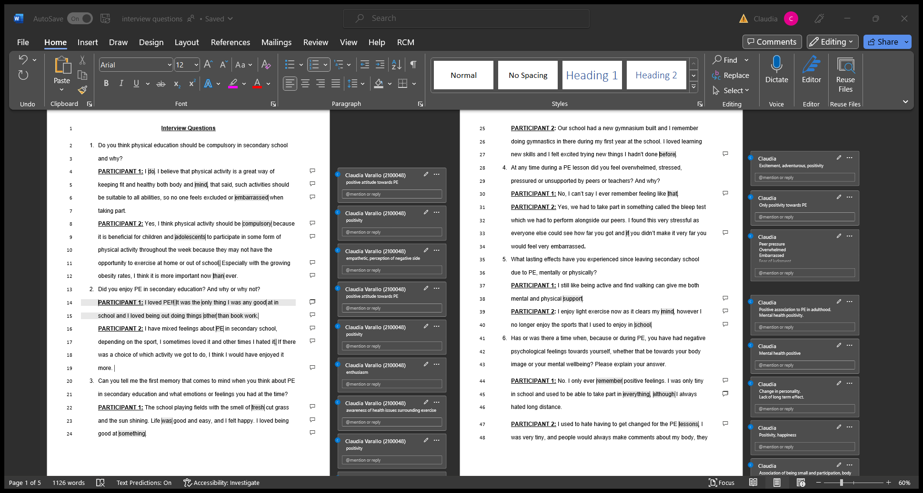
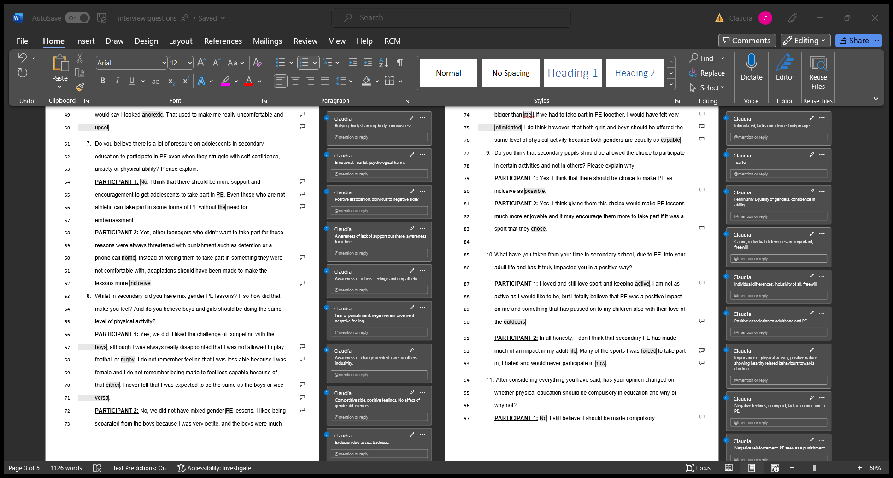

Appendix 2: Consent form and debrief form.
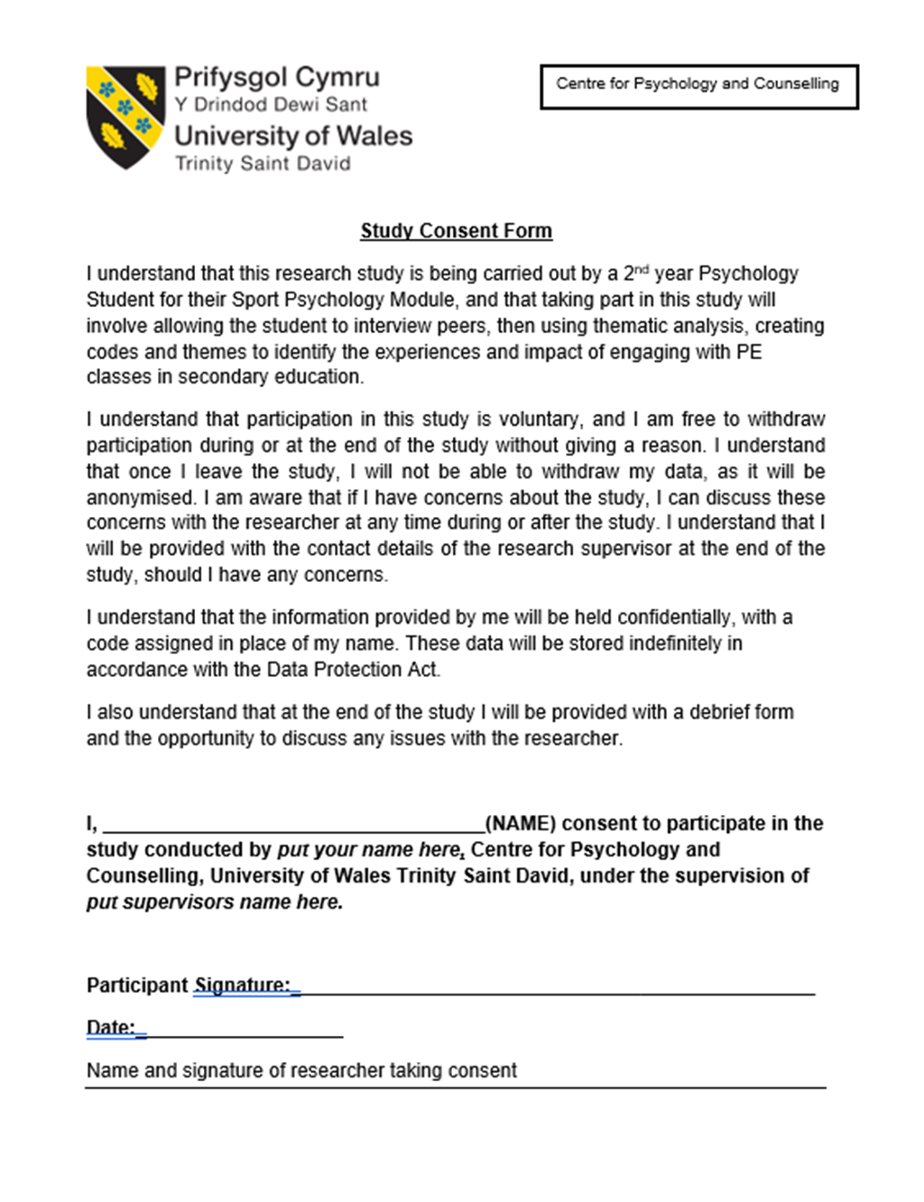

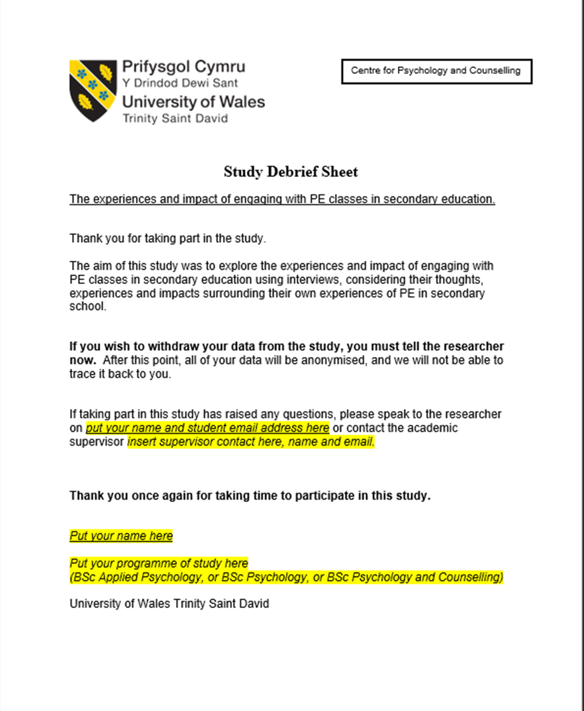

Appendix 3: Ethical form
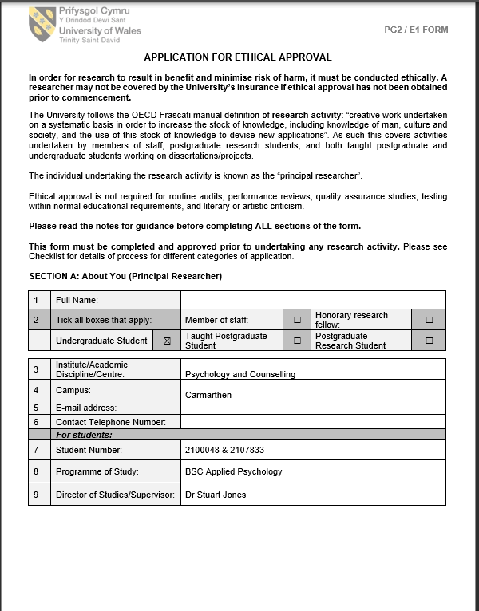
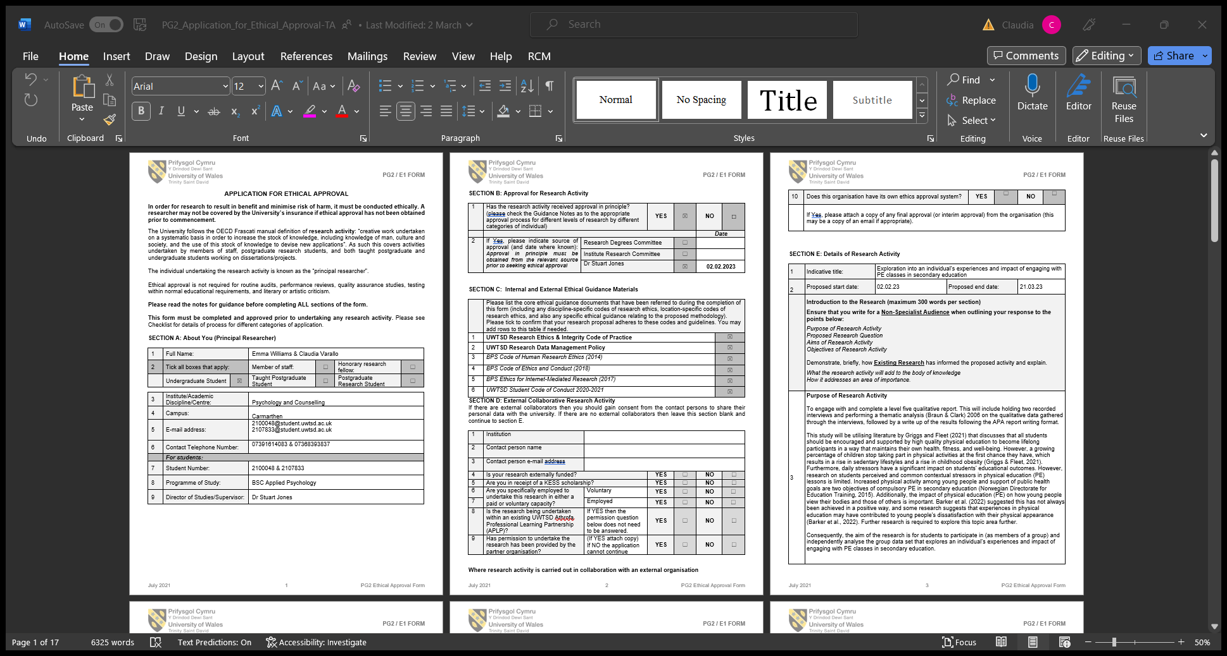

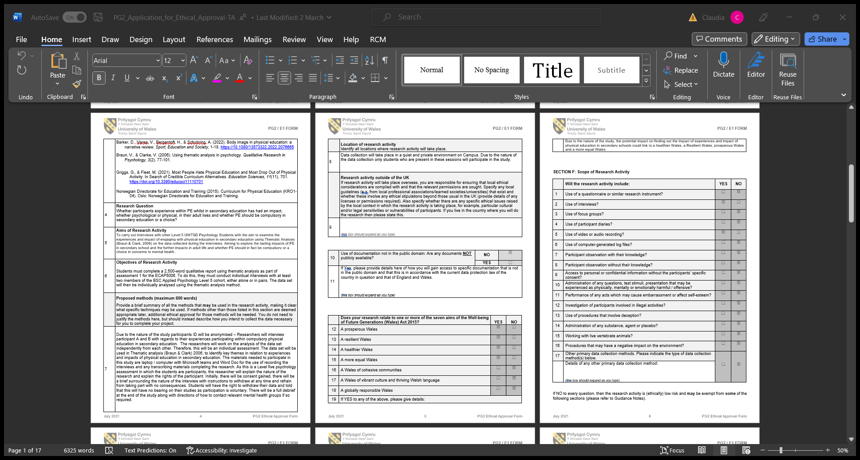
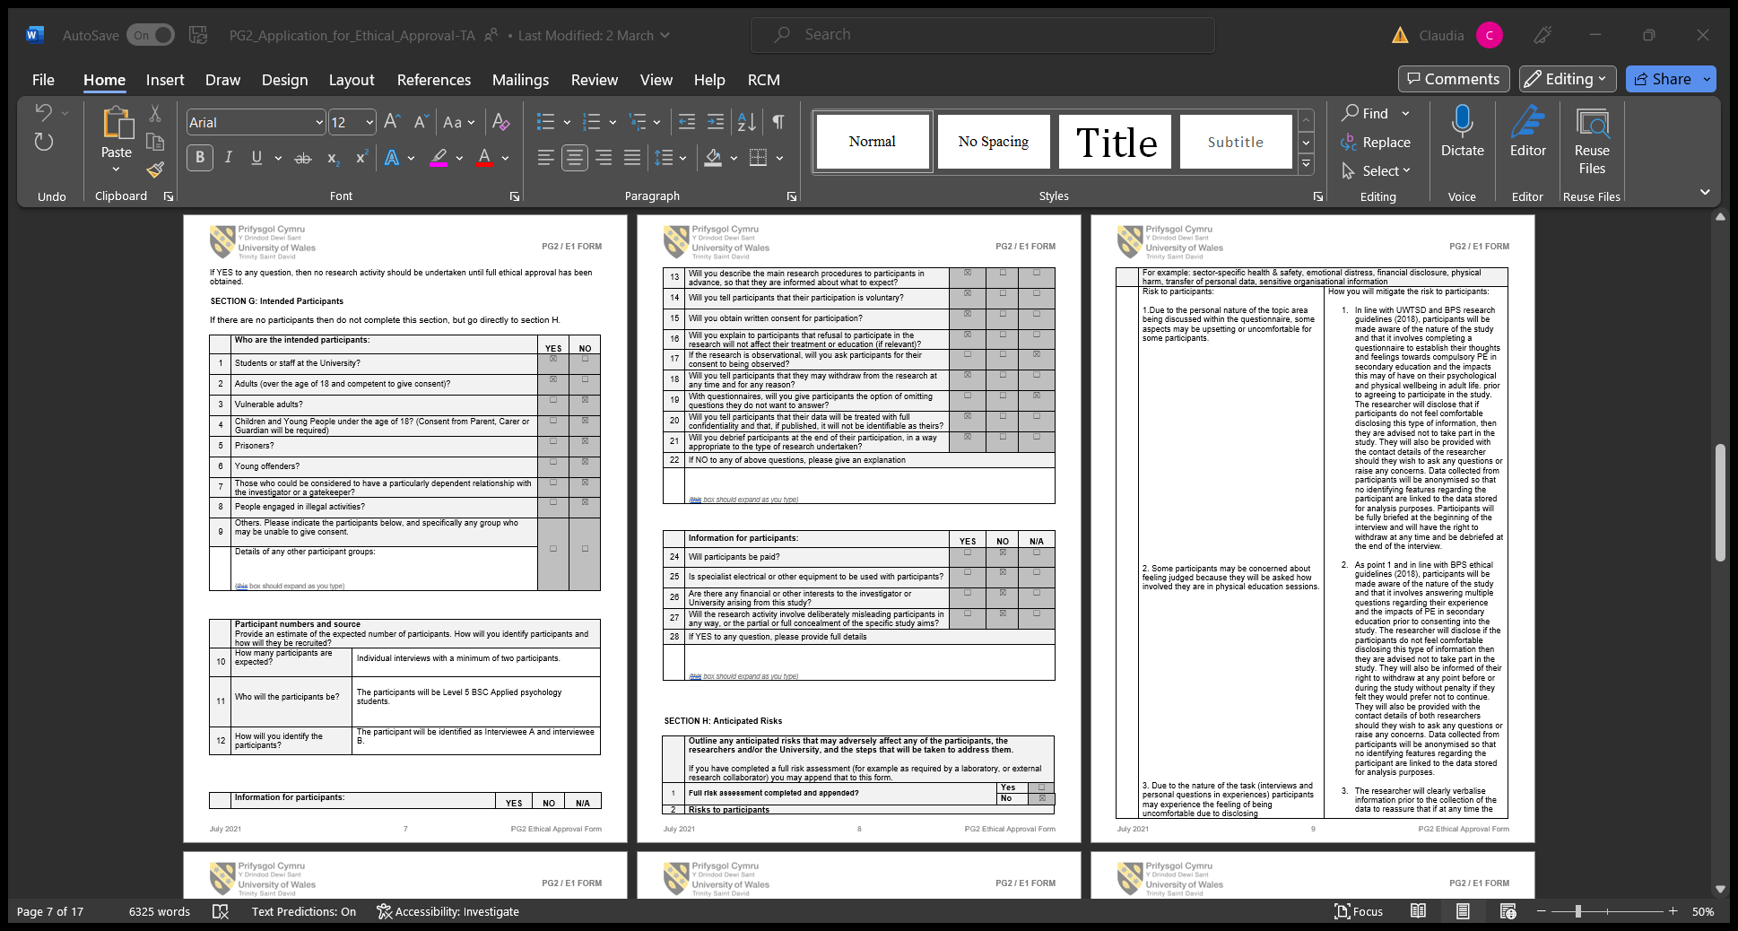
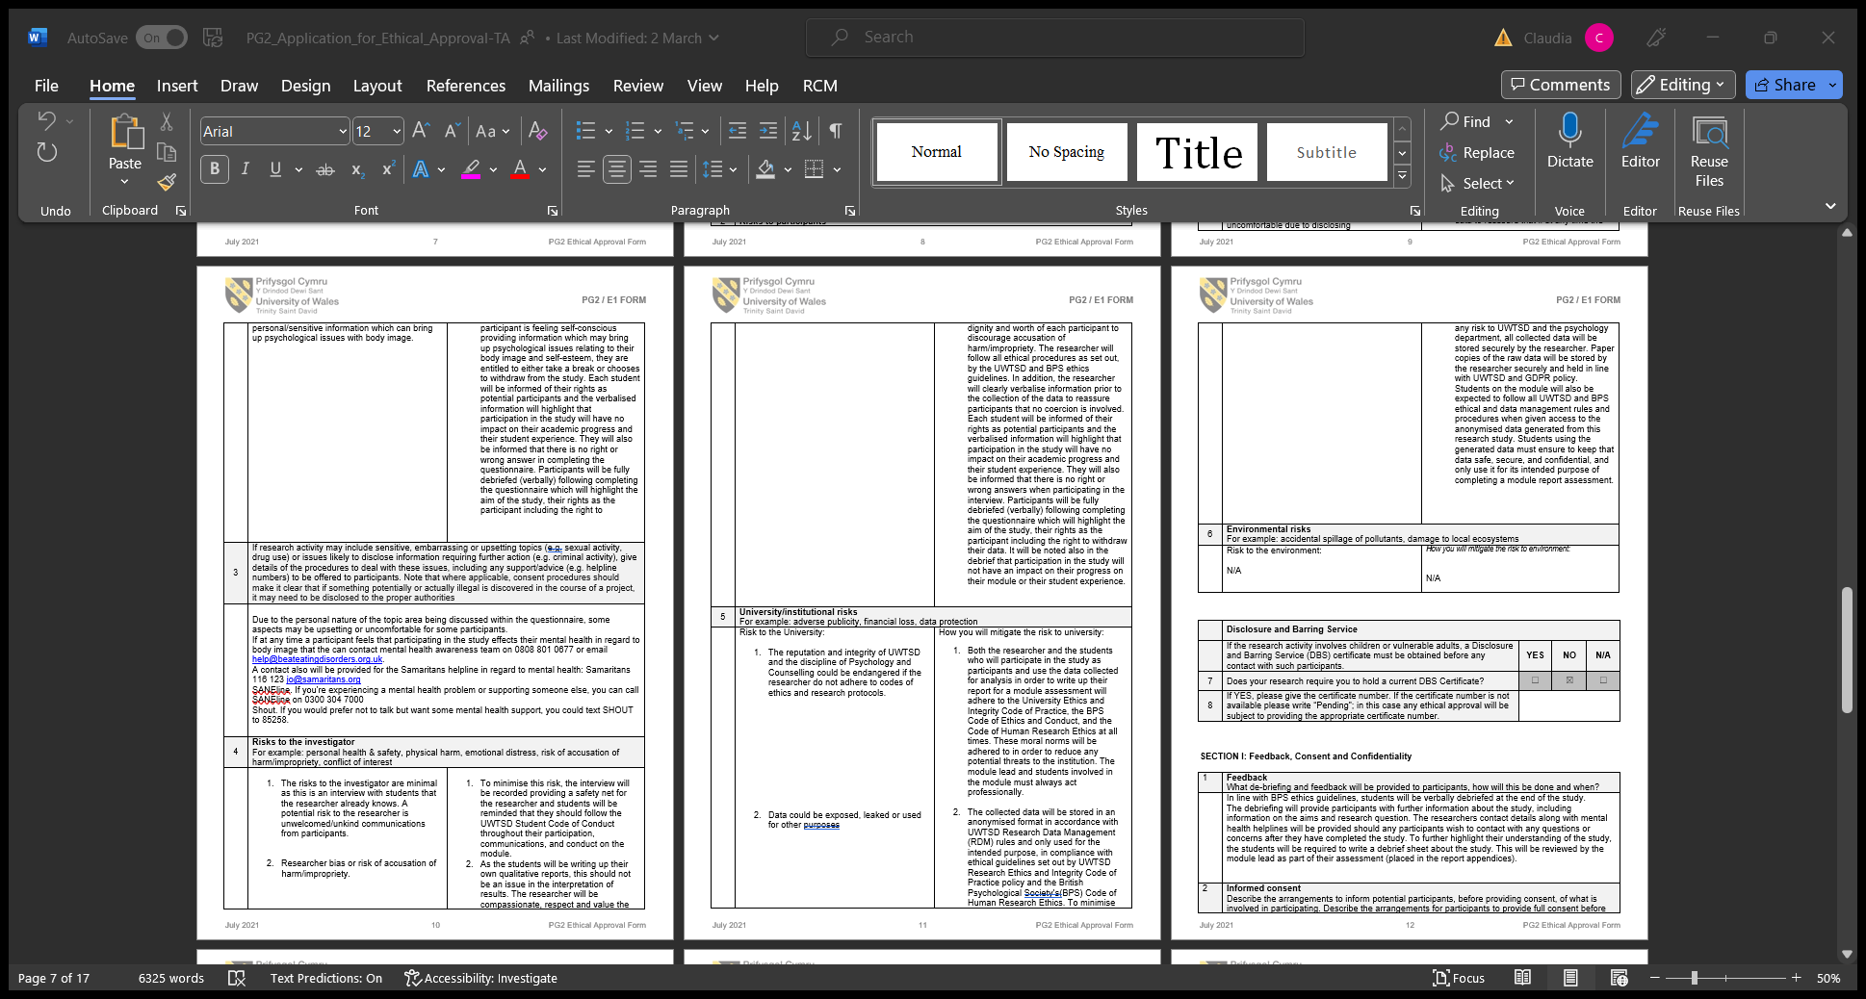

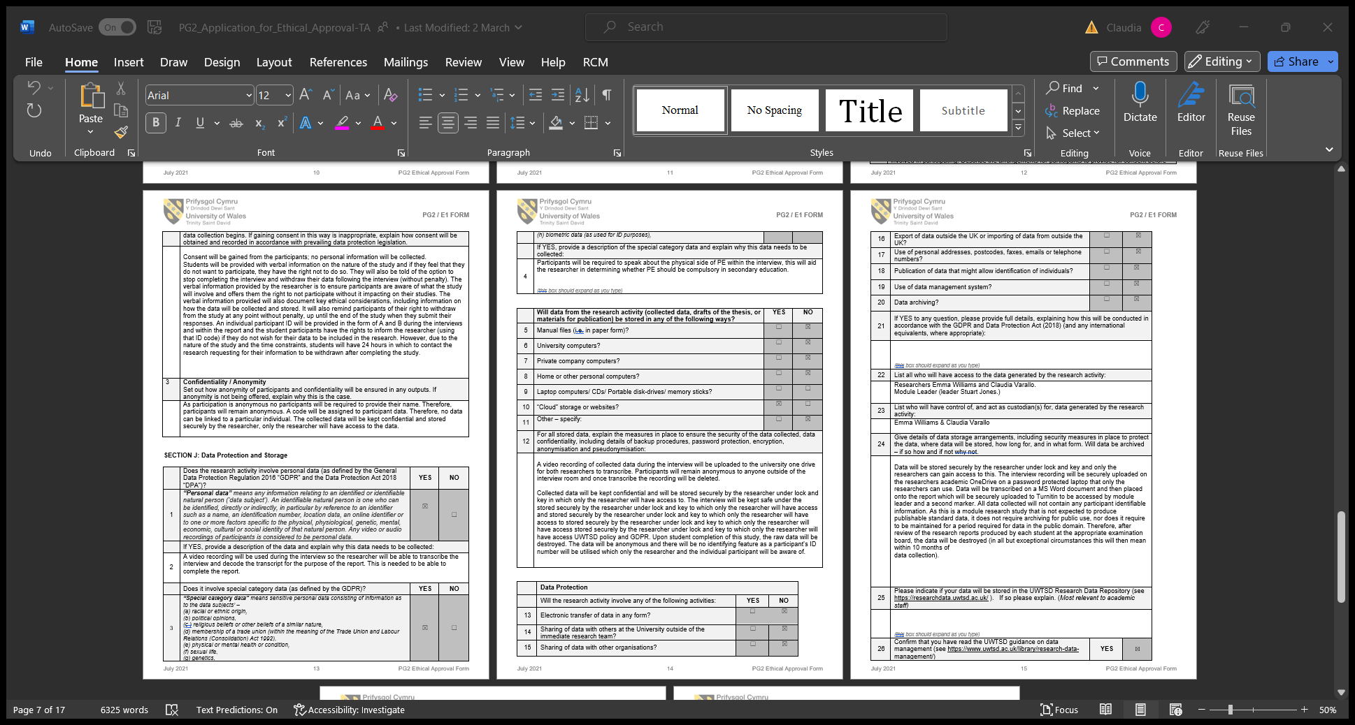
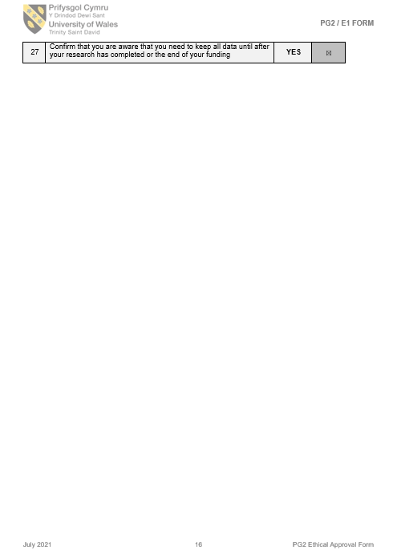


Appendix 4: Standardised procedure
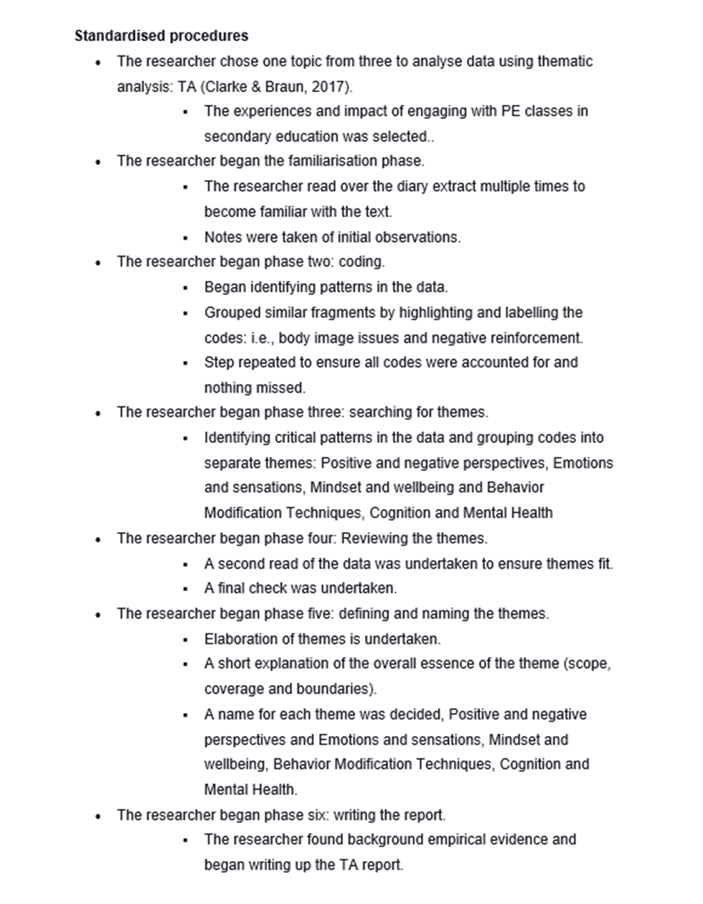

Appendix 5: codes and page numbers
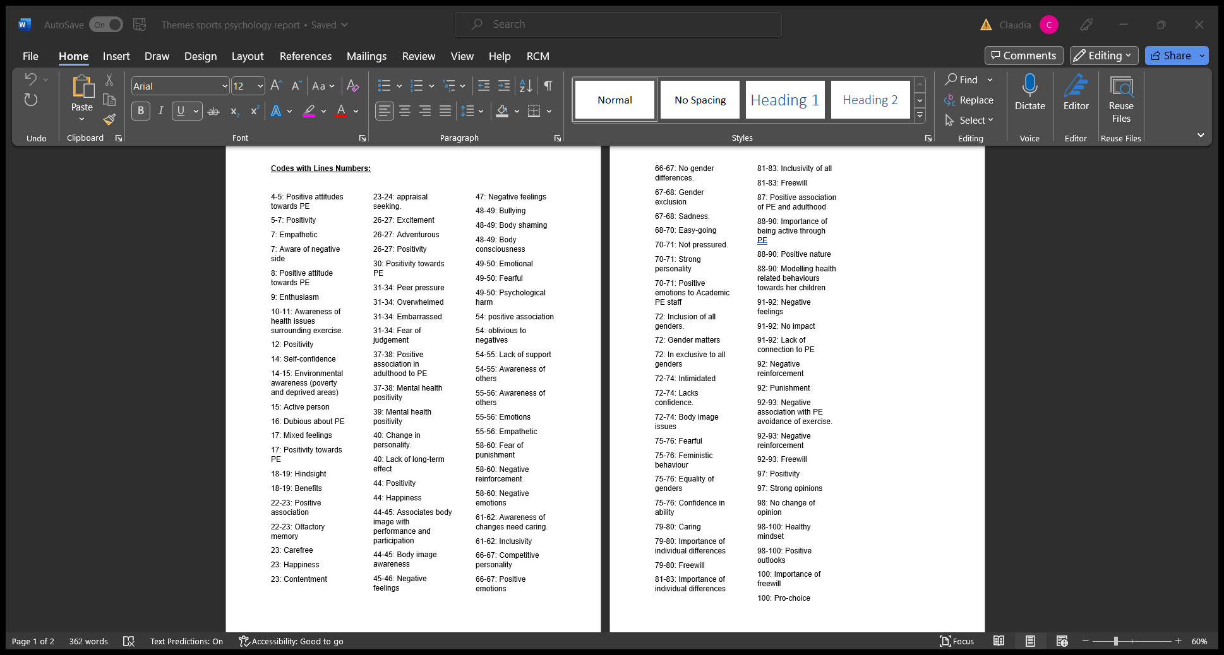

Appendix 6: themes and codes


Appendix 7: Familiarisation
- PE is seen as a positive and negative activity.
- Pros and cons to PE in secondary school.
- Both are for PE in secondary schools.
- Mental health related answers.
- Lots of feelings.
- Set mindset.
- Negative experiences have impacted the future.
- Positive experiences have had a great impact on future children and self.
- Emotions are clear throughout.
- Mental health elements throughout.
- Lots of suggestions from participant B.
- Differences between both participants
- Different outlooks between both participants.

