

how individuals’ beliefs, attitudes, Along with values, impact on workplace behaviour
EQUITY THEORY OF MOTIVATION

sabrina reid 1920873
lecture: Dr Obinna Nkwocha
DEVELOPING WORKPLACE CRITICAL THINKING BMSW5101

Table of Contents
Equity Theory of Motivation 2
Introduction 2
The Glass Ceiling and Racial Discrimination 3
NHS 3
MacDonalds 6
MacDonald’s rewards and benefits 8
Boots Benefit Box 9
NHS England Benefits 11
NHS England 11
Figure 9, NHS England Employee Benefits 12
Figure 10, NHS England Benefit Overview & Local Benefits 13
Figure 11, NHS England Financial Wellbeing 13
Figure 12, NHS England Health, and Wellbeing 13
Figure 13, NHS England Lifestyle, Learning, Education and Development 14
Pay Rise 15
NHS 15
NHS Pay Rise a Penny to Two Pence 15
Recommendation 15
Conclusion 16
Reflective Report 16
References 16

Equity Theory of Motivation

Introduction
This report explores and assesses the equity theory of motivation (ETM), as well as its use and relevance in the present-day workplace. Together with providing a succinct history of the Equity Theory of Motivation, including instances of its concepts, and supporting postulates from various organizations, along with conveying substantiations of the theory's advantages and disadvantages within these establishments today. In conjunction with a summary of the findings of this thesis, a recommendation for future effectivity and appurtenant
Equality and Fairness were identified as crucial elements of a motivated individual by John Stacey Adams in 1963. The concept of equity theory is that integrity, honesty, and fairness motivate people. The stronger a person’s perceived sense of equality and fairness, the more motivated they will be conversely, the moment a person is cognizant of an unfair situation, they will become demotivated. (Adams,1963).
Once discrepancies have been established regarding co-workers and their comparator proportion of contribution or rewards in comparison to their own, they will adapt their productivity in terms of achieving their deemed parity. (Lerner, 1965), (Lerner & Miller, 1978).Ultimately workplace equality affects employees, take for example, when co-workers compare their work to that of someone else who receives more pay than them. The lack of equal pay can cause a lack of motivation and be a source of discrimination. This was such a major issue it was recognised within the law, which subsequently brought in the Equality Act in 2010 (Gov.uk, 2013).
Equity theory of motivation, assist organisations with minimizing the exploitation of their employees. If an organisation has employees of whom, work the same shifts but have different length of breaks or holidays, the organization is administering discrimination over their employees in working condition terms and are not following the equality philosophies (Gov.uk, 2013). Employees are motivated to do their work when they recognize that they are receiving equal and fair management practices. This also motivates employees to work well in a team which improves working conditions and increases workplace proficiency and productivity (Bargh et al., 1996).
One of the main drawbacks of Equity of theory motivation is the distinction of perception amongst employees and employers. For instance, two employees’, ‘A’ &’B’, employee ‘A’ believes they are contributing the same as their co-worker employee ‘B’, whilst in receipt of a lower salary. However, employee ‘B’ is more proficient and productive in contrast, which the organisation identifies and reflects this through employee ‘B’ salary. Employees compare themselves to their counterparts and aspire to be in the same position or earn the same salary. However, unlike commodities, which have predetermined pricing for equivalent things, this is impractical for people, resulting in this disadvantage (Cable, and Judge, 1996).
Furthermore, irrespective of implementing every aspect of equality management over employee’s, this cannot determine an employee will be proficient and productive within the workplace (Albinger and Freeman, 2000), (Backhaus et al., 2002), (Greening and Turban, 2000), (Turban and Greening,1997). Moreover, irrespective of co-workers in receipt of the same salary, if one is presented an optimal position from a competitor organization, that employee will leave, regardless of implementing equity of theory motivation within the organisation (Albinger and Freeman, 2000), (Backhaus et al., 2002), (Greening and Turban, 2000), (Turban and Greening,1997).

The Glass Ceiling and Racial Discrimination

NHS
Glass ceilings exist for people of specific statures; while they can view the top, they will never reach it. Racial and ethnic diversity in the workforce has been steadily increasing in recent years (Hiem), (Corthouts, Scheerder, 2020). The Workforce Race Equality Standard (WRES) were established in 2015 in response to the substantial number of ethnic minorities who were unable to advance in their careers. Statistics of these individuals who endure discrimination within the NHS due to their race or ethnicity at work in 2017 were complied. It was the responsibility of WRES in addressing inequities that the Black and Minority Ethnic (BME) population faced within the NHS, as well as implementing access to employment opportunities and equitable treatment for BME employees. (Interfederal Centre for Equal Opportunities, 2018), (Randhawa, 2018).

Figure 1, illustrates the percentage of NHS employees who believe they receive equal opportunities for career progression or promotion 2015 - 2017
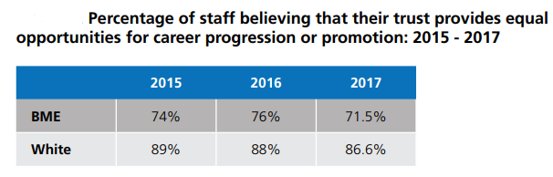
(NHS England, 2018)

Figure 2, illustrates the percentage of NHS employees who believe they receive equal opportunities for career progression or promotion by region 2017
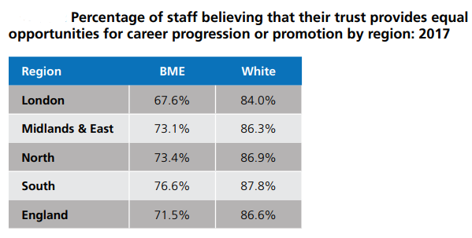
(NHS England, 2018)
In terms of facts, London is an anomaly, with the most multicultural workforce but the least varied leadership: 40% of the population is from a BME heritage, 43% of the NHS staff is from a BME culture, but only 14% of board-level posts are held by individuals from a BME origin. The discussion began with a forceful reminder from Simon Stevens, Chief Executive of NHS England, that race equality is not merely about equality, it is also critical to the NHS aim of eliminating disparities in care (Randhawa, 2018).

Figure 3, illustrates the percentage of NHS BME that experienced discrimination between 2015 - 2017
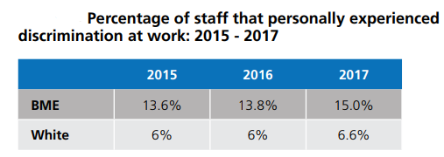
(NHS England, 2018)
Irrespective of an individuals’ age, race, religion, sex, sexual orientation, or levels of physical (dis)ability in the workplace people expect to be treated fairly as well as acquire equally to their counterparts (Bryne,1971). Discrimination among ethnic minorities in the workforce is a reality. Most BME people could easily produce an extensive list of injustices, those from individual experiences, many from all sectors of society, if they were asked. Despite this, many individuals form a reasonably fair and just perspective of the world (Hafer and Be`gue, 2005), (Jost & Banaji, 1994), (Lerner and Miller, 1978).

Figure 4, illustrates the percentage of discriminated BME employees by trust type 2017
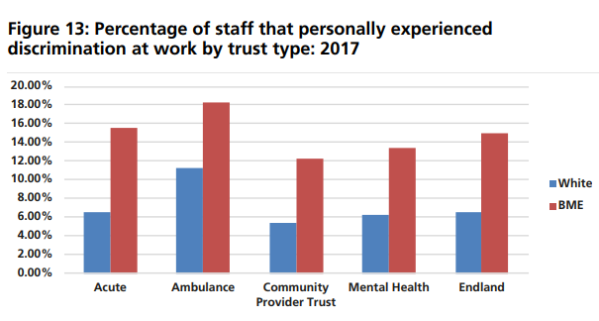
(NHS England, 2018)
Equality act covers all forms of discrimination. This includes discrimination against sex, age, race, and disability. The glass ceiling allows all employees to believe they are eligible for promotion within the company, when the reality is only employees which fit a specific kind of criteria will receive advancements.
Figure 5, illustrates the BME staff headcount in NHS England Trust & Percentage of staff by band pay increase
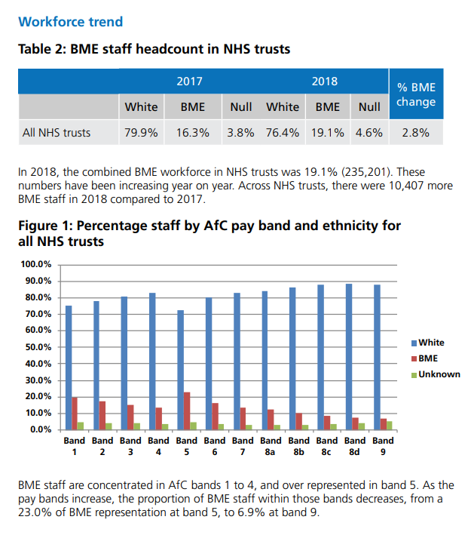
(NHS England, 2018)

MacDonalds
A new and aspiring MacDonalds employee wanted to move up the ladder but needed to have training to progress. The current supervising manager did not want the employee to do their training, preventing him from progressing, along with providing him with shifts during his study periods, even though he had initially submitted his college timetable availability. The manager’s prevention of him from progressing within the company was a sign of the limitation of how far he could go. This form of lack in motivation can be a contributing factor to MacDonalds high turnover of employees, as successful training and development creates job satisfaction and usually reduces costly turnovers (Maund, 2018). The glass ceiling is a form of discrimination. However, occasionally it can prove to be difficult to substantiate (Gov.uk, 2021).

Figure 6, illustrates MacDonalds employee reviews
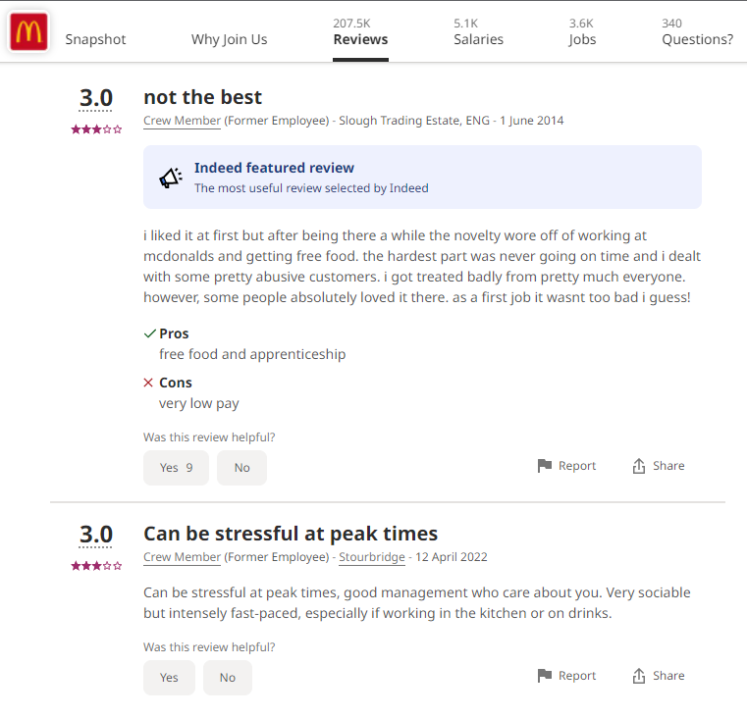
(Indeed.com, 2022).

MacDonalds have experienced a high reduction of their employees since 2012, here are the figures that illustrate that reduction between 2012 – 2020:

Figure 6, MacDonalds worldwide employees between 2012 and 2020
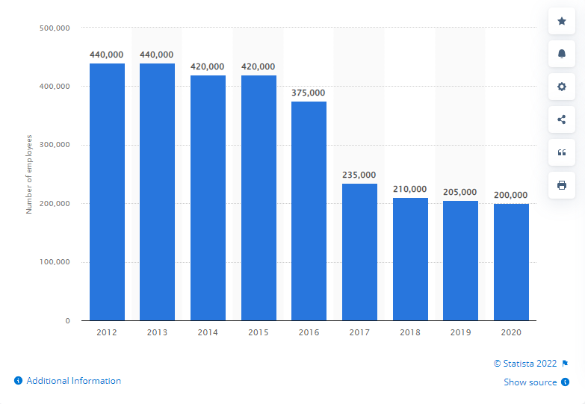
(Statista, 2022)

MacDonald’s rewards and benefits
MacDonald's place a high value on rewarding employees for their efforts and ensuring that they are progressing at the appropriate rate. McDonald's is quite forward about what they have to offer and how they want to assist their employee’s advancement. Employees start on a basic wage of £18,750 in the first year and may work their way up to a salary of £31,000 by the conclusion of the course, with ongoing pay and benefit increases as they successfully execute successive stages of training or promoted through the organization.

Figure 7, illustrates MacDonalds employee reviews
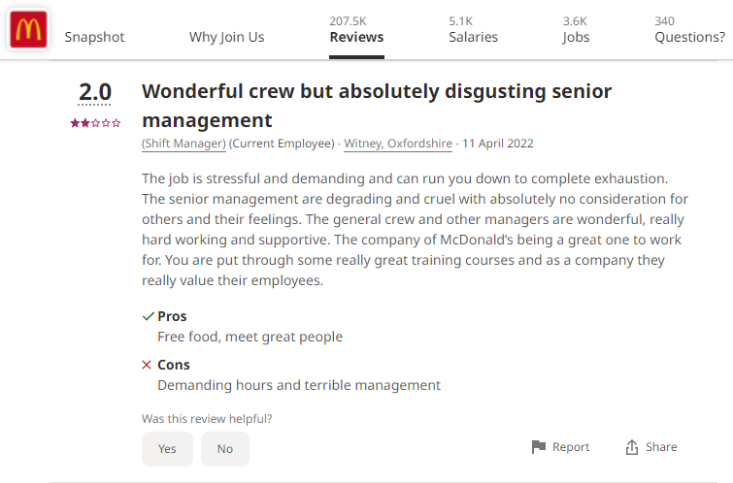
(Indeed.com, 2022).

Figure 8, MacDonalds Programmed Benefits
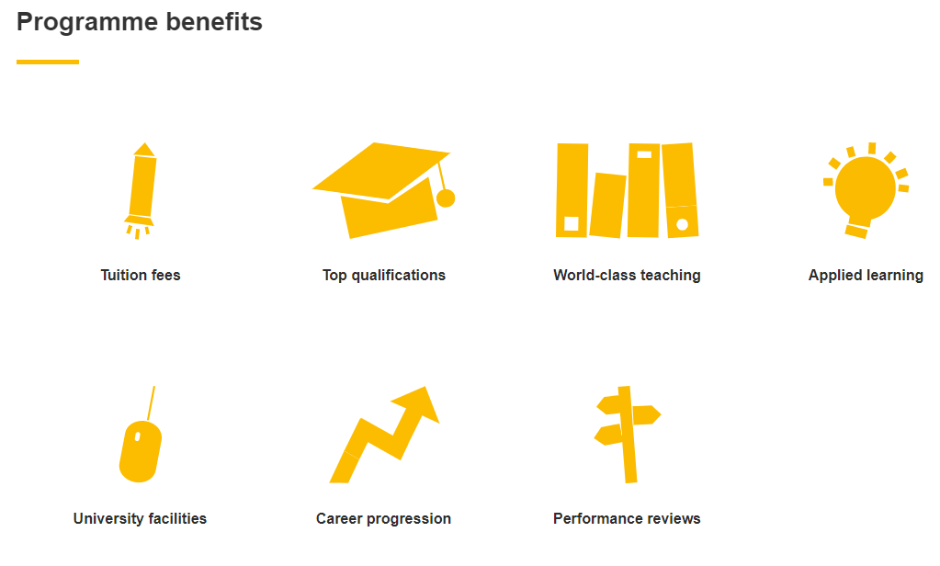
(Macdonald's Careers UK, 2022).

Boots Benefit Box
Boots have a benefit box scheme for their employees, where they receive vouchers depending on the length of time collaborated with them. For example, they give vouchers for employee’s long-term commitments to the company. They conduct company performance reviews every six months where employees receive rewards. When employees fair well, they receive a pay rise, which is an incentive to stay, as every time an employee may think of leaving, that extra pound in their wage packet will encourage them to think otherwise. Employees can choose from a range of things/items that can benefit them and their families. Boots also have flexible working times for parents, affording parents the availability to work around the school run. (Boots Pharmacy, 2018).
In order to motivate employees’, companies tend to offer a range of benefits. Here is an example of the benefits which Boots Pharmacy offer:

Figure7, Boots Employee Rewards and Benefits

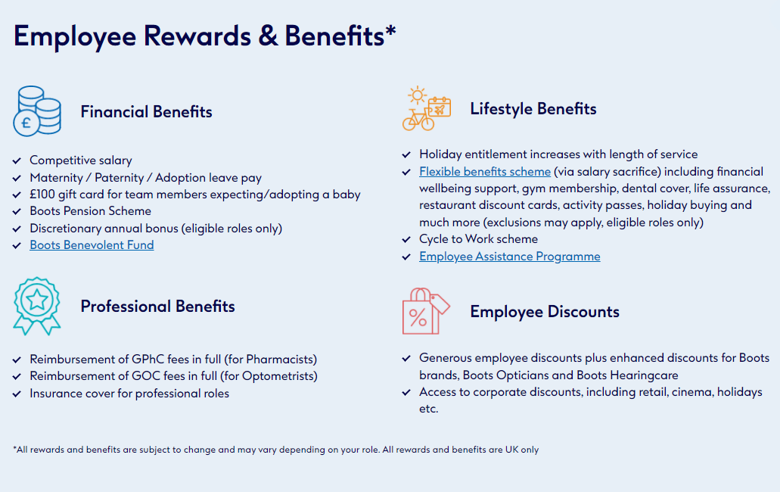
(Boots, 2018).

Pay Reviews.
Pay reviews are performance based, as employees need to meet a specific criteria before they are promoted. Here is an example of reviews, left by previous and current employees regarding the company they work(ed) for:

Figure 8, Boots Employee Reviews
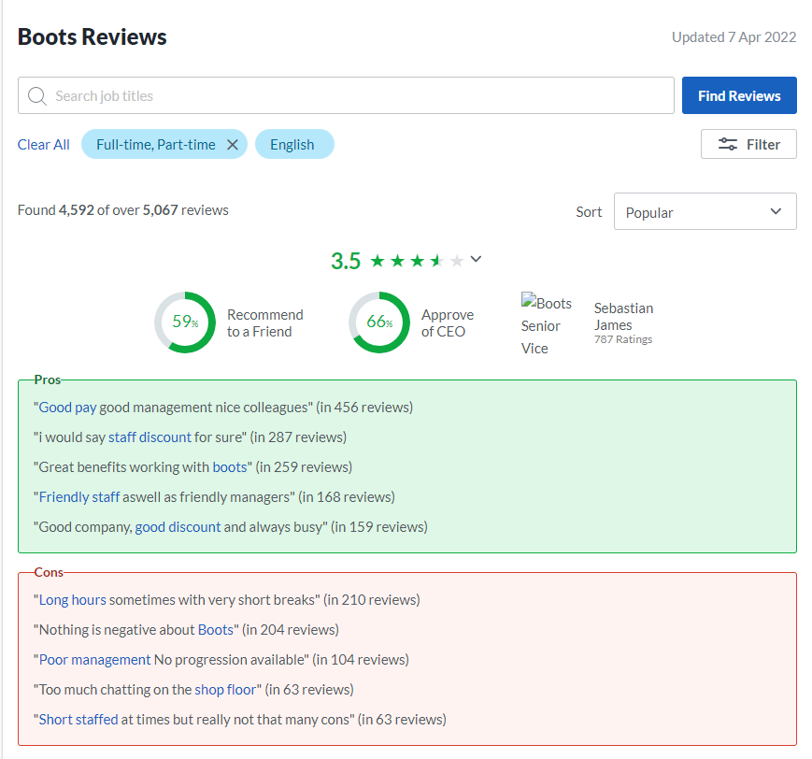
(Glassdoor, 2022).
The Benefit Box however would not be an incentive as it would not be significant, once an employee discovers they are in receipt of a lower salary than their counterparties (Albinger and Freeman, 2000), (Backhaus et al., 2002), (Greening and Turban, 2000), (Turban and Greening,1997). Since the pandemic there has been remote working options, which also helps with childcare and saves cost on transportation.

NHS England Benefits
NHS England and NHS Improvement released the NHS People Plan in July 2020. This is a follow-up to the Interim People Plan, that was released in June 2019 and outlines out the steps that organisations, employers, employees, and systems need to do to expand on the progress that has been accomplished as well as the extra knowledge gained through COVID-19 (NHS Employees, 2020). NHS England employs 1.5 million people nationwide. The public's admiration for all NHS personnel has grown as a result of the pandemic. Furthermore, there are both personal and financial advantages to working in this field. The NHS provides a variety of benefits, including a Blue Light discount programme, a well-known pension plan, childcare, and housing aid, along with flexible work schedules (NHS England, 2021). Being a member of the NHS workforce has several advantages as illustrated in these examples:

Figure 9, NHS England Employee Benefits
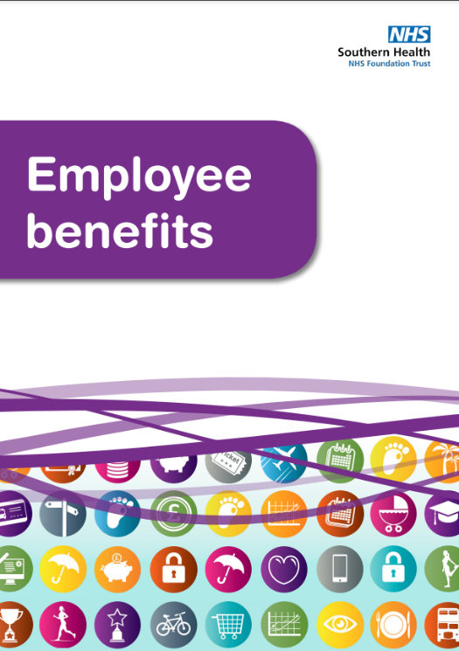
(NHS England, 2021).

Figure 10, NHS England Benefit Overview & Local Benefits
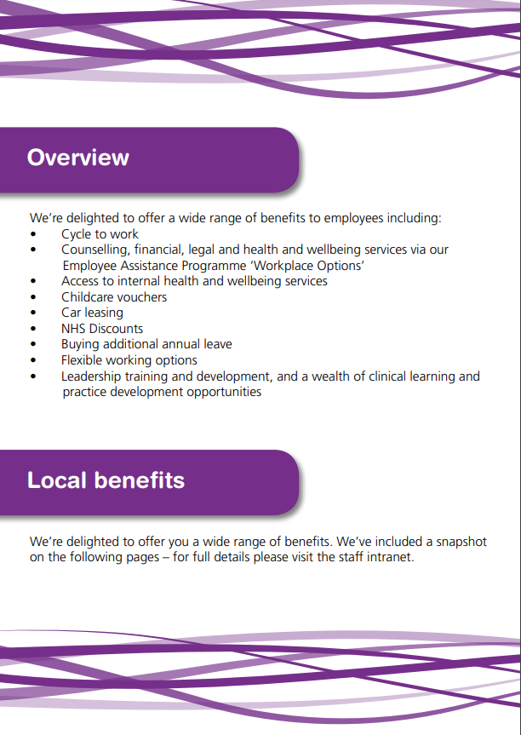
(NHS England, 2021).

Figure 11, NHS England Financial Wellbeing
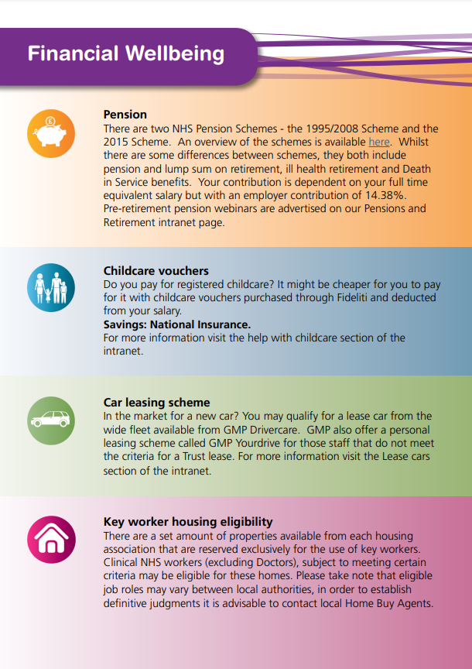
(NHS England, 2021).

Figure 12, NHS England Health, and Wellbeing

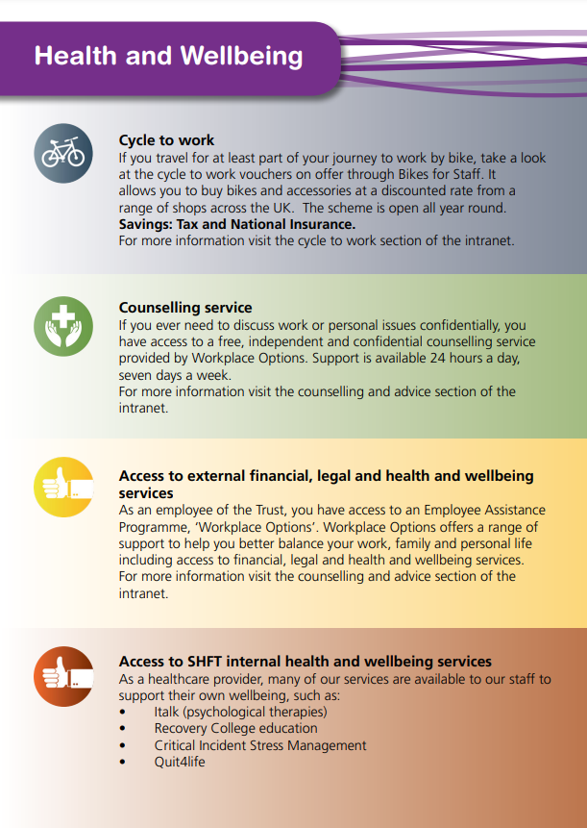
(NHS England, 2021).

Figure 13, NHS England Lifestyle, Learning, Education and Development
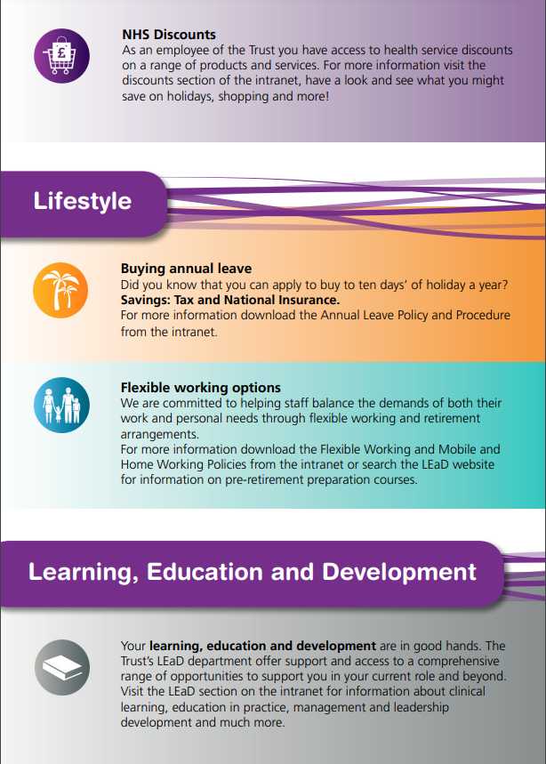
(NHS England, 2021).

Figure 14, illustrates NHS England Employee Reviews
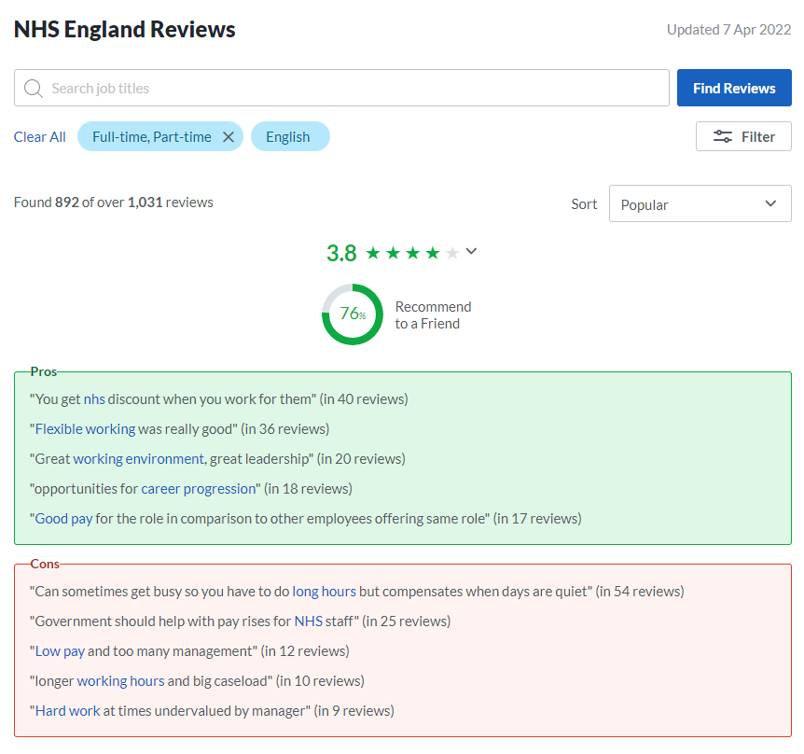
(Glassdoor, 2022).

Pay Rise

NHS
The Department of Health and Social Care for England, disclosed in July 2020 that salaried General Practicians (GP’s), in recognition of their arduous work and dedication during the Covid 19 pandemic, were to be awarded a back dated pay rise of 2.8% from April of 2019. As proposed by the Review Body on Doctors and Dentists Remuneration. However, the GP Partners, trainees, and NHS staff (including nurses) were not eligible to the same pay rise due to being in a second year of a multiyear deal.
Doctors and nurses were left feeling exploited and indignant with this and felt after their dedication in encountering and toiling through the most exacting and life-threatening time of their careers and lives, they were not being recognized. Furthermore, the Covid pandemic was an unanticipated occurrence leaving them ill-equipped to make any contingency stipulations in the case of any eventualities when they agreed to their multiyear deal. (Rimmer, A, 2020) (Gov.uk, 2021)

NHS Pay Rise a Penny to Two Pence
NHS Healthcare professionals throughout England who have toiled through the Covid pandemic, are now confronted with feelings of pressures to resign from their jobs due to the Covid mandates. They are feeling demoralized and devalued by the government, they are not being motivated or given any feeling of recognition as an incentive to remain in their profession.
The government has had to rethink and do a u turn on their decision as the staff turnover would have been too excessive. Over worked and under paid even through a pandemic and they were prepared to purge them. Individuals have encountered dismissals, solely for not having the vaccine, irrespective of their human rights, NHS England is not worth enough to make such a life changing decision for, so people would prefer to lose their job and change profession as there is a lack of motivation. (Sanford-Wood, 2020)

Recommendation
Equality and Fairness are crucial elements of a motivated individual and a vital principle for any company to implement. NHS England would do well to recognise this theory and ensure its implementation is evident within its establishment, as Race equality is not simply about equality, it is also vital to the NHS to eliminate the current disparities within the healthcare system.
MacDonalds need to ensure their managing staff oversee all new recruits along with existing employees are partaking in their require training. A digital record of their employee’s progression should be reviewed monthly with progression review discussions, in conjunction with meetings with general staff and higher management as attendees. These should take place every 3 months. This will ensure equity is maintained throughout the company. Additionally, those who aspire to develop their skills should be given the opportunity for advancement within their establishments. Furthermore, all managing staff need to recognize they employ many students and administer respect to their individual study sessions.
The government need to recognize the hard work and the life-threatening risks the healthcare professionals endured throughout the pandemic. They should then compensate these professionals accordingly. Additionally, stipulations and contingency plans need to be put into place, in the case of any unforeseen eventualities when constructing multiyear deals. Moreover, NHS employees’ salaries should be reflective of their demanding work. Implementing these equity theories throughout the NHS will automatically improve their employees’ motivation and morale within the whole healthcare system.

Conclusion
If a person does not feel motivated to work, they will leave. Furthermore, their quality and quantity of work will be determined by the equity motivation.

Reflective Report

Introduction
This report will reflect over the positive impact the information I have learnt whilst studying this module has had in my life, how it has assisted me with understanding the importance of critical thinking and its effectiveness. Along with, how I have developed and reshaped my critical analytical skills, how I will implement these skills in the future and where utilizing this concept has already made a difference in my academic and personal life. Driscoll’s model will be applied for this reflection.

Figure 1, Driscoll’s Model of Reflection
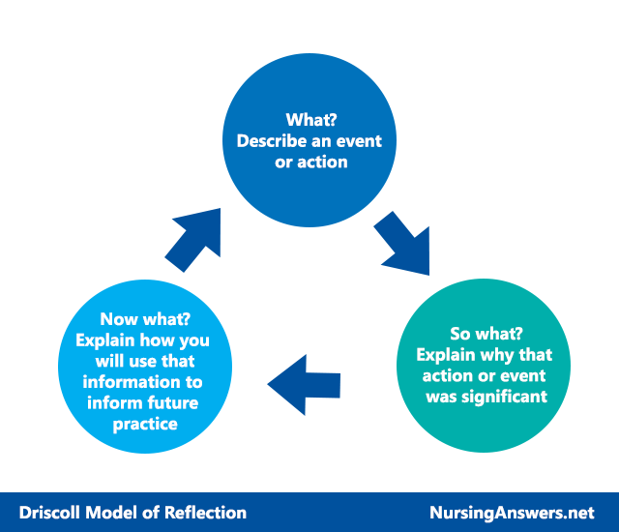
(Nursing Answers, 2022).

Logical Reasoning
I had initially believed myself to have very good analytical skills and thought I applied these skills quite well in life and my academic work. I soon came to find this was not entirely true. We were learning about Logical Reasonings inductive and deductive reasoning and trying to understand the concept of the truth of the premises. Honestly, aside from algebra I have never found a subject so confusing and yet, somehow, I manage to get some questions correct (just like algebra I guess). Not having clarity on what I was doing did not sit well with me, I went home and practiced until I was more confident in my understanding here.
With much quizzical practice online, along with a strong group effort, working together as a team with one goal, to understand. I finally gained appreciation for the concept of the inductive and deductive premises and how to apply deductive premises to valid, invalid reasoning sound and unsound arguments. Which was evident when taking my next test, I was more confident in my understanding and this development was reflected in my results.
I have a son who is a very logical and critical thinker. At times we would disagree, and I couldn’t see or understand why. I believed he was just being an obstinate teenager. When in actual fact it was just his way of thinking and how his mind works. Once I understood this, I started implementing logic and reasoning when conversing with him. Immediately I saw a change in his response. I was able to achieve progression with him. Which has been a lovely breakthrough for me. I also see how critical thinking can be beneficial to me in my future working environments and situations, when maintaining peace or simply ensuring staff are working productively.

Values, Beliefs and Attitudes
I never really appreciated how much our personal beliefs, values and attitudes can impact our working relationships. I have always been of the mind that we are all intitled to our own values and beliefs. That being said, from personal experience, I have learnt that people do not always appreciate one another’s values and beliefs. Through this module I have come to understand that when it comes to working relationships, it is best to leave personal beliefs, values, and attitudes at the door in order to maintain professional working relationships.
Furthermore, I gained understanding on the negative attitudes that can arise, from personal preconceptions of beliefs and values, when others do not share the same sentiments, it can create conflict within the workplace, tensions, and unrest. This is not good business practice, and I would not uphold it in my company .
I have learnt that people in a working environment have their individual values beliefs and attitudes, and these can sometimes be reflected in their conduct. I believe by implementing strong company values beliefs and attitudes within the workforce will be fundamental to assisting the maintenance of social respect and harmony within my future business. Implementing these theories will be fundamental in order for my business to run efficiently, my workforce to work smoothly as a team combined with, being harmonious as well as approachable by customers and clients.
This has also assisted me with learning to appreciate that even though I have taught my children my own values and beliefs, as they mature into men of their own right. My eyes have been opened to the fact that these young men have not only taken on my teachings but have gone onto form their own values and beliefs, that they live and stand by. Without these lessons I could have misread these developments as defiance or even arrogance.
people are intitled to have their own values and beliefs, and attitudes, but based on the standard of these can determine the reputation of my business. Therefore, I will be implementing strict codes of conduct where company values, beliefs and attitudes will be key principles my company stands on.

Theory of Management
I really enjoyed learning about the theories of management. As a mother I have automatically taken on a type of managerial role when managing the children, their conduct, and the running of our home. However, in business this concept of management theories I discovered to be more intricate. I found myself aligning my thoughts with how I could implement this theory into the development of my future business adventures. I understood the value of identifying the right people eligible to perform effectively as well as the value in ensuring my staff are always trained to current standards, to maintain efficient productivity throughout my business.
I understood the concept of management theories and its role within a company. I found myself analysing how I could use this theory to become a good leader with my company and motivate my workforce whilst creating productive communication and reducing contention amongst co-workers. I believe this will be a beneficial skill to me in my future.
with the content I have aquired through this theory, I believe using this theory in my company, will aissist in steering me into becoming a good leader. I believe by implementing this tool it will assist my company with changing developments and organising the company’s top priorties along with maintaining the focus on my goals for my business. I also believe these skills will assist me with maintaining great communication within my workforce.

References
Adams, J.S. 2019. Organizational injustice and emotional labour in the hospitality industry: A theoretical review. International Journal of Hospitality Management. [Online]. 83(1), 56-64. [8 April 2022]. Available from: https://www.sciencedirect.com/science/article/pii/S0278431918304821
Bargh et al., 1996. How Employees’ Perceptions of CSR Increase Employee Creativity: Mediating Mechanisms of Compassion at Work and Intrinsic Motivation. Journal of Business Ethics: JBE; Dordrecht. [Online]. 153(3), 629-644. [13 April 2022]. Available from: https://www-proquest-com.ezproxy.uwtsd.ac.uk/docview/2151026933?pq-origsite=primo&accountid=130472
Boots. 2018. A Rewarding Career. [Online]. [8 April 2022]. Available from: https://www.boots.jobs/why-boots/rewards-benefits/
Byrne, B.M (2018). BA in Leadership and Management Skills for the Workplace Student Yearbook, 1st Year. (1st ed.). England: Sage Publications.
Cable, and Judge, 1996. How Employees’ Perceptions of CSR Increase Employee Creativity: Mediating Mechanisms of Compassion at Work and Intrinsic Motivation. Journal of Business Ethics: JBE; Dordrecht. [Online]. 153(3), 629-644. [13 April 2022]. Available from: https://www-proquest-com.ezproxy.uwtsd.ac.uk/docview/2151026933?pq-origsite=primo&accountid=130472
Cambridge. 2022. Cambridge Dictionary. [Online]. [8 April 2022]. Available from: https://dictionary.cambridge.org/dictionary/english/glass-ceiling
Corthouts. J. & Scheerder. J. 2020. Race', Ethnicity and Racism in Sports Coaching. [Online]. (1st ed.). London & Routledge: Taylor & Francis. [12 February 2022]. Available from: https://library.oapen.org/handle/20.500.12657/46489
Glassdoor. 2022. Boots Reviews. [Online]. [12 April 2022]. Available from: https://www.glassdoor.co.uk/Reviews/Boots-Reviews-E327390.htm
Glassdoor. 2022. NHS England Reviews. [Online]. [12 April 2022]. Available from: https://www.glassdoor.co.uk/Reviews/NHS-England-Reviews-E1799989.htm
Gov.uk. 2013. Equality Act 2010: guidance. [Online]. [8 April 2022]. Available from: https://www.gov.uk/guidance/equality-act-2010-guidance
Hafer and Be`gue. 2005. Social Disadvantage and the Self-Regulatory Function of Justice Beliefs. Journal of Personality and Social Psychology. [Online]. 100(1), 149-171. [12 April 2022]. Available from: https://web-p-ebscohost-com.ezproxy.uwtsd.ac.uk/ehost/pdfviewer/pdfviewer?vid=0&sid=cf77eadc-157b-4e97-811c-d3bbda12e0e3%40redis
Heim. C. 2020. Race', Ethnicity and Racism in Sports Coaching. [Online]. (1st ed.). London and Routledge: Taylor & Francis. [12 February 2022]. Available from: https://library.oapen.org/handle/20.500.12657/46489
Hur, W, Moon, T & Ko, K. 2018. How Employees’ Perceptions of CSR Increase Employee Creativity: Mediating Mechanisms of Compassion at Work and Intrinsic Motivation. Journal of Business Ethics: JBE; Dordrecht. [Online]. 153(3), 629-644. [13 April 2022]. Available from: https://www-proquest-com.ezproxy.uwtsd.ac.uk/docview/2151026933?pq-origsite=primo&accountid=130472
Indeed.com. 2022. Working at MacDonald's Reviews. [Online]. [13 April 2022]. Available from: https://uk.indeed.com/cmp/McDonald's/reviews
Interfederal Centre for Equal Opportunities. (2018) Race', Ethnicity and Racism in Sports Coaching. [Online]. (1st ed.). London & Routledge: Taylor & Francis. [12 February 2022]. Available from: https://library.oapen.org/handle/20.500.12657/46489
Jost & Banaji. 1994. Social Disadvantage and the Self-Regulatory Function of Justice Beliefs. Journal of Personality and Social Psychology. [Online]. 100(1), 149-171. [12 April 2022]. Available from: https://web-p-ebscohost-com.ezproxy.uwtsd.ac.uk/ehost/pdfviewer/pdfviewer?vid=0&sid=cf77eadc-157b-4e97-811c-d3bbda12e0e3%40redis
Laurin et al. 2011. Social Disadvantage and the Self-Regulatory Function of Justice Beliefs. Journal of Personality and Social Psychology. [Online]. 100(1), 149-171. [12 April 2022]. Available from: https://web-p-ebscohost-com.ezproxy.uwtsd.ac.uk/ehost/pdfviewer/pdfviewer?vid=0&sid=cf77eadc-157b-4e97-811c-d3bbda12e0e3%40redis
Lerner. 1965. Social Disadvantage and the Self-Regulatory Function of Justice Beliefs. Journal of Personality and Social Psychology. [Online]. 100(1), 149-171. [12 April 2022]. Available from: https://web-p-ebscohost-com.ezproxy.uwtsd.ac.uk/ehost/pdfviewer/pdfviewer?vid=0&sid=cf77eadc-157b-4e97-811c-d3bbda12e0e3%40redis
Lerner & Miller. 1978. Social Disadvantage and the Self-Regulatory Function of Justice Beliefs. Journal of Personality and Social Psychology. [Online]. 100(1), 149-171. [12 April 2022]. Available from: https://web-p-ebscohost-com.ezproxy.uwtsd.ac.uk/ehost/pdfviewer/pdfviewer?vid=0&sid=cf77eadc-157b-4e97-811c-d3bbda12e0e3%40redis
Lock, S. 2022. Statista. [Online]. [7 April 2022]. Available from: https://www.statista.com/statistics/819966/mcdonald-s-number-of-employees/
Macdonald's Careers UK. 2022. EARLY CAREER OPPORTUNITIES, MANAGEMENT DEGREE APPRENTICESHIP PROGRAMME, REWARDS, BENEFITS AND MORE . [Online]. [13 April 2022]. Available from: https://people.mcdonalds.co.uk/early-career-opportunities/management-degree-apprenticeship-programme/rewards-benefits-and-more/
Maund. A. 2018. BA in Leadership and Management Skills for the Workplace Student Yearbook, 1st Year. (1st ed.). England: Sage Publications.
NHS England. 2021. Employee Benefits. [illus.]. Available from: https://www.nhsemployers.org/sites/default/files/2021-06/Southern-Health-NHS-Foundation-Trust-benefits-leaflet_0.pdf (Accessed:13 April 2022)
NHS Employees. 2020. The NHS People Plan - workforce health and wellbeing. [Online]. [13 April 2022]. Available from: https://www.nhsemployers.org/articles/nhs-people-plan-workforce-health-and-wellbeing
Nursing Answers. 2022. Academic Support for Nursing Students. [Online]. [13 April 2022]. Available from: https://nursinganswers.net/reflective-guides/driscoll-model-of-reflection.php
Randhawa, M. 2018. Closing the gap on BME representation in NHS leadership: not rocket science. [Online]. [7 April 2022]. Available from: https://www.kingsfund.org.uk/blog/2018/03/bme-representation-nhs-leadership
Rimmer, A. 2020. GPs call for partners to receive same pay rise as salaried colleagues. GPs call for partners to receive same pay rise as salaried colleagues. [Online]. 371(1st), 1. [13 February 2022]. Available from: https://www.proquest.com/docview/2465658707/fulltextPDF/1E586FBBA67C4630PQ/1?accountid=130472
Sanford-Wood, M. 2020. GPs call for partners to receive same pay rise as salaried colleagues. GPs call for partners to receive same pay rise as salaried colleagues. [Online]. 371(1st), 1. [13 February 2022]. Available from: https://www.proquest.com/docview/2465658707/fulltextPDF/1E586FBBA67C4630PQ/1?accountid=130472
Gov.uk. 2021. NHS pay review announcement - key questions and guidance. Posted on: 22 July 2021. Department of Health and Social Care Media Centre. [Online]. [14 February 2022]. Available from: https://healthmedia.blog.gov.uk/2021/07/22/nhs-pay-review-announcement-key-questions-and-guidance/

