DS 1 Template

My Screenshots/Photos
- Please add 4–6 screenshots or photos of your digital life.
- You can use your phone or laptop.
- For each screenshot, write one or two sentences explaining what it shows.

Screenshot/Photo 1
[Insert Photo/Screenshot below]
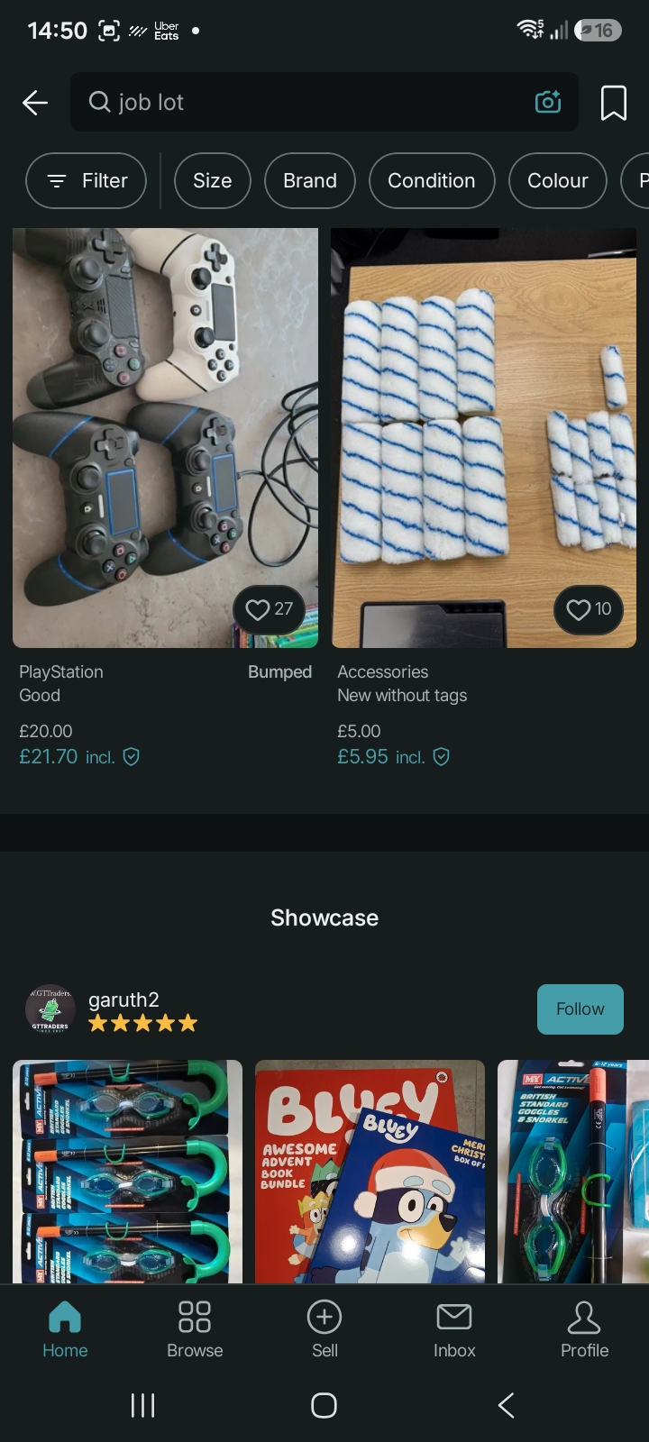
This is my vinted app, its an app used to sell and buy unwanted items from people around the UK. This app has many features such a barging with prices, creating bundles and many more. This is a vary safe app and is used by thousands around the country.

Screenshot/Photo 2
[Insert Photo/Screenshot below]
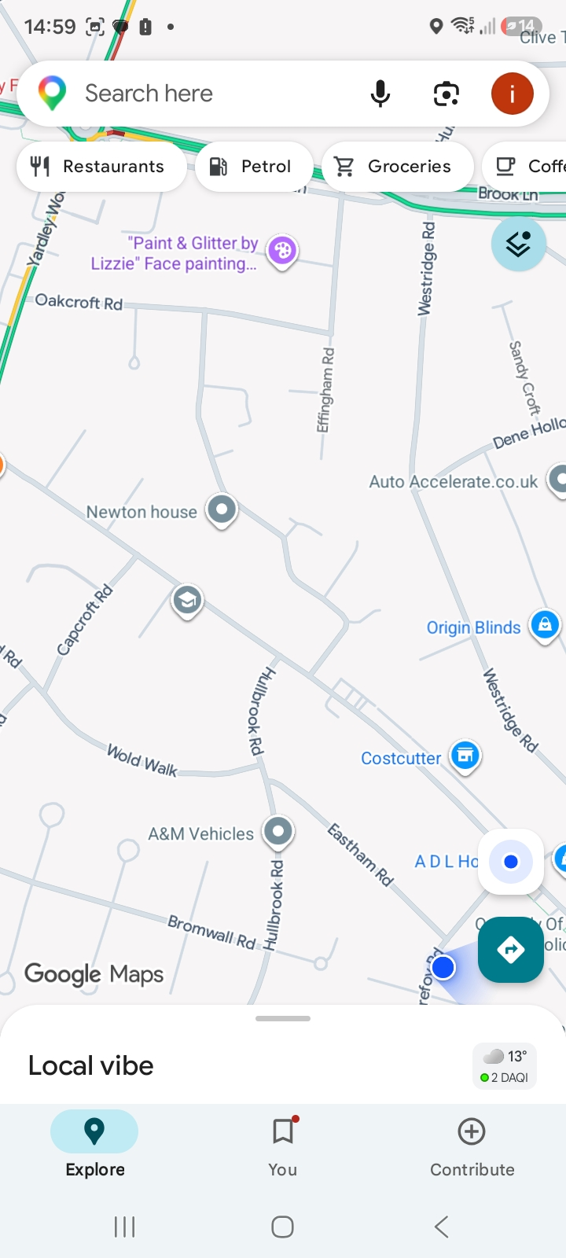
This is my google maps app, I use this app to find my way around unfamiliar places. I use this app everyday as I travel a lot and journey can tell a lot longer if taken the wrong route. My favourite feature in this app is that it informs you of any road closures, delays due to traffic and motorway delays this can save lots of time.

Screenshot/Photo 3
[Insert Photo/Screenshot below]
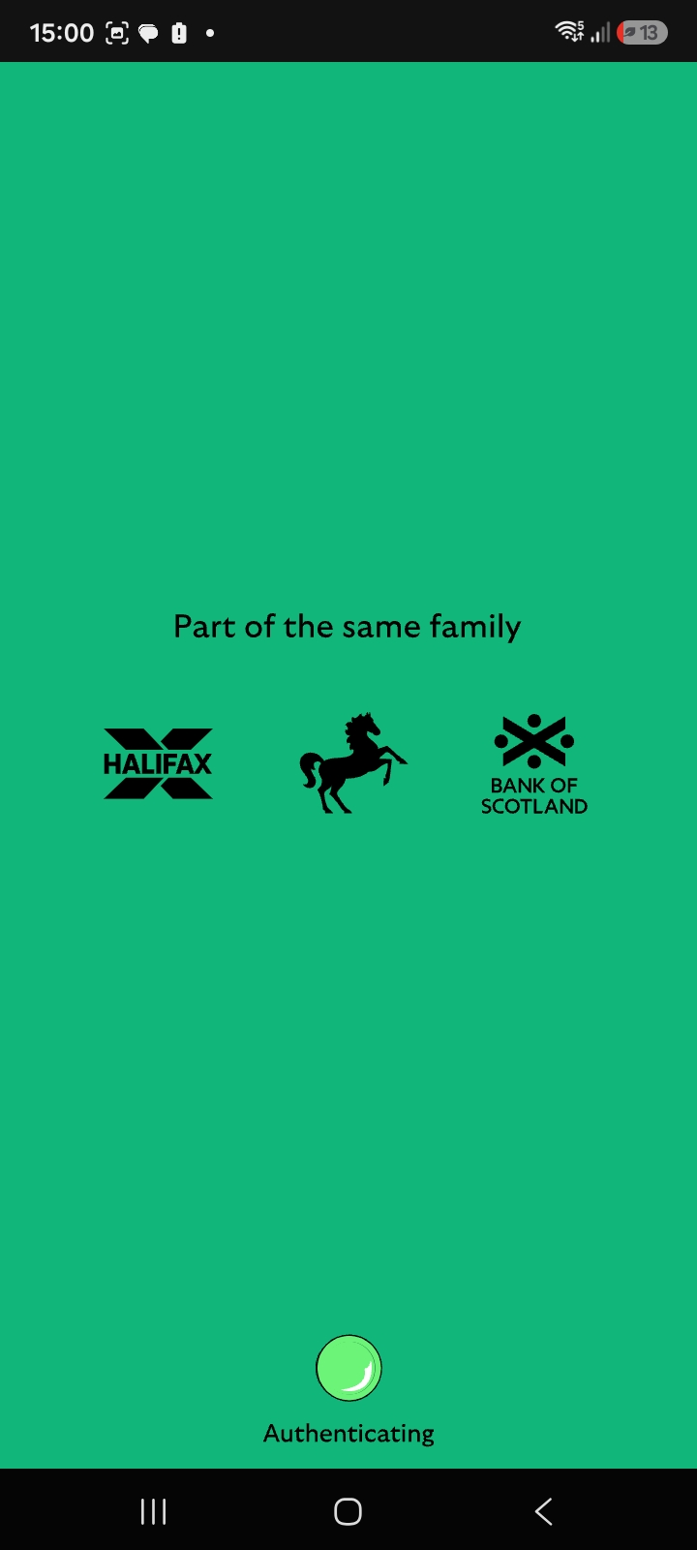
This my Lloyd banking app I use this app to keep track of my savings. This app informs me by sending me notifications whenever money leaves of enters my account. I use this app daily to organise my funds and spending. My favourite feature of this app is that I can still make payments using the app even if I lose my card

Screenshot/Photo 4
[Insert Photo/Screenshot below]
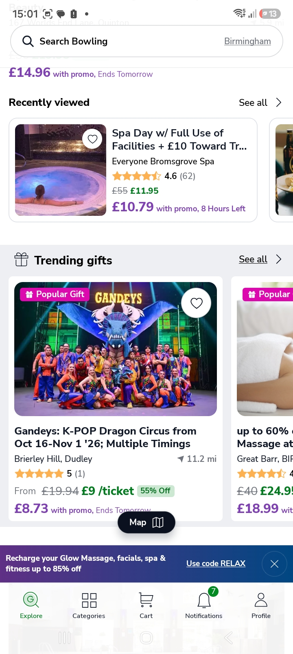
This is my Groupon app, this app is designed to provide you with all the great deals on activities. This app provides new deals around the web so you do not have to search thought different websites. I have use this app to book spa days, SeaLife centre tickets and outdoor activities for my child.

Screenshot/Photo 5
[Insert Photo/Screenshot below]
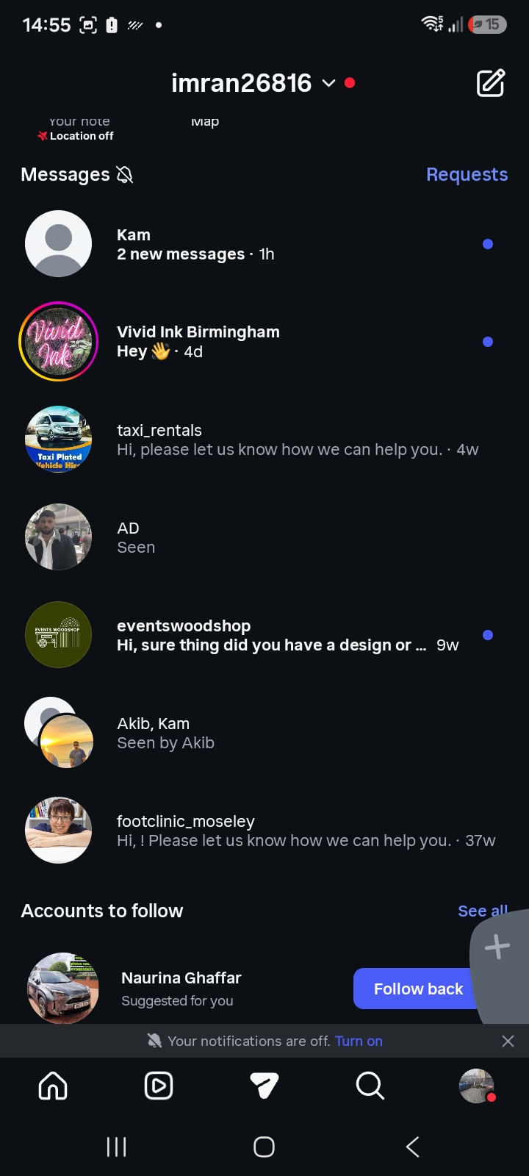
This is my Instagram app, I use this app daily to scroll through videos in my spare time. This app makes me feel less trapped in reality and makes me feel like I can travel the world using my imagination. My favourite feature of this app is that I can follow my idols and on their daily life which then inspires me to work harder

Screenshot/Photo 6
[Insert Photo/Screenshot below]
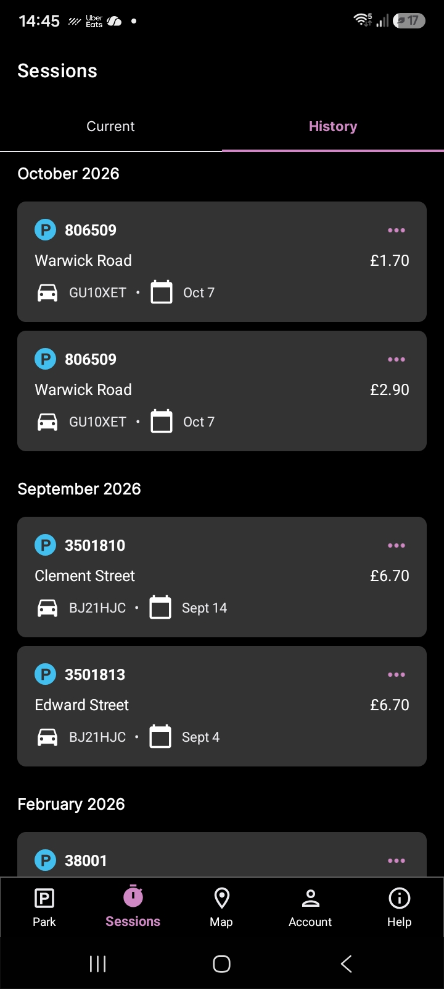
This is my ring go app I use this app to pay for parking. Ringo is used in majority parking areas it is an easy way to pay for parking in the comfort of your car using the location code. My favourite feature is that it informs you when your parking is about to finish and you can extend your parking time without returning to your car.

My Short Reflection
- Write 5–8 simple sentences about your digital life.
- You can use the sentence starters below if helpful.

Sentence starters
- I use digital tools to …
- I feel confident when I …
- I want to improve …
- I often use these tools: …
- I sometimes feel nervous about …
- I hope this module will help me …
- Digital skills are important for me because …
You can write more if you want.

Submission Checklist
Before you submit, please check:
​​​ ☐ I added 4–6 screenshots
☐ I wrote short sentences for each screenshot
☐ I wrote my short reflection
☐ My work is my own
☐ My file opens correctly
​​☐ My file opens correctly

