University Trinity Saint David

Marketing Report

Grace Davies
Niche Marketing and Social Media
BMTP4014
Jacqui Jones
December 18th 2022
Executive summary
This report shows a business plan for principality stadium to attend the 2023 world travel market. The main aim of this plan is to increase profits for the stadium and draw attention to the types of events that they hold there. This report considers the financial feasibility and target market for such event. It also demonstrates a detailed description of the appearance of the stand as well as the activities and promotions that will be held there. Business to business sales are made at world travel market, it is in the companies best interest to attend.

Introduction
Cardiff’s Principality Stadium is in the heart of Wales. It is a large venue that holds a plethora of events ranging from Rugby matches to business meetings. As it is a predominant part of Welsh culture, it should be show cased at World Travel Market. This report shows a business proposal for World Travel Market 2023. This proposal hopes to catch attention, interest and desire as well as sparking action to increase business to business sales at the event and increase the net profit for the country.

World travel market stand 2022
World Travel Market is a trade show that enables the growth of the tourism industry globally through business-to-business contact (World Travel Market, 2022). At the 2022 World Travel Market, Wales’s stand lacked character and enthusiasm and therefor was lost amongst the rest. Wales is a vibrant country with a rich history; however, it was clouded by the flamboyant stands produced by other countries. World Travel Market 2022 showcased 55 nations at their 3-day event and hosted over 35,800 guests that are invested in the travel industry through business (World Travel Market, 2022).
The Principality Stadium should make an appearance at World Travel Market 2023 to generate an interest and to give the world a taste of what Wales has to offer. The Principality Stadium is the largest events venue in Wales (Scott. T, 2021). It is renowned for hosting rugby matches and stadium tour music concerts. When thinking of events in Wales it is what people naturally gravitate towards. People travel from all over the world to attend events at the stadium. The events and tourism industry are closely linked.

Target market
Although Wales is a small country it has 3 large capacity stadiums that can cater for over 20,000 people and a generous footmark in the events industry. The principality stadium is the largest of the 3 with a capacity of 74,500 people compared to the smallest of the 3, Swansea.com stadium with a capacity of 21,000 people (Scott. T, 2021). With many competitors Wales has to increase business to business sales to make Wales a renowned events destination. Since Covid-19, there has been a decrease in large scale events in the UK. With restrictions in place, many concerts and sports games were cancelled, and business meetings moved online. Now that the pandemic has eased and events are running as usual, Principality Stadium must target a wider audience to get their sales back up to normal.
World travel market is all about business-to-business sales, attending this trade show would allow the stadium to access a wide range of demographics that would usually be inaccessible. The target market for the Welsh stand at World Travel Market 2023 is people that are willing to invest, resell rooms or become a stakeholder in the stadium. The Principality stadium has a wide target market it is a venue for so many different events. The main target market would be that of those who attend rugby matches as this is the event that occurs most frequently and has the largest media presence. People who attend rugby matches are mostly men between the ages of 18 and 35. It is important to cater to these people at the stand at travel market because they are the ones most likely to buy.

Catering to the Target Market
According to Kotler and Armstrong (2014) “Marketing is the process by which companies create value for customers and build strong customer relationships in order to capture value from customers in return”. Targeted marketing allows for direct access to the specific target market. The Principality Stadium stand at World Travel Market 2023 must fit into the theory of ‘Maslow’s Hierarchy of Needs’. It has been proven that these ‘needs’ are the basis to successful marketing and event planning. The stand will satisfy the first 2 of his 5 needs. The first of the ‘needs’ pyramid is physiological, the stand will do this by providing food, drink and shelter to guests. The second need is safety, this will be created in the layout of the stand so that guests feel protected. (Maslow, A.H, 1943).
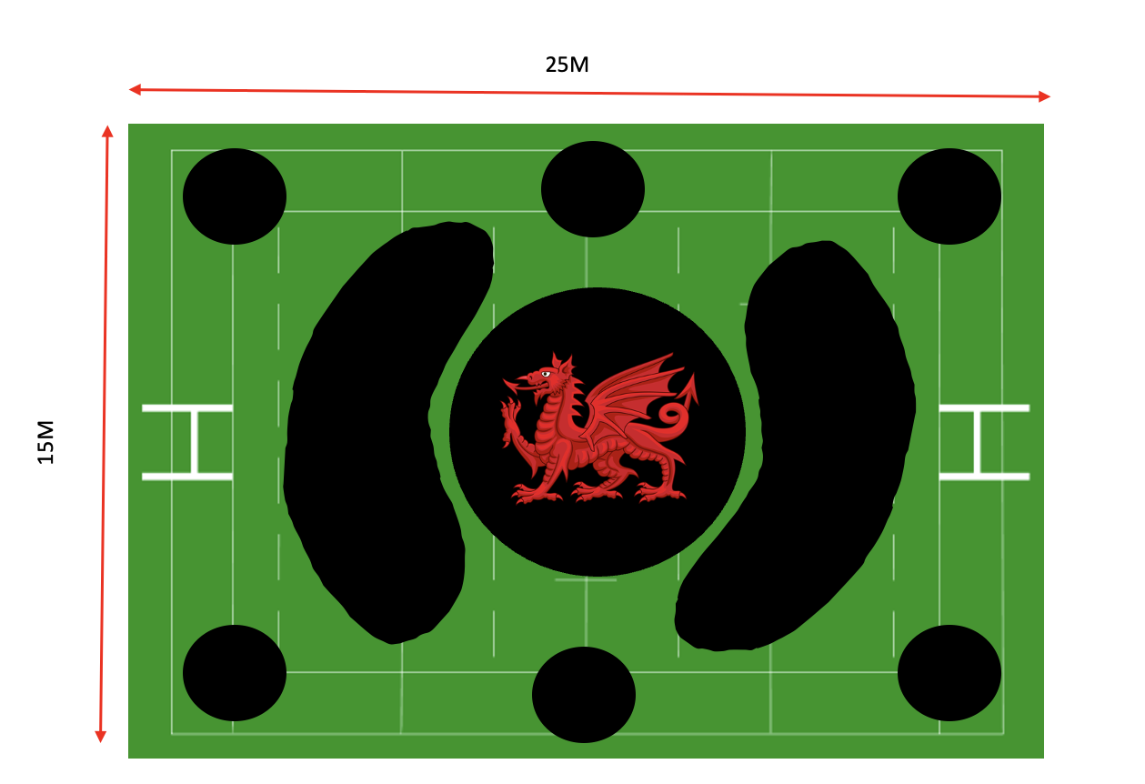
The World Travel Market stand 2023
The black circle in the centre of the diagram will be a round, castle shaped building with a large Welsh dragon on top. This will be 5M tall, so that the stand is visible from the whole venue. It will be 2 stories high. On the ground floor there will be Welsh music playing with traditional Morris dancers performing in costumes. On the first floor of the castle there will be people serving fresh Welsh cakes to those attending. There will be a champagne tower with wines from local vineyards such as White Castle Vineyards, this will give the VIP feel that most investors are looking for.
The smaller black circles surrounding the stall will be booths for business-to-business sales. They will be designed to make customers feel welcomed, this should encourage sales. Safety is Maslow’s second step in his ‘Hierarchy of Needs’ and the design of the booths will support this (Maslow, A.H, 1943).
The floor of the stand will be designed to look like a rugby pitch. It is a quarter of the size of an actual rugby pitch. Where the rugby posts would be, there will be stands displaying photos and videos of past events that have been held in the principality stadium. The black sections surrounding the castle will be areas for people to socialise and create connections with other businesspeople. The stand will be the same colours as the Welsh flag, red, green and white. This will draw maximum attention.

Financial Feasibility
It is important to consider the cost implications for attending World Travel Market. It is vital to count every outgoing payment and compare it to the profits made through B2B sales. Looking at the price of the pitch for the stand, the ingredients for the Welsh cakes and the wages of those working at the stand. The cost of the 25m by 15m pitch at ExCel in London is £8000 for the full 3 days of travel market. It will cost £4000 to create the castle in the middle of the pitch. The stand will be sponsored by the principality building society and they have a Welsh dragon that can be used on top of the castle. World Travel Market had over 35,800 visitors in 2022, when considering how much wine and Welsh cakes will be needed across the 3 days. If every guest has 1 Welsh cake and a glass of wine, will need 35,800 Welsh cakes and 9000 bottles of wine. A bottle of white castle wine from the Welsh vineyard costs £18 a bottle, this means that it will cost £161,100 (Vineyards of Wales,2022). This is a large amount of wine; it might be best to come up with a partnership deal with the white caste vineyard. Welsh cakes cost £10 for 30 Welsh cakes; this means it will cost £11,933. Buying ingredients in bulk will make this slightly cheaper.

Sponsorships and Promotions
As mentioned earlier, the principality building society is already a sponsor for the principality stadium, a lot of funding for this event will come from them. The white castle vineyard should give wine to the stadium to promote on game days and during other events. Promotions on the day will include exclusive package deals for buys to attend a concert or game of their choice for free. This is one of the Ps of marketing mix (Jones, J, 2022).

Bibliography

Jones, J. (2022). BMTP4014: Niche Marketing and Social Media. University Trinity Saint David. Unpublished.

Kotler and Armstrong (2014) Marketing: An Introduction. Available at: https://www.shivajicollege.ac.in/sPanel/uploads/econtent/fc48e83e7dfca961a590ca81ac802f38.pdf (Accessed: December 16th 2022).

Maslow, A.H. (1943). “A Theory of Human Motivation”. In Psychological Review, 50 (4), 430-437.

Scott, T. (2021) Largest Stadiums in Wales, UK. Available at: https://rlist.io/l/largest-stadiums-in-wales-uk (Accessed: December 16th 2022).

Senedd Cymru (2022) A local tourism levy for Wales: your questions answered. Available at: https://research.senedd.wales/research-articles/a-local-tourism-levy-for-wales-your-questions-answered/ (Accessed: December 16th).

Vineyards of Wales (2022) White wine archives. Available at: https://whitecastlevineyard.com/Welsh-Wines/white-wine/ (Accessed: December 18th 2022).

World Travel Market (2022) About World Travel Market. Available at: https://www.wtm.com/portfolio/en-gb/about.html#:~:text=World%20Travel%20Market%20(WTM)%20enables,connect%2C%20learn%20and%20do%20business (Accessed: December 16th 2022).

World Travel Market (2022) WTM 2022 Review. Available at: https://content.yudu.com/web/2zc2/0Auv9i/wtm-2022-review/html/index.html?page=4&origin=reader (Accessed: December 16th 2022).

