

Postgraduate/Distance Learning
Assignment coversheet & feedback form

THIS SHEET MUST BE THE FIRST PAGE OF THE ASSIGNMENT YOU ARE SUBMITTING (DO NOT SEND AS A SEPARATE FILE)

For completion by the student:
Student Name: Kathy Vinton

Student University Email: 2212888@student.uwtsd.ac.uk
Module code: HPCA 7028  Module title: Sacred Skies | Student ID number:  2212888 |  |  | Educational support needs:  /No
Assignment title: A Critical Examination of the Sky in Material Culture

Assignment due date: 4 May 2023
This assignment is for the 1st 2nd 3rd 4th 5th 6th module of the degree
I confirm that this is my original work and that I have adhered to the University policy on plagiarism.
Signed ……………………………………………………………
Email submission:if you are submitting this form via email, please tick this box x
(as a substitute for your signature) to confirm that you agree to the above declaration.
Assignment Mark
1st Marker’s Provisional mark
2nd Marker’s/Moderator’s provisional mark
External Examiner’s mark (if relevant)
Final Mark

NB. All marks are provisional until confirmed by the Final Examination Board.

For completion by Marker 1 :
Comments:

Marker’s signature: |  |  | Date:
For completion by Marker 2/Moderator:

Comments:

Marker’s Signature: |  | Date:
External Examiner’s comments (if relevant)

External Examiner’s Signature: |  | Date:

A Critical Examination of the Cultural Representation of the Sky in
Angel of the North by Antony Gormley (1998), and Rise by Wolfgang Buttress (2011)
Word Count: 4575

Introduction
This essay aims to critically examine the cultural representation of the sky in Angel of the North by Antony Gormley and Rise by Wolfgang Buttress, each situated on their respective city's outskirts, of Gateshead in north east England and Belfast in Northern Ireland. Whilst the two sculptures are visually very different, they are similar in both being outdoor, monumental pieces of art work, commissioned by their city councils to be site-specific,, at a time when Gateshead was emerging from post-industrial decline and Belfast was seeking to re-build a united city following the Good Friday Agreement in 1998. They were both funded part publicly, part privately, and with lottery funding. Through the shortlisting of international artists by Gateshead council, and an international competition in Belfast, the commissions were awarded for the pieces which were to be at the time the largest sculptures in England and Northern Ireland respectively, and each notably similar in consisting of representions of the sky, one, an angel, and the other, a rising sun.

Talking about the sky, Tim Ingold questioned whether we can paint it, what we mean when we say we see it, and, finally, 'what is the sky?' Although hesitant to give an answer, he continued 'The sky is the kingdom of light, sound and air.' There are many ways of defining the sky itself, commonly by illustrating or describing objects within it, and Daniela Bertol has described how, from the early constructions at Stonehenge to contemporary land art projects, 'humans have always expressed the desire to communicate beyond their local space, establishing built places that reach out to the sky above', continuing that 'Art becomes a means to reconnect us to the universe, bringing to us an awareness of our presence in space and time.'

Land art, which began as a concept in the 1960's, fostered steps to move art away from the domain of galleries and private collectors, described by Mark Rosenthal as ' an urge to reject the gallery system'. This resulted, initially in America, in large-scale sculptures sited in locations where space was no object, made by, as described by Alan Sonfist in 1983, a group of artists 'whose work makes a statement about man's relation to nature' and was classed under terms such as earth art, environmental art and land art, although he included that their 'methods, styles and even intentions vary widely'.

This essay, therefore, in order to discuss the sky's cultural representation in the two sculptures, has considered the context for their commissioning, the artists and the details of the sculptures, together with their position in connection to the wider, continuing land art concept. From this discussion, concluding remarks are made regarding the cultural representation of the sky in Angel of the North and Rise.

Academic Rationale
The representation of the sky in art has historically reflected the thoughts and beliefs of the age, with the concept of the sky arousing different feelings in each of us, and holding a number of different meanings. Forming, as expressed by Darrelyn Gunzberg, fifty percent of our visual world, it is perhaps inevitable that its imagery, as she continued, concurring with Bertol, 'has reflected our place in the cosmos'. Daniel Brown has also emphasised the significance of the sky, describing the night sky as having 'shaped myth, inspired built environments, created cosmologies . . .'. The different perceptions have taken many forms in different cultures, with Fabio Silva outlining, 'Different cultures might have “access” to the same sky but “see” completely different skyscapes', the relevance of which he described as showing 'how it is not only possible but even desirable to look at the skyscape to shed further light on human societies.' The sky, in providing the source of people's religions or cosmologies is inextricably linked with art's representation and expression of it, as William Malpas has described, when stating that art has been 'deeply associated with magic and religion for at least 40,000 years, and probably millennia more'.

A different view of the sky, however, has been introduced in the more recent past and, from perceiving sky as above us, science is clarifying our position with images sent back to us from space, both of distant stars and also our own planet. It may be thought that the traditional sense of the heavens above is gradually being eroded, as shown in research looking at the developing views of children, detailed by Tim Ingold, with the older children replacing the word 'sky' with 'space', which he parallelled with the 'paradigm shift in the history of science'.

Additionally, we are becoming increasingly aware of what we are doing to the sky in terms of carbon emissions, and how this affects weather patterns, with Alexandra Harris in 2016 stating that the last few years of investigations have been probably the 'most momentous time of all'. She also described the weather as 'made up of personal memories and moods; an evening sky is full of other evenings', and describing how these moments are 'set down permanently' by writers and artists'. Therefore, in examining these two sculptures' relationship with aspects of the land art movement, which has reflected an aspect of recent cultural attitudes both to art and our relationship with nature and the sky, the cultural representation of the sky in these two sculptures may be found to include reflections on a different, environmental perspective, or that the sky is still purely linked to memory, emotion and imagination.

Context for the commissioning
The installation of Angel of the North, thirteen years prior to Rise, followed smaller-scale public art commissions in Gateshead which, as described by Brown and others, led the way in a national movement of arts-led regeneration and was created further to their idea of creating an 'opportunity for an artist of international standing to produce a major landmark commission'. As a 'millennial image that would be a marker and a guardian for our town', it was first conceived by Gateshead Council in 1990 for this particular location, a reclaimed former colliery site, on which 'a mound ready for an artwork' had already been created from the remains of its pithead baths. Finally installed in February 1998, it was then the tallest sculpture in Britain.

At the moment of Angel of the North's installation in Gateshead, the final negotiations were taking place in Belfast which would lead, two months later in April 1998, to the signing of the Good Friday Agreement. Joana Etchart has described how 'As peace developed, so did urban regeneration plans aiming at giving a new face to the city' and, from this point, as with Gateshead, Belfast City Council also undertook a process of developing public art schemes prior to the commissioning of Rise due to their perceived 'beneficial effect', which included Beacon of Hope and Spirit of Belfast . The expressed hope was that Rise would initiate a process of regeneration in Belfast, similar to that which Angel of the North was credited with accomplishing for Gateshead, as described by Hocking. Belfast City Council's aim, 'to position Belfast on the world stage as a progressive European capital', resulted in the installation in 2011 of Rise, which remains the largest piece of public art in Belfast.

The Sculptors and Sculptures
Both artists were in the latter half of their forties when they created these sculptures, (Gormley, born in 1950, was 48 and Buttress, born in 1965 was 46). They are both British, with Gormley a Roman Catholic of German/Irish descent, and Buttress of German/British descent. Gormley has explained that 'his strict Catholic childhood and subsequent search for enlightenent influenced his decision to become a sculptor' and Buttress has connected himself with environmental issues, demonstrated by his work Hive in Kew Gardens, as well as with scales of size 'from the cosmic to the microscopic', acknowledging that 'We are all stardust. The use of scale can remind us of universality and wonder'.

Gormley's Angel of the North has been described as depicting a 'standing man with outstretched industrial wings instead of arms' as shown in Figure 1. Described by John Walker as a 'huge public sculpture', it stands 20 metres high and 54 meters wide (similar to the wingspan of a jumbo jet) weighing 200 tonnes. The materials and construction, together with the exposed structural supports in the body and the wings, reflect the industrial site on which it stands, with the use of weathering steel (a copper-containing alloy) which weathers naturally to form a rust-coloured patina, and which in turn stabilizes the surface of the steel indefinitely. The materials and construction also accentuate the relationship with engineering and its creation was a collaboration between Gormley, Gateshead Council and engineering, manufacturing and installation teams. Located on the main southern gateway approach to Gateshead and Tyneside, it was claimed as 'Dominating the skyline for miles around' by Paul Nicholson, with Walker having described that 'From some viewpoints, the statue forms a stark silhouette against the sky and it appears to be located in a rural setting, but from others in built-up zones, it looms rather strangely above the rooftops of houses or stands between tower blocks.'

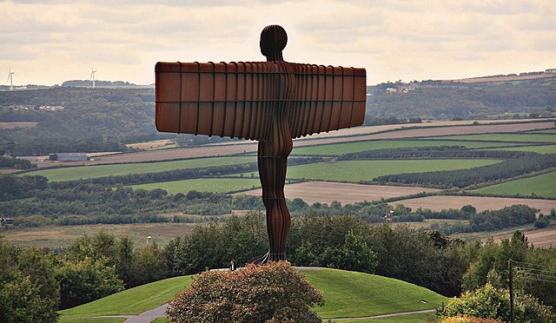
Figure 1 Antony Gormley (1950-), Angel Of The North, 1998, sculpture, Low Eighton, Gateshead. Image: Wikimedia Commons, Credit: Flickr, Barly, 6150534524.

As with Angel of the North, Rise is sited at one of the main gateways to Belfast, on The Broadway roundabout in West Belfast, at the junction of the Westlink and M1 motorway. The location, however, is more urban than rural, as shown in Figure 2, with Etchart having stated that 'most of the adjoining areas are access roads, commercial premises or empty plots of land' and Hocking describing that 'despite its key gateway location, the panorama circling the roundabout bears witness to the effects of urban blight and deindustrialization.'

The brief for Rise, as described by Hocking, contained an overall emphasis that it had to make 'a bold, large- and this is the key word - statement about Belfast's future potential' [Hocking's italics]. Cast in white steel, and standing at nearly twice the height of Angel of the North, (37.5 metres), Rise is described by its engineers as consisting of 'two hovering concentric geodesic spheres, made from 60mm diameter steel tubes', with one sphere (15 metres in diameter) suspended inside the other (30 meters in diameter)'. They have further described that, with the outer sphere held aloft supported on twenty-one slender steel columns, and the inner sphere held by a network of cables that create a three-dimensional tensegrity, the sculpture appears to float. As with Angel of the North, it was made in collaboration with a team including Belfast City Council, steelworkers and structural engineers, as described on Buttress's website.

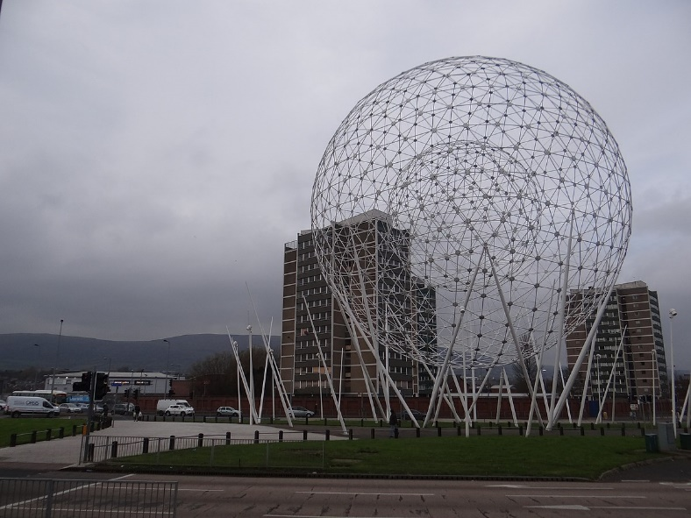

Figure 2 Wolfgang Buttress (1965-), Rise, 2011, sculpture, Broadway Roundabout, Belfast.
Image: Wikimedia Commons, Credit: Geograph Britain and Ireland, Ian Paterson, 4252476.jpg.

Discussion
The sky has continued to hold the stories of people relating to their culture, as well as deeply meaningful personal stories, and both portrayal of angels and the sun have played significant roles as sky images throughout history, not least as preserved in popular culture through songs such as George Harrison's Here Comes The Sun, and Robbie Williams' Angels. In the case of the two sculptures, their creation was prompted by the respective councils' desire for pieces of public art to be seen by as many people as possible and, being on major road sites, it was estimated that tens of thousands of car drivers and passengers would see them daily, as well as being recognised on an international level and a local level. Both artists had previously completed pieces of public art and Nicholson reported Gormley as saying 'The art of our time has failed us if it has to rely on the special conditions of the museum, of the private collection, of the commercial gallery'. This sentiment echoed one of the founding forces behind the land art movement, a difference between them, though, being that public art is commonly, at least partly, dependent on public finances and, as with the case of these two sculptures, this may have had some influence in the creative process.

Although land art is generally thought of as artistically shaping natural materials and landscapes in natural settings, this did not always appear to be the case, with an example being Nancy Holt's (1938-2014) Sun Tunnels, using concrete, as can be seen in Figure 3. Malpas however had noted that the term land art included 'a wide variety of artistic forms' with Sonfist describing the artists as frequently constructing work outside, expressing the idea of 'monumentality, of earth moving, made possible by industrial tools; bulldozers, dump trucks'. Negative connotation with the use of manufactured material may be perceived to be unnecessary, however, considering that, as Terry Eagleton has noted, 'The word 'manufacture' originally means handicraft, and is thus 'organic', going on to describe that 'only over time has it come to denote mechanical mass production which can be perceived negatively. Nevertheless, the characteristic monumental size of some pieces of land art, as well as the use of industrial materials, has connected it to Rise and Angel of the North, together with the consequential involvement of diverse teams of people in their creation and installation.

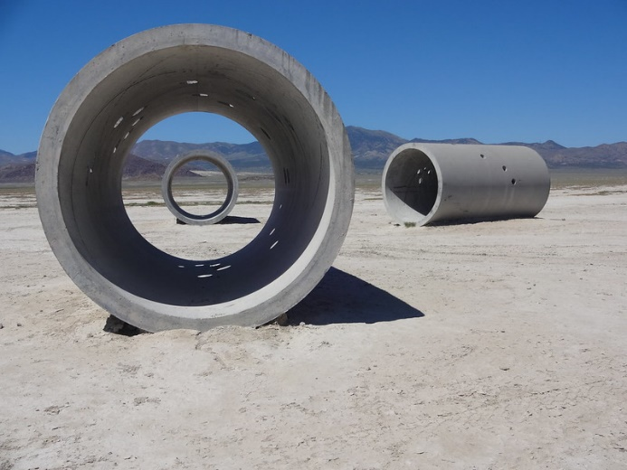

Figure 3 Nancy Holt (1938-2014) Sun Tunnels, 1973-1976 Sculpture Great Basin Desert, Utah
Image: Openverse.org, Credit: Retis, 21068930789_4b918fb7e6_c

As with Sun Tunnels, both sculptures react with the light of the sky, Angel of the North also reacting with the weathering elements of the sky which protect it. Additionally, Rosenthal's description of Robert Morris's (1931-2018) Observatory and Robert Smithson's (1938-1973) Broken Circle/Spiral Hill as having 'a strong emphasis on ambitious large-scale, geometrically composed structures, united with specific sites primarily because of scale' could equally have applied to them. With regard to the siting of land art, Malpas had described that 'Land artists, like nature poets and mystics, are inspired by particular places'. Although Rise and Angel of the North were on sites not chosen by the sculptors, Buttress confirmed that he had had a vision of the sun rise over Belfast and Gormley, having initially rejecting what he termed 'roundabout art', on seeing the site, was said to have 'identified with it'.
Despite its solid, industrial, manufacturing style, it is evident that Gormley's sculpture was designed to represent an angel, also borne out by its unambiguous name, and having followed on from a previous series of angel sculptures, A Case For An Angel,, the title of which Gormley described as making a case for the imagination. Liz Greene has stated that 'Angels, or angelic beings, have formed part of the human religious imagination for at least two millennia', adding that ' a sense of comfort, contact, and communication with heavenly realms' is still provided by them to 'many modern individuals of both orthodox and unorthodox religious and spiritual persuasions'. Walker explained that Gormley thought of angels as emblems of 'inspiration and imagination', as beings 'that might be at home in the air, but brought down to earth, hence they are mediators between two realms: the spiritual and the material'. Gormley's use of the angel symbol may have partly resulted from his Christian upbringing but the rectangular wings of Gormley's angels, reaching out horizontally from the body, have been described by the Tate Gallery as 'More reminiscent of aeroplanes than birds, [they] provide an unusual variation on the theme of man's desire to fly, both physically and spiritually.' In the unity of the spiritual and the physical, the angel symbolism in Angel of the North has concurred with Bertol, Brown and Gunzberg's comments describing how the sky's depiction has impacted our view of our place in the cosmos.

With Rise, the choice of the sun as subject was the fulfilment of Buttress's vision of a rising sun 'heralding a new dawn for Belfast', as described on his website. The title of the piece, Rise, is more ambiguous than with Angel of the North and less obviously connected visually with the sculpture depicting the rising sun. The only specification for the sculpture, apart from the desire for something large, was a condition by the council, as related by Hocking, 'In a city with religious differences, we didn't want anything that smacked of even a remotely religious connotation'. The choice of the sun, therefore, described by Barbara Weightman as 'the supreme cosmic power; denoting centrality of existence, it is the heart of being,’ was evidently seen as sufficiently neutral but meaningful. Additionally, the circle imagery itself has been described by Malpas as being 'one of the primeval symbols of eternity, cycles, time, rebirth . . . ,' continuing that, in some religions, 'it speaks of the 'feminine' and the goddess'. The inclusion of sunrises in art has commonly depicted times of calm, patient hope, as portrayed by Alexandra Harris in describing J.M.W. Turner's (1775-1851) expression of sunrises as 'the slow relief of dawn' and, referring to his 'Frosty Morning , as the time when 'the barren landscape softens moment by moment in the tawny glow', as shown in Figure 4. However, Buttress, with the use of white, powder coated steel has produced a more dramatic effect, although the non-solid structure could be seen as demonstrating a sense of fragility. In this respect, it aligns itself with the ephemeral nature of some land art.

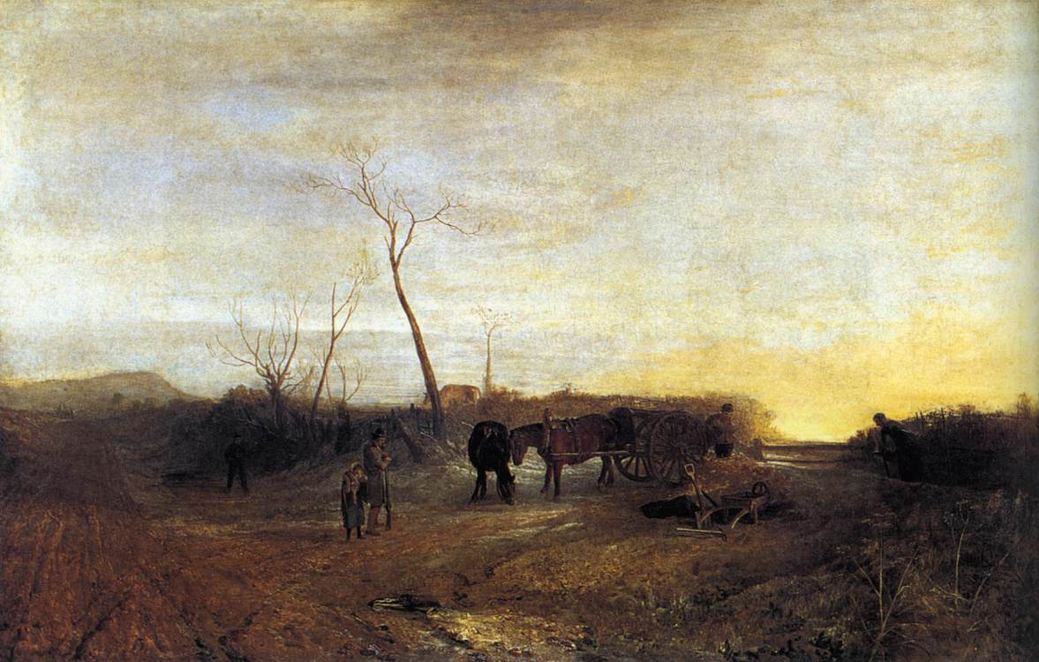

Figure 4 Joseph Mallord William Turner, Frosty Morning, Oil paint on canvas, exhibited 1813, Tate Britain, London). Image: Wikimedia Commons Credit: RKD Images WGA23168, jpg.

Rosenthal also described some land art as having a 'comparison with ancient and tribal monuments that seek accommodation with, signify worship of, or aspire to protection from natural deities', going on to say that 'Whether the contemporary artists share these motives is ambiguous'. He further described that 'There is then, not only a mystical side to land art, but also a nostalgic element . . . back to a former, even ancient era'. These statement could easily be linked to Gormley's sculpture of the angel, but also Buttress's, in respect of his interesting incorporation of twenty one steel columns supporting the outer sphere, which are described on the Buttress website as having significance in representing 'the marshland which previously grew there'. Although Etchart has noted that this created a connection with Belfast's past', the symbolism as reeds could also be interpreted as pointing to a connection with the ancient Egyptian temple of the Sun God, Amun-Re, in Karnak. Richard Wilkinson has described how Egyptian temples were the 'interface between the divine and human spheres . . . ' with the roof of the temples' hypostyle halls being supported by large numbers of columns. Relating this to Egyptian mythology, Wilkinson described that 'the celestial realm of the sky was supported above the earth on columns . .' and, with specific reference to Karnak, described how these columns could also represent the marshland vegetation which sprang up around the primeval mound of creation - symbolized by the temple's inner shrine,.' The columns are shown in Figure 5.

From these descriptions, it may be interpreted that the link between the sun and reeds in Rise perhaps reflects this imagery, with Buttress's inner sphere representing the inner shrine, where, according to Elizabeth Blyth, daily rituals took place with 'celestial and terrestrial combin[ing] to form heaven upon earth. . . , with, additionally, specific emphasis on the sun being described by Wilkinson at special festivals when images of the gods were taken to await the year's first sunrise or

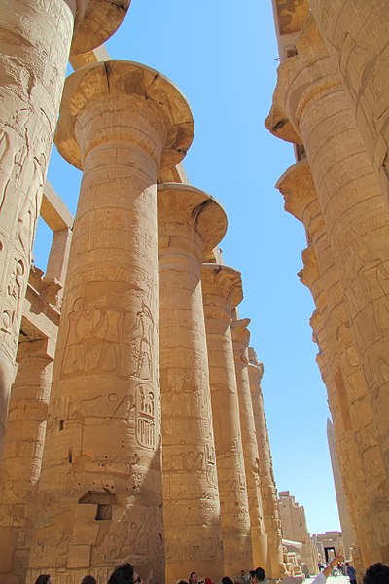

Figure 5 Central Columns of the Great Hypostyle Hall, Karnak circa. 1300 BCE, Image: Wikimedia Commons Credit: Djehouty CC BY-SA 4.0

unite with the sun. Wilkinson suggested that this ritual may express 'an obvious symbolism embracing the god's activity in the underworld and heavens as well as on earth'. Although not specifically mentioned, Buttress may have alluded to this when saying, as quoted by Etchart, 'Before there were people on this spot, there were reeds and marsh and I wanted to make a connection to the land, and something universal'. Furthermore, continuing this connection with the temples of ancient Egypt, Angel of the North may also be interpreted as representing a connection between the underworld with the land and sky, in respect of its foundations going deep into the mound made with spoil from the earlier underground mining site. All of these possibilities demonstrate a link to land art's connection with ancient symbols and their current importance in our imaginations.

Buttress has further illustrated a possible sympathy with the land art movement, following on from Sonfist's description that some land art pieces 'speak of themselves and not the land they occupy' whereas others change the land as little as possible 'because of the threat of its destruction', stating that his dream was to have a place where 'the actual journey to the place is part of the artwork' and 'the challenge would be to let it exist without destroying the surrounding context'. Malpas has also described how land art is sometimes grouped with environmental art, with Sonfist having described that 'A growing concern for nature has appeared worldwide over the last two decades. With his use of the geodesic sphere design, recognisable as that patented by Buckminster Fuller (1895-1983), and popularised in the Spaceship Earth ride at the Epcot Theme Park in Walt Disney World, (1982 - , Bay Lake, Florida), Buttress may have also prompted a connection between the sun and planet earth, in recognition of the current threat of global warming.

Initially, neither of the sculptures were welcomed by the local communities with Angel of the North, as reported by Hunter, having mixed comments ranging from 'a hideous rusting monstrosity' to 'daring, awesome, formidable' and Rise being nicknamed 'Balls on the Falls'. Additionally, Angel of the North was initially thought to be a potential accident risk in drawing people's attention whilst driving, and Rise as creating a space for sectarian action to take place. However both of these concerns have proved to be unwarranted. Other criticism has been levelled, however, with one critic claiming that Angel of the North's 'symbolic pretensions . . . are vague enough to attract mass appeal', whilst a critic of Rise condemned it as being part of 'civic identikit symbolism' and Hocking, in 2015, stating that 'the universal, contemporary symbolism represented by the geodesic sculpture Rise has yet to have much impact as a global branding tool for the city', described how perhaps the fact that it was unveiled just months before the launch of the Titanic centenary celebrations and visitor centre, resulted in its symbolism of the 'new' Belfast' having largely faded 'in favour of the commercial appeal of the 'old' symbol'.

Frances Westley and Carl Folke have explained, 'Symbols, unlike icons, do not depend for their impact on resemblance to the real object represented. It is through the interpretation of the viewer that the symbol . . . draws its power.' In this respect, as recorded by Brown and others, 'Angel of the North's clearly human-like form provides a key hook for people to attach their own meaning, making it more readily engaging'. With respect to Rise, Etchart has outlined that leaflets on Belfast stated that '. . . the importance laid on universal values and symbols - typically exemplifed by the rising of the sun, pointed to the cosmopolitan character that has been attached to the sculpture' thus demonstrating positive responses.

As with land art, the act of visiting and experiencing has changed people's perceptions, with Brown and others having described how people can go right up to Angel of the North, 'experiencing the power of it head-on . . .in deep perspective against a sky backdrop'. Regarding Rise, Etchart described that it brought in 'new, fresh perspectives into the built environment through the use of light materials (white, silver steel) and round shapes (two globes, one inside the other)', adding that 'More importantly, it contributes to putting people back in the frame by becoming a place to visit.' The nature of public art means that, contrary to land art sited, perhaps, in distant places, it is visible to everyone and, as Brown and others detailed, 'Appreciating art requires a balance of objective information and subjective opinion,' explaining that 'Understanding more about the artwork and its context allows more robust opinion.' The ability to reach the people in the cars driving past the sculptures each day obviously poses a problem, but may illustrate why Angel of the North through its name and its appearance has more successfully accessed the angelic symbolism of the sky, whereas it may take more time for the people of Belfast to identify with Rise, especially with the ongoing political stalemate.

From the above, it appears that both Angel of the North and Rise fit into the wider land art description, even taking into consideration the requirements imposed by the specific civic requirements for them to portray hope and expectation for the future, contributing to their cities' redevelopment process. Each sculpture has portrayed, in their respective sky symbolism, both historic and current desires to connect the natural environment with the sky and thus provided, as described by Silva, insight into our society.

CONCLUSION

Levinson has described that 'Much art derives its impact from exploring the narrow edge between universal association and cultural form' describing how we can be enraptured by 'primitive' sculpture or haunted by a song in a foreign tongue 'but our appreciation gains another dimension when we can hear the cultural code'. In this essay, therefore, the cultural expression of the sky in Antony Gormley's Angel of the North in Northumberland and Wolfgang Buttress's Rise, in Belfast has been discussed, in light of their role as site-specific public pieces of art, commissioned with the specific aim of portraying the hope and expectation of a new future for their respective areas.

As 'gateways' to their respective cities, a dominant requirement was that they had to be large. Their designs were chosen from among a number of other artists' proposals and, although there had been a suggestion made to Gormley to reproduce one of his 'angels' further to his previous series of angel sculptures, with Belfast, the specification was that the content had to be non-political and non-religious. Both sets of city councillors chose sculptures representing the sky in different ways, demonstrating that their respective images were perceived by them to be meaningful and powerful. With the sky having been described as, throughout history, forming cosmologies and creating built environments by Brown, their choices were perhaps unsurprising.

Angels were described in the essay as still being widely associated with the idea of messengers and guardians from the heavens, and the sun, whilst a powerful life-source, was illustrated as portraying a feeling of calm and optimism in its rising, perhaps with a sense of fragility. These descriptions, together with an analogy to ancient beliefs connecting the earth with the sky, as described by Bertol, gave a clear impression that both sculptures contained moving historic and current representations of the sky. This connection, as well as a number of other attributes discussed, connected the two sculptures with the wide variety of work included in the land art movement.

As Bernadette Brady has described, with 'a shared night sky that knows no national boundaries, then its human observers create a culture that transcends such borders', which ideal was certainly something Belfast desired. With art bridging the gap between an elusive sky containing such dreams as are only restricted in our imagination, the concepts held in the sky imagery in these sculptures have therefore signalled powerful messages which had initial appeal to the policy-makers, in winning each of the artists the commission, but were doubted on a pragmatic and financial level by local people, however whose messages appear to have subsequently reached out further to a culture of optimism and hope. In their sky imagery, both sculptures have the potential to remind and encourage us to reconnect to the universe.

Bibliography

Bertol, Daniela, 'Framing The Land And Sky: Art Meets Cosmology In A Sustainable Environment', Leonardo, Vol. 39, No. 2 (2006), pp. 125-130. https://www.jstor.org/stable/20206183
Brady, Bernadette, 'Images In The Heavens', in The Imagined Sky, ed. by Darrelyn Gunzberg, pp. 234- 258.
Brown, Daniel, 'Sky Belief, Engagement And Architecture, Traditional Dwellings And Settlement Review, Vol. 30, No. 1, (2018), pp. 89-90.
Brown, Jules, North of England Civic Trust, and Cathy Edy, Anna Pepperall and Rebecca Farley, Arup, for Gateshead Council and Historic England, A Study Of The Significance Which The Angel Of The North Gains From Its Setting, (January 2018), https://infrastructure.planninginspectorate.gov.uk/wpcontent/ipc/uploads/projects/TR010031/T R010031-001113-ANG.JB.000118.SettingStudyFinal%20Diags%20SMALL%20(002).pdf [Accessed 17 March 2023],
Buttress, Wolfgang, https://www.architonic.com/en/project/wolfgang-buttress-lucent/5102545
Buttress, Wolfgang, https://www.wolfgangbuttress.com/rise-project-detail
Etchart, Joana, 'Belfast Renewed: A Sign Of Change?', in Changes In Contemporary Ireland, Texts And Contexts', ed. by Catherine Rees, (Newcastle-upon-Tyne: Cambridge Scholars Publishing, 2013), pp. 32-50.
Gormley, Antony, https://www.antonygormley.com/works/sculpture/series/a-case-for-an-angel

Gormley, Antony, https://www.antonygormley.com/resources/texts/space-and-place
Greene, Liz, 'Heavenly Hosts: Angelic Intermediaries As Soul-Gates', Culture And Cosmos, Vol 15-2, Autumn/Winter (2011), abstract.
Gunzberg, Darrelyn, ed., The Imagined Sky, (Sheffield: Equinox Publishing Ltd., 2016).
Harris, Alexandra, Weatherland Writers And Artists Under English Skies, (London: Thames and Hudson, 2015).
Hocking, Bree T., The Great Reimagining, Public Art, Urban Space, And The Symbolic Landscapes Of A 'New' Northern Ireland, (Oxford:Berghahn Books, 2015).
Ingold, Tim, 'Earth, Sky, Wind, And Weather', Journal Of The Royal Anthropological Institute (N.S.), 2007, pp. 19-38.
Ingold, Tim, 'Reach For The Stars! Light, Vision And The Atmosphere', in The Imagined Sky Cultural Perspectives, Ed. by Darrelyn Gunzburg, (Sheffield: Equinox Publishing Ltd., 2016), pp. 215-233.
'Keep Britain Tidy', The Burlington Magazine, Vol. 152, No. 1292, Sculpture, November (2010). https://www.jstor.org/stable/25769833 [accessed 5 April 2023].
Levinson, Stephen C., 'Space And Place', From Some Of The Facts, Tate St Ives, Cornwall, UK, 2001.
Malpas, William, Land Art, Earthworks, Installations, Environments, Sculpture, (Kidderminster: Crescent Moon Publishing, 1996).
Nicholson, Paul, 'Antony Gormley, The Angel Of The North, 1998', Occupational Medicine, 68, (2018), pp. 352-353.
Price Myers, https://www.pricemyers.com/projects/rise-11
Quinn, Miri, 'Interview: Wolfgang Buttress Creator Of The Hive At Kew', Essential Surrey & SW, (2016), Interview: Wolfgang Buttress creator of The Hive at Kew - Essential Surrey & SW London [accessed 11 April 2023].
Rosenthal, Mark, 'Some Attitudes Of Earth Art: From Completion To Adoration', in Art In The Land, A Critical Anthology Of Environmental Art, Ed. by Alan Sonfist, (New York: E.P. Dutton, Inc., 1983), pp. 60-72.
Silva, Fabio, 'The Role And Importance Of The Sky In Archaeology: Introduction', Skyscapes, The Role And Importance Of The Sky In Archaeology, eds. Fabio Silva and Nicholas Campion, (Oxford: Oxbow Books, 2015), pp.1-7, https://www.jstor.org/stable/j.ctvh1dksg.5
Sonfist, Alan, (Ed), Art In The Land, A Critical Anthology Of Environmental Art, (New York: E.P. Dutton, Inc., 1983).
Tate, https://www.tate.org.uk/art/artworks/gormley-a-case-for-an-angel-iii-t07005
Walker, John A., Art And Outrage, Provocation, Controversy And The Visual Arts, (London: Pluto Press, 1999). https://www.jstor.org/stable/j.ctt18mbdd7.42. [accessed 5 April 2023].
Westley, Frances R. and Carl Folke, 'Iconic Images, Symbols, And Archetypes: Their Function In Art And Science', Ecology and Society, Vol. 23, No. 4, December (2018). https://www.jstor.org/stable/26796894 [Accessed 4 April 2023].
Wightman, Barbara A., 'Sacred Landscapes and the Phenomenon of Light,' Geographical Review 86, no. 1 (1996). Doi:10.2307/215141.
Wilkinson, Richard H., The Complete Temples of Ancient Egypt, (New York: Thames and Hudson, 2000).

Antony Gormley, Angel Of The North, [Cor-Ten Steel], (1998, Lower Eighton, Gateshead).
Wolfgang Buttress, Rise, [Steel], (2011, Broadway Roundabout, Belfast).
Bree T. Hocking, The Great Reimagining, Public Art, Urban Space, And The Symbolic Landscapes Of A 'New' Northern Ireland, (Oxford:Berghahn Books, 2015), p.63.
Jules Brown, North of England Civic Trust, and Cathy Edy, Anna Pepperall and Rebecca Farley, Arup, for Gateshead Council and Historic England, A Study Of The Significance Which The Angel Of The North Gains From Its Setting, (January 2018), https://infrastructure.planninginspectorate.gov.uk/wpcontent/ipc/uploads/projects/TR010031/TR010031-001113-ANG.JB.000118.SettingStudyFinal%20Diags%20SMALL%20(002).pdf [Accessed 17 March 2023], p. 7.
Tim Ingold, 'Reach For The Stars! Light, Vision And The Atmosphere', The Imagined Sky Cultural Perspectives, Ed. by Darrelyn Gunzburg, (Sheffield: Equinox Publishing Ltd. 2016), pp. 215-233, p. 231.
Daniela Bertol, 'Framing The Land And Sky: Art Meets Cosmology In A Sustainable Environment', Leonardo, Vol. 39, No. 2 (2006), pp. 125-130, p. 125. https://www.jstor.org/stable/20206183
Mark Rosenthal, 'Some Attitudes Of Earth Art: From Completion To Adoration', in Art In The Land, A Critical Anthology Of Environmental Art, Ed. by Alan Sonfist, (New York: E.P. Dutton, Inc., 1983), pp. 60-72, p. 62.
Alan Sonfist, Ed., Art in the Land, Art In The Land, A Critical Anthology Of Environmental Art, (New York: E.P. Dutton, Inc., 1983), p. xi.
Darrelyn Gunzberg, Ed., The Imagined Sky, (Sheffield: Equinox Publishing Ltd., 2016), p. ix.
Gunzberg, The Imagined Sky, p. ix.
Daniel Brown, 'Sky Belief, Engagement And Architecture, Traditional Dwellings And Settlement Review, Vol. 30, No. 1, Fall, 2018, pp. 89-90, p. 89.
Fabio Silva, 'The Role And Importance Of The Sky In Archaeology: Introduction', Skyscapes, The Role And Importance Of The Sky In Archaeology, eds. Fabio Silva and Nicholas Campion, (Oxford: Oxbow Books, 2015), pp.1-7, p. 2. https://www.jstor.org/stable/j.ctvh1dksg.5
Silva, 'The Role And Importance', p. 4.
William Malpas, Land Art, Earthworks, Installations, Environments, Sculpture, (Kidderminster: Crescent Moon Publishing, 1996), p. 32.
Tim Ingold, 'Earth, Sky, Wind, And Weather', Journal Of The Royal Anthropological Institute (N.S.), 2007, pp. 19-38, p. 20.
Alexandra Harris, Weatherland Writers And Artists Under English Skies, (London: Thames and Hudson, 2015), p. 379.
Harris, Weatherland , p. 15.
Brown and others, A Study, p.7.
Brown and others, A Study, p.7.
Brown and others, A Study, p. 7.
Brown and others, A Study, p. 7.
John A Walker, Art And Outrage, Provocation, Controversy And The Visual Arts, (London: Pluto Press, 1999), p. 219. https://www.jstor.org/stable/j.ctt18mbdd7.42. [accessed 5 April 2023].
Joana Etchart, 'Belfast Renewed: A Sign Of Change?', in Changes In Contemporary Ireland, Texts And Contexts', ed.by Catherine Rees, (Newcastle-upon-Tyne: Cambridge Scholars Publishing, 2013), pp. 32-50, p. 32.
Etchart, 'Belfast Renewed', p. 40.
Andy Scott, Beacon of Hope, [Steel], 2006, Thanksgiving Square, Belfast.
Dan George, Spirit of Belfast, [Steel], 2009, Arthur Square, Belfast.
Hocking, The Great Reimagining, p.53.
Hocking, The Great Reimagining, p. 45.
Stephen C. Levinson, 'Space And Place', From Some Of The Facts, Tate St Ives, Cornwall, UK, 2001 https://www.antonygormley.com/resources/texts/space-and-place
Wolfgang Buttress, Hive, [Aluminium], 2016, Kew Gardens, London.
Wolfgang Buttress, https://www.architonic.com/en/project/wolfgang-buttress-lucent/5102545
Brown and others A Study, p. 7.
Walker, Art And Outrage, p. 214.
Paul J. Nicholson, 'Antony Gormley, The Angel Of The North, 1998', Occupational Medicine, 68, (2018), pp. 352-353, p. 352.
Walker, Art And Outrage, p. 220.
Etchart, 'Belfast Renewed', p. 37.
Hocking, The Great Reimagining, p. 47.
Hocking, The Great Reimagining, p. 52
Price Myers, https://www.pricemyers.com/projects/rise-11
Price Myers, https://www.pricemyers.com/projects/rise-11
Wolfgang Buttress, https://www.wolfgangbuttress.com/rise-project-detail
George Harrison, Here Comes The Sun, [song performed by The Beatles on the album Abbey Road], (1969, EMI Recording Studios (now Abbey Road Studios)), Prod. by George Martin.
Robbie Williams and Guy Chambers, Angels, [song performed by Robbie Williams on the album Life Thru A Lens], (1997, Matrix Maison Rouge Studios, London), Prod. by Guy Chambers and Steve Power.
Nicholson, 'Antony Gormley, The Angel Of The North, 1998', p. 353.
Nancy Holt, Sun Tunnels,[Concrete, steel, earth], (1973-76, Great Basin Desert, Utah).
Malpas, Land Art, p. 6.
Sonfist, Art in the Land, p. xi
Terry Eagleton, The Idea Of Culture, (Oxford: Blackwell Publishers, 2000), p. 4.
Robert Morris, Observatory, (1977, Swifterringweg, Netherlands).
Robert Smithson, Broken Circle/Spiral Hill, [Water, earth, topsoil, sand, boulder], (1971, Emmen, The Netherlands).
Rosenthal, 'Some Attitudes', p. 64.
Malpas, Land Art, p. 7.
Brown and Others, A Study, p. 8.
Antony Gormley, A Case For An Angel, [lead], (1989-2006, series of sculptures at different locations)
Antony Gormley, https://www.antonygormley.com/works/sculpture/series/a-case-for-an-angel
Liz Greene, 'Heavenly Hosts: Angelic Intermediaries As Soul-Gates', Culture And Cosmos, Vol 15-2, Autumn/Winter (2011), abstract, online, np.
Greene, 'Heavenly Hosts', online, np.
Walker, Art And Outrage, p. 216.
Tate, https://www.tate.org.uk/art/artworks/gormley-a-case-for-an-angel-iii-t07005
Wolfgang Buttress, https://www.wolfgangbuttress.com/rise-project-detail
Hocking, The Great Reimagining, p. 52.
Barbara A. Weightman, 'Sacred Landscapes and the Phenomenon of Light,' Geographical Review 86, no. 1 (1996), p. 2. doi:10.2307/215141.
Malpas, Land Art, p. 32.
Joseph Mallord William Turner, Frosty Morning, [Oil paint on canvas], (exhibited 1813, Tate Britain, London).
Harris, Weatherland, p. 272.
Rosenthal, 'Some Attitudes', p. 64.
Malpas, Land Art, p. 39
Wolfgang Buttress, https://www.wolfgangbuttress.com/rise-project-detail
Etchart, 'Belfast Renewed', p. 38.
Richard H. Wilkinson, The Complete Temples of Ancient Egypt, (New York: Thames and Hudson, 2000), p. 8.
Wilkinson, The Complete Temples, p. 65.
Wilkinson, The Complete Temples, p. 66.
Elizabeth Blyth, Karnak Evolution Of A Temple, (Abingdon: Routledge, 2006), p. 2.
Wilkinson, The Complete Temples, p. 68.
Wilkinson, The Complete Temples, p. 68.
Etchart, 'Belfast Renewed', p. 38.
Sonfist, Art In The Land, p. xi.
Miri Quinn, 'Interview: Wolfgang Buttress Creator Of The Hive At Kew', Essential Surrey & SW, (2016), Interview: Wolfgang Buttress creator of The Hive at Kew - Essential Surrey & SW London [accessed 11 April 2023].
Sonfist, Art In The Land, p. xi.
Walker, Art & Outrage, p. 220..
'Keep Britain Tidy', The Burlington Magazine, Vol. 152, No. 1292, Sculpture, November (2010), p. 711. https://www.jstor.org/stable/25769833 [accessed 5 April 2023].
Hocking, The Great Reimagining, p. 184.
Hocking, The Great Reimagining, p. 181.
Frances R. Westley and Carl Folke, 'Iconic Images, Symbols, And Archetypes: Their Function In Art And Science', Ecology and Society, Vol. 23, No. 4, December (2018), np. https://www.jstor.org/stable/26796894 [Accessed 4 April 2023].
Brown and others, A Study, p. 12.
Etchart, 'Belfast Renewed', p. 38.
Brown and others, A Study, p. 33.
Etchart, 'Belfast Renewed', p. 37.
Brown and others, A Study, p. 14.
Levinson, 'Space And Place'.
Bernadette Brady, 'Images In The Heavens', The Imagined Sky, ed. by Darrelyn Gunzberg, pp. 234-258, p. 255.

