

Student name: Maria Cristina Dumitru
Student ID: 2007781

Module name: Public Health Policy
Module code: BMHP5013_LON
Lecturer name: Dr. Edward Goka

Table of contents
1 Introduction 3
2 Strategies in the UK and Australia 3
3 Public Health Policies UK and Australia 5
4 Theories and Models 6
5 Impact of legislation and policy 7
6 Ethical considerations 8
7 Recommendations and conclusions 8
References 10
Appendix 1 14
Appendix 2 15

1 Introduction
This report will offer a critical understanding of the coronavirus pandemic, evaluate different public health strategies including latest developments in legislation and policies. The report will offer definitions of public health and coronaviruses and explore the impact of policies on individuals, communities and concluding with ethical considerations and future recommendations.
Public Health is a science of preventing disease and improving the health and wellbeing of people and their communities. This science is designed to prolong life and promote health with the help of public and private organisations. According to World Health Organization (WHO), the mission of public health is to “provide maximum benefit for the largest number of people”. (Centers for Disease Control and Prevention, 2021)
Coronaviruses are a family of viruses that affect the upper-respiratory tract. These viruses can cause mild to moderate illnesses similar to common cold. Hundreds of coronaviruses exit and are most common in animals like pigs, cats, and bats. Spillover events occur when a coronavirus jumps from an animal reservoir to humans. In the last two decades this event happened three times. In 2002 SARS coronavirus caused severe acute respiratory syndrome, in 2012 MERS coronavirus, Middle East respiratory syndrome, was identified, followed by SARS-CoV-2 coronavirus in 2019 causing COVID-19 disease originating in China. This coronavirus was declared in March 2020 a global pandemic by WHO. (National Institute of Allergy and Infectious Diseases, 2020). Covid-19 is characterised by an upper-throat and lower respiratory tract infection that shows symptoms like fever, coughing, fatigue, loss of smell and taste, nausea, and shortness of breath. The virus can lead to more severe symptoms like pneumonia, heart and liver problems. (WebMD, 2021)
The report will compare similarities and differences in guidelines, legislations, and strategies during the pandemic to measure, monitor and control Covid-19 from United Kingdom (UK) and Australia.
2. Strategies in UK and Australia
Many strategies have been adopted during the global pandemic and evolved as time passed and scientists continued to learn new things about the new discovered virus.
Governments, through national and regional authorities and organisations, have developed different strategies of prevention, management and containing coronavirus outbreaks whilst taking in consideration the apparition of variants. Variants appear as viruses constantly mutate and create a new form of the initial virus. (CDC, 2020).

First two cases of covid are registered on the 29th January 2020 in the UK. The country public health initial response to the pandemic was to adopt the strategy of “herd immunity”, when a large number of people become immune to a disease by natural infection from the same disease that will result in developing antibodies against future infections, without imposing any restrictions on the British public. (Mayo Clinic, 2020). This strategy was lately blamed by WHO that supports achieving “herd immunity” by vaccination and not by natural infection with the virus. (World Health Organisation, 2020) By 29th January 2020 overseas travel is suspended by the Department of Health and Social Care.
Australia registered its firs Covid-19 case on the 25^{th of} January 2020 in Victoria. Australia initial response to control the disease was for the Minister for Health to declare a Public Health Emergency by the 16^{th of} March 2020 with the Chief Minister with the National Cabinet announcing non-essential activities and business to be suspended. (Parliament of Australia, 2020)
As a response to prioritise the care o Covid-19 cases both countries departments of Health and Social Care decide to suspend non-urgent surgeries. In Australia the Minister of Health puts a hold on non-emergency dental procedures for three months. (Parliament of Australia, 2020b). In the UK, the NHS proceeds to publish the Next Step on NHS Response to Covid-19 by postponing all non-urgent surgeries for three months, discharge all patients fit to leave the hospital and GP remote appointments. (The Health Foundation, 2020)
A testing approach is a strategic design to help monitor the transmission of the virus and. By analysing testing data Governments can make evidence-based decision on the population level of how to predict future infections, increase awareness, and how to respond to the pandemic. (Nichols et al., 2021)
Infection prevention and control of the disease by testing programmes were rolled out by both countries since the biggening of the pandemic until present.
As of January 2022, Australia registered 4087.44 Covid-19 cases per 100.000 inhabitants whilst the UK confirmed 21,701.97 per 100.000 in the same period. There is a big difference when interpreting data from the two countries. (Our World in Data, 2022). The reasons are shown to be the lack of restrictions UK has imposed over the winter of 2022 and the relaxation of restrictions much sooner than many EU countries like France and Spain, by reopening nightclubs sooner and allowing households mixing indoors. Comparatively, the cumulative cases per million people, estimates of number of infections due to limited testing than can make the numbers appear lower, the two countries show significant differences. (Appendix 1) (World Health Organisation, 2022).
WHO implements and urges Governments to implement face covering as a key strategy to reduce transmission and “save lives”. (www.who.int, 2020). UK implemented the wearing a face covering mandatory in public transport for the first time on the 15 June 2020. (GOV.UK, 2020). By this time most nations like Italy and Germany had already adopted this strategy. Australia introduced this strategy also in July 2020 followed by a movement restriction of 5 km and an 8pm curfew in August whilst keeping hospitality settings closed. Non-essential settings reopened in June 2020, and a 10 pm curfew was settled in England and Whales for hospitality sector only. (Baker, Brown and Barber, 2021)
3. Public health policy UK and Australia
In the UK, the national and local and regional decision-makers alongside the communities partners and governments continue to work together in developing policies to stop the spread of the virus and contain Covid-19 outbreaks outlined into the Local Outbreak Management Plans and the government’s public health objectives, COVID-19 Response: Autumn and Winter Plan 2021. A guide of policy implementation is available through the Outbreak Management Toolkit set up for specific settings as education system, prisons, or adult social care. Apart from public health concerns, the aim of policy making is to protect the NHS for coming under pressure. Test, Trace and Self-Isolation Strategy was recently revised to limit transmission whilst empowering individuals to self-asses risks. Individuals with Covid-19 symptoms are encouraged to self-isolate for 10 days and get tested, whilst testing stays free. Vulnerable groups remain priority for Health and Social Care and local authorities to tackle the disproportionate impact of Covid-19. (GOV.UK, n.d.)
Present policies in the UK refer to vaccine immunisation and the rollout of the vaccine, guidance and communication to keep people informed on how to protect themselves and following global approach on vaccination programme. The Directors of Public Health work alongside with the National Screening and Immunisation Team to deliver the vaccine and increase vaccination rates through the Covid-19 vaccine delivery plan. (GOV.UK, 2021)
Australia recently announced through the National Cabinet that limited antigen testing will remain free for citizens for up to 5 tests a month while anyone experiencing symptoms can access a free clinic for testing. Emergency Management Australia, responsible with emergency health and risk management is currently dealing with some vaccine shortages in remote area. (www.pm.gov.au, 2022). As is in the UK, Australia has also prioritised the vaccine rollout whilst reassuring the public the vaccines are safe and effective through a unique approach, Operation COVID Shield. The main decision-making body is the Australian Health Protection Principal Committee that concentrate all chief medical officers under one umbrella. The committee oversees developing policies and procedures and plans to protect the nation’s health. Australia response plan is constantly updated as data is collected by the Technical Advisory Group of Immunisation. Australia aims a safe vaccine administration through the programme whilst still providing advice for future research. (Health, 2017)
Australia population over the double vaccinated over 16 years of age reached 91.5 per cent (Health, 2022) whilst UK was at 83.1 per cent rate. (GOV.UK, 2021a). In Appendix 2 the vaccination rates of the two countries are available including the percentages of populations that received first, second and third vaccine dose.
4. Theories and Models
Health Belief Models (HBM) refer to the ability of public health to encourage people to try and prevent illness through strategies that can detect disease in its early stage by screening. This was the initial use of the model, developed in 1950 by social scientists. Later, the model included treatment compliance from patients and their response to symptoms. The model ultimately evaluates the personal perspective of individuals to benefits, costs, vulnerability, and risks of health behaviour. (sphweb.bumc.bu.edu, n.d.)
The concept of HBM applicable to Covid-19 pandemic is the perceived susceptibility that is represented in the two countries by vaccine hesitancy. The population rate that is vaccine hesitant in Australia is close to 10 per cent. (Wrethman, 2021) UK quantitative data is inconclusive but is it found that vaccine hesitancy in North-West London was reaching 6 per cent and it is estimated of being 13 times higher in socio-economic deprived communities. (Imperial News, 2021)
Recent research found that HBM is influenced by health behaviours driven by the perception of benefits of a certain healthcare procedure or intervention. Regarding vaccine hesitancy is driven by the public perception of its benefits. Health policy makers in both countries have developed Covid-19 vaccine guidance compliance made available to the public for a better understanding of the importance of the vaccine. (Shmueli, 2021)
Research on health-related behaviours shows that it was found to have a large impact on mortality and morbidity rates. The way that the public engage with primary care in health systems is related to the development of disease prevention strategies. Interventions to change some behaviours have been made in both countries related to different governmental policies during the coronavirus pandemic prevention and control strategies. Face covering hesitancy are present in both countries regardless of guidance and mandates put in place by authorities and public health institutions. England sees rates like 64 per cent of individuals planning to wear face covering in public transport and shops. (www.ons.gov.uk, n.d.) Australia has seen throughout the pandemic strict face covering policy in almost all indoors and outdoors spaces with big percentage of compliance. (Our World in Data, n.d.)
The Covid-19 Preventive Behaviours Index has evaluated what implications the Theory of Reasoned Action Model had during the pandemic. It was found that the model is a powerful tool to predict if individuals are likely to engage in Covid-19 preventive behaviours and activities. This tool is important as it can influence future policies and can impact research models. (Breakwell, Fino and Jaspal, 2021)
5. Impact of legislation and policies
Health care settings have experienced a great financial impact during the coronavirus pandemic. As a result of this, governments have initially developed extra financial support plans to keep individuals safe whilst offering standards of care, good practice and safe treatments. (www.england.nhs.uk, n.d.).
In the UK the financial support was introduced by HM Treasury Department for NHS and local authorities announced in the 2020 plan pledging £5 billion to ensure the necessary resources are available, to support local authorities including adult social care. Australia’s Victorian Premier has offered $1.3 billion in Victoria district alone in 2020 to support healthcare system and adding 4000 intensive care beds in Hospitals. (Parliament of Australia, 2020c). Both countries have adopted furlough schemes to support individuals and securing their jobs further financially.
Reports have shown that the biggest impact of policies, such as movement restrictions, “work from home”, curfews and national lockdown was on mental health and wellbeing. England 2021 findings showed a 29.5 per cent increase in clinical reports made by adults over psychological distress and anxiety with most common symptoms being loneliness, depression, and high levels of stress. 26.1 per cent of reported cases have declared they experienced self-harm and suicide thoughts.
Australia has seen similar population response because of lockdowns and restrictions. It was reported a significant increase in mental health services access due to psychological distress. Australian Department of Health has registered an increase in suspected suicide deaths. Life satisfaction index has seen a decrease during lockdown months. Between 2019-2020, 310,000 emergency department cases were mental health related of which 77 per cent were urgen and should be assessed by a health practitioner in 30 minutes. (Australian Institute of Health and Welfare, n.d.)

6. Ethical considerations
Vast ethical dimensions have been considered during Covid-19 pandemic both n population and policy makers. Ethical frameworks are important when making clinical decisions that diminish public health emergencies. As a response to contain the spread of the virus and minimizing health risks on population, countries have worked together in developing a vaccine. The vaccines are minimising the risk of developing severe symptoms from contacting Covid-19 and reduce hospitalisation chances. At the beginning of the pandemic the world witnessed the struggles of Italy, as second most affected country in the world, with the allocation of ICU ventilators on the ethical basis of evaluating highest chances of survival patients and prioritise those with higher index. (RC PSYCH ROYAL COLLEGE OF PSYCHIATRISTS, n.d.)
Death cases associated with covid in Australia were 2578 with 1.5 million cases as of January 2022. In the same period UK registered 151,612with over 15 million cases. (www.worldometers.info, 2021). Public health policy makers in both countries have begun to be implement a Covid-19 vaccination proof in different circumstances. These will become an employment criterion for NHS, frontline, and social care workers as of April 2022 and currently requested upon entrance into big indoor venues that host over 5000 people. In the UK 90 per cent of NHS staff are doble vaccinated. (GOV.UK, n.d.) Australia has a Covid-19 vaccination pass as a request for most social activities, event attending and employment in industries from health care, social care, supermarket workers and teachers.
Ethical considerations to be made upon enforcing vaccine mandates are: the Privacy Act 1988 that protect private medical information, Human Rights Act 1998 and the right to bodily autonomy, informed choice and without being victims of any type of coercion.
7. Recommendations and conclusions
Future recommendations in public health policies, mainly concerning pandemic responses, should consider sustained behaviour changes as a key to react and deal with a pandemic. This could exponentially grow the capacity of governments abilities to convince large population segments of a change in behaviour when facing compliance to rules and guidance, and better mitigation rates. Future advice could include better responses to individual needs because of policy implementation. As a result of long-term isolation and consequences of movement restrictions, where individuals could not travel, see loved ones and spend time in social settings, many people suffered mental and psychological issues. More help should be available in public health organisation with higher rates of response.
The Coronavirus pandemic impacted the entire global population. Governments from the two countries evaluated in this report have shown to develop policies and regulations to monitor and prevent the infection rates growing whilst considering possible impacts on individuals and keeping moral and ethical grounds.

References
Australian Institute of Health and Welfare. (n.d.). Mental health services in Australia, Australian Government expenditure. [online] Available at: https://www.aihw.gov.au/reports/mental-health-services/mental-health-services-in-australia/report-contents/expenditure-on-mental-health-related-services/australian-government-expenditure [Accessed 5 Jan. 2022].
Baker, C., Brown, J. and Barber, S. (2021). Coronavirus: A history of English lockdown laws. commonslibrary.parliament.uk. [online] Available at: https://commonslibrary.parliament.uk/research-briefings/cbp-9068/ [Accessed 4 Jan. 2022].
Breakwell, G.M., Fino, E. and Jaspal, R. (2021). The COVID-19 Preventive Behaviors Index: Development and Validation in Two Samples From the United Kingdom. Evaluation & the Health Professions, [online] 44(1), pp.77–86. Available at: https://journals.sagepub.com/doi/pdf/10.1177/0163278720983416 [Accessed 4 Jan. 2022].
CDC (2020). Coronavirus Disease 2019 (COVID-19). [online] Centers for Disease Control and Prevention. Available at: https://www.cdc.gov/coronavirus/2019-ncov/variants/about-variants.html [Accessed 2 Jan. 2022].
Centers for Disease Control and Prevention (2021). Introduction to Public Health|Public Health 101 Series|CDC. [online] www.cdc.gov. Available at: https://www.cdc.gov/training/publichealth101/public-health.html [Accessed 2 Jan. 2022].
GOV.UK (2021a). Official UK Coronavirus Dashboard. [online] coronavirus.data.gov.uk. Available at: https://coronavirus.data.gov.uk/details/vaccinations [Accessed 4 Jan. 2022].
GOV.UK. (n.d.). COVID-19 contain framework: a guide for local decision-makers. [online] Available at: https://www.gov.uk/government/publications/containing-and-managing-local-coronavirus-covid-19-outbreaks/covid-19-contain-framework-a-guide-for-local-decision-makers [Accessed 4 Jan. 2022].
GOV.UK. (2020). Face coverings to be mandatory in shops and supermarkets from 24 July. [online] Available at: https://www.gov.uk/government/speeches/face-coverings-to-be-mandatory-in-shops-and-supermarkets-from-24-july [Accessed 4 Jan. 2022].
GOV.UK. (n.d.). Making vaccination a condition of deployment in the health and wider social care sector. [online] Available at: https://www.gov.uk/government/consultations/making-vaccination-a-condition-of-deployment-in-the-health-and-wider-social-care-sector/making-vaccination-a-condition-of-deployment-in-the-health-and-wider-social-care-sector [Accessed 5 Jan. 2022].
GOV.UK. (2021b). UK COVID-19 vaccines delivery plan. [online] Available at: https://www.gov.uk/government/publications/uk-covid-19-vaccines-delivery-plan/uk-covid-19-vaccines-delivery-plan [Accessed 4 Jan. 2022].
Health, A.G.D. of (2017). Australian Technical Advisory Group on Immunisation (ATAGI). [online] Australian Government Department of Health. Available at: https://www.health.gov.au/committees-and-groups/australian-technical-advisory-group-on-immunisation-atagi [Accessed 4 Jan. 2022].
Health, A.G.D. of (2022). COVID-19 vaccine rollout update – 4 January 2022. [online] Australian Government Department of Health. Available at: https://www.health.gov.au/resources/publications/covid-19-vaccine-rollout-update-4-january-2022 [Accessed 4 Jan. 2022].
Imperial News. (2021). Real-world data provides valuable insights into COVID vaccine roll-out | Imperial News | Imperial College London. [online] Available at: https://www.imperial.ac.uk/news/232834/real-world-data-provides-valuable-insights-into/ [Accessed 4 Jan. 2022].
Mayo Clinic (2020). Herd immunity and COVID-19 (coronavirus): What you need to know. [online] Mayo Clinic. Available at: https://www.mayoclinic.org/diseases-conditions/coronavirus/in-depth/herd-immunity-and-coronavirus/art-20486808 [Accessed 2 Jan. 2022].
National Institute of Allergy and Infectious Diseases (2020). Coronaviruses | NIH: National Institute of Allergy and Infectious Diseases. [online] www.niaid.nih.gov. Available at: https://www.niaid.nih.gov/diseases-conditions/coronaviruses [Accessed 2 Jan. 2022].
Nichols, J.D., Bogich, T.L., Howerton, E., Bjørnstad, O.N., Borchering, R.K., Ferrari, M., Haran, M., Jewell, C., Pepin, K.M., Probert, W.J.M., Pulliam, J.R.C., Runge, M.C., Tildesley, M., Viboud, C. and Shea, K. (2021). Strategic testing approaches for targeted disease monitoring can be used to inform pandemic decision-making. PLOS Biology, 19(6), p.e3001307.
Our World in Data. (2022). Confirmed COVID-19 deaths per million vs GDP per capita. [online] Available at: https://ourworldindata.org/grapher/daily-confirmed-deaths-of-covid-19-per-million-people-vs-gdp-per-capita?xScale=linear&yScale=linear&country=AUS~GBR [Accessed 4 Jan. 2022].
Our World in Data. (n.d.). COVID-19: Face Coverings. [online] Available at: https://ourworldindata.org/covid-face-coverings [Accessed 4 Jan. 2022].
Parliament of Australia (2020a). COVID-19: a chronology of state and territory government announcements (up until 30 June 2020). [online] www.aph.gov.au. Available at: https://www.aph.gov.au/About_Parliament/Parliamentary_Departments/Parliamentary_Library/pubs/rp/rp2021/Chronologies/COVID-19StateTerritoryGovernmentAnnouncements [Accessed 2 Jan. 2022].
Parliament of Australia (2020b). COVID-19: a chronology of state and territory government announcements (up until 30 June 2020). [online] www.aph.gov.au. Available at: https://www.aph.gov.au/About_Parliament/Parliamentary_Departments/Parliamentary_Library/pubs/rp/rp2021/Chronologies/COVID-19StateTerritoryGovernmentAnnouncements [Accessed 2 Jan. 2022].
RC PSYCH ROYAL COLLEGE OF PSYCHIATRISTS. (n.d.). COVID-19 - Ethical considerations | Royal College of Psychiatrists. [online] Available at: https://www.rcpsych.ac.uk/about-us/responding-to-covid-19/responding-to-covid-19-guidance-for-clinicians/covid-19-ethical-considerations [Accessed 5 Jan. 2022].
Shmueli, L. (2021). Predicting intention to receive COVID-19 vaccine among the general population using the health belief model and the theory of planned behavior model. BMC Public Health, [online] 21(1). Available at: https://bmcpublichealth.biomedcentral.com/articles/10.1186/s12889-021-10816-7 [Accessed 4 Jan. 2022].
sphweb.bumc.bu.edu. (n.d.). Behavioral Change Models. [online] Available at: https://sphweb.bumc.bu.edu/otlt/MPH-Modules/SB/BehavioralChangeTheories/BehavioralChangeTheories_print.html [Accessed 4 Jan. 2022].
The Health Foundation. (2020). COVID-19 policy tracker. [online] Available at: https://www.health.org.uk/news-and-comment/charts-and-infographics/covid-19-policy-tracker [Accessed 3 Jan. 2022].
WebMD (2021). Coronavirus. [online] WebMD. Available at: https://www.webmd.com/lung/coronavirus [Accessed 2 Jan. 2022].
World Health Organisation (2020). Coronavirus disease (COVID-19): Herd immunity, lockdowns and COVID-19. [online] www.who.int. Available at: https://www.who.int/emergencies/diseases/novel-coronavirus-2019/question-and-answers-hub/q-a-detail/herd-immunity-lockdowns-and-covid-19?gclid=CjwKCAiAlfqOBhAeEiwAYi43F5wtSNL48kw_UeHEpU-QcPLqdhKuTueSVVfTJ43jfFZqK19QIhCSUhoClrAQAvD_BwE [Accessed 3 Jan. 2022].
world Health Organisation (2022). WHO Coronavirus Disease (COVID-19) Dashboard. [online] covid19.who.int. Available at: https://covid19.who.int/region/euro/country/gb [Accessed 3 Jan. 2022].
Wrethman, E. (2021). Vaccine Hesitancy Report Card. [online] Melbourne Institute. Available at: https://melbourneinstitute.unimelb.edu.au/publications/research-insights/ttpn/vaccination-report [Accessed 4 Jan. 2022].
www.england.nhs.uk. (n.d.). Coronavirus» Finance. [online] Available at: https://www.england.nhs.uk/coronavirus/finance/ [Accessed 5 Jan. 2022].
www.ons.gov.uk. (n.d.). Two-thirds of adults still plan to wear masks in shops and on public transport - Office for National Statistics. [online] Available at: https://www.ons.gov.uk/peoplepopulationandcommunity/healthandsocialcare/healthandwellbeing/articles/twothirdsofadultsstillplantowearmasksinshopsandonpublictransport/2021-07-16 [Accessed 4 Jan. 2022].
www.pm.gov.au. (2022). National Cabinet Statement | Prime Minister of Australia. [online] Available at: https://www.pm.gov.au/media/national-cabinet-statement-62 [Accessed 4 Jan. 2022].
www.who.int. (2020). Coronavirus disease (COVID-19): Masks. [online] Available at: https://www.who.int/emergencies/diseases/novel-coronavirus-2019/question-and-answers-hub/q-a-detail/coronavirus-disease-covid-19-masks [Accessed 4 Jan. 2022].
www.worldometers.info. (2021). Australia Coronavirus: 1,072 Cases and 7 Deaths - Worldometer. [online] Available at: https://www.worldometers.info/coronavirus/country/australia/ [Accessed 5 Jan. 2022].

Appendix 1
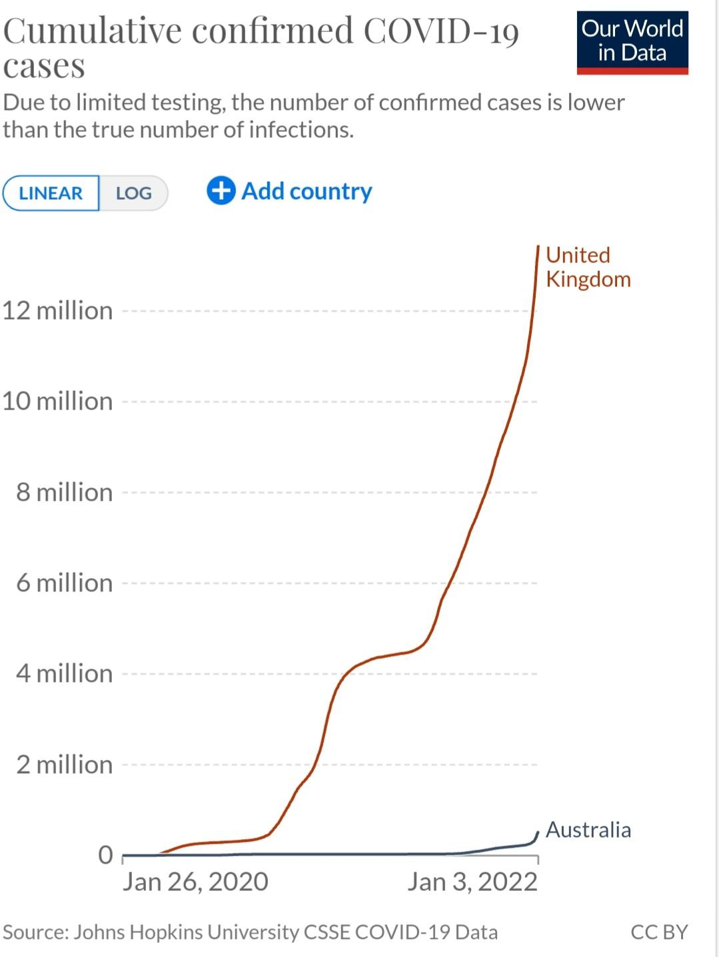
(Our World in Data, 2022)

Appendix 2
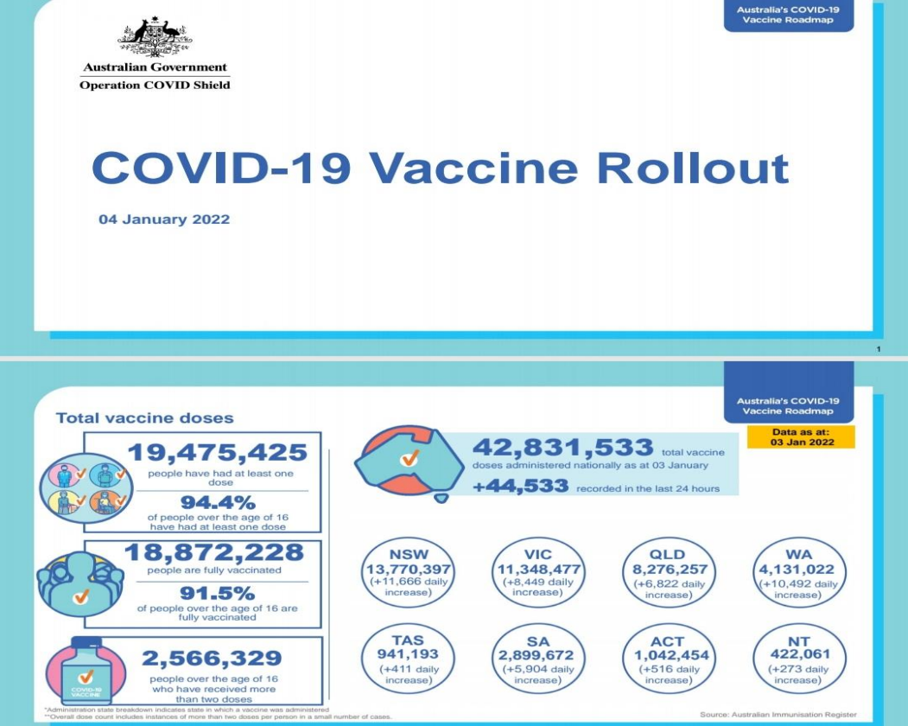
(Health, 2022)
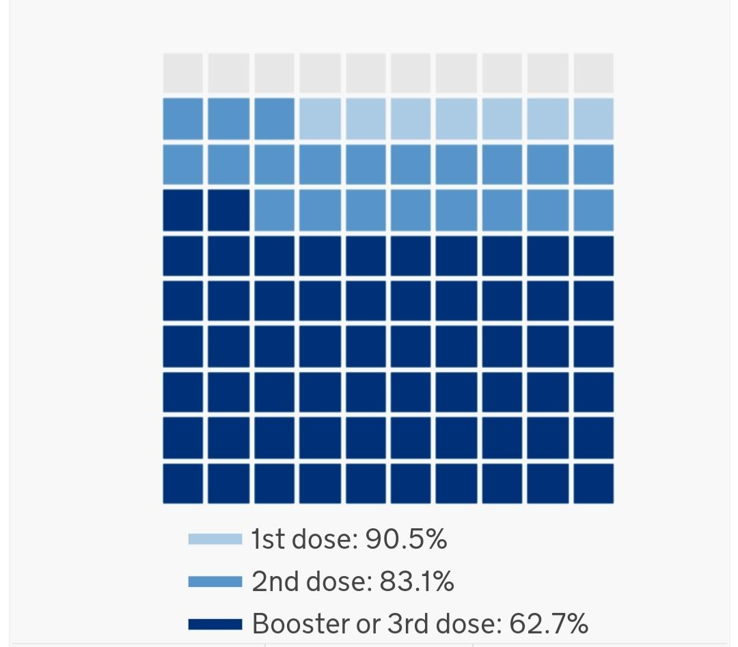
(GOV.UK, 2021a)

