Equality, Diversity and Inclusion within Industry
Event planning presentation

Dina Priedulena
Student ID Number: 2233688
International Meetings Management for the Hotel Industry
BMIH6007
Kathryn Flynn
07.02.2025.

I acknowledge using ChatGPT (https://chatgpt.com/) from 13 January to 3 February 2025 to support my research, including searching for a bibliography and using tools to summarise, compare, and interrogate materials.

I acknowledge using ChatGPT (https://chatgpt.com/) from 13 January to 3 February 2025 to check my own text/creation for grammatical and syntactical mistakes, including rephrasing my own work within specific standards.

I acknowledge the use of ChatGPT (https://chatgpt.com/) on 13 January – 3 February 2025 to support me in structuring my submission, including creating a draft argument structure, identifying parts and headings, etc.

I confirm that I have not presented any AI-generated text as my own work. I confirm I have copies of my drafts, notes, and other resources I used before, and after the use of AI tools which I may be asked to provide in evidence.

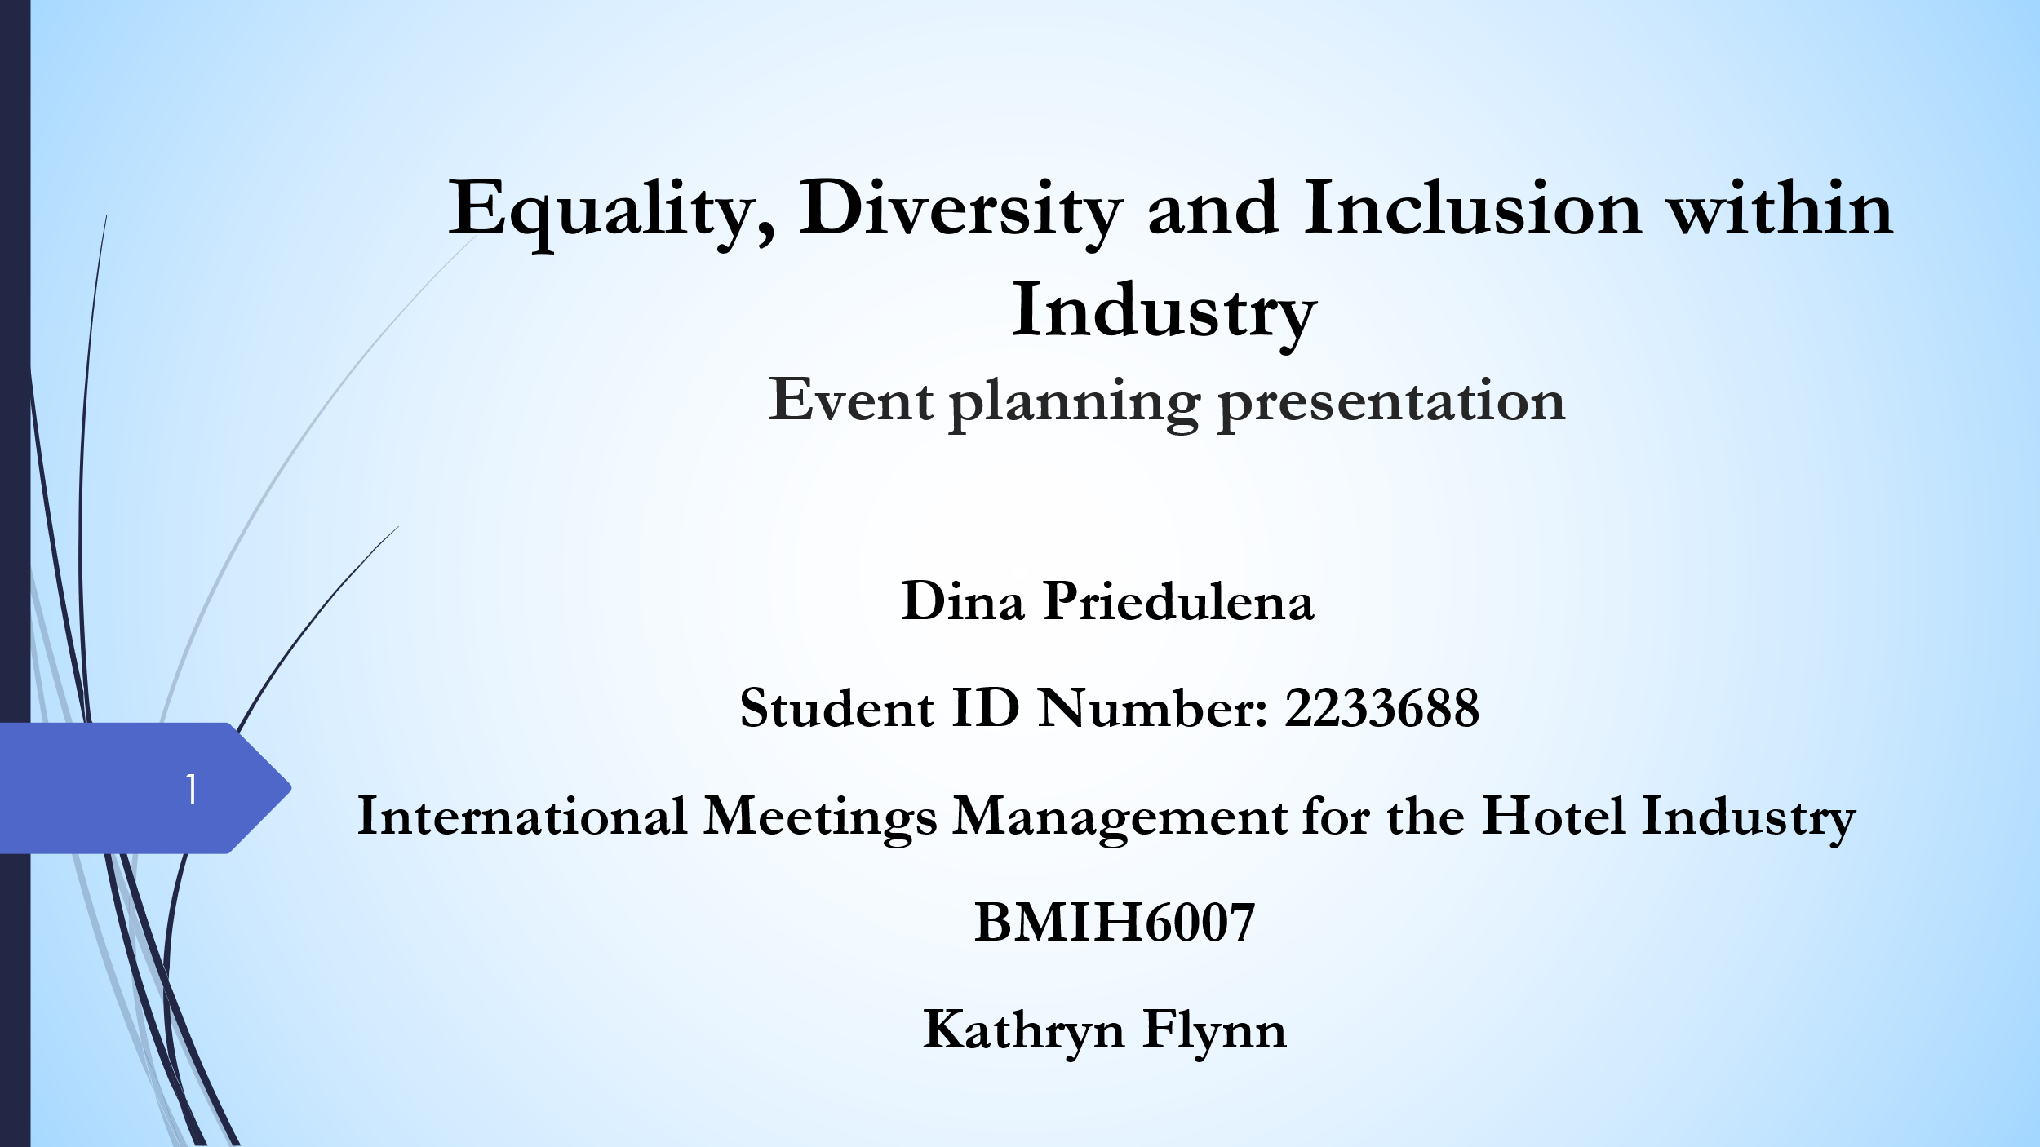
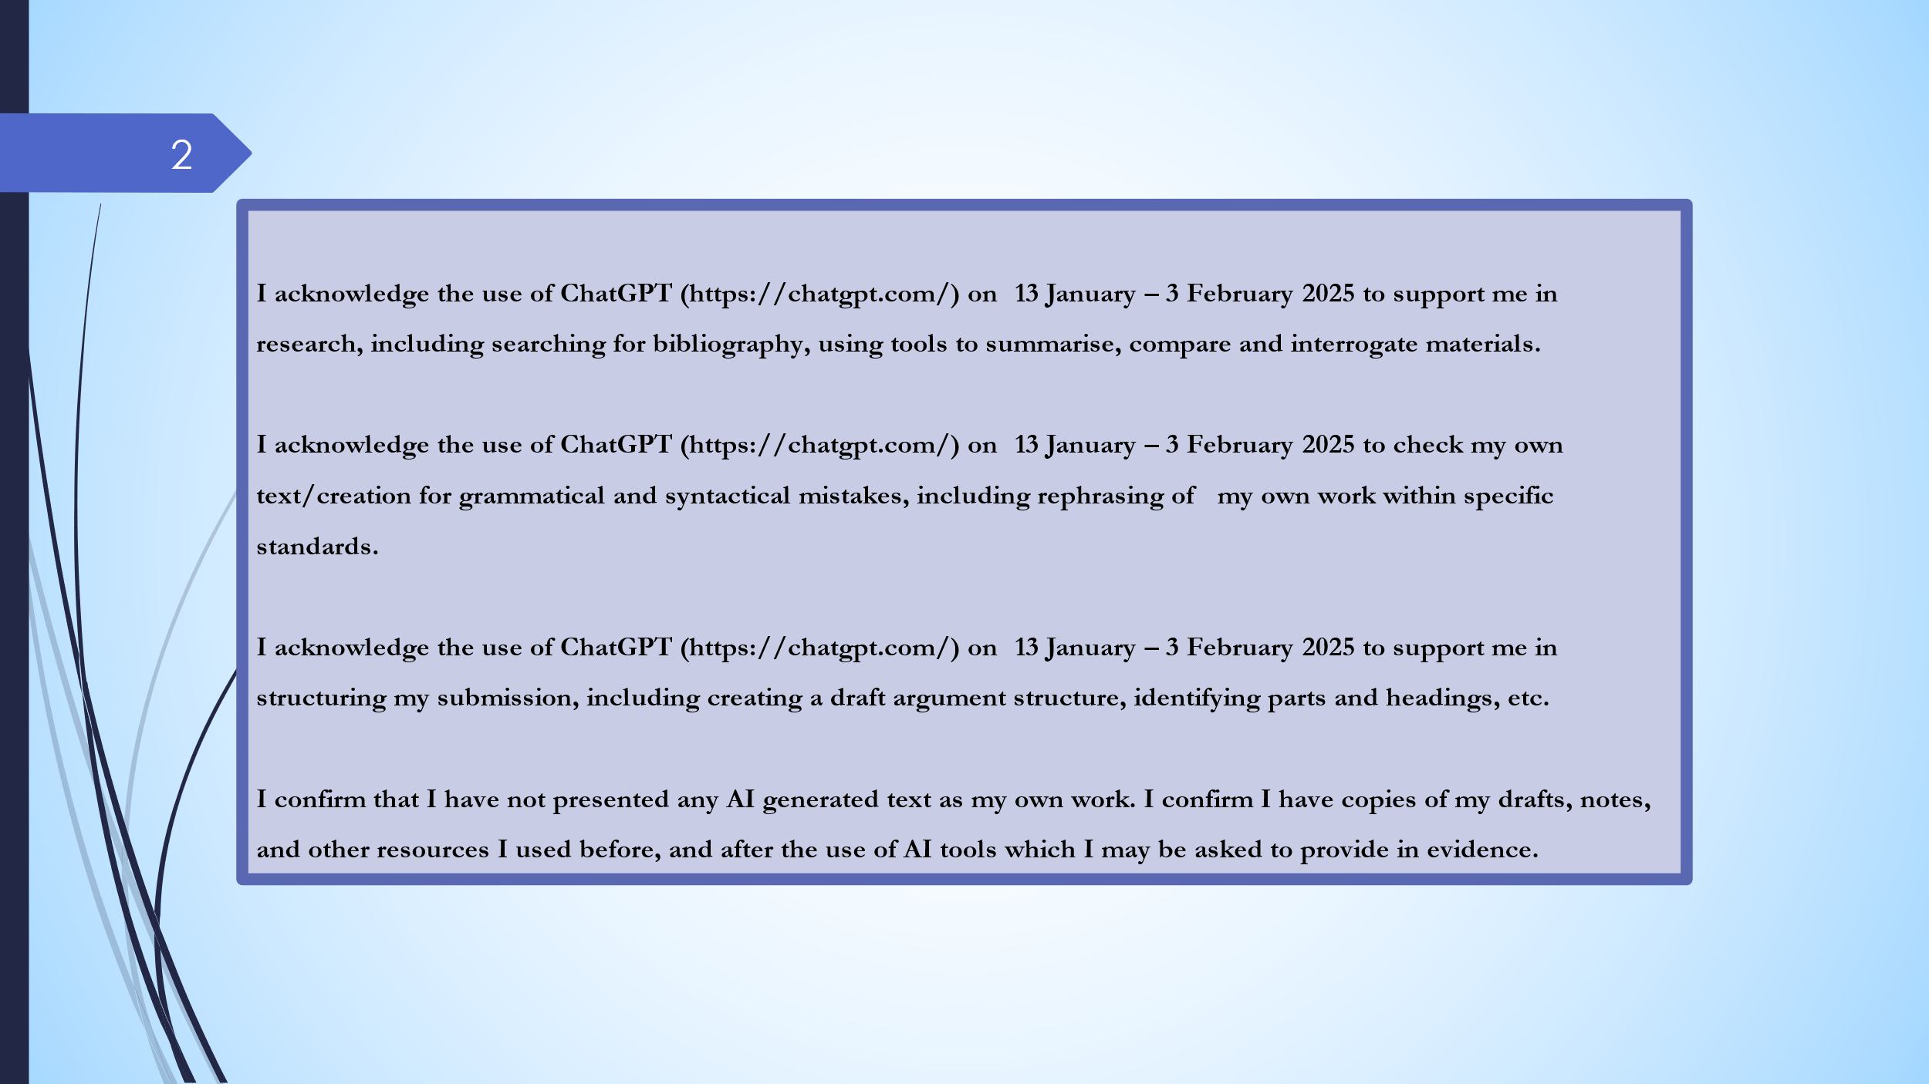
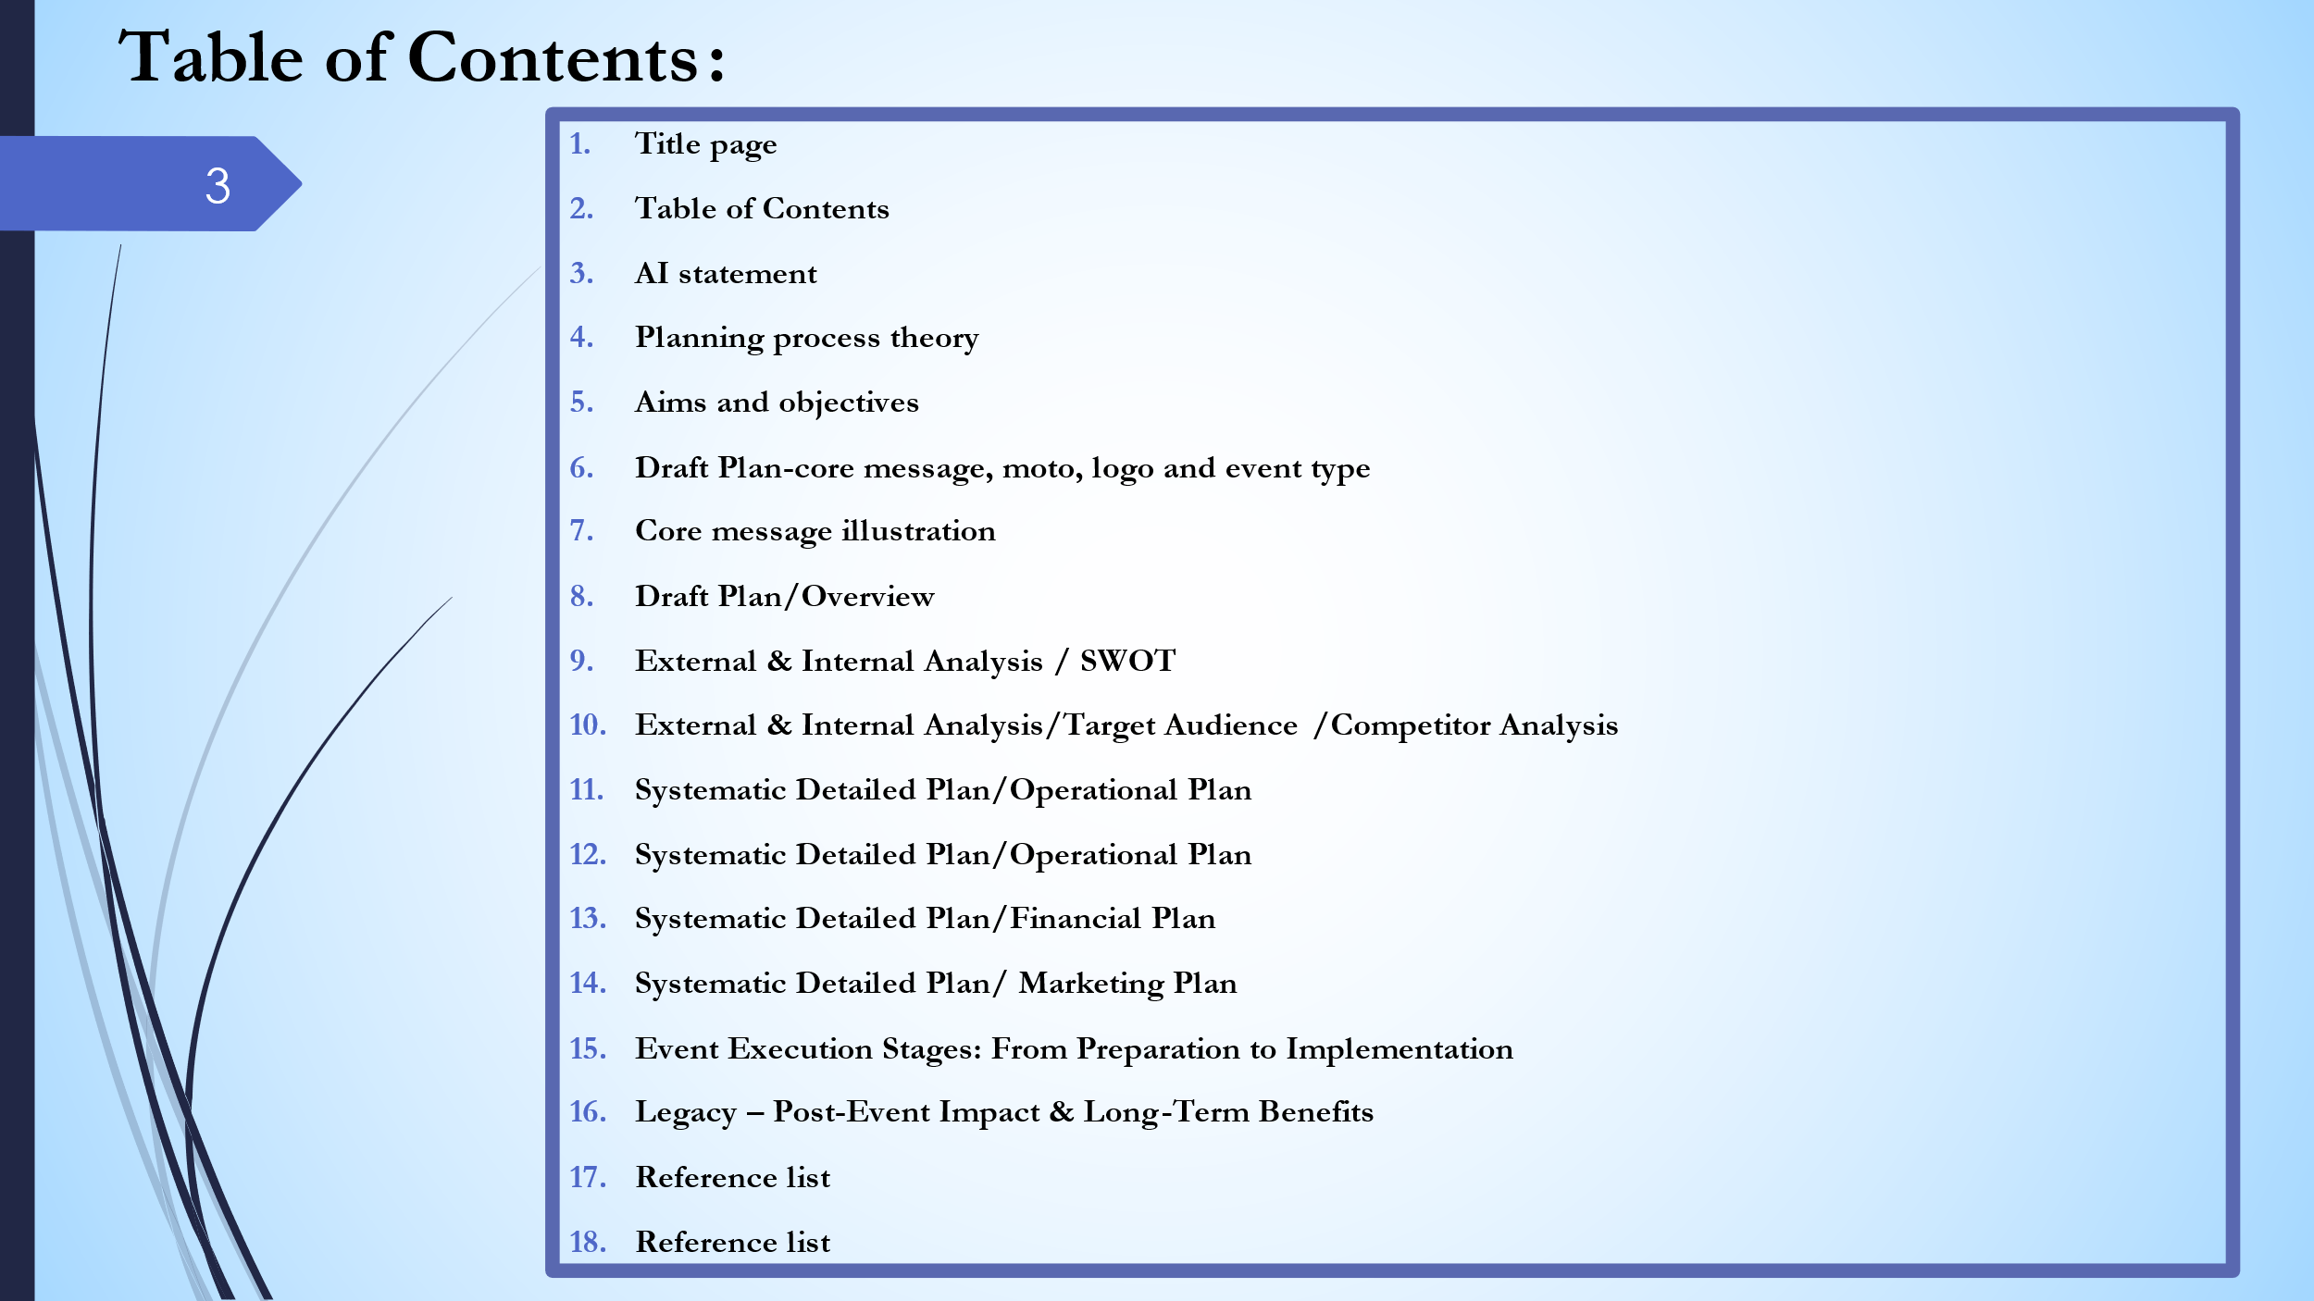
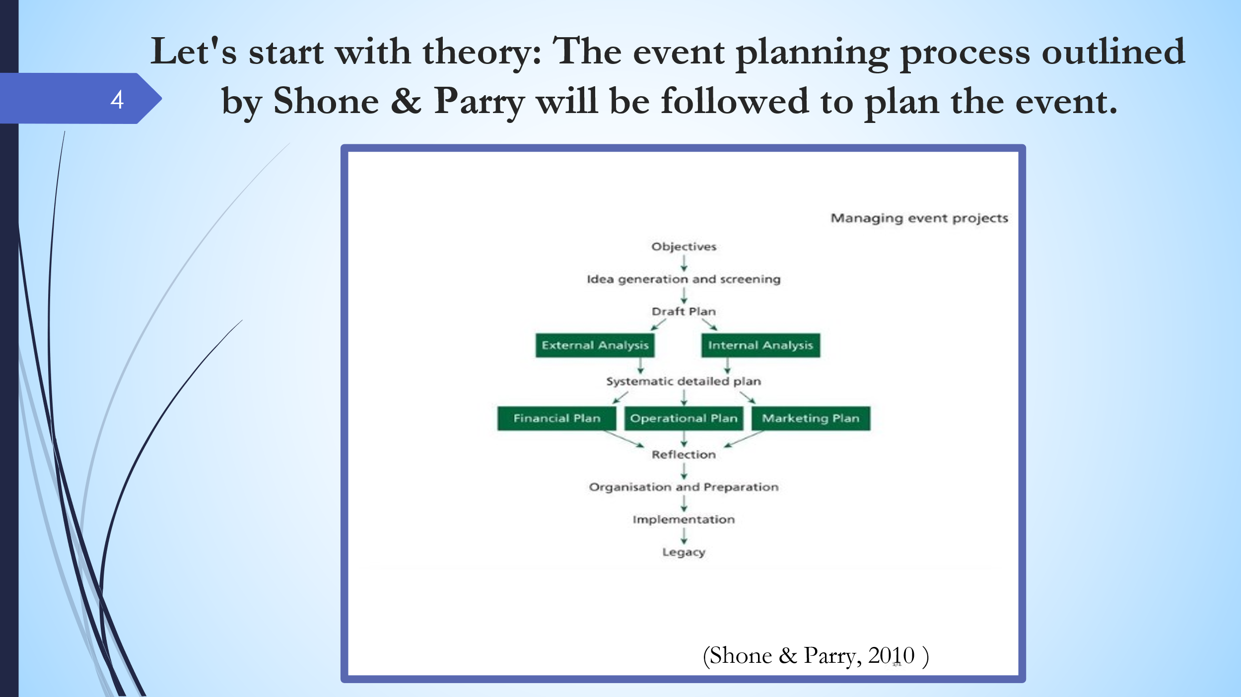
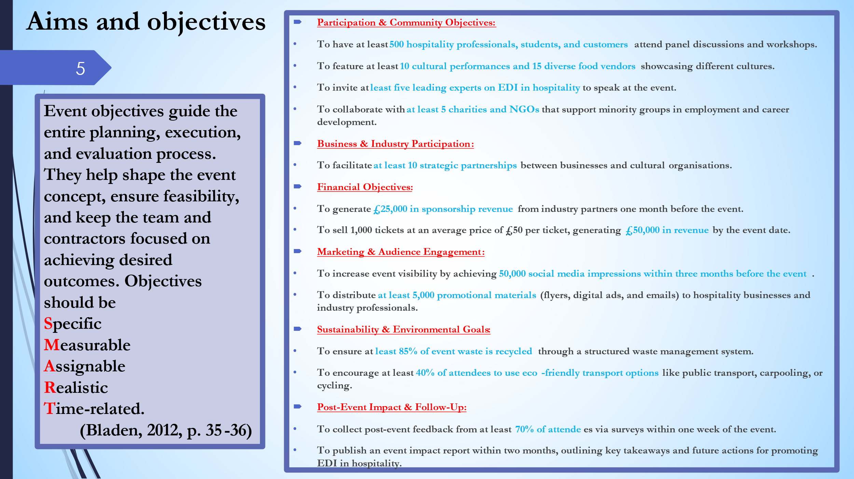
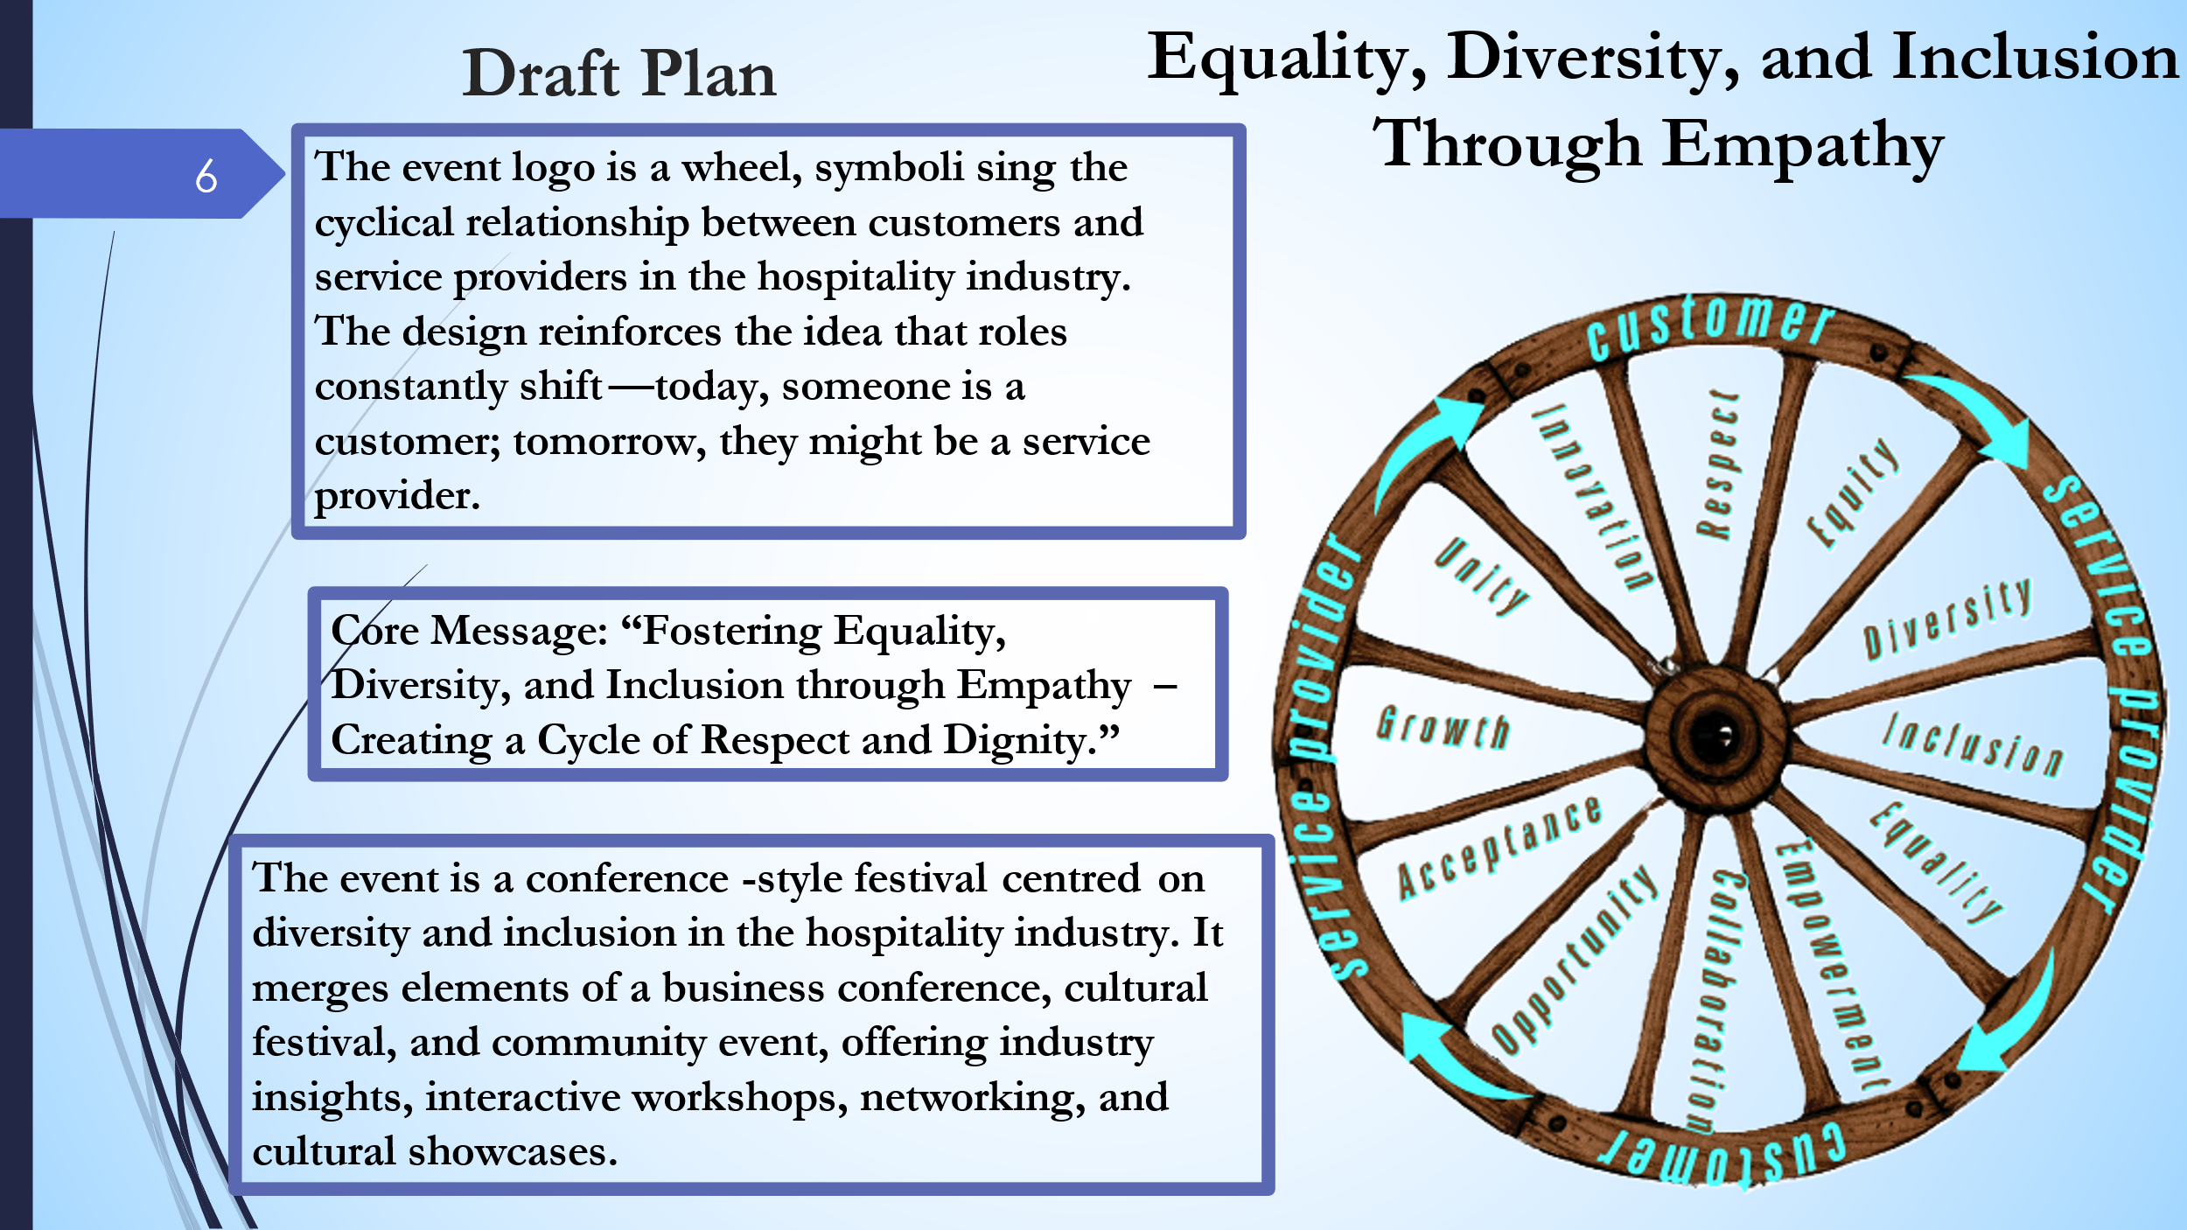
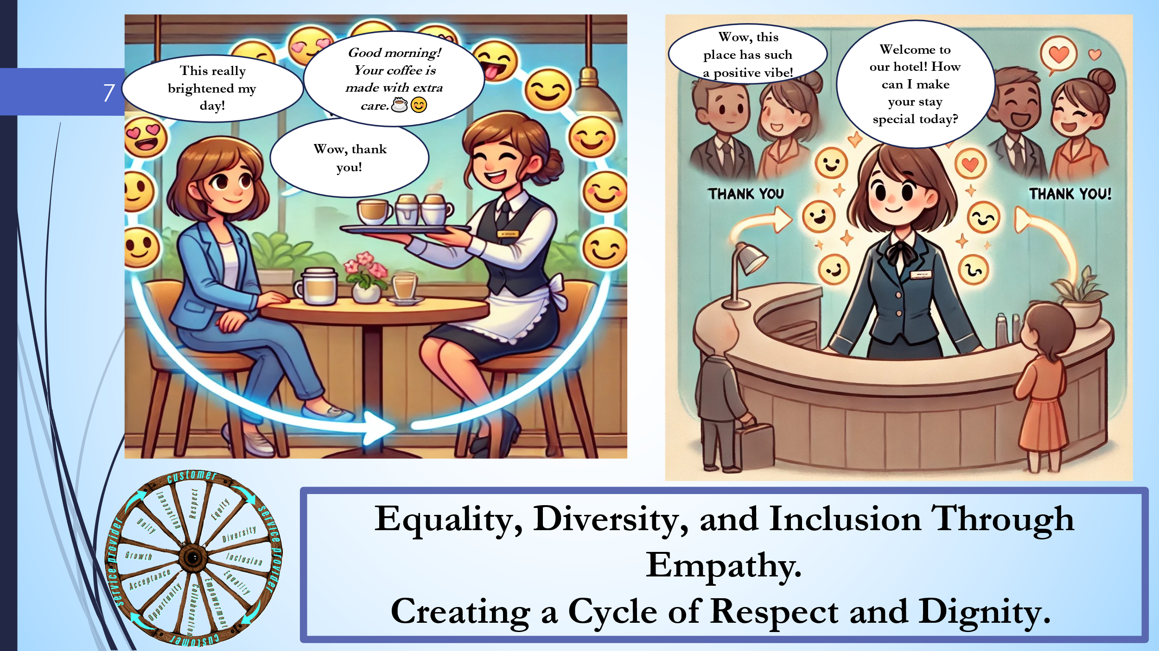
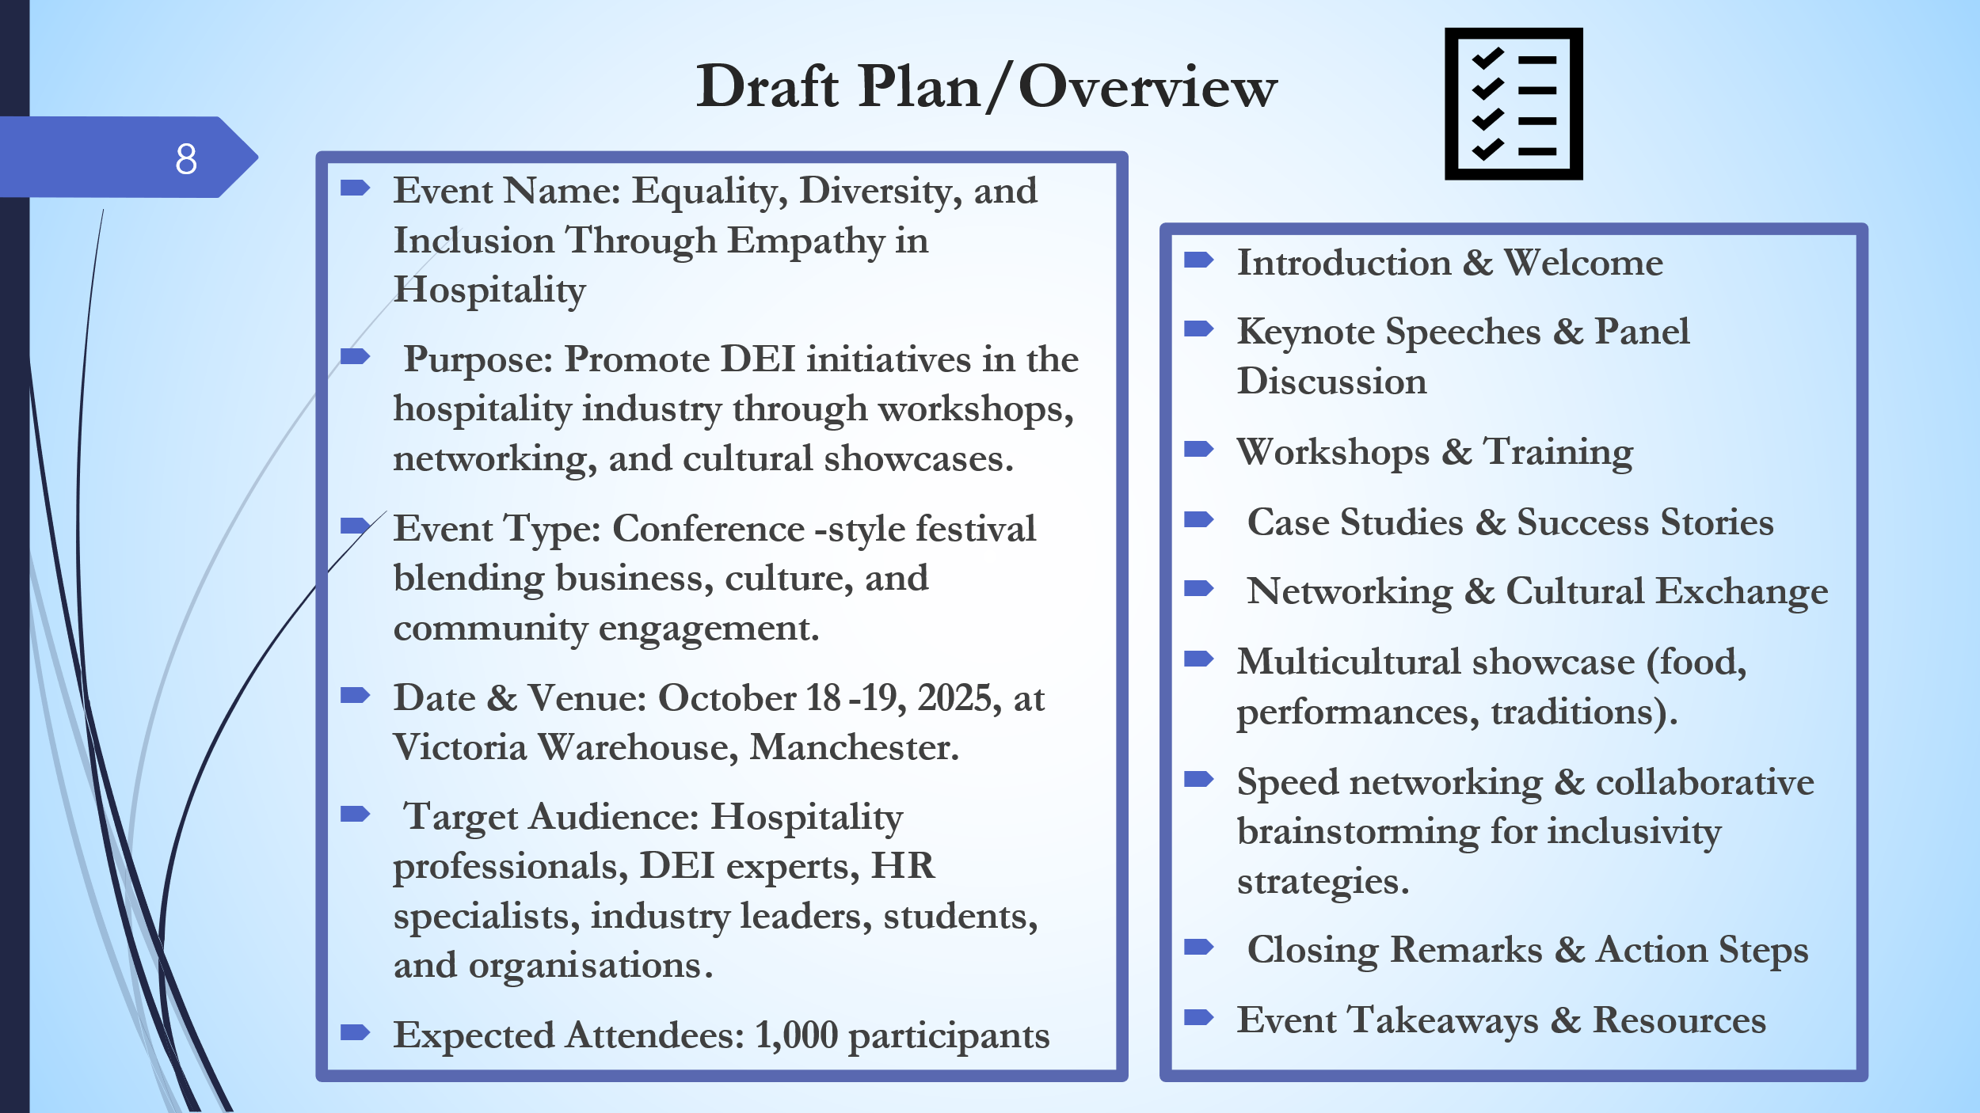
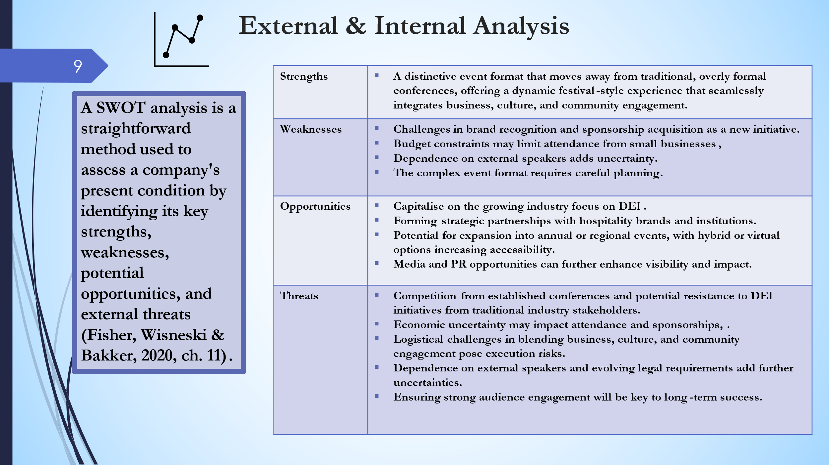
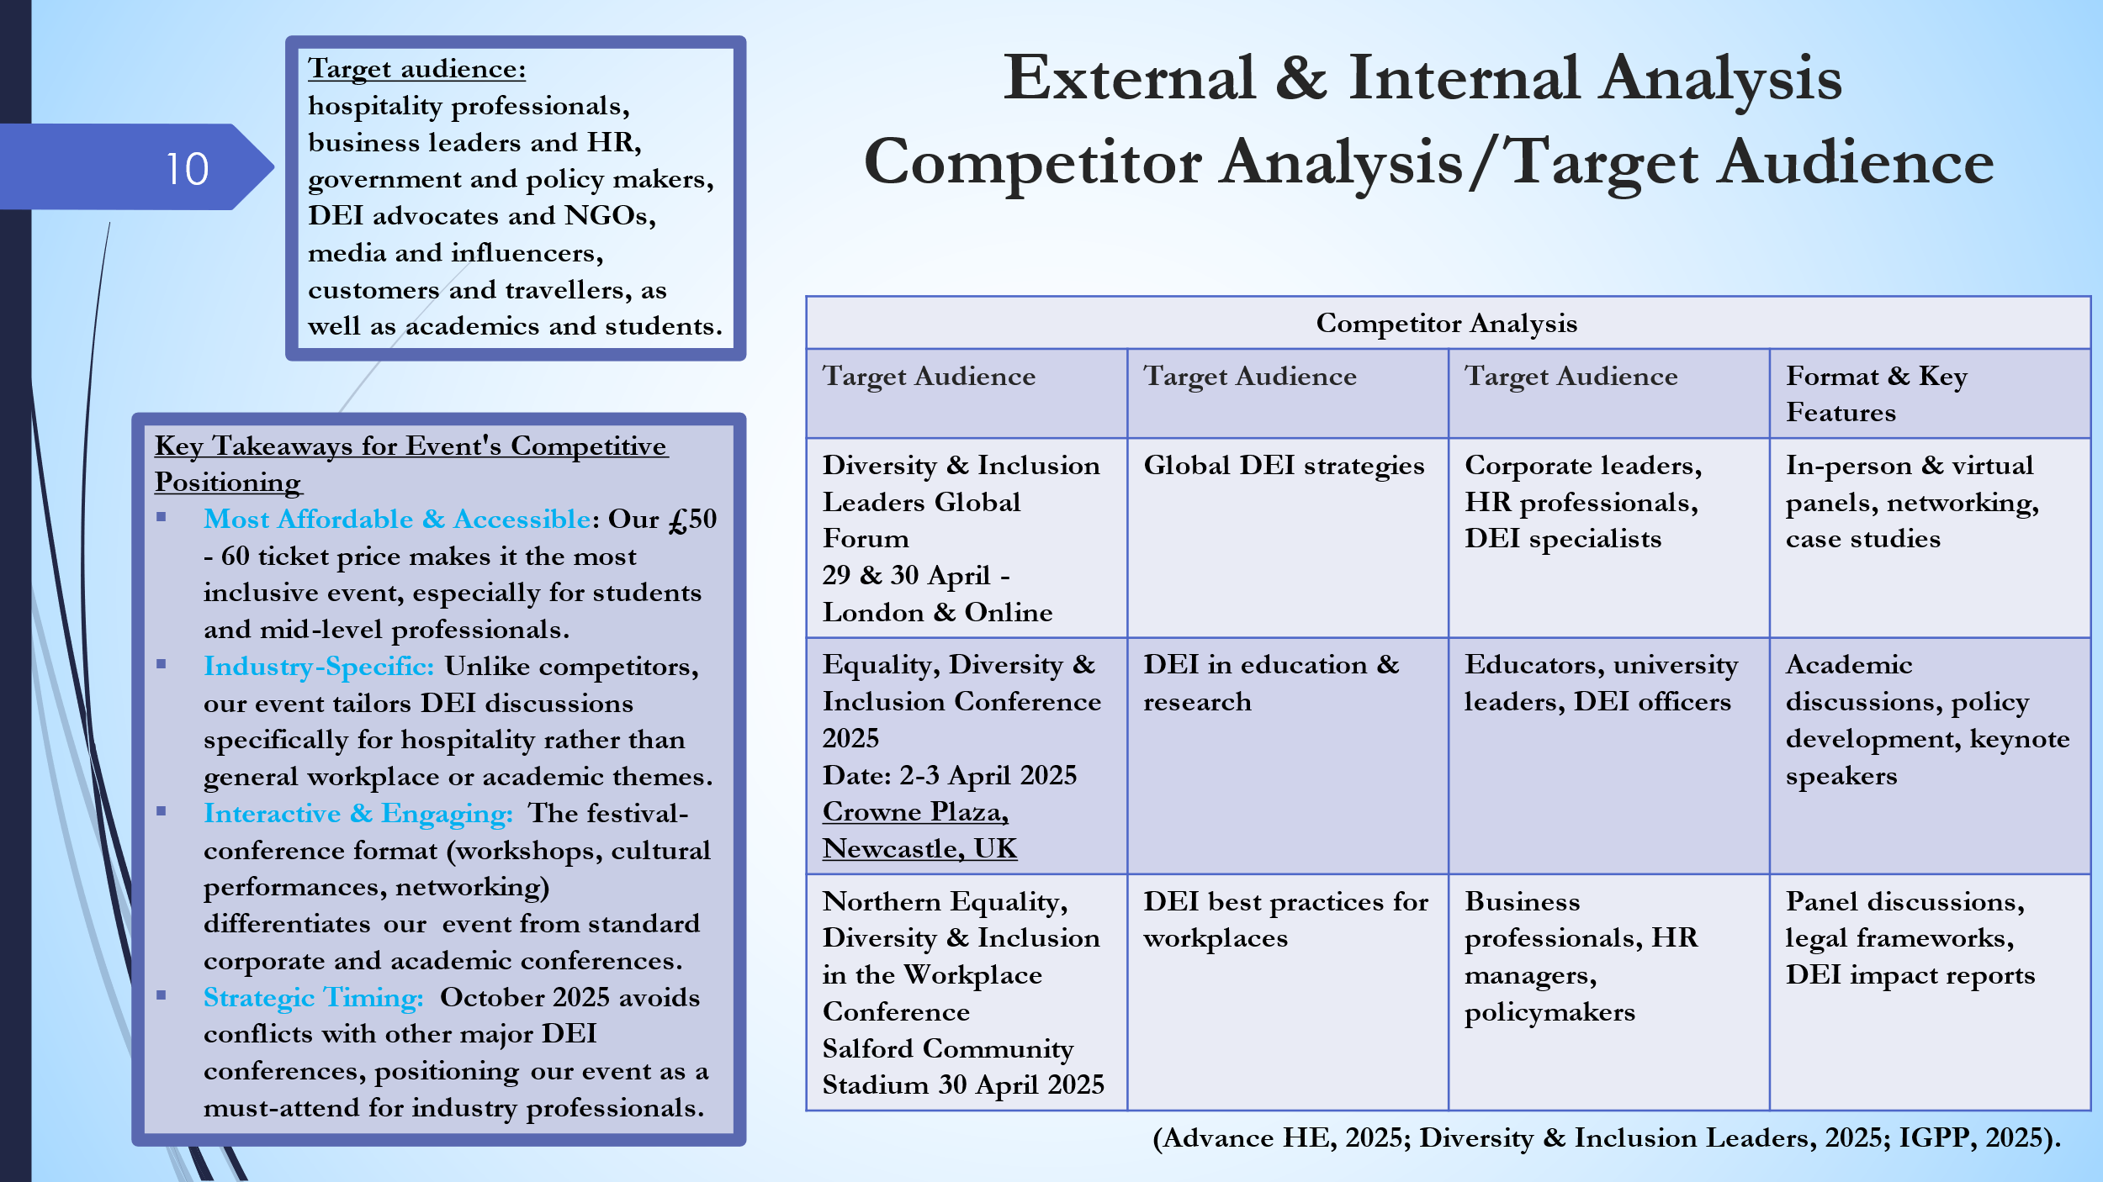
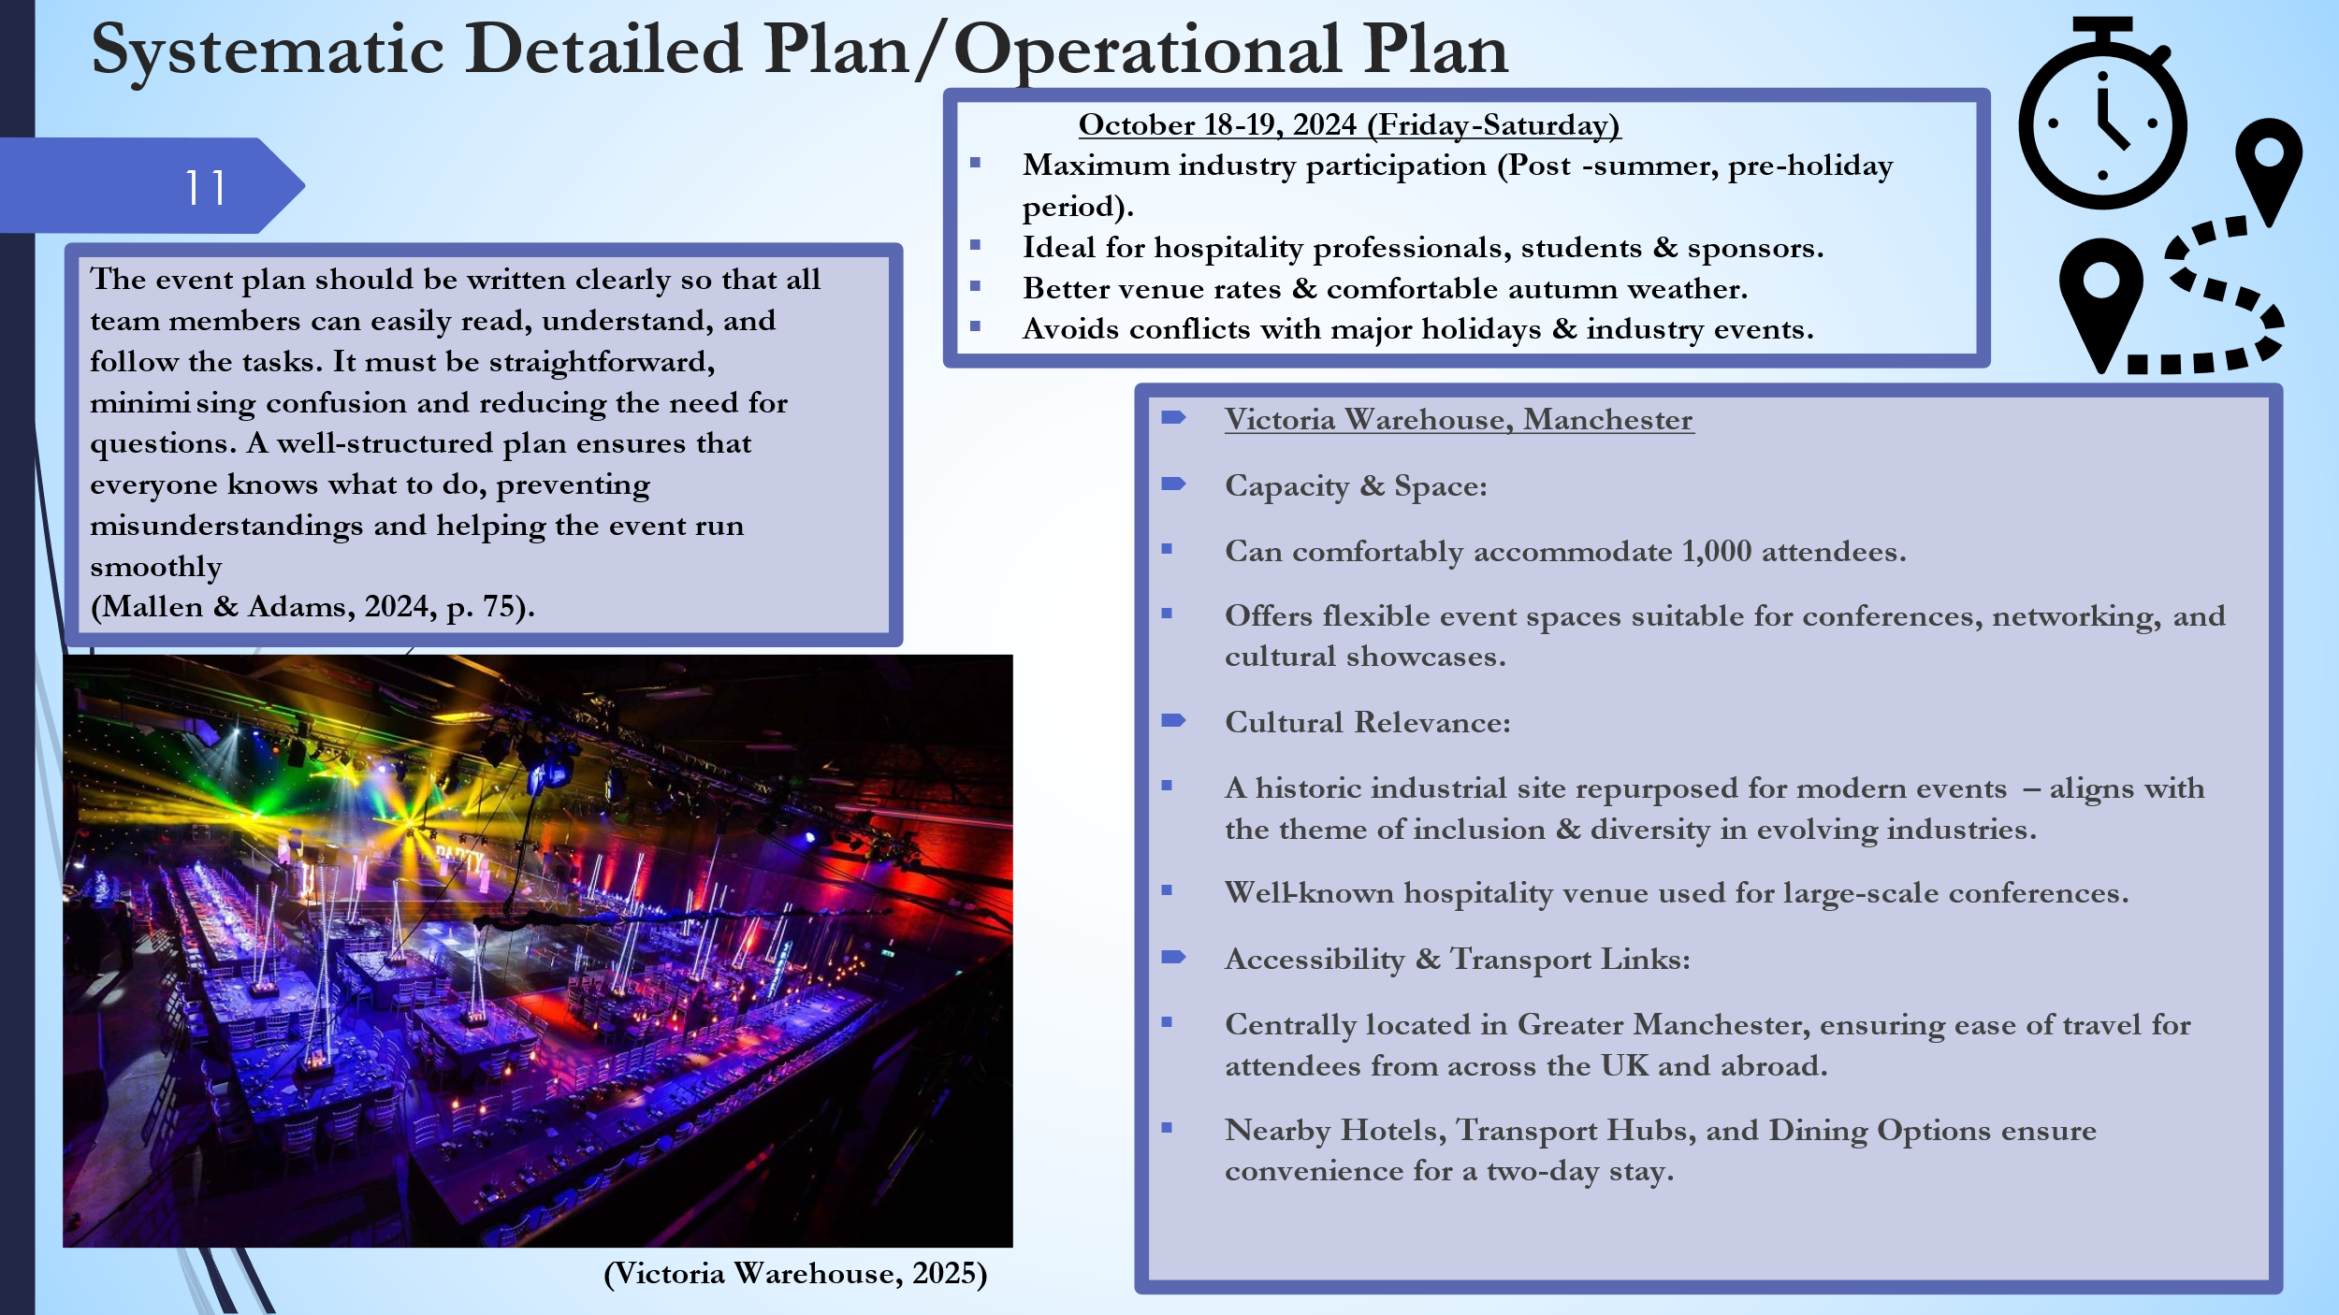
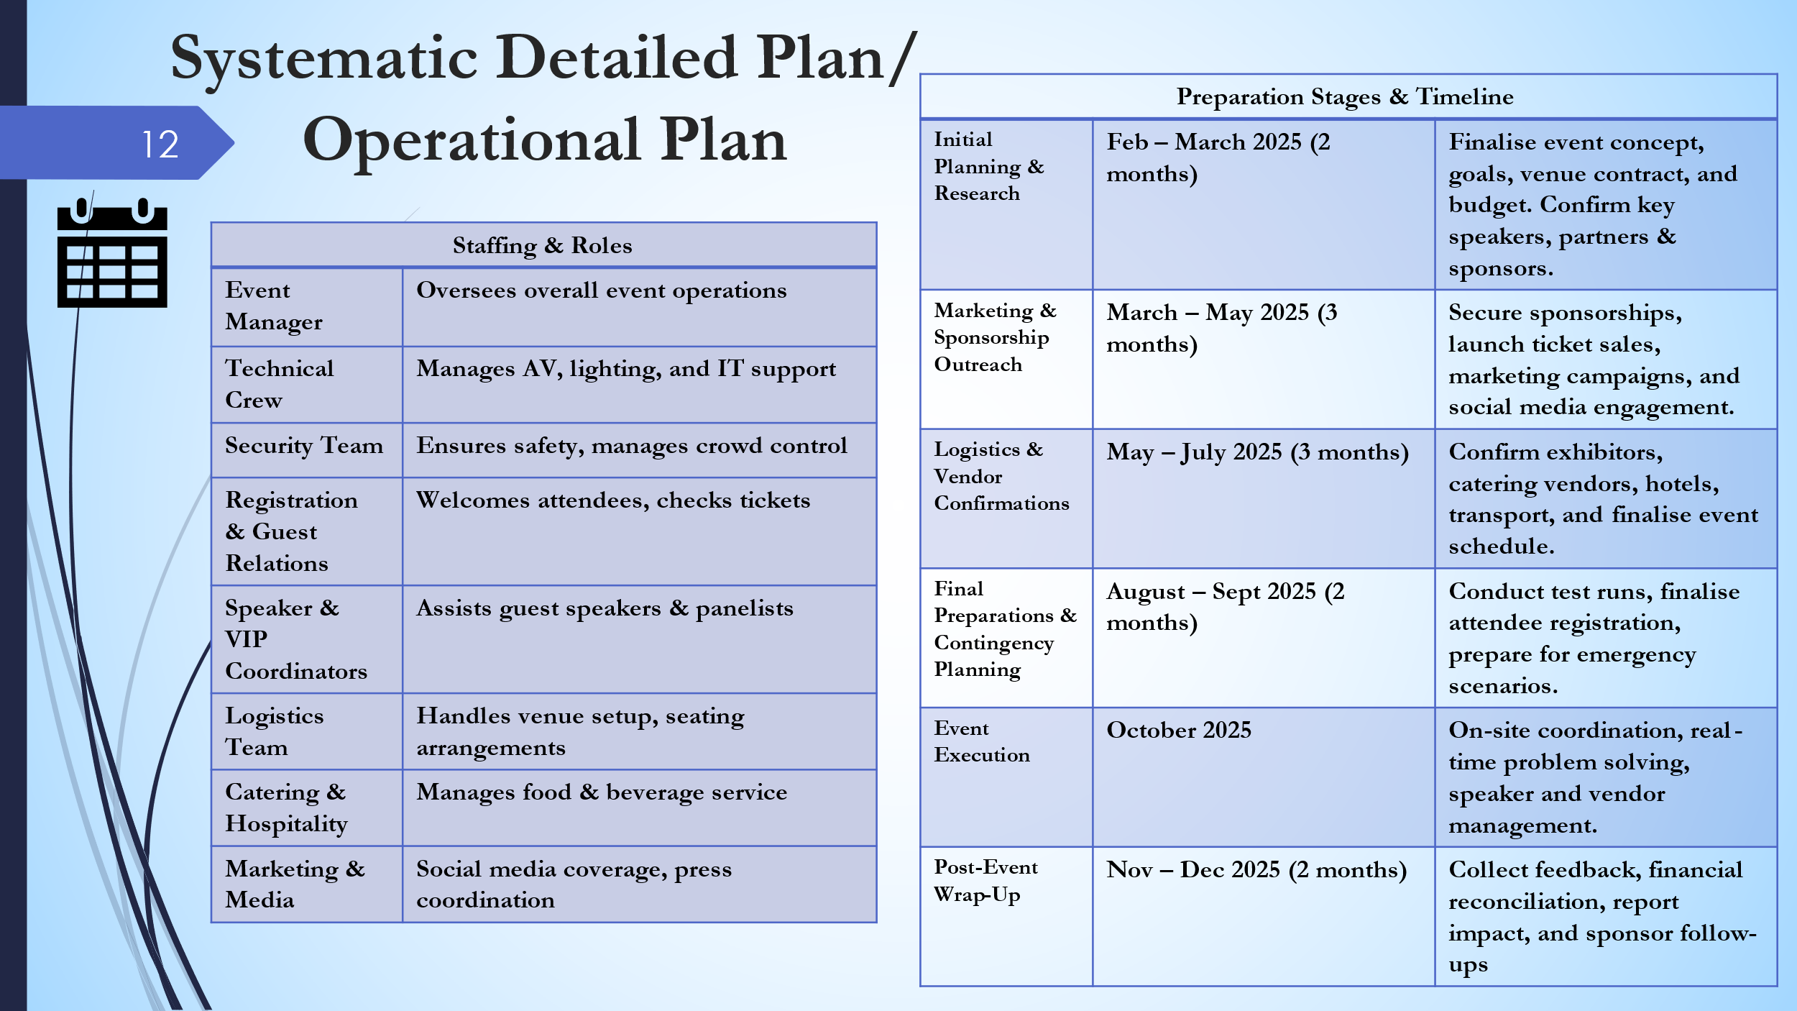

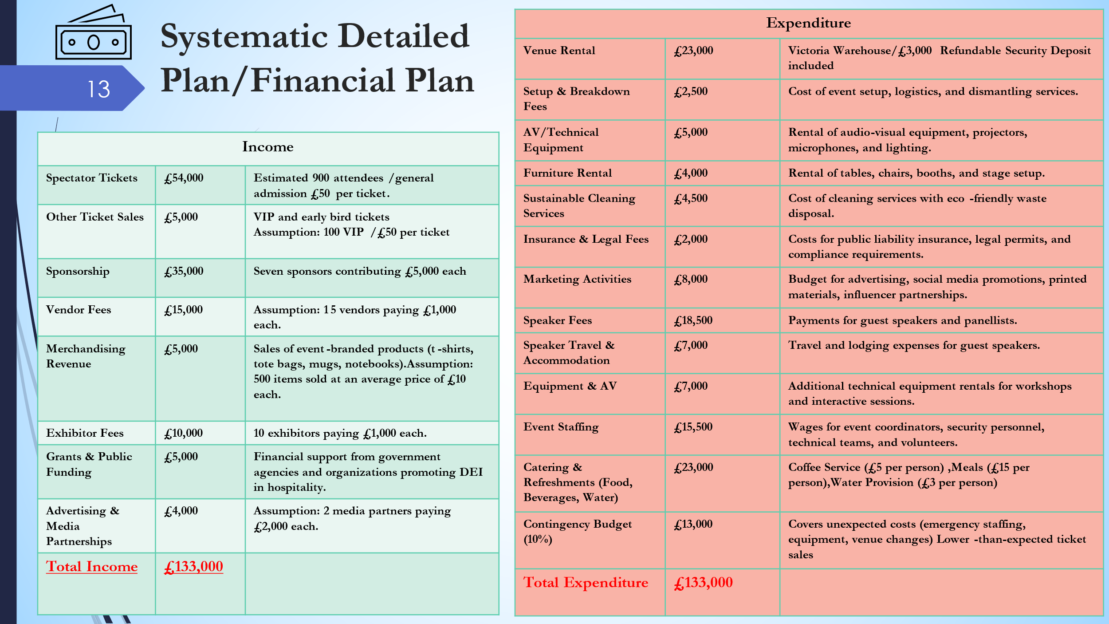
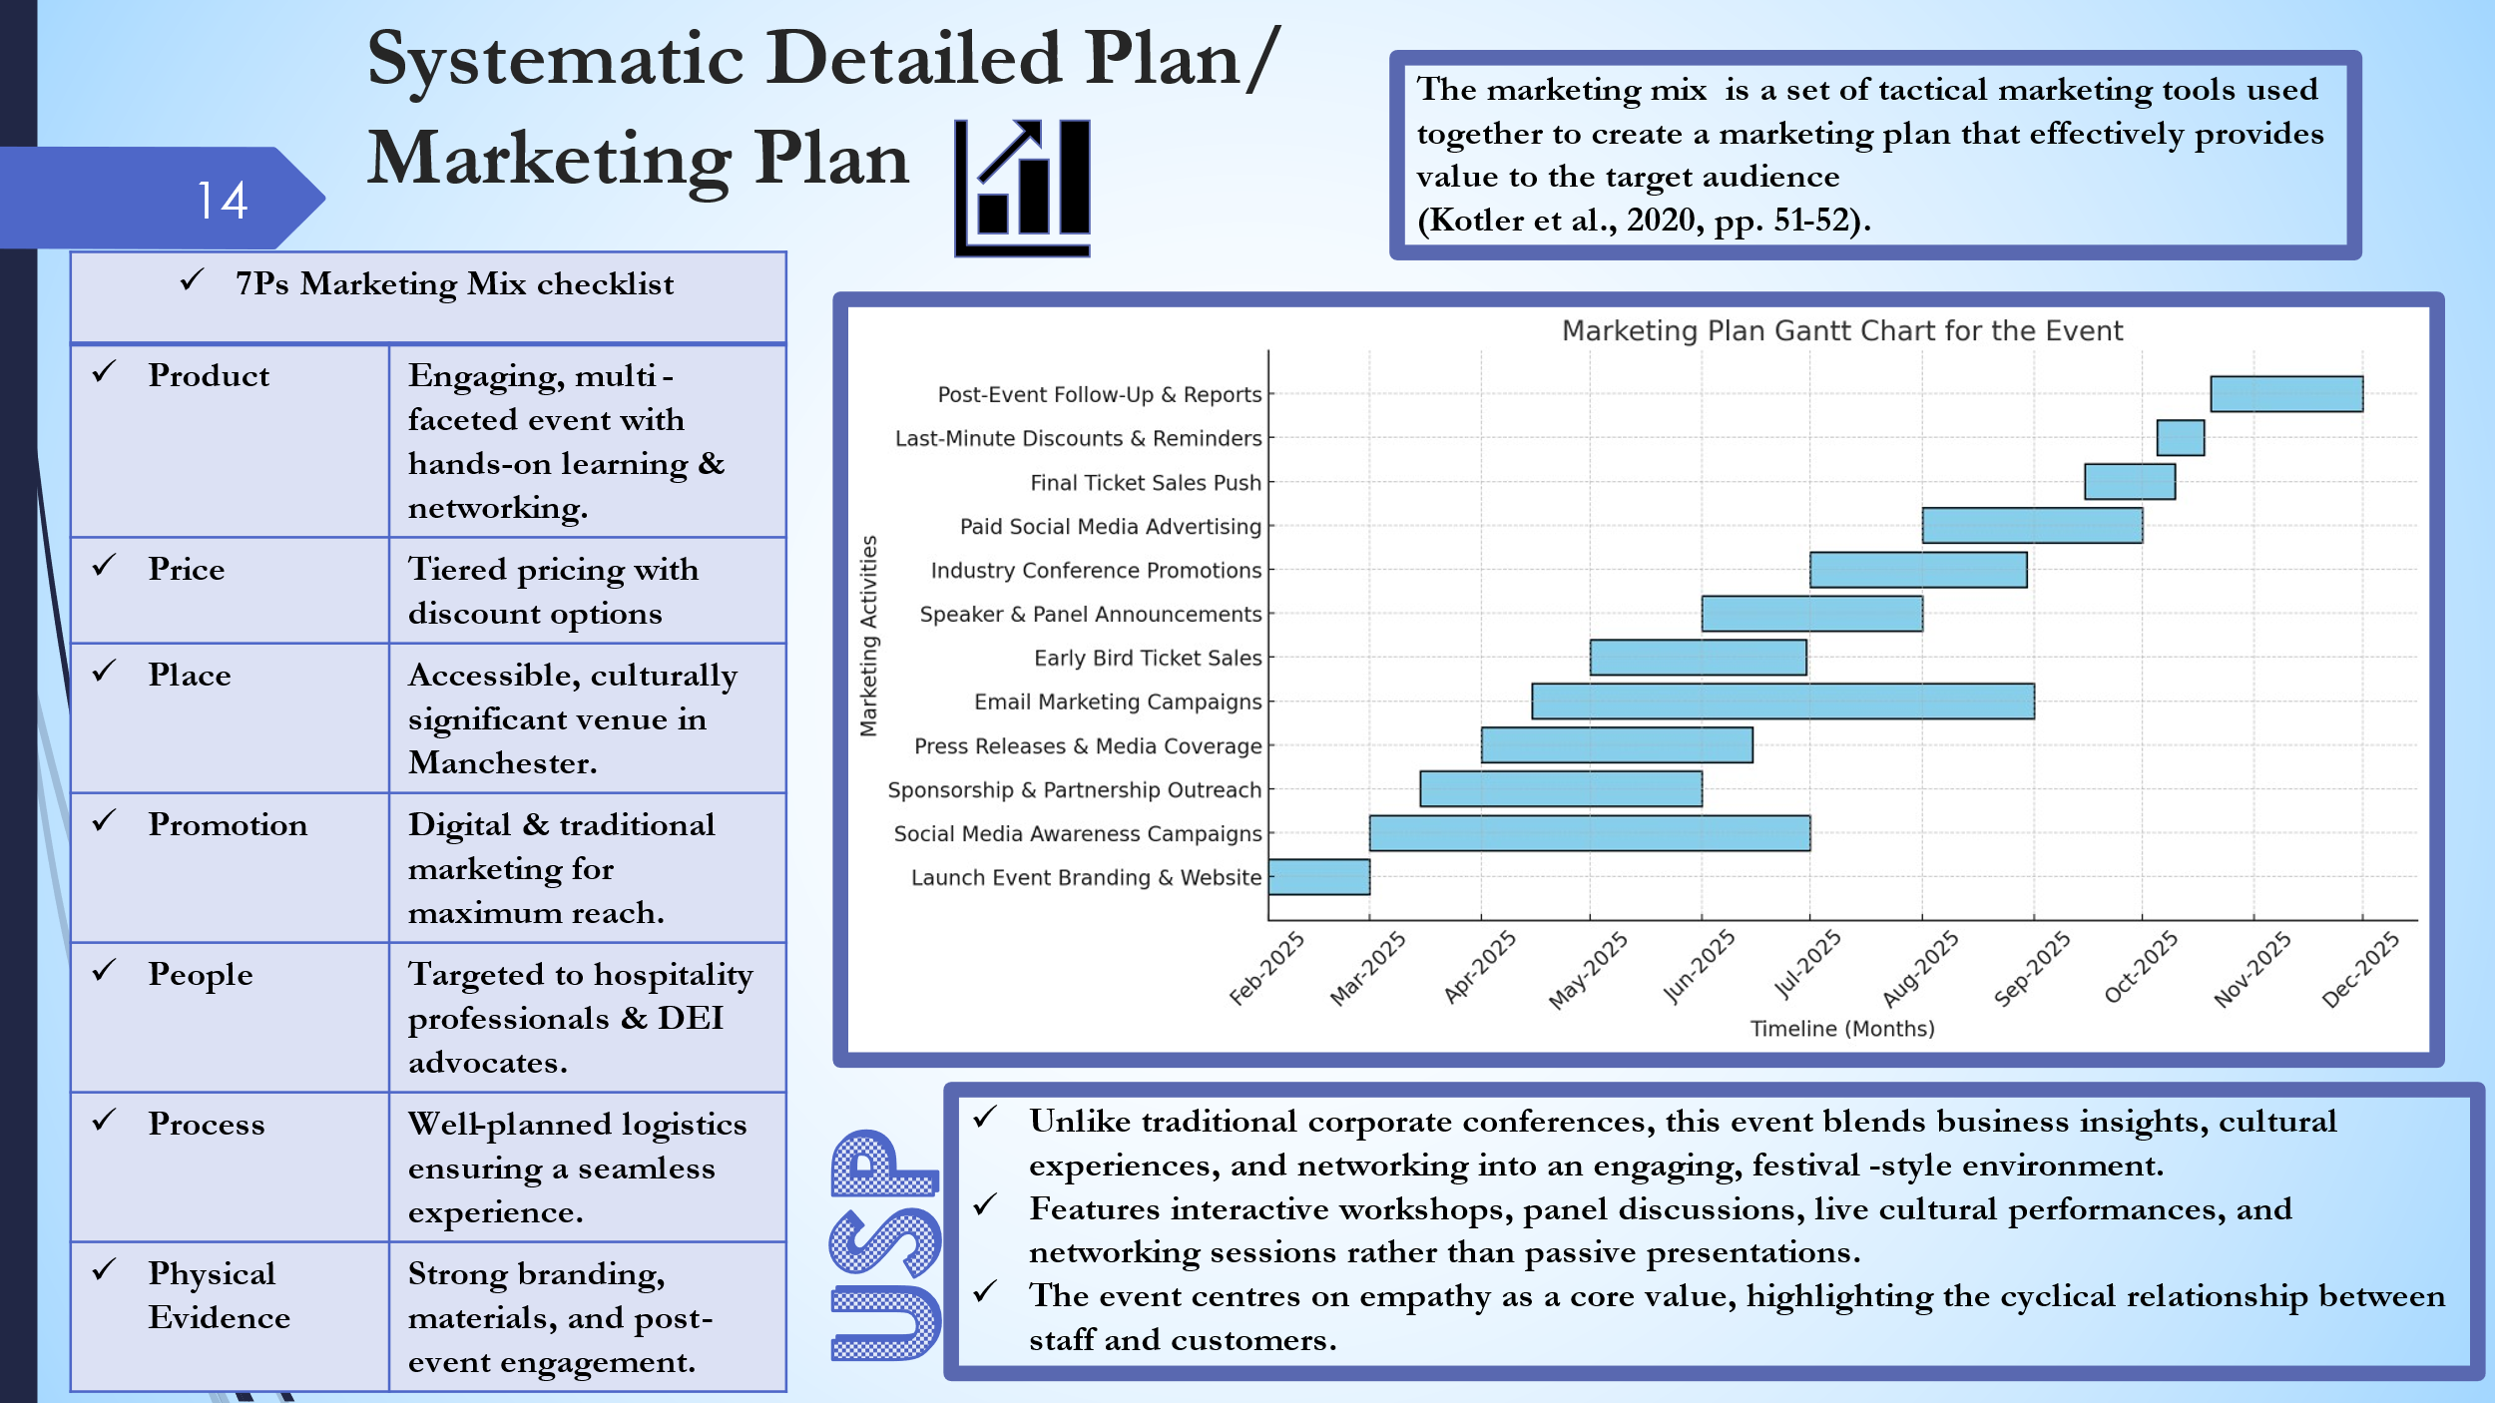
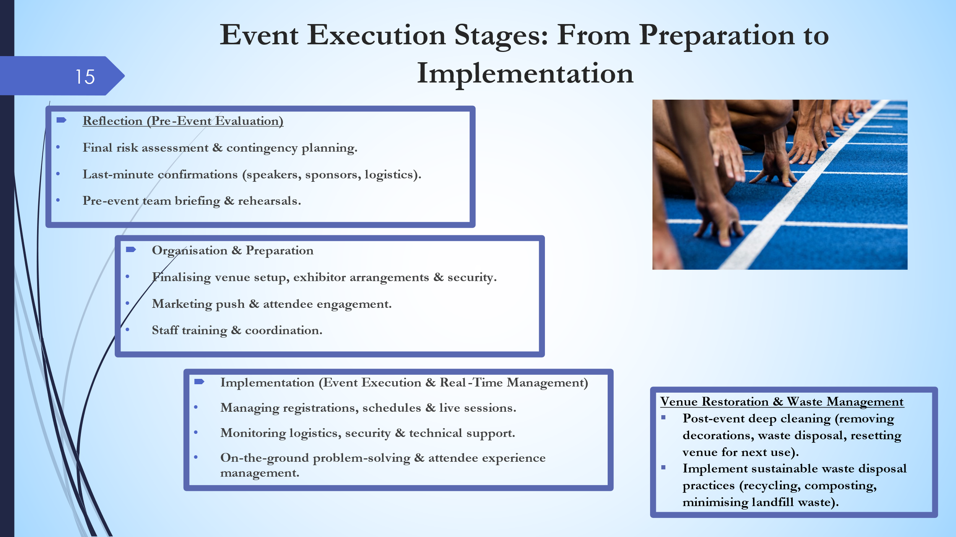

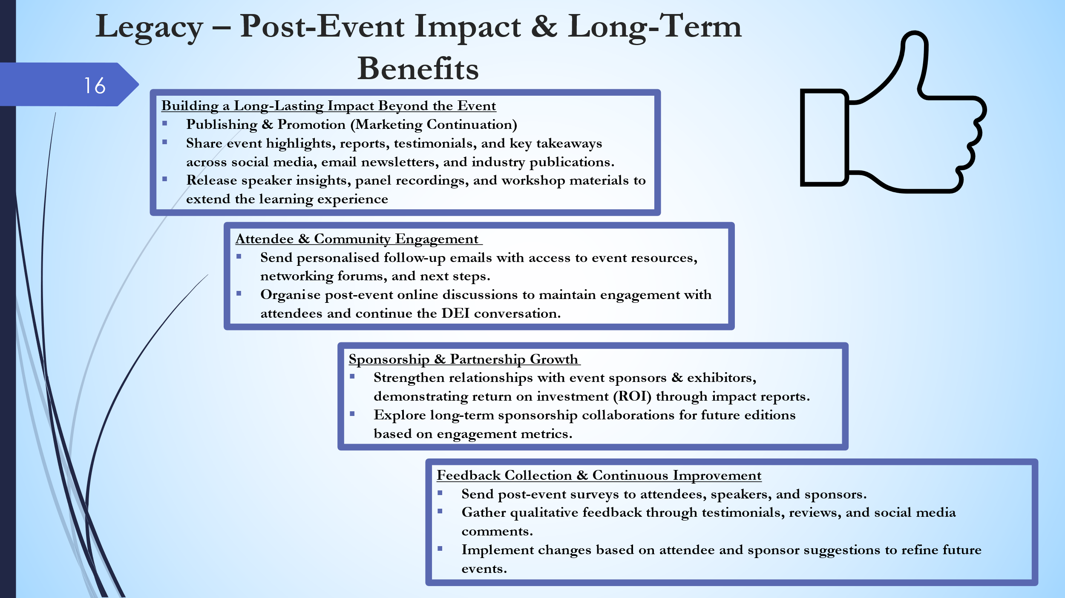
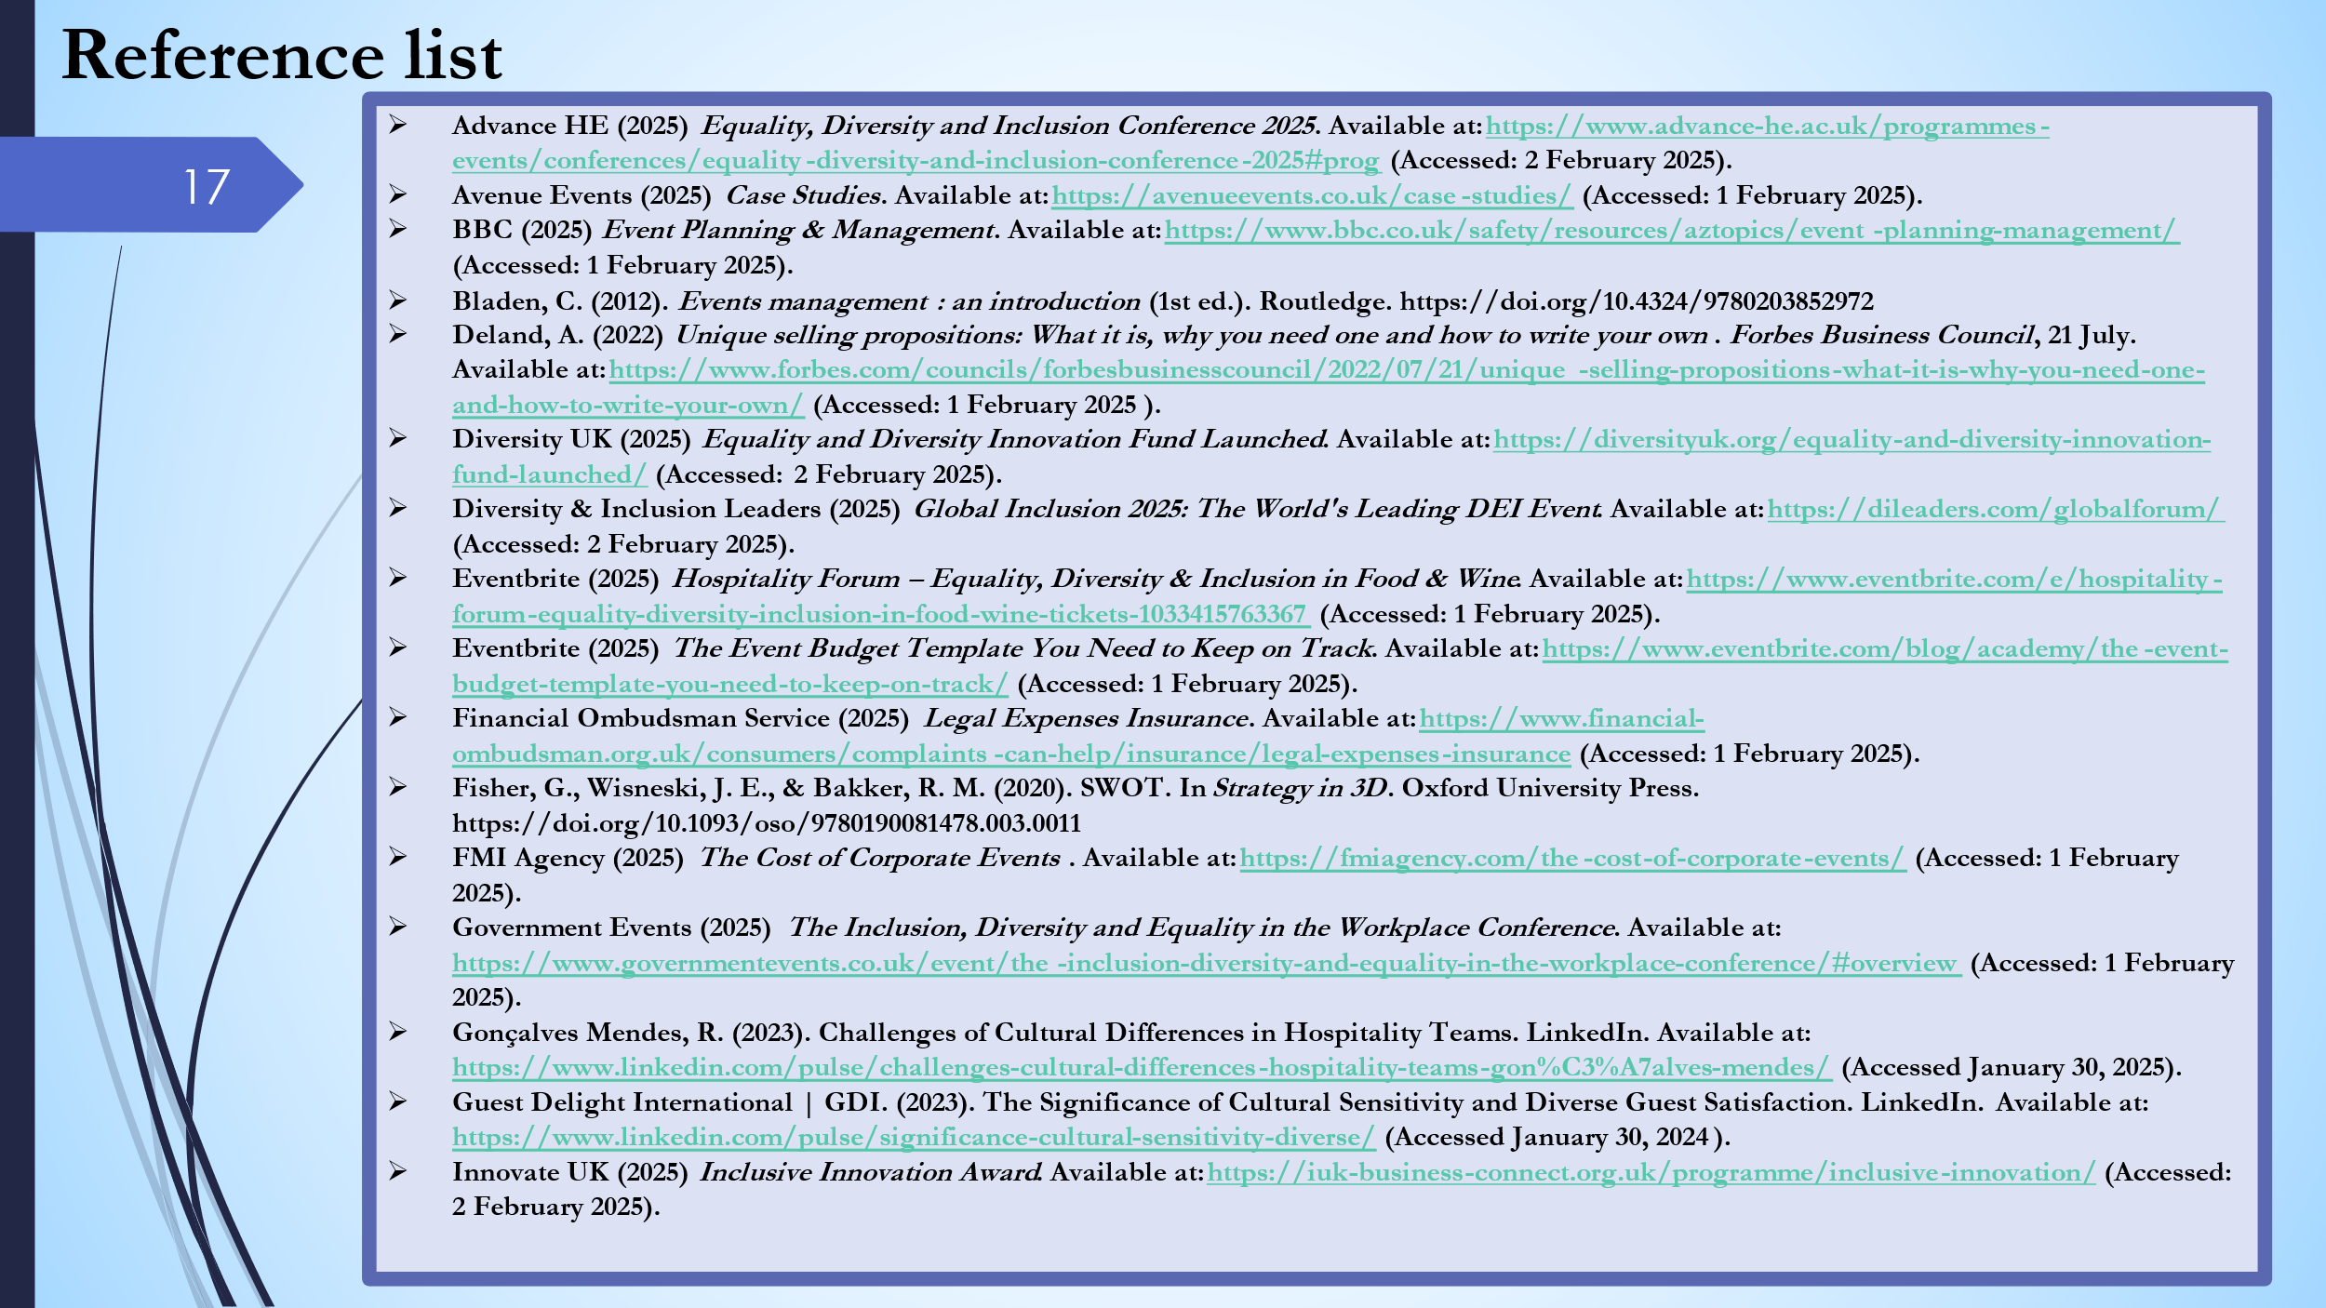
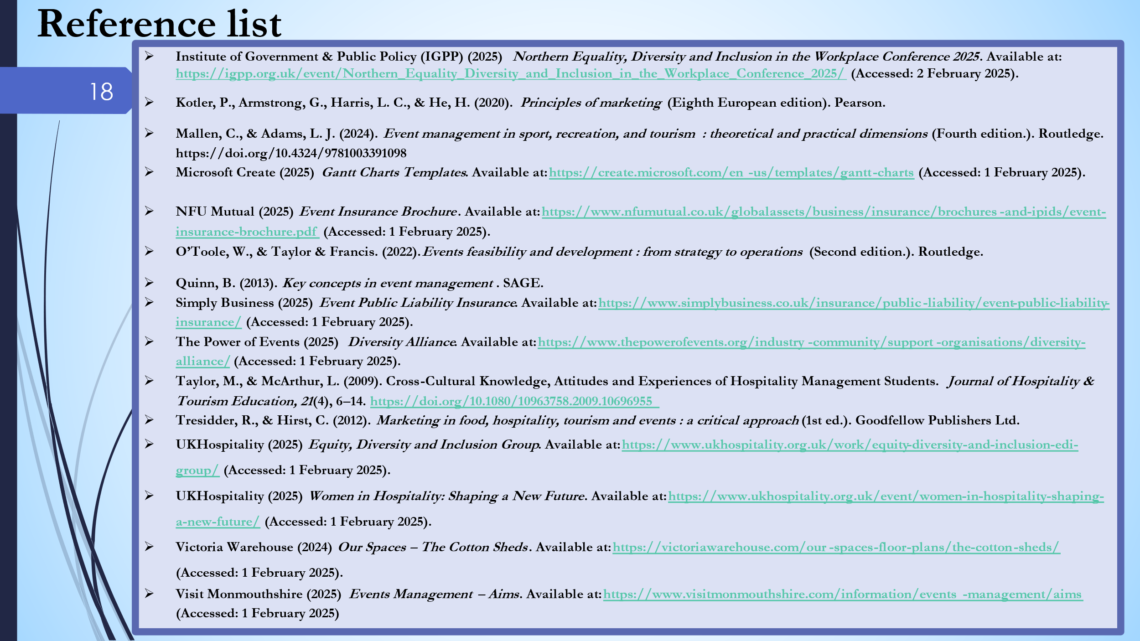

Reference list:
- Advance HE (2025) Equality, Diversity and Inclusion Conference 2025. Available at: https://www.advance-he.ac.uk/programmes-events/conferences/equality-diversity-and-inclusion-conference-2025#prog (Accessed: 2 February 2025).
- Avenue Events (2025) Case Studies. Available at: https://avenueevents.co.uk/case-studies/ (Accessed: 1 February 2025).
- BBC (2025) Event Planning & Management. Available at: https://www.bbc.co.uk/safety/resources/aztopics/event-planning-management/ (Accessed: 1 February 2025).
- Bladen, C. (2012). Events management : an introduction (1st ed.). Routledge. https://doi.org/10.4324/9780203852972
- Deland, A. (2022) Unique selling propositions: What it is, why you need one and how to write your own. Forbes Business Council, 21 July. Available at: https://www.forbes.com/councils/forbesbusinesscouncil/2022/07/21/unique-selling-propositions-what-it-is-why-you-need-one-and-how-to-write-your-own/ (Accessed: 1 February 2025).
- Diversity UK (2025) Equality and Diversity Innovation Fund Launched. Available at: https://diversityuk.org/equality-and-diversity-innovation-fund-launched/ (Accessed: 2 February 2025).
- Diversity & Inclusion Leaders (2025) Global Inclusion 2025: The World's Leading DEI Event. Available at: https://dileaders.com/globalforum/ (Accessed: 2 February 2025).
- Eventbrite (2025) Hospitality Forum – Equality, Diversity & Inclusion in Food & Wine. Available at: https://www.eventbrite.com/e/hospitality-forum-equality-diversity-inclusion-in-food-wine-tickets-1033415763367 (Accessed: 1 February 2025).
- Eventbrite (2025) The Event Budget Template You Need to Keep on Track. Available at: https://www.eventbrite.com/blog/academy/the-event-budget-template-you-need-to-keep-on-track/ (Accessed: 1 February 2025).
- Financial Ombudsman Service (2025) Legal Expenses Insurance. Available at: https://www.financial-ombudsman.org.uk/consumers/complaints-can-help/insurance/legal-expenses-insurance (Accessed: 1 February 2025).
- Fisher, G., Wisneski, J. E., & Bakker, R. M. (2020). SWOT. In Strategy in 3D. Oxford University Press. https://doi.org/10.1093/oso/9780190081478.003.0011
- FMI Agency (2025) The Cost of Corporate Events. Available at: https://fmiagency.com/the-cost-of-corporate-events/ (Accessed: 1 February 2025).
- Government Events (2025) The Inclusion, Diversity and Equality in the Workplace Conference. Available at: https://www.governmentevents.co.uk/event/the-inclusion-diversity-and-equality-in-the-workplace-conference/#overview (Accessed: 1 February 2025).
- Gonçalves Mendes, R. (2023). Challenges of Cultural Differences in Hospitality Teams. LinkedIn. Available at: https://www.linkedin.com/pulse/challenges-cultural-differences-hospitality-teams-gon%C3%A7alves-mendes/ (Accessed January 30, 2025).
- Guest Delight International | GDI. (2023). The Significance of Cultural Sensitivity and Diverse Guest Satisfaction. LinkedIn. Available at: https://www.linkedin.com/pulse/significance-cultural-sensitivity-diverse/ (Accessed January 30, 2024).
- Innovate UK (2025) Inclusive Innovation Award. Available at: https://iuk-business-connect.org.uk/programme/inclusive-innovation/ (Accessed: 2 February 2025).
- Institute of Government & Public Policy (IGPP) (2025) Northern Equality, Diversity and Inclusion in the Workplace Conference 2025. Available at: https://igpp.org.uk/event/Northern_Equality_Diversity_and_Inclusion_in_the_Workplace_Conference_2025/ (Accessed: 2 February 2025).
- Kotler, P., Armstrong, G., Harris, L. C., & He, H. (2020). Principles of marketing (Eighth European edition). Pearson.
- Mallen, C., & Adams, L. J. (2024). Event management in sport, recreation, and tourism : theoretical and practical dimensions (Fourth edition.). Routledge. https://doi.org/10.4324/9781003391098
- Microsoft Create (2025) Gantt Charts Templates. Available at: https://create.microsoft.com/en-us/templates/gantt-charts (Accessed: 1 February 2025).
- NFU Mutual (2025) Event Insurance Brochure. Available at: https://www.nfumutual.co.uk/globalassets/business/insurance/brochures-and-ipids/event-insurance-brochure.pdf (Accessed: 1 February 2025).
- O’Toole, W., & Taylor & Francis. (2022). Events feasibility and development : from strategy to operations (Second edition.). Routledge.
- Quinn, B. (2013). Key concepts in event management. SAGE.
- Simply Business (2025) Event Public Liability Insurance. Available at: https://www.simplybusiness.co.uk/insurance/public-liability/event-public-liability-insurance/ (Accessed: 1 February 2025).
- The Power of Events (2025) Diversity Alliance. Available at: https://www.thepowerofevents.org/industry-community/support-organisations/diversity-alliance/ (Accessed: 1 February 2025).
- Taylor, M., & McArthur, L. (2009). Cross-Cultural Knowledge, Attitudes and Experiences of Hospitality Management Students. Journal of Hospitality & Tourism Education, 21(4), 6–14. https://doi.org/10.1080/10963758.2009.10696955
- Tresidder, R., & Hirst, C. (2012). Marketing in food, hospitality, tourism and events : a critical approach (1st ed.). Goodfellow Publishers Ltd.
- UKHospitality (2025) Equity, Diversity and Inclusion Group. Available at: https://www.ukhospitality.org.uk/work/equity-diversity-and-inclusion-edi-group/ (Accessed: 1 February 2025).
- UKHospitality (2025) Women in Hospitality: Shaping a New Future. Available at: https://www.ukhospitality.org.uk/event/women-in-hospitality-shaping-a-new-future/ (Accessed: 1 February 2025).
- Victoria Warehouse (2024) Our Spaces – The Cotton Sheds. Available at: https://victoriawarehouse.com/our-spaces-floor-plans/the-cotton-sheds/ (Accessed: 1 February 2025).
- Visit Monmouthshire (2025) Events Management – Aims. Available at: https://www.visitmonmouthshire.com/information/events-management/aims (Accessed: 1 February 2025)

