

Strategic Management (LCMB7003)

Strategic Analysis of British Airways
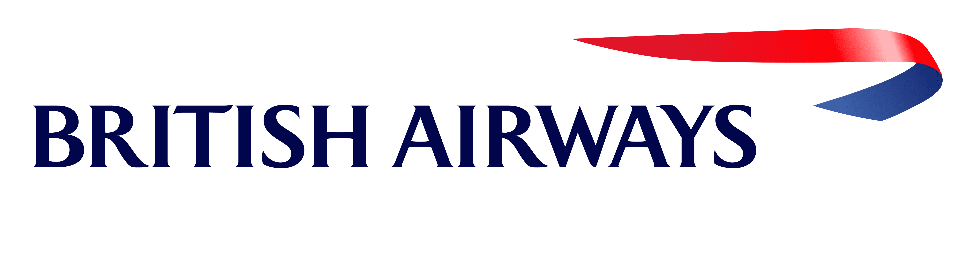

Student name: MD Saifur Rahman
Student Number: 2431872
Lecturer: Andry Rakotovololona
Word count: 5476
Submission Date: 22/12/2025

Table of Contents
1. Introduction 4
2. Background 5
3. British Airways’s Mission and Objectives 5
3.1 Mission Statement Analysis 5
3.2 Strategic Objectives (Short-term vs. Long-term) 6
4. Macro-Environment Analysis 7
4.1 Pestle Analysis 7
5. Micro-Environment Analysis 9
5.1 Industry Life Cycle 9
5.2 Porter’s Industry Five Forces Analysis 10
5.3 Critical Analysis of the Forces 11
6. Internal Analysis 12
6.1 British Airways’s Strategic Resources and Capabilities 12
6.2 Value Chain Analysis 13
6.3 VRIO Analysis of Distinctive Resources and Capabilities 15
6.4 SWOT Analysis 17
7. Strategies to Sustain Competitive Advantage 19
7.1 "Premium Mass Market" Strategy Analysis 20
8. Growth Strategies 21
8.1 Ansoff Matrix Application 21
8.2 International Strategy 22
9. Green Strategy and CSR 23
9.1 BA Better World Program 23
9.2 Investment in Sustainable Aviation Fuels (SAF) 23
9.3 Social Responsibility Initiatives 23
10. Conclusion 24
11. Recommendation 25
References 27
Appendix 30
Appendix 1: Summary of PESTEL Factors Affecting British Airways 30

1. Introduction
The present report is a strategic analysis of British Airways (BA), the flag carrier of the United Kingdom and one of the key subsidiaries of the International Airlines Group (IAG). The proposed research includes a critical analysis of the current operational and financial position of the airline based on the information regarding the 2023 and 2024 financial years. It seeks to unpack the manner in which British Airways is negotiating the complexities of the post-pandemic aviation environment with particular attention paid to its recovery path, operational resilience, and the strategic shift towards sustainability. The report evaluates the competitiveness of the airline in the international market and how it has managed to strike a balance between delivering premium services to its clients and the pressure of the current cost in the contemporary aviation industry.
Summary of Strategic Frameworks Applied to guarantee a rigorous and systematic assessment, this report is based on a set of established strategic management frameworks. The PESTEL framework is utilized to analyse the external macro-environment to determine the drivers of change in politics, economics, and social aspects, whereas the Five Forces analysis is used to determine the level of competitive rivalry and the appeal of the industry. On the internal front, the report applies the Value Chain Analysis and the VRIO framework and isolates the distinct resources and capabilities that the airline has including the Heathrow slot portfolio of the airline that forms the basis of its sustainable competitive advantage. It is this internal and external information that is translated into a SWOT analysis that underlies the analysis of how British Airways can strategize its future using Porters Generic Strategies and the Ansoff Matrix. The evidence-based recommendations will be the final part of the analysis intended to ensure the long-term development and market leadership of the airline.

2. Background
British Airways (BA) is a flag carrier of the United Kingdom and one of the oldest existing commercial airlines, which was founded in the early 20th century. BA is now a wholly owned subsidiary of International Airlines Group (IAG) and therefore enjoys shared financial resources, procurement economies of scale and access to alliance relationships throughout the group (International Airlines Group, 2024). It has its base in London Heathrow (LHR), which is one of the limited capacity airports in the world, and a secondary base in London Gatwick (LGW). This two-hub model allows BA to cater to both the high end long-haul and competitive short-haul markets (Kassem et al., 2023).
By 2024, BA had an average workforce of 37,401 employees, which indicates that the company continues to expand its workforce after a period of downsizing due to the pandemic (British Airways, 2025). The airline has also gone back to profitability and these are backed by the high demand in the transatlantic market, the increasing premium leisure bookings and operational recovery in the international markets (British Airways Plc., 2024). By placing itself as a mass-market premium carrier, BA can use its heritage brand equity, global network presence, and loyalty system to compete in the corporate travel sector as well as in leisure travel.

3. British Airways’s Mission and Objectives

3.1 Mission Statement Analysis
The mission of British Airways is stipulated by its motto which states that it has the responsibility of linking Britain and the world and vice versa. This is not just a logistic statement because the airline has become a cultural and economic ambassador of the UK. This mission has been supplemented over the last few years with the BA Better World sustainability programme that entails the integration of environmental responsibility into its primary mission (British Airways Plc., 2023). The mission statement is a sign of a twofold concern, providing a customer with a world-class, premium service and accepting the greater responsibility of the airline to society and the planet. The customer should be at the core of its operation, and by doing so, BA seeks to become the carrier of choice when people travel internationally and use its British heritage as a unique brand value in a very saturated global market (International Airlines Group, 2024).

3.2 Strategic Objectives (Short-term vs. Long-term)
The strategic direction of the airline is divided into short-term operations recovery and long-term sustainable development. A major strategic element at the moment is the presence of a £7 billion investment plan that is meant to modernize the digital estate and enhance customer experience (British Airways, 2025).
Table 2: British Airways Strategic Objectives
Horizon | Strategic Focus | Key Objectives
Short-Term (1-3 Years) | Operational Resilience and Experience | • Operational Excellence: Improve punctuality and reduce cancellation rates through better resource planning (Wong, 2022).  • Digital Transformation: Overhaul the ba.com website and mobile app to enhance user experience and personalization (British Airways, 2025).  • Customer Investment: Upgrade 600+ short-haul aircraft cabins and open new lounges (e.g., Miami, Dubai) to reinstate premium positioning (Yildiz et al., 2024).
Long-Term (5+ Years) | Sustainability and Innovation | • Net Zero 2050: Achieve net zero carbon emissions through the BA Better World initiative, including 10% Sustainable Aviation Fuel (SAF) usage by 2030 (International Airlines Group, 2025).  • Fleet Modernization: Complete the transition to next-generation aircraft (e.g., Boeing 777-9, continued A350 rollout) to lower fuel consumption by up to 20% (British Airways Plc., 2023).  • Digital-First Airline: Utilize AI and machine learning to predict operational disruptions and automate customer service solutions (Wong, 2022).
Source: (British Airways Plc.., 2024)

4. Macro-Environment Analysis
A dynamic interplay of geopolitical, economic and regulatory factors creates the macro-environmental landscape of British Airways (BA). To overcome this dynamic environment, the airline needs to keep checking external factors that affect its strategic positioning. This analysis of the external drivers is critically presented in the PESTEL framework below, with the assistance of the information of the 2023/2024 financial year.

4.1 Pestle Analysis
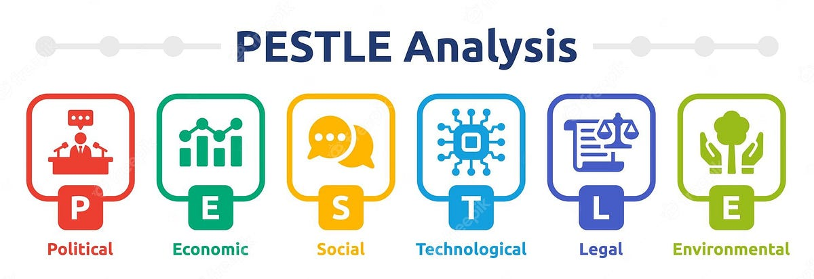
Figure 2: PESTLE Analysis Source: (Johnson et al., 2020)
Political Factors
The UK-based airlines are still experiencing a turbulent political climate in the post-Brexit period. The initial shock of exiting the EU has subsided although regulatory divergence has caused operational tension and increased compliance expenses. Another political trend was the fact that in 2023, a UK government decision to raise Air Passenger Duty on long-haul flights was heavily criticized by IAG as harmful to the UK global connectivity and competitiveness (Kassem et al., 2023). Also, the geopolitical instability is still a factor affecting the route networks (Albers and Rundshagen, 2020). The blockage of services to war-torn areas and the necessity not to fly over Russian airspace have decreased the efficiency of networks and raised the consumption of fuel because of longer routes. On the contrary, the intended abolition of aviation tax in Sweden in 2025 indicates a slight yet significant political change in favour of air connectivity but this is the exception and not the rule in Europe (Evans, 2024).
Economic Factors
The economic situation has changed into a continuous cost inflation instead of the growth of demand shocks in connection with the pandemic. Household income pressure during the 2023 cost-of-living crisis did not affect air travel demand, with premium leisure segments showing strong demand (International Airlines Group, 2024). But airlines are also experiencing increasing costs of operation which comprise of soaring airport fees and continuous volatility in fuel prices. Despite the fact that the fuel hedging strategy of IAG allowed stabilising the costs, fuel is the most important economic variable. The demand of corporate travel has been slower to recover than leisure and has necessitated Britain Airways to shift its economic model to focus less on frequent business travellers and more on higher yielding leisure travellers (Johnson et al., 2020).
Social Factors
Passenger demand is changing under the influence of social trends. The expansion of the leisure travel has changed the booking trends and use of the cabin and a growing number of older and wealthier travellers fits into the premium positioning of BA. Meanwhile, the rising level of environmental awareness has resulted in so-called flight shame, especially in younger consumers, which has caused a reputational pressure and impacted travel decisions (Graf-Vlachy, 2021).
Technological Factors
Efficiency and sustainability are all about technology. The digital transformation is a priority in the investment program of British Airways, which will involve using AI to enhance operational resiliency and punctuality. Sustainable Aviation Fuel is the best technological solution in the short term in propulsion, and it is backed by strategic partnerships with suppliers (Moore and Taylor, 2021).

Environmental Factors
The environmental policy is not turning out to be voluntary, but rather mandatory. The rising expenses of sustainability as a financial and ethical necessity are due to the expansion of emissions trading schemes and national decarbonisation policies (Bugayko and Ierkovska, 2021).
Legal Factors
The legal climate is becoming more and more restrictive. Legal and operational risks associated with capacity limits, slot control, consumer protection statutes and employment legislation are all persistent and especially in times of system-wide failure (Nkuda, 2019).

5. Micro-Environment Analysis

5.1 Industry Life Cycle
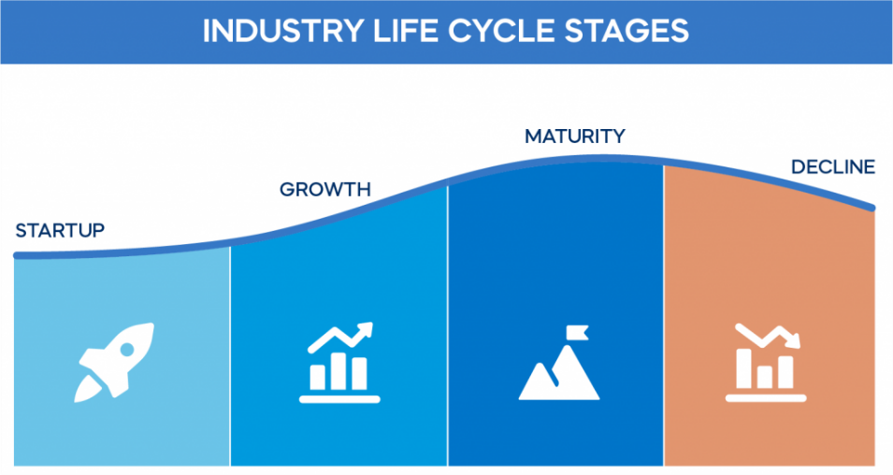
Figure 3: Industry Life Cycle Source: (Samunderu, 2019)
The contemporary airline sector in the world is in a complicated state, which is between the Maturity and the Renewal stage of the industry life cycle. Traditionally, the industry has the signs of maturity. The market saturation in the developed world (North America and Europe), the strong rivalry on prices, and the consolidation trend can be observed, which is demonstrated by the leading role of the big airline conglomerates, including IAG (the parent company of British Airways), Lufthansa Group, and Air France-KLM (Kassem et al., 2023). But the post-pandemic situation has set a unique phase of Renewal. It is marked by a change in the driving forces of demand, namely the increase in the number of premium leisure travel, as well as a technological revolution that is focused on decarbonisation and digitization (Santana et al., 2019). British Airways is proactively manoeuvring through this renewal by retiring inefficient four engine airplanes (such as the Boeing 747) in favour of two engine, fuel efficient aircrafts such as the Airbus A350, actually resetting its asset life cycle to mirror current efficiency standards and environmental regulations (Lauer, 2019).

5.2 Porter’s Industry Five Forces Analysis
To understand the competitive pressures British Airways faces, Porter’s Five Forces framework provides a critical lens on the intensity of competition and the airline's profitability potential.
Table 4: Summary of Porter’s Five Forces Impact on British Airways
Force | Intensity | Key Driver for British Airways
Threat of New Entrants | Low to Medium | High Barriers: Restricted slot availability at London Heathrow (LHR) creates a formidable "moat" against new competitors (Alanezi and Al-Zahrani, 2020).
Bargaining Power of Suppliers | High | Duopoly Control: Reliance on Airbus and Boeing for fleet, plus Rolls-Royce for engines, limits negotiation leverage on delivery timelines (Albers and Rundshagen, 2020).
Bargaining Power of Buyers | Medium to High | Fragmented yet Empowered: Corporate buyers have negotiating power; leisure travelers are price-sensitive but increasingly demand value-added experience (Lynch, 2021).
Threat of Substitutes | Medium | Modal Shift: High-speed rail (Eurostar) competes on short-haul; video conferencing technologies (Zoom/Teams) permanently replace some business travel (Taylor et al., 2019).
Competitive Rivalry | High | Market Saturation: Intense price wars with Low-Cost Carriers (LCCs) in Europe and service battles with legacy carriers on transatlantic routes (Lauer, 2019).
Source: (Lynch, 2021)

5.3 Critical Analysis of the Forces
The structural threat of new entrants is low because of the capacity of the airports. British Airways manages a dominant proportion of Heathrow slots, and as the airport is functioning at close to full capacity, it is highly challenging to have competitors build a meaningful hub presence (Yang et al., 2022). There are also new niche or virtual carriers that can be formed, which is not disruptive due to the scale.
Supplier bargaining power on the other hand is high. BA has a strong dependence on the limited number of aircraft and engine producers, which implies that any delay or performance problems directly limit fleet management and revenue generation (Evans, 2024). Cases such as Boeing 777-9 delays and the Trent engine reliability are examples that reveal its susceptibility to the disruption of the supply chain (Button, 2020).
The buyer power has risen since the pandemic. Business customers have been comparing the need to travel with online alternatives and this lowers BA pricing power (Teece, 2019). Competition is heightened by low switching costs of leisure passengers. The loyalty programmes and revenue management by BA aim at reducing defection.
Substitute threat is also not even. The high-speed rail is an efficient replacement of short-haul flights, and video communication has structurally decreased the need to make one-day business trips (Samunderu, 2019).
The intensity of competitive rivalry is high. LCCs in Europe have been putting pressure on the cost of BA, which has led to the development of BA Euroflyer to compete more effectively (Nkuda, 2019). Joint ventures on long-haul routes reduce competition, but intense competition by Virgin Atlantic and Gulf airlines necessitates investment in premium products to maintain its position (Moore and Taylor, 2021).

6. Internal Analysis

6.1 British Airways’s Strategic Resources and Capabilities
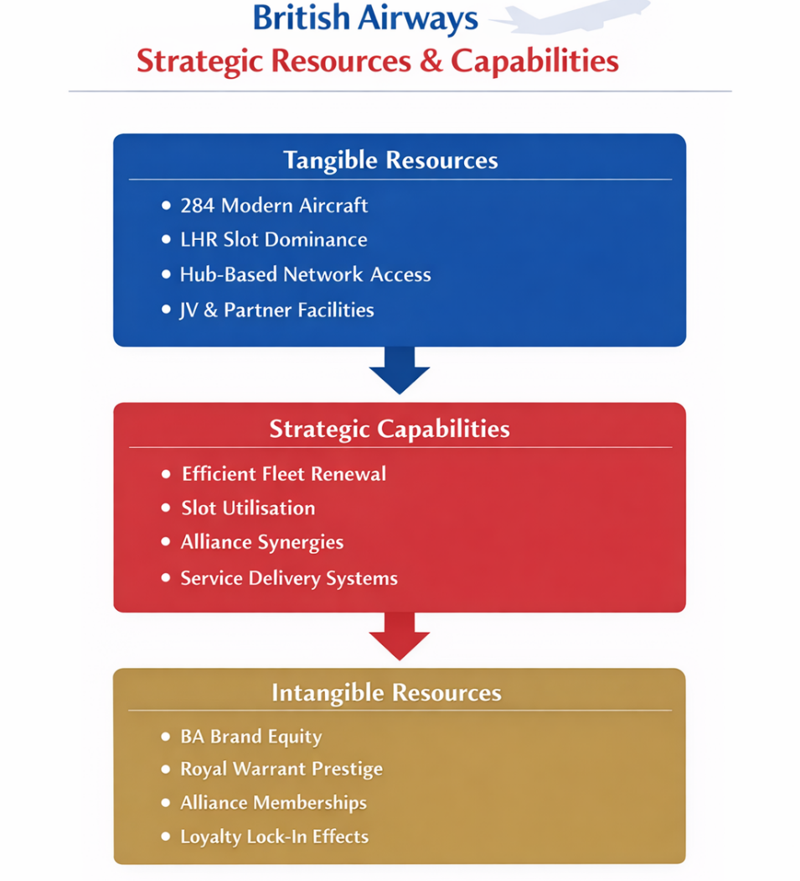
Figure 4: BA’s Strategic Resources and Capabilities (International Airlines Group, 2025)
A. Tangible Resources (Strategic)
British Airways has a great deal of tangible resources, which support its competitive stance. Its fleet power comprises 284 aircrafts as of December 2023, comprising of the latest fuel-efficient Airbus A350-1000 and Boeing 787-10 aircrafts that promote operational efficiency and environmental performance (Graf-Vlachy, 2021). The airline has grandfathered slot rights at London Heathrow Airport, limiting over half of all slots there, giving it a privileged entry to the most profitable UK aviation market and limiting the growth of its competitors (Bugayko & Ierkovska, 2021). The physical resource base of BA is enhanced by the global hub and spoke network that is based at LHR and LGW and thus connects major business and holiday routes. Also, network efficiency and capacity utilisation is augmented by joint physical access to partner airline facilities by alliance participation.
B. Intangible Resources (Strategic)
BA also possesses good intangible resource strengths based on its long history and high-quality brand name. Brand equity is built over the course of over a century of operation, which allows the airline to be linked with the attributes of reliability and quality service delivery (Yang et al., 2022). Its British Original branding and Royal Warrant help to strengthen the national identity and reinforce the premium positioning of the market. Moreover, the presence of the one world alliance and the transatlantic Joint Business Agreement with American Airlines is a source of further intangible value because it allows more profound cooperation, mutual schedules, and connectivity into key international markets (Scheiwiller and Zizka, 2021). Such customer lock-in relationships are sustained by compounded customer loyalty programmes, protracted elite status benefits, and reciprocity services.
C. Capabilities
The strategic capabilities of BA are based on the good utilization of its resources and collaborations. The airline has a high potential to utilize alliance and joint venture to increase route network and to improve connectivity beyond services operated by them. Its experience in fleet management aids a long-term programme of efficiency enhancement and reduction of emissions by technological enhancements and aircraft replacement. Efficiency in the use of airport slot holdings helps in market protection, optimisation of departure as well as better scheduling performance. Also, the customer relationship management features are reinforced by the incorporation of the loyalty systems in the partner airlines, and the repeat patronage of the high-value customer segments by the service consistency and earned benefits.

6.2 Value Chain Analysis
British Airways’ value chain reveals strengths in centralised procurement, loyalty-driven marketing, and hub-based operations that support premium pricing and network efficiencies. However, punctuality challenges, labour rigidity, and legacy IT systems weaken operational reliability and increase costs, reducing the sustainability of its competitive advantage. Continuous digital investment is needed to enhance performance across primary and support activities.
Table: Value Chain Analysis of British Airways
Value Chain Activity | Key Practices | Strategic Implications | Sources
Primary Activities
Inbound Logistics | Centralised fuel hedging; coordinated crew planning | Reduces cost volatility; improves resource reliability | (Wong, 2022)
Operations | Hub-and-spoke at LHR/LGW; maintenance; safety; punctuality issues | Supports premium connectivity but increases disruption exposure | (Wong, 2022)
Outbound Logistics | Revenue management; direct digital sales | Improves yields; lowers distribution costs | (Wong, 2022)
Marketing & Sales | Avios loyalty; premium cabin/brand offerings | Raises switching costs; strengthens differentiation | (Yildiz et al., 2024)
Service | Service recovery; digital self-service | Protects brand credibility during disruption | (Yildiz et al., 2024)
Support Activities
Infrastructure | Shared IAG governance and services | Enables scale efficiencies; supports compliance | (Yildiz et al., 2024)
HR Management | Crew training; labour relations | Builds service capability but risks inflexibility | (Yildiz et al., 2024)
Technology | IT/AI upgrades and platforms | Enhances punctuality and operational resilience | (Yildiz et al., 2024)
Procurement | Group-wide purchasing | Secures economies of scale | (Yildiz et al., 2024)
Source: (Yildiz et al., 2024; Wong, 2022)
The brief value chain shows that competitive strength of British Airways is primarily based on network efficiencies, differentiation through loyalty and procurement benefits on the group level in IAG. Centralised buying, online distribution and maximisation of revenues help in keeping the costs under control and increasing the yields, which supports the premium positioning of BA (Wong, 2022). Nevertheless, the weaknesses of operations are also a constant factor: the constraints of outdated IT, time constraints and inflexibility of labour hinder the flexibility and threat the expectations of high-quality service. These drawbacks are enhanced by the fact that BA relies on the overcrowded infrastructure of Heathrow, which makes it vulnerable to disruption. The development of workforce capability and modernisation of technology is hence important in the maximisation of full value creation potential along the chain (Yildiz et al., 2024). Unless BA makes structural changes to improve punctuality and consistency of services, it will lose the sustainability of its differentiation advantage despite its high brand equity and loyalty platforms.

6.3 VRIO Analysis of Distinctive Resources and Capabilities
The VRIO framework evaluates whether British Airways' resources are Valuable, Rare, Inimitable, and Organized to capture value, determining the sustainability of its competitive advantage (Harvey and Turnbull, 2020).
Table 5: VRIO Analysis of British Airways
Resource / Capability | Valuable? | Rare? | Inimitable? | Organized? | Competitive Consequence
Heathrow Slot Portfolio | Yes | Yes | Yes | Yes | Sustained Competitive Advantage
Brand Heritage & Reputation | Yes | Yes | Partially | Yes | Sustained Competitive Advantage
Alliance/JBA Network Synergies | Yes | No | No | Yes | Temporary/Parity Advantage
Fleet Renewal & Efficiency (A350/787) | Yes | No | No | Yes | Competitive Parity
Loyalty & Customer Lock-In (Avios) | Yes | No | Partially | Yes | Temporary Advantage
Source: (Johnson et al., 2020)
According to the VRIO analysis, the two resources that can be followed as the sustained competitive advantages are only the Heathrow slot dominance and the long-term brand heritage (Johnson et al., 2020). They both have the barriers of rarity and imitation: Heathrow slots are structurally limited, and legally safeguarded and heritage brand trust is decades old and a socially convoluted concept to imitate. Other capabilities provide value but are not rare or inimitable, which restricts strategic defensibility (Scheiwiller and Zizka, 2021). Only parity benefits are gained via fleet modernisation and joint ventures since other carriers in the industry are able to obtain similar aircraft technology and alliances. The Avios loyalty platform enhances customer stickiness but is losing its rarity as other competing alliances launch similar loyalty systems. BA thus has a very small range of unique strengths, which amplify its vulnerability in case regulatory, operational or reputational incidents undermine Heathrow or brand equity (Bugayko and Ierkovska, 2021). To maintain long term benefit, BA needs to transform additional short term benefits, especially digital and loyalty and operational resiliency capabilities, into more difficult to copy systemwide capabilities.

6.4 SWOT Analysis
SWOT analysis evaluates strategic position of a company by looking at internal strengths that help it to be more competitive, weaknesses which restrict performance, external opportunities to grow and threat posed by the market forces. It aids in decision making by ensuring that capabilities are connected to the environmental pressures to inform strategic decisions and the prioritisation of resources to generate sustainable competitive advantage (Porter, 2008).
Table: British Airways SWOT Analysis
Strengths (Internal) | Weaknesses (Internal)
Strong financial resilience within IAG – £1,431m operating profit, 10% margin (British Airways Plc., 2024) | Low punctuality (58% in 2023) harming corporate travel reliability (British Airways Plc., 2024)
Leading market share on profitable North Atlantic routes (Harvey & Turnbull, 2020) | Legacy IT systems cause outages and operational disruption (International Airlines Group, 2024)
High-margin loyalty ecosystem via Executive Club/Avios (British Airways, 2025) | Inconsistent service from newly hired post-pandemic staff (British Airways Plc., 2023)
Strong premium brand equity and flag-carrier identity (British Airways, 2025) | High Heathrow-based cost structure reduces price competitiveness vs LCCs (Yildiz et al., 2024)
Opportunities (External) | Threats (External)
£7bn digital transformation enables AI efficiency gains and IT modernisation | Macroeconomic volatility reduces premium demand
SAF leadership potential through Project Speedbird (Moore & Taylor, 2021) | Intense competition: LCCs in EU and Gulf carriers in long-haul
Growth in premium leisure travel demand | Increasing environmental taxes and capacity restrictions (British Airways Plc., 2024)
Network re-entry into Asian markets (Albers & Rundshagen, 2020) | Supply chain fragility and aircraft delivery delays (International Airlines Group, 2024)
Source: (British Airways Plc.., 2024)
British Airways has good internal strategic resources, financial strength in IAG, transatlantic market strength, profitable loyalty program, and high brand equity. The same strengths are however undermined by the continued operational vagaries, old IT systems and high legacy costs, which limit competitiveness with low-cost airlines (Lauer, 2019). Outside, there exist plausible opportunities in the digital transformation, SAF leadership, and premium leisure growth, although there are macroeconomic volatility, tightening regulation, and increasing competition as threats to margins and capacity growth. All in all, the SWOT indicates that the competitive advantage of the BA is at a risk unless operational reliability and technological capabilities are enhanced to transform financial and brand strength into a sustainable performance (Button, 2020).

7. Strategies to Sustain Competitive Advantage
The core strategy of British Airways is Differentiation because it implies providing customers with distinctive service qualities that can could be charged a higher price (Lauer, 2019). The connectivity through global networks, Heathrow hub, high standards of premium services, multi-class cabins, loyalty benefits due to Avios and alliances synergies in oneworld support differentiation. These characteristics help BA to reap more benefits out of corporate travellers that value reliability, frequency and international coverage above lowest fare options (Porter, 2008).
Nonetheless, the increasing competitive intensity, especially of European LCCs and premium Gulf carriers, poses strategic threat of being stuck in-between that does not lead to cost leadership or total exclusivity (Porter, 2008). To help allay this, BA is increasingly using some aspects of Cost Focus in short-haul Europe, undressing services like free catering in order to compete based on price. This mixed strategy is a manifestation of the desire to maintain the high brand equity and, at the same time, eliminate its structural high-cost base to maintain the margins (Barney, 1991).
Table 7: Application of Porter’s Generic Strategies to British Airways
Strategy Dimension | Evidence in British Airways Operations
Differentiation (Core Strategy) | Product Innovation: Investment in "Club Suite" with privacy doors to match luxury standards.  Network Dominance: Exclusive use of LHR Terminal 5 and "Air Bridge" frequency to New York.  Brand Equity: "British Original" campaign emphasizing heritage and service culture (Wong, 2022).
Cost Focus (Tactical Strategy) | Operational Efficiency: Launch of BA Euroflyer at Gatwick with a lower cost base to compete with EasyJet.  Unbundling: Introduction of "Economy Basic" fares (hand baggage only) to capture price-sensitive demand.  Densification: Increasing seat counts on short-haul aircraft to lower cost-per-seat (British Airways Plc., 2023).
(Source: Analysis based on British Airways Plc., 2023)
British Airways integrates differentiation and selective focus of cost. The advantages of the premium products, a robust branding, and Heathrow network serve to sustain high yields, whereas the cost-oriented strategies, such as BA Euroflyer, unbundling, and seat densification, can be used to protect the share of the short-haul market. Such a blend is a premium positioning but cost pressure approach that may lead to inconsistency in the services provided to the different segments (British Airways Plc., 2023).

7.1 "Premium Mass Market" Strategy Analysis
The "Premium Mass Market" approach is the effort of British Airways to combine both the volume and the value. The strategy operates on the principle of front of the plane (First and Club World) to produce most of the profitability with the operating costs being made up by the back of the plane (World Traveller) through high load factors. This volume-based strategy is confirmed by the 2023 financial performance with the passenger load factor of 83.6% (British Airways, 2025). The premium mass carrier strategy allows BA to cater to the high-end of the mass market, known as the masstige segment: consumers who are not very rich, but can afford a small premium on top of low-cost airlines to perceive themselves as reliable and enjoy the benefits of premium slot times and the safety of a legacy carrier (Porter, 2008).
The flexibility of the fleet of the airline supports this strategy operationally. Large-premium cabins are fitted to wide-body aircrafts such as the Boeing 777-300ER to generate high-yield revenue, where more dense arrangements on leisure flights (e.g., Gatwick to Orlando) are more focused on volume (Harvey and Turnbull, 2020). This strategy will be successful provided that the airline can provide the economy passengers with a consistent experience of the premium quality. Emerging expenditure on free snacks (water and pretzels) and enhanced Wi-Fi are planned maneuvers to regain the premium distinction between BA and low-cost competitors, where the mass market customer is left believing that he/she is getting a better product at the added cost (Johnson et al., 2020).

8. Growth Strategies

8.1 Ansoff Matrix Application

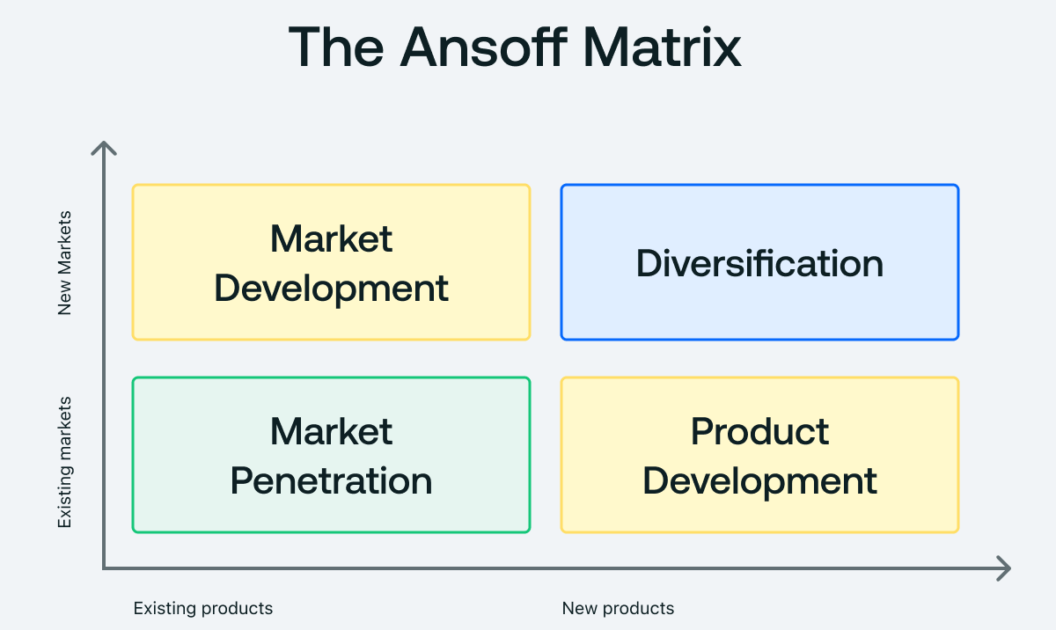
Figure 6: Ansoff Matrix Source: (Scheiwiller and Zizka, 2021)
The development strategy of British Airways can most effectively be evaluated in terms of Ansoff Matrix, where the primary focus of the development strategy is made on the Market Penetration and Product Development (Bugayko and Ierkovska, 2021). Market Penetration is still the primary growth driver of the airline as the focus is to gain additional value out of the current markets (e.g., North America and Europe). This can be understood in the strategy of densification of the London-New York route, the first billion-dollar route in the world and in which BA maximizes its frequency to gain market share in the corporate arena. At the same time, the airline is also vigorously seeking Product Development in an attempt to distinguish its offering in the crowded markets (Graf-Vlachy, 2021). A good example is the implementation of the new long-haul fleet of the new product, the Club Suite business class. With the current aircraft retrofitted to feature this privacy-oriented cabin, BA will target to upsell current customers to higher yield buckets to essentially increase revenue without necessarily increasing the route network (Moore and Taylor, 2021).

8.2 International Strategy
In the international strategy, British Airways uses Strategic Alliances as a multiplier of force. BA instead of making capital-intensive and risky expansion efforts depends on its own membership in the oneworld alliance, and Joint Business Agreements (JBAs). The Transatlantic JBA involving American Airlines, Finnair and Iberia form the basis of this strategy (Button, 2020). It enables the partners to share income and organize the flights on the North Atlantic routes and essentially act as one unit. This virtual merger allows BA provide a seamless connectivity to more than 200 destinations in the US beyond its own gateways that outsmarts the network advantage of the US competitors such as the Delta or the United (Lynch, 2021).

9. Green Strategy and CSR

9.1 BA Better World Program
The British Airways has also consolidated its environmental and social activities under the name, BA Better World, which is a move towards a shift towards a compliance mode of CSR to a proactive approach of sustainability strategy (Kassem et al., 2023). The Net Zero 2050 roadmap, which is a legally binding pledge to reduce net carbon emissions to none by mid-century, is the centerpiece. This is not just a dream; it is also implemented by interim goals, including the 10 percent net carbon emissions by 2030 when compared with those of 2019. The roadmap is strongly based on the renewal of the fleet, and the retirement of the fuel-guzzling Boeing 747 fleet in the course of the pandemic acted as a booster of the rapid efficiency increase (Santana et al., 2019).

9.2 Investment in Sustainable Aviation Fuels (SAF)
The Sustainable Aviation Fuels (SAF) investment is the most important lever in this green strategy. Understanding that electric propulsion cannot be employed to support the long-distance flight, BA has set a goal to use 10 percent of its flights with SAF by 2030. To implement this, the airline has signed a strategic partnership with LanzaJet in the form of Project Speedbird to establish the first commercial scale SAF facility in the UK. The aim of this vertical integration into the fuel supply chain is to obtain a limited resource that will become critical in future license to operate (Lauer, 2019).

9.3 Social Responsibility Initiatives
In the social front, BA is determined to address diversity, equity and inclusion (DEandI) as a business imperative. The airline has established goals of having more women in the pilot positions and top management. Moreover, the resources are directed to local projects through the "BA Better World Community Fund" which strengthens the license to operate of the airline as it shows that it does not only provide connections to the community but also real value (Samunderu, 2019).

10. Conclusion
The British Airways strategic analysis demonstrates that it is a strong legacy carrier that managed to overcome the post-pandemic recovery and re-establish profitability. Among the major results, it should be noted that the airline boasts of strong competitive advantages, namely its Heathrow slot control and good transatlantic network, but is weak in operational vulnerability and high-cost pressures. The financial aspect of the Premium Mass Market strategy is working well with the operating profit of £1.4bn in 2023, although the gap between its premium branding and uneven service delivery is a long-term reputational risk. Finally, the British Airways can leverage a good strategic position to take advantage of the industry life cycle at the stage of renewal, however, it has to effectively implement its £7bn investment in digital transformation and operational resilience. The competitive advantage of the airline in the future will not rely so much on its historic heritage but rather the capacity to operationalize sustainability and seamlessly incorporate the use of technology in the customer journey.

11. Recommendation
Recommendation 1: Focus on Digital and Operational Transformation.
Short-Term Impact
The operational control upgrades and legacy IT should be prioritised to stabilise the operational platform of BA, minimising the number and severity of disruption of the systems affecting punctuality and customer satisfaction (International Airlines Group, 2024). On-time performance will be essential in safeguarding high-yield corporate traffic, which is highly time sensitive and, hence, more sensitive to service reliability (British Airways Plc., 2024).
Long-Term Impact
Disruption management, predictive maintenance and automation, which are facilitated by AI, can reduce operating cost, increase aircraft utilisation rates, and build resilience against systemic disruptions and bring BA nearer to operational excellence benchmarks (Wong, 2022). Capacity growth in limited hub settings would be supported by the capacity to reduce cancellations and operating delays.
Limitations and Mitigation
Digital transformation involves disruption risks of transition and high intensity of capital. The instability will be minimised through a staged implementation strategy aided by change management programmes and shadow systems during the migration to enable the employees to be familiar with new processes.
Recommendation 2: Commercialise Sustainability Leadership within the Corporate Segment.
Short-Term Impact
BA would need to turn decarbonisation initiatives and SAF acquisition into sellable corporate products. Premium pricing can be justified by introducing the Green Corporate Tiers with the help of Science Based Targets verification, which would allow firms with growing requirements to disclose the Scope 3 emissions (Moore and Taylor, 2021).
Long-Term Impact
The differentiation and regulatory compliance of SAF partnerships are enhanced by first-mover advantage, which makes it more expensive to travel in a carbon-intensive way as the European ETS growth and the rise in APD rates make it harder. This creates long term strategic insulation as compared to the cost-oriented rivals.
Limitations and Mitigation
The scarcity of SAF poses the risk of supply and price fluctuation. BA needs to enter into long-term supply contracts, capitalize on the government subsidies as well as partnering with IAG group carriers to achieve economies of scale.
Recommendation 3: Enhance European Short-Haul Service Experience.
Short-Term Impact
The negative perception of passengers can be overcome by selective upgrades to onboard service and consistency, to reconcile the product experience with the expectations of a premium brand (British Airways Plc., 2023).
Long-Term Impact
This increase in the quality of soft products will support brand equity and counter the erosion of the competitive advantage of LCCs that target short-haul markets of BA (Yildiz et al., 2024).
Limitations and Mitigation
The margins will be eroded because of added service costs; BA must implement business-critical route enhancements and use data-based pricing strategies in order to maintain profitability.

References
Alanezi, F., and Al-Zahrani, R. (2020, January). Strategic management of Emirates Airlines. In Proceedings of the 2020 2nd Asia Pacific Information Technology Conference (pp. 172-177).
Albers, S., and Rundshagen, V. (2020). European airlines′ strategic responses to the COVID-19 pandemic (January-May, 2020). Journal of air transport management, 87, 101863.
Barney, J. B. (1991). Firm resources and sustained competitive advantage. Journal of Management, 17(1), 99–120.
British Airways Plc. (2023). Annual Report and Accounts: Year ended 31 December 2022. https://www.iairgroup.com/media/v32fsxl4/british-airways-annual-report-and-accounts-2022.pdf
British Airways Plc. (2024). Annual Report and Accounts: Year ended 31 December 2023. https://www.iairgroup.com/media/2h0hgqdq/british-airways-annual-report-and-accounts-2023.pdf
British Airways. (2025). Factsheet: Investing in our customer experience. British Airways Media Centre. https://mediacentre.britishairways.com
Bugayko, D., and Ierkovska, Y. (2021). Institutional measures of air transport safety strategic management at the level of state regulation. Electronic scientific and practical publication in economic sciences, 6.
Bugayko, D., and Ierkovska, Y. (2021). Institutional measures of air transport safety strategic management at the level of state regulation. Electronic scientific and practical publication in economic sciences, 6.
Button, K. (2020). Interactions of global competition, airlines strategic alliances and air traffic safety. In Aviation Safety, Human Factors-System Engineering-Flight Operations-Economics-Strategies-Management (pp. 525-544). CRC Press.
Evans, N. G. (2024). Strategic management for tourism, hospitality and events. Routledge.
Graf-Vlachy, L. (2021). Competitive irrationality: When being better is a bad strategy. Rutgers Business Review, 6(1), 37-43.
Harvey, G., and Turnbull, P. (2020). Human resource management and industrial relations. In Air Transport Management (pp. 327-340). Routledge.
International Airlines Group (IAG). (2025). Annual Report and Accounts 2024. https://www.iairgroup.com/investors-and-shareholders/financial-reporting/annual-reports/
International Airlines Group. (2024). Our strategy and business model. Retrieved December 18, 2025, from https://www.iairgroup.com/en/our-group/our-strategy
Johnson, G., Whittington, R., Regnér, P., Angwin, D., and Scholes, K. (2020). Exploring strategy: Text and cases (12th ed.). Pearson.
Kassem, R., Salama, A., and Ganepola, C. N. (2023). CSR, credibility, employees' rights and legitimacy during a crisis: a critical analysis of British Airways, WizAir and EasyJet cases. Employee Relations: The International Journal, 45(1), 1-20.
Lauer, T. (2019). Generic Strategies, Outpacing and Blue Ocean–Discussing the Validity of Three Strategic Management Theories Using Case Studies from Airlines and Grocery Retail. Theory, Methodology, Practice–Review of Business and Management, 15(01), 57-66.
Lynch, R. (2021). Strategic management. Sage.
Moore, S., and Taylor, P. (2021). Class reimagined? Intersectionality and industrial action–The British Airways dispute of 2009–2011. Sociology, 55(3), 582-599.
Nkuda, M. O. (2019). Case methodology as a pivot of strategic management. Current Perspective to Economics and Management, 2, 39-59.
Porter, M. E. (2008). The five competitive forces that shape strategy. Harvard Business Review, 86(1), 78–93.
Samunderu, E. (2019). Air transport management: Strategic management in the airline industry. Kogan Page Publishers.
Santana, M., Valle, R., and Galan, J. L. (2019). How national institutions limit turnaround strategies and human resource management: A comparative study in the airline industry. European Management Review, 16(4), 923-935.
Scheiwiller, S., and Zizka, L. (2021). Strategic responses by European airlines to the Covid-19 pandemic: A soft landing or a turbulent ride?. Journal of air transport management, 95, 102103.
Taylor, P., Moore, S., and Byford, R. (2019). Cabin Crew Conflict: The British Airways Dispute 2009-11. Pluto Books.
Teece, D. J. (2019). A capability theory of the firm: an economics and (strategic) management perspective. New zealand economic papers, 53(1), 1-43.
Wong, J. D. (2022). Flexible Corporate Nationality: Transforming Cathay Pacific for the Shifting Geopolitics of Hong Kong in the Closing Decades of British Colonial Rule. Enterprise and Society, 23(2), 445-477.
Yang, H. H., Chang, Y. H., and Lin, C. H. (2022). A combined approach for selecting drone management strategies based on the ICAO Safety Management System (SMS) components. Journal of Air Transport Management, 104, 102257.
Yildiz, F., Dayi, F., Yucel, M., and Cilesiz, A. (2024). The impact of ESG criteria on firm value: A strategic analysis of the airline industry. Sustainability, 16(19), 8300.

Appendix

Appendix 1: Summary of PESTEL Factors Affecting British Airways
PESTEL Category | Key Factors (summarised) | Impact on BA | Sources
Political | • Post-Brexit regulatory divergence• UK Air Passenger Duty rise for long-haul (2024)• Restricted access to Russian airspace and conflict zones• Sweden’s proposed aviation tax abolition (2025) | • Higher compliance and operating costs• Reduced route efficiency & longer flight times• Pressure on UK competitiveness | (Barney, 1991; Johnson et al., 2020)
Economic | • Post-pandemic inflationary pressure• Resilient premium leisure demand despite cost-of-living crisis• Rising fuel price volatility & airport charges• Slower corporate travel rebound | • Higher cost base that requires hedging• Strategic shift toward leisure focus | (Barney, 1991; Johnson et al., 2020)
Social | • Growth in premium leisure/bleisure travel• Aging affluent traveler demographic• Increasing climate-driven flight shame among younger consumers | • Premium market opportunity• Reputational pressure & changing demand patterns | (Graf-Vlachy, 2021)
Technological | • Digital transformation priority• Use of AI for operational resilience and punctuality• Strategic adoption of Sustainable Aviation Fuel | • Efficiency, sustainability benefits, improved reliability | (Moore & Taylor, 2021)
Environmental | • Mandatory compliance with emissions schemes• National decarbonisation and sustainability policies | • Higher sustainability-related operational costs | (Bugayko & Ierkovska, 2021)
Legal | • Capacity limits and slot constraints• Consumer protection regulation• Employment legislation liabilities | • Increased regulatory risk exposure operationally and financially | (Nkuda, 2019)

