
DATA HANDLING AND BUSINESS INTELLIGENCE

ASSESSMENT 2
MODULE CODE: LCBB5000
STUDENT NAME: ELENA ALINA GRIGORAS
STUDENT ID: 2112864
LECTURER NAME: DR XAVIER MATIENI

TABLE OF CONTENTS

PART I: HOTEL RESERVATION DATA SET ANALYSIS 3
1. Introduction 3
2. Data Pre-processing with Microsoft Excel 3
3. Analysing the Data with the Average if Formula 4
4. Analysing the Data with Pivot Table 5
5. Visualising Trends with Chart 6
6. Conclusion 7
PART II: SCHOOL SURVEY 9
1. Gender analysis of students 9
2. Number of students who have been and not been qualified for reduced or free lunch 10
3. Mean and median of the number of students eligible and not eligible for reduced or free lunch 11
4. Mean and median differences of students' pre-test and post-test scores 12
5. K-Means Clustering 12
6. Data mining and text mining techniques 13
7. Advantages and disadvantages of using SPSS and Excel for data analysis 14
REFERENCES 16

PART I: HOTEL RESERVATION DATA SET ANALYSIS

1. INTRODUCTION
As the hotel industry is continuously evolving, it is equally important for travellers and hoteliers to understand hotel booking pricing trends. This data analysis project focused on performing statistical tests and analysing this statistical data from the provided hotel booking dataset available in the module in order to understand the variation in average room booking prices for the period 2017-2021. As a data analysis task, the main purpose of this report is to process, analyse and visualize data free of charge using the powerful tools of Microsoft Excel to assess valuable information that can help drive an informed decision-making process. The record contains important information such as reservation status, reservation date and average price of a room reservation. Using Microsoft Excel functionality, a learner can perform a comprehensive analysis looking at changes and patterns in average prices over a given five-year period. Efficient data pre-processing requires the use of Excel's multifunctional features such as if and lookup options for cleaning, classifying and organizing data sets. A pivot table is also used to summarize and group the data by year to briefly describe the average room booking rate for each year. The report also includes meaningful charts and graphs that visually represent the observed changes in hotel booking prices.

2. DATA PRE-PROCESSING WITH MICROSOFT EXCEL
The key stage of data analysis was seen as the pre-processing phase, which entailed a cleaning, conversion and organisation of unprocessed data in order that it could be analysed further. As a powerful platform for pre-processing data, Microsoft Excel's wide range of functions and features is enabling learners to get the most out of it. Several key steps to ensure accurate data consistency have been taken at the Data Pre-processing stage of hotel reservation datasheets in that context (Guerrero et al. 2019).
- The first step in data processing was cleaning and formatting the data. This is built into the handling of missing and untagged corrected data types to ensure consistency across data sets. The dataset has several categorical variables, such as Room types, reservations, meal plans, market types, availability and many more. I used the If function to create a new column with a numeric field and a level representing each category. This process allowed the datasheet to transform the categorical data into a format suitable for further analysis. Depending on the analytical purpose, data transformation was also performed and new functions were developed based on existing data. For example, total nights are calculated by adding weekend nights and nights using the Sum function in Excel.
- Focusing on the data relevant to the analysis, the data was filtered to create subsets of the dataset based on certain criteria. We propose that the filtering and sorting capabilities of Excel were used to narrow down the data to the desired time period (eg 2017 to 2021) (Kuriakose, 2023).

3. ANALYSING THE DATA WITH THE AVERAGE IF FORMULA
The learner has used the usual formula “Average if” to find the average price of hotel reservations over a 5-year period from the dataset. The Average if the function has been described as a powerful Microsoft Excel tool that allows users to re-condition and provide valuable insight into price movements within a dataset. Evaluate the average room booking price for each year using the "average if" formula.
- Two columns are used in the same worksheet, one with year headings and the other with average prices.
- Next, write the five years from 2017 to 2018 in the year column, five lines each.
- Then the corresponding formula was entered in the cell to the right of each cell. The formula is "=AVERAGEIFS(Average price range, Arrival year range, Each year)". For example, the average price of hotel rooms in 2017 was determined by "=AVERAGEIFS(Q:Q, J:J, 2017)" (Becker and Gould, 2019).
Year | Average price
2017 | 90.04985
2018 | 106.4527
2019 | 101.7813
2020 | 105.3399
2021 | 101.2333
2022 | 101.4992
Table 1: Obtained data after applying the Average if formula
(Source: Developed by author)
Data represent average room booking prices from 2017 to 2022. Values ​​indicate the average price per reservation for each year. The average price increased significantly from 2017 to 2018 and slightly decreased in 2019. Meanwhile, average prices rose slightly in 2020 but fell again in 2021. Overall, the data show that average hotel room prices are fluctuating between 2017 and 2021, reflecting potential shifts in demand and market trends (Njeru et al. 2020).

4. ANALYSING THE DATA WITH PIVOT TABLE
Analysing data using pivot tables in Microsoft Excel provides a powerful and efficient way to extract valuable insights from complex data sets. A pivot table can be thought of as a data summarization tool that helps users organise groups and calculate data based on specific dimensions and measures. Hotel booking data allows users to use pivot tables to explore trends and patterns in average room booking prices from 2017 to 2021 (Schmuller, 2021).
AVERAGE OF AVERAGE PRICE

Arrival year | Total
2017 | 90.0498541
2018 | 106.4527274
2019 | 101.7812994
2020 | 105.339899
2021 | 101.2333333
2022 | 101.499242
Grand Total | 103.4235391
Table 2: Pivot Table
(Source: Developed by Author)
Working on the provided data set has been representing average room booking prices over a six-year period from 2017 to 2022. This table has mainly focused on the average of the Average Price column, which has been representing the mean room reservation price for that year. In addition, the Year of Arrival column has been listed each year and the Total column has been showing the calculated average price for each year (Guerrero et al. 2019).
A 2017 analysis represented that the average room booking price can be calculated as £90.05, that has been representing a percentage of all room booking prices for that year. The data has also been showing that despite the challenges caused by the global pandemic this year, the hospital industry has greater possibilities to be adapting to changing conditions that have resulted in higher prices. However, the average room booking price for 2021 is estimated at 101,235 indicating a price drop. As the dataset was originally intended to cover through 2021, this entry is a projection or partial data update and needs to be considered carefully when drawing conclusions. Overall, the total average price of all computers over the 6-year baseline was estimated at 103.42. This figure provides a comprehensive overview of the average room booking prices for all years analysed in the dataset (Kuriakose, 2023).

5. VISUALISING TRENDS WITH CHART
Line charts in Excel are used to represent data points connected by straight lines, making it easier to see patterns and chains. This type of chart is often used to visualise time series data and show changes over successive intervals. Line charts are also considered ideal for comparing data points, visualizing changes and identifying fluctuations in data. Therefore, we used a line chart to show the change in the average hotel booking price over six time periods from 2017 to 2022 (Becker and Gould, 2019).
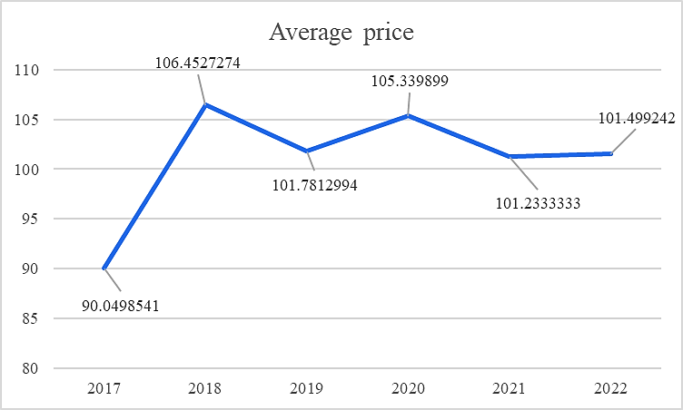
Figure 1: Line chart showing average room prices from 2017 to 2022
(Source: Developed by author)
In the line chart above showing average room rates from 2017 to 2022, it can be observed that the data provides insight into average room booking rates over the period, reveals changes in representations and shows trends in the hotel industry over the period (Njeru et al. 2020).

6. CONCLUSION
It can be concluded from the above discussion that this report has helped in providing an opportunity to process, analyse and visualize data free of charge using the powerful tools of Microsoft Excel to assess valuable information that can help drive an informed decision-making process. The key stage of data analysis was seen as the pre-processing phase, which entailed a cleaning, conversion and organisation of unprocessed data in order that it could be analysed further. The learner has used the usual formula “Average if” to find the average price of hotel reservations over a 5-year period from the dataset. Overall, the total average price of all computers over the 6-year baseline was estimated at 103.42. This figure provides a comprehensive overview of the average room booking prices for all years analysed in the dataset. In the line chart above showing average room rates from 2017 to 2022, it can be observed that the data provides insight into average room booking rates over the period, reveals changes in representations and shows trends in the hotel industry over the period.

PART II: SCHOOL SURVEY
This section of the assignment would be focusing on analysing a data set provided in the module for assisting hello girls school and in the data set information from 2133 school students has been provided. Along with demographic information of students such as their gender age School setting, school type classroom eating method and qualification for free or reduced lunch that have been observed to be non-numeric data the pre-test and post-test scores of the students have also been provided and the scores have been regarded to be numeric data. The main objective of this data analysis section can be regarded as helping the school in determining the investigation developed by it on the relationship between reduced and the lunch eligibility of students on the basis of their Gender and analysing the change of pre-test and post test scores among the students and evaluating if the implemented test by the local School has been effective for students or not. Therefore, SPSS data mining application has been utilised for analysing the provided data from students for determining the number of students getting reduced or free lunch in the school and the gender ratio among the students as well as the relationship between the pre-test and post-test scores.

1. GENDER ANALYSIS OF STUDENTS
In the SPSS data mining tool, the descriptive statistics of the gender category have been found from which the frequency of male and female students from the data set has been recognised. The results have been showing that among 2133 students 1056 students have been surveyed to be female, representing nearly 49.5% of the total students who have participated in the survey. Similarly, from the frequency, it has also been evaluated that among 2133 students nearly 1077 students have been solved to be male that has been representing nearly 50.5% of the total students who have participated in the survey. The data has shown a higher number of males within the school in comparison to female students and the gender ratio in the school can be regarded as 1:1 as there is very little Gap in the number of male students and female students. The data has been representing good progress in gender equality in the local school (Okagbue et al. 2021).

 |  | Frequency | Percent
Valid | Female | 1056 | 49.5
Valid | Male | 1077 | 50.5
Valid | Total | 2133 | 100.0
Table 3: Gender of students
(Source: Developed by author)

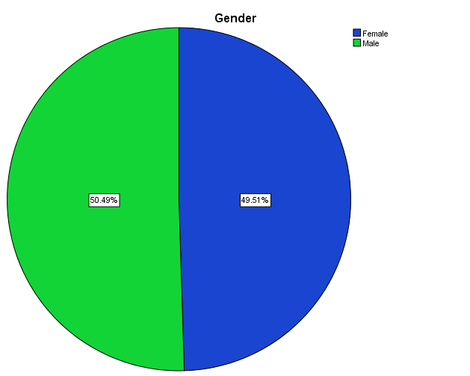
Figure 2: Gender of students
(Source: Developed by author)

2. NUMBER OF STUDENTS WHO HAVE BEEN AND NOT BEEN QUALIFIED FOR REDUCED OR FREE LUNCH
In the SPSS data mining tool, the descriptive statistics of the lunch category have been found from which the frequency of students who qualified and do not qualify for reduced or free lunch from the data set has been recognised. The results have been showing that among 2133 students 1215 students have been surveyed to be not qualified for reduced or free lunch, representing nearly 57% of the total students who have participated in the survey. Similarly, from the frequency, it has also been evaluated that among 2133 students nearly 918 students have been solved to be qualified for reduced or free lunch that has been representing nearly 43% of the total students who have participated in the survey. The data has shown a higher number of not qualified for reduced or free lunch students within the school in comparison to qualified for reduced or free lunch students (Aziz and Aftab, 2021).
 |  | Frequency | Percent
Valid | Does not qualify | 1215 | 57.0
Valid | Qualifies for reduced/free lunch | 918 | 43.0
Valid | Total | 2133 | 100.0
Table 4: Number of students who have been and not been qualified for reduced or free lunch
(Source: Developed by author)

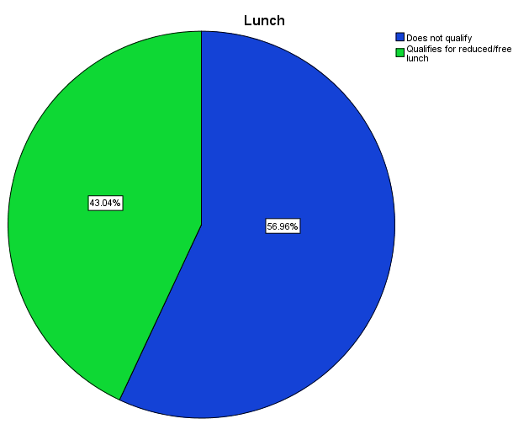
Figure 3: Number of students who have been and not been qualified for reduced or free lunch
(Source: Developed by author)

3. MEAN AND MEDIAN OF THE NUMBER OF STUDENTS ELIGIBLE AND NOT ELIGIBLE FOR REDUCED OR FREE LUNCH
The column lunch has been displaying whether or not the students qualified for free or reduced meals. The mean and median of the number of pupils eligible and not eligible for reduced or free lunch cannot be calculated since the data contains non-numerical information. According to the statistics, it has been determined that 918 pupils qualify for reduced or free lunch, whereas 1215 students do not qualify for reduced or free lunch (Purwanto, 2021).

4. MEAN AND MEDIAN DIFFERENCES OF STUDENTS' PRE-TEST AND POST-TEST SCORES
STATISTICS
 |  | Pre-test | Post-test
N | Valid | 2133 | 2133
N | Missing | 0 | 0
Mean |  | 54.96 | 67.10
Median |  | 56.00 | 68.00
Table 5: Descriptive statistics
(Source: Developed by Author)
In the SPSS data mining tool, the descriptive statistics of the pre-test and post-test categories have been found from which the mean and median differences of students' pre-test and post-test scores from the data set have been recognised. Based on the data, it has been determined that the survey participants' pre-test scores ranged from 54.96 on the mean to 56.00 on the median. Similar to this, it may be inferred that the mean pre-test score for the students questioned was 67.10, with a median of 68.00. According to the statistics, the survey students' mean disparities between their pre-test and post-test scores may be calculated to be 12.14. Similarly to this, the survey's students' median discrepancies between their pre-test scores and post-test scores may be approximated to be 12.00.

5. K-MEANS CLUSTERING
Final Cluster Centres
 | Cluster
 | 1 | 2
Pre-test | 43 | 65
Post-test | 55 | 78
Table 6: Final Cluster Centre Table
(Source: Developed by Author)

The final Classes Centre table has been representing the main values of the pre-test and post-test course of each of the two clusters generated by the K-means clustering algorithm.
Cluster 1:
- Pre-test: The mean pre-test score for Cluster 1 is 43.
- Post-test: The mean post-test score for Cluster 1 is 55.
Cluster 2:
- Pre-test: The mean pre-test score for Cluster 2 is 65.
- Post-test: The mean post-test score for Cluster 2 is 78.
Interpretation of the final cluster centres table identified two clusters with an estimated pre-test value of 43 and a post-test estimate of 55 for cluster 1, suggesting that cluster pre-test mean scores were lower compared to cluster 2. It was also noted that Cluster 1 had a lower post-test score than Cluster 2. Students started at low-level sports before the test and reported moderately improved performance after the test.

6. DATA MINING AND TEXT MINING TECHNIQUES
Data mining and text mining are considered powerful techniques used by enterprises to extract valuable insights and patterns from large amounts of data and textual information.
- Classification is considered an Amazon data mining technique that identifies beans as a supervised learning method primarily used to classify data into predefined categories and classes based on their characteristics. Telecommunications companies use this technique to classify and predict whether customers are likely to churn based on consumption patterns, historical usage data and other relevant characteristics.
- Clustering is also considered an important decision technique and was identified as an unsupervised learning method used to group similar data points based on similarity. E-commerce platforms group customers based on their browsing and purchasing behaviour.
- Association rule mining is also recognized as an important data mining approach for identifying interesting relationships between variables in large data sets. This data mining technique has been used by online retailers to analyse customer purchase data to identify associations between products that are frequently purchased together (Shanthi, 2019).
- Sentiment analysis is considered to be one of the most important text mining techniques, using this technique to determine the moods and emotions expressed in text. Hotel chains use sentiment analysis to analyse customer reviews across platforms.
- Name Entity Recognition is also considered another text mining technique used to identify and classify entities mentioned in the text, such as the name of an organization, the location of a person, etc. News aggregators use this technique to identify key elements within articles (Babbie et al. 2022).

7. ADVANTAGES AND DISADVANTAGES OF USING SPSS AND EXCEL FOR DATA ANALYSIS
ASPECT | SPSS | EXCEL
Data Handling
Advantages | SPSS is designed for data analysis, making it robust and efficient in handling large data sets. SPSS offers a wide range of data manipulation and analysis functions, suitable for advanced statistical analyses. | Excel is widely available and familiar to many users, making it accessible for basic data manipulation. Excel's data entry is flexible, suitable for small datasets and quick data exploration.
Disadvantages | Steeper learning curve for beginners due to its statistical focus and complex interface. Loading and managing data may require additional steps compared to Excel's simpler data entry. | Limited statistical functions compared to SPSS, making it less suitable for advanced statistical analysis. Slower performance when dealing with large datasets and complex calculations.
Statistical Analysis
Advantages | SPSS offers a range of customizable charts and graphs, optimized for displaying statistical results. | Excel's charting capabilities are user-friendly and allow for a quick visual representation of data.
Disadvantages | Performing non-standard analyses or custom procedures may be challenging in SPSS's structured environment. | Limited to basic statistical analyses; not suitable for more advanced statistical modelling.
Data Visualization
Advantages | SPSS offers a range of customizable charts and graphs, optimized for displaying statistical results. | Excel's charting capabilities are user-friendly and allow for a quick visual representation of data.
Disadvantages | Customizing graphs and visualizations may be more time-consuming in SPSS. | Excel's charting options might be limited when compared to specialized data visualization tools like Tableau.
Practical Example | Importing and managing a large dataset with 500 records is more efficient in SPSS, ensuring smooth data handling and storage. | For quick data entry and exploration, Excel provides a familiar interface, allowing the researcher to start working with smaller datasets with ease.
Table 7: Advantages and disadvantages of using SPSS and Excel for data analysis
(Source: Sambuo, 2021)

REFERENCES
1. Aziz, N. and Aftab, S., 2021. Data mining framework for nutrition ranking: Methodology: SPSS modeller. International Journal of Technology, Innovation and Management (IJTIM), 1(1), pp.85-95.
2. Babbie, E., Wagner III, W.E. and Zaino, J., 2022. Adventures in social research: Data analysis using IBM SPSS statistics. Sage Publications.
3. Becker, L.T. and Gould, E.M., 2019. Microsoft power BI: Extending excel to manipulate, analyse, and visualize diverse data. Serials Review, 45(3), pp.184-188.
4. Guerrero, H., Guerrero, R. and Rauscher, 2019. Excel data analysis. Springer International Publishing.
5. Kuriakose, S., 2023. MS Excel–Statistical procedures.
6. Njeru, N.M., Owiti, E. and Ahmed, A., 2020. Development Of An Excel-Based Cost Effectiveness Analysis Tool For Ascertaining Value For Money In Implementation Of Hiv And Other Health Interventions At Bomu Hospital, Kenya.
7. Okagbue, H.I., Oguntunde, P.E., Obasi, E.C. and Akhmetshin, E.M., 2021. Trends and usage pattern of SPSS and Minitab Software in Scientific research. In Journal of Physics: Conference Series (Vol. 1734, No. 1, p. 012017). IOP Publishing.
8. Purwanto, A., 2021. Education research quantitative analysis for little respondents: comparing of Lisrel, Tetrad, GSCA, Amos, SmartPLS, WarpPLS, and SPSS. Jurnal Studi Guru Dan Pembelajaran, 4(2).
9. Sambuo, D.B., 2021. Quantitative Methods for the Social Sciences: A Practical Introduction with Examples in SPSS and STATA.
10. Schmuller, J., 2021. Statistical analysis with Excel for dummies. John Wiley & Sons.

