Student name: Gertie vidot
Student ID: 2336702
Program: BA (Hons) Leadership and Management Skills in the Workplace

Module: Project Management Module code: LCLM5003
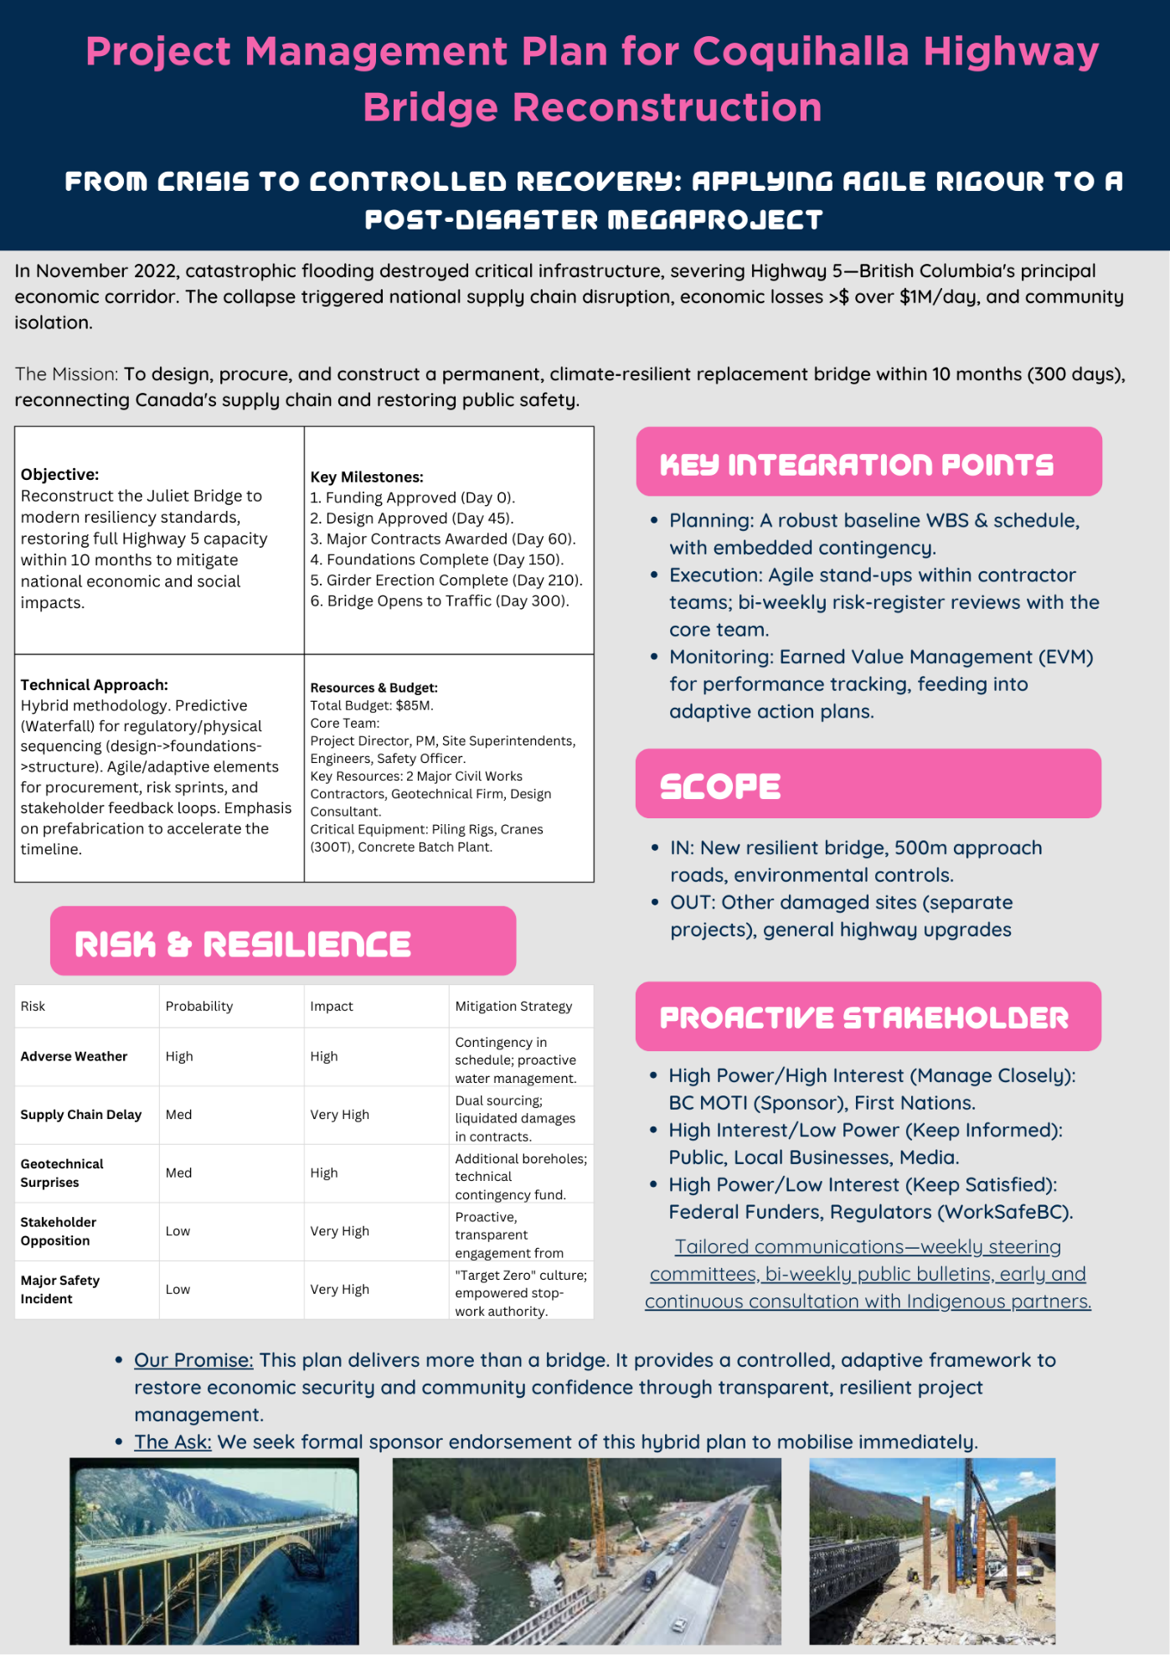
Table of Contents
Introduction: 5
Project Description: 5
Scope: 6
Work Breakdown Structure (WBS): 7
Quad Chart: 8
Gantt chart 8
Stakeholders' Involvement: 9
Allocation of Resources 10
Risk Analysis: 11
Conclusion: 12
References 13

Part B
The assessment provided to me by the tutor and my peers helped give me a more mature understanding of the basic components of the initial project plan and the outstanding work to be done before the final submission. The critical reflection of this feedback served as a learning process, allowing the optimisation of the knowledge about project management principles and making the final plan more comprehensive, organised, and academic (Egan, 2013).
The first strength that was mentioned by the tutor and peers alike was the clarity of the project's overall purpose and the relevance of the selected scenario. The Highway 5 reconstruction project was chosen successfully since it stood out as a realistic extension of the project management theories in a real-world scenario. My colleagues indicated that the plan well defined the importance of the project, particularly on the economic and social front, which facilitated the development of a compelling argument on why the project needed proper management. This establishes the fact that my introduction has established the context and purpose of the project and allowed the stakeholders to comprehend the purpose of the project.
The other good point that the tutor noticed was how the plan was logically organised. The chapters were very logical, and the explanation of the main aspects: work breakdown structure, stakeholder engagement, and risk management was organized in such a way that it resembled the project management models. This indicated that I successfully put into practice the theoretical concepts I have learned in the module, such as principles of PMBOK and PRINCE2. Also, the tutor praised the thoroughness of the project description and scope, saying that these aspects showed a solid grasp of the intricacy of the infrastructure projects in a post-disaster environment.
The feedback, however, also found some spheres of improvement to be necessary. The main thing that both the tutor and peers consistently pointed out is the necessity to reinforce the academic basis by means of adding more in-text citations in the plan (Winstone and Carless, 2019). Despite the references, however, I would have used more and more academic support, particularly in my arguments on the project management methodologies and disaster recovery frameworks (Infrastructure Canada, 2022).
The other area that was noted to be improved was the fact that a more detailed explanation of the Gantt chart and schedule assumptions was needed. Although the timeframe was brought out clearly, the tutor recommended discussing why these activities were sequenced in the way they were and how one task was dependent on another. In the last plan, I will thus give more justification about the timeline, especially the weather constraints, resource availability, and interdependence of the engineering and construction activities.
Furthermore, the peers stated that the section on stakeholders could be improved by outlining the engagement strategies and possible disagreements between the groups of stakeholders more clearly. I will elaborate on this part by adding a communication plan with more depth and illustrations of how the concerns of the stakeholders will be addressed.

Part C

Introduction:
This report outlines the Project Management Plan (PMP) of the emergency reconstruction of the essential bridge infrastructure on Highway 5, also known as Coquihalla Highway, after the devastating flooding and landslides that hit the area in November 2022. Coquihalla is the main inland arterial route in British Columbia, and it supports both the transportation of goods and people between the Port of Vancouver and the rest of Canada. Its temporary shutdown has cut national supply chains, caused economic losses totaling millions of dollars a day, and isolated some communities.
The proposal is a systematic and integrated approach to the methodology that will establish a safe and resilient permanent bridge solution. It is not only conceptualised as a construction project but also as a mission-critical recovery project which has a large political, economic as well and social implication. The PMP combines the traditional project-management discipline with the responsiveness of agility to sail through unimaginable uncertainty, the complexity of stakeholders, and high time constraints. The general intention of this is to gain formal approval, harmonize all the stakeholders, and provide the final road map to the execution, monitoring, and controlled closure of the project.

Project Description:
The specified project is the Coquihalla Highway 5 - Juliet Bridge Emergency Reconstruction Project. The Juliet Bridge is a dummy name representing a critical path that collapsed, thus demonstrating the weakness revealed by the flood incident. The overall collapse of the building provided the largest discontinuity on the highway since its creation. The main project goal is to design, order, and build a long-term and durable substitution construction, within a ten-month timeframe, and, hence, restore normal, secure four-lane commercial and passenger traffic. Success is measured using a complex set of criteria: scope completion to updated engineering standards resistant to 1 in 200 year flood event; a set 300 days schedule since the time financial approval; meeting all the applicable requirements of the Canadian Standards Association and the British Columbia Building Code; an ideal safety record represented by zero lost-time injuries; and the preservation of stakeholder confidence with respect to transparent communications (CSCE, 2023).
The rationale behind this project is too strategic. On the economic front, the Coquihalla highway supports billions of dollars of trade every year. Its congestion means both direct costs through long routes and indirect costs through instability in the national supplies that impact the industries (Moody, 2022). On the social front, the highway links families and provides access to healthcare, as well as supports remote communities. The government's reaction is currently under heavy political scrutiny in the areas of its agility and effectiveness. The project, therefore, goes beyond the conventional value measurement that includes national economic security and social recovery. The deliverables can thus be tangible, a new geotechnical and hydraulic appraisal, a ratified design package, the actual bridge structure, rebuilt approaches, and all the documentation handed over to maintenance authorities.

Scope:
The project scope will encompass all the activities that will be necessary to bring Highway 5 to a safe operating level. This involves ensuring that the levels of structural damage and geological changes caused by the floods are determined with the help of thorough engineering and geotechnical evaluation. Teams will be involved in carrying out the duty of removing the debris, clearing slopes, and preparing the site to ensure safe working conditions. Broken bridges shall be rebuilt based on the foundation, till the superstructure is based on new recommendations of structural engineering. Washed away areas of the roads will be rebuilt using stabilised roadbeds, asphalt surfacing as well and fortified shoulders. Moreover, slope stabilisation measures like retaining walls, drainage systems, and protective barrier installation are necessary to ensure risks of landslides in the future are reduced (Hydrologic Engineering Center, 2022).
Where needed, temporary bypass lanes are going to be installed to maintain the flow of essential and emergency traffic during the reconstruction. Environmental protection entails such obligatory project requirements as sediment control, wildlife observation, and reporting compliance. The scope ends with the final inspections, safety audits, and formal opening up of the corridor. It lacks the reconstruction work on other provincial highways, long-term regional transportation planning, and the compensation programmes to the businesses and residents, as these are not part of the direct mandate of the project (BC Ministry of Transportation and Infrastructure, 2022).

Work Breakdown Structure (WBS):
The Work Breakdown Structure divides the project into work packages in sequential order and rationally. As PMI (2021) says, the WBS is one of the primary project-management tools that help to define deliverables clearly and plan them properly (Project Management Institute, 2021).
On the topmost tier, the project will include initiation, engineering and assessment, site preparation, bridge reconstruction, roadway reconstruction, slope stabilisation, temporary bypass creation, quality and safety management, and project closure. The process of project initiation involves the development of the project charter, stakeholder validation, and the development of procurement planning. The engineering and assessment stage is filled with thorough geotechnical, hydrological, structural, and environmental investigations to aid further technical decision-making (Agile Alliance, 2022).
Site preparation includes clearing of the debris, setting up of the temporary access paths, and utility relocation. Bridge construction involves foundation preparation, superstructure construction, and testing. Roadbed stabilisation, asphalt, and construction of signage and guardrails are part of roadway reconstruction. Slope stabilisation aims at building retention walls, installing drainage systems, and providing rockfall protection. Other operational measures that are put in place in cases of temporary bypassing are temporary lanes that are built to ensure minimal interference in transportation during major works. The quality and safety management framework incorporates all the inspections, audits, and compliance activities. Project closure includes final documentation, approval by stakeholders, and post-project evaluation. The WBS will make every part of the reconstruction defined, traceable, and measurable, thus facilitating effective coordination.
Objective:  Reconstruct the Juliet Bridge to modern resiliency standards, restoring full Highway 5 capacity within 10 months to mitigate national economic and social impacts. | Key Milestones:  1. Funding Approved (Day 0).  2. Design Approved (Day 45).  3. Major Contracts Awarded (Day 60).  4. Foundations Complete (Day 150).  5. Girder Erection Complete (Day 210).  6. Bridge Opens to Traffic (Day 300).
Technical Approach:  Hybrid methodology. Predictive (Waterfall) for regulatory/physical sequencing (design->foundations->structure). Agile/adaptive elements for procurement, risk sprints, and stakeholder feedback loops. Emphasis on prefabrication to accelerate the timeline. | Resources & Budget:  Total Budget: $85M.  Core Team:  Project Director, PM, Site Superintendents, Engineers, Safety Officer.  Key Resources: 2 Major Civil Works Contractors, Geotechnical Firm, Design Consultant.  Critical Equipment: Piling Rigs, Cranes (300T), Concrete Batch Plant.

Quad Chart:

Gantt chart
Months 1-2: Initiation & Design. Activities 1.1 and 1.2 run concurrently. Critical path is anchored to Design Approval (M60).
Months 2-3: Procurement. Activity 1.3 overlaps late-stage design. Contract Award (M90) is a critical milestone.
Months 3-7: Construction.
Months 3-5: Site Prep & Foundations (1.4.1, 1.4.2). This is the highest-risk period on the critical path, subject to weather.
Months 5-6: Substructure (1.4.3).
Months 6-7: Superstructure & Deck (1.4.4, 1.4.5). Girder delivery must align precisely with crane availability.
Month 8: Highway & Finishes (1.5). Final paving and signage depend on bridge completion.
Months 9-10: Commissioning & Closure (1.5.3, 1.7). Final inspections, load testing, and administrative closure.
A Gantt chart shows activity timelines and dependencies and offers a visual depiction of the project schedule (Kerzner, 2022). Activities in the Highway 5 restoration project are spread out over a twelve-month timeline. The first two weeks are dedicated to the project initiation phase, which is followed by six weeks of engineering and assessment work starting in the first month. The reconstruction of the bridge is carried out between the third and eighth months, whereas site preparation is carried out in the second and third months. This is the period coinciding with roadway reconstruction, which will occur in the seventh and ninth months. The slope stabilization process occurs simultaneously with other structural processes between months four and seven.
During the second month, temporary bypass lanes are initiated to ensure required movement. Quality and safety audits are performed on a regular basis throughout the project and serve to ensure continuous adherence to provincial standards. During the 11th and 12th months, the project ends with final checks and approval by the stakeholders. The interlacing nature of the tasks represented in the Gantt chart shows the utilization of schedule compression tools, including fast-tracking, that are common in post-disaster infrastructure projects where timely restoration of service is essential (Project Management Institute, 2021).

Stakeholders' Involvement:
The presence of stakeholders in the development of large-scale infrastructure, especially the assets of the state and emergency reconstruction, is a compulsory condition. Each of the teams takes up their roles, according to their technical expertise, and the project needs, to be accountable and deliver effective tasks. The players in this project are the British Columbia Ministry of Transportation and Infrastructure (MoTI), construction contractors, engineering consultants, environmental regulators, Indigenous communities, municipal governments, logistics companies, and the residents.
MoTI is the project sponsor, and it gives governance, funds, and top-level supervision. Frequent progress meetings and monthly reports keep everything on track with the government’s expectations. The construction contractors will undertake the actual work as well as be part of the daily coordination meetings to maintain safety and efficiency. The engineering consultants provide structural, geotechnical, hydrological, and environmental advice and attend technical workshops at both ends of the project life cycle. The provincial emergency management authorities offer advice regarding health and safety, especially in relation to the reduction of risks in case of active flooding. Indigenous people form part of the project since the area is culturally and ecologically important; their involvement corresponds with the concept of reconciliation and ensures that the culturally significant areas are shielded or conserved accordingly (Government of British Columbia, 2022). Local government and residents of the impacted area insist on constant updates of information so that they can control the inconveniences of traveling and security threats. Logistics companies are also involved in providing information about operational requirements, thus helping in the design of a temporary bypass.
Stakeholder engagement is effectively realised with the help of regular meetings, consultations with the population, site visits, community news, digital communication, and feedback mechanisms. The Office of Government Commerce (2020) claims that early and continuous involvement of stakeholders will reduce conflict, facilitate informed decision-making, and facilitate project acceptance. This will make the reconstruction process transparent, inclusive, and aligned with the interests of various groups.

Allocation of Resources
The allocation of resources is based on the PMBOK 7 standards of resource planning (Project Management Institute, 2021). Human resources include project management teams, structural and geotechnical engineers, environmental scientists, skilled labourers, machinery operators, procurement specialists, safety officers, and administrative staff. Material resources include heavy construction equipment such as excavators, bulldozers, pavers, and cranes. Steel beams, concrete, asphalt, geotextiles, and drainage components that are used as raw materials are supplied by various vendors to reduce supply-chain delays. The use of surveying equipment, drones, and GIS technologies allows for observing the situation on the sites precisely. The budget is estimated at CAD 300 million to CAD 350 million; the bigger share is given to bridge reconstruction, road construction, and slope stabilization. It has a contingency fund of about five percent that is set aside in the event of unexpected events, as it reflects the recommended contingency rates in large-scale civil engineering projects (Kerzner, 2022).
Technology resources are also critical, especially during engineering design, digital modelling, environmental surveillance, and scheduling of projects. By using sophisticated modelling software, it is possible to forecast soil behaviour and hydraulic forces accurately, thereby being important in designing strong structures that can withstand weather extremes in the future. The development of technological tools is supported by the integration that helps make informed decisions and boosts the efficiency of the projects.

Risk Analysis:
Risk management is part and parcel of the project plan, especially regarding the intricate environment and structural factors in flood recovery. Risks are determined, assessed, and avoided according to PMBOK 7 risk-management models (Project Management Institute, 2021). Some of the greatest risks include weather-related disruption; weather in mountainous regions cannot be predicted, thus any construction activity may be slowed down, especially during winter seasons. Some of the mitigation strategies involve fitting seasonal weather patterns in the schedule, the use of winter-adjusted construction practices, and the flexibility of the schedule.
Another threat is the issue of material shortages, which are particularly difficult to view in the context of the instability of global supply chains. To handle this, the procurement is spread among many suppliers, and the materials that are in need are pre-ordered. Geotechnical risks are caused by the ignorance of the characteristics of the subsurface, such as unstable soil layers or concealed structural failures due to erosion by floods. To minimize this risk, large-scale geotechnical research is done during the assessment phase.
Heavy civil construction is a risky activity, especially on steep and unstable land. The project also introduces the use of a detailed health, safety, and environment (HSE) plan, which includes daily safety briefings, the use of constant supervision, and adherence to safety standards (WorkSafeBC, 2023). The use of technology is essential during the engineering design, digital modelling, environmental monitoring as well and project scheduling. Environmental risks should include possible effects on local environments and water resources; it is defined that the environmental standards, like the sediment control structures and active monitoring of the wildlife, should be met to ensure that the provincial regulations are considered (Government of British Columbia, 2022).
The financial risks include cost overruns, which can be addressed using very strong cost management, contingency budgeting, and regular financial reporting. Social risks, e.g., discontent of a community caused by noise, delays, or constant closures, are addressed by proactive communication and up-to-date information. Successful resolution of the problems protects risk management during the reconstruction.

Conclusion:
This Project Management Plan is a plan that is action-based and a detailed plan that seeks to ensure the success of the Coquihalla Juliet Bridge Reconstruction Project. The plan strikes the perfect balance between strict management of scope, cost, and quality, with flexibility needed to manage the complex case of post-disaster due to a hybrid management approach. The detailing scope, WBS, schedule, and resource allocations bring out a clear standard of measuring performance. The proactive stakeholder and risk management activities aim at maintaining the social license and forecasting key future issues.
This project is a serious aspect of the recovery of the British Columbia and Canadian economies. Under this crisis, the project team is mobilizing and is set to start operations as urgently, accurately, and transparently as this crisis deserves, without the formal approval of this plan. With high regard, we seek the approval of the Steering Committee to go ahead.

References
Agile Alliance. (2022). Agile Manifesto. http://agilemanifesto.org/.
BC Ministry of Transportation and Infrastructure. (2022). Post-Event Review: November 2021 Atmospheric River Event.
CSCE. (2023). Post-Flood Infrastructure Reconstruction Guidelines. CSCE Publications.
Egan. (2013). Skilled Helper: A Problem-Management and Opportunity-Development Approach to Helping. Belmont, CA: Brooks/Cole.
Government of British Columbia. (2022). Flood Response and Recovery Report. Province of BC.
Hydrologic Engineering Center. (2022). Hydraulic and Hydrologic Modelling in Post-Flood Scenarios. U.S. Army Corps of Engineers.
Infrastructure Canada. (2022). Disaster Relief and Infrastructure Restoration Report. Government of Canada.
Kerzner. (2022). Project Management: A Systems Approach to Planning, Scheduling, and Controlling. (13th ed.). Wiley.
Moody. (2022). Project Management Practices in Disaster Recovery and Infrastructure Rebuilding. Journal of Infrastructure & Project Delivery.
Office of Government Commerce. (2020). Managing Successful Projects with PRINCE2. The Stationery Office.
Project Management Institute. (2021). A Guide to the Project Management Body of Knowledge (PMBOK® Guide). (7th ed.). PMI.
Winstone and Carless. (2019). Designing Effective Feedback Processes in Higher Education: A Learning-Focused Approach. London: Routledge.
WorkSafeBC. (2023). Occupational Health and Safety Regulation.

