Llanllyr Landscape Report
Nicholas Drake
HPAR4001
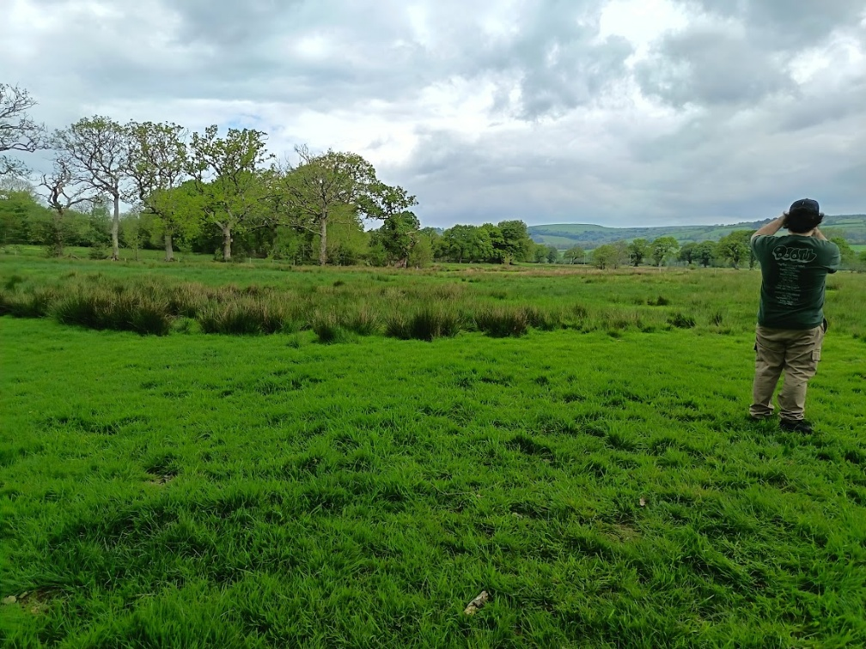(Self-taken)
Geological Landscape of Llanllyr

Table of Contents
- Surroundings/Location
  - General Location
  - Natural Formations Surrounding
- Glacial Lake
2.1 Origin
2.2 Glacial Moraines
2.3 Importance to Excavation
- Soil Deposits
3.1 Composition
3.2 Importance to Excavation

- Surroundings/Location
  - General location
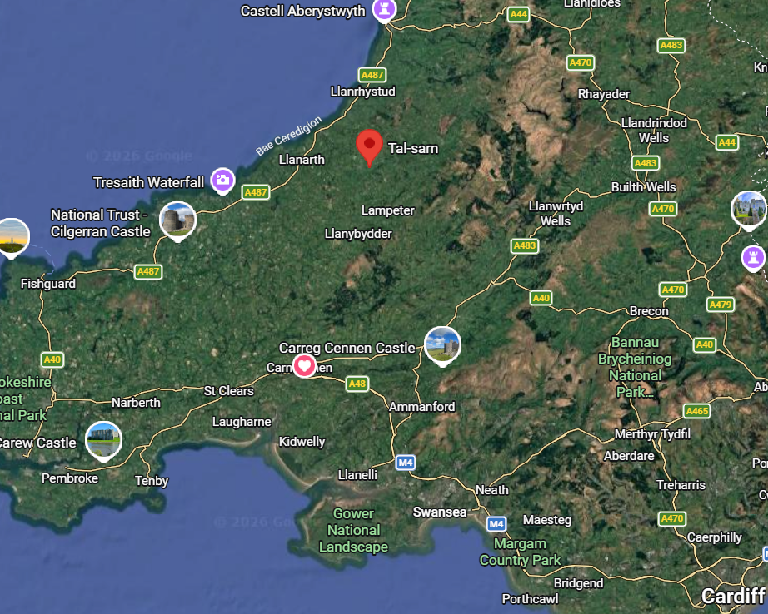(Google Maps)
The site in question is in Llanllyr, a farmland just south of Talsarn, in Ceredigion.
1.2 Natural formations surrounding
The site is within the Aeron valley. The Aeron valley is a river valley that stretches from Mynydd Bach to the town of Aberaeron. Nearby is the River Aeron, sourced from Mynydd Bach flowing into Aberaeron (Discover Ceredigion).
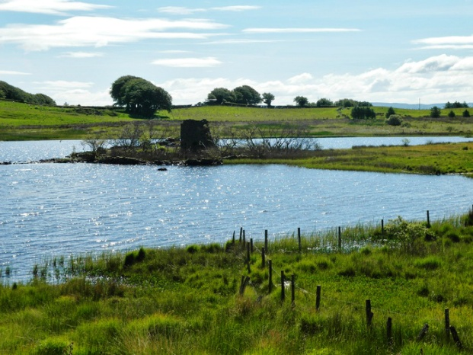 (White)
Both formations were inhabited by the Aeron Glacier until roughly fourteen thousand nine hundred years ago, when the glacier is predicted to have been melted (Glasser et al.).
The site is also on several small islands in a former glacial lake, which will be explored in further detail in section 2.
- Glacial Lake
  - Origin
The site being explored is a former glacial lake from just after the Devensian. The Devensian is the last glacial period of Britain. In the area of the Aeron valley during the Devensian, there was the Aeron Glacier, fed by the Irish Sea and Cambrian ice sheets converging in the area (Natural Resources Wales).
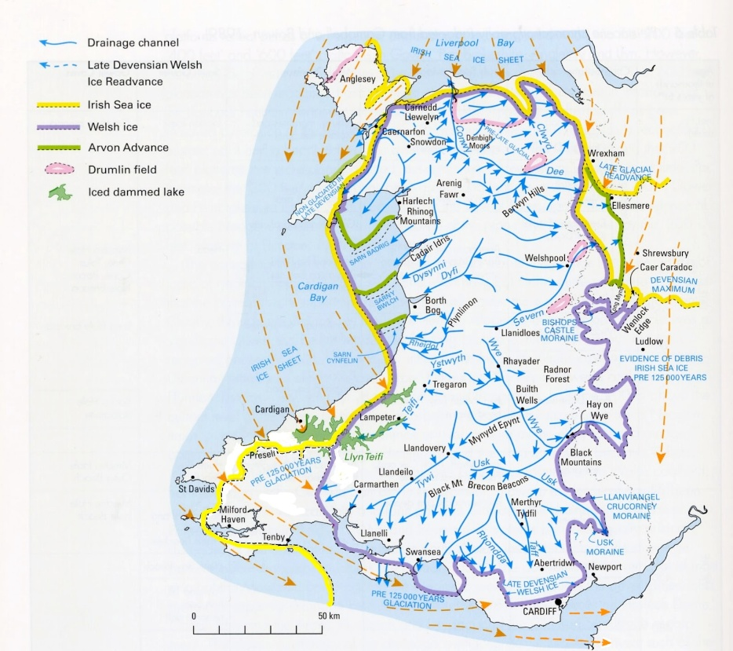 (JOHN)
The area where the ice sheets converged in the Aeron valley is shown within the red box.
Please note that all processes talked about here have occurred over thousands of years and are not instantaneous.
Glaciers move throughout time, eventually created depressions in the ground which were filled with ice. Once the glaciers melted, the meltwater formed several lakes around the valley. Most lakes have dried up, but are still noticeable through changes in vegetation—such as darker grass, plants needing more moisture being denser in population, etc— and land formations such as drops in elevation and moraines (Natural Resources Wales).
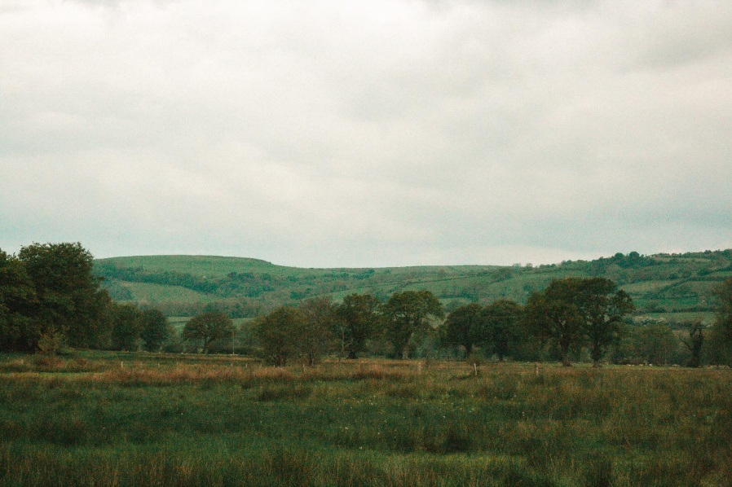 (Montague)
One can notice a change in elevation just under the trees on the left, as well as denser vegetation at the lower level, indicative of a high moisture area compared to the sides of what would have been the lake.
  - Glacial Moraine
What is being excavated are mounds slightly elevated above where the water level would be. These could be moraines. Moraines, in the glacial definition, are mounds, ridges, or other distinct features that have been made by glacial ice depositing sediment (Klaus K E Neuendorf et al.).
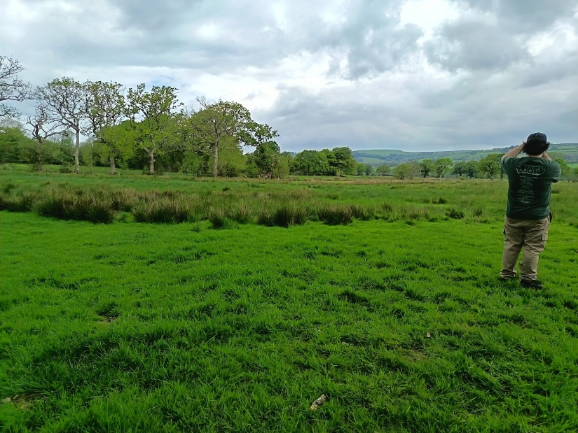(Self-Source)
The photo above has been taken atop one such moraine. They extend across large areas and only raise one to one and a half at a gradual slope. This could point to it being a ground moraine. A ground moraine is an accumulation of sediment that was released during ablation, the process of ice and snow melting away from a glacier, to form a large area of low relief (Klaus K E Neuendorf et al.). The melting of ice under the glacier releases the sediments picked up over time, eventually creating the moraine.
The moraines would have brighter grass and less juncus plants, showing that they have less moisture. This proves that these moraines would have been above the water level when the lake was around, becoming small islands within the lake.
  - Importance to Excavation
We are searching the site for presence of human activity during the Mesolithic period, roughly ten thousand years ago, when the lake would have still been around. Lakes have ecosystems around them—plants, fish, birds, mammals, etc—among those could be human beings, coming to use the water source, hunt, and fish. Humans naturally do not stand around in water all the time, so they would spend most of their time on the banks or on islands, dry land bordering the lake. That is why the excavation is digging on what would have been the banks and what would have been small islands around the lake. If humans today work on islands and banks around water, then humans in the past should be no different. This is the basis for the location of digging.
- Soil Deposits
  - Composition
The sediment around the site and especially the moraines would have been mostly deposited by glaciers. After the glaciers melted, the deposits were moved and worked by new rivers and streams moving and shaping them throughout the valley (Natural Resources Wales).
The sediment mostly is lacustrine in nature, or pertaining to current or previously existing lakes, as it is on the grounds of an ancient lake. The soil has several meters of lake clay and silt, as well as deposits of peat and gravel (pers com. Bates, Martin).
The soil is primarily clay and silt, proven through several samples seen from boreholes, long shafts dug into the ground vertically. One borehole taken in Ystrad Aeron, a town less than two miles away from Llanllyr, found fifty three meters of such clay and silt underneath nine and a half meters of loose soil (Davies et al.).
  - Importance to Excavation
The soil composition helps us understand the timeframe surrounding the site. Large deposits of lake clay and silt show the parameters of the lakes, and at what depths activity could have happened.
The peat is useful in another way, as the peat can preserve organic material quite well, including pollen. When pollen samples are taken, they can give a sense of the biodiversity of the period taken in, as we can see what kind of plants were there and how old they were. This sort of information is vital to understanding the question archaeology is always trying to answer, which is how humans lived in their environment.

Bibliography:
Bates, Martin. Personal Communication
Davies, J. R., et al. “Lampeter District, Sheet 195, a Brief Explanation.” Webapps.bgs.ac.uk, 2006, webapps.bgs.ac.uk/Memoirs/docs/B06109.html.
Discover Ceredigion. “Aeron Valley and Mynydd Bach - Discover Ceredigion.” Discoverceredigion.wales, 2026, www.discoverceredigion.wales/areas-of-ceredigion/ceredigions-river-valley-routes/aeron-valley-and-mynydd-bach/. Accessed 21 May 2026.
Glasser, N. F., et al. “Late Devensian Deglaciation of South-West Wales from Luminescence and Cosmogenic Isotope Dating.” Journal of Quaternary Science, vol. 33, no. 7, Aug. 2018, pp. 804–18, https://doi.org/10.1002/jqs.3061. Accessed 18 Jan. 2020.
Google Maps. Google Maps. 2024, www.google.com/maps/place/Tal-sarn,+Lampeter+SA48+8QB/@51.9587208,-4.1757181,130799m/data=!3m1!1e3!4m6!3m5!1s0x486f0ea756dce749:0xa60647fffb54fe73!8m2!3d52.185817!4d-4.129258!16s%2Fm%2F0105lv6w!5m1!1e4?entry=ttu&g_ep=EgoyMDI2MDUxMy4wIKXMDSoASAFQAw%3D%3D.
JOHN, BRIAN. “Wales Devensian Map Revised.” Blogspot.com, 21 May 2026, brian-mountainman.blogspot.com/2012/12/wales-devensian-map-revised.html. Accessed 21 May 2026.
Johnson-Marshall, Seth. “Afon Aeron - Afonydd Cymru.” Afonydd Cymru, 28 Nov. 2024, afonyddcymru.org/aeron/. Accessed 21 May 2026.
Klaus K E Neuendorf, et al. Glossary of Geology. Alexandria, Virginia American Geosciences Inst, 2011.
Lewis, Colin A., and Andrew E. Richards. The Glaciations of Wales and Adjacent Areas. Logaston Press, 2005.
Natural Resources Wales. National Landscape Character- Bro Ceredigion. 31 Mar. 2014.
White, Paul. “Llyn Eiddwen, the Source of the Aeron on the Mynydd Bach.” People’s Collection Wales, Online Image, afonyddcymru.org/aeron/.

