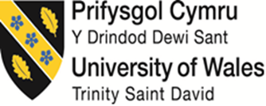

Effective Team Working and Communication (BMSW4009)

Student ID: 2412462

Table of Contents
1. INTRODUCTION 3
1.1 Defining Effective Teamwork 3
1.2 Personal Team Role Assessment 3
2. MAIN FINDINGS 4
2.1 Learning Journey in Teamwork Dynamics 4
2.2 Key Theoretical Models and Their Application 4
2.3 Practical Application in Group Assessments 8
3. CONCLUSIONS 8
3.1 Self-Reflection Summary 8
3.2 Future Action Plan 8
4. REFERENCES 10
5. APPENDICES 12
Appendix A: Belbin Self-Perception Inventory Results 12
Appendix B: Thomas-Kilmann Conflict Management Questionnaire Results 14

1. INTRODUCTION

1.1 Defining Effective Teamwork
Here’s how effective teamwork is a more complicated definition… Lencioni (2002) affirmed that the basis of a successful teamwork is built on the five key elements, that are: trust, constructive conflict, commitment, accountability and collective results. In addition, West (2012) states that effective teams are characterized by clearly stated and shared objectives, appropriate leadership, common patterns of interaction and effective management of difference. Typical teams that excel are psychologically safe, meaning that they feel comfortable taking interpersonal risks (Edmondson, 2018). Furthermore, Salas et al. (2015) provide other determinants of team success, such as effective communication, mutual support, and adaptability, which are very relevant in high pressure situations.

1.2 Personal Team Role Assessment
According to results of my Belbin Self Perception Inventory, the natural roles I occupy within teams are mainly ‘Resource Investigator’ and ‘Teamworker’. I’m a Resource Investigator, good at making my networks, getting external information and working new leads for the team. I find my tendencies as a Teamworker through my diplomatic way of handling things, active listening skills and ability to take other people under my wing in order to lighten the tension in the team. This matches what I like to do, i.e I am naturally inclined to build a strong relationship with people, and encourage collaboration.
And according to my Thomas – Kilmann Conflict Management Style Questionnaire, I am more likely to use the "Compromising" and "Collaborating" approach when conflicts occur. This also implies that I appreciate searching for acceptable resolutions and also attempting to attend to underlying concerns for all parties. I actually have a secondary “Accommodating” tendency that sometimes causes me to place more value on keeping relationships in tact versus getting the best possible result on a task, something that I’m becoming ever more aware of.

2. MAIN FINDINGS

2.1 Learning Journey in Teamwork Dynamics
Through this module, I have learned how complicated relationships in a team are. According to Hackman (2011), the effectiveness of a team is not simply providing talented individuals, but offering the right conditions for it to be able to work together in a collaborative manner. This understanding has led me to the understanding that my previous emphasis on individual contribution sometimes deems the development of process and relationship within teams unimportant.

2.2 Key Theoretical Models and Their Application
2.2.1 Belbin Team Roles
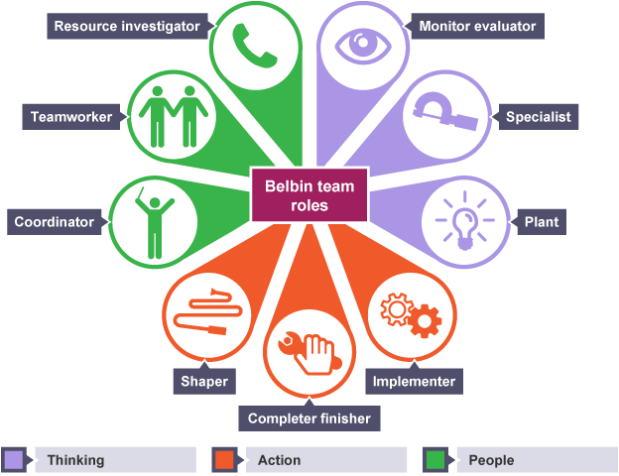
I have been able to formulate a way to understand complementary roles within effective teams using Belbin's (2010) team role theory. I have been able to recognize the importance of having a mix of the nine different roles (Plant, Resource Investigator, Coordinator, Shaper, Monitor Evaluator, Teamworker, Implementer, Completer Finisher, and Specialist) and valued the diversity amongst team members and how the balance in these roles within teams contributes to its success. I was able to understand and appreciate better what different strengths individual team members have, and also know better my natural tendency.
However, I intentionally used my Resource Investigator strengths when working in our group to research external sources and bringing new points of view to our discussion topic. But I also recognized that our team's raw 'Completer Finisher' can not finish the day without the final passes of quality, and I wanted to help support that effort by ensuring my contributions submitted far enough in advance for final checks.
2.2.2 Tuckman's Stages of Group Development
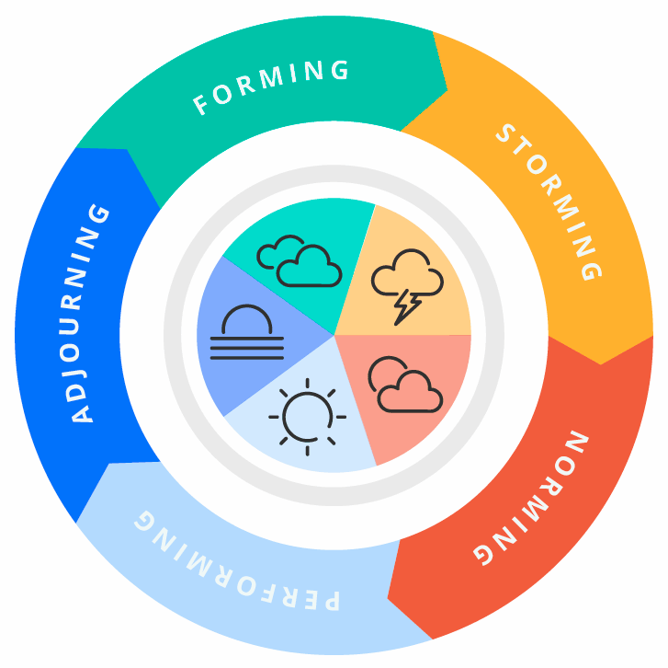
(1965) Tuckman’s (1965) model group development forming (Tuckman & Jensen 1977)—norming, storming, forming, Team progression has been described using Tuckman's (1965) group development stages; forming, storming, norming, performing, later (Tuckman & Jensen 1977) adjourning. It is beneficial to be aware of these natural stages, changing my expectations and contributions, to fit. When our presentation team was in the "storming" phase and differences in working styles were being made clear, I used this knowledge to normalise the experience as I wouldn’t have perceived it as team dysfunction.
According to Wheelan (2009), they need varied support at different stages of development of the team. When I realized that our team had transitioned from 'forming' to 'storming', I recommended that we set up more well defined protocols of communication and decisions – making, which accelerated our progress to the 'norming' stage.
2.2.3 Thomas-Kilmann Conflict Resolution Model
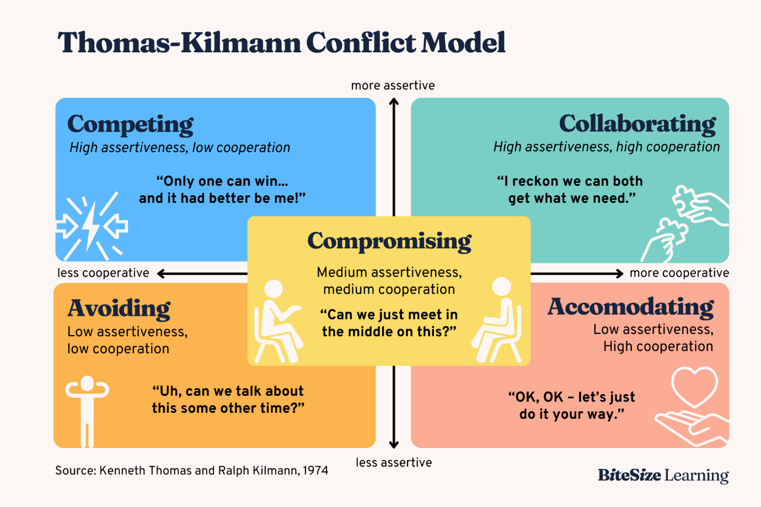
I have gained more knowledge on conflict management styles like competing, accommodating, avoiding, compromising and collaborating, as thoroughly covered by the Thomas-Kilmann model (Thomas and Kilmann, 1974). Using this framework I have come to realize that some conflict styles might be appropriate in different circumstances instead of regarding some styles as more superior.
A different approach I took when our presentation team would disagree about content priorities was to consciously switch my default approach from being a ‘compromiser’ to a ‘collaborator’. Following Deutsch's (1994) advice on constructive conflict resolution, I had the department managers compare underlying interests in preferences for solutions rather than go straight to competing positions, and as a result we arrived at a more integrated and innovative solution than accommodative compromise would have.
2.2.4 Transactional Analysis
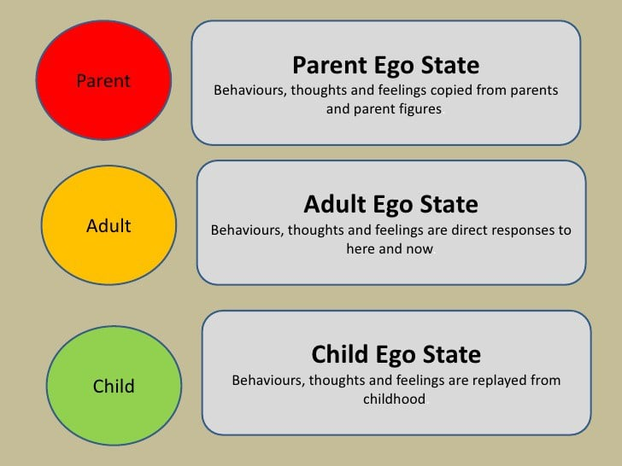
The Parent, Adult, Child communication technology of Berne’s (1964) Transactional Analysis theory has been utilized to understand communication patterns. Fostering productive interactions has gotten easier with learning how to recognize these states in myself and others. To offer an example, I once realized that I was responding from a ‘Critical Parent’ state in team discussions and I deliberately moved myself into an ‘Adult’ communication by focusing on data and problem solving instead of judgment.
According to Stewart and Joines (2012), being aware of transaction patterns can aid the prevention of communication breakdowns. While preparing our presentation, I saw one of the team members reacting defensively (Child Ego State) to feedback. This took the form of consciously staying in an Adult to Adult transaction and recognizing the value in their view, which helped diffuse potential conflict.

2.3 Practical Application in Group Assessments
These theoretical frameworks were able to be applied to our presentation group which gave us some practical application to these conceptual frameworks. For instance, I adapted the notion of ‘vulnerability based trust’ by Lencioni (2002) and shared honestly about the points where I needed help, to stimulate the same honest behavior from teammates. On those occasions when scheduling conflicts arose, I used Fisher and Ury’s (1981) principled negotiation approach and tried to find solutions that both parties can live with by negotiating on interests rather than positions.
Additionally, by mirroring characteristics outlined by Katzenbach and Smith (1993) to distinguish between working groups and teams, we were able to progress beyond mere efforts in reserving tasks towards true integration in our work. Instead of building isolated presentation sections, we had regular checkpoints for giving and taking feedback and for integration into a more cohesive final product.

3. CONCLUSIONS

3.1 Self-Reflection Summary
From this module, I have now further understood, both theoretically and practically, teamwork principles. I basically learnt that we need to learn to adapt as per the team context as to how to use team roles and how to manage conflict rather sticking to one preferred style. I have come to realize that my Resource Investigator and Teamworker strengths are able to contribute value in terms of building relationships and generating ideas, however this tendency can sometmes keep me from optimum results when collaboration would be more suitable.

3.2 Future Action Plan
In order to become more effective in future team environments, I will:

While practicing the high pressure team situations, consciously use "Adult" communication patterns.
Work on my “Shaper" capabilities to assist in maintaining team’s progress when drive dwindles
Set personal boundaries on accommodating tendencies versus tasks which must be accomplished
Self awareness will also be increased through actively seeking feedback on my team contributions.
To practice collaborative conflict resolution approaches, most especially when I would normally default to ‘give and take’
Develop abilities at recognizing and responding to diverse stages of team development.
Develop my adaptability by creating opportunities to work with different team role compositions

4. REFERENCES
Belbin, R.M. (2010) Team Roles at Work. 2nd edn. London: Routledge.
Berne, E. (1964) Games People Play: The Psychology of Human Relationships. New York: Grove Press.
Deutsch, M. (1994) 'Constructive Conflict Resolution: Principles, Training, and Research', Journal of Social Issues, 50(1), pp. 13-32. https://spssi.onlinelibrary.wiley.com/doi/abs/10.1111/j.1540-4560.1994.tb02395.x
Edmondson, A.C. (2018) The Fearless Organization: Creating Psychological Safety in the Workplace for Learning, Innovation, and Growth. Hoboken: John Wiley & Sons.
Fisher, R. and Ury, W. (1981) Getting to Yes: Negotiating Agreement Without Giving In. Boston: Houghton Mifflin.
Hackman, J.R. (2011) Collaborative Intelligence: Using Teams to Solve Hard Problems. San Francisco: Berrett-Koehler Publishers.
Katzenbach, J.R. and Smith, D.K. (1993) The Wisdom of Teams: Creating the High-Performance Organization. Boston: Harvard Business School Press.
Lencioni, P. (2002) The Five Dysfunctions of a Team: A Leadership Fable. San Francisco: Jossey-Bass.
Salas, E., Shuffler, M.L., Thayer, A.L., Bedwell, W.L. and Lazzara, E.H. (2015) 'Understanding and Improving Teamwork in Organizations: A Scientifically Based Practical Guide', Human Resource Management, 54(4), pp. 599-622.
Stewart, I. and Joines, V. (2012) TA Today: A New Introduction to Transactional Analysis. 2nd edn. Nottingham: Lifespace Publishing.
Thomas, K.W. and Kilmann, R.H. (1974) Thomas-Kilmann Conflict Mode Instrument. Mountain View, CA: Xicom.
Tuckman, B.W. (1965) 'Developmental Sequence in Small Groups', Psychological Bulletin, 63(6), pp. 384-399.
Tuckman, B.W. and Jensen, M.A.C. (1977) 'Stages of Small-Group Development Revisited', Group & Organization Studies, 2(4), pp. 419-427.
West, M.A. (2012) Effective Teamwork: Practical Lessons from Organizational Research. 3rd edn. Chichester: BPS Blackwell.
Wheelan, S.A. (2009) 'Group Size, Group Development, and Group Productivity', Small Group Research, 40(2), pp. 247-262.

5. APPENDICES

Appendix A: Belbin Self-Perception Inventory Results
BELBIN SELF-PERCEPTION INVENTORY RESULTS
Primary Team Roles:

Resource Investigator (19 points)
Teamworker (17 points)

Secondary Team Roles:
3. Coordinator (14 points)
4. Implementer (12 points)
Least Preferred Team Roles:
5. Plant (9 points)
6. Shaper (8 points)
7. Monitor Evaluator (7 points)
8. Completer Finisher (7 points)
9. Specialist (7 points)
Role Descriptions:
Resource Investigator (Primary Role):

Explores opportunities and develops contacts
Extroverted, enthusiastic, and communicative
Develops connections and networks effectively
Responds well to challenges
Can lose interest once initial enthusiasm passes

Teamworker (Primary Role):

Cooperative, perceptive, and diplomatic
Listens well and averts friction
Builds strong relationships within the team
Adapts to different situations and people
May be indecisive in crucial situations

Personal Development Notes:

The Resource Investigator strength can be maximized when team members maintain external relationships and introduce novel concepts to their work teams.
Teamworker abilities enable solving disagreements between team members while preserving unity.
Pay attention to signs of indecisiveness and build assertiveness skills that will benefit you in this stage.
Work on acquiring Monitor Evaluator capabilities to maintain enthusiasm while practicing critical evaluation

Appendix B: Thomas-Kilmann Conflict Management Questionnaire Results
Primary Conflict Management Styles:

Compromising (8 points)
Collaborating (7 points)

Secondary Conflict Management Styles:
3. Accommodating (6 points)
Least Used Conflict Management Styles:
4. Avoiding (5 points)
5. Competing (4 points)
Style Descriptions:
Compromising (Primary Style):

Moderate assertiveness and moderate cooperativeness
Seeks expedient, mutually acceptable solutions
Addresses issues more directly than avoiding but doesn't explore them as deeply as collaborating
Effective when time constraints exist or when temporary solutions are needed

Collaborating (Secondary Primary Style):

High assertiveness and high cooperativeness
Works to find solutions that fully satisfy all parties' concerns
Explores issues in depth to identify underlying needs
Most effective for complex problems where creative solutions are needed

Personal Development Notes:

Know the times compromise produces inferior results
Competing style must be practiced in defense situations that protect important principles or goals.
Take note of your habit to give others too much while potentially disregarding your personal requirements.
The development of healthy comfort with necessary conflicts that support team advancement needs more attention.
Decide conflict approaches based on situational factors instead of using compromise as a default method

