Hannah Hoyles
UWTSD
A Critical Analysis Of How Drinking Culture and Economic Change Has Affected Pubs Within Swansea
Hannah Hoyles 1804582
BMBM5001

Contents
Abstract 3
Chapter 1 3
1. Introduction 3
1.1 Rational 4
1.2 Aim: 5
Objectives: 5
1.3 Background 5
1.4 COVID 19 7
Chapter 2 8
2. Chapter Introduction 8
2.1 Literature Review 8
2.2 Rising cost of alcohol 9
2.3 Mental health 10
2.4 ‘’Pre-drinking’’ 10
2.5 Drugs and rave culture 11
2.6 Consumer behaviours 11
2.7 The influence of social media and technology 12
2.8 Women and pubs 12
2.9 Travel 13
2.10 Food 13
2.11 Conclusion 14
Chapter 3 14
3. Chapter Introduction 14
3.1 Research methodology 15
3.2 The Research Onion 15
3.3 Research Philosophies 16
3.4 Research approaches 16
3.5 Research method and data collection 17
3.6 Sample 18
3.7 Data Analysis 18
3.8 Quantitative research 18
3.9 Limitations and ethical considerations 19
3.9.1 Time management 19
3.9.2 Ethical Considerations 19
3.10 Chapter summary 19
Chapter 4 20
4. Chapter introduction 20
4.1 Figure 1 (What is your Gender?) 20
4.2 Figure 2 (What is your age?) 21
4.3 Figure 3 ( I think about the potential risk to myself that can occur on a night out?) 22
4.4 Figure 4 (Where do you spend most of your time drinking?) 23
4.5 Figure 5 (Do you pre-drink before a night out?) 23
4.6 Figure 6 (How often do you go to pubs? + I think alcohol is expensive in pubs.) 24
4.7 Figure 7 (What encourages you to go to the Pub?) 25
4.8 Figure 8 (What discourages you to go to the Pub?) 26
4.9 Figure 9 (Why do you pre-drink?) 27
4.10 Figure 10 (What would encourage you to go to the pub more often?) 28
Chapter Summary 29
Chapter 5 29
5. Chapter introduction 29
5.1 Objectives 30
5.2 Main Findings 30
5.3 Limitations 32
5.4 Conclusion/ Recommendations 33
References 34
Appendix 38

A critical analysis of how drinking culture and economic change has affected pubs within Swansea

Abstract
This research project looks at how drinking culture and economic change has affected pubs and pub trade within Swansea. It explores the reasons that encourage and discourage individuals to go to the pub and tries to understand the main reasons for the decline in the pub trade. A survey has been distributed to individuals within the Swansea area asking for their opinions on this topic in question to try and bring clarity to the situation in hand. Results will be processed from these finding to see what the peoples view on the pub is in the local area. It will gather the data to try to understand the main reasons and provide a discussion of the findings along with recommendations for the pub trade to consider carrying forward.

Chapter 1

Introduction
This business research project is going to be trying to understand why pubs in the UK are closing at such a vast rate and assessing the potential reasons why the closures are occurring. It will explore the economic and social factors that could bring an understanding into how and why British pubs are in decline and offer potential actions that could be made to understand what a consumer wants and needs are from the pub environment. The project will be assessing credible literature from other sources so the researcher can gain more knowledge and understanding of the topic from different perspectives, opinions and previous research. Surveys will be distributed to the public so the researcher can perform their research based on questions and information gathered from other credible sources within the literature review. The data will be assessed and discussed to gain an understanding of the issues surrounding pub closures and the general drinking culture of our society. The research will be conducted within Swansea, discussing the drinking and pub culture of that specific area. It will also be explaining research methods and philosophies which are going to be used to aid the research project in an organised and effective way.

1.1 Rational
The numbers of pubs in the UK since 2001 has declined by 20% ‘’The Office for National Statistics (ONS) said the number of pubs had fallen from 52,500 in 2001 to 38,815.’’ (Davies and Partington, 2020). Research by (The Guardian, 2018) has indicated that there are several reasons for the dramatic number of pub closures since 2001. This research seeks to understand the reasons amongst a student sample compared with a sample from a small traditional pub of why people are not going to the pub anymore.
People are changing how they drink and now going down the pub is not peoples first port of call to enjoy and unwind. Multiple factors contribute to the closure of pubs due to the shift in consumer habits. These factors may include the beer tax, the cost of alcohol in pubs compared to off-licences, the diversification of restaurants, cafes and bars, and other sources of entertainment are among just a few.
This business research project will be exploring the main factors in why people are not going to the pub and find out the main reasons for this by surveying students and traditional pub-goers. This research will be conducted within Swansea to understand why and how people within the local area drink and their view on traditional pubs.
Due to unforeseen circumstance, changes to the project have been made as a result of COVID 19. The project was originally going to be looking at a specific traditional pub establishment called The Brunswick Arms which is situated within Swansea. Unfortunately, this is not achievable at this time so the project will be looking at pubs in general within the UK as a whole, but more specifically understanding the drinking behaviours of those within the Swansea area. Changes to the aims and objectives have also been made to fit the new approach of this research project.

1.2 Aim:
• To critically evaluate the reasons for pub closures from the perspective of customers

Objectives:
• Conduct a survey stating factors contributing to pub closures and present them to the public through a survey

• Ask the consumers in question to state the reasons based on their personal opinion of the problems surrounding the pub.

• Assess the information gathered and use it to understand the changes to drinking culture within the city and understand what would get people back in the pub.

1.3 Background
The local pub was once the heart of the community, where people would go after a stressful day at work to unwind, where people would go on the weekend to sink a few beers with their friends, but of the last decade, the number of pub closures has rapidly increased with 18 pub closures a week at one stage according to CAMRA (campaign for real ale) (Johnson, 2019).
Individuals are now more likely to drink in private in places such as their house as it is more affordable and for some more enjoyable to be within their own space as some studies have shown (Independent, 2013). “Fifty years ago, the pub was one of the only leisure options for a lot of people. Now people have so many choices and their own homes have become entertainment zones in a way that they were not before,” (Brown, 2013)
Individuals are finding other ways to unwind and enjoy themselves as opposed to the pub, especially young people who have the disposable income to spend on such activities. The world of entertainment is ever-growing and there are so many options for leisure activities to do that people are less inclined to drink. This shows a change in consumer behaviour as people that are usually the demographic to market to when there is a change in social behaviours, this will directly affect the market that is usually it's main demographic. ‘’While the diversification of restaurants, cafes, and bars even in smaller cities and towns means the pub isn’t the only place for people to go and socialise after work.’’ (Lodhia, 2018)
There are many contributing factors as to why these pub closures are occurring such as the beer tax, the other sources of entertainment individuals opt for, such as concerts and shisha bars, the diversification of bars and restaurants and the general outlook young people have on their own mental and physical health causing them to choose not to drink. Young people today are very mindful of their drinking habits due to their mental and physical health, and drinking is not their only source of entertainment, whether it be individually or with their peers.
According to Lodhia (2018), there has been an increase in university students seeking mental health support within the UK, one of the contributing factors to the decline in student’s mental health is alcohol and binge drinking. The number of people drinking on and off campus has declined in recent years and this could be one of the contributing factors.

1.4 COVID 19
After the UK implemented a 24-hour curfew in March 2020, UWTSD took steps to support the research student and research during the curfew and University building closures.
Formal supervision meetings continued as much as possible and arranged via suitable meeting software and documents shared electronically.
Some research was at greater risk to delays, for example, projects requiring physical presence to undertake interviews, fieldwork or data collection. Supervisors and research students urgently reviewed their research plans. UWTSD understands that some students’ projects and dissertations were planned to require in-person research and data collection that is not possible in this period of remote learning. Digital research activities that advance the studies, were prioritised. If it was no longer possible to continue with the existing plan then consideration to changes to the project plan should be considered to offset, wherever possible, undue future delays to the project/dissertation submission. All fieldwork conducted by students occurred remotely using electronic means wherever possible.
Students, with the help of their supervisors, are urged to document the extent of the disruption to their research.

Chapter 2

Chapter Introduction
This chapter is going to be analysing literature and research that has already been conducted to help the researcher understand more about the topic in question. It shows research that relates to the topic of pubs and drinking culture of people today and tries to understand the drinking and buying behaviours of individuals and how this related to the topic of pub closures and the change in peoples drinking habits.

2.1 Literature Review
This literature review will discuss the key literature that relates to the topics of pub closures, drinking habits of individuals and the economic changes that encourage or discourage people to go to the pub, referring to the current global pandemic (COVID 19). This literature review will discuss and consider similar research that has already mentioned topics that should be considered within this business research project. It will be analysing other literature to accurately research the situation in question, helping the researcher to understand what types of questions need to be asked to the public to collect accurate and effective information. These topics will be analysed through the reading of online articles, online journals, books and other sources of credible literature to help with the understanding of the reasons in which individuals do or do not go to the pub.
Through further research, the researcher has found that there is a lack of credible literature into the findings and understanding of pub closures in the UK. The literature that has been found raises some interesting questions into the topic that can be researched further within this project. Some possible contributions to the change in drinking habits and the rise in pub closures have not been previously discussed and will be explored within this research project.

2.2 Rising cost of alcohol
As of March 2020, the government have introduced a minimum pricing law upon all alcoholic beverages. It has also been referred to as the ‘Strongbow’ tax due to the fact it will largely affect cheap strong ciders. The government have introduced this law so that any retailers or outlets selling or serving alcohol must charge at least 50 pence per unit. (BBC 2020)
Due to the current global pandemic (COVID 19) which had already begun at the time of this change, this factor would be difficult to accurately assess whether it is something to consider as people are currently drinking at home and are unable to go to pubs so it would be difficult to understand whether the increase has made them less likely to go to the pub as they are currently unable to do so. Although this could be considered when trying to understanding peoples drinking habits, an article from (The Independent (2013) has shown that more and more people are preferring to socialise and drink at home which is currently what the nation are doing during this pandemic.
Beer tax isn’t a new concept and has been around and effected businesses in different ways for years. The Campaign for real ale (CAMRA) and the society of independent brewers (SIBA) have argued that there are barriers created in the market due to the beer tax effectively disadvantaging small breweries. (Pugh et al., 2001)

2.3 Mental health
Mental health is a topic that needs to be considered within this project due to the rising numbers of mental health cases and the overall outlook society has on their mental health and looking after it. Weale (2019) has stated that 38,000 university students admitted to phycological stress within their life during their studies and more than 44.7% of university students have admitted to using coping mechanisms, alcohol being one of them with 1 in 10 people stating that it was a regular occurrence. This shows a real indication into how alcohol is being viewed within certain groups of people and how it is directly affecting their mental health and in turn with sales of alcohol. Lohida (2018) has also discussed the reasons in which the younger generation don’t tend to go to the pub is due to factors such as mental health and wellbeing but also mentions the fact that university fees and living away from home is expensive enough let alone the added expense of drinking in pubs.

2.4 ‘’Pre-drinking’’
Giles (2015) and Lohida (2018) discuss the introduction of ‘pres’ and how drinking at home before usually going clubbing was introduced in the early 2000’s due to the change in drinking behaviours in the ’90s with ‘rave culture’ being introduced and the rise of alcohol prises in the early 2000s. It was discussed that the change in drinking culture had created ‘determined drunkness’ drinkers, usually within the 20 somethings category, in which their main aim from going out is getting as drunk as possible to have a good time. This sort of attitude towards alcohol takes its toll on university students pockets, people are there for discouraged to drink in pubs and use other means to achieve this goal.

2.5 Drugs and rave culture
Drinking culture and people’s social behaviours towards alcohol have changed drastically over the years, this can be down to different economic changes within the drinking world. An article from Giles (2015) discusses the social and economic changes towards drinking and how this has had an overall impact on drinking culture. The writer discusses the idea of how the 1990s had a massive impact on young peoples perception of alcohol due to the rise in recreational drugs and the ‘rave culture’ that influenced many individuals drinking habits. ‘’Ravers didn’t want beer when they had Ecstacy’’ (Giles 2015) This has had an overall impact on drinking amongst the younger generation, this was around the time that alcopops and drinks like Hooch emerged due to the fact that they had stimulants and were an enjoyable tasting drink that fitted the culture and market.

2.6 Consumer behaviours
There are many reasons in which people drink and places they choose to drink, in the last decade or so, drinking has become more of an event that people make an occasion out of, going out for dinner and cocktails is something that seems to appeal to society today rather than just going down the pub for a few pints. Brown (2013) discussed the rise in a wide range of leisure activities that are now available whereas once the pub was one of the only places people could spend their leisure time. Since 29% of young adults aged between 18-24 have stated they are non-drinkers according to The Guardian (2018), the idea of going to an establishment where the sole focus is not drinking is refreshing for a group for friends in which some of them identify as non drinkers as discussed by Lohida (2018).

2.7 The influence of social media and technology
Due to the rise in social media over that the last decade especially, the change in social attitudes people have towards each other has changed. People have constant contact with friends and family through their phones so people are less inclined to meet up in the pub for a catch up when they know what their friends have been doing whilst they do it as it is posted for everyone to see. A study by (Cabras, 2011) has stated that pubs are essential withing community’s and their cohesion for personal interaction, where people come together, however, today's society can rely upon social media and technology to keep us connected. (Burch, 2020) has discussed, although about teenagers can be said for people of the younger generation in general, are deprioritising healthy interpersonal communication. People today are consumed by other things and going to socialise with friends seems to be a luxury rather than a necessity for a healthy social life.

2.8 Women and pubs
There is a stigma around the pub atmosphere that it’s a place for older men. An article by Schmidt and Sapsford (1995) has stated that one thing women can agree on is that these male-dominated atmospheres is where they’re made to feel unwelcome or have been or felt harassed. The risks that are opposed to women under the influence especially are worrying for the individual as a repot by Drink Aware (n.d) has stated that 35% of women have received unwanted sexual contact or attention on a night out and stated that it has ruined their night. This reason alone could discourage an individual or group of people from visiting certain types of establishment from the stigma that has been created.

2.9 Travel
An argument that could be made but has no credible evidence to show that this is a factor that could be considered in the rise of pub closures is the transport to and from pub venues. Due to the obvious fact that it is illegal to drink and drive shows an inconvenience for the individual in questions travel from a pub, usually in taxis. The idea of catching taxis can be a factor that discourages people from drinking out of the house due to the added expense of this commodity. However, there is no evidence to show that this is a contributing factor, including an article form Smith (2018) which has stated that Swansea is among one of the cheapest places to get a taxi in the UK ranking at number 5 at £2.45 per mile. This could be an interesting question to consider within the research project to help understand whether this reason contributes to the loss in the pub trade.

2.10 Food
Pubs today often serve food as a way of generating custom by other means, the early 20th century was when establishments such as pubs started serving food for working-class employees, converting the pub into a place where drinking was not now the only function of the business as stated by (Kirkby 2007). However, today people’s diets have changed extensively, and people are more mindful of the type of foods they put in their body as stated by (AHDB 2018). The rise of diets like veganism has created a whole new demographic and market for pubs and other food establishments to market towards which could be a pull factor for some individuals. In addition to this, an article by (Smithers, 2018) has shown that regular pub-goers want food to be kept simple as over recent years due to the growth of cooking shows, pub chefs create elaborate menus that people do not see fit for a pub atmosphere. It would be interesting to see if food alone is a factor to consider whether people go to the pub or not.

2.11 Conclusion
As said previously within this literature review, there seems to be a lack of literature into understanding the reasons why exactly these pub closures are occurring. There is literature surrounding possible contributing factors into why individuals drinking habits and culture has changed, which could be possible contributors to the closure of pubs, but there is not enough evidence to show how these factors have directly affected the pub trade. The purpose of this business research project has changed significantly thorough the time of writing due to the unforeseen circumstances that have occurred, (COVID 19) and through research that the researcher has conducted. The literature review has made it apparent that there is a need into getting a clearer understanding of people’s views and opinions on the topic in question, hoping this can bring clarity to the business research project question.

Chapter 3

Chapter Introduction
This chapter will be explaining the research philosophies and processes to show how the research will be conducted. It will explain what the research onion is and how it will be used to aid this research project. This chapter will also be discussing the research approach and strategy, discuss the research sample and the reliability and validity of it, it will explore ethical issues within the project and will discuss limitations of the project in hand.

3.1 Research methodology
Research has been defined as the ability to investigate a research question to generate knowledge on the subject area (Collis and Hussey, 2014). Research is important because without research individuals cannot understand fully the true extent of an issue.
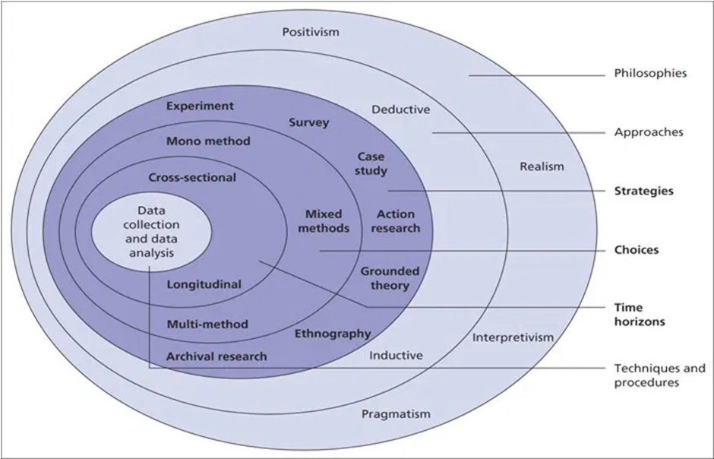

3.2 The Research Onion (Saunders et al, 2009)
To conduct meaning full research, (Saunders, Lewis and Thornhill,2009) developed a model which they named the ‘Research Onion’. The research onion is a model that helps to understand the different pathways and methods of research as well as the different factors that need to be considered as part of the research process.
The Research onion consists of 6 layers, techniques and procedures, time horizons, choices, strategies, approaches and philosophies. These are used to create a pathway for the research that is going to be gathered later on in the project. Figure 1 shows the pathway that has been used in researching this project.

3.3 Research Philosophies
‘’The research philosophy you adopt contains important assumptions about how you view the world’’ (Saunders et al, 2009)
Positivism can be explained as a way in which information can be gathered and can be verified and shows logical or mathematical proof.
(Smith, 1996) Explains that positivism is a way in which an individual can explain the sciences of a social construct.
The research involving positivism within social environments can vary since it can all change due to opinion rather than fact. Positivism is a way in which the researcher can present a set of statistics in a way that is appropriate, unbiased and understandable.

3.4 Research approaches
This business research project will be using a deductive approach to the research element. Using a deductive method is the most appropriate method to use for this form of research. ‘’It involves the development of a theory that is then subject to a rigorous test through a series of propositions.’’ (Saunders, Lewis, Thornhill, 2019) Through this project, data will be collected from individuals within the Swansea area in which the data will be assessed and a conclusion will be made based on the hypothesis and finding out the main reasons from those current findings.

3.5 Research method and data collection
This business research project has used the questionnaire method to collect the appropriate data to help analyse the issue in question. This method has been chosen to help indicate exactly what peoples issue is with drinking in pubs per individual, it will show the different factors that encourage and discourage people to go to the pub and will be a valuable insight into people’s drinking habits and how this effects drinking culture. ‘’the success of a survey has more to do with the researcher’s ability to think through and integrate the various stages of the process than with following a rigid set of rules’’ (Flowerdew and Martain, 2005)
The questionnaires that have been distributed to people have been created using google forms in which the researcher has distributed these forms through various social media channels such as Facebook, Instagram and Twitter via the researchers' personal account, due to the convenience of being a resident in the place of the conducted research. Social media is a good way of distributing questionnaires to participants that would be more inclined to engage with the post due to the social interaction with that individual previously. ‘’Social media have provided new opportunities to consumers to engage in social interaction on the internet. Consumers use social media, such as online communities, to generate content and to network with other users. The study of social media can also identify the advantages to be gained by business’’ (Hajli, 2014)
Questionnaires are a good way of conducting research due to the fact it can be a quick way to achieve a statistic for something but also due to the fact it can be rather convenient for the participant due to social media and the internet. ‘’The questionnaire is by far the most common instrument, whether administered in person, by phone or online.’’ (Kotler, Armstrong, Harris and He, 2019)

3.6 Sample
The sampling method that has been put into place is a convenience sample within this business research project, which is also known as an opportunity sample. ‘’Convenience sampling, as its name suggests, involves selecting sample units that are readily accessible to the researcher.’’ (Lewis-Beck, Bryman and Futting Liao, 2020)
This will mean that the researcher will be distributing the questionnaires within the Swansea area through various social media channels.

3.7 Data Analysis
Appropriate statistical tests have been made to accurately assess the data collected to ensure that the outcome of the statistics was under a controlled assessment to show more accurate data.

3.8 Quantitative research
A quantitative approach is used when the researcher starts with a hypothesis and conducts their tests for confirmation or disconfirmation on the theory in question. (Newman, Benz and Ridenour, 1998) The project contains quantitative research methods due to the previous research already available around the topic of pub closures, to help understand the main reasons for the rise in pub closures and assessing the change in drinking culture and how this has directly affected that industry.

3.9 Limitations and ethical considerations

3.9.1 Time management
To ensure that the researchers time is used effectively, certain measures have been put in place including a Gantt chart to ensure time is spread out effectively thought the project. Gantt charts are used to plan workloads for individuals and projects as without them the functionality of a workplace or project could be altered due to lack of planning (Gantt Charts: A Centenary Appreciation, 2003). A Gantt chart that has been created for the project can be seen in the Appendices under number 18.

3.9.2 Ethical Considerations
When researching any work or project involving people or companies, certain ethical considerations need to be taken into consideration to ensure peoples happiness and safety.
No one under the age of 18 has been involved within this project due to the nature of it involving alcohol, it does not include vulnerable people or illegal activities. The aim of This project is not to cause distress for others but rather to retrieve appropriate information for the project in hand. (Wilson, 2014)

3.10 Chapter summary
This chapter has discussed the research philosophies and has shown the methods that have been considered and undertaken within this business research project. It has explained the research onion in which the researcher will use to aid the research methods that have been conducted. It discussed factors that need to be considered to ensure that meaningful and accurate data has been collected. It has discussed the research approaches, strategy’s, sample, the reliability and validity of the research has mentioned the ethical considerations that have been made to the project.

Chapter 4

Chapter introduction
This chapter will be looking at the data that has been collected from the sample of individuals asked through a survey. The sample in question were individuals who are associated with the researcher’s social media account, therefore could impact some of the answers due to the personal connections the researcher has with the participants. The research was conducted through the IBM Statistics, this application has been used to provide the graphs seen in this chapter. The word clouds within this section were made using Microsoft Word to show the open-ended questions that were asked within the survey. All other questions that have not been discussed within this chapter can be found in the appendix in a graph form.

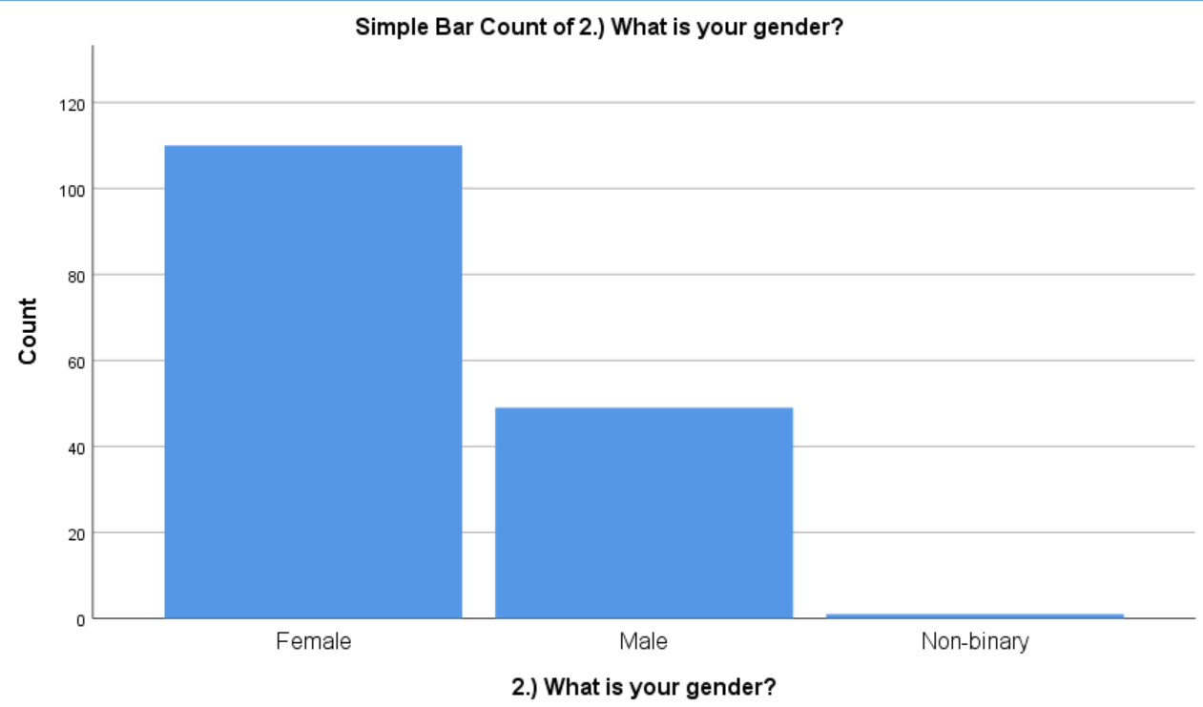

4.1 Figure 1 (What is your Gender?)

Figure 1 shows the gender of the participants within this survey since a large majority of individuals being female, it would be interesting to know what a female's honest opinion is on the pub given the nature of the environment is predominantly a male-dominated. (Schmitt and Sapsford 1995)

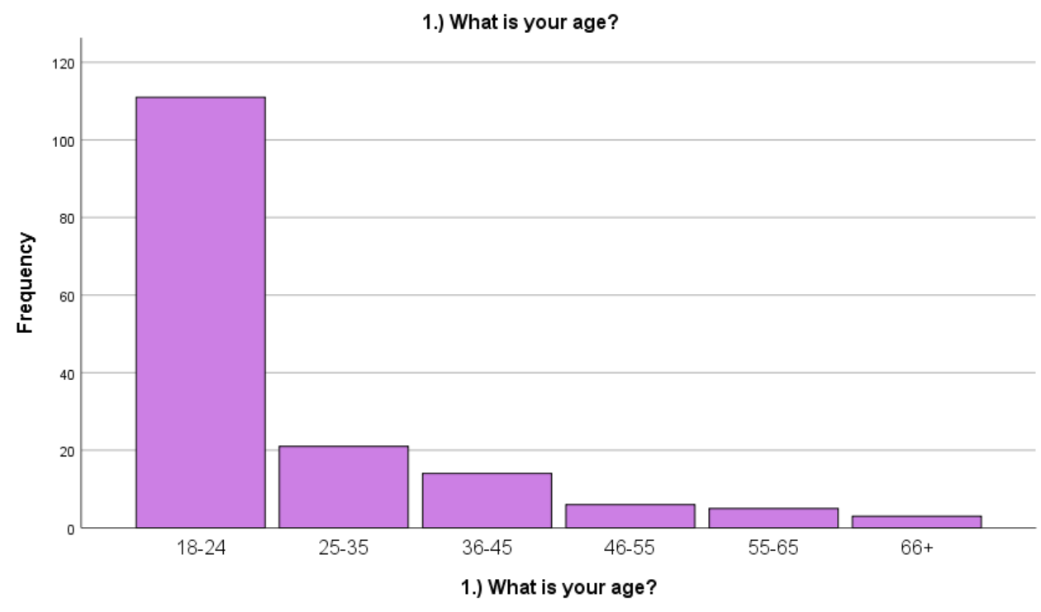

4.2 Figure 2 (What is your age?)
Figure 2 shows the age range of the participants and shows a large majority of people of a younger generation including students, meaning that the data will be strongly influenced by their opinions alone.
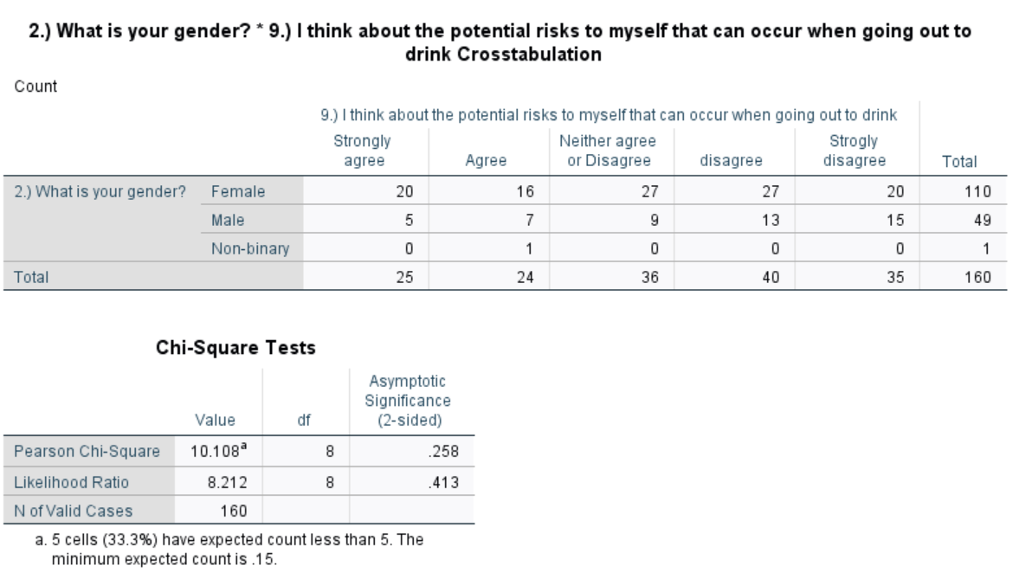

4.3 Figure 3 ( I think about the potential risk to myself that can occur on a night out?)
Figure 3 shows the comparison between gender and the thoughts on their safety when going out to drink, as the chi-square shows the percentage is above 0.005 indicating that it is not statistically significant but does show a wide range of peoples views on their safety when going out to drink. There is a stigma that surrounds the pub, also mentioned in the literature review by Schmidt and Sapsford (1995) that male-dominated places such as the pub are where women are made to feel unwelcome or harassed. this evidence also suggests the statistics from (Drink Aware n.d) previously mentioned within this project, that Women receive unwanted physical and sexual contact on nights out stating that it has ruined their night, is true is somewhat true in this case.

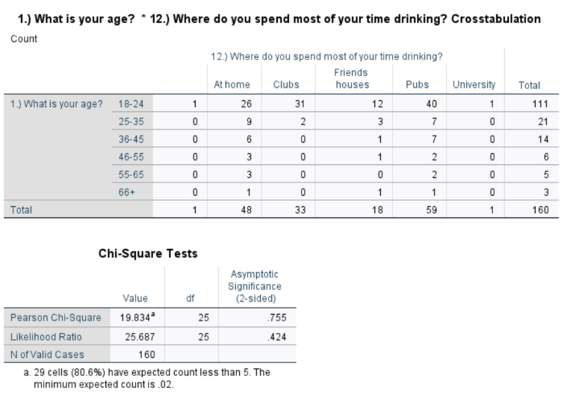

4.4 Figure 4 (Where do you spend most of your time drinking?)

Figure 4 shows a comparison between age and drinking environments. The chi-square shows the percentage is above 0.005 indicating that it is not statistically significant, however, it shows that the individuals asked still favour the pub although there is still a large majority of people who choose elsewhere. At home is the second-highest figure, this could be due to the rising cost of alcohol and as said previously within the literature review, an article by (The Independent 2013) has stated that people tend to spend most of their time at home to drink and socialise due to the convenience and price. (Brown 2013) has also discussed previously that people’s homes have the place of entertainment as opposed to placed like the pub.

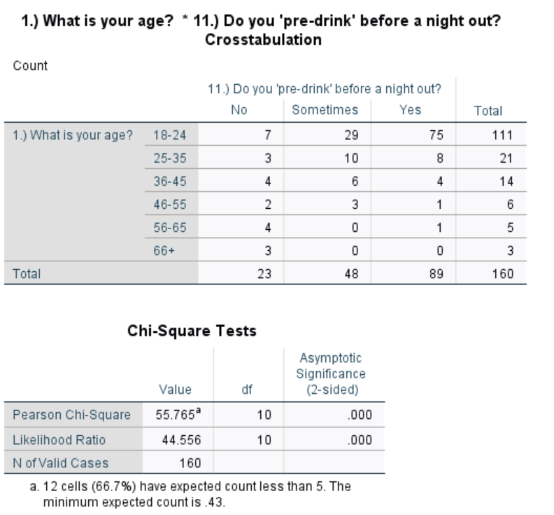

4.5 Figure 5 (Do you pre-drink before a night out?)
Figure 5 shows that due to the chi-square being below 0.005 that the data collected is significant and there are definitive links between the factors in question. The figure shows the comparison between age and whether the individual pre-drinks before going out. The chart shows that 89 people out of the 160 asked do pre-drink, with the majority of these individuals being in the 18-24 category. This could be due to the drinking habits of a student with the ‘’ determined drunkness’’ drinkers as discussed by both Giles (2015) and Lohida (2018).

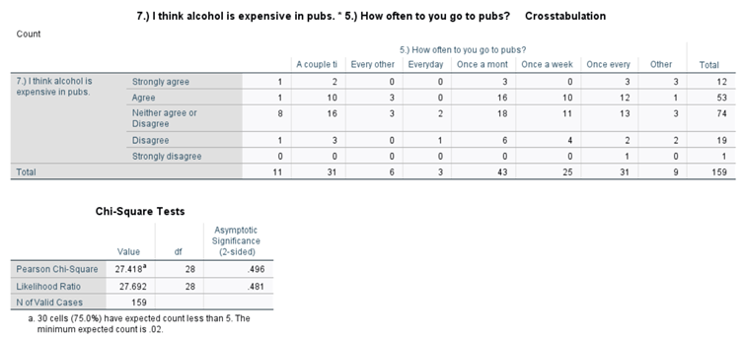

4.6 Figure 6 (How often do you go to pubs? + I think alcohol is expensive in pubs.)
Figure 6 shows the comparison between how often the individual goes to the pub and their opinion on the price of alcohol. This graph shows that because the significance of the chi-square is above 0.005 it is an insignificant factor within the project and has no definitive links, however, it does show some interesting findings. It shows that the majority of people who participated neither agree nor disagree with the statement made but the results show it leaning more to the agree side of the graph. This shows along with many of the other tests shown in this project that the price of alcohol is a major contributing factor to why people are discouraged from going to the pub.

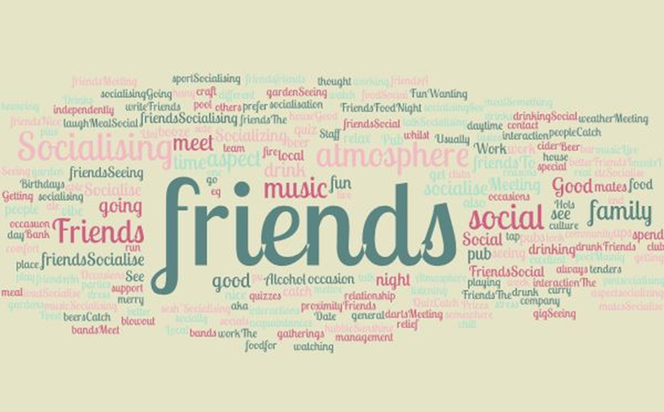

4.7 Figure 7 (What encourages you to go to the Pub?)
Figure 7 shows a word cloud with the regularly mentioned words from the open-ended questions the individuals were asked. It is clear to see most of the reason for people visiting the pub establishment is to socialise with family and friends which is essential in the cohesion of communities and their personal interactions as stated by (Cabras 2011). However, it could also indicate as shown in figure 4, there are multiple different places in which people can communicate, and due to the rise in social media, people are deprioritising their inter-person communication, therefore there is less need for an establishment such as a pub to socialise in as discussed by (Birch 2020).
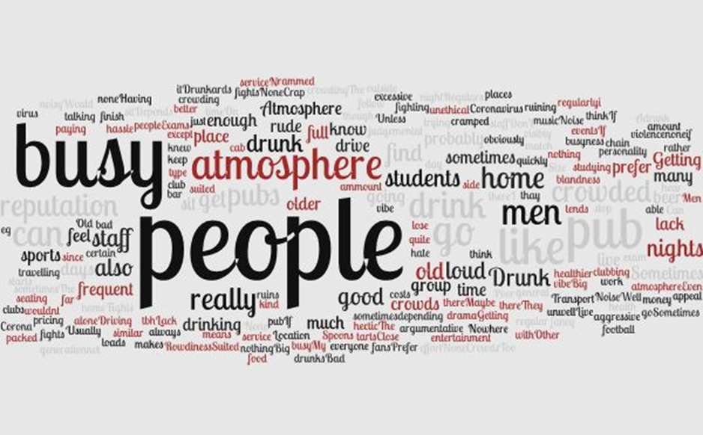

4.8 Figure 8 (What discourages you to go to the Pub?)
The word cloud shown in figure 8 is quite an interesting discovery to this research project as it shows that of price nor any logistics of the pub atmosphere that discourage individuals to go to the pub but the actual presence of other groups of people. However, it does state men and atmosphere
The word cloud shown in figure 8 is quite an interesting discovery to this research project as it shows that of price nor any logistics of the pub atmosphere that discourage individuals to go to the pub but the actual presence of other groups of people. However, it does state the words men, atmosphere and old quite clearly within the word cloud which relates to the statements around the pub atmosphere previously stated within this research project, that it feels like it is a male-dominated atmosphere in which women are made to feel unwelcome (Schmidt and Sapsford 1995). With the large majority of individuals who participated within this survey being women as shown in figure 1, these statements made prove these statements true in this case.

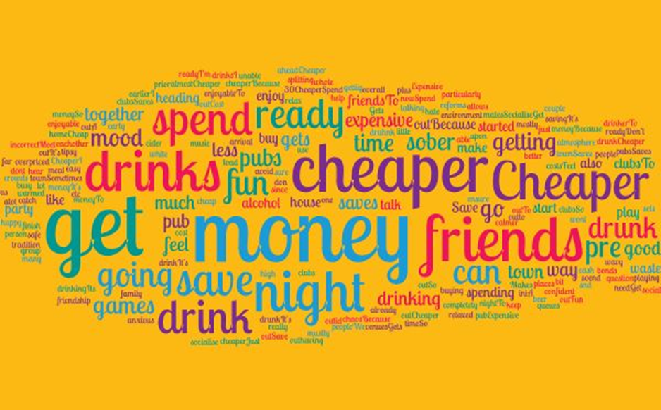

4.9 Figure 9 (Why do you pre-drink?)
The word cloud in figure 9 shows at one of the main reasons for people pre-drinking before going out is because it is cheaper and saves money. The word cloud also shows it is because pre-drinking is now part of the night out experience as it is a place for friends to congregate together before going out. It is also shown within this word cloud the reasons for pre-drinking is because they intend on drinking a large amount of alcohol at home to prevent spending money when out, which is discussed within the project from statements made by Giles (2015) and Lohida (2018) that there is now ‘determined drunkness’ drinkers. These drinkers are in the 20 somethings category who’s aim from going out to drink is getting as drunk as possible. With the majority of participants who participated in this project being of that age range as shown in figure 2, this statement has proven true in some cases.

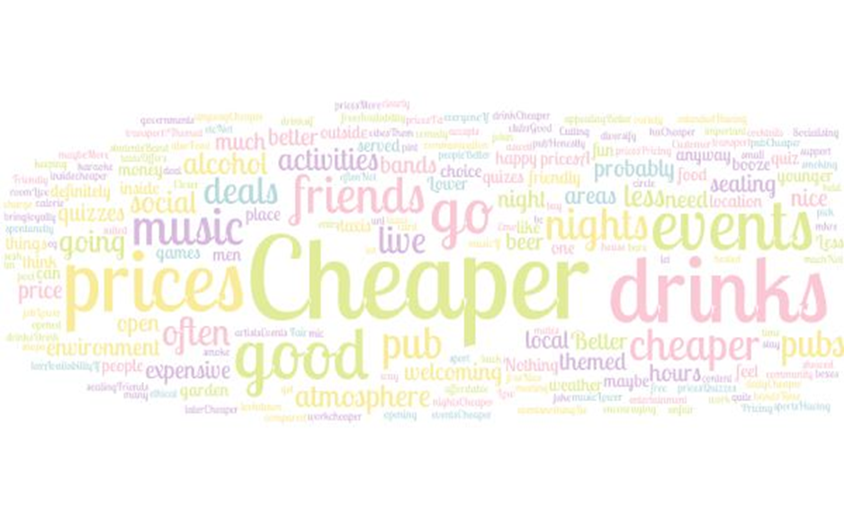

4.10 Figure 10 (What would encourage you to go to the pub more often?)
The word cloud shown in figure 10 shows the factors most important reasons to encourage the people who participated in the surveys to go to the pub more often. The word cloud clearly shows that prices and the overall cost of going to the pub is an issue for individuals. It also shows that people want more from their going out experience, people seem to want events and live music along with games and quizzes to entertain themselves and their friends. Brown (2013) was mentioned in the literature review stating that there is such a wide range of leisure activities to choose from instead of just the pub in today’s society. Also stated in the literature review by (Lohida 2018), that many individuals today do not drink or choose not to for personal reasons, so for those individuals going to an establishment where the sole focus of the place is drinking can seem unappealing.

Chapter Summary
This chapter has displayed the findings of the research the researcher has accumulated within the test section for this business research project. It has shown different tests the researcher has made to try to better understand the reasons into which people are discouraged to go to the pub and provides new and interesting information about the topic in question. It has displayed multiple different finding to support but also challenge the previous findings and discussed the factors surrounding drinking that matter to individuals that live within Swansea.

Chapter 5

Chapter introduction
This chapter will be discussing the research that has been found within the business research project and how it relates to the topic of pub closures, drinking habits and behaviours of individuals within Swansea.

5.1 Objectives
The objectives of this research project were to conduct a survey stating factors contributing to pub closures and present them to the public through a survey. This objective has somewhat been met as the survey did not state reasons for pub closures but rather asked the individual questions surrounding the possible contributing factors. The objectives also stated that the project was going to ask the consumers in question to state the reasons based on their own opinion of the problems surrounding the pub. This objective has also been met due to the question asked within the survey asking the participant to state reasons that encourage and discourage them to go to the pub. The final objective was to assess the information gathered and use it to understand the changes to drinking culture within the city and understand what would get people back to the pub. This objective was partly achieved as the information has been gathered and assessed within chapter 4 and through this chapter also. This project has also gained an understanding of drinking culture within Swansea and statements have been made by the participants on ways in which to improve custom for pub establishments.

5.2 Main Findings
The results from the research show that the majority of participants who contributed to the survey were young females within the 18-24 category, which means that the data collected from this projects is biased as it has less information and understanding of other demographics of people within society. However, the data is not useless as is does bring an understanding of the view on the pub from that standpoint. The results showed mixed results for the question regarding the risks opposed to people and their awareness of it, showing that it was mostly women that consider these risks before going out to drink. This factor has previously been mentioned within this business research project with Schmidt and Sapford (1995) stating that women are made to feel uncomfortable or have been sexually harassed within these establishments creating this dislike to the place. This reason alone could encourage women or groups of people to be discouraged from visiting the establishment. The survey has also shown that despite the reasons for undergoing this project in question, people still favour the pub over other establishments, however, the figure is not overwhelmingly big in comparison to other places people choose to drink. many people still prefer to drink at home, this has been stated by (Brown 2013) in which people’s homes have become the place of entertainment as opposed to the pub. People who pre-drink before going out to drink were in this case young women indicating the articles by (Giles 2015) and (Lohida 2018) that there are now ‘’ determined drunkness’’ drinkers which are of the age category in question, in which their main aim is to get as drunk as possible. However, pre-drinking is now more than just to save money on drinks when out, the idea of ‘pres’ is about people congregating together before going out as it is now part of the night out experience. The survey also showed that most people choose the option to nor agree or disagree with the statement that alcohol is expensive in pubs although statistically leaning to the more expensive side. This shows that although the price is a main contributor to people not going to the pub, there are factors elsewhere that may discourage the individual more so. The purpose of the pub has previously been discussed as a place in which people come together and has been stated as a place for community cohesion (Cabras 2011), the results showed that the main encouragement to go to the pub was socialising with friends and family. This finding, although seems obvious, could still be impacted by factors such as social media and technology. Birch (2020) discussed the idea that people are deprioritising interpersonal communication due to such factors as social media, therefore discouraging people to even go to the pub in the first place as communication with friends and family can be achieved by other means. The survey also asked participants of the reasons that discourage them to go to the pub, results showed that the main factor was that of other groups of people or the presence of other individuals that discouraged them. The words old, men and atmosphere are main words within the findings indicating that the statements made by (Schmidt and Sapsford 1995) in that male-dominated atmospheres are where they are made to feel uncomfortable of have felt harassed. These reasons could discourage not just one person but an entire group or demographic of individuals to visit establishments in which they are made to feel that way. The individuals asked within the survey stated that things that would encourage them to go to the pub more often, the participants stated that as well as the cost of alcohol, more activities or events such as live music, themed nights, quizzes and games to entertain themselves and their friends is what they felt would encourage them to go to the pub more often. Brown (2013) discussed that with the wide range of leisure activities now available for people to do, it is understandable that pubs are losing custom as it is not the only place to meet with others. Many individuals today, however do not drink, so for those individuals the idea of going somewhere with a group of people where the sole purpose is drinking seems unappealing, therefore perhaps discouraging an entire group of people for one individual.

5.3 Limitations
This business research project has been successful in many ways however there are a few factors that could have impacted the results. The fact that the surveys were distributed through various social media channels via the researcher’s accounts could have made the data found somewhat unreliable due to the personal connection the researcher has with the individual in question. The data gathered was from some individuals the researcher knows personally so some inappropriate language and responses were made, however, the purpose of the project was to gain understanding into the main reasons into why individuals do not go to the pub, therefore, the inappropriate responses were not taken into consideration. COVID-19 was another contributing factor to the changes and issues within this project. The initial idea for this project has had to change over the time of writing due to such factors as COVID-19, interviews and research that was going to be conducted from certain establishments was unable to go ahead due to the country’s lockdown.

5.4 Conclusion/ Recommendations
This business research project has shown that there are multiple different reasons in which individuals are encouraged and discouraged to go to the pub, however, there are reoccurring themes within the findings that suggest that individuals want cheaper drinks, more events, live music, games and general activities. People now want more from the pub and need something to entice them to bother leaving the comfort of their own homes where people spend most of their time drinking and entertaining these days. The pub will remain a part of British culture and fits a purpose within society, keeping the cohesion of communities together for decades to come and a place many seem to cherish, however, the world of hospitality, catering and leisure is ever-growing indicating that pubs will have to keep up with modern trends and the drinking culture of Britain today. Pubs as a whole need to understand what individuals want from their experience at a pub and will need to adhere to that if they are going to remain a main competitor within the business world.

References
Schmidt, R. and Sapsford, R., 1995. Womens View Of Pubs - A Study Of Methods. Journal of Managerial Psychology, [online] 10, pp.18-25. Available at: <https://www.emerald.com/insight/content/doi/10.1108/02683949510075542/full/html?queryID=34%2F5409317> [Accessed 16 April 2020].

Drinkaware.co.uk. 2020. You Wouldn't Sober, You Shouldn't Drunk. [online] Available at: <https://www.drinkaware.co.uk/advice/staying-safe-while-drinking/sexual-harassment/> [Accessed 16 April 2020].

Burch, K., 2020. How Social Media Affects The Mental Health Of Teenagers. [online] Business Insider Australia. Available at: <https://www.businessinsider.com.au/how-does-social-media-affect-teenagers-2020-3> [Accessed 16 April 2020].
Cabras, I., 2011. Industrial and Provident Societies and Village Pubs: Exploring Community Cohesion in Rural Britain. Environment and Planning A: Economy and Space, 43(10), pp.2419-2434.

the Guardian. 2018. Nearly 30% Of Young People In England Do Not Drink, Study Finds. [online] Available at: <https://www.theguardian.com/society/2018/oct/10/young-people-drinking-alcohol-study-england> [Accessed 14 April 2020].

Brown, J., 2013. Stay-At-Home Drinking And Socialising On The Rise In Britain. [online] The Independent. Available at: <https://www.independent.co.uk/news/uk/home-news/stay-at-home-drinking-and-socialising-on-the-rise-as-britons-avoid-paying-premium-of-being-served-9001375.html> [Accessed 14 April 2020].
Lodhia, D., 2018. Millennials Haven't Killed Pubs – Pubs Just Haven't Kept Up | Devarshi Lodhia. [online] the Guardian. Available at: <https://www.theguardian.com/commentisfree/2018/nov/12/millennials-killed-pubs-prices-diversification-boozer#maincontent> [Accessed 14 April 2020].

Alcohol Change UK. 2020. Drinking Trends In The UK | Alcohol Change UK. [online] Available at: <https://alcoholchange.org.uk/alcohol-facts/fact-sheets/drinking-trends-in-the-uk> [Accessed 12 April 2020].

Pugh, Geoff, Tyrall, David, Wyld and John, 2001. Will progressive beer duty really help UK small breweries? A case study in proffit appropriation. Journal of small businesses and enterprise development, [online] 8(4), pp.311-337. Available at: <https://www.ingentaconnect.com/content/mcb/271/2001/00000008/00000004/art00002> [Accessed 12 April 2020].
Weale, S., 2019. Levels Of Distress And Illness Among Students In UK 'Alarmingly High'. [online] the Guardian. Available at: <https://www.theguardian.com/education/2019/mar/05/levels-of-distress-and-illness-among-students-in-uk-alarmingly-high> [Accessed 9 April 2020].

The Independent. 2013. Stay-At-Home Drinking And Socialising On The Rise In Britain. [online] Available at: <https://www.independent.co.uk/news/uk/home-news/stay-at-home-drinking-and-socialising-on-the-rise-as-britons-avoid-paying-premium-of-being-served-9001375.html> [Accessed 9 April 2020].

BBC News. 2020. Minimum Alcohol Pricing Comes Into Force. [online] Available at: <https://www.bbc.co.uk/news/uk-wales-51674263?intlink_from_url=https://www.bbc.co.uk/news/topics/cq23pdgvrrrt/minimum-alcohol-pricing&link_location=live-reporting-story> [Accessed 9 April 2020].
Kirkby, D., 2007. Beer, Women and Grub’: Pubs, Food and the Industrial Working Class. Springer link, [online] 1(1), p.136. Available at: <https://link.springer.com/chapter/10.1057/9780230597303_9#citeas> [Accessed 13 May 2020].
Smithers, R., 2018. 'We Don't Want Carrot Fluff': UK Pubs Urged To Keep Their Food Simple. [online] the Guardian. Available at: <https://www.theguardian.com/lifeandstyle/2018/sep/06/good-pub-guide-2019-pubs-urged-to-keep-food-simple> [Accessed 13 May 2020].

Ahdb.org.uk. 2018. Our Changing Eating Habits | AHDB. [online] Available at: <https://ahdb.org.uk/news/consumer-insight-our-changing-eating-habits> [Accessed 14 May
Brown, J., 2013. Stay-At-Home Drinking And Socialising On The Rise In Britain. [online] The Independent. Available at: <https://www.independent.co.uk/news/uk/home-news/stay-at-home-drinking-and-socialising-on-the-rise-as-britons-avoid-paying-premium-of-being-served-9001375.html> [Accessed 23 March 2020].
Collis, J. and Hussey, R., 2014. Business Research. 4th ed. Basingstoke, Hampshire: Palgrave Macmillan, p.3.
Davies, R. and Partington, R. (2020). More than 25% of UK pubs have closed since 2001. [online] the Guardian. Available at: https://www.theguardian.com/business/2018/nov/26/uk-pub-closures-financial-crisis-birmingham-ons-figures [Accessed 4 Feb. 2020].
Davies, R. and Partington, R., 2018. More Than 25% Of UK Pubs Have Closed Since 2001. [online] the Guardian. Available at: <https://www.theguardian.com/business/2018/nov/26/uk-pub-closures-financial-crisis-birmingham-ons-figures> [Accessed 23 March 2020].
European Journal of Operational Research, 2003. Gantt Charts: A Centenary Appreciation. [online] 149(2), pp.430-437. Available at: <https://www.sciencedirect.com/science/article/abs/pii/S0377221702007695> [Accessed 22 March 2020].
Flowerdew, R. and Martain, D., 2005. Methods Of Human Geography; A Guide For Students During A Research Project. 2nd ed. New York: Taylor and Francis, p.82.
Grabe, M. and Christophe, k., 2005. Evaluting the advantages and disadvantages of providing lecture notes: the role of internet technology as a delivery system and research tool. The internet and higher education, [online] 8(4), pp.291-298. Available at: <https://www.sciencedirect.com/science/article/abs/pii/S1096751605000576> [Accessed 23 March 2020].
Johnson, J., 2019. Pubs Are Closing Down At A Rate Of One Every 12 Hours, New Figures Show. [online] The Telegraph. Available at: <https://www.telegraph.co.uk/news/2019/02/24/pubs-closing-rate-one-every-12-hours-new-figures-show/> [Accessed 9 March 2020].
Kotler, P., Armstrong, G., Harris, L. and He, H., 2019. Principles Of Marketing. 6th ed. Harlow, United Kingdom: Pearson Education Limited, p.120.
Lewis-Beck, M., Bryman, A. and Futting Liao, T., 2020. Convenience sample. The SAGE Encyclopedia of Social Science Research Methods, [online] 0. Available at: <https://methods.sagepub.com/reference/the-sage-encyclopedia-of-social-science-research-methods/n176.xml> [Accessed 22 March 2020].
Lodhia, D., 2020. Millennials Haven't Killed Pubs – Pubs Just Haven't Kept Up | Devarshi Lodhia. [online] the Guardian. Available at: <https://www.theguardian.com/commentisfree/2018/nov/12/millennials-killed-pubs-prices-diversification-boozer> [Accessed 10 March 2020].
Newman, I., Benz, C. and Ridenour, C., 1998. Qualitative - Quantitative Research Methodology: Exploring The Interactive Continuum. United States Of America: Southern Illinois university press, pp.1-10.
SAGE Journals. 2020. A Study Of The Impact Of Social Media On Consumers - M. Nick Hajli, 2014. [online] Available at: <https://journals.sagepub.com/doi/abs/10.2501/IJMR-2014-025> [Accessed 21 March 2020].
Saunders, M., Lewis, P. and Thornhill, A., 2009. Research Methods For Business Students. 5th ed. Harlow: Pearson, p.108.
Smith, S., 2009. International Theory. 1st ed. Cambridge: Cambridge Univ. Press, p.11.
The Independent. 2020 Stay-At-Home Drinking And Socialising On The Rise In Britain. [online] Available at: <https://www.independent.co.uk/news/uk/home-news/stay-at-home-drinking-and-socialising-on-the-rise-as-britons-avoid-paying-premium-of-being-served-9001375.html> [Accessed 23 March 2020].
Wilson, J., 2014. Essentials Of Business Research: A Guide To Doing Your Business Research Project. 2nd ed. London: SAGE publications, pp.90-94.

Appendix

1 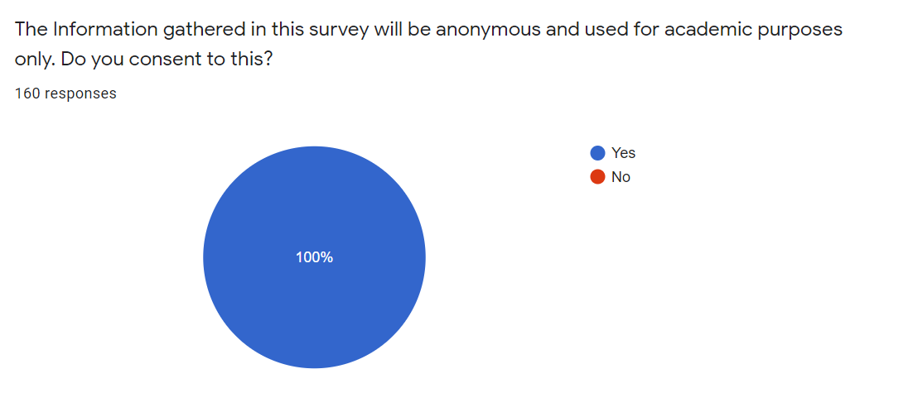
2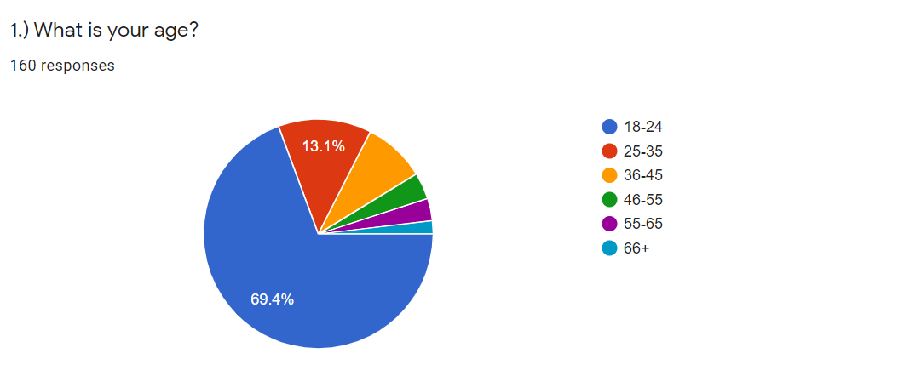
3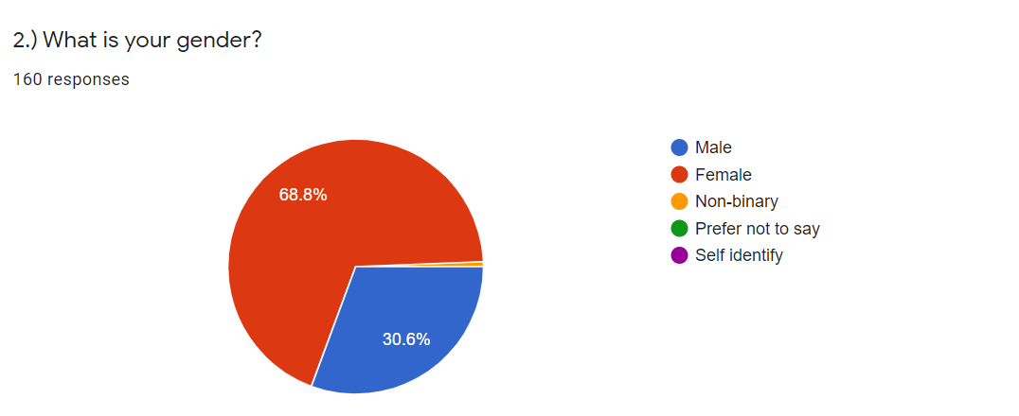
4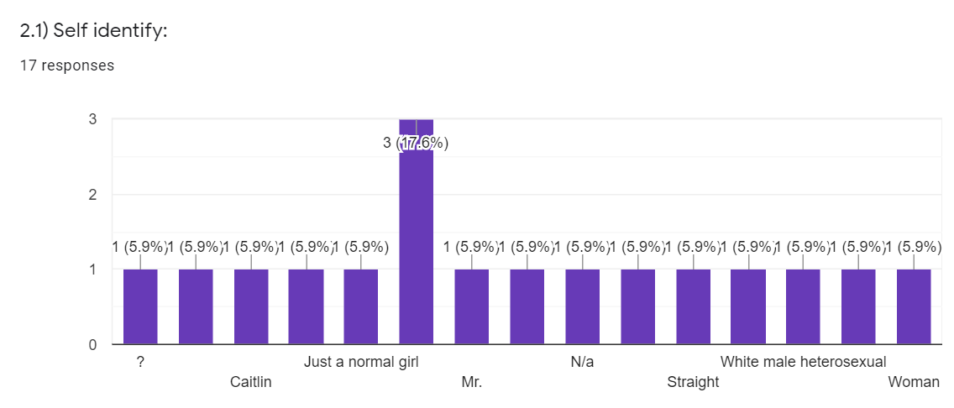
5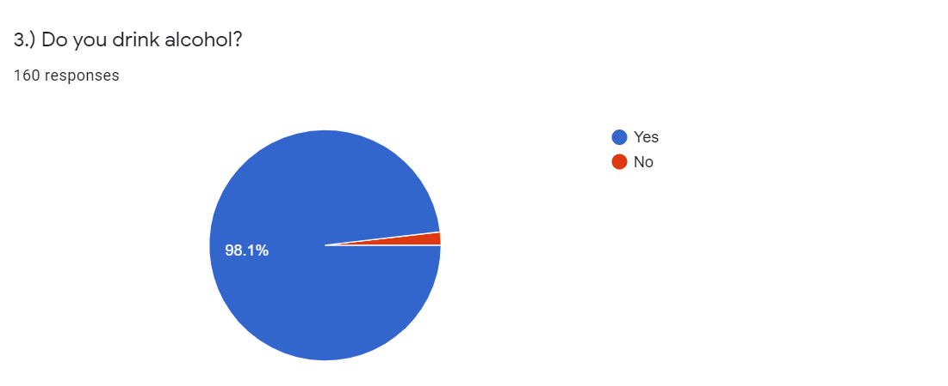
6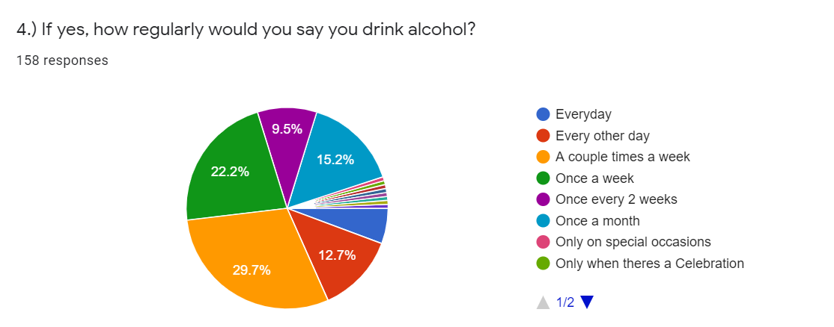
7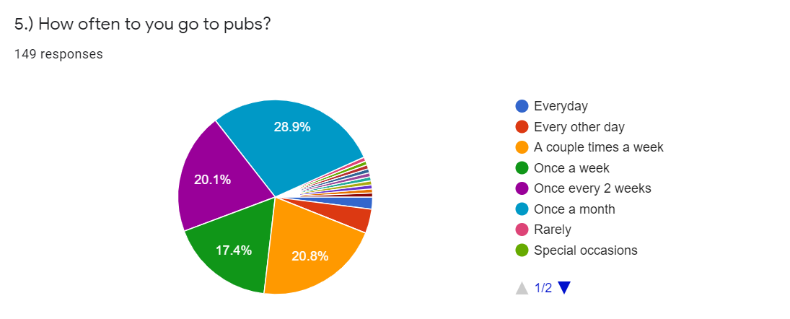
8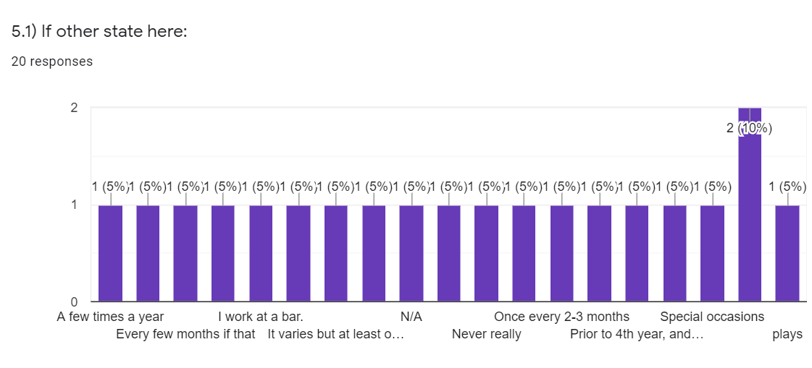
9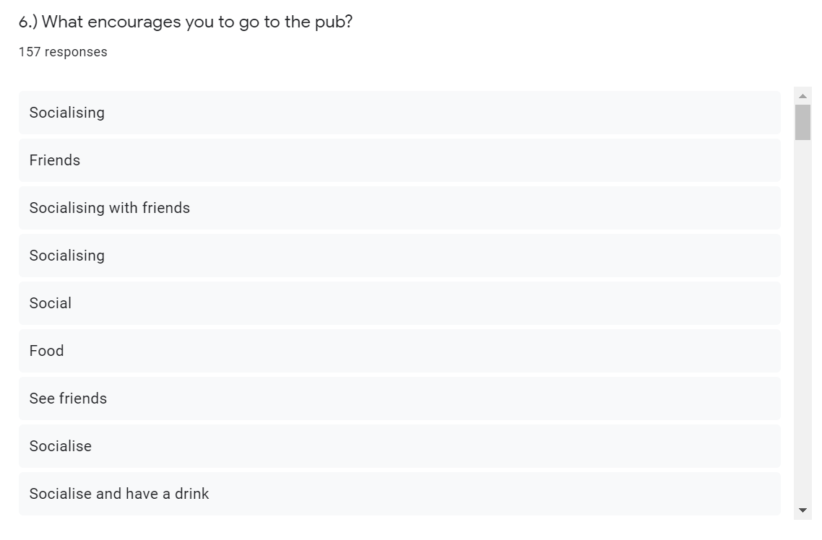
10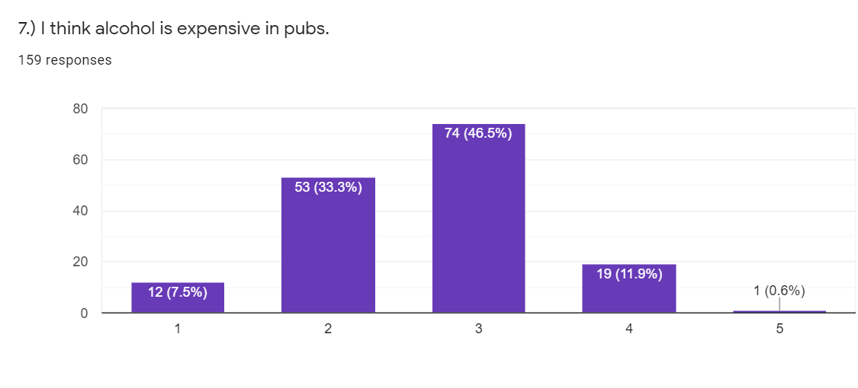
11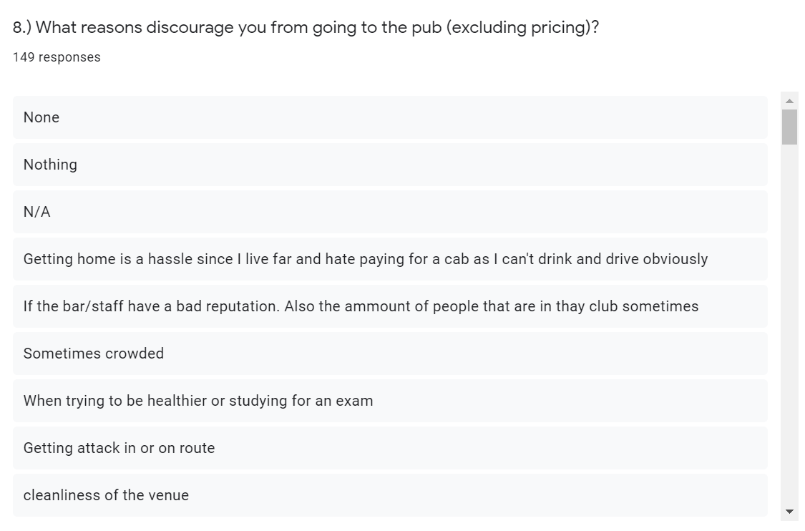
12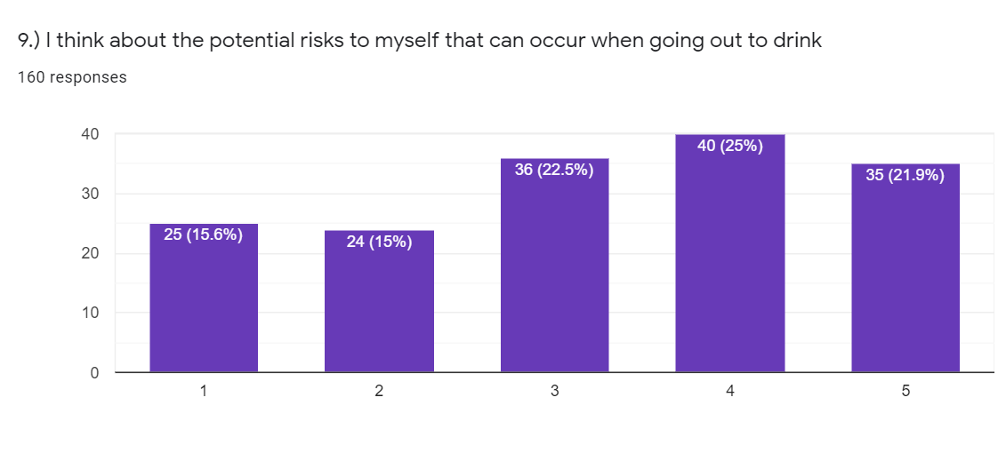
13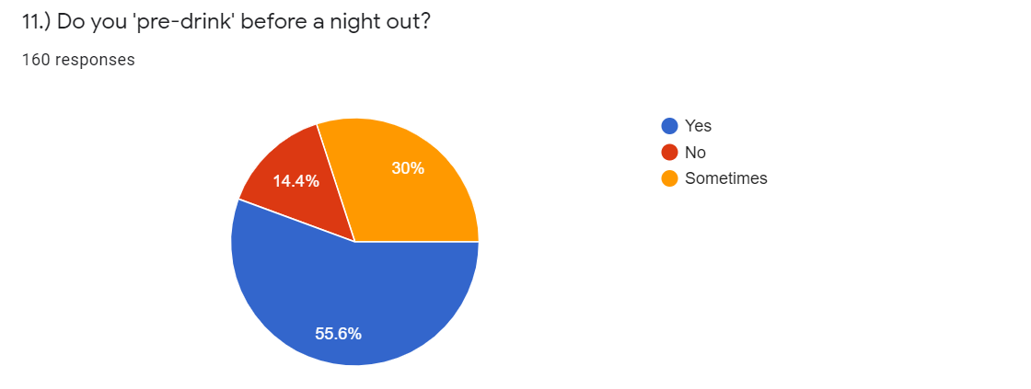
14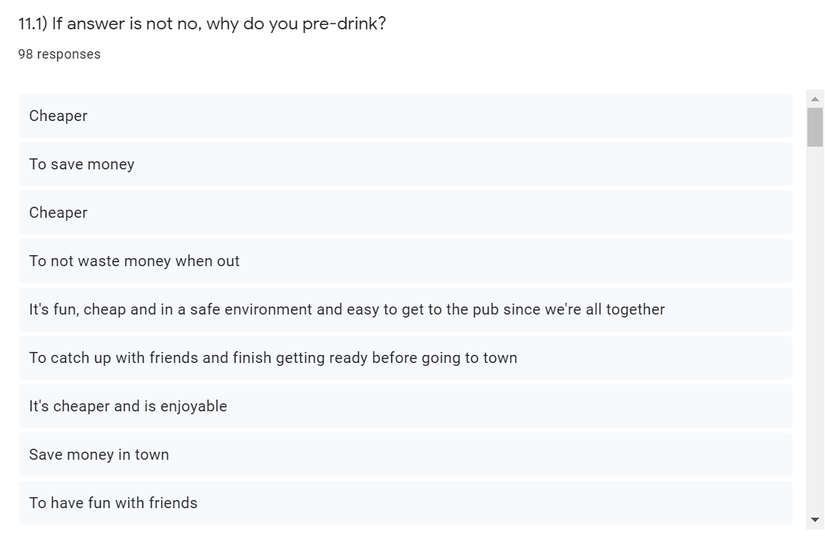
15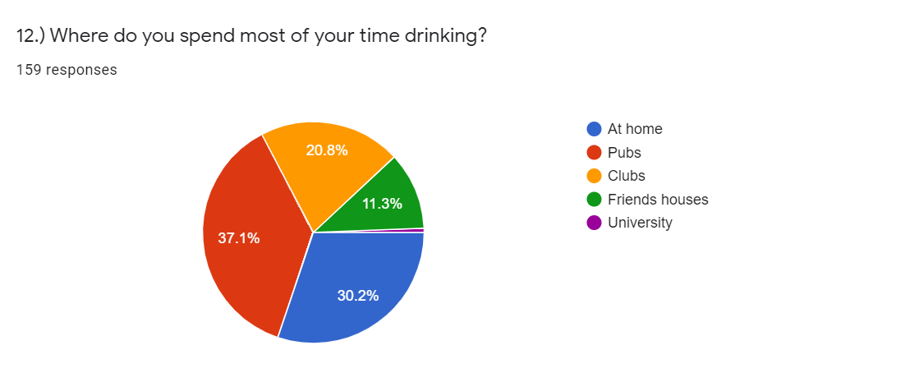
16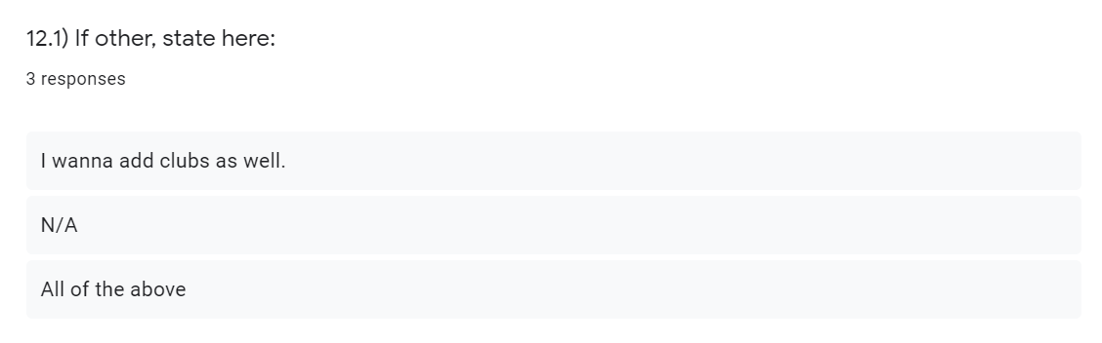
17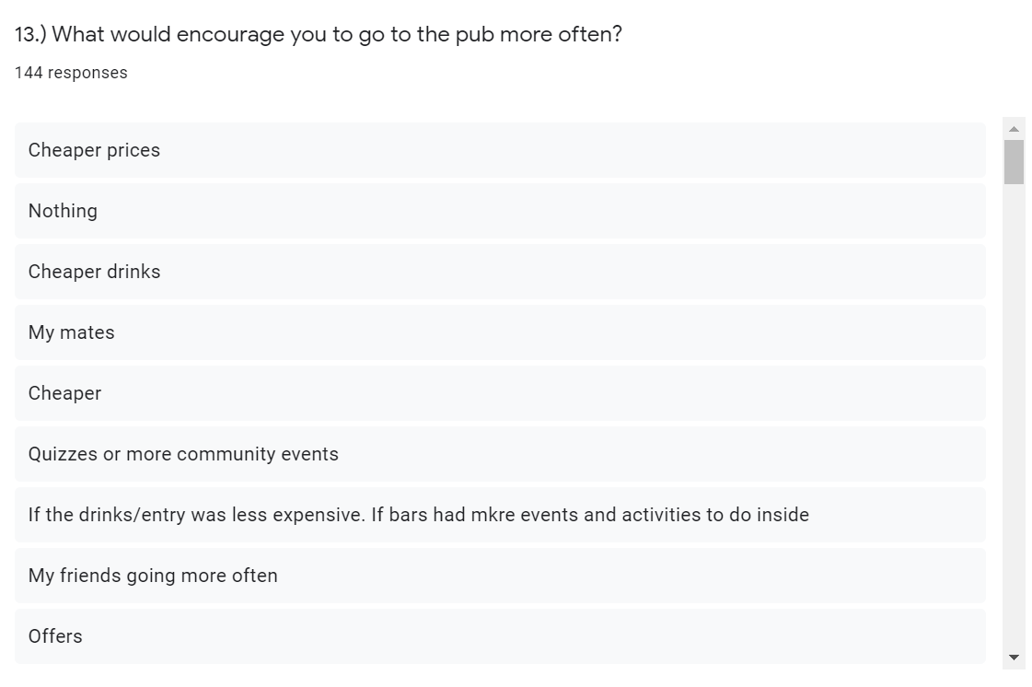
18

