Recognise the major forces shaping the global business environment and
gain an
understanding of the changing global business environment.
• Apply relevant business models (Porter’s Diamond, Value Network, and Five Forces)
within the context of an international environmental analysis (PESTEL).
• Identify and critically evaluate the reasons why organisations engage in international
trade.
• Assess markets in action, understanding their micro-economic and macroeconomic
foundations, different market structures and their influence on firm strategy, long-run and
short-run changes, and major features of the current international economy

Consider the automobile industry, select a brand and critically evaluate the challenges of their internal and external business environments. In your evaluation, you should reflect on the challenges they encounter in trading across the globe; your evaluation should be critical enough to address their SWOT, PESTLE utilising Porter’s Five Forces, Value Chain, and their competitive advantages concerning their core values on sustainability.

Introduction

Understanding of the changing global business environment.
Introduction Of Ford company

(Macro and Micro Business Environment )
SWOT, PESTLE utilising Porter’s Five Forces, Value Chain

Identify and critically evaluate the reasons why organisations engage in international
Trade – competitive advantages concerning their core values on sustainability.

• Assess markets in action, understanding their micro-economic and macroeconomic
foundations, different market structures and their influence on firm strategy, long-run and
short-run changes, and major features of the current international ec
Global business environment :

Corporations look abroad both to buy and to sell: to obtain better or cheaper inputs, and to expand their markets. Many corporations buy and sell internationally, however without becoming multinationals: they import, they export, but they don’t establish foreign operations. International production has its costs: coordination and control, are more difficult at a distance; it is neither easy nor cheap to adapt to operation within a foreign culture and an unknown institutional setting; lack of local knowledge and political connections can expose the company to large and unknown risks. Guy, (2009)

Introduction Of Ford company:
The Ford Company was founded by Henry Ford in 1903 with 11 investors. Since its inception, it has become one of the most recognizable and best-selling cars in the world of automotive construction. Thanks to their service quality and variety, to this day it remains at the forefront of the most common and best-selling cars in the world (Ford, 2020)(Fig.1).

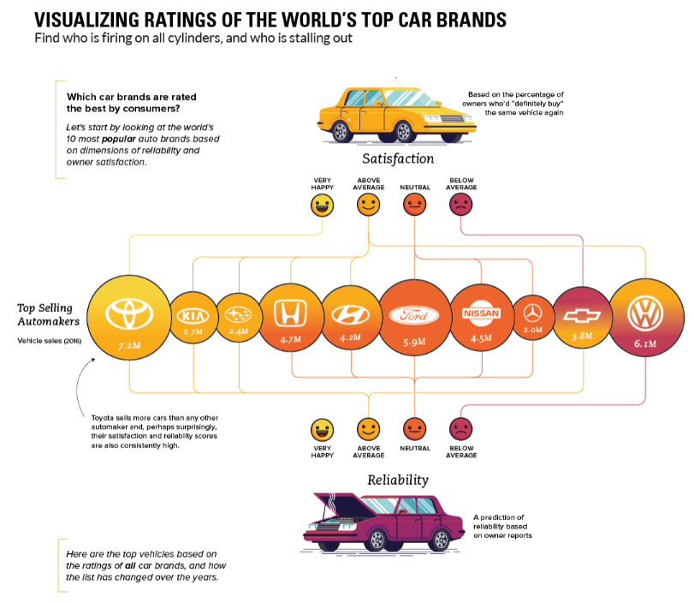
Figure.1 Global Ratings of the top car brands
Source: Desjardins,2021
Figure.2 SWOT Analysis of Ford
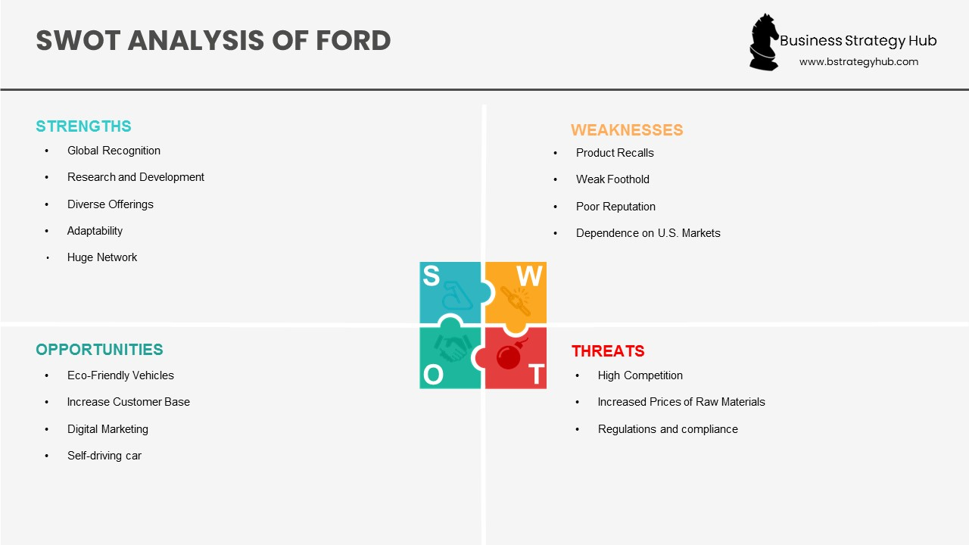

Source: Business Strategy Hub, 2021

Ford’s Strengths:

Global Recognition:
Accordingly, to Statista, (2021) The successful alliance between Ford and Lincolm puts them at the forefront thanks to their marketing and advertising earnings of $ 10.44 billion for 2021.

Research and Development:?
The company ranks second in America in sales after (GM) and fifth after (Toyota, Volkswagen, Hyundai, GM) with sales of 4,187,000 cars in the world (Carlier, 2021).

Diverse offerings:
They try to cover all groups of people, different types of cars that include cheaper and more expensive luxury and not so much for younger and older people. It also applies to other types of cars such as vans and trucks.

Adaptability:
With a wide variety of customer attention and improving the quality of the design of the drive and technology of the car. The company introduced to the market its best-selling pickup F-150 which aims to adapt to rapidly evolving technology launch electric cars (White, 2020).

Weaknesses: Internal Strategic Factors:
In 2016, the company had major problems with the quality of the cars and had to return some of the cars to the factory for various reasons. Defects such as rear door locks, airbags, burning electric car batteries (CNBC staff, 2016).
Another weakness is that the main market is in America and Europe, sleeping with their competitors who offer their range in other countries such as India and China.
Another unpleasant fact is that Ford is dependent on the American market, compared to 2020, the company sold 15% less sales than in 2019.
It has focused on the production of trucks and SUVs and has a great variety. The production of cars has decreased by as much as 45% since the beginning of the production of trucks and SUVs. THIBODEAU, (2022).

Opportunities – External Strategic Factor:
Ford is beginning to follow and adapt to other companies in the market and is trying to offer more types of movement with forms of energy.
From mid-2020, they will increase their market share in India and China. So, Ford can work on digital marketing and be more successful in the market (Ford, 2022).

Threats – External Strategic Factors:

Ford aims to keep innovating because it is in strong competition with other companies in the market. Increasing targets for iron and raw materials may have a huge impact on profits Business Strategy, (2022).

The next caveat is that they have to think more about the environment, the rules for vehicles change every year and the company has to comply with that Business Strategy, (2022).

Pestle Analysis:

Political Factors:
Ford relies heavily on all types of markets, one of which is extremely important and that is the European Union. But there are always risks as Britain wants to leave the union. Duties must be paid and more difficult to deliver.
And in other markets such as South America, Asia, and Brazil it is increasing Marketing, (2022).

Economic Factors:
Due to inflation, all housewives have problems, and this applies to car companies such as Ford, which owns the American market and parts of other markets. There is a large spat supply and demand which leads to fewer car sales Marketing, (2022).

Social Factors:
There are plenty of different brands and types for all kinds of people, Ford understands that it needs to focus on hybrid cars and has several different modifications. He stands for one of the leading positions in this category Marketing, (2022).

Technological Factors:
The great variety of motor vehicles and the great competition increases the taste of consumers, it is becoming more and more mandatory to have more extras. Ford manages to satisfy people's tastes, even adding a system that can drive the car itself. Ford is investing $ 1 billion in it, and Tesla and Google are also investing in it Marketing, (2022).

Legal Factors:
There are regulations and legal environments that hinder Ford's growth. Respects the rules and modernizes and changes the look of the vehicles and the normal development process Marketing, (2022).

Environmental Factors:
Ford understands what people need to do about humans and nature, so it plans to improve its electric cars and hybrids, to invest in Focus Electric and Fusion Hybrid models Marketing, (2022).

Porter’s Five Force:

Competitive Rivalry:

All companies influence the Ford company, the reason is competition. To be one of the best-selling brands, a company needs to invest in innovation. There is also another fact that they influence, such as negotiations with diggers or manufacturers and transport companies

Edward F, (2017)

Power of Buyers:

The other factor is the diggers how they influence Ford, it is easy to change the company from which you dig cars, so Ford has to adapt to this and find alternatives and focus on heavy sales. The company must work hard to meet the needs of the consumer Edward F, (2017).

Power of Suppliers:

Another external factor that can affect is the supplier, if there are a large number of suppliers the price of parts will be lower. The supplier influences when negotiating the quantity and quality and delivery time consumer Edward F, (2017).

Substitute Product:

As an alternative to the company Fotd are transport services, the reason is that easily a user of the brand can take action to use public transport. But it doesn't because Ford provides comfort and safety Edward F, (2017).

Threat of New Entrants or New Entry:

The production of cars and new brands that threaten Ford's business is minimal. The process of brand supply and the capital that is needed is a very complex process and the chance of realization is very small. The threat of new brands and substitutes is very difficult to implement Edward F, (2017).

Value chain:

Inbound:

Ford has plants around the world and supplies them from a variety of raw material suppliers from around the world. Perhaps the most important of these is the DHL. Also in the contract between them it is written that DHL can hire companies and monitor them Pratap А, (2020).

Outbound:

Logistics play a big role in the proper fast and functional delivery of cars and parts. Good logistics is the most important thing in the chain, it aims to reduce delivery mileage as much as possible and increase efficiency down the chain Pratap А, (2020).

Operations:
The company sells its cars worldwide. To make this happen, it owns many canters, shops, offices, and factories and divides them in five parts (North America, South America, Europe, the Middle East and Africa and the Asia-Pacific region). In fact, almost the whole corporation is owned by Ford in America and abroad Pratap А, (2020).

Marketing and sales:
Due to the growing rivalry between the models, Ford has to invest more money every year in online and offline marketing. In 2021, $ 4 billion has been spent, including car shows promotions and advertising Pratap А, (2020).

Products and services:
The company presents a wide variety of vehicles such as cars, SUVs, trucks, electric and luxury cars with the help of modernization and research. With the support of the company Lincoln, which covers the highest standard of tastes Pratap А, (2020).

Technology:
Innovation controls the entire car market, whatever company develops something new, it will dominate. Ford knows this very well and invests every year in its production capacity and improves its supply Pratap А, (2020).

Infrastructure:

Ford's CEO is James Hackett, who takes care of the company's infrastructure and technology, and is actively involved in the design. Ford manages its business globally and regionally. All regions have their leaders. They monitor the work of marketing, production, and design, as well as funding from a country Pratap А, (2020).
HRM:
In 2019, the company has 190,000 employees. The human factor is a very important unit and Ford knows this, it takes care of its employees by giving them the opportunity to grow, as well as rewards and stimulates financially. Conducts programs for training and improving competence Pratap, (2018).

Procurement:
The corporation works with many suppliers around the world, the long-term partnership builds a strong relationship between them and increases new partnerships. With this it provides security and quality deliveries and services Pratap А, (2020).

Competitive Advantage and Future:

SWOT: Ford SWOT Analysis 2021 | SWOT Analysis of Ford - Business Strategy Hub (bstrategyhub.com)

PASTLE: Ford PESTLE Analysis | PESTEL Analysis of Ford Motor Company (marketingtutor.net)

Porter’s Five Force: Porter’s Five Forces (Porter’s Five Forces Model) of Ford-Porter Analysis

Value chain: https://notesmatic.com/value-chain-analysis-of-ford-motors/

Identify and critically evaluate the reasons why organisations engage in international : Organizational change at Ford Motor Company in the face of international financial crisis | Cairn.info

Micro and Macro economics : Macro And Micro Environment Analysis Of Ford Motors (ukessays.com)

Different market structures and their influence on firm strategy: Ford Motor Company and Oligopolistic Market Structure - Free Essay Example | EduZaurus

Ford Motor Company's Competitive Advantage and Future | Business Paper Example (business-essay.com)

References:
Business Strategy, (2022). SWOT Analysis of Ford, Available at https://bstrategyhub.com/swot-analysis-of-ford-2019-ford-swot-analysis/
Carlier M, (2021), Ford - global vehicle sales by quarter 2019 & 2020, Available at: https://www.cnbc.com/2016/08/04/ford-recalls-830000-2012-2016-ford-and-lincoln-vehicles-to-fix-latches.html

CNBC.com staff, (2016), Ford recalls 830,000 2012-2016 Ford and Lincoln vehicles to fix latches, Available at: Ford recalls 830,000 2012-2016 Ford and Lincoln vehicles to fix latches (cnbc.com)
Desjardins, J. (2018). Visualizing Ratings of the World’s Top Car Brands, Available at: https://www.visualcapitalist.com/visualizing-worlds-top-rated-car-brands/
Guy, F. (2009) The global environment of business [electronic resource] . Paperback ed. Oxford :, Oxford University Press.
Ford Motor Company, (2020), ABOUT US, Available at: https://corporate.ford.com/about.html
Statista, (2021), Most valuable brands within the automotive sector worldwide as of 2021, by brand value, Available at: https://www.statista.com/statistics/267830/brand-values-of-the-top-10-most-valuable-car-brands/
THIBODEAU, (2022). Ford sales were off 3% last year, but industry-wide totals still hit 17.1 million, https://www.ford.com/new-hybrids-evs/?searchid=337470059%7C1311717501487247%7C81982395190892%7Cseg-hybb-181002&s_kwcid=AL!2519!10!81982365311248!81982395190892&ef_id=W3PKtAAABNhWjMFc:20181214060845:s
Ford, (2022). The Family of Ford Hybrid and Electric Vehicles, Available at:https://www.ford.com/new-hybrids-evs/?searchid=337470059%7C1311717501487247%7C81982395190892%7Cseg-hybb-181002&s_kwcid=AL!2519!10!81982365311248!81982395190892&ef_id=W3PKtAAABNhWjMFc:20181214060845:s

Marketing, (2022). Ford PESTLE Analysis, Available at https://www.marketingtutor.net/ford-pestle-analysis/

Edward F, (2017), Ford Motor Company: Five Forces Analysis (Porter’s Model) Available at: http://panmore.com/ford-motor-company-five-forces-analysis-porters-model
Pratap А, (2020), Value chain analysis of Ford Motors, Available at: https://notesmatic.com/value-chain-analysis-of-ford-motors/

Pratap, (2018), Human Resource Management at Ford Motors, Available at: https://notesmatic.com/human-resource-management-at-ford-motors/

