Student Name: Elzbieta Beuca  Student ID: 2232428  Module Title: Foreign Languages & Cultural Awareness  Module Code: BMIH5003  Lecturer: Lisa Bassler  Date:07.02.2024 | 
ASSIGNMENT 1: PORTFOLIO
(4 Components)

Component 1: Professional Reflection (500 words +/- 10%)

Weighting: 25%
As an employee at the Holiday Inn Birmingham, I observed a cultural misunderstanding in the hotel restaurant during dinner service between a colleague and a Japanese guest.
The guest, who spoke limited English, appeared confused when presented with the menu. My colleague, intending to be helpful, spoke louder and slower, mistakenly thinking that volume was the issue.
The guest seemed increasingly uncomfortable, probably feeling like the way he was being treated was rude or like they were being talked down to. Additionally, my colleague used hand gestures that were unfamiliar to the guest, leading to further confusion.
Reflection:
Cultural misunderstandings often happen because of assumptions about language proficiency or communication styles.
In this instance, my colleague assumed that speaking louder would aid comprehension, not recognizing that the guest's discomfort was due to the manner of speech, not the language barrier itself. Furthermore, the use of culturally specific gestures added another layer of misunderstanding.
To prevent such misunderstandings, developing cultural competence and sensitivity is important. This involves understanding and respecting cultural differences in communication styles.
Hofstede's Cultural Dimensions Theory can provide valuable insights into cross-cultural communication.
According to Hofstede (1980), cultures vary in their power distance, individualism, masculinity, uncertainty avoidance, long-term orientation, and indulgence, which influence communication styles and preferences. Being aware of these dimensions can help anticipate and navigate potential misunderstandings.
Active listening skills are also vital. This means paying close attention to non-verbal cues and being patient, as suggested by Adler and Elmhorst (2005) in their work on effective communication.
By observing body language and expressions, one can better gauge if the message is being understood or if there's discomfort. Active listening also involves clarifying and confirming understanding, which can prevent assumptions and misinterpretations.
Furthermore, learning about specific cultural norms and etiquette related to dining and hospitality can be immensely helpful. For instance, Japanese culture places a high value on politeness and respect, which should be mirrored in our service approach. Familiarising yourself with these cultural nuances can enhance guest experience and prevent misunderstandings.
Learning basic phrases in the guest's language or using visual aids can bridge communication gaps. As Fantini (1995) discusses in "Language: Its Cultural and Intercultural Dimensions," knowing even a few words in another language can significantly enhance cross-cultural interactions. Moreover, using pictures or symbols on menus can help guests understand options without relying heavily on verbal explanations.
In conclusion, to avoid cultural misunderstandings in the future, I need to develop greater cultural sensitivity, improve active listening skills, acquire basic knowledge of key phrases in different languages, and familiarise myself with specific cultural norms related to hospitality. By doing so, I can ensure a more welcoming and comfortable experience for all our guests, regardless of their cultural background.
References:
Fantini, Alvino. (1995). Introduction-language, culture and world view: Exploring the nexus. International Journal of Intercultural Relations - INT J INTERCULT RELAT. 19. 143-153. 10.1016/0147-1767(95)00025-7.
Adler, R.B. and Jeanne Marquardt Elmhorst (2005). Communicating at work: principles and practices for business and the professions. New York: Mcgraw-Hill.
Nickerson, C. (2023). Hofstede’s Cultural Dimensions Theory & Examples. [online] Simply Psychology. Available at: https://www.simplypsychology.org/hofstedes-cultural-dimensions-theory.html.

Component 2: Training Plan (500 words +/- 10%)

Weighting: 25%

Identified cultural misunderstanding (in a few words):
The training aims to equip employees with skills and knowledge to effectively communicate with guests from diverse cultural backgrounds, emphasising sensitivity to different communication styles and cultural norms.

Training plan (Why/What//Who/Where/When):
What (Content of Training):
Cultural Awareness and Sensitivity Training: According to Getimpactly this covers basic principles of cultural diversity, focusing on understanding and respecting different cultural norms, values, and communication styles. It will include specific modules on common cultural norms in various countries, with a focus on countries most represented in our guest demographics.
Communication Skills Enhancement: Focused on improving active listening skills as suggested by Adler and Elmhorst (2005). This will include understanding non-verbal cues and learning to communicate effectively with guests who may not be fluent in English.
Language Skills Development: Basic language training in key languages spoken by our guests, starting with Japanese. As Fantini (1995) highlights, understanding even basic phrases in a guest's language can greatly improve communication and guest experience.
Practical Hospitality Training: Tailored role-play scenarios and case studies to apply cultural sensitivity in real-life situations, particularly in dining and hospitality settings.
Who (Target Audience):
The training is designed for all front-of-house staff, including receptionists, wait staff, and management.
Receptionists, as the first point of contact for guests, will learn to appreciate cultural differences, ensuring a welcoming environment for everyone.
Wait staff will gain skills in communicating effectively across cultural boundaries, enhancing the dining experience for guests. Management staff will also participate, ensuring a top-down approach to cultural awareness and consistency in service.
To ensure ongoing excellence in service and cultural competence, all employees will participate in regular refresher courses. These courses will build on the initial training, incorporating new cultural insights, advanced communication techniques, and shared learning experiences. This approach keeps our staff updated and well-equipped to cater to a diverse clientele.

Where (Location):
Training sessions will be conducted in the hotel's conference room, utilising both in-person and digital resources for a comprehensive learning experience.
When (Schedule):
The initial training program will be conducted over a period of 3 months, with each module spanning one week. Subsequent refresher courses will be scheduled every 6 months. Additionally, new staff members will undergo this training as part of their onboarding process.
By implementing this training plan, the hotel aims to foster a culturally sensitive and aware environment, enhancing the quality of service and ensuring that all guests feel respected and valued during their stay.
References:
Fantini, Alvino. (1995). Introduction-language, culture and world view: Exploring the nexus. International Journal of Intercultural Relations - INT J INTERCULT RELAT. 19. 143-153. 10.1016/0147-1767(95)00025-7.
Adler, R.B. and Jeanne Marquardt Elmhorst (2005). Communicating at work: principles and practices for business and the professions. New York: Mcgraw-Hill.

Impactly (n.d.). Cultural Sensitivity Training: Everything You Should Know. [online] getimpactly.com. Available at: https://www.getimpactly.com/post/cultural-sensitivity-training#:~:text=Cultural%20sensitivity%20training%20refers%20to.

Component 3: Student Self-Reflection (500 words +/- 10%)

Weighting: 25%
Utilising Gibbs' Reflective Cycle, I will critically reflect on my understanding of the importance of cultural awareness within the hospitality industry. This approach will allow me to systematically analyse my experiences and the lessons learned about respecting and understanding diverse cultures.
1. Description:
Initially, my grasp of cultural awareness in hospitality was superficial. I understood it as simply being polite to guests from different backgrounds. However, witnessing the misunderstanding between a colleague and a Japanese guest at the Holiday Inn Birmingham dramatically changed my perspective. This incident highlighted the complexities of cross-cultural interactions.
2. Feelings:
During the incident, I experienced a combination of feelings: surprise and worry. The surprise came from my realisation that I hadn't completely understood the complexity of cultural differences. This was a revelation to me. On the other hand, I felt concerned because this situation highlighted a significant shortfall in our service. This shortfall has the potential to impact our guests' happiness negatively and could harm the reputation of our hotel. This mix of emotions was a wake-up call, indicating that we need to pay more attention to cultural sensitivities to ensure that all our guests feel welcomed and valued during their stay.
3. Evaluation:
The experience was eye-opening. It revealed the importance of cultural sensitivity, not just in theory but in real-world hospitality settings. While the situation was uncomfortable, it provided a critical learning opportunity. My colleague's well-intentioned but misguided attempt to communicate underscored the need for proper training and awareness.
4. Analysis:
Upon reflection, I realise that cultural awareness in hospitality is multifaceted. It's not just about language barriers, but also about understanding and respecting different cultural norms and communication styles. Trompenaars and Hampden-Turner's Model of National Culture Differences (Trompenaars and Hampden-Turner, 1997) serves as a potent illustration of this concept, highlighting the profound impact of cultural values on interpersonal interactions and expectations. In a similar vein, Hall's Theory of High and Low Context Cultures (Hall, 1976) offers insightful perspectives on the pivotal role of context in effective communication across diverse cultural landscapes. Moreover, Byram's (1997) model of intercultural communicative competence underlines the significance of acquiring not just language proficiency but also cultural sensitivity to foster meaningful connections with guests from different backgrounds.
5. Conclusion:
My understanding of cultural awareness has evolved from a simple concept of politeness to a deeper appreciation of its complexities in the hospitality context. The incident made me recognize the necessity of cultural sensitivity, not only to avoid misunderstandings but to genuinely connect with and serve guests from diverse backgrounds.
6. Action Plan:
Going forward, I will actively seek opportunities to expand my cultural knowledge and language skills. This includes participating in cultural awareness training and learning basic phrases in languages common among our guests. I will also advocate for regular training for all staff, emphasising the importance of understanding cultural nuances in enhancing guest experiences.
In conclusion, the importance of cultural awareness in hospitality cannot be overstated. It is essential for providing high-quality service that respects and values the diversity of guests. As my understanding of this subject deepened, I learned that effectively managing cultural differences is key to the success of any hospitality business.

References:
Fons Trompenaars (1997). Riding the waves of culture: understanding cultural diversity in business. London: Nicholas Brearby.

Hall, E. (1976). Beyond Culture. [online] Available at: https://monoskop.org/images/6/60/Hall_Edward_T_Beyond_Culture.pdf

Mind Tools (2022). The Seven Dimensions of Culture. [online] www.mindtools.com. Available at: https://www.mindtools.com/a5ce21r/the-seven-dimensions-of-culture.

The University of Edinburgh (2020). Gibbs’ reflective cycle. [online] The University of Edinburgh. Available at: https://www.ed.ac.uk/reflection/reflectors-toolkit/reflecting-on-experience/gibbs-reflective-cycle

www.scirp.org. (n.d.). Byram, M. (1997). Teaching and Assessing Intercultural Communicative Competence. Clevedon, UK Multilingual Matters. - References - Scientific Research Publishing. [online] Available at: https://www.scirp.org/reference/ReferencesPapers?ReferenceID=1524544
Component 4: Training Presentation (6 Slides)

Weighting: 25%
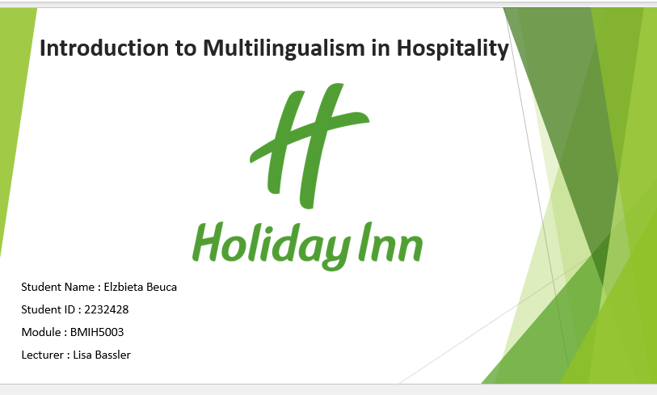
[Content Slide 1]
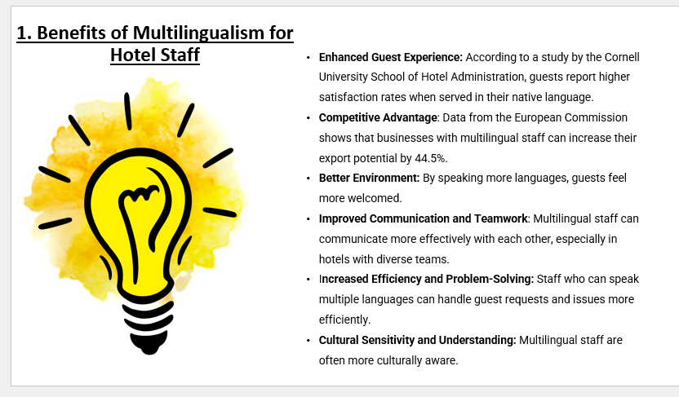
[Content Slide 2]
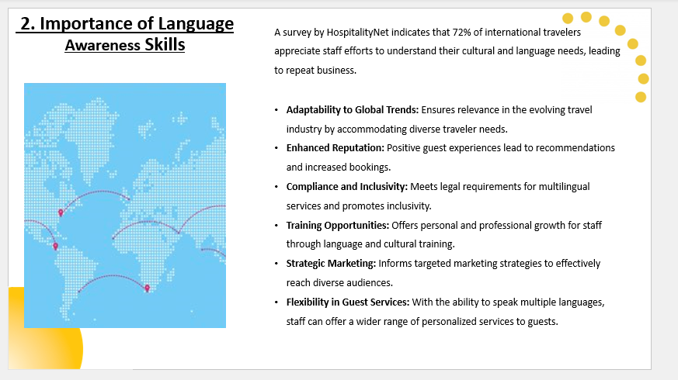
[Content Slide 3]
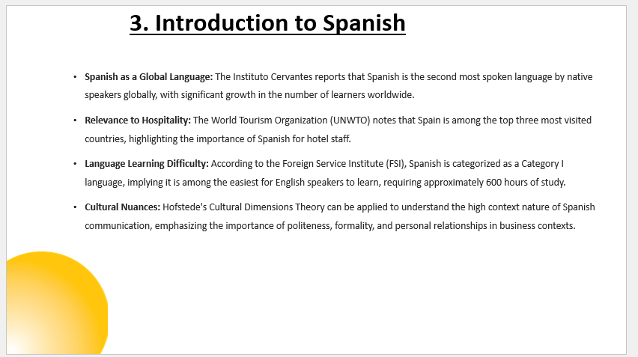
[Content Slide 4]
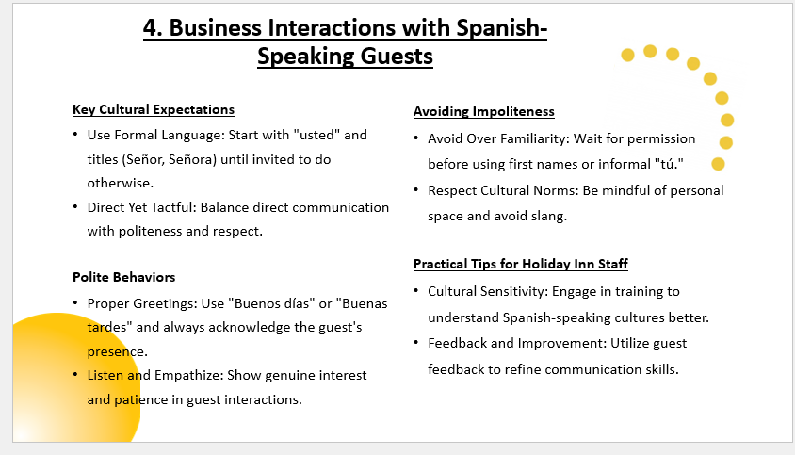
[Content Slide 5]
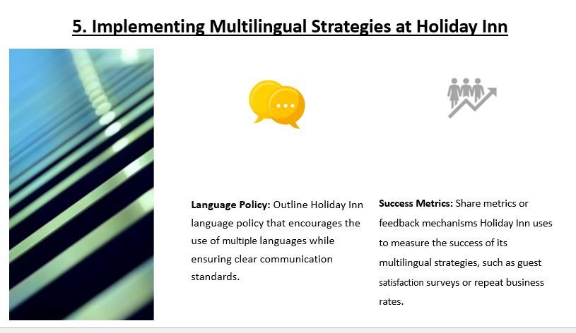
References (no screenshots):

- ELAN: Effects on the European Economy of Shortages of Foreign Language Skills in Enterprise. 2006.
- “FSI Language Difficulty.” Www.fsi-Language-Courses.org, www.fsi-language-courses.org/blog/fsi-language-difficulty/.
- Hofstede, Geert. “Dimensionalizing Cultures: The Hofstede Model in Context.” Online Readings in Psychology and Culture, vol. 2, no. 1, Dec. 2011, pp. 1–26, scholarworks.gvsu.edu/cgi/viewcontent.cgi?article=1014&context=orpc.
- Hospitality Report, Cornell. “Hotel Performance Impact.” • Www.chr.cornell.edu •, vol. 16, no. 10, 2016, sha.cornell.edu/wp-content/uploads/sites/4/2019/03/anderson-engaged-consumers.pdf.
- Martyn, Elizabeth, and Christopher Anderson. The Importance of Focused Training. Vol. 18, no. 9, ecommons.cornell.edu/server/api/core/bitstreams/22a76aa4-a337-45f0-bf44-90ad6dbfddf6/content.
- Net, Hospitality. “Cultural Sensitivity Core to Business Success | by Mark Satterfield.” Hospitality Net, www.hospitalitynet.org/opinion/4081054.html.
- Spanish, a Language Spoken by 580 Million People, and 483 Million of Them Native «Blog Del Instituto Cervantes de Londres. blogs.cervantes.es/londres/2019/10/15/spanish-a-language-spoken-by-580-million-people-and-only-483-million-of-them-native/.
- “World Tourism Organization Underscores Tourism’s Importance for COVID-19 Recovery in Audience with the King of Spain | UNWTO.” Www.unwto.org, www.unwto.org/news/unwto-underscores-tourisms-importance-for-covid-19-recovery-in-meeting-with-the-king-of-spain.

