Quit smoking Health Campaigns
By Catherine Reynolds

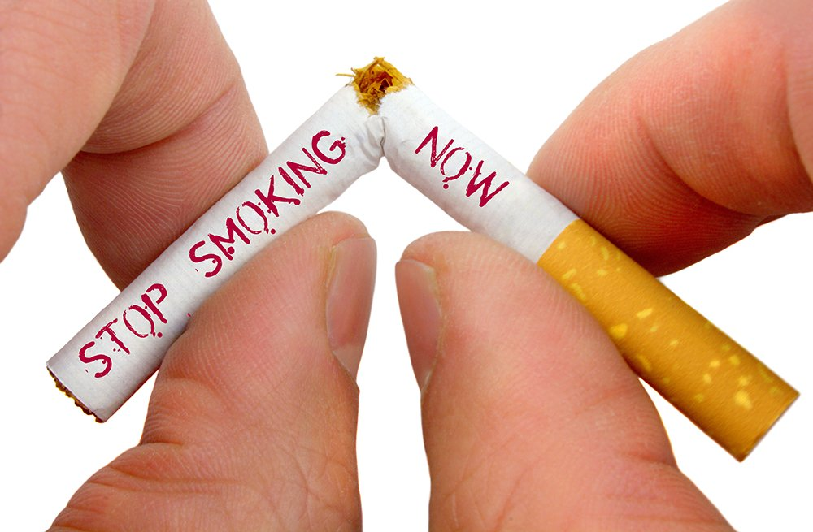

Contents Page

Page 1 – Introduction
Page 2
Page 3
Page 4
Page 5

Health Campaigns
Introduction

How effective are health campaigns? The government has several health policies and targets set to reduce the number of active smokers throughout the United Kingdom (UK). With the number of smokers treated by the National Health Service (NHS) every year being high so are the number of deaths per year. Campaigns are introduced when a condition or conditions increase due to a set reason therefore putting a strain on the health services (Publichealthmatters2019) https://publichealthmatters.blog.gov.uk/2015/12/30/promoting-health-ans-wellbeing-nationally-a-year-in-review/ Accessed 10/01/2020. Campaigns are used to raise awareness to health issues and the importance of it which will guide groups or individuals to gain important information or services if needed, any increase in knowledge will help towards changing a person’s attitude in the long term; particularly when other intervention programmes are being used (agency 2019). For many years, the amount of individuals smoking had increased through the whole of the United Kingdom (UK); but since 2011 statistics has shown that these numbers are significantly reducing every year. Looking at England, Ireland, Scotland and Wales there will be many statistics produced throughout this report highlighting the age ranges that are more likely to smoke, categories including education and ethnicity that have the higher rate of smokers, which sex is more likely to smoke men and women, and how many deaths and hospital admissions each country deal with yearly and lastly the ones that have quit completely and the individuals that have taken to vaping.

Problem Identification
Over the years there have been many health campaign promotions that have contributed to lowering the number of active smokers, to name just a few there was the ban on smoking in the workplace and enclosed public places, change of age from 16 – 18 years to legally purchase cigarettes which was introduced in 2006- 2007. 2015 a campaign to protect youngsters from passive smoking with banning smoking in cars whilst under 18’s are present, the reasoning behind this is because it has now been recognised that passive smoking is the main cause to lung cancer due to the smoke being burnt at the end of the cigarette this is called side stream smoke which is known to be more toxic to people around the smoker than it is to the smoker themselves (NHS, 2019). In 2017 they introduced a change in packaging to all cigarette manufacturers and retailers had to take cigarettes off display. According to the Annual population survey (2018) the following statistics were released highlighting that Scotland had the highest amount of active smokers in the UK with 16.3% (678,000) of the population smoking in comparison to England having the lowest amount of smokers with 14.4% (5.9 million) of the population smoking. Northern Ireland’s population is made up of 15.5% (213,00) smoking and Wales proportion of smokers are 15.9% (383,000). After looking at each country individually the overall number of individuals smoking cigarettes in the UK is 14.7% (7.2 million) but in contrast by 2018 this had decreased by 5% since 2011. Surprisingly, majority of smokers are aged between 25 years to 34 years with 19.2 % (1.6 million) with the minority being aged 65 years and above with 7.9 % (905,00). These figures are made up of 16.5 % (3.9 million) are male and 13.0 % (3.2 million) are female.

How big is the problem?
Smoking harms nearly every organ within our body and causes more than 480,000 deaths each year with women suffering more with lung cancer by 25.7 %, death rates have risen over the last 50 years in both women and men which is a big concern (Prevention 2018). Lung cancer was once a rare disease, it was so rare that when there was a confirmed case doctors were shocked to see it, in the 1940’s and 50’s cigarettes were recognised to be the problem to lung cancer causing 1.5 million deaths a year (Proctor 2013). The national office of statistics (2019) released figures of deaths caused through smoking in each country has England – 77,800 deaths, Northern Ireland – 2,300 deaths, Scotland – 10,000 deaths and Wales – 5,500 deaths per year.
Looking at the type of people that smoke they are broken down into categories and the figures for 2018 according to opinions and lifestyle surveys (2018) are released for each one; and these categories are as following; Employed – 15.0 % are smokers yet, people that are un-employed was 29.2 %; 9.5 % of married people smoked, but, 21.0 % of smokers were single, yet Widowed/divorced or separated smokers were at 16.8 %; Smokers that left education with-out qualifications is 29.8 %, where-as, people that smoke who are educated to degree level is 7.5 % of the UK population. Ethnicity provided the following results that 7.9% - Chinese, 9.2 % - Asian and 20.4 % - mixed ethnic groups.
In 2018 it was recorded that 6.3 % (3.2 million) use e-cigs, this have increased from 3.7 % in 2014 but there is no evidence to prove that vaping is good or bad for the person however, there has been an outbreak in 2019 of lung disease which could have been caused through vaping but there is not enough evidence to prove this so more investigation is being done to see if vapes are the cause to this (Today, 2019).

What is currently being done?
in 2012 smoking was banned in public and work places in wales which was a huge success to public health resulting in people not having to breathe in second hand smoke, prevalence rates in wales has fallen by 19% which is a great achievement and by 2020 they hope to have the rates down to 16% (Evans, 2017). Furthermore, a smoking ban was introduced in October 2015 in wales, England and Ireland, smoking with a person under the age of 18 is not allowed resulting with a big fine If caught smoking within the vehicle, the outcome of this ban since 2015 has had big effects on children’s health, just a single cigarette in a vehicle with the window half open results in two thirds as much second- hand smoke as in a full pub of smokers, so this ban was introduced to protect children from the harmful chemicals in cigarettes (Cymru, 2019). In 2017 England introduced a tobacco control plan which also Wales have done where they banned smoking in cars and public places. Since their recent control plan smoking prevalence has reduced significantly to where there were 20.2% of smokers now reduced to 15.5% and still currently reducing daily. However, as this has been a great success so far more needs to be done as there are still certain parts of England with over 25% of people still smoking due to suffering with mental health problems and people on a low income (Health, 2017). In Ireland there is currently a campaign called ASH which is voluntary organisation working closely on reducing tobacco use, they constantly highlight the issues with smoking to make a change in relevant legislation. ASH is charity run by volunteers who are constantly raising awareness of the outcome from smoking to make it a tobacco free industry, they have a target to make Irelands campuses tobacco free by 2025 (Ireland, 2018).
Ireland have also seen a decrease in smoking due to the campaign called quit smoking that was launched in early 2017, “I will survive” shows people lip-syncing to Gloria’s Gaynor’s famous 1978 song whilst they decided to quit smoking. The advert was released by the government health service as part of their quit campaign, they have a lot of campaigns in Ireland, but this is their strongest one and works very well, so well that other countries are now doing their campaign hoping it will work for them (staff, 2018).

Who does it effect and what is currently being done?

Change of behaviour
There is an overwhelming evidence to how people’s health related behaviour can have a severe impact on some of the largest causes of mortality (NICE, 2007). A report outlined positions to the future to which have a high level of public engagement with health are high, a scenario identified the report to be the best option for future organisations and delivery of the NHS services which requires changes in peoples behaviours and their social to be the heart of disease prevention strategies (Hillary Thompson, 2006). The transtheoretical which is also known as the stages of change model was developed by Prochaska and DiClemente in the late 1970s which involved studies examining smokers who could quit on their own or those requiring further help and treatment and understand why some people are capable of quitting on their own, it was known that people will quit smoking if they are ready to do so. The Transtheoretical model operates the assumption that people do not change their behaviours quickly and decisively and is a habitual behaviour (LaMorte, 2019). The Transtheoretical suggests individuals moves through six stages of change which is precontemplation, contemplation, preparation, action, maintenance, and termination, for the each stage change different intervention strategies intervention are most effective at moving a person to the next stage of change (Cherry, 2019). Effective people are organised and competitive they produce things that makes the biggest different to them as a person, they have goals that they want to achieve and they will achieve those no matter what, they know exactly how to plan them and do not let anything come in their way to not achieve their goal, they believe in themselves and that they are in control of their life which results in being an effective person and allows them to achieve a good outcome for their future (Haden, 2014).

How effective is the campaign and has it made an impact?

Results and recommendations

Conclusion

Appendices

Intro
Smoking statistics
Health campaign policys
Evaluation of the policys
Change of people’s behaviour people’s attitudes
Recommendations and conclusion

Smoking prevalence target (what the government plan on achieving ) you will need evidence to see if these are on target or achievable
- England to cut down 12% by 2022
- N. Ireland to cut down 15% by 2020
- Scotland to cut down 5% by 2034
- Wales to cut down 16% by 2022

Useful websites
- local tobacco control profiles
- compendium of smoking statistics
Intro 15%
Overview and definition of theories 20%
Evaluation of theories 20%
Points for improvement 20%
Conclusion 15%

